Exhibition review

Figure List:

Figure 1. Kane.M (2023), Carcass, [latex and wire], top of Studio Griffith.

A component of the Changemakers module, was to create an art exhibition, a public display of art, opening on the March 30, 2023. Within this essay, I shall review the process of creating, curating and organising the exhibition, with the purpose of eventually coming to a judgment on the methods that were used to create a conclusion that I can refer to during preparation for the degree show.
Firstly, I feel that to reflect upon the exhibition fairly, it is essential to comment on the uncontrollable circumstances that made the organisation of this exhibition more difficult. For instance, there was uncertainty about the spaces that were available, and to what extent the First Year Fine Artist’s work would be included, as well as what that would look like and where it would be located. I certainly found preparing for the exhibition stressful, particularly as the exhibition had begun to hold a greater importance to me - because it was the only opportunity that I would get to present my work from this academic year.
Therefore, naturally, I wanted to focus on creating my art, so that by the time it came to finalising my selection of work for the proposal, I would have a large variety of good-quality pieces. By doing so, I felt confident that no matter what space I was partnered with, I could present something that I felt reflected myself and my art to the public. I believe that this approach allowed me to view all the available space with an open mind, giving me the freedom to select a location I felt best suited the work that already existed, as I had no fixed vision of how I wanted my art to be presented. Instead, I essentially wanted to work with the space, to create the most effective way of hanging my art. For me, this is important as my work attempts to evoke physical feelings from within the viewer. Thus, it could be argued that my work is unfinished without the final exchange between the art piece and its viewers. This echoes Duchamp’s argument that “the creative act is not performed by the artist alone; the spectator brings the work in contact with the external world by deciphering and interpreting its inner qualifications and thus adds his contribution to the creative act” (1973, pg.140). As a result, I felt my art needed be exhibited in a way that strengthened its elements and purpose.
My approach towards preparing for the exhibition was inspired by Grant Foster, after hearing about his exhibition Open to You (2022-23) at Art-Lacuna. It was insightful to observe how the artist had used the space to exhibit his unique paintings on burlap and wooden stands. Especially, as Foster creates an additional, reverse painting on the back of his wooden stands; “Each page, front and back becomes non-linear – it’s potential is interchangeable” (Foster, n.d). Therefore, his art, like my latex sculptures, ideally should be able to be viewed from every angle. So, when completing our group walk around the building, I selected the windows of Studio Griffith to display my work. After selecting my space, it suddenly seemed like a vision was developing in my mind as I planned to use the space in between the windows, to hang my paintings. I knew it would be a huge amount of work to achieve this vision, but I was happy to put in the intense amount of labour needed.
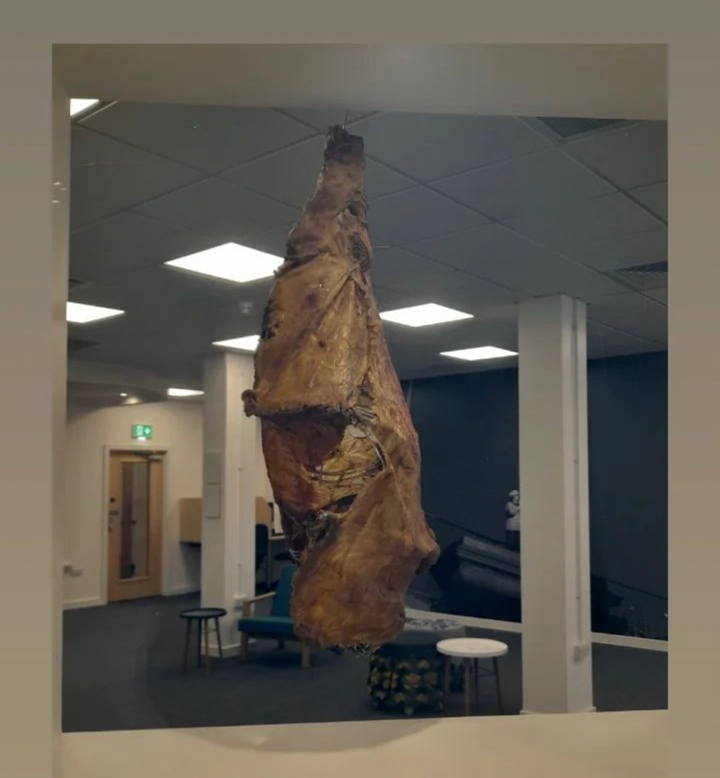
Figure 1. Kane, M (2023) Carcass
Visiting the Glynn Vivian Art Gallery to view the Swansea Open (2023) exhibition was useful because one could observe how a professional gallery with curators approached hanging art. Ironically, I disliked the way the gallery had used a Salon Style hanging, defined as: creating a crowd of paintings that either compliment or contrast each other (See, 2019), as I felt it was too crowded and individual pieces weren't given the space to be able to breathe. Therefore, the visit confirmed I didn't want a Salon Style hang and ensured that I was aware of the space I was giving my work when developing my proposal.
Creating a map of the venue helped massively when preparing for the exhibition because a physical, visual representation of the space ensured that the exhibition would flow and that the different elements of other artists would cohesively overlap and intertwine. For example, Anastasia Sevcova’s series Meat n’ Bone (2023), shares huge parallels to my work, but also touches upon other interesting elements of meat. Therefore, after careful deliberation over the similarity of our subject, we decided that our styles were different enough for the audience to recognise our work as two separate artists, and her work was exhibited after one can observe my sculptures through the foyer window, and before one can view my paintings.
Furthermore, we discussed finalising the map and publishing it for the opening, so that viewers could easily ensure that they had viewed all the art. This was a good idea that was executed and worked well, communicating the layout effectively to the viewer.
To conclude, the exhibition name, Passing Rhythms subtly informed the viewer that the reason for the number of differing themes, notions and styles were present throughout the exhibition, because all the artists were UWTSD Fine Art and Photography students exploring their own interests. Extra elements such as, posters, maps, catalogues and postcards were great additions and executed well as roles were delegated so, that we could share responsibility. I had some responsibility for the bar, a job that involved collecting money, buying drinks and supervising the bar on the night. Issues arose such as, the postcards and catalogues becoming our responsibility to sell on the night, frustratingly, without the information of how much they were being sold for. Although, we were able to quickly print out that information after we had found out. In future, it must be highlighted that everyone should stay behind for ten minutes after the official opening has ended to help clear up, as it felt like it was a lot of work for a few people. Additionally, rotating the responsibility of supervising the bar with such a small number of people was annoying as I only got ten minutes off, which led to me missing vital feedback on my work that may have helped me develop as an artist. However, the exhibition was enjoyable, and the majority of the logistics worked out well, it was great experience and good practice for our final degree show!

Bibliography

Books

Duchamp, M. (1975). ‘The Creative Act’. In M. Sanouillet and E. Peterson (Ed.) (pp. 137-140), New York: Oxford University Press.

Websites

Art Lacuna, ‘Open to you’ (Art Lacuna, 2022)
http://artlacuna.org/Open_to_You
Accessed 1 May 2023

See, G. I. ‘How To Create The Perfect ‘Salon-Style’ Hang’ (The Artling, 27 February 2019) <https://theartling.com/en/artzine/salon-style-hanging/#:~:text=The%20Salon%20Style%20method%20of,to%20and%20above%20each%20other. > accessed 1 May 2023

Exhibitions

Passing Rhythms, UWTSD Dynevor Campus, March 30, 2023- April 17, 2023, Exhibition.

Open to You, Art Lacuna, November 26, 2022-January 13, 2023, Exhibition.

Swansea Open, Glynn Vivian Art Gallery, January 28, 2023-April 16, 2023, Exhibition.

Photographs

Gomes, P (2023) Carcass, (2023), Passing Rhythms Exhibition

