Business Report -Comparison of Two Hospitality Organisations
Student name: Anat Dranciuc-Georgescu
Student Id: 2125394
Module: Financial Management for the Hotel Industry (BMIH5007)
Lecturer name: Tristan Hawkins
Word Count: 2228

Contents
Executive summary 1
INTRODUCTION 1
Main body 7
Recommendations 10
Reference list: 12

Executive summary
This paper will cover the following topics: financial statements and comparations from both Corinthia and Ibis/Accor companies, their marketing position and the impact they offer to their customers, sustainability issues and plans for the years to come.

INTRODUCTION

This report is written as a financial comparison of two different classes of hotels: Corinthia, a high luxury end hotel, and Ibis, a Premium, Mid-economic hotel, and part of the Acor Group hotel chain.
The following data is taken from the financial statements of International Hotel Investment (The Group, p.3, 2023), from January 1 to 30 of June 2023 in comparison with the 2022 December period. The Group registered a total revenue of 124.8 million euros compared to 95.8 million euros registered in the previous year, seeing an increase of 30 per cent, not being affected by the Covid lockdown. In the meantime, EBITDA was 18.78 million euros in the first half of the year compared with the 2022 Covid year which registered 17.3 million euros, hitting 15 per cent due to inflation, increase in energy costs, the situation in Budapest, exchange rates from other currencies to euro and the expenses of building new Corinthia hotels in 2024 and 2025. At the same time, interest income and expenses have increased by 4.5 million euros from a total of 12.8 million up to 17.3 million euros. 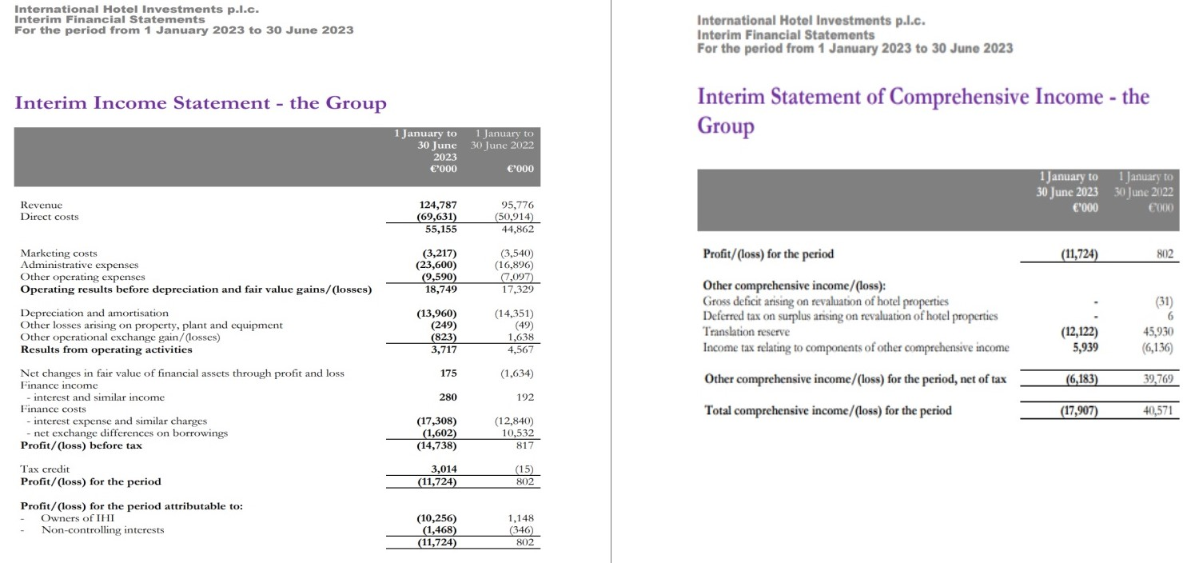International Hotel Investments p.l.c. (p.4,5, 2023)

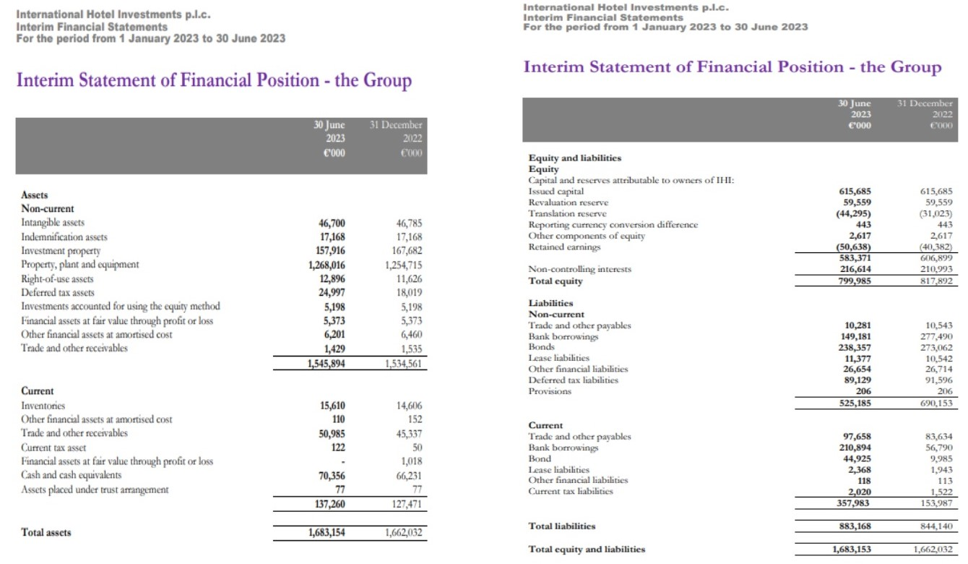International Hotel Investments p.l.c. (p.6,7 2023)
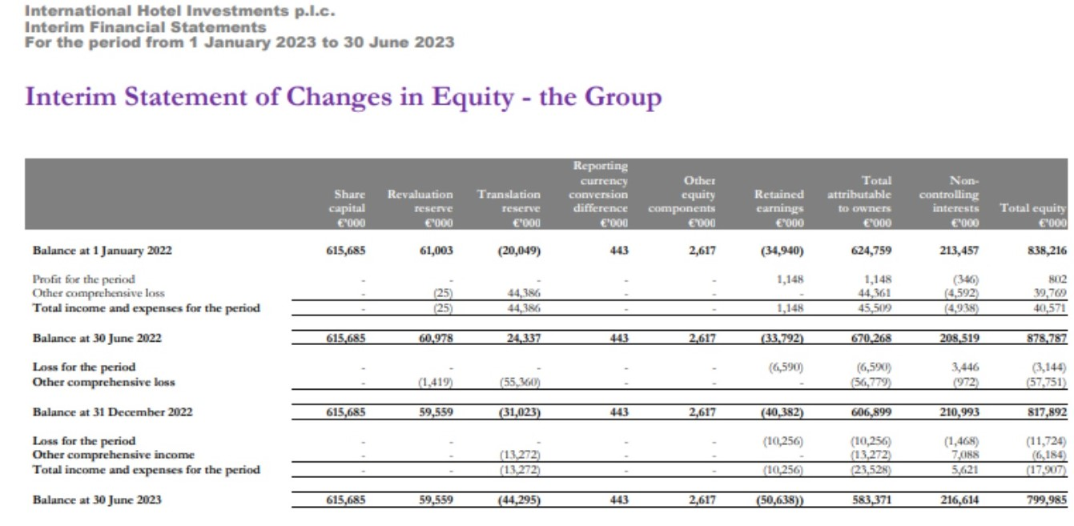International Hotel Investments p.l.c. (p.8 2023)
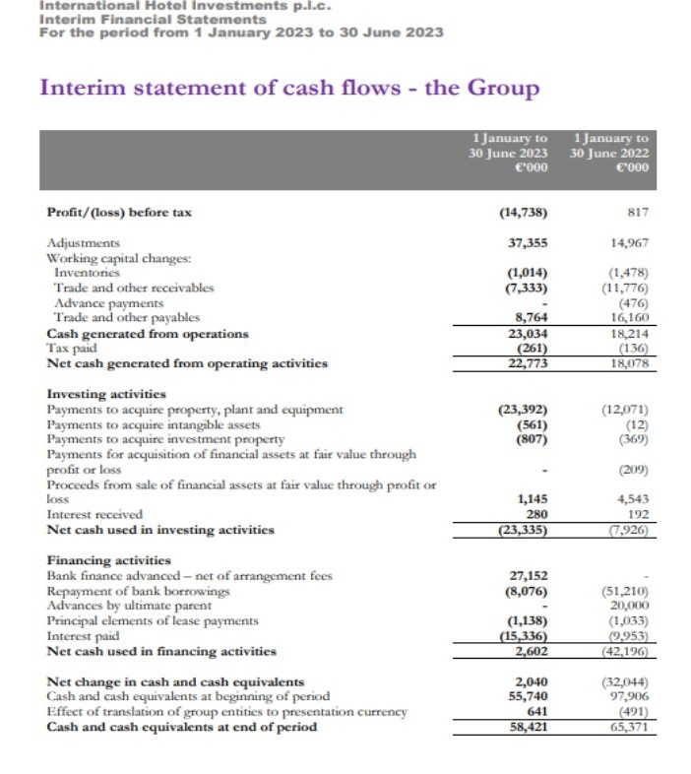International Hotel Investments p.l.c. (p.9 2023)
Oxford English Dictionary (2023) points out that EBITDA is defined as earnings before interest, tax, depreciation, and amortization.
As it is shown in the graphs and declarations the increase in revenue in the year 2023 is much more significant compared to the same period of the year 2022, proving that companies can recover in a short amount of time after a pandemic, the massive rise of price risings and even country confrontations. And of course, expanding the business with high-class hotels is a huge investment that will impact the company for a short period till it starts to produce itself.
As for Ibis hotels, Accor (p. 4, 2023), points out that since 2019 it has seen a huge increase in the recovery of the business, going up 19 per cent in RevPAR after the Covid pandemic and the lifting of the strict policy post-Covid in China in its late 2022’s. As for the first part of 2023, the company opened 114 hotels, equivalent to 14,500 rooms, with this the net unit growth rose to 3,5 in the last 12 months, for the whole year, the company declared a forecast of net unit growth of the network would be between 2 and 3 per cent. 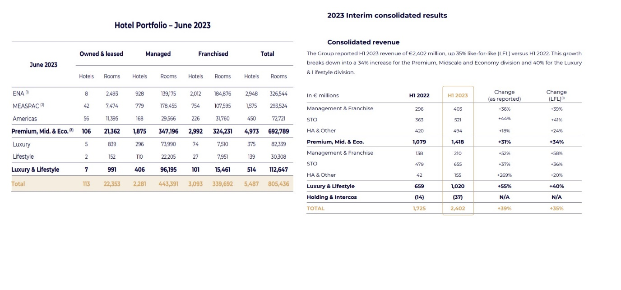 Accor (p.4,5 2023)
These graphs show an increase of 34 per cent for the year 2023 pointing to the recovery of the business over the years after the Covid pandemic period with a revenue of 1,418 million from the Premium, Midscale and Economic sectors.
Since 1st January 2023, Accor (p.27, 2023) changed the way its organisation functions by splitting the company into two independent divisions to accommodate customers' needs, on “Premium, Midscale and Economic” which covers Ibis and other brands such as Novotel, and second division are “The Luxury lifestyle” for example Orient Express.
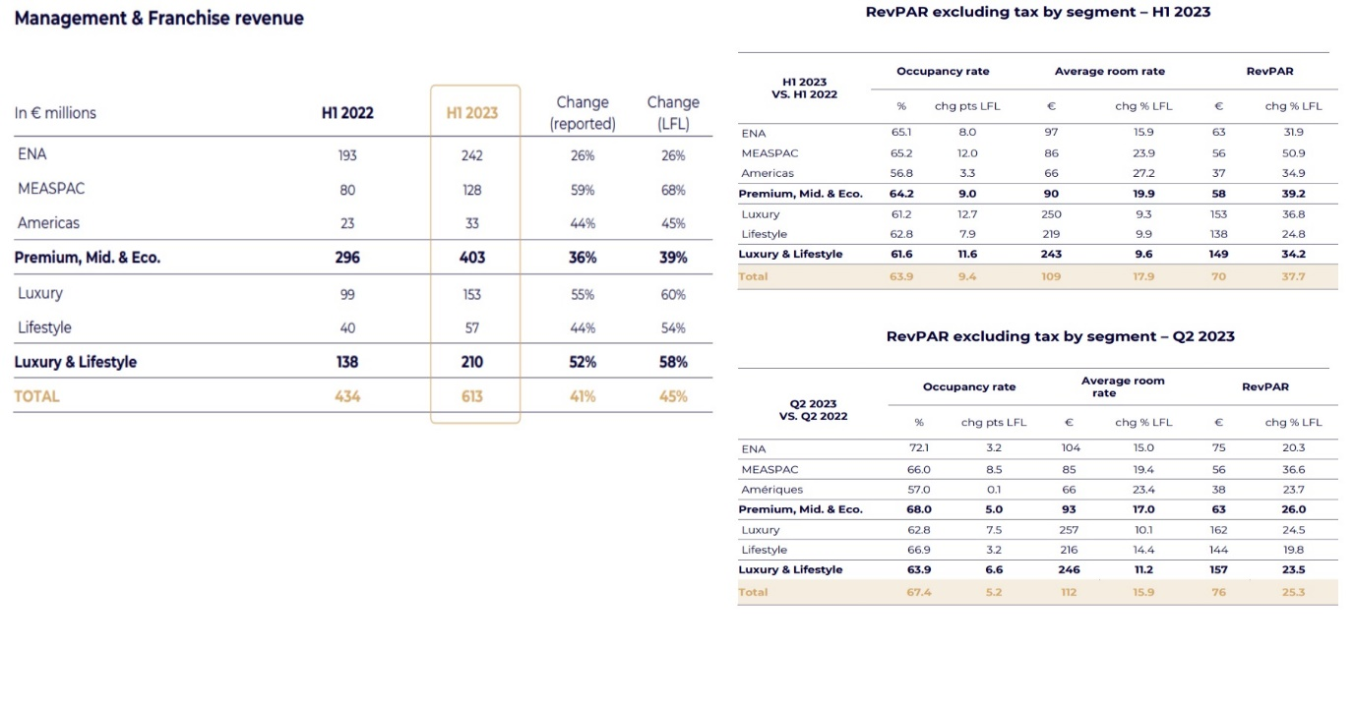 Accor (p.6,7 2023)
Accor (p6,7 2023) points out that, The Premium, Midscale and Economy division grew its RevPAR by 26% versus 2022, still mostly driven by prices rather than the rise in occupancy rates. The United Kingdom, which represents 12% of the region's room revenue, posted a balanced growth in RevPAR between London and other cities. In Germany, the country which accounts for 13% of the region's room revenue, RevPAR improved significantly in the second quarter but continued to be behind compared with the rest of Europe.
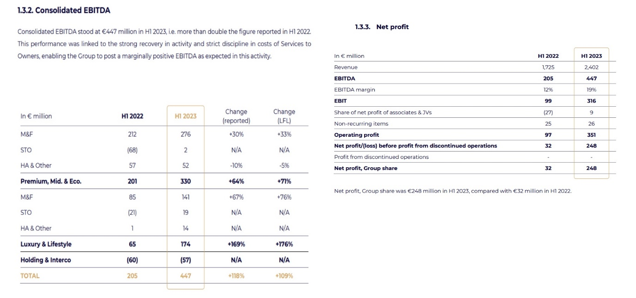 Accor (p.9 2023)
As for EBITDA, Accor (p.9 2023) explains the following: The Premium, Midscale and Economy division generated EBITDA of 330 million euros, up 71% versus 2022. The Management & Franchise (M&F) business posted an EBITDA of 276 million euros, up 33% versus 2022, and Services to Owners EBITDA came to 2 million euros in 2023, slightly positive because of strict cost control.
The net profit visible changes were made due to the improvement in the share of net profit of equity-accounted investments, positive at 9 million euros vs a negative of 27 million euros in 2022, which is primarily driven by the recovery at Accor Invest, which enjoyed a rebound in business, particularly in Europe.
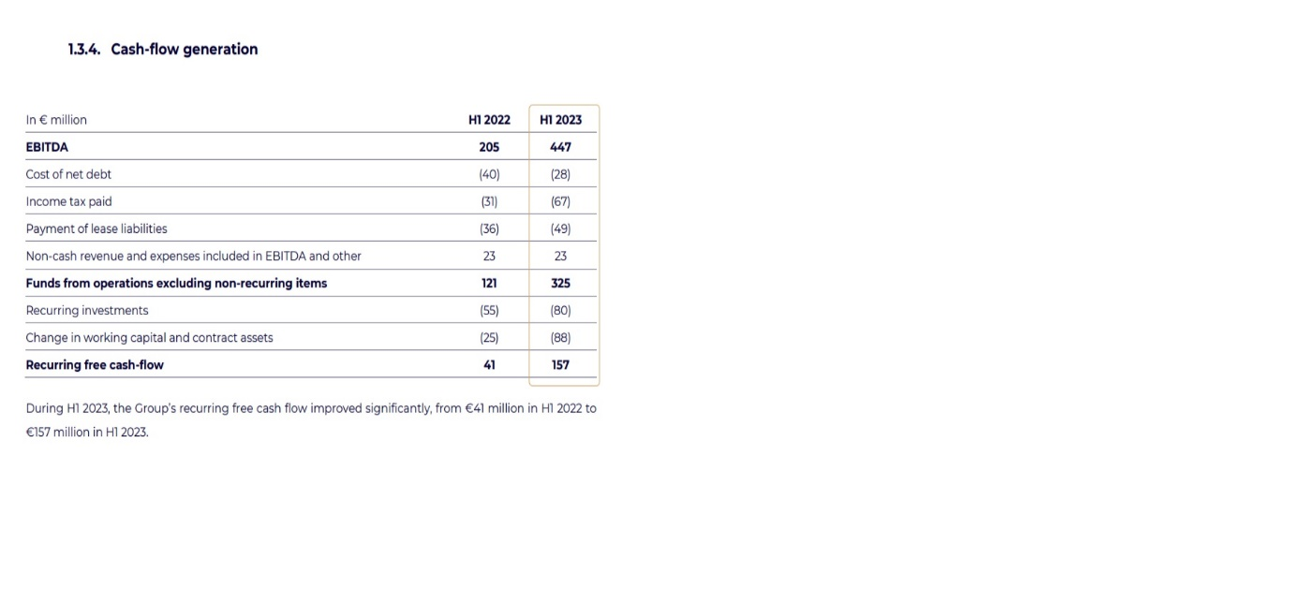 Accor (p.11 2023)
Accor (p.11 2023) also discusses the cost of net debt decreased from H1 2022 to H1 2023, increasing interest rates on cash investments. Recurring expenditure, which includes "key money" for development and digital and IT investments, was slightly higher than in the initial 2022 at 80 million euros, given the Group's acceleration in the Luxury & Lifestyle segment. Repeating investments in 2023 are expected to be more than 200 million euros. In H1 2023, a shift in working capital is observed and reflects the business growth reported. At the end of June 2023, the group's net financial debt increased to 1,837 million euros, compared to 1,658 million on December 31, 2022. On June 30, 2023, Accor's average cost of debt was 2.5%, with an average duration of approximately three years, with no major repayments due before 2026. At the end of June 2023, Accor had a liquidity position of 2.7 billion euros.

Main body
Space International Hotel Design (2015) discuss how Corinthia hotels meets the demands of shareholders, fulfils the growth of their management team, and delivers the brand’s values to the guests. Maintaining authenticity and having faith in the development and expansion of the brand are considered crucial by many. Investors, it seems, prefer to be connected to a sincere and motivational narrative. Making one's goal known and implementing it along the way is therefore seen as essential. The demand for premier trophy properties in strategic cities appears to be constant. The company claims to carefully select compassionate and eager individuals who go above and beyond to make visitors' stays unforgettable. By promoting talented employees to management positions, Corinthia Hotels aims to foster a sense of devotion towards the company and its brand. Through routine implementation of standard operating procedures and training, they claim to guarantee consistency in service provision. The company claims to create their success story by genuinely caring about their clients. They believe that hospitality is a time-honoured skill that requires a team effort. The principles of sincerity, understanding, accuracy, and enthusiasm are said to be critical to the brand's essence. These values are supposed to guide employees in their work. Managers are encouraged to lead by example and treat their team members with respect and decency to effectively communicate the brand's values to visitors.
When it comes to company shares and customer reward systems, Corinthia Group (2024) points out a series of terms and conditions for the PRIVILEGE CARD to be used within their facilities and one of them is that the Shareholder Privilege Card may not be used in combination with any other Corinthia offer, Elite Card or any other Corinthia Group discount scheme, employee benefit or ongoing promotions.
The Shareholder Privilege Card is non-transferable and may only be used by the registered cardholder, it is only offered to Shareholders having 1,000 or more IHI Ordinary Shares.
The card does not have an expiry date and will remain valid as long as the holder is still in possession of 1,000 or more IHI ordinary shares. The card will be automatically terminated should the holder dispose of the investment.
Discounts apply if the outlets concerned are operated by a Corinthia Group subsidiary. From time to time some outlets at Corinthia Hotels might be operated under independent management.
As for the discounts that the shareholders receive Corinthia Group (2023) gives the following data: Accommodation at overseas hotels, shall be discounted by 10% on the best available rate. The discounted rate includes VAT and excludes Breakfast. Free upgrade to the Executive Club and access to executive facilities, subject to availability.
Accommodation at Corinthia London at a special fixed rate of £445 per room excluding Breakfast and VAT. (Excluding the period between 29 May to 1 June during the Champions League Final and 1 July to 14 July during the Frieze Art Fair). Other Benefits - Overseas 15% DISCOUNT Food and beverage consumption. (Excluding Kerridge’s Bar & Grill at Corinthia London, Caviar & Bull Restaurant and Uncensored by Caviar & Bull at Corinthia Budapest).15% DISCOUNT All treatments at the SPA at Corinthia Lisbon.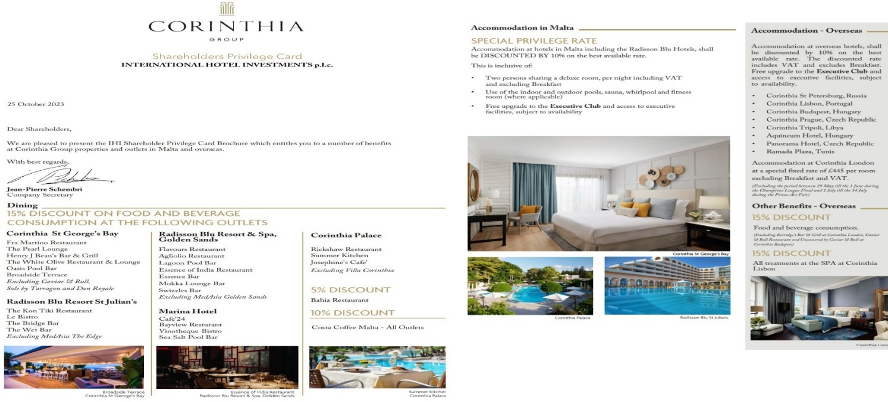 Corinthia Group (2023)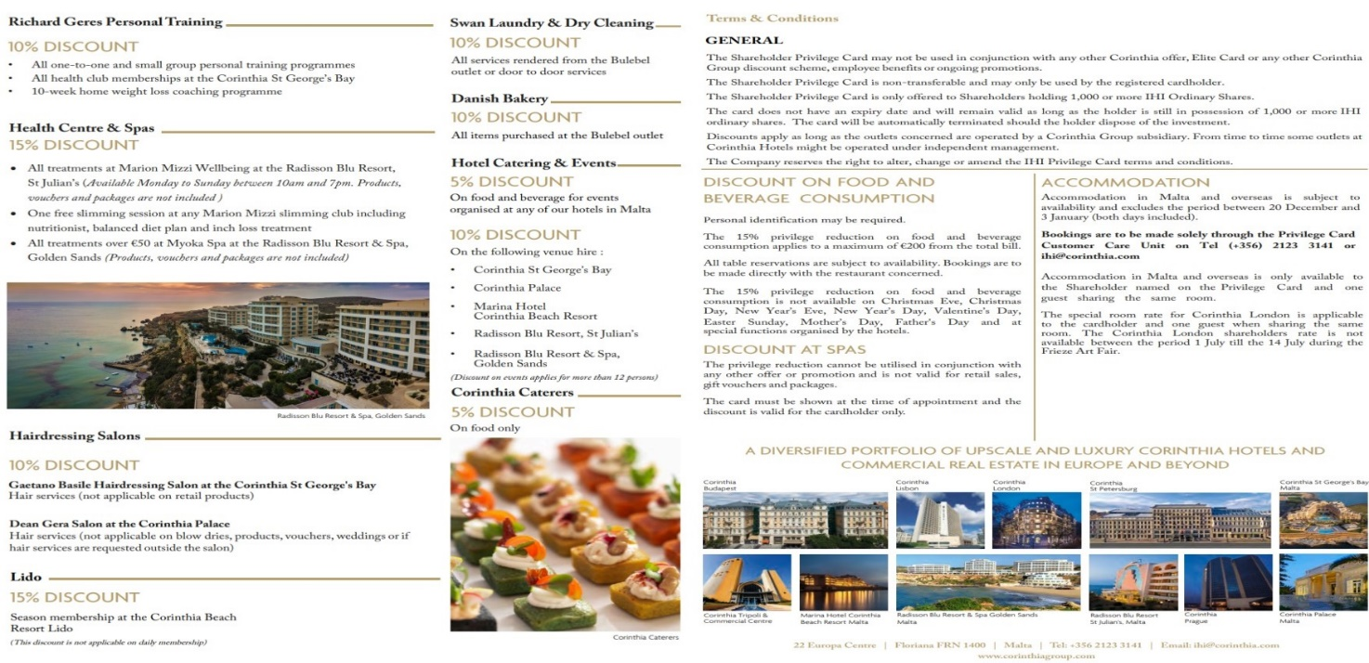 Corinthia Group (2023)
All these benefits offered to shareholders tend to get customers to invest in the company just for the benefit that they receive from it.
For the position within the market including customers reviews and current discounts U.S. News and World Report (2024) ranked Corinthian London hotel on number 13 among the best London, England hotels, the Corinthia Hotel London's suites, diversity of amenities, and level of service frequently impress guests. However, a few preceding tourists have mentioned that the nightly accommodation costs were high.
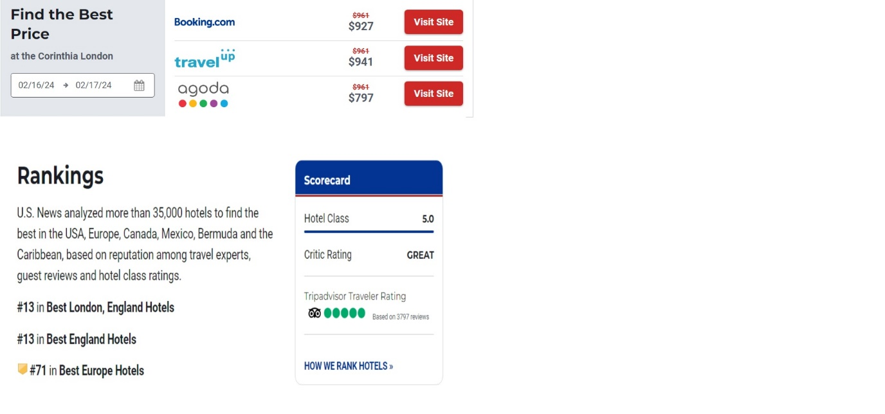 U.S. News and World Report (2024)
Coming back to Ibis by Accor, All things fitness and wellness (2024) discuss the idea that customer experienced change more post the covid pandemic then it used to be before, that guests try to disconnect from their day-to-day life and heal somehow from the daily stress. As such 80 per cent across all Accor brands, meaning 4 out of 5 of the guests are looking to improve their well-being while on holiday, in this case offering all the necessities for them is crucial, from building hotels in a sustainable matter, to all available facilities and certain healthy foods.
On another note, Accor Group Homepage (2024) points out that the Ministry of Tourism in Saudi Arabia has recently entered a strategic partnership with Accor, to support and develop Saudi talent within the hospitality industry. The collaboration, known as the "Tamayyaz by Accor" program, aims to provide opportunities for fresh graduates and talented individuals to advance their careers, expedite nationalization efforts, identify crucial roles within each department, nurture internal talent, implement onboarding programs, and create plans for career growth. Upon completion of the 6-month program, a total of 256 trainees will be employed in their preferred departments within the hotels.
The "Tamayyaz by Accor" program consists of three distinct tracks: Hospitality Specialist, Hospitality Operations, and Hospitality Leadership. The Hospitality Specialist track introduces local talent to the fundamental aspects of non-operating hotel departments, such as Talent and Culture, Marketing, Finance, Business Development, and Guest Experiences. The Hospitality Operations track focuses on departments like Food and Beverage, Front Office, Housekeeping, Culinary, and Engineering. Lastly, the Hospitality Leadership track aims to enhance leadership skills by applying the Accor Leadership Framework.
All these innovations and efforts from both Corinthia and Ibis/ Accor for their guests prove that there is no limit when it comes to hospitality when supporting customers and communities around the world and finance is not an issue.

Recommendations and conclusions
Accor (2024) points out that the travel and tourism industry, are responsible for 9 to 12% of the world's greenhouse gas emission and must address these challenges and build more sustainable models to meet the expectations of stakeholders such as investors, owners, business partners, team members, and guests, while efforts have been made to limit the impacts of activities on the planet and its inhabitants, it is recognized that the future of hospitality relies on the sustainable business model built today. The ambition is to make a positive contribution to society, from local economies to environmental impact, with a strong focus on people and nature as the core of the sustainability strategy.
The primary objective is to have a positive impact on people and nature, two fundamental aspects of the sector and its activities, travel, and tourism, which account for up to 10% of global employment, have a crucial role to play in promoting positive values within the industry.
Furthermore, tourism is intricately linked to the natural world, relying on its resources, and drawing appeal from the unique environments of each destination. At Accor, in line with the Paris Agreement, they have pledged to achieve Net Zero carbon emissions by 2050 and actively reduce greenhouse gas emissions. The commitment extends to the preservation and responsible use of natural resources, as well as the protection of ecosystems and biodiversity, aligning with the Kunming-Montreal Agreement to preserve and restore at least 30% of the world's land, coastal areas, and oceans by December 2022.
As for Corinthia hotels, Corinthia.com (2024) points out that it aims to build The Corinthia Oasis which is a regeneration project that aims to transform a brownfield, derelict, and disused site into a top-tier Mediterranean resort that the island can truly be proud of. The project follows a forward-thinking sustainability philosophy, aspiring to meet green design standards and achieve eco-certification from industry-leading accreditation institutions.
The resort will boast various features, including eco-gardens and green roofs, natural climatization solutions, ventilation and thermal insulation systems, heat recovery systems, and the reuse of both rain and grey water. Additionally, the site will offer onsite green transport and cycle paths, intelligent, energy-efficient, and low-impact lighting, as well as site-wide waste management systems.
After comparing both Corinthia and Ibis/Accor companies the key futures that need to be remembered is that hospitality and the way guests expect holidays to have changed through the years. No matter if they access a 5-star hotel or an economy one, guests expect to find wellness awareness, sustainability awareness and good financial management all the way.

Reference list:
Accor (2023) Financial Results/Financial Report. [Online] Available at: https://group.accor.com/en/finance/results-and-publications/financial-result (Accessed: 1 February 2024).
Accor (2024) Sustainability Strategy. [Online] Available at: https://group.accor.com/en/commitment/approach/sustainability-strategy (Accessed: 2 February 2024).
Accor Group Homepage (2024) Accor and the Ministry of Tourism Join Forces to Empower 256 Saudi Talents through “Tamayyaz by Accor”.[Online] Available at: https://press.accor.com/middle-east-africa-turkey-asia-pacific/accor-and-ministry-of-tourism-join-forces-to-empower-256-saudi-talents-through-tamayyaz-by-accor/?lang=en?&utm_medium=social%20media&utm_source=Linkedin&utm_content=ALL-EN-ALL-ALL&utm_term=20240127 (Accessed: 2 February 2024).
All things fitness and wellness (2024) Key Wellness Travel Trends with Accor's Emlyn Brown - YouTube. [Online] Available at: https://www.youtube.com/watch?v=7Uk9IdsBdEw (Accessed: 2 February 2024).
Corinthia Group (2023) Shareholders Privilege Card/ International hotel investments. [Online] Available at: https://www.corinthiagroup.com/wp-content/uploads/2023/10/IHI-Shareholders-Privilege-Card-Brochure-October-2023-V4.pdf (Accessed: 2 February 2024).
Corinthia.com (2024) SUSTAINABILITY. [Online] Available at: https://www.corinthia.com/en-gb/oasis/sustainability / (Accessed: 2 February 2024).
Corinthia Group (2024) PRIVILEGE CARD. Available at: https://www.corinthiagroup.com/investors/privilege-card/ (Accessed: 2 February 2024).
International Hotel Investments p.l.c. (2023) Interim Financial Statements (Unaudited) For the six months 1 January 2023 to 30 June 2023. [Online] Available at: https://www.corinthiagroup.com/wp-content/uploads/2023/08/IHI-Interim-Financial-Statements-30-June-2023.pdf (Accessed: 1 February 2024).
Oxford English Dictionary (2023) Meanings, EBITDA [Online] Available at:https://www.oed.com/search/advanced/Meanings?textTermText0=EBITDA&textTermOpt0=WordPhrase&quotDateFirstUse=all&page=1&sortOption=AZ (Accessed: 1 February 2024).
Space International Hotel Design (2015) ALFRED PISANI, FOUNDER & CHAIRMAN, CORINTHIA HOTELS. [Online] Available at: https://hotelspaceonline.com/people/alfred-pisani-founder-chairman-corinthia-hotels/ (Accessed: 2 February 2024).
U.S. News and World Report (2024) Best U.S. news rankings -Corinthia London. [Online] Available at: https://travel.usnews.com/hotels/review-corinthia_hotel_london-london-united_kingdom-117986/ (Accessed: 2 February 2024).

