

BA Business Management

Management Economics
LCBB5003

Individual Report

Valentin Victor Zlate
Module Lecturer: Muno Zuwirai

To: ASI Management
From : Business Planning manager
Date: 1st July 2022
Subject: Profit Maximisation Theory

Report Title:

Profit Maximisation Theory and its application in light of ASI and Allan Scheepers’

Introduction
In the current competitive business environment, the main aim of business organisations is to focus on the maximisation of their profits so that they can ensure their long-term survival as well as a competitive edge in the crowded business market. The reference to the Profit Maximisation Theory gains prominence in this respect. In the present study, the focus shall be on the application of this theory in terms of All Supplies Incorporated. Further, a range of economic theories and concepts including the Demand-and-Supply theory shall be applied in an effort to evaluate different issues that need to be taken into consideration by the management in terms of decision-making by the management team of ASI.

Table of Contents

Profit Maximisation Theory and its application in light of ASI and Allan Scheepers’ statement 4
Other issues of importance for ASI to improve 5
Evaluation of various issues to be considered by management in decision making by ASI management 5
Conclusion 10
Recommendations 11
Reference List 12

Profit Maximisation Theory and its application in light of ASI and Allan Scheepers’ statement
Profit maximisation essentially refers to the act performed for achieving the highest profits or revenues. It is generally used as a benchmark for the most effective situation and for planning purposes. In simpler terms, profit maximisation is all about the utilisation of a product for the purpose of generating a desired return or investment or profit. In this context, the Profit Maximisation Theory is the principle that every business organisation needs to operate with the sole purpose of making a profit (Anning, 2018). It is possible for profitable companies to achieve the same by selling more by charging higher rates for their offerings and minimising production and operational costs. From an economical perspective, the Profit Maximisation Theory presumes that a company is likely to select the course of action that ultimately leads to generating the maximum profits (Casson, 2018). The maximisation of profits is also a principle of economics that states that organisations tend to choose the course that enables them to have the lowest production costs, even when other possible alternatives may result in low total costs or high total benefits.
In the context of ASI, it is observed from Scheepers’ statement that the company's main objective at present centres on the maximisation of profits following a decline in the past few days. Fact Because the company happens to be the largest retailer having the biggest retail shop network, ASI is not likely to face any hindrances when it comes to maximising its profits. It may be observed that the company has previously applied the Profit Maximisation Theory by increasing the prices of its products. As the theory asserts, profitable companies achieve higher profits by selling more charging higher rates for their offerings and minimising production and operational costs (Anning, 2018). Given the positive reputation of the consumer goods retailer in the market, this strategy helped ASI to drive higher sales in the market. This could be predominantly because of the fact that despite higher prices, customers continued to be drawn to the offerings of ASI for its brand image and market share.
In addition to the above, it might be observed that ASI is thinking to concentrate on increasing the prices of the brands, particularly the ones that it owns exclusively. These brands offer products that customers would not otherwise have found anywhere else. As such, this initiative is likely to be proven to be particularly successful in enabling the firm to be a market leader in the consumer goods segment following a stagnancy observed in profits in recent days.

Other issues of importance for ASI to improve
As has been observed from the given scenario, ASI has faced a certain slump in terms of profits over the recent days. In order to recover from the same, it is advisable to focus on areas and strategies other than increasing the prices of existing products from exclusive brands to drive higher profits. For one, ASI would be required to concentrate significantly on the issue of competition it faces in the market, which is also a major contributor to the firm’s declining profits in recent times. In this reference, it is important to focus on how it differentiates its products from those offered by its competitors in the consumer goods market. As pointed out by Hossain and Azmi (2020), the differentiation strategy goes a long way in enabling companies to develop unique niches within the competitive markets or industries, which thereby enables them to flourish. The idea behind this is to focus on appearing as the company willing to offer superior quality products that are innovative in their functionality at the same time.
It might also help for ASI to take into serious consideration a possible expansion to markets outside the UK. This can enable the firm to reach out to a much wider customer base and thereby drive higher sales and profits. As per the opinions of Bortoluzzi et al. (2018), international expansion contributes significantly to a steady increase in terms of business growth. Foraying into overseas markets allows for rapid growth for business organisations. As such, it would indeed make sense for ASI to concentrate on launching operations in other countries apart from the UK in an effort to maximise profits.
Overall, it can be summed up from this that based on the given scenario, ASI has successfully implemented the Profit Maximisation Theory by increasing the prices of its offerings to ensure higher rates of profits. However, at the same time, it is not merely enough to focus on this particular issue. An equal amount of focus also needs to be laid on other key issues such as competition and a possible international expansion.

Evaluation of various issues to be considered by management in decision making by ASI management
Theory of Supply and Demand
This theory is key to gaining a deeper understanding of the Economic system and the core functions it has to perform. The quantity that is demanded of a service or good refers to the amount that customers plan on buying during a certain period at a distinct price. The Theory of Supply and Demand is founded on the notion that the market is essentially governed by the law of demand (Maliniak et al., 2020). The quantity of a product demanded by consumers during a definite period is inversely related to its price as well as other things. Moreover, producers are likely to be willing to supply a product only when they can at a minimum cover their marginal production costs. In the context of ASI, it can be presumed from the given scenario that taking into consideration the fact that the consumer goods retailer has been operating since 2010, it has managed to remain one of the market leaders in its respective industry. This points toward the fact that the company has enjoyed considerable demand and supply of its products among its consumers in the market.

Q1 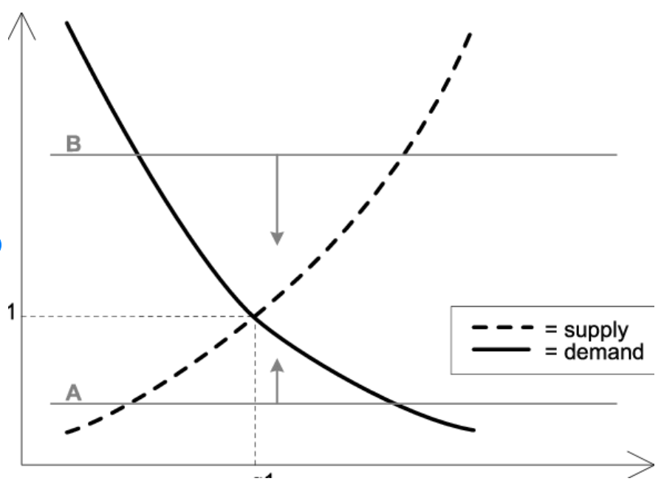
T1
Figure 1: Theory of Demand and Supply
(Source: Maliniak et al., 2020)
The cost-benefit rule implies that an organisation needs to take action if its benefits are much greater than its costs (Sepulveda, 2020). As per this concept, it might be noted that the increased demand for ASI's products is much more likely to represent the benefits of the buyers while the supply shall represent the costs of the sellers as well as the individual decisions pertaining to how much of something shall be done. Furthermore, the fact that ASI is considering setting higher prices for its exclusive brands indicates a price elasticity of demand which involves measuring the change in terms of the consumption of a product or service in relation to a change in its price (Kupcik, 2022). ASI's products may be considered elastic if an increase in their prices causes a considerable change in their supply or demand.
Business Environment
In order to assess the different issues that are to be considered by the management in terms of decision-making by the ASI management, the PESTLE tool can be used as shown below:
Political: In the UK, BREXIT has adversely impacted the consumer goods industry by compelling the companies operating within it to pay new customs and tariff duties (McKenzie, 2022). For ASI, non-tariff barriers in the form of hidden expenditures are likely to prove to be largely costly to the business organisation, thereby posing a key threat to its primary objective of maximising profits.
Economic: During the first quarter of 2022, an expansion of 8.7% has been recorded in the UK's economy (Trading Economics, 2022). While this can provide an opportunity for ASI to expand its operations to other countries outside the UK and also increase its exclusive products, a threat looms over the economy owing to the impacts of the Russia-Ukraine war.
Social: It is expected that the UK’s population shall reach up to an estimated 67.44 million by end-2022 (Trading Economics, 2022). This is expected to provide an opportunity for ASI to reach a wider pool of customer base in the home market. The profits gained in the home country can then be used for launching operations in other countries outside the UK. At the same time, improved revenue would also help the company to invest significantly in incorporating innovation in existing products to drive a competitive edge.
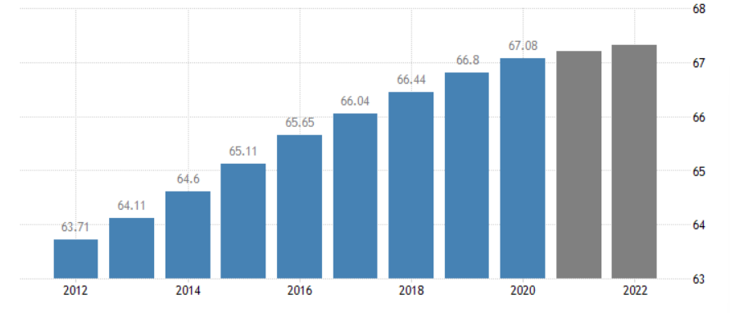
Figure 2: Population growth in the UK
(Source: Trading Economics, 2022)
Technological: As per 2022 figures, an estimated 67 million people in the UK actively use the internet while around 53 million are active users of social media platforms (Statista, 2022). These figures present an opportunity for ASI to reach out to customers online to inform them about any new variations or specifications in their newest products. Moreover, expanding to another region would also be relatively easier with the marketers of the company reaching out to customers over social media and creating awareness among them.
Legal: In the UK, companies are prohibited from engaging in anti-competitive behaviour under the Competition Act of 1998’s Chapters I and II (Office of Fair Trading, 2022). The enactment of this Act poses a potential threat to ASI when it comes to attempting to squash competition in the market through product differentiation. At the same time, however, the company has the opportunity to not engage in practices that encourage the abuse of its future dominant position in the consumer goods market.
Environmental: Over the years, the food retail sector and consumer goods sector have been engaging in various CSR initiatives to make a positive impact on the wider society in which the organisations operate. This presents an opportunity for ASI to strengthen its brand image in the minds of the consumers in its home market which can also be carried forward to new foreign markets.
Business Objectives
In the context of ASI, it is noted that the organisation has the primary objective of maximising profits to recover its past profitability and growth. For any organisation to be able to survive in the current competitive environment, it is necessary to focus on practices and strategies that can bring in the much-needed profits (Klemm, 2004). In the case of ASI, it is seen that the organisation needs to focus on analysing its competition and incorporate innovation in its line of products to stand apart from its competitors. Additionally, it is also necessary to expand to new markets to widen the existing customer base.
Market structure
The term, ‘market structure’ denotes how varying industries are differentiated and classified based on their nature and degree of competition for goods and services (Azar and Vives, 2021). For ASI, it is much-needed to focus on an oligopoly market structure wherein a limited number of larger firms would operate selling identical or differentiated products. ASI would have to create agreements in order to share the market by restricting production, resulting in supernormal profits.

Stakeholder issues
ASI has various stakeholders including shareholders, investors, employees, board of directors, customers, suppliers and the community. Based on the given scenario, it is found that the main shareholder is not happy with the company’s declining profits in recent times. From an economical perspective, this can be said to be an issue caused while trying to align various stakeholders. Apart from this, this can also be an instance of the competing priorities between the different stakeholders.
As concurred by Amadi et al. (2018), stakeholders tend to carry their own goals and expectations into an organisation. In the case of ASI particularly, it can be assumed that some of the priorities tend to compete or contradict each other. Those of the main shareholders in particular are contrasting with those of the board of directors of the firm. In this case, it is advisable to focus on the creation of an effective communication plan that can help the stakeholders to stay right on the same page. Such an action would be highly beneficial in terms of supporting sound business deliberations. 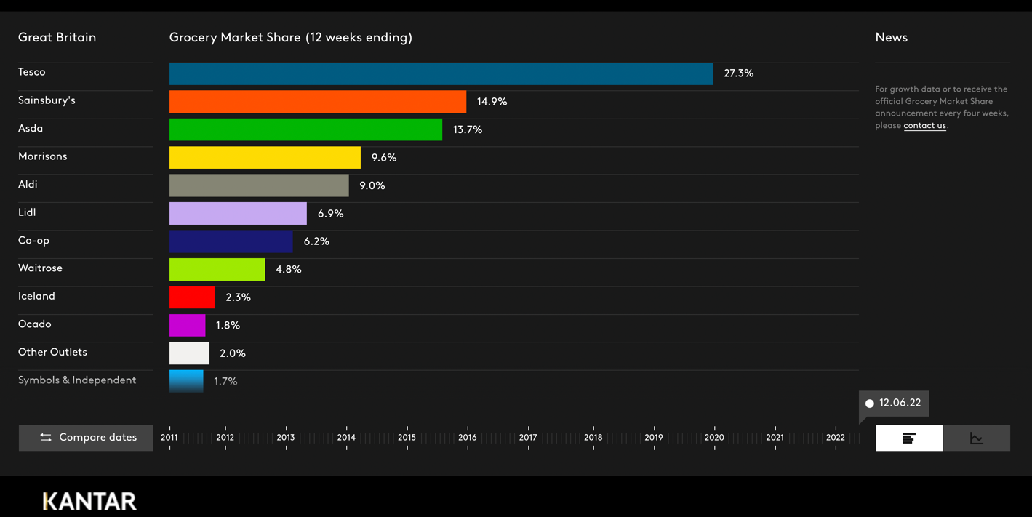
Figure 3:Grocery Market Share
(Source: Kantar World Panel,2022)

Interest rate
A percentage of the principal, or the amount loaned, is what a lender charges a borrower as interest. The annual percentage rate, or APR, is the usual unit used to express the interest rate on a loan (APR).

A savings account or certificate of deposit earnings at a bank or credit union may also be subject to an interest rate (CD). The interest received on these deposit accounts is measured in annual percentage yields (APY).

Knowledge of Interest Rates
In essence, interest is a fee assessed to the borrower for the use of a resource. Borrowed assets may include money, merchandise, automobiles, and real estate.

Conclusion
From the above discussions, it can be surmised that the concept of profit maximisation has gained major prominence, particularly in the context of the fiercely competitive business environment. The case organisation, ASI, is found to have applied the Profit Maximisation theory by increasing the prices of its products to allow for higher profits. However, it has been found that the external business environment of the company might be moderately suitable for increasing the prices of the company’s exclusive brand offerings. Further, opting for an oligopoly market structure appears to be a more feasible option for a consumer goods selling company such as ASI without having to resort to unethical means to maximise profits.

Recommendations
Based on the above findings, the following recommendations can be implemented by ASI to maximise its declining profits successfully:
- Boosting the sales value
As opined by Holopainen et al. (2020), whichever product a brand sells, enticing customers to purchase more while shopping in its store is one of the ideal ways to boost its sales value. ASI can focus on boosting its sales value by concentrating more on higher promotion and marketing of its products and improved quality of the same. The authorities would be required to analyse where they mainly earn their revenue from and subsequently focus on making even more profits in those very areas of the services and products.
- Increasing product prices
As pointed out by Hailu and Weersink (2011), for a brand, the ideal way to position itself in the market is by packaging its services in order to provide maximum value to both its clients and themselves. The authorities of ASI are advised to take into serious consideration increasing the prices of their products. However, for this, it is necessary to check whether they have priced their services and products correctly in the first place and whether or not it would be feasible to boost the prices without leading to weakened sales.
- Finding new markets and new customers
It is a known fact that new customers can go a long way in helping a company to grow its business, primarily in terms of sales, profits and resultant market share. In this case, making ample use of market research can be extremely helpful for determining if the business can be expanded into newer areas. As ASI currently operates only within the UK in the position of a market leader, the company can as well expand to other viable markets where it can not only achieve more prominence with its products but also establish a loyal customer base, thereby successfully maximising profits.

Reference List
Amadi, C., Carrillo, P. and Tuuli, M., 2018. Stakeholder management in PPP projects: external stakeholders’ perspective. Built Environment Project and Asset Management.

Anning, F., 2018. An assessment of the traditional theory of firm based assumption of profit maximization in an organization. Available at SSRN 3235066.

Azar, J. and Vives, X., 2021. General equilibrium oligopoly and ownership structure. Econometrica, 89(3), pp.999-1048.

Bortoluzzi, G., Kadic-Maglajlic, S., Arslanagic-Kalajdzic, M. and Balboni, B., 2018. Innovativeness as a driver of the international expansion of developing markets’ firms: Evidence of curvilinear effects. International Marketing Review.

Casson, M., 2018. The theory of international business: the role of economic models. Management International Review, 58(3), pp.363-387.

Hailu, G. and Weersink, A., 2011. Commodity price volatility: the impact of commodity index traders (No. 1618-2016-134659).

Holopainen, T., Rantala, J., Virtanen, M. and Korhonen, T., 2020, July. Sales process evolution. In International Conference on Applied Human Factors and Ergonomics (pp. 174-179). Springer, Cham.

Hossain, K. and Azmi, I.B.A.G., 2020. Linking entrepreneurial orientation dimensions with multidimensional differentiation strategy. Management Science Letters, 10(8), pp.1881-1886.

Klemm, A., 2004. Profit maximisation and alternatives in oligopolies. Institute of Fiscal Studies.

Kupcik, J., 2022. Firm’s Own Price Elasticity of Demand in Dominant Position Analysis. Journal of European Competition Law & Practice, 13(3), pp.187-199.
Maliniak, D., Peterson, S., Powers, R. and Tierney, M.J., 2020. Supply-and demand-side explanations for the theory-practice divide. Bridging the theory-practice divide in international relations, pp.231-247.

McKenzie, B. 2022. Brexit: Key Implications for the Consumer Goods & Retail Sector. [online] Available at: <https://www.bakermckenzie.com/-/media/files/insight/topics/brexit/cgr_brexit-updated.pdf> [Accessed 8 June 2022] (McKenzie).

Office of Fair Trading, 2022. Competing fairly. [online] Available at: <https://assets.publishing.service.gov.uk/government/uploads/system/uploads/attachment_data/file/284411/oft447.pdf> [Accessed 8 June 2022].

Sepulveda, C.F., 2020. Explaining the demand and supply model with the cost-benefit rule. International Review of Economics Education, 35, p.100194.

Statista, 2022. UK: digital population 2022 | Statista. [online] Available at: <https://www.statista.com/statistics/507392/uk-number-and-penetration-rate-of-internet-and-mobile-internet-users/> [Accessed 8 June 2022].

Trading Economics, 2022. United Kingdom GDP Annual Growth Rate - 2022 Data - 2023 Forecast. [online] Available at: <https://tradingeconomics.com/united-kingdom/gdp-growth-annual#:~:text=UK%20Annual%20GDP%20Growth%20at,2%25%20and%20construction%207.4%25>. [Accessed 8 June 2022].

Trading Economics, 2022. United Kingdom Population - 2021 Data - 2022 Forecast - 1950-2020 Historical - Chart. [online] Available at: <https://tradingeconomics.com/united-kingdom/population#:~:text=Population%20in%20the%20United%20Kingdom%20is%20expected%20to%20reach%2067.44,macro%20models%20and%20analysts%20expectations> [Accessed 8 June 2022].

