Marketing Management Assessment 1

Name: Tsvetomir Georgiev

Student Id: 2124036
TABLE OF CONTENTS
INTRODUCTION 3
KEY BUSINESS FACTS OF UNILEVER 4
MARKETING STRATEGY OF UNILEVER 5
MARKETING MIX OF UNILEVER 6
4C OF UNILEVER 8
BRANDS AND CATEGORIES OF UNILEVER PLC 8
BRANDING OF UNILEVER 9
5M THEORY FOR ADVERTISEMENT MODEL OF UNILEVER 10
FOCUS ON SUSTAINABILITY 12
POWER BRAND STRATEGY OF UNILEVER 13
PORTER FIVE FORCES MODEL ANALYSIS FOR UNILEVER PLC 13
EVALUATION OF THE SUCCESS OF CONSUMER INDUSTRY PRODUCT MANUFACTURING OF UNILEVER 14
CONCLUSION 16
REFERENCES 17

INTRODUCTION
The report is based on the assessment of innovative marketing strategies and maximising the customer satisfaction aspect. The information has chosen Unilever PLC of the evaluation. The report will begin with discussing some key business facts of the chosen organisation. Further, the report will move to the current innovative business model of Unilever. After this, the report will focus on discussing the marketing strategy of Unilever (Deepak and Jeyakumar, 2019). After this, the report will proceed to analyse the marketing mix of Unilever. Moreover, the reports will discuss the 4C theory of Unilever. Apart from this, the reports will also discuss the innovative branding strategies of Unilever. Alongside discussing the 5M theory of the advertisement model of Unilever. Lastly, the report will include conclusive statements.
Background of chosen organisation:
Unilever PLC is a consumer goods organisation. It is a multinational consumer goes organisation in the United Kingdom (Unilever, 2023). The headquarters of Unilever PLC is in London, England, United Kingdom. The present CEO of the Unilever PLC of Alan Jope.

KEY BUSINESS FACTS OF UNILEVER
2.5 billion People are currently using the products of Unilever on the Daily. In the year 2016, the sustainable living brands of Unilever PLC HAD had ideally grown up 50 per cent faster than the other businesses. Unilever PLC has been chosen as the No.1 graduate employer of the FMCG of choice in 44 out of the 52 nations. In the year 2017, Unilever PLC proceeded to maintain zero waste (non-hazardous) for the landfill aspect. Forty-seven per cent of the managers are specifically women (Adams et al., 2019). One hundred sixty-one thousand of the people work for Unilever PLC. 12 brands specifically have sales of around €1 billion a year. Fifty-eight per cent of the business is in the current markets (emerging). €53.7 billion has the turnover in the year 2017. In the 44 nations, are the most desired employer of Unilever PLC is the most desired employer aspect. Seventy per cent of the turnover growth in the year 2017 was from the living brands on the sustainability aspect.
Business Model of Unilever
The business model of Unilever proceeds to start with the consumer insight that is responsible for informing the brand innovation of Unilever PLC and also covers the following aspects:
Manufacturing | Unilever PLC is the No. 1 Supply chain entity in the world. It has 306 factors and needs to invest ideally in eco-production and efficiency.
Logistics | Unilever PLC is working to centralise its key operations with the ideal network of international ultra-logistic control all over the towers for improving the aspect of consumer service, cutting down and reducing the emissions of the carbon-di-oxide (Park, 2020).
Marketing | The multiple platforms of Unilever PLC work to achieve the cut-through in the ideal fragmented media aspect. Efficient digital marketing is quite necessary to influence shopping at the key stages of the process of decision-making and via all key mediums and channels.
Sales | Unilever PLC is working very ideally and closely with the entity of retailers to win in the aspect of the marketplace, to make sure the brands are particularly available and appropriately displayed in all key mediums from the e-commerce and supermarkets (Kotabe and Helsen, 2022).
Consumer insight | Unilever PLC does not only require insight into the different trends but also the particular capability for predicting them with the objective of maintaining a competitive advantage.
Collaboration | Unilever PLC is working ideally with governmental bodies, stakeholders and NGOs to drive different change that is very good for the businesses as well as for the society and working with the entity of supply chain for creating innovative tactics in the packaging and products (Gardini, 2022).
Innovation | The Research and Development wing of the Unilever PLC mission proceeds to build the brand via the benefit-led aspect of innovation that is unlocked by technology and science.
Sourcing | It has a €34 billion procurement program (annual) involving raw materials on an agricultural basis, 51 per cent of which are specifically and sustainably sourced aspect.

MARKETING STRATEGY OF UNILEVER
All the key programs and activities that the design marketers of FMCG also proceed to perform for delivering value to the consumers of the FMCG and for winning the aspect of loyalty relating to one specific element or other range of components (Hutt and Speh, 2021). So, in the sector of FMCG, the entity of the marketing mix could also be seen as the product combination, the network for distribution, price and methods for promotion.
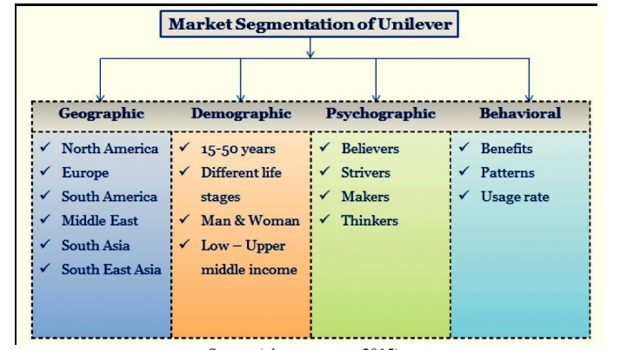
Figure 1: Market segmentation of Unilever
(Source- Rust, 2020)

MARKETING MIX OF UNILEVER
All the key brands of Unilever PLC have several kinds of market segmentation that are based on the entity of features and the aspect of a value proposition. The entity of the price also varies that are dependent on the product type. Unilever PLC also uses the promotional range of tools that are available to the entity of marketers. The range of products of Unilever PLC is specifically found all over 190 nations. All the key brands of Unilever PLC proceed to separate the strategy of a brand, but each has the message, ideology, design and logo of Unilever (Rust, 2020). The logo of Unilever has specifically 25 icons specifically representing the significance of the 400 brands of Unilever PLCteh Unilever PLC has approx. 165000 employees across the globe with a larger network of distributors and retailers. The majority of its products of Unilever have specifically come in bottles and plastic packaging. They could be purchased in the entity of retail stores, online and in a shopping mall.
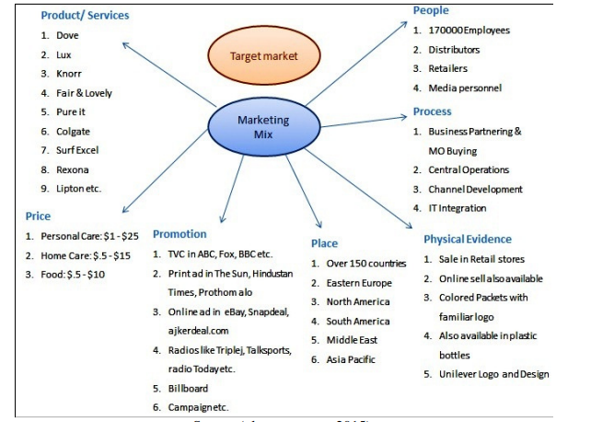
Figure 2: Marketing mix strategy of Unilever
(Source- Sander, 2019)
The customers or clients of Unilever PLC could be ideally divided into major categories in the aspect of needs, income and ages from the Unilever PLC. The entity of customers of Unilever PLC is generally of different age sections. The home care segment and personal section have a specific age group of approx. 14-50, the income of the high to medium. The age group aspect for the food segment generally begins from the age of 5 and has healthy foods and a preference for tasty food factor (Sander, 2019). The entity of cost of the products of Unilever PLC involves the distribution, marketing, packaging and production, etc., that also involves the products and their pricing. Unilever PLC also relies on using different mediums of communication and also explores considering the new range of mediums via communication with the entity of consumers could also be made. The entity of the customers of Unilever PLC proceeds to purchase the range of products for the online shops, super shop and retail stores. And Unilever PLC proceeds to participate in getting an ideal and better store location than any other aspects of the competitors.

4C OF UNILEVER
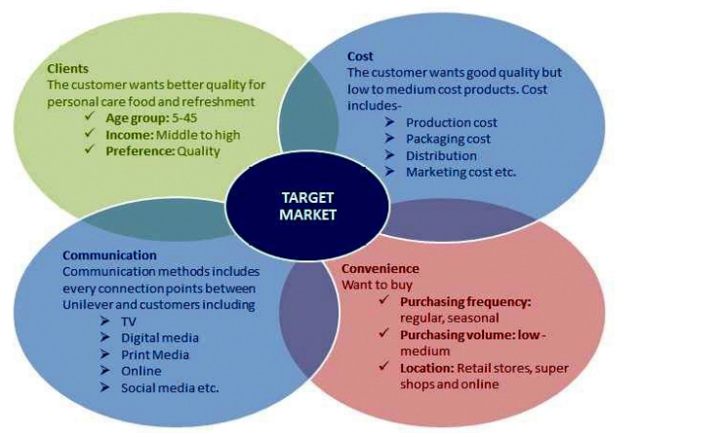
Figure 3: 4C OF UNILEVER
(Source- Gölgeci and Kuivalainen, 2020)

BRANDS AND CATEGORIES OF UNILEVER PLC
The personal care, foods, home care and refreshment aspect and categories of Unilever PLC also proceed for containing the portfolio of the brands that also aim to deliver responsible, profitable, competitive and consistent growth that is supported by the aspect of investment in marketing and innovation. Unilever PLC has approx. Thirteen brands with €1 billion in sales or above and the aspect of growing number of living brands of sustainability aspect, like Surf, Sunsilk, Rexona, Rama, Omo, Magnum, Lux, Lipton, Knorr, and Hellmann, also proceed to deliver the ideal and strong environmental and social benefits and they also proceed for ideally managing the portfolio in the year 2015 that also adds the skincare aspect of the prestigious product of the skin care for the personal care via acquisition, and the aspect of focused some of the range of food brands in the new cooking, baking and spreading business (Gölgeci and Kuivalainen, 2020).
Unilever PLC also operates in approx. One hundred ninety nations, and it is also present in 7 out of 10 households internationally. Some range of geographic is latest; others the Unilever PLC has also been in for approx. 100 years. However, Unilever PLC also operates in some of the range of markets that are of specific risks and volatile, and its scale and size provide consistency and risk diversification of the entity of returns over the longer term (Bag et al., 2021). The scale also means that Unilever PLC can also take advantage of international manufacturing and the aspect of distribution to provide the aspect of efficiencies of the factor of driving and scaling the costs. Currently, Unilever PLC also has a 161 range of products in their entity of product line. It includes refreshment and food (68 products), home care (34 products), and personal and beauty care (59 products).

BRANDING OF UNILEVER
The brand is specifically the combination, design or symbol, sign, or term of them, intended for identifying the services and goods of one specific entity or seller and for differentiating them from competitors. Unilever PLC is an internationally well-known brand by everyone. This is because Unilever PLC also proceeds to maintain a strict range of rules and to use its aspect of other patterns, symbols and logs (Chen and Wang, 2019). All the aspect of brands of Unilever PLC needs to separate the strategy of branding, but each entity has its message, ideology, design, and logo of Unilever PLC.

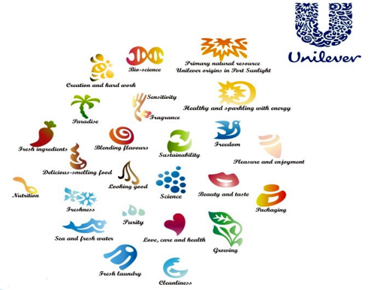
Figure 4: Logo of major products of Unilever
(Source- Unilever, 2023)

5M THEORY FOR ADVERTISEMENT MODEL OF UNILEVER
The factor effectiveness of the key advertisement could also be measured by different methods such as Online Streaming, Radio Airplay, Consumer Neuroscience, etc. The promotional and marketing aspects of Unilever PLC also takes place on the platforms, intermediaries and different medium (Farjadian et al., 2019). The aspect of the traditional mediums also involves the distributors, retailers, POSM, televisions, print, radio, etc. At the same time, the other online mediums involve search engine marketing, social media and e-commerce, etc.
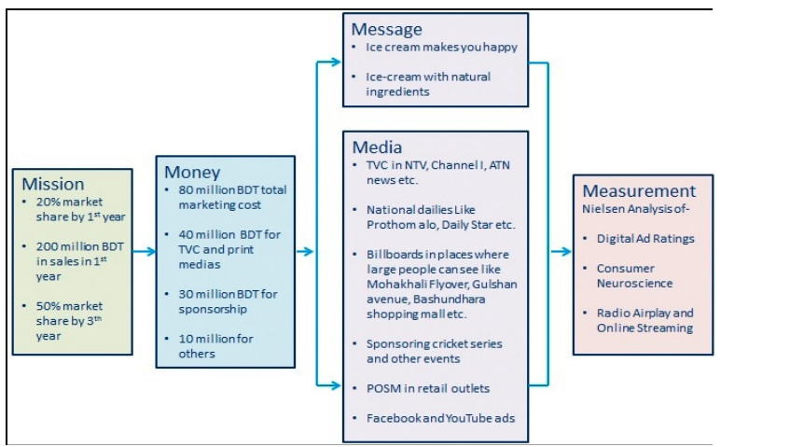
Figure 5: Advertisement model of Unilever
(Source- Hutt and Speh, 2021)
The major focus of Unilever PLC is to proceed with shifting from the media (traditional) to the latest phenomenon, such as social media, as more and more range of people are ideally getting included with the factor of social media as it also includes the ideal opportunity for engaging the people with the aspect of brands. The major focus of Unilever PLC is to focus on creating the marketing (Omni-channel) for the organisation where the range of customers could proceed to engage with the organisation from wherever they need to purchase from anywhere else (Hutt and Speh, 2021). Unilever is also included in the factor of sponsoring different events, including social awareness, community and artistic performances raising the aspect of programs. The majority of the events of Unilever PLC focus on different brands that are associated with the aspect of sponsoring a range of events. The majority of the time, Unilever PLC also focuses on promoting the vent with other organisations too. All the different sponsorship of Unilever PLC must need to match its sustainable plan of development and the factor of core values.

FOCUS ON SUSTAINABILITY
Unilever PLC also focuses on the purpose-driven aspect. As the company's range of origins and its key purpose are also very basic and simple, they make the conventional way of living very sustainable. Each day, 2.5 billion people use the products of Unilever PLC (Goworek et al., 2020). The people are generally affected by these types of changes which also pose the latest challenges the Unilever PLC, which are fluctuating prices of commodities, quite unstable markets and the factor of shortage of different but sustainable raw materials. The entity of the business is generally no longer an aspect and similar option. Unilever PLC also focuses on formulating three key goals that are responsible for aiming for reaching sustainable growth.
- to provide help to more than 1 billion people in improving their well-being and health.
- To halve the environmental impact of its services and products.
- Source 100 per cent of agricultural material ideally and sustainably.
The sustainable living plan of Unilever is also linked to the returns and earnings aspect. It also focuses on driving growth, reducing costs, mitigating risks and attracting talent. The Unilever PLC focus on planning and identifying the three major mission of the Unilever PLC, i.e. Reducing environmental impact, Improving health and well-being and Enhancing livelihoods (Deepak and Jeyakumar, 2019). At the same time, every mission focus comes with the concentrated goals set. Unilever PLC also understands the factor of climate change proceeds for tightening the legislation of the environment and increasing the consumer awareness aspect that has an influence on its entity of the business. Unilever PLC also focuses on its efforts of sustainability in four major areas, i.e. Sustainable sourcing, waste reduction, and greenhouse gas emissions.
Unilever PLC also announces its SLP, i.e. Sustainable living plan; this focus on setting out commitments aspect of sustainability and also targets for the upcoming decades. It also focuses on aiming and decoupling the growth of the business from the environmental influence so that while the organisation increases in its specific size, it would be reducing in whole environmental footprint all across the aspect of the value chain. The organisation has also worked to reduce some of the factors of stretching the targets (Adams, Freitas and Fontana, 2019). Unilever PLC also aims to help more than billions of people take action to improve their well-being and health, halving the focused environmental footprint of its services and products, sourcing 100 per cent of its raw material (agricultural) ideally and sustainable, and linking more than approx. Half of a million smallholder aspect of farmers and distributors (small scale) to its entity of the supply China management.

POWER BRAND STRATEGY OF UNILEVER
Unilever proceeded to begin the aspect of implementing the strategy of 'power brands' in September 1999. The entity of power branding also referred to building the aspect of multi-category brands and multi-products aspect that had international reach. The specific idea behind this particular strategy was to build international brands that also endorse the multiple levels of products in different categories (Park, 2020). The path of the growth-focused strategy of Unilever also aims at the procedure of re-structuring the brand portfolio aspect to concentrate on the factor of core brands to bring about the improvements (considerable) in the entity of supply chain and the factor of innovation, to have the closer consumer focus aspect, and to also build the entity of agile organisation values. The power brand strategy of Unilever aims to make Unilever PLC effective and efficient and its entity of brand portfolio more innovative and manageable. However, Unilever also saves €4 billion ($4.9 billion) in the entity of costs over five years (2000-2005). It also witnesses a 31 per cent fall in profit in the year 2004 to around €1.9 billion (£1.3 billion)

PORTER FIVE FORCES MODEL ANALYSIS FOR UNILEVER PLC
For the aspect of businesses of cost leader aspect like Unilever PLC might also help for remaining profitable with buyer's power, substitute products, supplier's power, and the entity of new entrants.
Rivalry: Unilever PLC also competes on the aspect of the basis of its range of prices since the product (low cost) of Unilever PLC and its ideal range of different products allow it and enjoying the customers. It is since of its entity of diversified range of product lines that also allows it to enjoy above-average profit and also to allow it for maintain the advantage (low cost) over its entity of competitors in the market (Kotabe and Helsen, 2022).
Customers: AS it is part of the competitive advantage of Unilever advantage that proceeds to offer lower prices that proceeds for helping it is for retaining the entity of customers and earing out profit.
Suppliers: Unilever, as the cost leader aspect, is also able to absorb the ideal price and also increase before it must raise the price for the customers.
Entrants: Unilever PLC for creating the barriers to marketing entry through its aspect of continuous form of focus on reducing costs and efficiency and the aspect of economies of scale.
Substitutes: As there are different substitutes available for the market to the products of Unilever PLC so for Unilever PLC is more likely to get cost for attracting the customer to stay with their range of products, investing and developing substitutes, purchasing, investing, and patents in the Research and Development (Gardini, 2022). As Unilever PLC proceeds to deal with a wider variety of different products and services so, it also focuses on its entity of value chain. It also produces for identifying and evaluating the methods of ways in which it could use its different resources for evaluating and identifying the methods in which its capabilities and resources of the different workers can also add value. It also focuses on its entity primarily alongside supporting the activities for activities different objectives. The brand of Unilever is also used in 125 billion also washes specifically a year. Unilever PLC also focuses on providing value to its entity of customers via the unique characteristics and features of its different services and products. This can also be done via high and ideal customer service, high quality, rapid innovation in product, an advanced form of technologically specified features, image management aspect, etc. As Unilever PLC also value focusing on lowering the costs of buyers with higher quality and quicker aspect of response to different problems (Hutt and Speh, 2021). Apart from this, it also focuses on the range of higher-quality products alongside sustainability measures.

EVALUATION OF THE SUCCESS OF CONSUMER INDUSTRY PRODUCT MANUFACTURING OF UNILEVER
The entity of succession of industry of consumer products also owes credit for well-planned strategies of marketing and coordination (proper) between the external and internal factors of the organisation in the share of the market. Since the factor of the industry is also very competitive, an entity of customer relationship also proceeds to account for the expansion do growth in this particular industry. For this specific case of Unilever PLC, the entity of extensive research is also done to enable the innovation of the fresh improvement and products of the current products to get fit the needs and requirements of the customer (Rust¸2020). This also includes the factor of regarding and getting customers in both global and local markets by the entity of smooth relations between the customers and the company. To achieve this, Unilever PLC needs to execute ideal strategies for customer relationship management. The execution of the strategy of cultural difference is another significant aspect towards the succession of the product industry of consumers. Unilever PLC also applies this specific strategy for penetrating into the entity of local markets.
This also contributes to the expansion in several kinds of markets at a very ideal and faster rate than the organisations that do not have a strategy. Unilever PLC should also proceed to combine this strategy with the process of building the ideal leadership behaviour for producing competent managers and employees (Sander, 2019). These also produce responsible staff, which also includes engaging in promotional programs focused on the socio-cultural aspect with the objective of winning the entity of customers hence the aspect of consumption of their services and product. Furthermore, the entity of succession in the industry also needs effective transformation in the entity of information technology. With the aspect of the faster-changing aspect of technologies, organisations require to keep tracing with applying e-commerce which enhances effective and quick aspects of transactions between the organisation and consumers.

CONCLUSION
As per the assessment of the report, Unilever proceeds to pursue the strategy of marketing because the aspect of the consumer in the aspect of emerging the range of markets is basically majorly focused on the aspect of price. It could also give the competitors (low-cost) the edge unless the organisation can also find the major ways to attract the entity of buyers with the prices (bargain) as well as the ideal services and products. Unilever PLC also trusts that the entity with a profitable range of growth must also be very responsible for the development and progress. The successful brand of Unilever proceeds from the innovation program and is also supported by the ideal level of the advertising and marketing range of activities involving the majority of the media. As there are the majority of the opportunities in the markets (foreign), the threats tendency is also very similar to its opportunities. The Research and Development wing, differentiated and diversified line of products and the analysis of the market are also very significant factors that are responsible for making the organisation enjoy its good and potential market to be shared in the foreign market. To maintain the ideal brand value should be ideal coordination and the entity of integration between the entity of the brand managers in the department of marketing.

REFERENCES
Adams, P., Freitas, I. M. B., and Fontana, R. (2019) Strategic orientation, innovation performance and the moderating influence of marketing management. Journal of Business Research, 97, 129-140.
Bag, S., Gupta, S., Kumar, A., and Sivarajah, U. (2021) An integrated artificial intelligence framework for knowledge creation and B2B marketing rational decision making for improving firm performance. Industrial Marketing Management, 92, 178-189.
Chen, Y., and Wang, L. (2019) Commentary: marketing and the sharing economy: digital economy and emerging market challenges. Journal of Marketing, 83(5), 28-31.
Deepak, R. K. A., and Jeyakumar, S. (2019) Marketing management. Educreation Publishing.
Farjadian, F., Ghasemi, A., Gohari, O., Roointan, A., Karimi, M., and Hamblin, M. R. (2019) Nanopharmaceuticals and nanomedicines currently on the market: challenges and opportunities. Nanomedicine, 14(1), 93-126.
Gardini, M. A. (2022) Marketing-Management in der Hotellerie. In Marketing-Management in der Hotellerie. De Gruyter Oldenbourg.
Gölgeci, I., and Kuivalainen, O. (2020) Does social capital matter for supply chain resilience? The role of absorptive capacity and marketing-supply chain management alignment. Industrial Marketing Management, 84, 63-74.
Goworek, H., Oxborrow, L., Claxton, S., McLaren, A., Cooper, T., and Hill, H. (2020) Managing sustainability in the fashion business: Challenges in product development for clothing longevity in the UK. Journal of Business Research, 117, 629-641.
Hutt, M. D., and Speh, T. W. (2021) Business marketing management: B2B. South-Western, Cengage Learning.
Hutt, M. D., and Speh, T. W. (2021) Business marketing management: B2B. South-Western, Cengage Learning.
Kotabe, M. M., and Helsen, K. (2022) Global marketing management. John Wiley and Sons.
Park, S. (2020) Marketing management (Vol. 3). Seohee Academy.
Rust, R. T. (2020) The future of marketing. International Journal of Research in Marketing, 37(1), 15-26.
Sander, M. (2019) Marketing-Management: Märkte, Marktforschung und Marktbearbeitung. Utb GmbH.
Unilever (2023) We are Unilever. Unilever. [Online]. Available at: https://www.unilever.com/our-company/. [Last accessed: 11/01/2023].

