DATA HANDLING AND BUSINESS INTELLIGENCE

Student Name: Utsav Kakadiya

Student ID: 2240174
Module Code: LCBB5000
Assignment Title: Practical Essay

Lecturer Name: Dr. Shengfeng Mei

Table of Contents
Part 1: Data Analysis 3
1.1 Introduction 3
1.2 Dataset Overview 3
1.3 Data Analysis Using SPSS 4
1.4 Data Analysis using Excel 8
1.5 SPSS Analysis 8
1.6 Overall Analysis Conclusion 10
Part 2: Evaluation and Data Mining Cycle 11
2.1 Advantages and Disadvantages of SPSS or Excel 11
2.1.1 Advantages of Using SPSS 11
2.1.2 Disadvantages of Using SPSS 11
2.2 Data Mining Cycle 12
References 14

Part 1: Data Analysis

1.1 Introduction
The report offers detailed data on the dataset properties possessing significant variables like price, number of bedrooms, bathrooms, area, and other structures and locational characteristics. The data set provides elaborate features of housing and properties, and therefore it makes a perfect data set for analytical purposes. The data also covers different areas, which provide information about the regional housing market and its characteristics. This diversity makes sure that the search for trends, patterns, and relationships of the variables of interest is wide-ranging. The main goal of this type of analysis is admittedly to identify patterns and trends, where applicable, in a tool like statistical software SPSS. The analysis revolves around questions such as the measures of central tendency to determine the extent of dispersion of housing prices and other vital parameters. Furthermore, simple relationships between price and the number of bedrooms is also explored to discover possible relationships. Consequently, using scatterplots and applying statistical analysis in this work’s context, the analysis can derive an understanding that may be useful in decision-making. The results contribute to the analysis of the housing market properties that benefit the interested individuals in decision-making processes or subsequent studies.

1.2 Dataset Overview
The USA Housing Dataset is constructed of several identifying features that concern properties in the United States. These are price, number of bedrooms and bathrooms, square footage – living area and land area, year of construction, and year renovated. The dataset also has nominal variables such as street address, city, state, and country, that give information on the locations of the properties. Extra attributes are; floor, waterfront, and view, and house condition also provides a comprehensive list of property attributes. The set includes housing offers with different prices, starting from rather cheap ones, up to prestigious villas. Which allows for analyzing the tendencies of different pricing segments (Pattyam, 2021). The dataset provides an opportunity to develop complex relations between housing prices and specific characteristics of the property, like size, location, and state. Using this data one can analyze how features such as square footage, number of bedrooms, or even the state of properties bears an impact on the final price. The dataset is also suitable for spatial analysis, for instance, the role that various cities, states, or neighborhoods play on housing prices. The provided dataset is a valuable source for statistical data analysis, data-driven predictions, and gaining insights about real estate property features in the USA.

1.3 Data Analysis Using SPSS
The mean value for Price
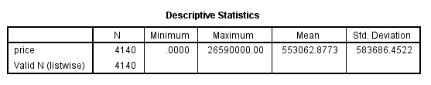
Figure 1: Mean Value for Price
The mean of the “price” variable is 553,062.8773 which acts as the average of all prices of the housing properties received in the dataset. This value means that on average the properties under the dataset cost a median price of 553,062.88. Mean can also be described as a measure of central tendency because it gives the average capability of the price data set. However, the use of mean as a measure has the shortcoming of being greatly affected by outliers since it averages out all the values (Hosen et al. 2024). Thus, while interpreting the results of the research based on the mean, it can lose sight of the variation in prices across different properties. Additional calculations, like the median or mode, mean that the middle or most frequently used price is in terms of pricing patterns in the given dataset.
Median Value for Price
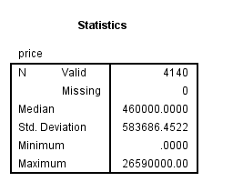
Figure 2: median Value for Price
Here, the median price of properties from the compiled dataset is 460,000 based on the median. This implies that 50% of the housing prices are less than 460,000 and more than 460,000 for the other 50%. The median is very useful because it is relatively resistant to outliers and should be used especially if the data are skewed. In this case, the median can be said to imply that the distribution of the price of the housing units is moderate and homes are evenly spread around this value. It is of equal practical value for making the central price point for properties in the particular data set more discernable. This information is formed to aid stakeholders who wish to get a consolidated picture of the market devoid of the influences of highly available homes.
Mode of the price
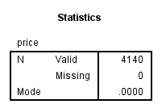
Figure 3: Mode of the Price
The ‘price’ variable is found to have a mode of 0, meaning that this price value of 0 is most frequently used in the dataset. This may probably imply there is always some case where the price has been omitted or recorded as 0 when it is never supposed to be. This is worthwhile emphasizing that the mode is used to show the most frequently used value in the sample. However, in the present case, the use of 0 as one of the categories of housing prices may distort the correct interpretation of the results (Bharadiya, 2023). This occurrence might even call for more research and data cleaning to get the right distribution of the prices. The incompleteness of the values also poses a critical problem in the dataset that needs to be solved before proceeding to the next analysis.
The standard deviation for the number of bedrooms
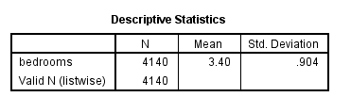
Figure 4: Standard Deviation Based on the number of bedrooms
The standard deviation for the number of bedrooms is also 0.904 which gives a measure of the variability or dispersion of the number of units in the bedroom set. That it has a standard deviation of 0.904 indicates that the number of bedrooms in most houses is usually close to the mean. Thus, the distribution of bedroom numbers is not wide; arguably, most houses possess a comparable number of bedrooms. A low value next to Standard Deviation points to a small variation and hence the built properties have few numbers of bedrooms with variation from the mean value. This relatively low variability might be due to the housing market. Where most properties may be of similar size and shape and fewer houses with immense differences in the number of bedrooms.
Larger Variance
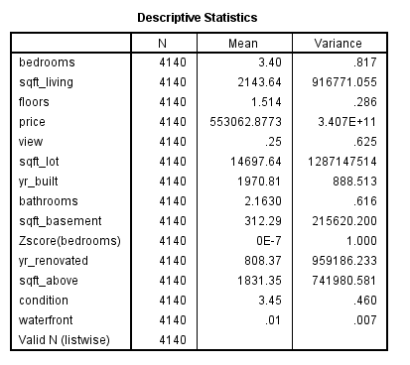
Figure 5: Variance of all variables
Price has the highest variance in the dataset, with 3.407E+11. This of course shows that the variance of this value is much higher than that of any other variable meaning high volatility of housing price. The value is significantly higher implying that the dataset has been obtained from a wide range of property prices; from relatively low prices to costly luxury houses (Puja et al. 2024). These high levels of dispersion are also an indication of the heteroscedasticity of housing prices due to differences in houses’ locational attributes, size, and condition. A high variance could also infer that there may be outliers in the data set and thus requires further investigation on how price relates to other variables.

Larger Standard Deviation
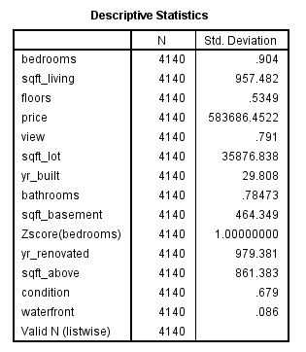
Figure 6: Standard Deviation of all Variables
The dispersion in the price is the highest in the given data set and the standard deviation present in this variable is 583,686.45. This is considerably higher than the standard deviation of any other variable, indicating a large amount of scattering in the housing prices observed in the above data set. High standard deviation means that the variation of housing prices is significant and there are cheap houses as well as luxury houses (Bany Mohammad et al. 2022). This may be due to the size of the property, the position, the condition of the property, and so on hence resulting in a range of prices. Therefore, the big variance shows that the dataset contains a lot of variation in housing markets.
Last three outcomes
The last three results give valuable information about distribution and dispersion within the dataset. The number of beds has the smallest standard deviation of 0.904 which means that the number of bedrooms does not vary much regarding most properties. This means that the majority of the homes in the dataset are likely to have a similar number of bedrooms as the average identified above (Tavera Romero et al. 2021). On the side of variations, price variation (3.407E+11) registers the highest levels signifying great variations in housing prices. Finally, the standard deviation for the price equals 583 686.45 which also indicates the dissimilarities between prices and confirms the heterogeneity of the housing market in the sample dataset.

1.4 Data Analysis using Excel
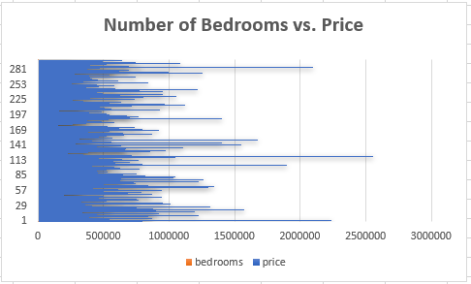
Figure 7: Number of Bedrooms vs. Price
The above figure demonstrates the relationship between the number of bedrooms and the price of houses in the dataset. The plot demonstrates a general upward trend; as the number of bedrooms increases, the price of the house tends to rise. It therefore implies that homes with more bedrooms are those with higher price tags. However, it is not linearly related; there is considerable variation for each bedroom count (Jaradat et al. 2024). Some high-bedroom properties have lower prices and vice versa with fewer-bedroom properties having higher prices. This overlap and variation lead to the implication of factors such as location, condition of property, and square footage.

1.5 SPSS Analysis
Correlation between price and number of bedrooms
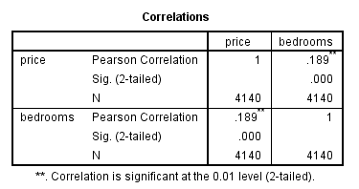
Figure 8: Correlation between Price and the number of bedrooms
The above figure depicts the correlation table between price and number of bedrooms, which represents the relationship between these two variables. The Pearson correlation coefficient is 0.189, indicating a weak positive correlation between price and the number of bedrooms. This means that although there is a tendency for the price to increase as the number of bedrooms rises, the relationship is not strong. The weak correlation means that the fact that more bedrooms could cause higher prices, and other things might be the most influential aspects of housing prices. Besides this, the Sig. (2-tailed) is 0.000 and less than 0.01, meaning that this correlation is statistically significant and that the observed relationship cannot have occurred by chance through the randomness of a phenomenon.
Scatterplot of the two variables
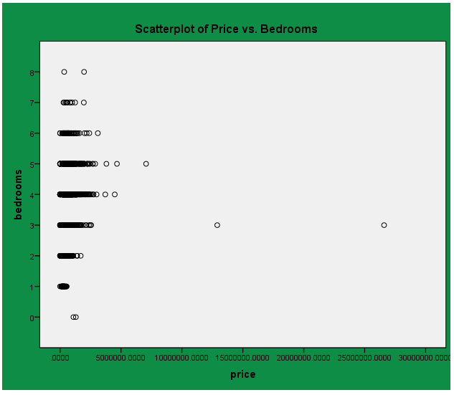
Figure 9: Scatter Plot of Price vs bedrooms
The figure above shows a scatter plot indicating the relationship between house price and number of bedrooms. Each dot on the plot represents a single house, with its horizontal position indicating the price and its vertical position representing the number of bedrooms. The plot generally shows an upward trend, suggesting that as the number of bedrooms increases, the price of the house tends to rise (Villegas-Ch and Luján-Mora, 2020). However, the relationship is not perfectly linear since there is a lot of variation in prices for houses that have the same number of bedrooms. Several key observations emerge from the plot: houses with one bedroom have a wide range of prices, which suggests that there are factors other than the number of bedrooms that contribute to pricing. With more bedrooms, the range of prices tends to increase with greater variety in types of property and market segments.

1.6 Overall Analysis Conclusion
The analysis of the USA Housing Dataset, this chapter has deduced several general aspects about housing price relations in respect of the properties surveyed. Though the mean prices of houses are reasonably very high and quite volatile mainly due to the factors related to locations, square feet, and condition, a median value gives a different kind of feel as the median indicates that house prices are being clustered at about $460,000. A weak positive association between price and the number of bedrooms at 0.189 means that the number of bedrooms is a minor input in determining price, and so more important factors are to come. The variance of prices and the standard deviations underscore the heterogeneity found within the housing market across different property values. This is further supported by the scatterplot and the results of the correlation analysis that shows larger properties tend to cost more but there is enough significant variation to suggest other influences on housing prices including location and condition.

Part 2: Evaluation and Data Mining Cycle

2.1 Advantages and Disadvantages of SPSS or Excel

2.1.1 Advantages of Using SPSS
SPSS, short for Statistical Package for the Social Sciences, is widely accepted statistical software used to cater to the needs of users in research, business, and academic settings. Advantages include:
- Comprehensive Statistical Functions: Adaptive computing provides a powerful solution for statistical analysis through the SPSS with the subs-models of descriptive sub-models, correlation sub-models, regression sub-models and hypothesize sub-models. Exploring the USA Housing Dataset, only simple statistics on the data can be calculated in SPSS using functions, such as mean, median, and variance (Rathor et al. 2022). It uses methods like linear, simple, or multiple linear regressive analysis to define relations between; prices for houses and their area, for instance.
- User-Friendly Interface: The software enables the researchers to perform complex statistical methods without writing a single line of code especially when it comes to teaching and researching. In the USA Housing Dataset, users can know their frequency distribution or histograms just by choosing some items on the list so it is easy to analyze without much input of technical skills.
- Data Handling Efficiency: It means that SPSS can work with large datasets involving many variables or with small datasets as well. For examination of the case of the USA Housing Dataset, SPSScano manages data, performs the needed transformations, and works with missing values (Iqbal et al. 2020). It is suitable for small-scale and big-scale analysis due to the data importation process from sources like Excel, CSV, and large data handling without compromising its performance.
- Advanced Data Visualization: Among the different sorts of visual representations that SPSS provides for data, there are histograms, scatter plots, box and whisker diagrams, and bar charts. These are effective in now presenting the facts in the form of trends, and this is very specific when presenting results to a broader audience. For instance, SPSS is capable of generating scatter plots to cross-check the correlation between the price of the house and the number of bedrooms of the houses in the USA Housing Dataset.

2.1.2 Disadvantages of Using SPSS
Although the software has several disadvantages, here are some advantages of its use:
- High Cost: SPSS is commercial software and is expensive to purchase for individual use, small-scale industries, or small academic institutions. Its paid license means it is not as easily available for users who can afford its price as R or Python with their free open-source code.
- Limited Flexibility for Advanced Analyses: SPSS is intended to perform a wide variety of statistical analyses, but it cannot be as flexible as a programming language like R or Python. Advanced users may find SPSS restrictive in implementing custom algorithms or complex analyses (Misra et al. 2020. The deep learning or complex clustering methods are more easily implemented in Python using libraries such as TensorFlow or Scikit-learn than in SPSS.
- Not Suitable for Big Data: SPSS can easily manage moderate-sized datasets but faces a challenge when dealing with very large datasets, especially those running into millions of records. The larger the dataset is, the more SPSS may start to perform poorly or take longer to give answers. People dealing with big data might prefer Hadoop or Spark for their tasks.
- GUI Dependency: SPSS relies very much on its graphical interface for most operations and can therefore limit the abilities of advanced users to conduct tailored analyses. Although the GUI is user-friendly, it may not meet the requirements of users who work in code or require total control over the analysis process (Maheshwari et al. 2021). This can be a great disadvantage for researchers and data scientists who are script-writing professionals.

2.2 Data Mining Cycle
The Data Mining Cycle is a systematic process used to extract valuable insights from large datasets. It consists of several stages that guide analysts from defining the problem to deploying the final model. Each stage plays a critical role in ensuring that raw data is transformed into actionable knowledge.
- Problem Definition: Stating the problem and understanding the purpose of the analysis. It has used the USA Housing Dataset to forecast housing prices or identify properties that have an impact on property value (Canhoto and Clear, 2020). The problem definition creates the framework for the study and defines which approach can be used in the analysis.
- Data Collection and Preparation: This involves data preprocessing where data has to be cleaned, information missing must be dealt with, duplicate records deleted, and data reduction where data transformation has to be done to a suitable form. The USA Housing Dataset may require cleaning regarding missing property records or unequal formatting of the variables.
- Data Exploration: Data examination entails surveying the data to assess trends and patterns or other relationships existing between the identified variables. Most of the time, measures of average or dispersion and diagrams like plots or bar charts can be used to examine a set of data. With the help of the USA Housing Dataset, analysts establish positive sweet relations; for instance, house prices have a relationship with the number of bedrooms.
- Modelling: Advanced computing techniques which include data mining with methods such as regression, classification, or clustering create predictive models (Nti et al. 2022). The USA Housing Dataset may contain regression analysis in order to constitute houses’ rates based on the following parameters: location, area, and the number of bedrooms.
- Evaluation: Once the above model is developed, it becomes important to make some estimate of its efficiency. Once the model is developed, the results are cross-validated by using new datasets to examine generalization effectively on unseen data.
- Deployment: After check and balance, the model is used in various working ventures. As for the housing prices, that company can use the model to predict future property prices in certain regions.

References
Bany Mohammad, A., Al-Okaily, M., Al-Majali, M. and Masa’deh, R.E., 2022. Business intelligence and analytics (BIA) usage in the banking industry sector: an application of the TOE framework. Journal of Open Innovation: Technology, Market, and Complexity, 8(4), p.189.
Bharadiya, J.P., 2023. Machine learning and AI in business intelligence: Trends and opportunities. International Journal of Computer (IJC), 48(1), pp.123-134.
Canhoto, A.I. and Clear, F., 2020. Artificial intelligence and machine learning as business tools: A framework for diagnosing value destruction potential. Business Horizons, 63(2), pp.183-193.
Hosen, M.S., Islam, R., Naeem, Z., Folorunso, E.O., Chu, T.S., Al Mamun, M.A. and Orunbon, N.O., 2024. Data-Driven Decision Making: Advanced Database Systems for Business Intelligence. Nanotechnology Perceptions, 20(3), pp.687-704.
Iqbal, R., Doctor, F., More, B., Mahmud, S. and Yousuf, U., 2020. Big data analytics: Computational intelligence techniques and application areas. Technological Forecasting and Social Change, 153, p.119253.
Jaradat, Z., Al-Dmour, A., Alshurafat, H., Al-Hazaima, H. and Al Shbail, M.O., 2024. Factors influencing business intelligence adoption: evidence from Jordan. Journal of Decision Systems, 33(2), pp.242-262.
Maheshwari, S., Gautam, P. and Jaggi, C.K., 2021. Role of Big Data Analytics in supply chain management: current trends and future perspectives. International Journal of Production Research, 59(6), pp.1875-1900.
Misra, N.N., Dixit, Y., Al-Mallahi, A., Bhullar, M.S., Upadhyay, R. and Martynenko, A., 2020. IoT, big data, and artificial intelligence in the agriculture and food industry. IEEE Internet of Things Journal, 9(9), pp.6305-6324.

Nti, I.K., Quarcoo, J.A., Aning, J. and Fosu, G.K., 2022. A mini-review of machine learning in big data analytics: Applications, challenges, and prospects. Big Data Mining and Analytics, 5(2), pp.81-97.
Pattyam, S.P., 2021. Data Engineering for Business Intelligence: Techniques for ETL, Data Integration, and Real-Time Reporting. Hong Kong Journal of AI and Medicine, 1(2), pp.1-54.
Puja, A.R., Jewel, R.M., Chowdhury, M.S., Linkon, A.A., Sarkar, M., Shahid, R., Al-Imran, M., Liza, I.A. and Sarkar, M.A.I., 2024. A Comprehensive Exploration of Outlier Detection in Unstructured Data for Enhanced Business Intelligence Using Machine Learning. Journal of Business and Management Studies, 6(1), pp.238-245.
Rathor, K., Mandawat, A., Pandya, K.A., Teja, B., Khan, F. and Khan, Z.T., 2022, November. Management of Shipment Content using Novel Practices of Supply Chain Management and Big Data Analytics. In 2022 International Conference on Augmented Intelligence and Sustainable Systems (ICAISS) (pp. 884-887). IEEE.
Tavera Romero, C.A., Ortiz, J.H., Khalaf, O.I. and Ríos Prado, A., 2021. Business intelligence: business evolution after industry 4.0. Sustainability, 13(18), p.10026.
Villegas-Ch, W., Palacios-Pacheco, X. and Luján-Mora, S., 2020. A business intelligence framework for analyzing educational data. Sustainability, 12(14), p.5745.

