LV6 Contemporary Themes
– Conference Learning Log

Student Name: | Katie Marshall (1804648)

Week 1 | Monday April 27th, 2020
Planning:

In the initial planning the team decided to broaden the scope of the theme for the conference to include not only sustainability but other current issues affecting tourism and hospitality. The team was the divided into three groups in order to divide and conquer so to speak. These groups are management, marketing, and technical. I am part of the marketing team and began research on marketing mix with a focus on how these aspects affect a virtual conference. Video calls were planned outside of the university hours – whole team on Mondays and teams to agree on individual meeting days.

Guest speakers were contacted. So far, it’s only Samantha Wilson-Croft from Twr Y Felin by Dan

Organising:

Our team was broken down into the three groups which are: management – Molly, Laurence, and Ranad; Marketing – Katie, Robbie, Abdul, Paval, and Jaliya; Technical – Dan and Mo

As part of the marketing team Robbie was designated as the team leader.

As of now the presentation structure is as follows: brief external video introducing topic individual introduction -> presentation -> repeat throughout conference
Managing:

The managing team developed a gannt chart in order to keep track of progress as well as help in larger areas where teammates may be struggling. There have been minutes taken at each meeting. Laurence has been made general manager which has proved a good choice. He speaks with the team individually to make sure everyone is on track and allows for everyone to speak their mind if need be in order to come up with a more favourable resolution.

Marketing:

This is more part of the planning aspect of the marketing side. We are in need of a name for the conference as well as the brand and message we want to convey to our target market. One of the main target markets will be students and educators. Some tasks were delegated such as making a flyer which I was in charge of. I will work with the technical team to develop this.

As part of the marketing team, before items could be compiled in a list of things we need to do, it was important to go back through marketing basics. I began researching the differences between marketing for a virtual conference as opposed to an in person one. It does not matter which version of the conference is utilized the marketing mix is still important to success. Developing the product to exactly what we want (moving from to virtual because of the virus, changing from a conference to more of a virtual learning area) has proved challenging. Until the product is fully realized other aspects of the mix are on hold such as promotion and people or target market. For example, if it were a virtual conference, we could keep the website private unless we were able to obtain some sort of charge (price) from recipients. The promotion could have been we charge 10 pounds for the website but have goes to charities involved with sustainability. Or larger groups, such as educational classes (people) would get a break in price depending on the amount of people.

Technical:

There has been a slight variation to the virtual conference to move towards a website. This website will not only be for us to use but can be passed down to future students at Trinity to create their version of a virtual area relating to contemporary themes in tourism and hospitality. A few ideas for logos have been developed although we are waiting for the group to make a vote on which one, we move forward with. There may be an idea where there is a short promo video before our individual videos are started that may become the actual beginning to all our videos.

The format for the video will be YouTube, Short Vids, and Pay to view, etc.
Problems/Resolution Action Plan:

I think the main issue is attendance. I am guilty of this. I have made several calls individually to others in order to make up for what I have missed and become a more active member of the marketing team.

Focus for the Week:

We are working on ideas to move forward in marketing. When these ideas are agreed upon, the tasks will be delegated between the team.

Week 2 | Monday May 4th, 2020
Planning:
The entire team is in the process of putting together their own short bio with a picture to go with presentations on the website. The name of our group as well as a logo has been voted on and now, we can move forward with marketing materials that incorporate the logo. Individual team members will continue to work on their presentation to get it the way they want before the launch date.
Organising:
After the marketing meeting we have divided some tasks amongst ourselves. Paval, Jaliya, and Abdul will be compiling a list of people to contact. I will be developing an email to send to those recipients. Robbie will be looking for YouTube videos to add to our website for a “spotlight” section because we no longer need guest speakers.
Managing:

We have stayed in contact with the management team to ensure that deadlines are being met. I was a little late to turn in my bio and head shot but at least it is done. I found out that with my information that leaves us with only 4 completed bios and pics. I relayed this to management for them to look into this aspect of our project.

Marketing:
I was tasked with the flyer last week. Although it is a virtual conference, we want to be able to possibly go to universities nearby and post this on a physical student board where applicable. I was also tasked with an ‘about us section’ for the website. This is what I have so far although I am not quite sure it is what I want for the final product: Originally, we were all brought together from all over the world to pursue higher education in International Hotel Management at University of Wales Trinity Saint David. The course further ignited our passion and curiosity to understanding all aspects of hospitality and tourism from… Our experience varies from cooks, servers, and bartenders in restaurants to managers of hotels and other hospitality establishments. We bring to the table a wide range of cultures and languages that have allowed us to further our knowledge and passion through in-depth research of contemporary themes related to tourism and hospitality in which we collaborate to share with you our findings on this website. We look forward to not only sharing our information with you but are interested to your thoughts and opinions as we analyse current issues to creatively develop ways to better the industry for not only people but also the environments as a whole.

Technical:
I worked with Mo to develop the flyer. Technology is not my strong suit, but I was able to create the message I wanted to send which gave Mo the ability to fully create the flyer for us. We are waiting for the rest of the bios and pictures to forward on to this team to begin uploading this aspect onto the website. Multiple website templates were developed and waiting for a vote to be had to decide which one to use.

Problems/Resolution Action Plan :

It seems as though our entire team has been divided into groups that aren’t specifically the groups for marketing, managing, and technical. I am not really sure how to resolve this situation as of yet. Some don’t seem like they want to be a part of the entire group and others seem as though they are having technical problems. For example, Paval was on our marketing call but his microphone was not working. We had to change the way we communicated to chats to him to make sure he was on the same page as us.

Focus for the Week:

I need to continue working on my coral reef presentation and paper.

I am working on drafting the email that would be sent to the list the others in marketing will be creating.

I need to continue my communication not just to individuals but be present when there are not only marketing meetings but also entire team meetings.

I am also currently thinking of ideas to further add to the value of the website such as areas where people could donate to certain funds such as 4oceans.

Student Signature:

__________________________________

Date:

_________________________________

Week 3 | Monday May 11th, 2020
Planning:

Email list will be created. Trying to create a ‘brand’ to market.

Organising:
Rough draft is complete for email list. Trying to organize my paper and presentation into a format that is not only easy to read but easy to follow.

Managing:

Managing a website seems to be quite a bit easier than managing a live conference. There are fewer moving parts. Having something virtual saved a good amount of money on costs not just for us but the attendees as well. We didn’t need to get guest speakers or find a place to hold the conference. There is no real interaction with people that visit our site other than the email list.

Marketing:

Still trying to generate ideas to further increase our capabilities. Thought about having a blog which could generate a more interactive community instead of just videos. For example, if someone knew about our topic a head of time, they could post a question that we could address in the next videos.
Find videos that are similar to our topic to reinforce the importance of our topics in the industry so we can put them on the website. I have contacted some people to see if they would like to contribute to the website. 4oceans, which would reinforce my topic dealing with coral reefs sent back some YouTube videos that we could use for the website. Even though we were doing a spotlight section, I wanted to add more videos that maybe people couldn’t find online.

Technical:

- Website layout
- Videos uploaded to YouTube
- Pictures, biographies, and direction on website
- Copyright given as soon as YouTube has verified the person as real, however this is not needed as we are keeping it private

Problems/Resolution Action Plan :
It was difficult to get responses for any other guest speakers. This could be due to the virus or maybe they aren’t willing to participate with such a small website. There really is not a plan of action to do here except keep sending out emails until a response are made.

Focus for the Week:

Finalize the draft email list. Look into the parts of a newsletter.

Student Signature:

__________________________________

Date:

_________________________________

Week 4 | Monday May 18th, 2020
Planning:

There are some of us, including me, struggling with deadlines which makes planning difficult for all.

Organising:

Organized the rough draft for the email to send out:
To…
We are class of 2020 International Hotel Management of UWTSD and are in the process of develop a virtual learning area in which students and educators can unite to collaborate on topics affecting the hospitality and tourism industries.

We welcome you to be a part of this process by not only giving you access to the website but join our mailing list. Through these emails, we will be able to show you what ideas we are working on currently.

Other ideas to add somehow: another aspect of you being a part of the mailing list is you will the ability to reach out to us to put your ideas on this website as well. Please forward this onto your students if they would like to be a part of this as well, below is a link in which they can sign up and join our team. Stay tuned for next month’s newsletter where we talk about…

Managing:

Management didn’t seem to like the email stating that it sounded too much like a junk email. Not really sure where to go from here on that.

Marketing:

Looked into making a newsletter. I researched a bunch of different sites to see what the consensus is on what would make a good newsletter. What I found that I thought would make a good newsletter for us would be: current events, spot light section of someone in the field, upcoming events in our area because as of now our target market is local hospitality educators and students, upcoming topics that would go into the next round of videos if we were to continue on this path, and what we are reading. Through the email list, the spotlight section could be developed as someone in the list that nominates someone local for what they are doing for sustainability and hospitality/tourism fields. This would allow us more interaction with the individuals on that list. This is also where the blog would have been useful. So, if next week they see we are going to be talking about food waste, someone could write in the blog for us to address in our videos.

Problems/Resolution Action Plan :

Trying to figure out how to make the email up to the standards of the group. I will have to keep trying until, I get something they like.

Focus for the Week:

Email.

Attendance.

Research paper and slides.

Student Signature:

__________________________________

Date:

_________________________________

Week 5 | Monday May 25th, 2020
Planning:

There are plans to make an about us section which I had already sent a copy of what I was working on to at least three team members which leads me to believe it was not up to their standards. My ‘about us’ section was done in week two.

Organising:

It could be kind of cool to organize the website to have interacting moving parts like quizzes or games that are educational and related to hospitality.

Managing:

It has to be way more difficult to manage during a lock down. Even when you call someone, they should pick up, but don’t or never call back. But you know they shouldn’t be gone for too long see as there are not many places to go at the moment.

Marketing:
A question and answer section apart from the blog could make the site more interactive. It shows that we care about the people visiting our site and making an effort.

Technical:
Since the website is free maybe make an area on the page where you have to sign up with your email to gain access. I have no idea if that is possible, but it would help to know if people are visiting our site and if not move marketing into another direction maybe.

Problems/Resolution Action Plan:

Focus for the Week:

Finalize both PowerPoint for presentation and research paper.

Student Signature:

__________________________________

Date:

_________________________________

Week 6 – Final Week | Monday June 1st, 2020
Planning:

We had to make sure all the videos were in to meet the planned launch date of next Monday. It might have been more beneficial to launch on a Tuesday. Research has suggested that Monday people are catching up and planning for their week with little time to add new items to their agendas.

Organising:

To add to the ability to easily reach more individuals should have organized other social media pages. On LinkedIn there are a quarter of adult internet users on that sight. And seventy three percent of Facebook is for professionals.
Organizing final details on the website.

Managing:
It could be beneficial to have some sort of way to see who is looking at the videos. It could be a way to manage the marketing and gear marketing towards products that the current viewers may like. This also could be a way to thank them for visiting out site and manage the email list.

Marketing:
Some sort of poll maybe at the end of the videos to add engagement. It could be as simple as did you enjoy the video, would like to learn more about this topic, and what other information would you like to know about with a couple choices they can pick from.
-no further guest speakers were available

Technical:
Technical has never been my strong suit. I was late in turning my presentation in and unsure on exactly how to do it whilst still being able to show my slides. My mom uses Zoom, so we were able to make the video. I know how to use not only Microsoft teams but also zoom for future presentations or virtual calls I may need to make. I also know the basics about both programs including forming teams, meetings, and sharing screens to show others what I am currently working on or what I am presenting.
-start to upload presentations to YouTube

Problems/Resolution Action Plan :

I was late to turn my video in which meant a possibility of not getting it to technical in time. I was able to forward it to technical in time and was posted on the site before launch date.

From Minutes:
“Due to no communication with marketing team we are unable to finish flyers/leaflets”
- The flyers were done and upload the week before

Focus for the Week:

Student Signature:

__________________________________

Date:

_________________________________

Conference Review | Planning; Organisation; Management; Marketing of the Event and Conference Delivery

Overall it turned out well. I did have problems showing up on time or if at all. What I did contribute was overlooked most of the time. My ideas did not seem to really matter to the team which is fine. There is always going to be creative differences when groups are together. We did have some problems for a while acting as a cohesive unit which I think ultimately effected the outcome of the website and possibly some of the friendships moving forward. I did, however, like the way the website turned out. I didn’t realize how hard it was going to be to get guest speakers or even work with the team as a whole. Even the smaller groups seemed a little dysfunctional. From a management perspective, if I were the project team leader, I would have acted similar to Laurence which was to contact certain individuals separately in order to check on progress. The aspect that I would do differently is ask if support was needed. The other aspect of managing is seeing when people work best. I work best at night and can barely function in the morning where some of my colleges are the opposite. It could have been beneficial to even separate us like that with the hopes of the most creativity between the groups is developed. From a marketing perspective, I don’t think any of us really contributed enough. That is clear looking through my logs what I could have or should have done differently. I felt somewhat rushed to come up with ideas and immediate deadlines when all actuality we had a little more time to creatively reflect on ways to increase our marketing products. That is not to say anyone is to blame other than myself for not voicing my opinion about this. At least moving forward in other areas of my life, if this were to occur, I would understand that communication is crucial to alleviate these strains. After looking into virtual and live conference these virtual experiences could be the future or at least a hybrid integration with both. The only problem with that is it could be difficult have to deal with both physical and digital components. It may attract more sponsors with the hopes of increasing the presence of the next conference. We also didn’t have to deal with cancellations, refunds, relocation, or attract sponsors and for a virtual conference didn’t have to deal with bandwidth or too many technical issues as it wasn’t live.

Location: Online – Microsoft Teams
Date: 27/04/20
Time: 10am-11am


Meeting minutes – April 20
Location: Online – Microsoft Teams
Date: 20/04/20
Time: 9am – 12pm
Attendees: Molly, Dan, Laurence, Robbie, Mo, Abdul, Jaliya, Sam

Agenda items
- Virtual Conference to be arranged
- Teams to be allocated
- Theme to be discussed

Action items | Owner(s) | Deadline | Status
Team Selection | All | 20/04/20 | Marketing – Ranad, Katie, Robbie, Paval, Jaliya  Management – Molly, Laurence, Dan  Technical – Mo, Abdul
Theme | All | 22/04/20 | All to decide theme of conference
Format of video | All | 22/04/20 | YouTube, Short Vids, pay to view etc.
Attendance of all members | Management Team | Continuous | On-going, maintain contact with groups and assure attendance
Finalise individual presentation topics | All | 27/04/20 | All members to agree topics for presentation

Meeting minutes – April 27
Location: Online – Microsoft Teams
Date: 27/04/20
Time: 10am-11am
Attendees: Molly, Dan, Laurence, Mo, Abdul, Jaliya, Paval, Ranad

Agenda items
- Grouping team advancements
- Highlighting individual chosen themes & allocating general conference theme accordingly
- Conference coordination

Discussion
- Update on website progress and gathering relevant resources from the team
- Umbrella theme chosen: Current Issues affecting global tourism & hospitality
- Individual themes specified:
Abdul; Wellness, Laurence; Terrorism and hotel strategies, Jaliya; Technology & paperless offices, Dan; Mass Tourism, Molly; Food tourism (or Sustainable menus), Mo; Globalisation, Ranad; Political instability and tourism
- Presentation’s structure: brief external video introducing topic → individual introduction → presentation → repeat throughout conference.
- Guest speaker arranged; Samantha Wilson-Croft from Twr Y Felin by Dan.
- Whole group review Mondays weekly and teams to agree on individual meeting days.

Action items | Owner(s) | Deadline | Status
Send photos to Mo for website | All | 04/05/2020 | Ongoing for all group members
Teams to create brief overview of objectives | All | 04/05/2020 | On-going for all groups, creating a shared online document for all to view.
Attendance of all members | Management Team | Continuous | On-going, maintain contact with groups and assure attendance

Meeting minutes – April 27
Location: Online – Microsoft Teams
Date: 27/04/20
Time: 9am – 12pm
Attendees: Molly, Dan, Laurence, Robbie, Mo, Abdul, Jaliya, Sam, Ranad

Agenda items
- Virtual Conference to be arranged
- Reiterated points from previous meeting
- Discussing rebranding of the conference: Current Issues Affecting Global Tourism & Hospitality
- Allocation of individual themes for conference
- Time slots for one to one meetings and team meetings

Action items | Owner(s) | Deadline | Status
Guest speaker arrangement | All | 04/05/20 | Contact Ryan Peters to be guest speaker (Level 4 Lecturer).
Ensure themes allocated to students who were absent | All | 04/05/20 | Back brief student who were absent, and ensure all themes are set.
Timeline | Management Team | On Going | Strategic timeline to implement deadlines and update regularly.
Team Brief Meetings | Management Team | 04/05/20 | 09:00-09:30 Management  09:30-10:00 Technical  10:00-10:30 Marketing

Meeting Minutes – April 27
Location: Online – Microsoft Teams
Date: 27/04/20
Time: 9am – 10am
Attendees: Molly, Dan, Laurence, Mo, Abdul, Jaliya, Sam, Ranad, Paval

Agenda items
- General update

Discussion

New course materials provided on Moodle

Next week Sam will host individual meetings, 10 minutes each

Rather than completing a documentation report now must complete a weekly learning log to be submitted at the end of term with an appendix that holds all extra materials we create.

Umbrella theme is key to a successful marketing strategy.

Action items | Owner(s) | Deadline | Status
Review Updated Course Materials | All | 04/05/20 | To be completed
Theme | All | 27/04/20 | Review as a team and report back to Sam.
Learning Logs | All | 10/06/20 | See course materials and fill out weekly to be submitted at the end of term with appendix containing all materials.
Attendance of all members | Management Team | Continuous | On-going, maintain contact with groups and assure attendance. Will reach out to members who did not attend.
Finalise individual presentation topics | All | 27/04/20 | All members to agree topics for presentation

Meeting minutes – May 3
Location: Online – Microsoft Teams
Date: 03/05/20
Time: 10am – 11pm
Attendees: Molly, Laurence, Ranad, Mo, Jalyia, Katie, Robbie, Dan

Agenda items
- Website/ Name of website
- Marketing direction

Action items | Owner(s) | Deadline | Status
To come up with a brand All 08/05/20 Pending
And logo.

Management - Meeting minutes – May 4
Location: Online – Microsoft Teams
Date: 04/05/20
Time: 9am – 12pm
Attendees: Molly, Laurence, Ranad, Sam

Agenda items
- Assignment of project manager
- Website & Publishing
- Self-Exec Summary

Action items | Owner(s) | Deadline | Status
Brand, Logo and Today Pending
Company name Management
Team
Decision making with teams “”
Self-exec Summary All 08/05/20 Send to marketing
Contemporary Theme All 06/05/20 Pending
Confirmation

Marketing - Meeting minutes – May 5
Location: Online – Microsoft Teams
Date: 04/05/20
Time: 10am-11am
Attendees: Robbie, Jaliya, Abdul, Laurence, Ranad, Sam

Agenda items
- Appointing team captain to oversee progress and support team members
- Discuss advancements of online presence and materials produced
- Assigning relevant tasks to the rest of the group to aid progress

Discussion
- Robbie to captain the marketing team, communicating issues, delegating tasks and ensuring deadlines are met
- Goals: deciding on logo, website colour scheme and email signature to reinstate brand and develop a brand voice
- Consider creating an e-mail list to create publicity ready for website launch
- Importance of attendance from all team members

Action items | Owner(s) | Deadline | Status
Send headshot and bio on yourself and why this chosen theme | All | 06/05/2020 | Ongoing for all group members
All to vote on name and logo | All | 04/05/2020 | On-going for all groups and team members
Attendance of all members | Management Team | Continuous | On-going, maintain contact with groups and assure attendance

Meeting minutes – May 4
Location: Online – Microsoft Teams
Date: 04/05/20
Time: 11.30am – 12.15pm
Attendees: Laurence, Robbie, Mo, Abdul, Ranad

Agenda items
- Discussing brand advancements
- Marketing requirements
- Guest speakers

Discussion
- Polls to be set up for all team members to vote on brand name and logo
- An overall introduction video summarising all chosen topics will be put together as opposed to individual videos for each topic
- Generating public interest to attract viewers
- Mohammed unable to be guest speaker, other options explored and emails to be sent out
- Importance of attendance from all team members

Action items | Owner(s) | Deadline | Status
Send headshot and bio on yourself and why this chosen theme | All | 06/05/2020 | Ongoing for all group members
All to vote on name and logo  Source video for overall theme  Email guest speakers | All  Tech & All  Management | 04/05/2020  15/05/2020  06/05/2020 | On-going for all groups and team members  On-going for all
Attendance of all members | Management Team | Continuous | On-going, maintain contact with groups and assure attendance

Logo 1

Logo 2

Logo 3

Logo 4

Logo 5
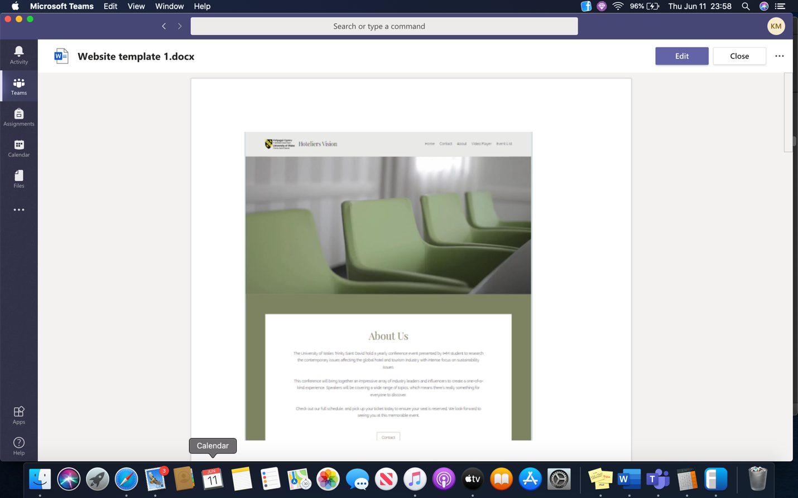
Website Template 1
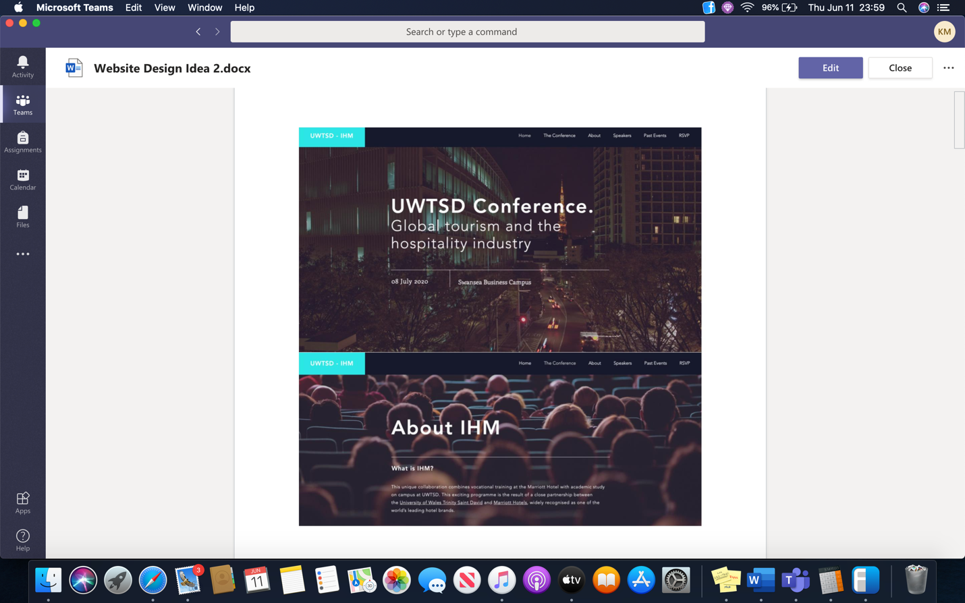
Website Template 2


Final Logo

Meeting minutes – May 18
Location: Online – Microsoft Teams
Date:
Time: 9am – 12pm
Attendees: Molly, Dan, Laurence, Katie, Ranad, Robbie, Mo, Abdul, Jaliya, Sam

Agenda items
- Recap on deadlines
- Molly, Robbie and Mo arrange a joint meeting
- Logo
- Picture and Bio over 30 second video of self intro
- Discussion about video to introduce topic
- Website layout
- Presentation recording

Action items | Owner(s) | Deadline | Status
Presentations to All 01/06/2020 Pending
teams
Mo 18/05/20 Done
Mo to assist Marketing
Newsletter, email template Marketing 22/05/20 Pending
Ranad to call potential guest speakers
Management 25/05/20 Pending

Technical - Meeting minutes – May 18
Location: Online – Microsoft Teams
Date: 18/05/20
Time: 9am – 12pm
Attendees: Dan, Laurence, Mo

Agenda items
- Website Layout
- Videos uploaded to YouTube
- Pictures, Biographies and Direction on the website
- Copyright given as soon YouTube has verified the person as real, however this is not needed as we are keeping it private.

Action items | Owner(s) | Deadline | Status
Mo to edit website 20/05/20 Pending
and have buttons underneath pictures

Work upload video to YouTube to get URL 20/05/20 Pending
Presentation to Sam 01/06/20 Pending

Marketing - Meeting minutes – May 26
Location: Online – Microsoft Teams
Date: 26/05/20
Time: 9am – 12pm
Attendees: Laurence, Abdul, Jaliya, Robbie
Agenda items:
- -Blurb/ Intro for the conference
- -One section regarding the website, about us section.

Contact list for the email campaign

Jackie Jones Email- Jaqui.jones@uwtsd.ac.uk
Programme Director Tourisme
UWTSD

Dr Anita Zhao Email: a.l.zhao@swansea.ac.uk
Associate Professor
Business and Tourism
Swansea University

Emily Bacon Email- emilybacon@gowercollegeswansea.ac.uk
Lecturer
Travel and Tourism
Gower College
Swansea

Dale Davies Email – dale.davies@nptcgroup.ac.uk
Lecture
Hospitality and Tourism
Neath College
Neath

Mr. Michael Bolton Email – m.bolton@bridgend.ac.uk
Lecture- Catering
Bridgend College
Bridgend

Gaurav Chawla. Email – Gaurav.chawla@southwales.ac.uk
Senior Lecturer Hotel and Hospitality
University of South Wales
Newport

Dr Emma Bettinson Email - ebettinson@cardiffmet.ac.uk
Senior lecturer Tourism and Hospitality
Cardiff metropolitan University
Cardiff

Dr Jennifer Hill Email - Jennifer.Hill@uwe.ac.uk
Senior Lecture – Tourism
University of West of England
Bristol

Dr Sumeetra Ramakrishnan Email - s.ramakrishnan@surrey.ac.uk
Programme Leader – Hospitality and Tourism
Surrey University
Surrey

Dr Lorraine Brown Email- lbrown@bournemouth.ac.uk
Associate professor – Tourism and Hospitality
Bournemouth University
Bournemouth

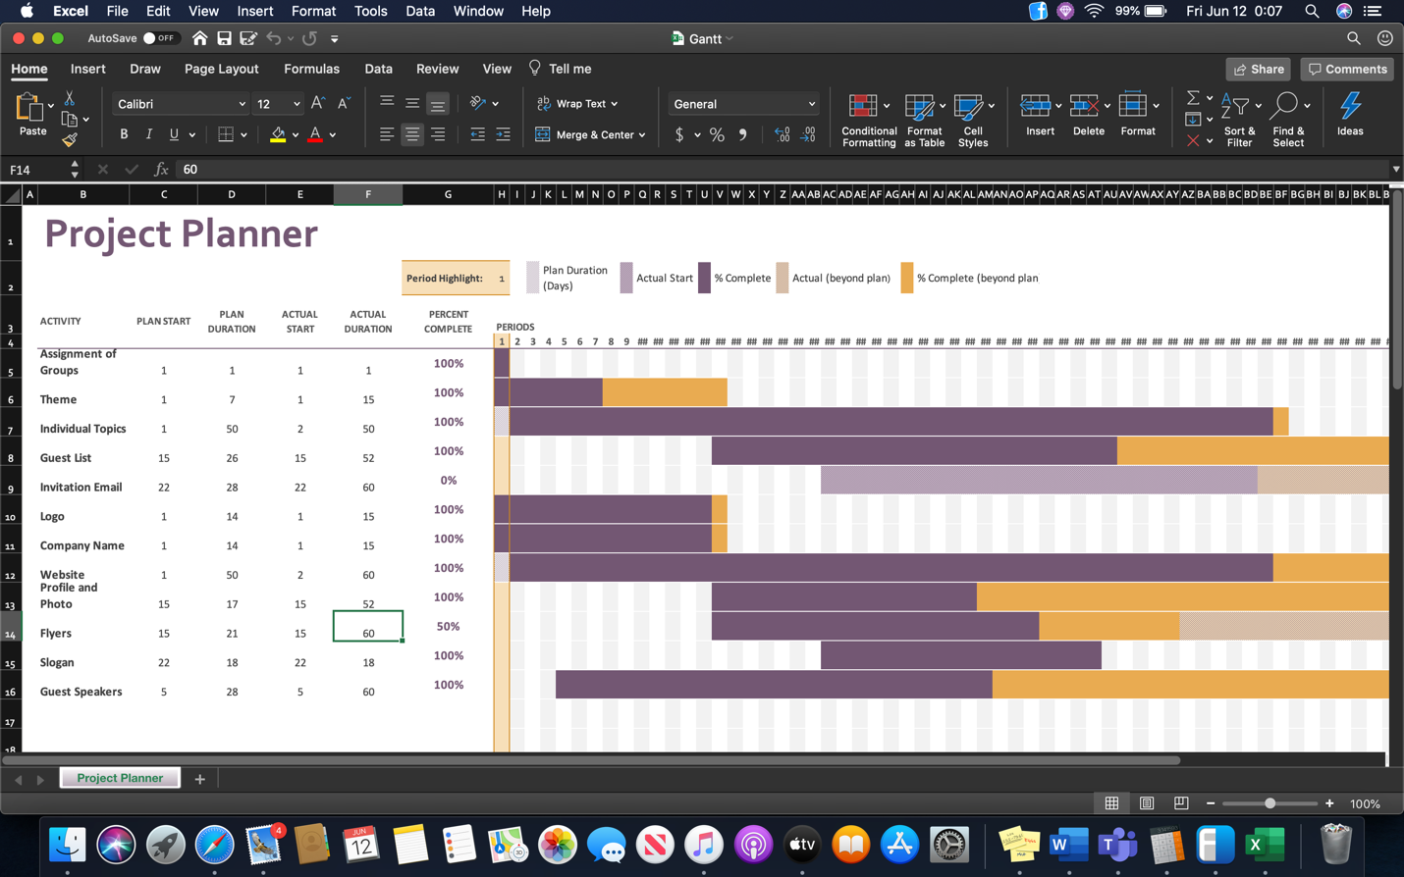

Meeting Minutes – June 2
Location: Online – Microsoft Teams
Date: 02/06/2020
Time: 10-10:30am
Attendees: Molly, Mo, Jaliya, Dan & Laurence

Agenda items
- Final details

Discussion

Completion of recording power points, to be sent to technical if not recorded on teams with Sam.

Technical to start upload of presentations to YouTube and the website.

No further guest speakers available

Due to no communication with marketing team we are unable to finish the flyers/leaflets, technical have a template but no content for them.

All Bios have been uploaded

Change the date of conference on the website

About us and Hospitrinity information to be updated

Dan to meet with John and Sam to show them how to navigate the website.
Action items | Owner(s) | Deadline | Status
Completion of recording PowerPoints | Everyone | 02/06/2020 | Due by 5pm
Upload of videos | Technical | 07/06/2020 | To be completed
Flyer template upload to teams | Technical | 05/06/2020 | To be completed
Change Date of conference | Technical | 02/06/2020 | Complete
Information Update | Technical/Molly | 02/06/2020 | Complete
Spelling/Grammar check website | Molly | 05/06/2020 | To be completed
Show John and Sam the website | Dan | 08/06/2020 | To be completed

Email to possible attendees and to develop contact list for future


To __________,

We are a student group of the International Hotel Management class at the University of Wales Trinity St. David with the purpose of increasing conversations about contemporary themes in the hospitality and tourism sectors.

To meet this purpose, we have created a website as a virtual area where collaboration can occur about these broad themes such as waste issues, biodiversity loss, health and wellness, and terrorism.

The form it will take is monthly slide shows with specific topics, a monthly newsletter, and interaction in blog format.

We invite you to participate in one or all of these endeavours.

A final ask is that you forward this on to your students so they can participate with us increasing the diversity and creativity to our website.

Some photos of the finished website
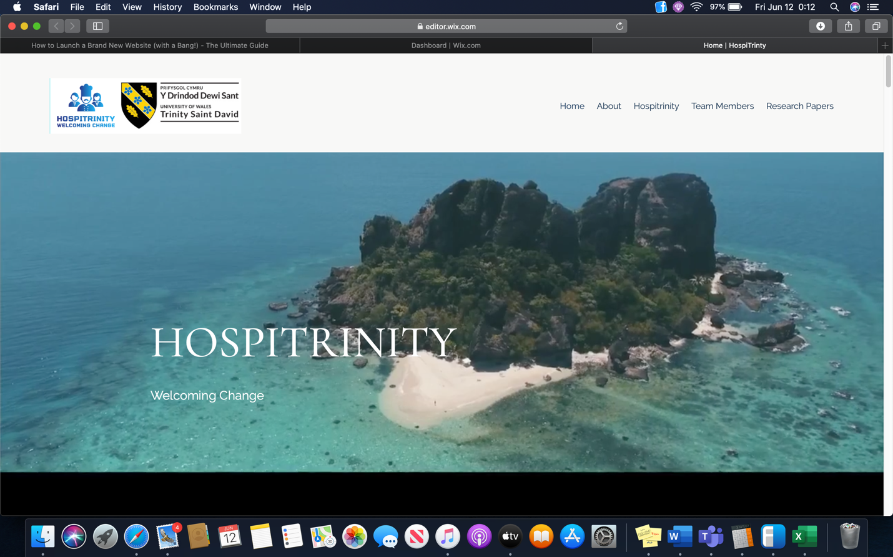
Looking forward to you joining us on this journey,
IHM Team

