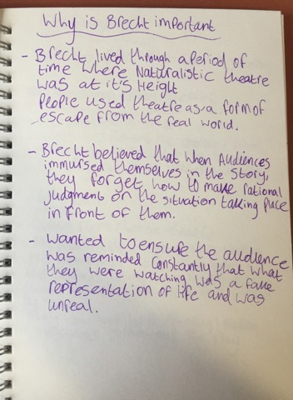
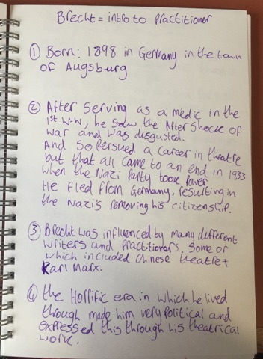
1 2

3 4
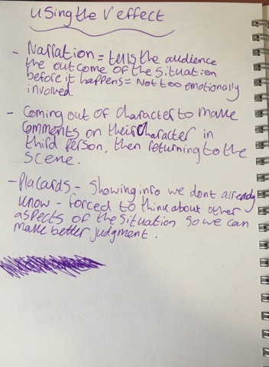
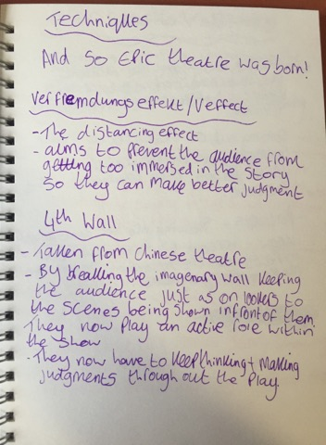

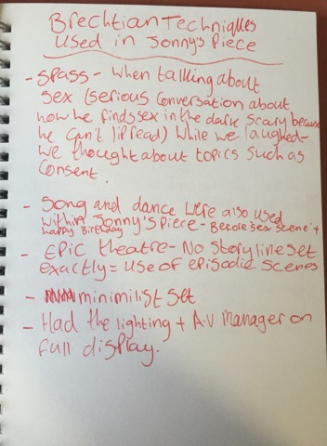
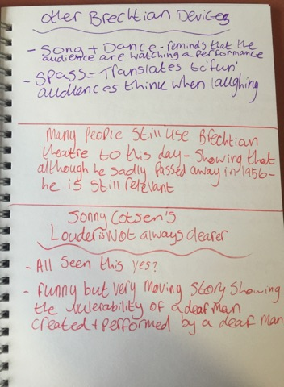
5 6

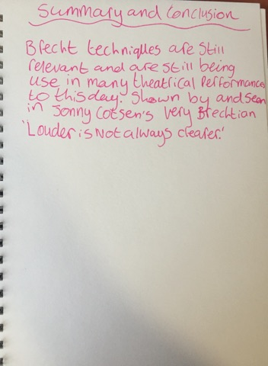
7 8
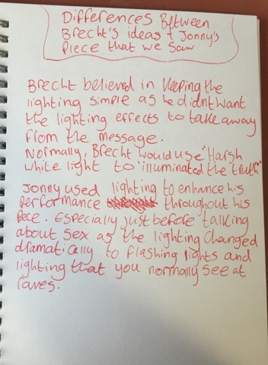

Bibliography
Willett, J., 1964. Brecht On Theatre. 13th ed. New York: Hill and wang.

BBC Bitesize. 2018. Epic theatre and Brecht. [ONLINE] Available at: https://www.bbc.com/education/guides/zwmvd2p/revision/8. [Accessed 29 March 2018]

