

Student Name: Szabina Molnar
Student Number: 2121168
Course Name: Managing People
Lecturer Name: Nishi Ramsurrun
Session: February 2023 Term

Abstract
Employee attrition within the nursing industry depends on the circumstances of the UK market. The whole process of retaining nurses depends on the factors which are beneficial for the overall growth of the nursing industry. To reduce attrition in the nursing industry, it is mandatory to follow up on some future recommendations which are beneficial for the nursing staff. The long and short-term recommendation depends on the steps which the NHS could apply for the nurses. To reduce attrition in the nursing industry it is mandatory to follow up with some steps which can develop the future performances of nurses.

Table of Contents
Analyse the causes and effects of employee attrition within the Nursing Industry in the UK. 4
Identification and evaluation of five monetary and five non-monetary existing retention schemes used by NHS for Nursing professionals 6
Make recommendations, both in the short term and in the longer term to improve nurse retention to lower the nurse attrition rate in the UK. 9
Conclusion 11
References 12

Analyse the causes and effects of employee attrition within the Nursing Industry in the UK
Employee attrition is a burning issue in the Nursing Industry of the UK. The UK faces employee attrition and it is harmful to the development and growth of the country. Nursing staff attrition is a major issue regarding the health sector employment. The managing skills of employee recruitment are dependent on and affect the whole industry. 13% of registered nurses leaving the field in 2022. The attrition within the Nursing industry has some causes and effects which give a clear image of the employer deduction and its harmfulness in the economic and social background. More than 11.5% of nurses leave the work field because of work pressure. More than 14.5% of nurses leave for the reason of ageing. More than 40,365 NHS nurses left service life (Nuffieldtrust.org.uk,2023).
Under-skilled labour: The under-skill is one of the main problem in the health sector. Less knowledge makes the whole service of the nurses more difficult and it's harmful for them. The main reason is the lack of knowledge and skills which they cannot transfer for their profession. For this reason, many nurses leave their active service life and most of them choose other professions. From February 2022, (lewissilkin.com,2022) care workers and home carers are recognized on the skilled worker shortage occupation list. Therefore, they do not need higher education to work in the industry. Transferable skills, what only educated nurses can provide make them feel less relevant for the health sector. This problem is harmful to the growth of this industry. Mainly the problematic thing about under-skilled labour is dependent on the hospital environment and the training provided. During training, the nurses feel confident or underconfident about their profession. The lack of communication and lack of appliances such as PPE, developed under-skilled labour attrition. This results in anxiousness which affect their performance. Lack of technical skill and communication skills makes professionalism dull towards the patient. The potentiality of the nurses gets harmed because of under-skilled labour. After the pandemic issue, the skilled efficiency of nurses decreased which is the most problematic factor for the under-skilled performances of nurses. One of the main reasons for increasing employee attrition in the nursing field is the lack of professionalism and work efficiency.
Work pressure: The work pressure in the health sector is a common factor. After the pandemic breakdown, the work pressure increased rapidly in the nursing industry. Employee attrition is also high because of this reason. More than 18% of nurses leave their service because of work pressure in the hospitals in the nursing industry of the UK (Nuffieldtrust.org.uk, 2023). Due to the work pressure more than 7,470 nurses leave their active service life during the pressure in the work field. After the pandemic breakdown, this work pressure in the nursing industry of the UK gets high by 34.4% (Ncbi.nlm.nih.gov,2023). The nurses of the UK feel pressured during the changes in duty shifts. The overall performance of workers in the health sector is dependent on the proficiency of the workers. 30% of the nurses feel the stress disorder after the first peak of the pandemic. The nursing industry faces employee attrition specifically during and after the pandemic. 44% of registered nurses feel work stress during the peak time of the pandemic and after the pandemic dissolves (Nursingtimes.net,2023 ).
The work pressure creates employee attrition in every sector. The work pressure is always high in the health sector of any country. In the UK, the nursing industry is an emerging and developing sector of the healthcare department. The overloading of work and duties increased after the pandemic breakdown, which affected the overall performance of every employee in the healthcare sector. To maintain the balance between the work life and personal life nurses face difficulties which is also a reason to leave their active service life before retirement.
Poor working environment: Surveys show that more than 22% of nurses feel the toxic work environment which is harmful to their performances and career life (Nuffieldtrust.org.uk, 2023). The surveys also show that the discrimination of colour and caste in the nursing field increases the attrition of nurses (Minoritynurse.com,2023). Bullying and harassment of the newly joined people in the workplace demotivate them and affect their overall future performance. Nurses feel the pressure and discrimination in the workplace more than other employees in the healthcare sector. In the UK nursing industry, 10% of the nursing staff complained about discrimination in the workplace environment (Nuffieldtrust.org.uk,2023). More than 3.5% of employees resign from their jobs every year during the poor working environment.
The nursing sector of the UK gets harmed by various factors including attrition problems after the Covid-19 breakdown. The pandemic emerged from many problems including work pressure, low pay, lack of training and lack of growth opportunities in the nursing industry of the UK. Nursing staff face problems regarding poor job fit, lack of PPE and lack of proper training. These factors build a storing reason for leaving their active service life. The data taken from the NHS survey shows 1500 nurses leave their jobs under the discrimination of the management and hospital authority in the UK (News.sky.com,2023). A toxic work environment is harmful to the mental health of every employee. The pressure of the overloaded work and the toxic environment makes the attrition rate high in the nursing industry of the UK. According to Herzberg, hygiene factors are a major cause of dissatisfaction, which leads employees to leave their jobs.
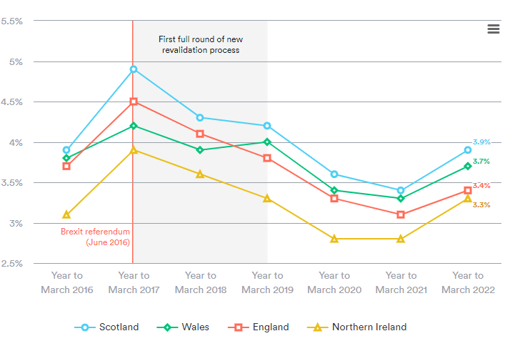
Figure 1: Number of nurses leaving the professional register across the UK
(Source: Nuffieldtrust.org.uk,2023)

Identification and evaluation of five monetary and five non-monetary existing retention schemes used by NHS for nursing professionals
The monetary and non-monetary retention schemes that are used by the NHS for the nursing staff are beneficial for the overall growth and development of the healthcare sector. NHS helps nursing professionals to develop their careers and lives through monetary and non-monetary retention schemes (England.nhs.uk,2023). Those schemes are beneficial for the reduce the attrition level of nursing professionals(Armstrong et al.,2017).

Monetary retention schemes:
Discount and profitable deals: NHS provide the Blue Light Card which helps to get discounts from various grocery stores, home electronics and other home appliances. This card helps to get money-saving expert advice for the card holders. The card costs £4,99 for 2 years of membership. Cardholder can use the discounts in several sectors as restaurants, gym, health, and beauty, or for holidays. After the pandemic some of the stores are closed or reduced the NHS discount. (chroniclelive.co.uk) Profitable discounts and deals help with living a balanced life for nursing professionals. (skintdad.co.uk)
Utility discounts: Utility discounts help the nurses to purchase gas, water, and electricity at a profitable rate. NHS promotes dedicated support to access water and gas to the nursing staff. The affordability of these utilities helps to get motivated towards the work field. The energy savings bills and techniques help to build up satisfaction among the nursing staff (England.nhs.uk,2023).
Travel discounts: The national schemes on travel make it more beneficial for the citizens. The discounts on travel fares and charges of hotels make travel more budget-friendly. NHS promotes car parking guidance for the working staff which is under the national scheme. The reduction in fuel costs is helpful for the blue light cardholder. The travel discounts for the nursing staff help to build a traffic-free ambience to reach the workplace.
Grocery cost reduction: The grocery cost reduction scheme helps the citizen more connected to the national scheme. The discounts and offers on household appliances make the nursing staff more motivated towards their work life. Reducing grocery costs promotes beneficial results for living circumstances. The attrition level of nurses reduces due to this process by promoting a healthy ambience in their personal life.
Child care cost discount: The discount on childcare costs is beneficial for reducing the attrition level. The healthcare workers found that this monetary scheme was most beneficial. The reduced cost of child care helps to motivate nurses to develop more in their workplaces. The childcare schemes help the nursing staff to get convenient towards the workplace environment. Some shops as Asda, Morrisons and Sainsbury’s have amazing deals for NHS workers’ children. The childcare discounts at hospitals and other industries help the working parent to be more professional towards their work environment.
Non-monetary retention schemes:
The non-monetary schemes help nursing professionals to be motivated towards their work and improve the retention of the staff recruitment process (England.nhs.uk,2023).
Flexible working hours: The flexibility in work hours for a day per week is beneficial for nursing professionals. The flexibility can make them more engaged towards their work. For nursing professionals, the shifts of overload duties low the motivation level of the nurses which is also a main cause of employee attrition. In an employee and their line manager unable to find a solution, there is an additional stage to identify other viable alternatives that could be considered. Flexibility in duties can increase the motivation level which is used by NHS for nursing professionals.
Administrative time: This refers to a designated period within a nurse practitioner’s workday where they not expected to see their patients. During this time, they can attend to administrative task, such as checking lab results, contacting patients, catching up on paperwork, working alongside other healthcare providers. A possible advantage to negotiate for is the option to use this administrative time remotely, allowing the nurse practitioner to work from a location outside of the office. By utilizing specific apps, they can contact their patients through their personal phone, while displaying their work phone number on the patient’s phone. Negotiating for remote administrative time can contribute to maintaining a healthy balance between work and personal life, thus reducing the risk of burnout. (linkpas.com)
Opportunities for professional and personal development: NHS gives opportunities to nursing professionals to develop their working skills as well as their personal development. This finely reduces the attrition level. Holding seminars and workshops for the nursing staff helps to develop their skills and motivated them towards their Nobel profession. NHS focuses on developing the work spirit of the nurses. They hold seminars belong to the development of nursing skills is beneficial for reducing attrition (Hdft.nhs.uk,2023 ).
Reward-giving system: The reward-giving policies are most effective to hold the motivation of every employee in every industry. This policy helps to guide the nursing staff to get connected with the workplace environment. This non-monetary scheme of NHS helps the nursing staff to get motivated and enhance work efficiency(TAYLOR et al.,2010).
Provide a healthy work environment: The healthy work environment enhance employee retention. In the field of healthcare, a positive and healthy environment gives beneficial results to the health worker. NHS provides and promotes a healthy work environment in hospitals and the health sector in the UK (England.nhs.uk,2023).
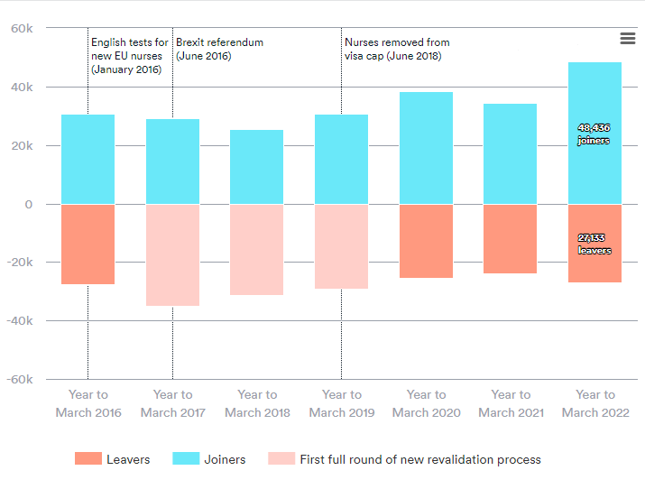
Figure 2: Number of staff joining and leaving the UK nursing register
(Source: Nuffieldtrust.org.uk,2023)

Make recommendations, both in the short term and in the longer term to improve nurse retention to lower the nurse attrition rate in the UK.
To reduce nurse attrition and improve the retention of nurses it is mandatory to follow some recommendations which would be beneficial for the nursing industry in the UK.
Short-term recommendations:
To enhance nurse retention and promote the overall performance of the nursing staff it is mandatory to follow up on some recommendations. There are many ways to promote the nurse retention process which can be beneficial for the medical sector of the UK.
1) Continuous Training and development for the nursing staff: Continuous training is beneficial for nurse retention. It will also help to slow the attrition process in the nursing field. The personal and professional development through this CPD helps the medical staff get on track and promotes their performance level. CPD helps to get the higher skill in a particular field. The skill-enhancing training is useful for the performance of nurses. The NHS could promote skill enhancement training by holding workshops and seminars. This step is beneficial for the improvement of nurse retention.
2) Increase Pay of nursing staff: The increment in the payment process of nursing staff gives higher motivation and promotes the retention of nurses. This is beneficial for the overall career performance of medical staff. The increment in pay scale motivates the employees. NHS could enhance the payment scale for the nursing staff to enhance retention and decrease nurse attrition. In the short term policy it is beneficial as instant action.
3) Increase communication in the workplace: The increase in communication between the employees makes the attrition process slow. In the short-term action plan, it is beneficial to develop the communication. The workplace environment promotes nurse retention and decreases the attrition process. NHS can promote communication between the nursing staff and enhance nurse retention by holding meetings(Torrington et al.,2014).
Long-term recommendation:
1) Nursing graduate scheme: In the long term recommendation NHS could promote a beneficial nursing scheme for the fresh graduates. It would high the motivation and attract the nursing students towards this field. NHS could generate such a scheme for developing the nurse retention process which is beneficial to reducing the rate of attrition.
2) Flexible working arrangement: Flexible working arrangements could develop the overall performance of every nursing staff. The overall growth of nursing could be defined by this long-term recommendation.
3) Healthy work environment: Generating a healthy work environment is a proper long-term recommendation that NHS could apply for reducing the attrition level. From the perspective of long-term benefits, it is essential to develop a healthy workplace environment. NHS could promote workshops and seminars to maintain and discuss the importance of the workplace environment which decreases the level of attrition of nurses.

Conclusion
In this discussion the main point which is coming to highlight is improving nurse retention and the ways to reduce the process of nurse attrition. The overall discussion has been about developing the circumstances of the nursing staff in the UK. The promoting factors which are beneficial for the future growth of the nursing staff are also depicted through the future recommendation.

References
Armstrong, M., Taylor, S., (2017) Armstrong's Handbook of Human Resource Management Practice, 14th Edition, Kogan Page
Chroniclelive.co.uk, 2023 Available at: https://www.chroniclelive.co.uk/news/uk-news/mcdonalds-nhs-discount-money-food-26411234 (Accessed on 19th April)
Digital.nhs.uk, Available at: https://digital.nhs.uk/data-and-information/publications/statistical/nhs-vacancies-survey/april-2015---june-2022-experimental-statistics (Accessed on 31st March 2023)
England.nhs.uk, 2023 Available at: https://www.england.nhs.uk/supporting-our-nhs-people/support-now/financial-support/supporting-our-staff-to-help-money-go-further/ (Accessed on 11th March 2023)
Hdft.nhs.uk, 2023 Available at: https://www.hdft.nhs.uk/patients/our-commitment/the-nhs-constitution/ (Accessed on 4th April,2023)
kingsfund.org.uk. 2023 Available at: https://www.kingsfund.org.uk/blog/2022/10/nhs-nursing-workforce (Accessed on 31st March,2023)
Lewissilkin.com, 2022 https://www.lewissilkin.com/en/insights/carers-become-eligible-for-skilled-worker-sponsorship (Assessed on 18th April, 2023)
Linkpas.com,2023 Available at: https://linkpas.com/nursing-career-benefits/ (Accessed on 11th April, 2023)
Minoritynurse.com,2023 Available at: https://minoritynurse.com/navigating-a-toxic-work-environment-as-a-nurse/ (Accessed on 10th April, 2023)
Ncbi.nlm.nih.gov,2023 Available at: https://www.ncbi.nlm.nih.gov/pmc/articles/PMC8673915/ (Accessed on 4th April 2023)
News.sky.com,2023 Available at: https://news.sky.com/story/nhs-crisis-why-are-so-many-staff-leaving-the-health-service-12812473 (Accessed on 10th April, 2023)
Nuffieldtrust.org.uk,2023 Available at: https://www.nuffieldtrust.org.uk/resource/peak-leaving-a-spotlight-on-nurse-leaver-rates-in-the-uk (Accessed on 31st March,2023)
Nursingtimes.net,2023 Available at: https://www.nursingtimes.net/news/workforce/stress-and-abuse-remain-high-among-nhs-nurses-reveals-survey-18-02-2020/ (Accessed on 4th April 2023)
Skintdad.co.uk, 2023 Available at: https://skintdad.co.uk/blue-light-card-discounts (Accessed on 19th April)
TAYLOR, S. (2010) Resourcing and talent management. 5th ed. London: Chartered Institute of Personnel and Development
Torrington, D., Hall, L., Taylor, S., Atkinson, C., (2014) Human Resource Management 9th Edition, Pearson

