Skills for the Work Place
Module: ‘Developing relationships and workplace achievement’
Module code: BMSK5002

Student name: Musammot Sima (1705525)
Organisation: University of Wales Trinity Saint David
Lecturer: Brynach Heffernan
Submission date: 14th December 2018

Task 1:
Critically evaluate development vehicles available to an organisation appropriate to the development needs of the individual.
Introduction:
There are many different types of development vehicle available that shows how it is useful to an individual and many organisations. Here are a few mentioned below that will be involved throughout. For example; Motivation, Performance management, Engagement and Training. There are many more development vehicles; learning organisation, appraisal, feedback and reflection. There will be different explanations on each vehicle as well as how it is beneficial to an individual and any organisations.
Motivation: Motivation is some internal and external features that stimulates desire and energy in employees to be constantly interested and focused to a job or to make the effort to achieve a goal. (Web finance, 2018).
Motivation is a development tool which is the main reason for people’s actions and goals to be achieved. An individual’s motivation can be stimulated by others or any manager in an organisation that acts behind the goal.
There are two types of motivation – Extrinsic motivation; this is when external factors that encourage the team to do what is beneficial for the organisation. For example; pay rises, time off, bonus check and the threat of losing the job are all extrinsic motivation. Intrinsic motivation; this is internal, and it is about having a personal wish to fulfil a challenge to give out a high-quality work or to work well with team members with trust. These people get a great feeling of satisfaction from they complete. Each member of staff is different and are bound to have different motivators. So, for a manager it is necessary to get to know the employees and discover what motivates them and decide which type of motivators they are so that they can be motivated successfully. (Swift, 2018).
It is important to understand what motivates an individual as it aids the organisation towards profits and encourages the development needs. There are different ways to positively influence motivation from the organisation, for example; financial wages, good working conditions, appreciate and open environment.
There are many ways to see how important motivation is in an organisation. There are many numbers of tests for motivation where a manager can see how motivated the staff are whilst completing their tasks. For example; The motivational styles questionnaire. This questionnaire was introduced by Tarleton in 1997. (Edenborough, 2009). Another example is a motivational questionnaire which assess the motivation level. There are no right or wrong in these questions. It was introduced by Marcia L. Conner in 1993. (Conner, 2013). Please see Appendix 1.
Mayo (1933, 1945) pointed out that it was necessary to consider the whole person on the job, he believed that because there was a change in the routinization of tasks brought about by the industrial revolution had served to massively reduce the possibility of finding satisfaction in the task itself. Because of this change the employees would begin to seek satisfaction elsewhere. There was a critic thinking that failure to treat workers as human can to be regarded as the cause of low morale, poor management and confusion. (Steers, Porter, Bigley, 1976).
The theorist suggested that motivation at work can be discussed and promoted in different ways. For example; good communication, involving others interest in jobs and good teamwork etc. For an example the Mayo theory is seen to take place in companies like Tesco etc. For Mayo communication is a very important factor in motivating the employees to get the best out of them. This may be through one to one discussion with managers and some formal structures, for example; Appraisals. (Tesco, 2018).
Performance management: Armstrong and Baron (in CIPD, 2009a) describe “performance management as a way which contributes to the effective management of individuals and teams in order to achieve high levels of organisational performance. As such, it establishes shared understanding about what is to be achieved and an approach to leading and developing people which will ensure that it is achieved.” Hutchinson, (2013). They also add up saying that - a plan which tells every action of the organisation set in the situation of its human resources politics, culture, style and communications systems. The nature of the approach depends on the organisational background and can vary from organisation to organisation. The SMART acronym was first discovered by George T. Doran in 1981. The acronym ‘SMART’ is used to define good purpose even though there are limitations especially inflexibility. (Armstrong, 2016).
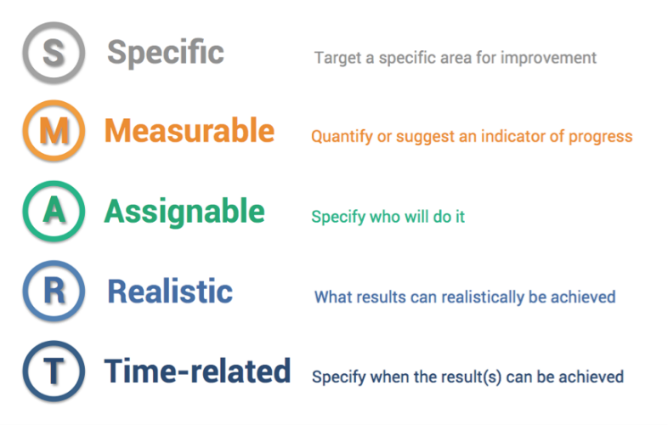 (Broadview, 2017).
A very important feature of performance planning is the process of aligning individual goals with the planned goals of the organisation.
SMART objectives focus on what it will look like when the objective is achieved. The premeditated aim is supported by the clinical service centre business plans and a wide range of corporate strategies and many objectives are planned directly from these plans. In arranging appraisal objectives, performance management and motivations should be considering the ‘golden thread’ that can be noticeable from these trust approaches all the way down to individual objectives. An example of how SMART has been used in clinical and non-clinical leadership and management roles in Portsmouth Hospital. (Portsmouth Hospital, 2018).
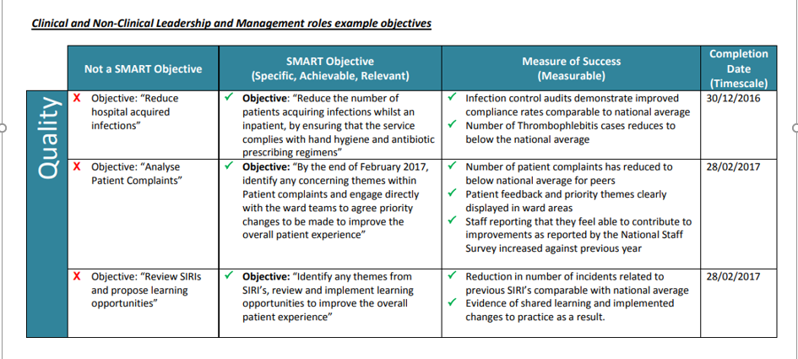
There are various theorist explaining the concept of performance management but there is Mabey who had discovered the model in a form of ‘Performance management cycle’. This cycle has 5 essentials parts which shows how performance management system can be applied into an organisation. (Agarwal, 2017).
The cycle consists of;
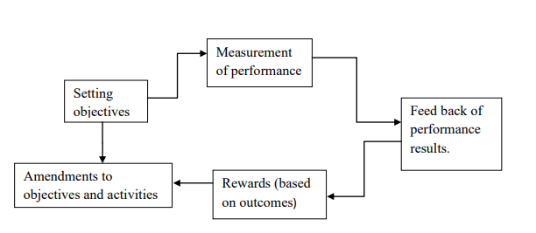(Mbise, 2014).
Engagement: Harter et al (2002); stated that employee engagement was the individual’s contribution and pleasure with as well as interest for work. But later around 2009 engagement was defined by Macey et al who stated an individual persistence and focused energy, evident to others in the presentation of personal resourcefulness, flexibility, determination and persistence directed towards organisational goals. The Institute for Employment Studies; IES model of engagement consists of three overlying components. The tool was established based on common drivers of engagement in all organisations though some variability is likely (Armstrong, 2016).
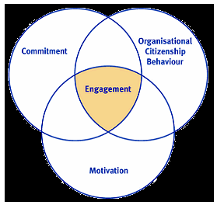
Engagement and commitment: the term commitment does not reflect adequately to parts of engagement. It is a two-way nature and the amount to which engaged employees are probably to have positive attitudes about their job.
Engagement and motivation: the motivation part in engagement is basic. Macey et al commented in (Armstrong, 2016) that: “when the work itself is meaningful it is also said to have intrinsic motivation. This means that it is not the pay or recognition that yields positive feelings of engagement but the work itself”. Engaging employees feel that their work and job is an important part of their motivation in workplace.
Engagement and organisational citizenship behaviour: employee behaviour is something that goes all the way above and contributes to organisational success. It is optional and not openly recognised by the employing organisations official reward system. Necessary behaviour has been shown to be associated more to the work situation than to individual dispositions. (Armstrong, 2016).
The Hawthorne effect refers to the feeling of some individuals to work harder and achieve better when they are being detected as part of an experiment.
Under the Hawthorne effect it is referred to as a study of employee productivity. It is named after one of the most famous experiments in the industrial history. (Bennett, 2018).
BT is one of the leading communications services companies of the world that serves the needs of customers in the UK and more than 170 countries of the world (BT, 2014).
For example; in BT the engagement levels have improved from 3.69 in February 2013 to 3.82 in February 2014 on a scale of 5. Statically 32000 employees provide feedback on employee engagement. There are many aspects where employee experience has shown improvement. Job satisfaction – having enriched and challenging job can improve the employee to work well, team engagement – this improves the asset to the organisation, manager – having a well organised and committed manager can improve the quality of work commitments from all individuals, company perception- this helps the quality of employee and organisation relationship and senior leaders – having senior leaders at workplace helps employees to engage well with other colleagues and stay motivated.(Maurya, 2014).

Training: Training is a database that will help all employees learn new and specific education or skills to establish and improve performance in their current roles and even for the future.
Training gives the opportunity to gain or improve certain skills or knowledge. Training can motivate employees and help them to work their way up into the top in the organisation. It can help the employees to take a big step in their next career step.
Following the training cycle is a fundamental stage to deliver effective learning and progress. It is critical for all trainers to be all-rounder at certain skills and understand the training process from start to finish. The training cycle provides a bigger picture of the process.
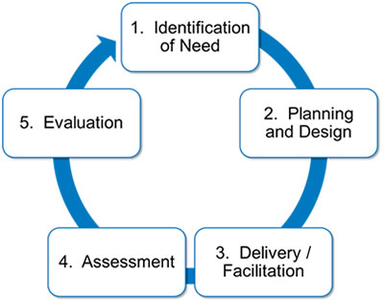 (gill Payne, 2014).
Even though training is important to both individual and organisations, there are two types of training available. On the job training and Off the job training. (Heathfield, 2018).
On the job training means training at work. It is a hands-on method of teaching the skills and knowledge needed for employees to achieve a specific job in the organisation. Employees mainly learn in a situation where they will practically be utilising the skills and knowledge which are obtained during training. (thetimes100, 2018).
Off the job training is a method of training where the employees learn their work roles away from the organisation and in a different sector where the employees are required to learn new skills and get well prepared with the techniques and methods that are used inside the organisation. (Business Jargons, 2018).
Tesco is the largest British retailer and is also the world’s third largest grocery retailer with outlets across Europe, USA and Asia. It had expanded with having over 2200 stores. It had approximately 280,000 employees in UK and over 460,000 worldwide. To serve the customers worldwide it needs trained staff that can identify the needs of all customers. Tesco recognises how much improving skills, knowledge and job satisfaction is necessary to have continuous growth for both organisation and individuals.
Tesco is an organisation that offers both on and off the job training. On the job training involves the following:
Coaching: this method will guide and instruct the trainee.
Mentoring: a line manager or well experienced person can provide advice and support.
Secondment: this can be when an employee is sent out in another place for a short period to learn new and useful skills.
Off the job training includes the following:
Training in specific new skills: developing the individual in areas such as team building, communication or organisation and planning.
External courses: attending courses outside the premises which are run by professional training organisation or qualified Tesco training staff.
Training the staff in Tesco motivates them to work harder with bigger knowledge which can lead up to more opportunities for the organisation and the individuals.
Conclusion:
As described above each development vehicle is mentioned with a theory which proves how it is beneficial for any individual in a workplace. These models have an impact on every employee as well as the organisation as it shows their confidence, motivation and the will to work effectively.

Task 2:
Critically assess the potential benefits to the organisation and the individual of personally developing individuals in the workplace.
Here there will be different development vehicle which demonstrate how it is beneficial to individuals and organisations. It will focus on motivation, performance management, engagement and training in organisations and individuals.
Benefits of motivation for individuals and organisation:
In motivation there are many theories that show benefits to each individual and organisation. For Adidas the ERG theory of motivation has been used. This theory was invented by Clayton Alderfer which has been revised from Abraham Maslow’s Hierarchy of Needs. Alderfer states that there are three stages of human needs that influence the employee’s behaviour.
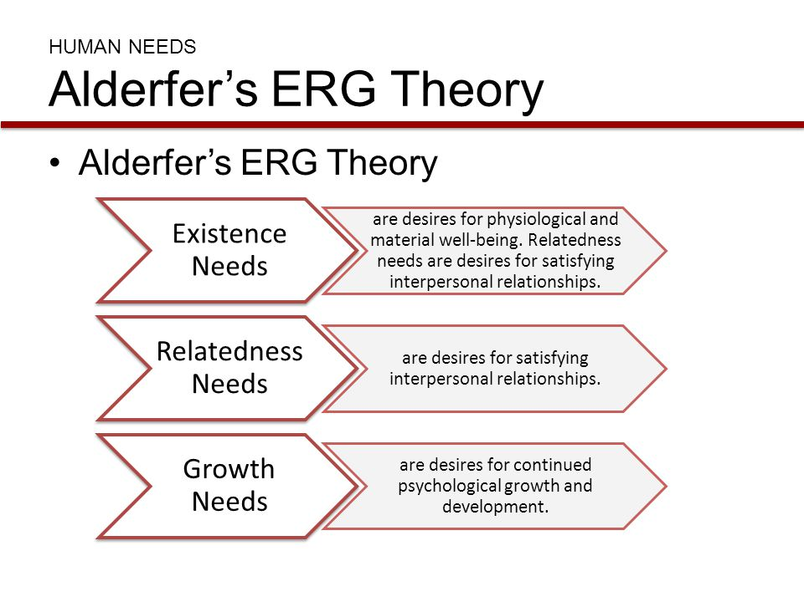
This theory allows the order of needs to be different for different people in the organisation. We can see that Adidas has applied the ERG motivation theory. for example;
Existence needs: the organisation offers all the individual an online safety measure, health insurance and as well as other type of insurance. Not only does the company provide locations where the employees can take a break, like football fields, tennis court or cafeteria etc. this shows how Adidas offers the employees with their existence needs.
Related needs: Adidas provides the employee’s family needs such as childcare centre where the employees children can enjoy, and this will help the employees to work well for the betterment for the organisation.
Growth needs: the organisation provides feedback for all individuals and provides them volunteering programs where they can improve for better skills and knowledge.
Adidas is a company where they bring about their employee’s performances where they can increase their motivation to work as well as having development discussions so that employees can allow them to work at their top performance. By doing volunteer work the employees can communicate well with other co-workers and this can expand the team spirit and progress their leadership skills and decision making. This can help with communication not only for employees but also for the customers. (Adidas, 2018).
Another motivation theory is the Mayo theory. For Mayo communication is a very important factor in motivating the employees to get the best out of them. This may be through one to one discussion with managers and some formal structures, for example; Appraisals. At Tesco the mayo theory is seen to be used throughout the company. As Mayo mentioned communication is extremely important in motivating the employees for the benefit of the organisation. In Tesco they undertake 1 to 1 discussion with managers, this can be through the company management or through more formal meetings like; appraisals. the line managers hold daily team meetings in Tesco to update staff with any information which goes on for the day and they even give out ‘Value awards’. These awards are given to any staff members to show appreciation and celebrating the achievements. This helps the employees to work even harder and gives boost in confidence and the willingness to achieve more. (business case studies, 2018).

Benefits of performance management for individuals and organisation:
Adobe Systems was founded by John Warnock and Charles Geschke in 1982. They both were part of the Research team at Xerox Corporation which they left to start the new company. In 1985 they had a sale of $1.9 million by inventing a product called laser printing. In 1986, their profits had increased to $16million which had an income of $4 million.
According to many reviews from the employees of Adobe, the employee network plays an important role in bringing all individuals together to build community and a comprehensive workplace. Each network is open to every employee across the organisation, they encourage each other in participation and teamwork across the workplace. They motto is ‘we are stronger together’.
Adobe is one of the most known cases in the spate of performance management revamps. The organisation has created the figures to verify that regular feedback makes sense. The company has voluntary employee turnover by some 30% after discovering a quick check in program. Adobe mentions that “involuntary departures” have increased by 50% as conferring to SVP for people and places Donna Morris, the new scheme needs managers to have regular tough discussion with everyone who struggle with their performance issues, instead of putting them off until the following performance review cycle come around. The organisation uses the performance management cycle which follows measuring the objectives, setting objectives, amending those objectives, having rewards and getting regular feedbacks. Performance management falls short now a days, but Adobe have always given their employees frequent feedback, open communication and collaboration with their colleagues. The organisation gets the employees to work together, not competing with one another, so then they achieve the same common goal. (Duggan, 2015).
Benefits of engagement for individuals and organisation:
In British Telecom employee engagement means establishing a climate where people are focused only on the organisations success. The employees value, believe and enjoy their work that helps the company. An engaged employee can bring creativity, passion and energy to the job. BT provides their employees feedback on employee engagement.
BT are always improving their engagement in various ways;
- They always more regular feedback.
-New quarterly survey informs business strategy
-Embedding engagement into business planning cycle
-More comments and conversations
- Monitoring impact of change programmes more proactivity
-better planning and line of sight
-change impact for key populations
- Leader led engagement programmes
-clarity around future direction
-building confidence and trust in leadership
-making leaders visible, accessible, public commitments
-developing leaders. (Gurteen, 2009).
John Lewis is one of the few UK organisations who have all of 76,500 permanent staff who are also partners and they eventually own the retailers 35 department stores and 272 Waitrose supermarkets, which then create an annual sale of more than £8billion. The company itself puts it; "Partners share in the benefits and profits of a business that puts them first.” This increases the employee engagement as the staff own have a share in the business.
The organisation structure also makes a list of official tasks to maximise the happiness of its employees. They involve a weekly magazine where the employees can put out their views about any type of policies and management if they choose. The head of finance and business; Tony Greenham states; ‘the idea that employees have nothing useful to contribute to administration belongs to the 19th century, not the 21st.’ Engaging with the employees is a major fact for John Lewis as their staff receive employee perks which are worth of £70 million. Giving the employees different types of benefits really help them stay motivated to work well for the organisation. Employee engagement has a positive impact on each individual and organisations as they both can double the benefits. If the employees are well engaged, then the customers leave good feedback for the organisation. It is necessary to stay engaged well with employees for the profit for the organisation as well as the employees to stay motivated. (Wood, 2012).

Benefits of training for individuals and organisation:
Many companies invest a lot in training program as they understand it will help both individual and the organisation. For example;

In an organisation there are many benefits from training some are mentioned below;
- Profit growth.
- Reduced employee turnover.
- Deeper talent succession pipelines.



For an individual there are many benefits, some are listed below;
- Increased employee motivation.
- Improved engagement.
- Improved productivity speed and competency. (Allencomm, 2018).

As stated in task 1 Tesco was mentioned and how it is the largest British retailer and is also the world’s third largest grocery retailer with outlets across Europe, USA and Asia. Tesco recognises how much improving skills, knowledge and job satisfaction is necessary to have continuous growth for both organisation and individuals. Tesco is an organisation that offers both on and off the job training. By on the job training Tesco provides coaching and mentoring which an employee’s development. These training and advice help the employee’s to recognise their strength in which role to take part in to develop the skills and knowledge required. The training facilities gives the benefit to every individual to give them the knowledge to work harder and to carry out specific jobs efficiently. Tesco provides with off the job training which helps the employee’s to learn new and certain skills which then is beneficial for both the individual and organisation. This can be done by team building activities, communication skills etc. they even provide external courses which helps the staff to be qualified to work in certain departments.
Training the staff in Tesco motivates them to work harder with bigger knowledge which can lead up to more opportunities for the organisation and the individuals.
Tesco is just an example that uses training to benefit the organisation. But there are many out there. For example; The Forestry Commission.
The forestry commission is a government department making it a public sector organisation. It is Britain’s largest land manager and is in charge for some of the UK’s most enormous landscapes. Over the last 20 years it has expanded Britain’s woods by an area more than three time the size of greater London.
The organisation heavily invests in different ranges of training for the better growth and development. For example; Health and safety training, technical skills programme and customer care skills etc. The forest commission has a culture of continuous professional development. This is maintained by a system of regular appraisals. An appraisal requires employees rereading performance with the line manager to recognise where improvement is necessary. Then training plans are developed to fill the gaps. Part of appraisal includes setting SMART objectives so the employees who are getting trained knows what to assume. The organisation undertakes both on the job and off the job training. For foresters this contains how to plant new seeding and guard them from the winter weather as well the summer weather. Approaches can include;
- Coaching: this method will guide and instruct the trainee.
- Mentoring: a line manager or well experienced person can provide advice and support.
- Secondment: this can be when an employee is sent out in another place for a short period to learn new and useful skills. (Times100, 2018).
The Forest Commission is an organisation which also wants the staff to be well trained, so they can give back to the organisation which will show profit for both the individual and the organisation.
Conclusion:
Each development vehicle has different benefits for both the individual and any organisations. The task demonstrates how different companies utilises different types of models which were invented by several theorists. There are definitions and explanations on the models. These models have always had an impact on organisations as it shows how organisations and individuals can improve on their skills and knowledge as well as how to stay motivated in workplace.

Task 3:
Develop a plan to meet the identified development needs and expectations of an individual.
Introduction:
Personal development plan requires sections of action to be taken to develop performance. By achieving the goals stated in the development plan gives the employees to keep up-to-date of any changes in their workplace. This plan highlights an employee’s strength and the zones where improvement is required. A personal development plan should contain a description of certain steps to be taken and specific objectives to obtain. In another word, what new skills and knowledge that can be learnt and how it will happen. (Aguinis, 2007).
Below there is a personal development plan for better customer assistant jobs:
Objectives | Measures | Priority | Support & Development  Internal External |  | Review dates | Other comments
Improve qualification | Complete: The NVQ Certificate/Diploma in Customer Service | High |  | External | 3 weeks | Check for the availability
Staff training for using the till | Provide training to learn the system and how to handle the till | High | Internal | External | 4 weeks | Investigate every month
Learn and improve customer skills | Guide the staff to have various skills by giving them guidelines to work with | High | Internal |  | 4 weeks | Check for improvement every 4 weeks
Improve staff and customer relationship | Team management sequences/exercises | Medium |  | External | 8 weeks | Arrange inside or outside gathering for staff to get to know each other
Undertake team work | Knowing the difference of working individually and in a team | High | Internal |  | 4 weeks
Job satisfaction of team | Challenge the employees and provide them with changed roles of work. | Medium | Internal |  | 8 weeks | Ask for staff’s feedback to check if they are not interested of the same job.

To be an employee with good customer service skills it is necessary to have the right qualifications. The NVQ Certificate/Diploma course is appropriate for all learners at any stage of a career in customer service. It has a high priority as it is very necessary to undertake this course as it will increase their skills in handling customer queries, analysing customers feedback and planning any kind of improvements. (City & Guilds, 2018). After every 3 weeks it will be helpful for a review as it will show improvements in the employees work.
Staff training can help all new and old employees to understand how the organisation runs and what it consists of as well as what improvements are required from the employees to undertake. These training can help customers to use tills/cashier and serve customers well. It contains high priority because it is important for all staff to understand what any customer seeks for whilst working and interacting with them. A review should be undertaken every 4 weeks for any recommendations that are required if there are less progresses. This can be completed by undertaking team management exercises. These training can be completed internally and externally to understand all the techniques and methods to work well.
For working as a customer assistant, it is important to understand how to work as a team, this is possible by knowing the difference of working individually and in a team. Team work does help any work get done quicker and efficiently. It has high priority as it helps the organisation reach their goals as well as every individuals level of confidence of working in a team. A review should be taken every 4 weeks to analyse how the employees have understood what is required to improve. Appraisals at that time will help the employees to stay motivated.
For an employee job satisfaction is a very important criterion. When an employer provides appraisals and uses any given feedback from employees it can show what an employee is providing for the organisation and in their job role. It is necessary to ask for staff’s feedback to check if they are not interested in the same role in the organisation. If an employee is not satisfied with their role, it is important to get it changed for both the employee and the organisation. The priority for job satisfaction of teamwork is medium, this is because it helps the team work well together and receive a satisfaction in mind. It is undertaken internally in the organisation by the line manager. A review should be placed every 8 weeks as this will decide if an employee is able to achieve their targeted goals. This plan will help an employee to increase their skills which can be used towards their job roles.
Conclusion:
Throughout this task a development plan has been mentioned for a customer assistant job where there are objectives that have been measured to understand the priorities to support the employees to improve their weaknesses.
It contained many development vehicles which shows how it benefits individuals and organisations in many different techniques. There are models which displays the improvements required for employees as this helps the organisation to achieve their goal.

Appendix 1


Reference List:
- (2013) Motivation, Available at: https://mcd1020adidas.wordpress.com/category/motivation/ (Accessed: 26th November 2018).

- (2014) Understanding the Training Cycle, Available at: https://www.gillpayne.com/2014/01/guide-understanding-the-training-cycle/ (Accessed: 20th November 2018).

- (2017) Broadview; SMART, Available at: boardview.io/content/uploads/2017/07/smart-goals-acronym.png (Accessed: 20th November 2018).

- (2018) Adobe, Available at: https://successstory.com/companies/adobe-systems-incorporated (Accessed: 20th November 2018).

- (2018) Alderfers Theory, Available at: http://slideplayer.com/slide/4282121/14/images/6/HUMAN%20NEEDS%20Alderferâ€™s%20ERG%20Theory.jpg (Accessed: 26th November 2018).

- (2018) City & Guilds, Available at: https://www.cityandguilds.com/qualifications-and-apprenticeships/business-skills/customer-service-and-contact-centre/4430-customer-service#tab=information (Accessed: 27th November 2018).

- (2018) Great place to work, Available at: http://reviews.greatplacetowork.com/adobe (Accessed: 24th November 2018).

- (2018) Motivation, Available at: http://www.businessdictionary.com/definition/motivation.html (Accessed: 04th November 2018).

- (2018) Off the Job Training, Available at: https://businessjargons.com/off-the-job-training.html (Accessed: 25th November 2018).

- (2018) Portsmouth Hospital Managers Guide to Setting SMART Objectives, Available at: https://www.porthosp.nhs.uk/learning/apdr/smart%20objectives%20-%20guidance%20v3.pdf (Accessed: 21st November 2018).

- (2018) Training, Available at: https://www.thetimes.co.uk/ (Accessed: 16th November 2018).

- (2018) What is Employee Training and Development? Available at: https://www.allencomm.com/what-is-employee-training-development/ (Accessed: 25th November 2018).

- Agarwal, A. (2017) Project Guru, Available at: https://www.projectguru.in/publications/models-and-theories-of-performance-management-system/ (Accessed: 20th November 2018).

- Aguinis, H. (2007) Performance Management, 2nd edn., New Jersey: Pearson Education Inc.

- Armstrong, M. (2016) Armstrong's Handbook of Management and Leadership for HR. Developing Effective People Skills for Better Leadership And Management, 4th edn. Philadelphia: Kogan Page.

- Bennett, C. (2018) The Economic Times; Hawthorne Effect, Available at: https://economictimes.indiatimes.com/definition/hawthorne-effect (Accessed: 19th November 2018).

- Conner, M. (2013) Motivational Style Questionnaire, Available at: http://marciaconner.com/dl/alcms051808.pdf (Accessed: 06th December 2018).

- Duggan, K. (2015) Fast Company, Available at: https://www.fastcompany.com/3054547/six-companies-that-are-redefining-performance-management (Accessed: 26th November 2018).

- Edenborough, R. (2009) Assessment Methods in Recruitment, Selection & Performance, 1st edn., British Library: Kogan Page Limited.

- Forestry Commission, Available at: https://www.thetimes100.co.uk/ (Accessed: 14th November 2018).

- Gurteen, D. (2009) BT Employee Engagement, Available at: https://www.slideshare.net/dgurteen/bt-employee-engagement (Accessed: 27th November 2018).

- Heathfield, S.M. (2018) On-the-job Training, Available at: https://www.thebalancecareers.com/how-on-the-job-training-brings-you-value-1917941 (Accessed: 25th November 2018).

- Hutchinson, S. (2013) Performance Management Theory and Practice, The Broadway, London: CIPD.

- Maurya, R. (2014) Employees' Motivation at British Telecom, Available at: https://assignmentwriting4u.wordpress.com/2014/08/02/employees-motivation-at-british-telecom-2/ (Accessed: 24th November 2018).

- Mbise, C, J. (2014) THE IMPACT OF PERFORMANCE MANAGEMENT SYSTEMS ON Employee PERFORMANCE, A CASE STUDY OF UNIVERSITY OF ARUSHA, Available at: http://repository.out.ac.tz/756/1/JENIFA_C_MBISE.MRHM_2014.pdf (Accessed: 19th November 2018).

- Steers, R.M., Porter, L.W., Bigley, G.A. (1976) Motivation and Leadership at Work, 6th edn., United States of America: The McGraw-Hill Companies.

- Swift, C (2018) Types of motivation, Available at: https://www.mindtools.com/pages/article/motivating-your-team.htm (Accessed: 04th November 2018).

- Tesco (2018) Available at: https://www.thetimes100.co.uk/ (Accessed: 14th November 2018).

- Tesco (2018) Motivational theory in practice at Tesco. A Tesco case study, Available at: http://businesscasestudies.co.uk/tesco/motivational-theory-in-practice-at-tesco/the-mayo-effect.html (Accessed: 18th November 2018).

- Wood, Z. (2012) The Guardian, Available at: https://www.theguardian.com/business/2012/jan/16/john-lewis-model-lessons (Accessed: 22nd November 2018).

