“Are Eye Conditions a result of an individual's lifestyle?”
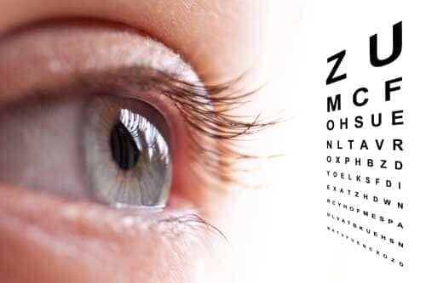
Individual project
Sundas Nasir
13MK

Content page

- Title
- Introduction
- Abstract
- Aims and Objectives
- Research Methods
- Analysis of Data and Information
- Conclusion
- Self Evaluation
- Bibliography
- Appendix

Introduction

For my Welsh Baccalaureate project, my chosen topic is looking at ‘Are eye conditions a result of an individual’s lifestyle?’. An increase of patients being diagnosed with eye conditions has sparked my interest to deepen my knowledge and understanding of the underlying eye health conditions.
Eye conditions indicate signs of problematic issues with one’s general health and lifestyle. This research will explore different conditions caused by lifestyle choices such as alcohol consumption, smoking and being exposed to sunlight (UV). Research suggests that smoking and alcohol consumption exposes ocular tissues to poisonous toxins which affect the eyes, leading to increased risk of cataracts, dry eyes and poor vision (Solberg, Ronsner, and Belkin, 1998). With more exposure to various devices, eye conditions have worsened over time. Eye fatigue, dryness, irritation and blue light from such devices are harmful and damaging to an individual's eyes. This research will look at correlation between lifestyle choices and such eye conditions.

This research will help me to gather information, which will feed into my studies at Higher Education. I intend to explore this further at university by studying optometry, assessing vision and treating various forms of visual impairments.This course will enable me to help diagnose eye conditions, prevent damage and eyesight loss and then as a qualified optician I would be able to prescribe suitable lenses for patients and correct abnormalities within the eyes. I would like to help people by correcting their vision which will improve the quality of their day-to-day life.

Abstract

The aim of this research project is to investigate the relationship between lifestyle choices and eye health. The study examines various eye conditions that may result from poor lifestyle choices, including age-related macular degeneration, cataracts, and dry eye syndrome. Through a comprehensive literature review, the study explores how lifestyle factors such as diet, smoking, UV radiation exposure, and prolonged screen time can impact eye health. Additionally, the study examines recent technological advancements in eye care, including blue light blocking glasses and virtual reality therapy, that may offer new solutions for addressing eye conditions. The results of this research indicate that a healthy lifestyle, including a diet rich in nutrients such as zinc, copper, vitamin C, and vitamin E, regular exercise, and protective eyewear, can significantly reduce the risk of developing age-related eye conditions. The study also found that technological advancements such as blue light blocking glasses and virtual reality therapy can be effective tools for managing and treating eye conditions. Overall, this research provides valuable insights into the impact of lifestyle choices on eye health and highlights the importance of taking proactive steps to protect and maintain healthy eyesight.

Aims and Objectives

Aim 1 - To explore whether eye conditions have become worse over the last 10 years due to lifestyle choices.

- Objective 1 = Research secondary sources to gather qualitative and quantitative data on diseases and correlations to lifestyle choices.

- Objective 2 = Primary research by conducting an interview with an optometrist.

Aim 2 - To investigate whether advancements in technology have contributed to more eye conditions

- Objective 1 = Investigate the effects of blue light through increased exposure to screen times using secondary and primary research.

- Objective 2 = Through primary research discuss the time spent on screen vs the eye health of participants.

Aim 3 - To analyse different solutions to eye conditions.

- Objective 1 = Conducting secondary research into solutions to modern day activities which will help to prevent eye conditions

- Objective 2 = Explore medications and natural products that are used to enhance good eyesight

Research Methods

This project is looking at reviewing the correlations of lifestyle choices and eye conditions. To conduct this, different forms of research methods will be applied. Some of the research carried out will drive down qualitative results through interviews and questionnaires concentrating on human behaviour. These methods allow the research to explore the topic in some depth and identify key findings to support the research aims. Quantitative research will also be used to gather suitable data which will be utilised to analyse the research aims and objectives further. The methods implemented for the primary research were conducting questionnaires and an interview with an expert in the field. The Interview will be carried out to explore the topic in some depth with an optometrist looking at current trends in eye conditions presented at their work. The questionnaires will collate responses from larger numbers of people in getting brief overviews of their opinions as well as gaining some detailed response from a represented sample with semi structured questions around their eye health and their lifestyle choices..

A large number of secondary sources such as relevant websites, academic journals and articles will be considered to evaluate and review the main findings of the project.

Primary research
Primary research is carried out specifically to answer the aims posed in this project. The information was obtained and analysed as previously stated through questionnaires, and interviews.

The data sampling will be chosen to be a random selection allowing for a varied representation for the questionnaire. A moderate sample size of 20+ will be chosen in order to increase the accuracy of the data. The questionnaire will contain both open and closed questions, the closed questions will help me to identify trends and patterns more easily and using open questions to understand why the individuals have chosen their answers therefore gaining a deeper apprehension of their responses. The questionnaire will be used to obtain qualitative results in order to gain deeper insight into the participants' opinions which were later translated into quantitative results ( graphs and charts ) to make comparisons easier.
The questionnaire will be sent to willing participants with no bias attached to it making it a credible and reliable source.

However for one of the interviews a medical professional will be selected due to their expertises in the field. Even though the interview will be highly biassed due to the self interest of the interviewee, it still gives a more in depth analysis from different perspectives. The participant will be kept anonymous as confidentiality of the individual is important. The interview will be held with an optician whom I did work experience with. She is a credible source as she is an employee of Specsavers and has been working as an optician for many years so will be able to give answers which are more specific and will help with my project. My interview will contain different questions than in the questionnaire, this is due to deepen my knowledge which will benefit my project.

Secondary research
Secondary research used in this project were scholarly journal articles as well as websites and historical research projects.

It is essential to establish that all the research used is current with detailed attention paid to the timeline. The relevancy of the sources was also hugely important when looking at the relation to the research question in the project. The authority of the credentials were important as it had implications for the information being trustworthy as well as accurate. Finally the purpose of the secondary research was considered as its essential to have an impartial or to identify and underlying bias and opinions.
The secondary research used were website articles conducted by researchers in the field looking at correlations between eye conditions and lifestyle choices from various angles. There were 10 different websites used to collate secondary information to analyse and evaluate the aims of the research, Each website was used on its relevance to the research aims and objectives with specific attention paid to authors looking at the credibility and reliability element of the source. The most up to date website I could find as it was published in 2022 and gives every reference used at the bottom which shows its a reliable source. I have used reliable, and reputable opticians such as Specssavers to find out about eye conditions. Specsavers being an Optical Group, the chain offers optometry and optician services for eyesight testing and sells glasses, sunglasses, and contact lenses (Specsavers.co.uk. (2011). Eye Conditions | Eye Health | Specsavers UK. [online] Available at: https://www.specsavers.co.uk/eye-health/eye-conditions.) The next online source I will use is an article written by the company Essilor (n.d.). What impact does your lifestyle have on your eyesight? [online] Essilor UK. Available at: https://global.essilor.com/uk/blog/your-life-and-eyes/lifestyle-impacts-on-eyesight#:~:text=Alcohol%20and%20smoking&text=Too%20much%20alcohol%20can%20result.) is an ophthalmic optics company that designs, manufactures and markets lenses to correct or protect eyesight (Essilor, n.d).Their article is all about what impact lifestyle has on eyes. This article highlights specific details which will provide me with in depth answers about my question. However this source does not mention when it was written or last reviewed. This decreases the reliability of the article meaning that it won't be as efficient when I refer to it during my research. Another source used is ‘Vision Matters - looking at poor lifestyles increases sight loss’. This article was published in 2015. This is fairly out of date and therefore does not supply new data. This source claims they are official partners with other reliable sources such as specsavers, central optical fund etc (Vision Matters, 2015).

Analysis of data

Do you wear glasses?
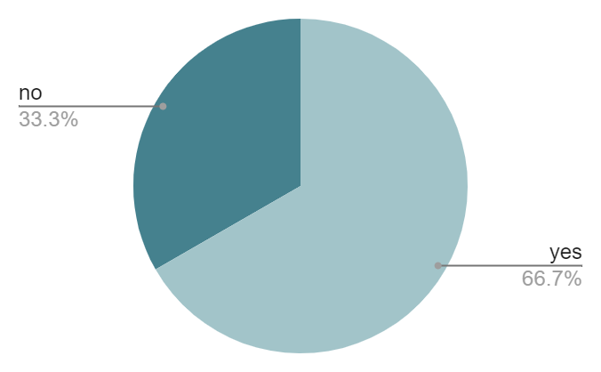
Figure1- My first question is do you wear glasses? Although this question doesn't directly answer my aims it still gives me a strong idea of the number of people around 17-18 years old who are prescribed glasses. For figure 1 the results highlight that the majority of pupils do wear glasses. The question gives an insight to decreasing strength of eye health at younger ages. This is relevant to my project as it helps answer my first aim of how eye health has changed within the last 10 years. Upon further secondary research I found that according to opticians who reported to daily mail. (Chalmers, V. (2019). Number of teens needing glasses has nearly doubled since 2012. [online] Mail Online. Available at: https://www.dailymail.co.uk/health/article-7351623/Number-teenagers-needing-glasses-nearly-doubled-2012-staring-screens.html). The article shows that Number of teenagers needing glasses has nearly doubled since 2012 'due to youngsters spending so many hours each day staring at screens'. Opticians said 35% of British 13 to 16 year olds needed glasses in 2018. They believe it is linked to the 26 hours per week teenagers spend on screens. The signs of eyes getting weak are not immediately clear, opticians warned. While a quarter of parents admit they do not take their children for a regular eye check.

Does anyone in your family wear glasses?
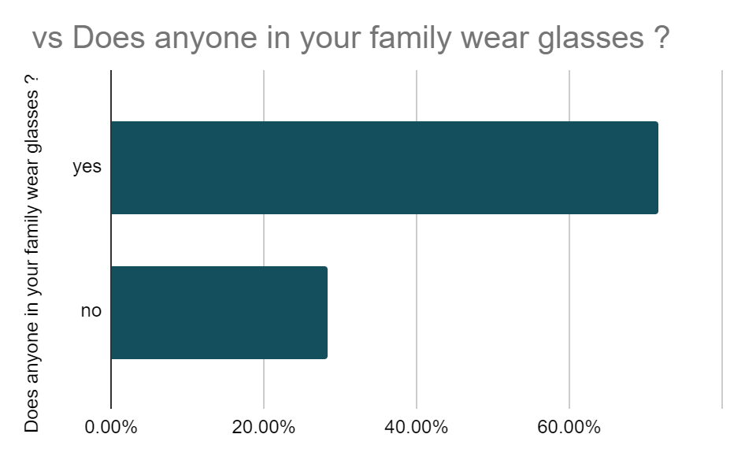

Figure 2- My second question was does anyone in your family wear glasses?. This question gives me an insight to whether there is a correlation between the number of people who wear glasses and if their family members wear glasses. This was done to show if the majority of eye conditions are hereditary or a result of lifestyle choices. The results are quite vague however upon analysing and comparing graphs it shows there is a stronger correlation in pupils who wear glasses and family members who also wear glasses. According to figure 2 the percentage of people with glasses was 33.3%(7 people) and the percentage of those who have family members who wear glasses was 71.6%(14 people). As there were approximately 20 responses, the difference in the number of people was 7. Although this question doesn't directly answer my aims, it is still beneficial in my research as it highlights the increasing relationship between young people who don't have ‘immediate’ family members who have glasses and young people themselves having glasses due mostly to their own choices.

To your knowledge does anyone in your family have Glaucoma?

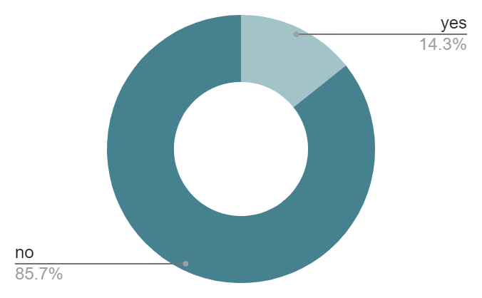

Figure 3- Shows that the majority/all pupils who answered the questionnaire dont have a history of glaucoma in their family or are unaware. Glaucoma can be self -inflicted as glaucoma can be inherited from diabetes and short/long sightedness however you're more likely to get glaucoma if a parent or sibling has glaucoma. Upon research I learnt that there are four major types of glaucoma, primary open-angle, closed- angle, congenital and secondary glaucoma. According to MedicinePlus (Medlineplus.gov. (2019). Glaucoma: MedlinePlus Medical Encyclopedia. [online] Available at: Medlineplus.gov. (2019). Glaucoma: MedlinePlus Medical Encyclopedia. [online] Available at: https://medlineplus.gov/ency/article/001620.htm..) I learnt that 2 of the 4 were self inflicted while 1 was hereditary and the cause of the other is unknown. Glaucoma is important to focus on as in parts of the world it is one of the most common reasons for blindness. In the UK 10% of people go blind from glaucoma. While reading an article on the National library of medicine. (Susanna, R., De Moraes, C.G., Cioffi, G.A. and Ritch, R. (2015). Why Do People (Still) Go Blind from Glaucoma? Translational Vision Science & Technology, [online] 4(2). doi:https://doi.org/10.1167/tvst.4.2.1.
) I was able to find that population-based studies suggest that over half of all glaucoma cases in the United States remain undiagnosed. In the Baltimore Eye Survey, 56% of patients with glaucoma were not diagnosed, and in Proyecto VER, 62% screened were unaware they had glaucoma. In order to obtain more data for my study it is vital to once again meet the aim ‘To explore whether eye conditions have become worse over the last 10 years due to lifestyle choices’. I feel as though this data provides vital information such as how glaucoma is mainly self-inflicted and the majority of people are unaware they have glaucoma or even a history of glaucoma in their family, which causes their eye condition to worsen which may end up resulting in severe damage such as blindness.

Do you have/do any of the following?

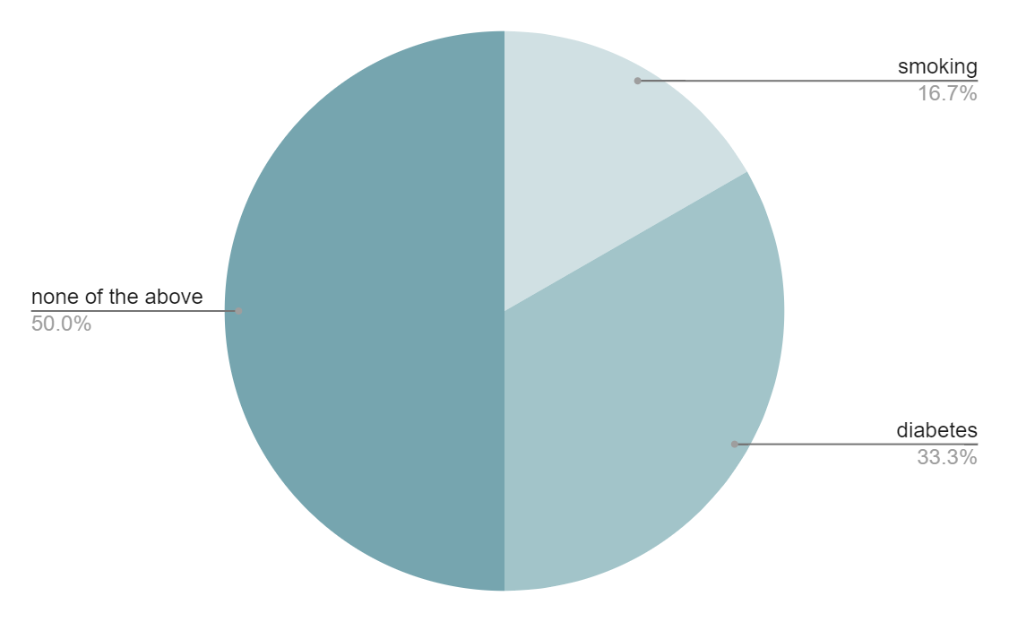

Figure 4- was to show if any of the pupils who answered the questionnaire do or have obesity, diabetes, smoking or none of them. This would allow me to identify if people who do/ have any of these and wear glasses then there may be a correlation between them. Although there were pupils which claimed they don’t do or have any of the following they still wear glasses. This question lacks validity as it requires people to answer honestly. I made sure that all responses were anonymous hoping to minimise the reliability of my questionnaire to be compromised. However people still may feel uncomfortable therefore putting answers they don't necessarily do. This question helped answer my aims highlighting the relationship between unhealthy lifestyle choices such as smoking, having developed excessively high blood sugar from their choices or having obesity. According to (dovuw (n.d.). What’s The Link Between Obesity And Eye Disease? [online] Oakbrook Optometry. Available at: https://www.drsnyder.org/2021/07/13/whats-the-link-between-obesity-and-eye-disease/#:~:text=Additionally%2C%20morbid%20obesity%20is%20associated )
[Accessed 22 Jan. 2023]. ‘Obesity is associated with higher inner eye pressure, which may increase one's risk of glaucoma and glaucomatous optic neuropathy, leading causes of vision loss and blindness’. Although no one who participated in my questionnaire had obesity, obesity in the Uk is a serious condition which is increasing in the population. The reason that none of the participants had obesity was due to obesity being most common in adults over the age of 45.

How likely are you to visit the opticians in the next 6-12 months ?
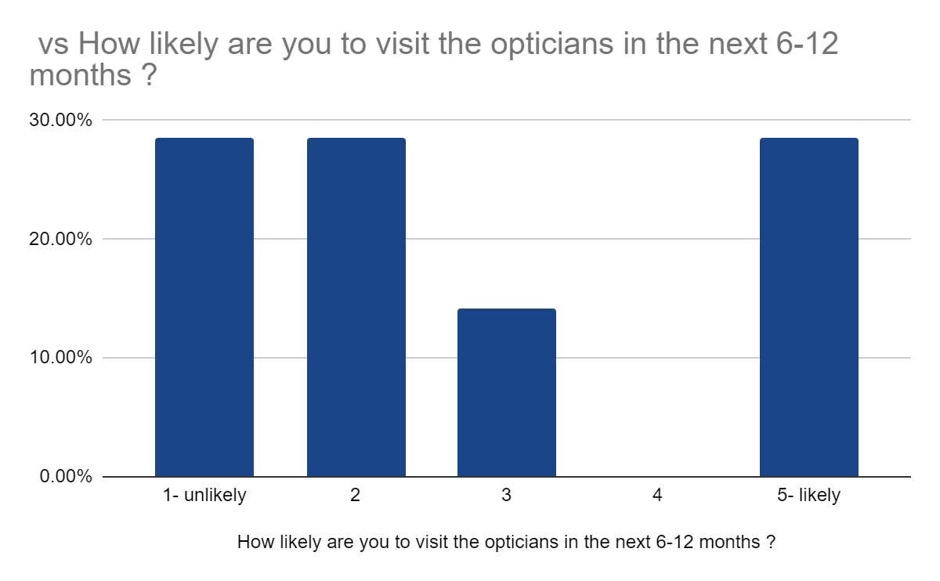
Figure 5- This question enabled me to assess the likelihood of people going to the optician regularly to check their eye health. Figure 5 represents that the majority of recipients are very unlikely to go to the opticians in the next 6-12 months. This is worrying as eye conditions can develop or worsen in a short amount of time. In total 57.2% said they are unlikely, 14.3% were in the middle, meaning that if they develop something concerning about their eyes for example have blurry vision or their prescription is causing severe headaches then they will make an effort to go to the opticians, 28.6% stated that they are likely to go for a check up. Regular eye check ups are crucial, ( Importance of getting eyes tested. (2016, August 16). Retrieved from nidirect website: https://www.nidirect.gov.uk/news/importance-getting-eyes-tested#:~:text=Regular%20eye%20examinations%20are%20important) This article stresses the significance of this by supporting their point with the evidence that more than 50% of sight loss is preventable, so getting your eyes tested can help prevent, or limit, the damage caused by certain eye conditions.

How many hours do you spend daily on your screen?

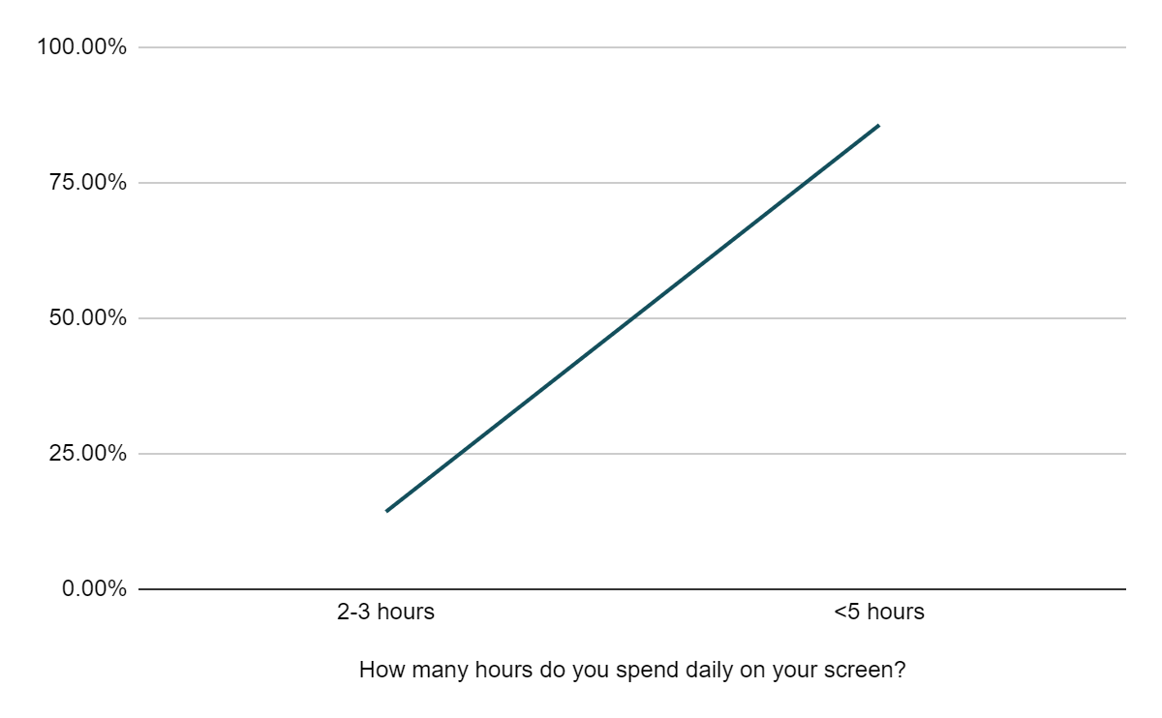

Figure 6 -In order to answer my second aim ‘To investigate whether advancements in technology have contributed to more eye conditions’, i asked pupils how long on average they spend on their phones. I provided options such as less than an hour, around 2-3 hours, around 4-5 hours and over 5 hours. 85.7% answered that they spend on average over 5 hours on their phone. The amount of time spent on screen is increasing which correlates to the increasing number of teenagers who require glasses. There are many proven facts that screens scientifically affect eyes. Upon research I found that ‘Phone screens, and other digital devices, generate blue light differently than natural sources. As a result, the blue light scatters more in the eye, creating more visual noise. The overstimulation leads to eye strain’. (calgaryfamilyeyedoctors.com. (2022). Are Phone Screens Bad for Your Eyes? | Calgary. [online] Available at: https://calgaryfamilyeyedoctors.com/are-phone-screens-bad-for-your-eyes/#:~:text=Those%20signals%20are%20what%20our). The constant exposure to the blue light being projected to the eyes could damage retinal cells and cause vision problems such as age related macular degeneration. I however didn't take into account other forms of screen such as Tvs, Laptops and Ipads. Although those devices have not been taken into account most people still answered that they spend over 5 hours a day on their screens.

Do you believe all eye conditions are hereditary?
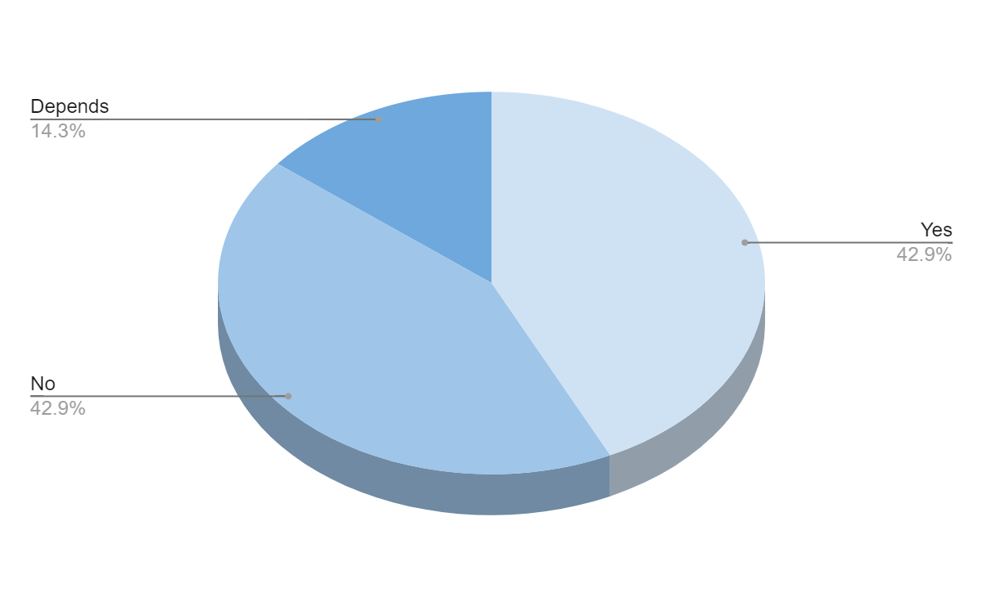

Figure 7- Despite this question giving quantitative research I was able to obtain answers which gave more of an understanding as I asked a question linking to this question. This graph gathers opinions from pupils aged 17-18 Figure 6 shows that there is an equal divide between people who think all eye conditions are hereditary and people who people believe otherwise, while there were 14.3% of pupils who believe there are other factors to consider. I asked a further question where, if selected ‘depends’ can you elaborate further, I had answers such as ‘poor eyesight runs in the family’ and ‘ a lot of people in my family wear glasses’. This answer favours the choice that eye conditions can be hereditary however poor eyesight is neither a dominant or recessive trait/ allele. Most articles claim that poor eyesight can be due to one or both of your parents having poor eyesight, however the majority state that eye health is much more complex than that and must take into account other factors such as environmental, health etc. Another answer which is useful in my research which a pupil gave was ‘ no one else has glasses in my family, but I spend a lot of time in front of my phone, Tv and computer’. This answer further emphasises the negative and harmful effects that technology has on one's eyes. Finally another very insightful response I received was ‘I believe some are hereditary, however people either develop or worsen the condition of their eyes through everyday activities’. This answer shows that this person has a wider understanding of this topic. The answer agrees with the preponderance of my research.

Analysis of information
Aim 1- Eye conditions & lifestyle choices.
Eye conditions
Throughout my research it was crucial that I had an understanding of general eye conditions before analysing which conditions are specific and correlate to lifestyle choices. ‘Eye health experts today marked National Eye Health Week (21 – 27 September) with a warning that unhealthy lifestyles are fuelling an alarming increase in avoidable sight loss as a new study’. This study provided an explanation of the research done by scientists who observed smoking, lousy exercise routines, and poor diet. I had to use a variety of publications because this aim was the most crucial and pertinent to addressing my research topic. Cleveland clinic produced a study to highlight these issues. Cleveland Clinic (2020). Common eye disorders & diseases that cause vision problems. [online] Cleveland Clinic. Available at: https://my.clevelandclinic.org/health/diseases/17130-eye-diseases.
This article is fairly reliable as it was last reviewed by a Cleveland Clinic medical professional on 01/14/2022. This page explores the meaning behind certain conditions while also including a few solutions to overcoming these. This page demonstrates that it is a reliable source because it includes a substantial amount of eye disorders that can be compared along with their causes. Several of the eye issues I frequently mention are introduced by Cleveland Clinic. They define a cataract as a clouding of the eye's lens and list the symptoms of cataracts, which include blurry vision, difficulty seeing at night, and sensitivity to bright lights. Glaucoma, another eye condition they mention, is brought on by an increase in the eye's usual fluid pressure. Eye pain, headaches, and inflamed eyes are glaucoma symptoms. However, to improve inaccuracies in my research it is imperative to consider both sides of the argument, some eye conditions such as colour blindness are not affected at all by any lifestyle choices. Another example could be lazy eye which is when one eye is weaker than the other.

Lifestyle choices
In addition to having an effect on your health, lifestyle decisions like smoking and consuming alcohol also have an effect on your eyes. In the short term, drinking too much alcohol might lead one's eyes to become drier and cause vision to become hazy. Long-term alcohol abuse might raise your chance of developing eye conditions like macular degeneration and cataracts. Red or bloodshot eyes are another adverse effect of consuming too much alcohol at once, as alcohol can cause the blood vessels in the eyes to expand, according to Louise Baillie S.A.C. Dip (Diet, Exercise & Fitness).Bloodshot eyes are brought on by enlarged blood vessels, but itching and discomfort can also occur.Alcohol can contribute to dehydration since it is a diuretic, which induces frequent urination. Additionally, one of the effects of alcohol is perspiration, which can further reduce fluid levels. Both of these factors contribute to dry eyes, which might worsen after drinking because there aren't enough tears to keep the eye lubricated. Long-term excessive alcohol use can cause toxic amblyopia, a condition that causes eyesight loss. Alcohol's toxins harm the optic nerve. Similarly, smoking can increase the risk of eye health problems. Smoking is also linked to cataracts and macular degeneration (Essilor, n.d). According to Science direct and their study of the effects of smoking and ocular diseases they claim that ‘Both cataract development and age-related macular degeneration, the leading causes of severe visual impairment and blindness, are directly accelerated by smoking’ Tobacco-alcohol amblyopia is a once-common but now-rare disease that is characterised by significant visual loss and is likely the result of toxic optic nerve damage. Tobacco smoking is the direct cause of this disease. The conjunctival mucosa is severely irritated by cigarette smoking, and nonsmokers' eyes are also affected as a result of passive smoking (secondhand smoking). Eye discomfort is the most typical symptom of passive smoking, followed by cough, nasal irritation, and headache. The conjunctival mucosa, like all other bodily mucosae, is extremely sensitive to chemicals and pollutants in the air. Cataracts are the leading cause of blindness and visual impairment worldwide, and several writers have found a strong correlation between cigarette use and an elevated risk of cataract formation. According to estimates, there are more than 15 million people who are estimated to be blind because of cataract. Having specific lifestyle choices gives a wider set of knowledge of the topic improving the accuracy and understanding of this knowledge. The research was published online on 4th december 1998. This is very old and advancements to technology have massively improved since 1998 meaning that the information they are providing isn't fully inclusive therefore diminishing the accuracy of the article.The article will still be useful as a quick read to familiarise myself with new terminology and also give a brief of the correlation between smoking and ocular diseases.
Interview with optometrist
In order to achieve my first aim I decided to hold an interview with an optometrist, as part of my primary research. I did this alongside my previous questionnaire. In the interview with the optometrist I was able to ask questions which were more specific and advanced to help answer my aims to a high standard. To ensure I had a deeper understanding of my research I made sure that all my questions were open providing qualitative answers. This was very beneficial in my research as it was able to answer my first aim while also providing information which will feed into my third aim, ‘ To analyse different solutions to eye conditions.’
My first question to the optometrist was ‘in your opinion, what are some of the major eye issues people are facing?’ I then made sure I made a note of the information she was contributing. After the session I compiled all the notes and organised the research. For the first question I was told that the major eye conditions were ‘Blurred vision which is when patients lose sharpness and definition from images. It's usually caused by tiredness. More and more patients complain of this condition, due to working with screens. It can be age related due to macular degeneration. In some cases it can be linked with diabetes and vision can fluctuate if blood sugar level is not controlled well. It needs to be checked immediately as it could lead to further complications because high blood sugar levels can damage the arteries behind the eye. Cataracts – it's clouding of the lens inside the eye and light rays can cause scattered vision. They develop with age mostly, however smoking and excess drinking or diabetes can also trigger it. Sometimes uses of certain steroids can also put one at a risk of developing cataracts.They are more common in women and can be hereditary. Conjunctivitis /Dry / itchy Eyes – Conjunctivitis is often an inflammation of the thin film that covers the eye under the eyelid. It’s usually caused by viral infection and is contagious. Dry and itchy eyes being one of the common reasons why people attend opticians. It can be caused due to several reasons such as hormonal changes or environmental factors and sometimes use of screen times and contact lenses. Glaucoma – is caused by an increased pressure which damages the optic nerve. It can harm the nerve fibres from the retina causing pain’ . The information I gathered was very useful for my research. The optometrist gave a substantial amount of relevant information. Upon analysing the responses I gathered that cataracts, blurred vision, conjunctivitis etc are some of the major eye conditions. After learning about this I made a conscious effort to include these eye conditions in the research project.
The second question I asked was ‘ In your opinion, what are some of the major causes of poor eye conditions?’. To which she responded by saying that half of all sight loss is avoidable yet the number of people living with sight loss in the UK will probably double in years to come especially as people age and can become blind or partially sighted by the age of 65. She further explained the findings by stating that these figures are shocking when you consider that having a regular sight to identify issues early, including leafy greens and fish in your diet, being more active and quitting smoking could significantly reduce your risk of sight loss, even if you have a genetic risk of eye disease. Irregular eye checks can cause eye conditions to deteriorate. Maintaining good eye health by eating healthy and exercising will reduce risk factors. Reducing screen times will enhance eye conditions. Firstly this question was asked to get direct answers. The optometrist's response was very insightful, from these answers I was able to further my knowledge to eventually be able to answer my first aim. Analysing the information I was able to conclude that the majority of common eye conditions are actually a result of lifestyle choices such as age, diet, smoking and spending excessive amounts of time on screens.

Aim 2: Advancements in technology & eye conditions
Eye strain can result from gazing at a screen for an extended period of time. When looking at a blue light on screen, people tend to blink less, and the movement of the screen makes it tougher for your eyes to focus. The position of the screen may put additional strain on the eyes. All of these problems add up to vision problems that can last a lifetime, especially in children. Possible effects of screen time can include
Eye tiredness which is when eyes can become fatigued from prolonged use, resulting in double vision, headaches, and concentration problems. Dry and irritated eyes might happen when you stare at a screen for an extended period of time and should be avoided because it might harm your eyes and impair your eyesight. Lastly, screens further cause a loss of flexibility within the eye, usually, this occurs as people age, but spending too much time in front of a screen might affect our capacity to swiftly adjust our eyes to see at all distances.

Advancements in eye care technology
The advancement of eye care technology in recent years has had a significant impact on people's lives all around the world. New technological advancements have made it possible for people who have endured eye difficulties for a long time to find relief. Health tech zone looks at some of the most exciting advancements in eye care technology that have been made recently. (www.healthtechzone.com. (n.d.). 6 Advancements in Eye Care Technology That You Need to Know About. [online] Available at: https://www.healthtechzone.com/topics/healthcare/articles/2022/12/05/454220-6-advancements-eye-care-technology-that-need-know.htm.
[Accessed 15 Mar. 2023].)Firstly the improvement in ‘phoropter is a device that helps doctors determine the power and type of lens needed to correct your vision. Advanced imaging is a type of eye care technology that helps detect and diagnose various eye diseases. Market Research Future states that the global robotics market will reach the $214.68 billion mark by 2030. That means with time, robotics is spreading out into various branches of industry and medical sciences. Robotic-assisted microsurgery is one such advancement.Retinal Gene Therapy is a new, noninvasive treatment for eye diseases. It uses gene therapy to treat age-related macular degeneration (AMD) and retinitis pigmentosa (RP).’

Aim 3: Different solutions to eye conditions
Interview with optometrist
The final question I asked the optometrists during our interview was ‘ What can people do more regularly to enhance their eye health?’ She gave a range of solutions such as, having a regular sight to identify issues early, including leafy greens and fish in your diet, being more active and quitting smoking could significantly reduce your risk of sight loss, even if you have a genetic risk of eye disease. Avoid smoking. Eating healthy, ensure a diet that incorporates vitamin B and E can protect against Cataracts and to cover up and be less exposed to UV light. During my questionnaire I asked pupils what they have implanted into their everyday routines to ensure their eye health is at a high standard. The responses from figure 7 show that some of the pupils who answered my questionnaire are implementing these concepts advised by professionals into their daily life. The purpose of my final question with the optometrist was to deepen my knowledge and also to help answer my last aim (‘ To analyse different solutions to eye conditions.’)

After conducting extensive research, I have discovered various practical and innovative ways to improve eye health through lifestyle changes. According to the Age-Related Eye Disease Study (AREDS), which was published in 2001 and updated in 2013, consuming specific nutrients such as zinc, copper, vitamin C, and vitamin E can decrease the risk of age-related decline in eye health by as much as 25 percent. Various studies have found that fish oil can be effective in treating dry eyes caused by prolonged computer use, while nuts are an excellent source of beneficial nutrients, including vitamin E, which can help protect against age-related eye damage. Citrus fruits are also a great source of vitamin C, which is beneficial for maintaining healthy eyes. Exposure to harmful UV radiation from the sun can lead to the development of cataracts, according to several studies, and the World Health Organization confirms that UV damage is the leading modifiable risk factor for cataract development. Wearing UV-blocking sunglasses or glasses is the best way to prevent this damage. While many prescription glasses now come with built-in UV filters, it's essential to ask your optometrist if your traditional pair of glasses has one. Finally, spending extended periods of time looking at computer screens can lead to tired and irritated eyes, blurry vision, headaches, and poor colour perception. One solution to this is to wear blue light-blocking glasses, which have specially designed lenses that filter or block blue light emitted by digital screens. The lenses are often marketed with lofty claims that they protect your eyes from eye strain and can help reduce potential damage to your retina from prolonged exposure to blue light. Practising the 20/20 rule also contributes to the protection of eyes from screens. Every 20 minutes, look at something 20 feet away for 20 seconds. “ By looking a further distance away, it forces the eyes to relax by breaking accommodation” stated by Dr. Bajic.”it also helps you to blink again at your body's normal rate”

Conclusion
Throughout my research I have come across arguments for and against eye diseases being influenced by people's lifestyle choices (aim 1). The important conditions I identified at the beginning of my research helped me to gain a thorough grasp of the basic optical disorders as a whole topic. This understanding helped me as the researcher as well as to explain it to my participants who voluntarily participated in my questionnaire. I was able to identify the essential elements of lifestyle decisions that more clearly emphasised the relationship between the two. What eye conditions and lifestyle decisions actually have an impact on a person's eyes was one of the first key concepts I looked into. I learned the following information: Specsavers offers key definitions for eye diseases and explains the key risk factors of each disease, as well as a summary video that explains the conditions, causes, symptoms, and tests.After learning these fundamental ideas, I was able to impart them to the participants, which was essential for my study since if any of the project's components were unclear to the participants, the results would not accurately reflect their responses. In addition to identifying key ideas that helped me comprehend the question clearly, I also wanted to learn what participants thought about the subject and learn whether they thought that eye conditions were primarily brought on by personal lifestyle choices, inherited traits, or developed as people aged, etc. The question was successfully incorporated into my questionnaire, and I went on to analyse the responses in great depth for my study findings. The conclusion made from the interview closely matched the secondary study I had independently undertaken. In order to ensure that I have accurate responses and supporting evidence for my objectives, I was able to rely on these final conclusions and incorporate these solutions into my results. By maintaining that professional intake throughout my project, I was able to increase the trustworthiness of my research through the conduct of this interview. It also enabled me to improve the efficacy of my research techniques. I got to the conclusion that the major eye problems that impact the majority of people are a result of making bad life decisions. However, some lifestyle decisions—like using a screen too much or wearing blue-light-blocking glasses—help people live healthier lives.

For my second aim I wanted to find out about the advancements in technology in terms of eye health technology. In order to do this I decided that collating secondary research was the most suitable way to attain information for my second aim. I used the study of advancements in eye care technology by Medical device news magazine.( Inc, M.D.N.M., a division of PTM Healthcare Marketing (2022). Recent Advances In Eyecare Technology - Medical Device News Magazine. [online] infomeddnews.com. Available at: https://infomeddnews.com/recent-advances-in-eyecare-technology/.
[Accessed 15 Mar. 2023].) As mentioned in my analysis of information there have been profound advancements in technology for eye care, from advanced phoropter to nanotechnology, the article mentions mobile eye care technology, wearable technology, robotic surgery and artificial retinas tye article focused on recent advancements to eye care which is more appropriate and relevant for my research project. The conclusion made from my analysis of information for aim 2 was that technology has a real negative impact on the condition of eyes. My questionnaire further helps explore this topic in terms of teenagers living in the uk.

For my last aim the conclusion drawn was that there are many simple and extricate solutions for eye conditions. In conclusion, the analysis of different solutions to eye conditions has revealed numerous advancements in eye care technology and treatments. The study of eye conditions and their treatment options is an ongoing and dynamic field, with new developments and advancements emerging constantly. The importance of regular eye exams and early detection of eye conditions cannot be overstated. With advancements in technology and increased awareness, there is hope for a future where eye conditions can be easily detected and treated, improving the quality of life for millions of people around the world

Self evaluation

Planning and Organisation

Choosing a topic for my individual project proved to be difficult especially when choosing an appropriate title. This was as I wanted to investigate something I was passionate about but due to it being such a broad topic, I had to figure out how to narrow the investigation down. This took longer than anticipated but I did end up selecting a title which was focused on eye health and medical research and I aimed to concentrate on issues around public opinion and awareness on lifestyle choices and looking at solutions. In my opinion, my planning for this individual project was well managed and organised. This can be highlighted by the way I prepared my structured interview questions a week before I interviewed my participant, emphasising how prepared I was.
Concerning the content of my questionnaires, if I were to improve them, I would have more of a semi structured layout. This would allow me to have gained more of a deeper understanding of the respondents view and why they chose the answers they did. I would aim to have more open questions in future to gain a deeper understanding of the way my participants thought and what were the factors that influenced them in answering the way they did. Furthermore, I would have also liked to interview another optician and also an increased number of people who answered my questionnaire.
However in terms of my interview, the benefit derived from the interview was that I had more scope to ask open questions since the respondent did not have to write up their answer and was able to pick up on non-verbal clues which would indicate what is relevant to the participants and how they are responding to different questions.As a result on the open questions I was able to gain full in depth answers from my participants. In terms of my direction through the questionnaire it was fairly structured as I was leading the respondent in my own way. With this there is a high possibility that I may have missed out on so many important points that the respondents could have provided me with, this can introduce bias, which will affect the reliability of responses. Therefore in order to improve this next time I should allow for more flexibility with the direction of the questionnaire whilst still attaining the answers I need. Also as I didn't ask many questions therefore another improvement is to ask the participants so that they are able to formulate and get across the opinion better.
Before starting the project I ensured that there was a minimum of 10 relevant articles in my bibliography to start off my research, throughout my research I added approximately 17 articles to increase relevance and detail.

Critical thinking and problem solving

Concerning my need to create graphs from data I found it was very difficult to establish complex data displays. If I were to improve this in the future, I would create a variation of questions that would allow me to expand on complex analysis and displays by just using quantitative data on certain questions.

When typing up the responses to my interview with the optician, I used skills such as critical thinking and problem solving to choose appropriate sources which reinforced their views and thoughts and even opposed my argument. For example, when talking about my interview with the optical professional, In order to display the overall difference in opinion on the issue regardless of the work profession I mentioned in my conclusion that their views contradicted each other. This highlighted my depth in analyses. However, If I were to improve this, I would comment on specific sources and opinions which contradicted their opinion instead of just stating the differences in responses between them. This would be done by comparing their words side by side with articles analysing why a difference may occur.
In addition, during the analysis of my questionnaire I had to interpret my data, find explanations and connect the questions to understand how people's opinions on the issue arose and what their opinions are. This was fairly difficult as I think my participants struggled on deciding and replaying their view due to the opposing argument that lifestyle choices do have impact but other factors may be playing a bigger role in the declining eye health.
Digital literacy skills

Graphs and charts are useful visual aids because they make information accessible and quick to understand. When data is displayed as a graph rather than a table, it is easier to understand since the graph can show a trend or comparison.The graphs were made using google sheets by copying my results from the questionnaire into tables and producing graphs. My understanding of digital literacy has significantly increased as a result of my study project. More specifically, I learned how to use unfamiliar tools when making graphs to visually depict the results from my questionnaire. My study required a significant amount of data, therefore I frequently had to use my digital literacy skills. I had to make sure that my data was displayed in the proper forms as well. To do this, I had to consider each question's nature and choose if a pie chart or a bar graph would be more appropriate. I was able to correctly store my data in the proper formats by removing the inappropriate selections. Throughout the course of my assignment, I also had to judge the reliability of the data from secondary sources. It was essential that I based my research solely on reliable facts, illustrations, and proof. I think that during my research, I was able to find dependable sources, ensuring that the information in my project was correct and trustworthy.

Literacy skills
I am certain that my literacy abilities will remain of a high quality throughout my study assignment. I worked very hard to make sure that my writing was correct and comprehensive. To enhance my reading abilities, I would pay attention to avoiding spelling and grammar mistakes. I needed to confidently research material and illustrate important ideas in my project. I wrote specifically to provide information in a clear and understandable way. Nonetheless, I believe that some of my questionnaire's questions should have been worded differently. There may have been a perception that certain questions were too specific while others were too ambiguous. I would work to make all of my writing more understandable and clear in order to strengthen my literacy skills. In the future, I intend to improve my Harvard referencing through my research.

Numeracy skills
I have seen a considerable development in my numeracy skills throughout this project, similar to how my literacy skills have improved. I gained the capacity to create procedures for accurately and reliably displaying and analysing the numerical data. This required developing suitable graphs based on the data I gathered and selecting the graph that would most effectively and precisely show the numerical data. Also, I was able to evaluate my data well, compare my results intelligently, and spot any trends or outliers. As a result, I was better able to comprehend the data and derive insightful conclusions from it.

Bibliography

No. | Source | Reliability
1. | https://global.essilor.com/uk/blog/your-life-and-eyes/lifestyle-impacts-on-eyesight#:~:text=Alcohol%20and%20smoking&text=Too%20much%20alcohol%20can%20result,risk%20of%20eye%20health%20problems. | This article is not very reliable as it fails to include a published date or publisher. However it does provide very relevant information about specific common lifestyle choices which impact eye health.
2. | https://www.specsavers.co.uk/eye-health/eye-conditions | This website is reliable as it is written by specsavers which is a trustworthy professional company dedicated to eye health. The relevance of this page is useful as it highlights common eye conditions while providing further information about them. It also provided information about how these problems arise.
3. | https://my.clevelandclinic.org/health/diseases/17130-eye-diseases | This article is fairly reliable as it was last reviewed by a Cleveland Clinic medical professional on 01/14/2022. This page explores the meaning behind certain conditions while also including a few solutions to overcoming these. This page shows that it is a suitable source as it has a substantial amount of eye conditions to compare with each other and their causes.
4. | https://www.visionmatters.org.uk/news/news/post/93-poor-lifestyle-increases-risk-of-sight-loss-regardless-of-genetic-predisposition | This article is not that reliable as it is outdated. It was published 21 September 2015. However this page gives relevant studies they conducted with verified opticians and scientists.
5. | https://www.raconteur.net/healthcare/eye-health/lifestyle-factors-eye-health/ | This article is very relevant for my project. It provides information which gives a unique and different perspective of eye conditions. The article is fairly recent as it was published on 30th september 2019, so information given is not completely out of date. However as eye health is deteriorating at an increasing rate than statistical evidence may differ significantly for 2022/2023.
6. | https://www.ncbi.nlm.nih.gov/pmc/articles/PMC2157550/ | This website has a list of all the references they used. The study was published in 2008 making the majority of the information out of date, however it gives a good introduction and explanation into how lifestyle choices scientifically affect the eye.
7. | The Association Between Cigarette Smoking and Ocular Diseases - ScienceDirect | This page evaluates the effects of smoking and ocular diseases. Having specific lifestyle choices gives a wider set of knowledge of the topic improving the accuracy and understanding of this knowledge. The research was published online on 4th december 1998. This is very old and advancements to technology have massively improved since 1998 meaning that the information they are providing isn't fully inclusive therefore diminishing the accuracy of the article.The article will still be useful as a quick read to familiarise myself with new terminology and also give a brief of the correlation between smoking and ocular diseases.
8. | https://www.aafp.org/pubs/afp/issues/1999/0701/p99.html | The article was written by a medical doctor and a professor of family and community medicine, both of whom have relevant qualifications and affiliations. This suggests that the information presented is likely to be credible. The article was published in a reputable medical journal called American Family Physician, which is a peer-reviewed publication. This suggests that the article underwent rigorous review by experts in the field before being published. The article was published in 1999, which may be considered outdated in the rapidly evolving field of medicine. However, the article provides foundational information about the treatment and management of hypertension, which has not changed significantly in the intervening years. References: The article provides a list of references at the end, which allows readers to verify the information presented and assess the credibility of the sources increasing its reliability. The relevance of this article to my research is that it considers vision loss in elderly people meaning that deteriorating eye health is not necessarily a consequence of lifestyle choices.
9. | https://infomeddnews.com/recent-advances-in-eyecare-technology/ | The website infomeddnews.com appears to be a news and information website related to the medical and healthcare industry, including advancements in technology. The specific article referenced, "Recent Advances in Eye Care Technology," does not provide an author or publishing date, which can raise concerns about the reliability of the information presented. However, the information presented in the article appears to be supported by credible sources, including academic journals and reports from well-known healthcare organisations. The article also includes quotes from healthcare professionals and industry experts, which adds credibility to the information presented
10. | https://lighthouseguild.org/save-your-vision-healthy-lifestyle-choices-that-help-avoid-eye-diseases/ | The author of the article is not listed on the webpage, which makes it difficult to assess their qualifications and expertise. However, the article does provide a source for the information presented, which is the American Academy of Ophthalmology (AAO), a reputable professional organisation for eye care specialists.The article was published in 2020, which suggests that the information presented is current and relevant.The article does provide a source for the information presented, which is the AAO. This suggests that the information is based on evidence-based guidelines and recommendations.the Lighthouse Guild website and the specific article linked to appear to be a reliable source of information on healthy lifestyle choices that help avoid eye diseases.
11. | (https://www.drsnyder.org/2021/07/13/whats-the-link-between-obesity-and-eye-disease/#:~:text=Additionally%2C%20morbid%20obesity%20is%20associated,of%20vision%20loss%20and%20blindness.) | The author of the article, Dr. Snyder, is listed on the webpage, and his qualifications are provided. Dr. Snyder is an optometrist and a member of the American Optometric Association, which suggests that he has expertise in the field of eye healthThe article provides references to support the information presented, which helps to establish the credibility of the information. The article was published in July 2021, which suggests that the information presented is current and relevant. This is relevant to my project as it focuses on the effects of obesity which is a lifestyle choice and eye health. Therefore this article is more than appropriate for my research.
12. | (Number of teenagers needing glasses has nearly doubled since 2012 'due to staring at screens' | Daily Mail Online | The Daily Mail is a British tabloid newspaper that is known for sensationalist headlines and often publishes articles that are not supported by scientific evidence.The article is not published in a scientific or medical journal and is instead published on a news website. The article does not provide references to support the claims made in the headline and the article. Therefore, it is unclear where the information comes from and whether it is based on reliable evidence.The language used in the article is sensationalist and lacks the precision and objectivity of scientific writing. This suggests that the article may be more interested in generating clicks and attention rather than providing accurate and reliable information.However this website does provide some simple easy statistics to include throughout the research.
13. | (https://medlineplus.gov/ency/article/001620.htm) | The website MedlinePlus is a reliable source of health information provided by the U.S. National Library of Medicine and the National Institutes of Health.The authors of the articles on MedlinePlus are health professionals, including doctors and nurses, who have expertise in the topics they are writing about. The articles are reviewed and updated regularly to ensure that the information is accurate and up-to-date.References: MedlinePlus articles provide references to support the information presented. This allows readers to verify the information and to explore additional sources of information. This article is very useful for me as its solely based on Glaucoma which is a condition I referenced consistently. This article provides me with the basic scientific perspective on this ocular disease.
14. | (https://www.ncbi.nlm.nih.gov/pmc/articles/PMC4354096/) | The article has undergone a thorough evaluation by independent experts in the field. The article includes detailed information about the research methodology, data analysis, and results, which indicates a high level of scientific rigor.Furthermore, the article includes references to other peer-reviewed research studies, which supports the reliability of the information presented. The authors are also affiliated with respected institutions in the United States, which adds to their credibility. Similarly to link 12 it is a research on glaucoma and why it still causes people to go blind. It provides necessary statistics and scientific opinions as well as many factors to why glaucoma is so harmful.
15. | https://calgaryfamilyeyedoctors.com/are-phone-screens-bad-for-your-eyes/#:~:text=Those%20signals%20are%20what%20our,overstimulation%20leads%20to%20eye%20strain. | The website provides information about eye health and eye conditions, as well as tips for maintaining good eye health. This article discusses the potential negative effects of phone screens on eye health. This is very helpful to my research as screens have a huge impact on eye health and is a topic which is compulsory for me to analyse and discuss in detail in my project. the article does not provide any references or sources to support the information presented. This lack of sources makes it difficult to verify the accuracy of the information and assess the reliability of the website as a source of information on eye health.
16. | https://www.nidirect.gov.uk/news/importance-getting-eyes-tested#:~:text=Regular%20eye%20examinations%20are%20important,be%20a%20risk%20for%20falls | This website appears to be a reliable source of information. It is published by the government of Northern Ireland, which suggests that the information provided is likely to be accurate and up-to-date. The website also provides information about the qualifications and credentials of the author, further increasing its reliability.n addition, the information provided on the website is supported by other reputable sources, such as the National Health Service (NHS) and the Royal National Institute of Blind People (RNIB), which adds to its credibility.Overall, the website appears to be a trustworthy source of information on the importance of regular eye examinations, and its reliability is supported by its authoritative source and the use of reputable sources to support the information provided. This website will help to achieve maximum efficiency as it has general statistics and figures on eye health.
17. | https://www.healthtechzone.com/topics/healthcare/articles/2022/12/05/454220-6-advancements-eye-care-technology-that-need-know.htm | HealthTechZone" appears to be a technology news website that covers a range of topics related to healthcare technology. While the website does not seem to be a scholarly or scientific source, it appears to be reputable and reliable in terms of reporting on advancements in eye care technology. However, it is important to note that the information presented on this website may be biassed towards promoting the latest technologies or products. This article highlights the advancements made in eye care technology, this helps to achieve and answer my third aim.
18. | https://www.medicalnewstoday.com/articles/321226#_noHeaderPrefixedContent | Medical News Today" is generally a reliable source of health information, as it is a well-established online publication that provides a wide range of health-related articles. The website has a team of qualified medical writers and editors who ensure that the content is accurate, up-to-date, and based on current scientific research.The article in question discusses the link between blue light exposure and eye health. The article provides a balanced discussion of the topic, citing both the potential risks and benefits of blue light exposure. It also includes quotes from several experts in the field, which adds credibility to the article. However, it is important to note that the article is not a primary source of information, as it does not reference any specific studies or research papers.

Appendix

Questionnaire

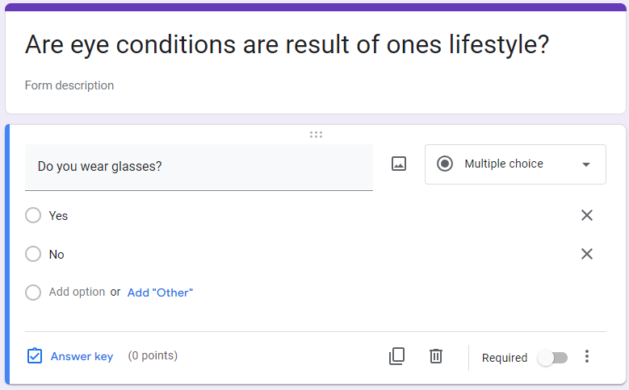
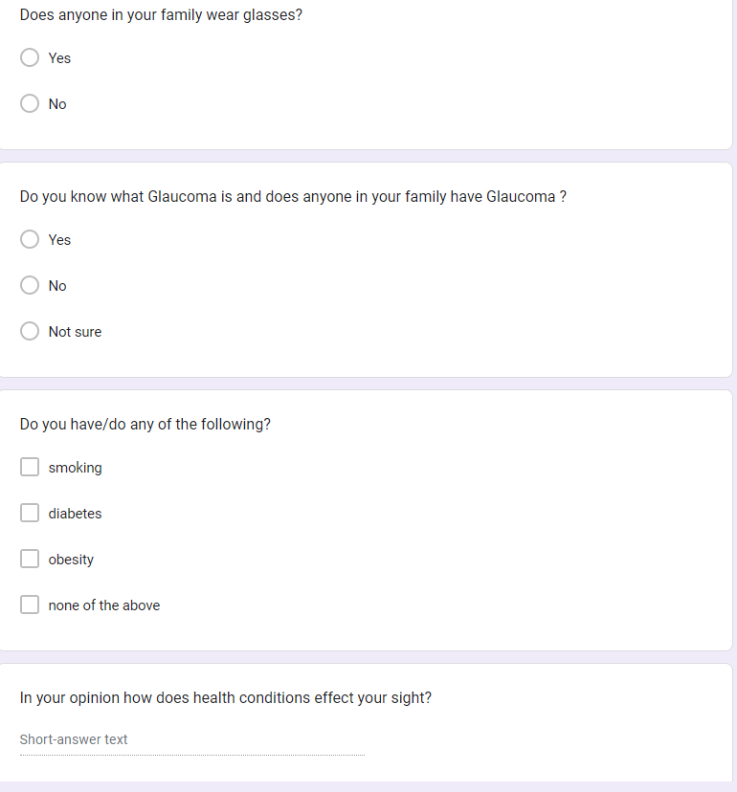
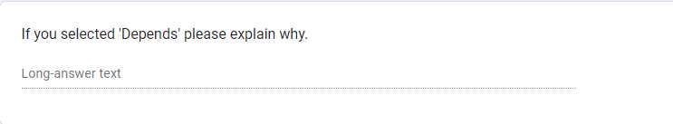
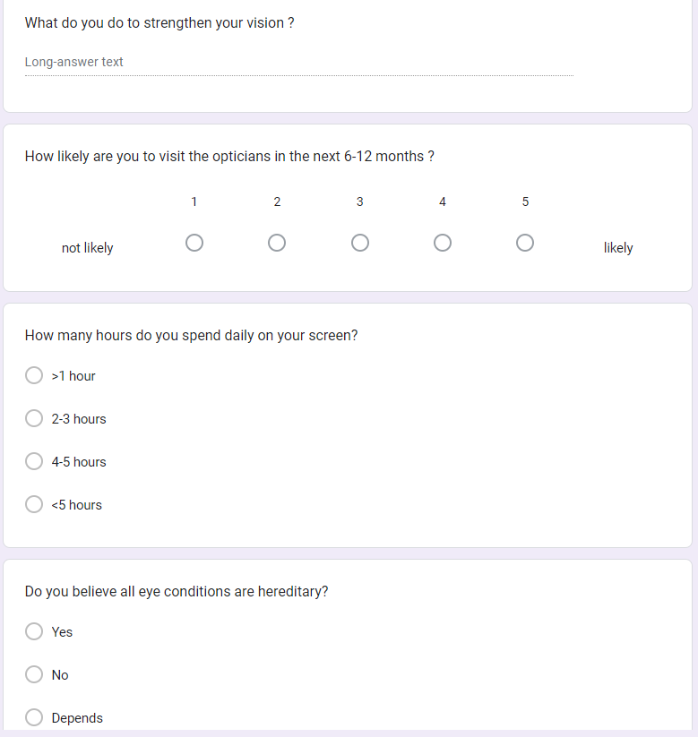

Interview questions


