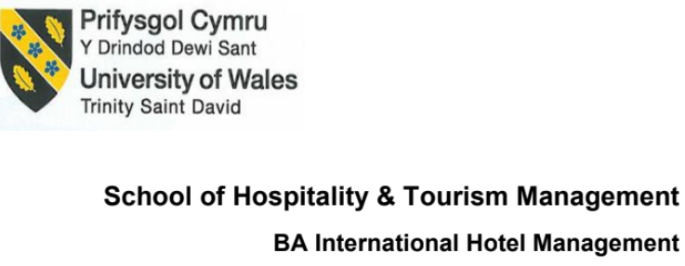
BMIH5003
Foreign Languages and Cultural Awareness

Student Name: Jaber Hossin Ruman
Lecturer: Rodrigo F. Aguilera
Student ID: 1812666
Contents
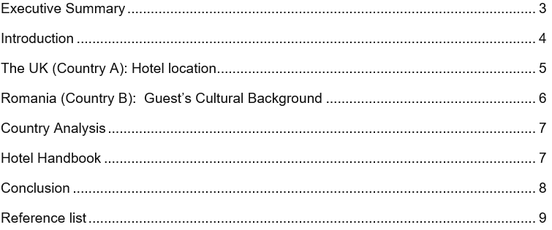

Executive Summary
This study makes an effort to contrast the two countries' cultural approaches to customer service in the hospitality industry. During the Six Dimensions of Culture phase at Hofstede, the focus of this article is on how to best serve guests from a wide range of nationalities. Using Hofstede's Six Dimensions of Culture, this paper aims to help hotels better serve their international clientele by accounting for their customers' backgrounds and preferences. For the purposes of this study, the Hofestede framework was selected because of its usefulness in conducting in-depth analyses of local culture. Overall, the study confirmed that there are significant cultural differences between the British and the Romanians. For example, the power distance between the two countries is much greater in Romania than in the United Kingdom.

Introduction
Culture, which is the most complex form, is also an umbrella term that encompasses several key elements, such as societal beliefs, norms found in human societies, arts, laws, abilities, customs, and habits of the individuals in these groups that originated from a particular religion or geographic location (Curtis et al., 2019). The personnel of the hotel is required to accommodate a wide variety of clients hailing from a variety of cultural traditions in order to guarantee the happiness of the customers. As a consequence of this, the Hofstede model, which was developed by Dutch social psychologist Geert Hofstede, makes it easier to recognise various cultural distinctions in order to better comprehend guests and deliver superior care to them. The Hofstede cultural dimension model is the primary topic of this research as it relates to the investigation of the cultural differences that exist between the United Kingdom and Romania in terms of the quality of hotel service. This paper also makes an effort to represent a table in which hotel guests' dos and don'ts are included as a notebook in an effort to meet the requirements set out by the visitors.

The UK (Country A): Hotel location
Throughout Hofstede's six dimensions model, all persons can easily get a cultural understanding of the people of the UK’s social behaviour, belief system, norms, and other practices to serve the guests, as hoteliers. The phase of understanding the cultures is significant that has a direct link-up with the lucrative business platform causing only the satisfied guests to bring lucrative profit within the hotel (Dimitrov, 2018). In the phase of the first dimension of Hofstede's six dimensions model in the United Kingdom, the power distance is low which is equal to 35. This score indicates that people of the UK are habituated to the phase of equality and fairness in case of employee position or anything’s rank. Overall, they treated all people with the phase of equality. The second dimension shows the high individual that is driven to emphasis personal and individual purposes and necessities more than the shared goal (Wenxin and Yue, 2022). That indicates that, within the hotel, UK people as hotel guests demand individualised responsiveness at hotels. People of the United Kingdom son do not bother with any gender preference, they treat people in an equal way whatever their gender.
In the phase of the fourth dimension, the United Kingdom has the willingness to embrace uncertainty and change which indicate that hotel guests or customers are more open to attempting new kinds of stuff if they can ensure all the required demand to meet their requirement. In the case of a goal-oriented program, they are in the middle portion like both the guests and hotelier are given importance more in the phase of short-term oriented goal to meet the long-term goal in the future (Dimitrov, 2018). The last dimension is about the phase of indulgence that indicated the intention to deal with enjoyment and pleasure. In the case of the United Kingdom, hotel guests prefer to conduct quality time and leisure activities with enjoyable and pleasurable moments. Overall, hotel guests from UK demand mutual respect, fair treatment, and the moment that provide them with prioritising feeling and enjoyment moment.

Romania (Country B): Guest’s Cultural Background
Romania is a nation with hierarchical societal impacts and respect for all types of individuals (Hofstede Insights, 2023). Use Hofstede's cultural aspects technique to gain a deeper understanding of Romanian culture. On the scale of Hofstede's dimension model, Romanians are a power-distance nation due to their inclination to secure and preserve their position in the hierarchy. Due to this, customers desire more pampering rather than reciprocity (Mihai and Novo-Corti, 2020). People are more satisfied when hotel staff goes above and beyond to satisfy all of their needs. On the other side, they have a low level of individualism, which indicates that they believe in shared benefits rather than individualism. In order to accommodate Romanian visitors, hotel employees must emphasise their strong sense of community culture (Lukacs, Lovin and Stefan, 2020). According to traditional gender norms and beliefs, they prefer a manly working environment, which is the third reality about masculinity. In hotels in Romania, gender roles are disregarded by customers.
In terms of avoiding uncertainty, they have a high score since they prefer stable environments with clear demands and constant communication. In order to achieve this, the hotel staff must maintain regular communication with guests. During the short-term goal-oriented phase of a goal-oriented program, both visitors and hoteliers are given extra weight to attain the long-term goal in the future (Mihai and Novo-Corti, 2020). The Romanian people have a low rate of indulgence in their traditions and are focused on the future because they are concerned with forward-thinking. As a whole, Romanian hotel visitors prioritize conventional services.

Country Analysis
In the phase of comparing two nations, the United Kingdom, which serves as the home country (A) for hotel service, and Romania, which serves as the host country (B), there are some significant differences (Mihai and Novo-Corti, 2020). In the same way that there is a low power distance in the UK, those living in Romania have a high power distance, which means that they have a higher expectation of being pampered. The cultural differences between Romania and the United Kingdom affect the quality of the personalised service and social interaction that are provided to guests, just as they do in other sectors of the economy.

Hotel Handbook
The following is a list of things that have been developed based on Hofstede's dimension model of culture in preparation for the phase of dealing with consumers from the United Kingdom and Romania.
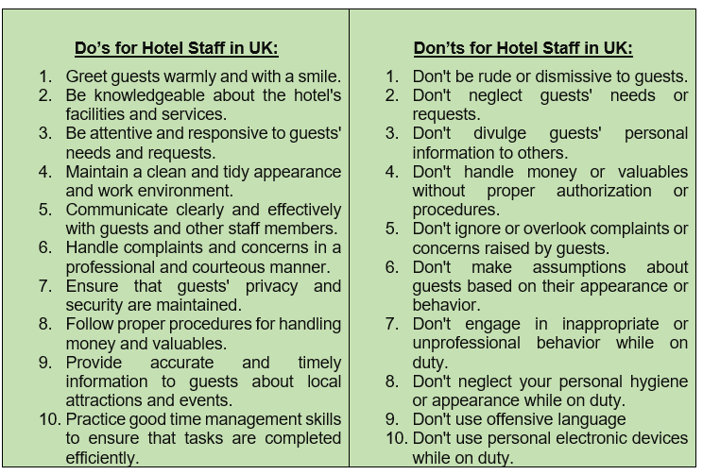
Table 1: Do’s and Don’t’s of Hotel Staff; Source: Set up Hotel (2023)

Conclusion
In conclusion, the phase of cross-cultural knowledge in the Hofstede model serves as an important tool for hoteliers to understand their visitors and treat them correctly by assessing cultural differences in light of the guiding principle of guest pleasure. Overall, the research study employed the Hofestede cultural model in an effort to unearth differences between the two countries, on the grounds that no enterprise can succeed without first gaining a firm grasp on its clientele. The study also includes advice for hotel workers on how to best accommodate customers of different ethnic backgrounds with the list of do's and don'ts.

Reference list
Curtis, E., Jones, R., Tipene-Leach, D., Paine, S.J. and Reid, P., (2019). Why cultural safety rather than cultural competency is required to achieve health equity. International journal for equity in health, 18(1), pp.1-17.
Dimitrov, K., (2018). Geert Hofstede et al's set of national cultural dimensions-popularity and criticisms. Journal on Education, 4(1), pp.73-94.
Lukacs, E., Lovin, D. and Stefan, R., (2020). Empirical Study Regarding Long-Term Versus Short-Term Orientation in Romania. In Proceedings of the International Management Conference, Vol. 14, No. 1, pp. 870-880.
Mihai, I. and Novo-Corti, M.I., (2020). Cultural distance and migration patterns in the EU: The Romanian Case.
Set up Hotel (2023) Home, Do's and Dont's. Available at: https://setupmyhotel.com/train-my-hotel-staff/front-office-training/852-front-office-do-s-and-dont-s.html (Accessed: February 23, 2023).
Hofstede Insights. (2023). Country comparison: Romania, the UK. Available at: https://www.hofstede-insights.com/country-comparison/romania,the-uk/ (Accessed: February 23, 2023).
Wenxin, Z. and Yue, W., (2022). An Analysis on Sino-UK Cultural Differences in Education from the Perspective of Hofstede’s Cultural Dimensions Theory (A Case Study of Are Our Kids Tough Enough?). Journal on Education, 4(2), pp.373-384.

