Student Name | Aneesah Zubair
Student Number | 1809520
Module | Understanding and engaging in the customer experience.
Module Code | BMSW 5103
Lecture Name | Vajira Balasuriya
Assignment title | Customer Relationship Management and Ethical Practices.
Submission Date | 27/11/2020

- Contents…………………………………………………………………………………………………………………………………....1
2.0 Introduction /Ethical marketing ,customer experience, ………………………………………………………………………………………………………………………………………………………….2
3.0 Figure 1) Airline case study, Figure2 1)……………………………………………………………………………………………………………………………………………….3/4/5.
6.0 Definition of ethics/Definition of sustainability ..........................................................................6
7. Ethics and sustainability ………………………………………………………………………………………………………………………………………………………7
8. Examples of how ethics can be applied ………………………………………………………………………………………………………..………………………………………..8/9
10.0 Conclusion upon sustainability and ethics CRM systems………………………………………………………………………………………………………………………………………10/11
12.0 Reference……………………………………………………………………………………………………………………………….12

(Introduction)
The objective of this report will consist upon Examining Airlines, this report will be a brief investigation in regards of providing feedback to the principle researchers at the research and analysis wing, which is a voluntary organisation currently gathering information in ethical trading and also to build sustainable resources of the airline service providers. Therefore, this report will be researching upon the potential solutions that can have either a positive or negative impact toward the consumers in regards of customer service provided by the airlines. This report will be split into sections which will be A),B)and C) regarding upon gathered investigation/ information based upon easy jet air lines and also upon emirates air lines, Ryanair lines Moreover, this report will be looking upon the Ethical and sustainability of each organisation.

(Task 1. A)
Ethical marketing
Ethical marketing is a process which is used by companies it allows the ability to market the facility’s and services that organisations act upon ethical marketing main aspects are to set principles and sympathise with emotions this tactic can be beneficial in regards of decision making. Ethical marketing can also benefit employees in regards of assisting them to increase retention. The principles of ethical marketing plan guides to develop an updated socially responsible environment ( Ferrell, 2013). Moving forward ethical marketing allows the ability to develop a trustworthy approach whilst promoting their business to the customer’s ethical marketing aim is to focus upon both marketing practices in regards of an organisation and also the social and environmental causes at once.

(Customer experience)
In this segment of the report the focus will be based upon Customer experience which is a very important element in regards of being either a beneficial or a negative impact towards organisations. As it allows management to create a digital marketing analysis judged based upon the perception of the customer’s/ consumers experiences. customer experience (CX) has taken on a much broader meaning than it previously did. It Initially allows the ability to create a relegated and post-purchase engagements that may be viewed as a cost of doing business, CX is now regularly interpreted to encompass the organisations/ consumer journey. It has elaborated from the Analysis of customer support to the forefront. The world of customer experience has progressed from a collection of multiple disciplines that vary by departments and companies to a coordinated effort with resources and authority. It has been stated by the following Meyer, 2007 Customer experience internally recreates a broader subjective response in regard of understanding consumer’s needs. Down below is a figure demonstrating and based upon improving customer experience. This figure shows clear determination in regards of pleasing and going the extra mile for consumers. Hendrickson, B.M., 2016.
Figure 1) 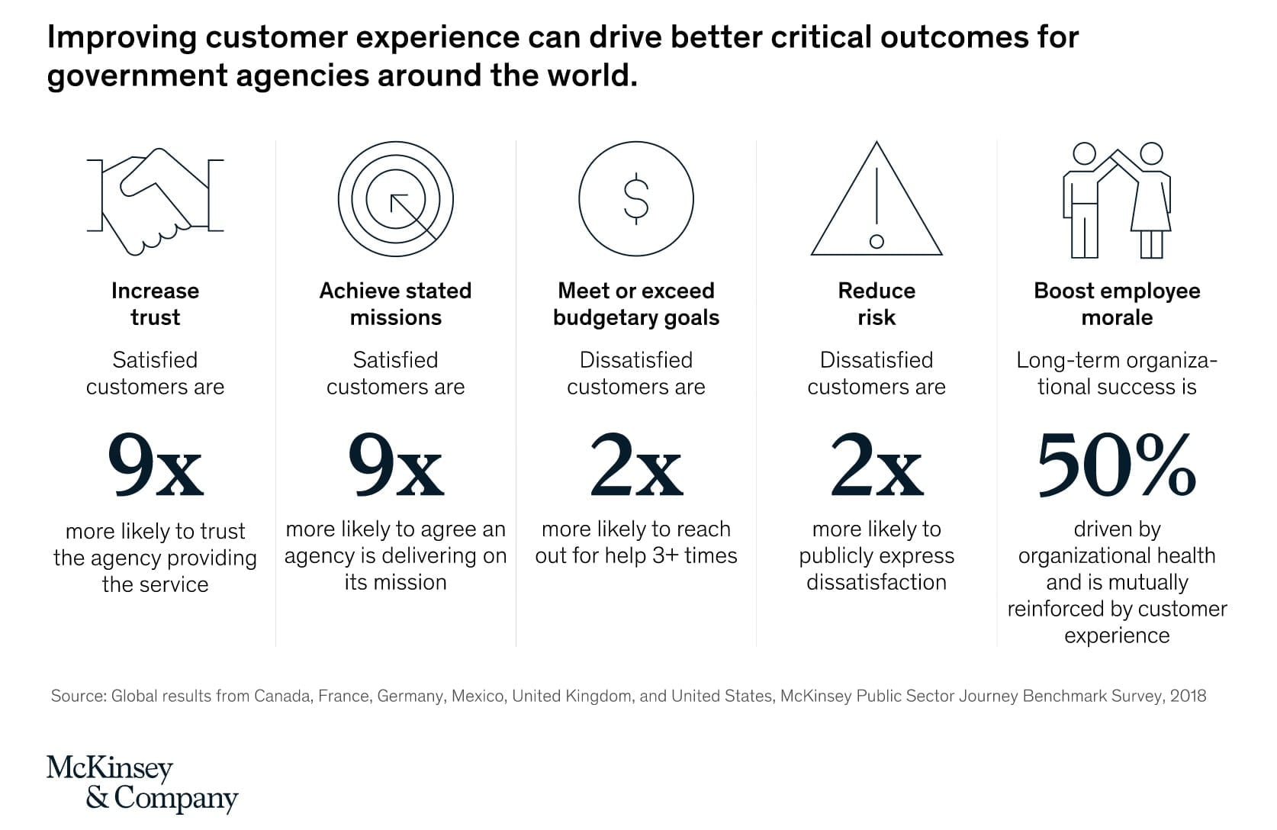

(Airline case study)
Moving forward, the main focus of this report will be based upon airlines and how they assist customer needs on a satisfactory level in regards of Ethical and sustainability before, during and after the customer’s experiences whilst traveling with the airlines. After critically researching regarding the Airline easy jet, the main advanced product that has been found of the organisations is that the company has invested in a digital marketing product which is a mobile app, which is called the easyJet mobile app. The founder of the digital marketing director peter Duffy, has stated that not only that the app is completely free to use/download, it also offers easyJet to profit in regards of simplifying the whole flight booking experience process that can be very time consuming for both the company and also the customers . The app can be downloaded for mobile phones that can be either apple phones or android, the app has multiple features that allows the customers to scan their passports before their flights.
The app also allows flight tracking and assists upon tracking their luggage, the app features allows the ability to satisfy customers and assisting them feeling reassured in regards of simplifying the whole process whilst and during boarding the aeroplane this technique allows the organisation to contribute to the economy by reducing paperwork and also satisfy customer’s by reducing the waiting times, which can often lead the customers feeling frustrated before their journey, therefore easy jet have found this solution very attentive in regards of being successful with customer service provided by the app. It has been studied and documented by the following Tlrumala. , 2019, sustainability is evolving with the new technologies’ which allow a widespread of productivity brought on by co-operating with the new modern era/ technology .
Moreover, easy jet has a company policy which is consider mandatory which is the following, easy jet find it compulsory to accept the policy of Anti-bribery and the organisation provides Ethical training that of which is provided by the company for management and also the administration in regards of expanding the employee’s knowledge in order to maintain Ethical trades and also keeping the staff updated regarding new rules and regulations within the organisation. However, the result upon the easy jet customer service that was provided after the flight / journeys outcome was very dissatisfying as the customers had felt that the customer service that was provided was very disappointing. Down below shows a figure upon the overall reviews based upon customer satisfaction.
Figure 2 Reviews 6,696
Filter by:
Rating
English
Excellent
14%
Great
7%
Average
4%
Poor
5%
Bad
70%

The customer service review was by an omnibus survey which was taken place in the following year 2020. As you can see the numbers Clearly navigates that the customer experience is very abhorrent in the defence of easy jet therefore, the main objective of the feedback received by the customer’s is, that during their flights the customer’s felt neglected due to several issues whilst traveling with the airline. As in the defence of the staff, coronavirus rules were broken in regards of wearing a face masks this issue was mentioned several times. Moreover, Easy jets main issues that were found after the flight, was lack of staff communication skills therefore for the near future Easy jet should provide further training to their staff members in regards of customer service / experience. According to Couasme,2016 In order for airline organisations to be successful in regards of customer management experience airlines must consider in updating and maintain staff training.
The next airline this report will be looking into is Ryanair, the organisation first started its business foundation in the year 1984 the airlines main propose was to provide reasonable flights to accommodate each customer’s needs who are wanting to travel within a suitable budget. As many airlines charge a higher rate in regards of traveling towards the same destinations.
Subsequent in researching upon Ryanair’s code of practice in regards of assisting customer’s with special needs was found limited due to Ryanair’s code of conduct which was the following, customers needing to be assisted whilst flying/ traveling may not be able travel alone due to the companies rules applied by the airline. Therefore, the customer needing assistance must be accompanied by a career who must be above the age of 16 if the customer needing assistance dose not have the appropriate assistance whilst traveling they are not permitted to board with the airline due to not being able to assist themselves which can be a major let down for many customers who have special needs.
In the year 2018 the new code of practice was put into place, Ryanair applied the rules in regards of helping the customers needing assistance may not be able to travel alone due to safety reasons and also the fact of not being able to facilitate the needs of individuals in such circumstances, in regards of providing special needs staff. Hence why, this can be discouraging for customers in regards of travel agency which acquire assistants. Many customers are losing interest within traveling with the airline, according to Davenport.,2019) the combinations of assisting and attaining a professional manor is essential in regards of assisting customer’s with needs.

In this segment of the report the focus will be upon the airline Emirates, is one of the pioneers in the airline industry. The company is owned by the United Arab Emirates the airline first started in the year 1985 in Dubai the chairman of the airline is the following (Ahmed bin Saeed). Emirates airline concentrates and focuses upon Eco- Environment practices in order to maintain sustainability within the environment and to also reduce the usage of technology such as flex tracks programmes.
Emirates aim is to avoid using engines that create a major amount of petrol use which then leads to pollution which can affect the air environment. Therefore, in the near future emirates main aim is to provide an alternative solution to reduce the emission footprint whilst taking the economy into consideration it has been stated by the following Stanojevi,. 2020 The main focus upon the Emirates airline is to represent examples for other airline organisations acknowledge the importance of sustainability in regards of building emissions that create less pollution whilst the airline is in flight.
However, the airline can be very expensive in regards of traveling with emirates as easy jet and Ryanair take into consideration whilst applying their airline ticket charges therefore, they are very economically friendly in regards of the airline fare prices. Emirates may be losing customer’s due the airlines high vast charges that the organisation applies therefore as a solution the company may consider lowering the flight costs as many individual consumers may not afford the set prices of the airline. Moving forward, Emirates like to maintain their reputation in regards of their customer services as the organisation considers it compulsory to satisfy each individual customer’s needs which they also provide special assistance in regards costumers with special needs whilst during /boarding in comparison with the airline Ryanair which is lacking assistance towards people with special needs, However Emirates is known to deliver highly advanced services in regards of keeping customers satisfied whilst traveling.
Furthermore, looking back at the company easy jet lacks communication skills in regards of accommodating customers’ needs. For an example as the above Figure 2 shows a customer satisfactory review which had clearly stated a negative review based upon the organisation easy jet. Therefore, Emirates airline provide a more attentive customer service which allows the customers to feel comfortable in regards of traveling in comfort with the Airline.

The definition of Ethics
Ethics is a term used to understand the positive and negative decisions that individuals act upon righteousness and wrongness. Moreover, Ethics can be used as a tool in regards of developing a better understanding upon how individuals acknowledge different aspects such as principles , values and also believes it has been stated by the following Levinas 1985) Business transactions can be a self -enclosed due to high/low calculation of its past transactions.
Ethics can be used in many forms such as consequentialist and also deontological therefore, it may be applied in order to create a balance within the given situations. Moreover it also allows the ability of creating new approaches in regards of the study of ethics to standardise the investigations in analysis of morals such as behavioural and traditional, ethics can also refer to rules or guidelines that establish for an example, code of conduct can express relevant ethical standards in many different fields such as medicine, and journalism It has been stated by the following Wheelwright, 1959), The aspect of ethics is very broad and there is no universal consensus, but ethics is, in a general sense, Defined as a systematic evaluation of activity based on moral principles, constructive preferences.

The definition of sustainability
Sustainability allows the ability to meet individual’s design and constructions; sustainability also assists upon creating an economic environment in regards of avoiding environmental issues such as pollutions and also safety for natural surroundings. Moving forward Sustainably focuses upon the three sectors which are People, Planet and also profit this trade assists in many forms through the environment and also the organisations by reducing cost. Sustainability also allows individuals to meet their own needs without having to compromise in regards of allowing future generations to develop their needs in a more simplified manor according to Kates., 2001) Sustainability allows different opportunities to be created in an initiated manor. Down below is Figure that highlights the main aspects of sustainability.
A concept that put in to practice particularly in sustainability and business by John Elkington who invented the triple bottom line in the following year 1997 he has focused upon the business financial, business profits and also organisations losses he has also taken sustainability into consideration, due to Ellington’s concept which has evolved into three over lapping circles that economy, social realities and environmental health. The concept of the triple circle bottom lined mainstreams the idea of People, Planet and also profit assists upon identifying more than just financial equity but also a clear indication for business to have a clear analysis upon sustainability which doesn’t have to lead the business giving up on the notion of financial success.
Figure 3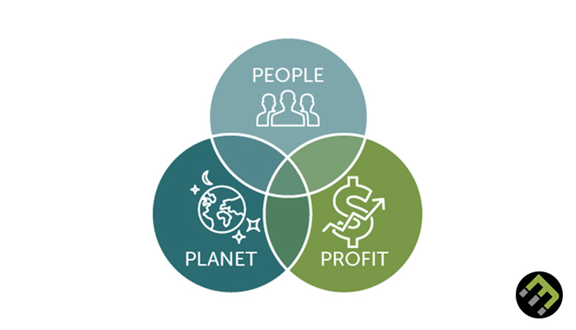

Ethical and sustainability.
The chosen topic to discuss in this part of the report is, Ethical and sustainability which are considered mandatory to have in any business or any organisation as Ethics allows the ability to manage a business operations in a more professional manner. And sustainability focuses upon the economy, creating a balance between ethics and sustainability allows an overall successful outcome for both business and the global industry For instance, it allows forward thinking in the 21st century enterprise which then allows to consider all aspects in regards of lowering costs. Sustainability also holds a major priority upon the economic environment Providing sustainable diverse advantages.
Furthermore, ethics manages the digital marketing fields to further strengthen an organisations and also to guide a business which allows the ability to respect the business and their stake holders. without applying either of these tools, many organisations can lead to disclosure . According to Biedenweg,. 2013) Ethical principles can relate towards sustainability and can be useful potentially in critical issues that can affect the upcoming future. Therefore, organisations must follow strategic formats that are acquired in business to work in an environment friendly atmosphere and an accurate prospective in regards of ethical and suitable backgrounds.

Example of how Ethical and sustainability can be applied.
The university of wales can be used as an example to define sustainability and ethics as the university considers all aspects in regards of staff. Students and also the decision makers at the university of wales. The university applies an Environmental auditing and management systems, by applying this method the university is able to analyse external performance within the environmental management (EMS).
According to Mustafa,. 2019) it scored a 90/100 percentage in regards of the level of EMS. The University of wales Ethical investment policy has scored 10 out 10 in regards of economical systematic, sustainable, and also the ethical dilemmas that the university may face in regards of how they deliver their education to students who can be Ethical challenging in regard s of understanding the university’s way of teaching therefore the university of wales works in a versatile manor to provide education that suites each individual student’s needs.
The university of wales takes great responsibility upon providing ethical and sustainable examples for their students for an example, the university encourages the students with different modules which students can benefit in their career goals and keep using long-term beliefs .According to Hayles., 2017) sustainable development is about making better decisions and it creates the idea in regards of creating the ability to take in consideration many key objectives that can have an effect upon the future generations of today 's decisions and learning to live without affecting the development, In a way that does not compromise future generations, it is about balancing social , environmental, cultural, and economic needs.

Part 2. B) Three quality theories.
In order to build a versatile and efficient Airline this report will be looking upon three theories/ 3 quality modules that will help assist improving customer relationships in regards of their management skills. Prior to the Easy jet customer services review the main focus upon the organisation that was found lacking was their communication and customer services skills, where found unsatisfied in regards off assisting the consumers therefore the most accurate quality that can be useful for the organisation is the guru Philp Crosby will be an ideal theory, Crosby has stated the following statement , Quality is free and also that lessons from an evolving life into the language of management he mentions the importance of doing it right the first time.
Crosby has also outlined a fourteen steps approach to quality and also the four absolutes of quality which are That the definition of quality is conference to the requirements which allows both the product and the customers’ requirements). Easy jet can benefit from this quality due to this theory quality’s main aim of this quality is to satisfy customers requirements. The second Absolute quality that Crosby has mentioned is the system of quality, the third is the performance standard zero defects and the last one mentioned is the measurement of quality is the price of nonconference.
EasyJet could create an performance chart for the staff in regards of monitoring individuals staff complaints that they are receiving from the customer reviews, this tactic will allow the ability to create an analyses of the main negative reviews regarding upon the staff who require further training or even a change of a job role within the organisation .
The airline Ryanair can also benefit from this theory as after investigating the airlines special needs assistance, does require further training or even a new updated code of conduct that will allow the ability to further assist special need customers to travel without any carers. For an example Ryanair can provide service for customer’s whilst there on flight with the airline, furthermore Ryanair can analyse Crosby’s theory in regards of attracting more customers with special needs for future reference.
Another quality that can be applied in regard of developing a better management understanding is the Walter A. Shewhart quality merged the disciplines and statistics of engineering and economics, he created the Shewhart cycle which is a control chart which allows the ability to have a professional quality in regards of auditing the given task it can assist moderately in regards of improving the voice clarity that he created for handsets Shewhart, applied his statistical methods in his finale achieved goals by using Shewhart’s charts, after applying these methods he applied them to factory production.
Shewhart pointed out the key points of reducing variation in a manufacturing process he also manged to understand the data being processed, therefore after investigating Shewhart’s theory which can then benefit both easy jet and Ryanair airline as the organisation must approve a normal distribution chart without analysing its customers it can affect the airlines marketing data.
Both the airlines can benefit from creating a rewards system using Shewhart’s control chart, the airlines will be able to monitor the Vass majority of customers the airlines can review how frequently customers have flown and in order for them to return they can use a reward system which will allow the customers who travel frequently feeling more satisfied and portraying a positive routine that will encourage customers to travel more frequently with the airlines organisations and also given the customers the satisfaction of receiving something in return due to their loyalty with the chosen airline organisations.
Easy jet does have a reward scheme but is very limited in the sense of the airline providing vouchers that have to be used/ applied within a certain period of time of this scheme therefore, the airline can create a better reward cycle/ scheme to attract many more customers who fly with the airline regularly .
The final quality that will be mentioned in this report will be Joseph M.Juran who first was acknowledged in the year 1904 he was instrumental in regards of changing the approach of the way organisations implement changes within the human side of quality. Juran is also known due to quality planning, control, and improvement in regard of assisting organisations. Juran had stated to identify the customer’s both internal and external of the quality provided to each organisation’s satisfaction he has also stated to determine customer’s needs. Therefore, as a solution for easy jet the human side of jurans theory can help assist the organisation in regards of analysing internally and externally to help create a suitable plan that will create a more professional quality staff training which will benefit the organisation and attract more customers and also encourage them to use the Airline more frequently and create a better understanding in regards of the customer relationship with the management.

(C) A conclusion of impact of ethical and sustainability polices CRM systems.
The final part of this reports main objectives is to produce a report based upon the impact towards ethical and substantiality polices and how they impact upon the quality of CRM systems. According to Sin., 2005) CRM is a comprehensive strategy that allows the ability for an organisation to identify, retain and also acquire a nurture profitable customers by allowing / keeping a relationship with the consumers.
CRM stands for the following Customer Relationship and management CRM adapts the ability to manage and lead in the most efficient way possible which then allows to create the most extract value upon financially benefiting organisations. For an example CRM refers to the system that company’s use to analyse customer interactions and also analyses the customer data throughout the customer’s life cycle the main aim of CRM is to improve business relationships through customer retention and also customer acquisition the outcome of this method allows to build a loyal customer base who then become advocates therefore this method allows the ability to create a more analysed and is sufficient for customers to have a better experience with organisations .
Moving forward a CRM strategy aims to create a full analysis for organisations to ensures that the customers continue to use the organisation facilities that are being provided, the airline emirates and also the airline Ryanair focuses upon the social CRM models that allows a contemporary approach for marketing method,
the CRM social process allows the ability to create customer productivity and also customer attention, emirates uses this method that also allows the ability for the organisation to develop an effective and wholesome strategy in regards of considering ethical and sustainability with the organisations it also allows the ability to guide its important decisions of the factors and reviews that the air is receiving feedback from their consumers down below is a figure that indicates how the social CRM model operates within organisations the figure highlights the main aspects of how the process indicates the CRM systems therefore CRM system allows to create the ability to Engage with the customer’s whilst benefiting the airline organisations such as emirates in digital marketing, ethical and also sustainable beneficial ways . It has been stated by the following Shurideh,2019 CRM has become a major representee for many practitioners and also scholars therefore companies are adopting the customer -centric strategies and also programmes that allow organisations to progress in regards of communicating with their customers.
Down below is a figure that allows to develop a better understanding within the CRM social process the aim of this method is to simplify the whole customer and management communication process this method creates the ability to remove any communication barriers within organisations. The social CRM processes focuses upon marketing, customer service, ideation, and also other platforms that can benefit organisations in regards of interacting with customers worldwide.
Figure 4)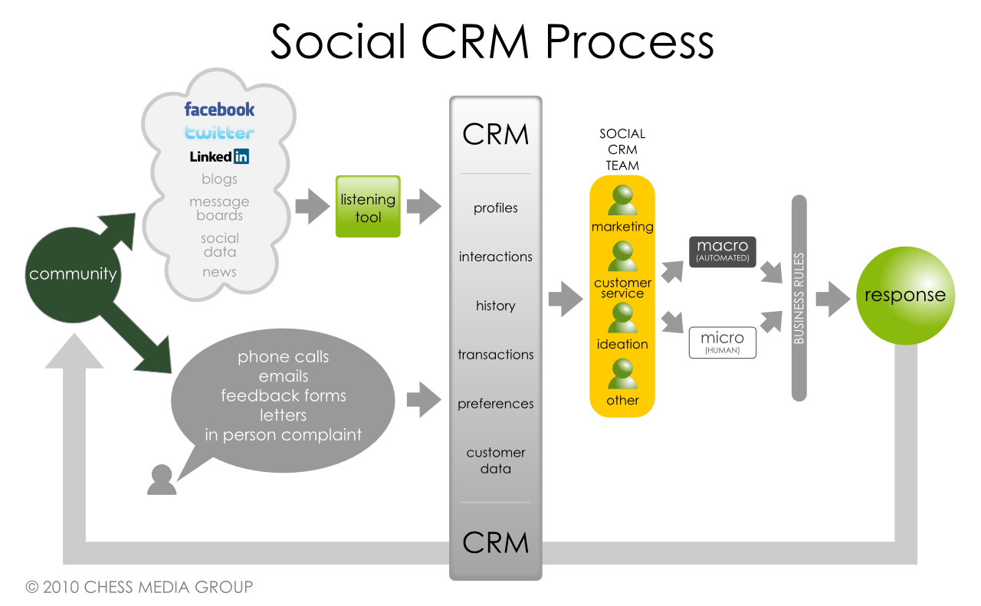

(Recommendations)
As a recommendation for this airline report the main objective that can be applied in regards of ethically and sustainably benefit theses chosen airlines that have been analysed within this report. The main acknowledgement factors that were found in both Ryanair and also the airline east jet is that the organisation’s seem to be lacking in regards of customer management, in order to benefit the organisation the solution which can be applied is that the staff can be trained in a more customer focused training and also for the organisations to consider creating a customer priority elements that will attract many more customer’s to frequently travel/ board the airlines . Another recommendation that can be applied in the air line emirates is that the fare prices can be reduce in regards of benefiting the airline and also taking sustainability into consideration the overall report has highlighted the main aspects that can have an positive effect in regards of establishing the airlines in a more ethical and sustainable manor.

(References)
AthuluruTlrumala, G. and Attuluru, A.R., Ytrre Inc, 2019. Real-time customer experience management systems and methods. U.S. Patent 10,325,102.
Al Shurideh, M., Alsharari, N.M. and Al Kurdi, B., 2019. Supply chain integration and customer relationship management in the airline logistics. Theoretical Economics Letters, 9(02), p.392.
Biedenweg, K., Monroe, M.C. and Oxarart, A., 2013. The importance of teaching ethics of sustainability. International Journal of Sustainability in Higher Education.
COUASME, M. and GURGEY, J., 2016. Airlines experiential marketing: gaining and retaining customers: Case studies of British Airways, SAS, Air France, Easy jet and KLM.
Crosby, P.B., 1996. Quality is still free: making quality certain in uncertain times (Vol. 111). New York: McGraw-Hill.
Davenport, A., 2005. The Disability Discrimination Act 1995 and the Travel Industry: Ross v. Ryanair in the Court of Appeal. Int'l Travel LJ, p.12.
Ferrell, O.C., Crittenden, V.L., Ferrell, L. and Crittenden, W.F., 2013. Theoretical development in ethical marketing decision making. AMS review, 3(2), pp.51-60.
GA, U., 2015. Transforming our world: the 2030 Agenda for Sustainable Development. Division for Sustainable Development Goals: New York, NY, USA.
Grewal, D., Levy, M. and Kumar, V., 2009. Customer experience management in retailing: An organizing framework. Journal of retailing, 85(1), pp.1-14.
Juran, J.M., 2003. Juran on leadership for quality. Simon and Schuster.
Kates, R.W., Clark, W.C., Corell, R., Hall, J.M., Jaeger, C.C., Lowe, I., McCarthy, J.J., Schellnhuber, H.J., Bolin, B., Dickson, N.M. and Faucheux, S., 2001. Sustainability science. Science, 292(5517), pp.641-642.
Levinas, E. and Nemo, P., 1985. Ethics and infinity.
Laczniak, G.R. and Murphy, P.E., 2006. Normative perspectives for ethical and socially responsible marketing. Journal of Macromarketing, 26(2), pp.154-177.
Mustafa, M. and Habib, M., Doctor in Business Administration University of Wales Trinity Saint David United Kingdom.
Stanojevic, S., 2020. Embracing sustainability in the drive from ordinary to outstanding case examples from Emirates, Jumeirah and Rotana. Worldwide Hospitality and Tourism Themes.
Nelson, L.S., 1999. Technical aids: notes on the Shewhart control chart. Journal of Quality Technology, 31(1), p.124.
Hendrickson, B.M., 2016. System and method for improving customer wait time, customer service, and marketing efficiency in the restaurant, retail, hospitality, travel, and entertainment industries. U.S. Patent 9,390,424.
Wilson, R.L., 2014, May. Ethical issues with use of drone aircraft. In 2014 IEEE International Symposium on Ethics in Science, Technology and Engineering (pp. 1-4). IEEE.
Hayles, C.S., 2017. An Inspired Education, the University of Wales Trinity Saint David. In Sustainable development research at universities in the United Kingdom (pp. 1-12). Springer, Cham.

