The Key to Effective Classroom Management
A three-phase process helps build strong teacher-student bonds, which can reduce disruptive behavior.
By Youki Terada
February 27, 2019
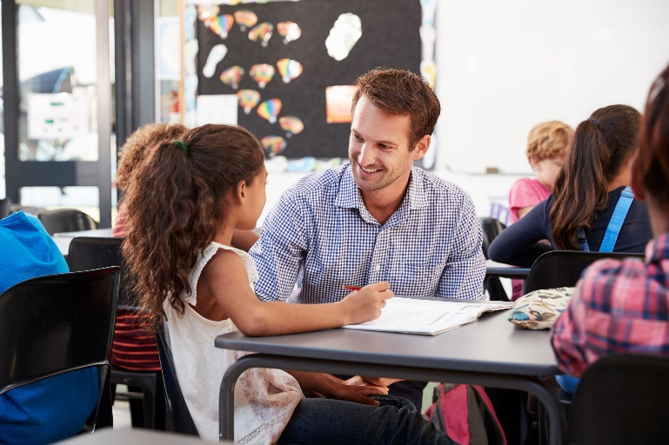
©Shutterstock/Monkey Business Images
It’s a daunting but all-too-common sight for many teachers: A classroom full of rowdy students who are unable to focus on the lesson. Classroom management techniques may get things back on track, but valuable time has already been lost.
Many experienced teachers know that making meaningful connections with students is one of the most effective ways to prevent disruptions in the first place, and a new study set out to assess this approach. In classrooms where teachers used a series of techniques centered around establishing, maintaining, and restoring relationships, academic engagement increased by 33 percent and disruptive behavior decreased by 75 percent—making the time students spent in the classroom more worthwhile and productive.
“Strong teacher-student relationships have long been considered a foundational aspect of a positive school experience,” explains Clayton Cook, the lead author of the study and a professor at the University of Minnesota. When those relationships are damaged, student well-being may be affected, leading to academic and behavioral problems.
In the study, teachers used an approach called Establish-Maintain-Restore to build positive interactions with students—a total of 220 in fourth and fifth grade—and boost their sense of belonging. (A follow-up study with middle school teachers used the same strategies, with similar results.) Relationship-building was broken down into three phases: the first meeting, maintenance throughout the school year, and points when a relationship may suffer damage, with useful strategies for each phase.
Since it can be easy for some students to fall through the cracks, a relationship reflection form—like the one we share here—can help teachers take notes on each individual student and highlight ones who need the most attention.

Starting on a Positive Note
At the start of the school year, the teachers in the study made time for establishing relationships. “The goal is to ensure all students feel a sense of belonging that is characterized by trust, connection, and understanding,” Cook and his colleagues explain. For students with learning or behavioral problems, cultivating positive relationships provided “protective effects” that helped them stay focused on learning.
To establish positive relationships, teachers can:
- “Bank time” with students. Schedule one-on-one meetings with students to get to know them better. The goal is to “make deposits into the relationship” to help ease conflict in the future if you have to give constructive feedback or address disruptive behavior.
- Encourage student-led activities. Students feel more invested in their learning if given opportunity to share their interests. Teachers can step aside, be supportive, and listen.
- Welcome students into the classroom. Activities such as positive greetings at the door and icebreaker questions help create a warm classroom culture.
- Use positive communication techniques. Open-ended questions, reflective listening, validation statements, expressions of enthusiasm or interest, and compliments help students—especially shy or introverted ones—ease into classroom discussions.

Maintaining Relationships
Without active maintenance, relationships deteriorate over time, the study authors point out. Teachers may focus too much on academics and not enough on supporting students’ emotional well-being, slowly using up the banked time they initially built up with students.
Teachers can maintain relationships by continuing to implement the strategies above, and in addition they can:
- Take note of positive and negative interactions with students. Teachers should aim for a five-to-one ratio.
- Regularly check in with students. Ask how they’re doing and what support they may need. In an Edutopia article, Todd Finley explains how 5x5 assessment time helped him focus on a handful of students every day.
- Acknowledge good behavior. When teachers focus attention on positive conduct, disruptive behavior is stemmed before it becomes an issue.

Repairing Harm Before Things Get Worse
Eventually, negative interactions such as misunderstandings, conflict, or criticism can weaken a teacher-student relationship. If these negative interactions are left unaddressed, students may feel disengaged and be less willing to participate in activities. They may also be more likely to misbehave, creating further damage. So it’s important for teachers to “intentionally reconnect” with students to restore the relationship to a positive state.
When relationships need repair, teachers can:
- Let go and start fresh. Teachers should avoid holding mistakes over a student’s head, instead giving them a chance to start each day with a clean slate.
- Take responsibility for their actions. Teachers can avoid blaming students when things go wrong, and think, “What could I have done to avoid the problem in the first place?” They shouldn’t be afraid to apologize when that’s called for—doing so helps build trust with students.
- Show empathy. There are two sides to every story, and a teacher can acknowledge that students may have a different perspective about what happened.
- Focus on solutions, not problems. Teachers can work with students to find a solution that everyone feels is fair.
- Separate the deed from the doer. It’s important to criticize the behavior, not the person. If teachers label children as “problem students,” there’s a danger that they’ll internalize that label, making it more likely that they’ll repeat the behavior in the future.
The takeaway: Effective classroom management starts with relationship building. When students feel a greater sense of belonging, they’re more likely to be academically engaged and demonstrate positive behavior.

FROM: https://www.edutopia.org/article/key-effective-classroom-management

