Data Mining
Dongsheng Cao

Table of Contents
Figures 3
Figures 4
1. Introduction 5
1. 1 Description of Data Set 5
The Origins of the Data 5
Dataset 5
Suitability for Analysis 8
1.2 Data mining process 8
2 Cross-industry standard process for data mining (CRISP-DM) 9
3. Data understanding 9
4. The pre-processing of data set 10
5. Data Visualization and Description 11
6 Data post-processing 15
7 Modelling of data set and analysis of it 16
7.1 J48 testing for Junction Control with Cross-validation method 17
7.2 J48 testing for Junction Control with Percentage Split method 19
7.3 The results of J48 classification for data set 19
7.4 JRip testing for the serious and fatal collision with Percentage Split method 19
7.5 The results of JRip classification for data set 20
7.6 Using cluster techniques: 20
8 Future Research 21
References 22
Appendix 23
1. The header of Collision.arff 23

Figures
Figure 1: Basic attributes of the Collision dataset 2
Figure 2: Raw Collision data 2
Figure 3: Basic attributes of the Vehicle dataset 3
Figure 4: Raw Vehicle data 3
Figure 5: Basic attributes of the Vehicle dataset 3
Figure 6: Raw Casualty data 1 4
Figure 7: Raw Casualty data 2 4
Figure 8: Crisp-DM Chart [7] 5
Figure 9: The Collision data set 2 7
Figure 10: Data Visualization of Collision 8
Figure 11: Data Visualization of Collision 8
Figure 12: Data Visualization of Collision 8
Figure 13: Data Visualization of Collision_SF 8
Figure 14: Data Visualization of Collision_SF 9
Figure 15: Data Visualization of Collision_SF 10
Figure 16: Data Visualization of Collision_SF Using Cluster Techniques 10
Figure 17: Google Map of Northern Ireland [10] 15
Figure 18: Data Information of Collision_FS 16
Figure 19: Data Information of Collision_FS 18
Figure 20: Data Information of Collision_FS_New 16
Figure 21: Cluster for data set 20

Tables
Table 1: Junction Control – J48 Tree Model 16
Table 2: Junction Control – J48 Tree Evaluation 16
Table 3: Junction Control – J48 Tree Model 19
Table 4: Collision Severity – JRip Tree Model 19

1. Introduction
In my report, firstly, this report will introduce some basic concepts of data mining process. Secondly, this report will describe the dataset will be used including basic information, pre-processing if it and some changes initially. Then, talking about the data working in Weka including the importing data into Weka, some kinds of visualization, the using of series of techniques for the dataset to establish model, test it and so on.

1. 1 Description of Data Set

The Origins of the Data
In order to report to the Police, the statistics regarding the injury road traffic collisions are generated by The Police Service of Northern Ireland [1], which are collected in accordance with the STATS20 guidance from the department for transport.

Dataset
There are three files in the dataset:
Collision2016.sav – The main focus of this file is the situations of the collisions. In details, it includes the collision severity, number of vehicles and casualties involved, time and location, weather and road conditions, and carriageway hazards and so on. Especially, this Collision2016.sav file consists of 9592 records and basically each of records has 14 attributes. There are some important attributes that be grouped as following:
- Date: Weekday of Collision, Day of Collision, Month of Collision.
- Time: Hour of Collision and Minute of Collision.
- Location of Collision: Location – Easting and Location – Northing.
- Road attributes: Junction Details. In details, Junction details explains the specific type of the junction such as Roundabout, Slip Road, Crossroads and so on.
- Facilitates’ information: Junction Control, Light Conditions, Pedestrian Crossing – Human Control, Pedestrian Crossing – Physical Control. In details, the attribute of Junction Control is to explain how this junction control the cars to across and some limits such as nothing at junction, authorised person, automatic traffic signal, stopping sign and give way.
- Accident influence information: Collision Severity, Number of Casualties and Number of Vehicles. Especially, the Collision Severity of 3 levels includes Fatal Injury collision, Serious Injury collision and the Slight Injury collision. Regarding to this attributes, I will split the data by it because there are absolutely not any value of some attributes in the records with the severity level is Slight Injury Collision.
- Other factors: Weather Conditions, Did a Police Officer Attend the Scene of the Collision, the Speed Limit and Road Surface Conditions with the values of Dry, Wet, Snow, Frost, Flood, Oil, Mud, Leaves, Slippery and Other.

There are the original basic attribute properties of the collision dataset in the Figure 1 below:
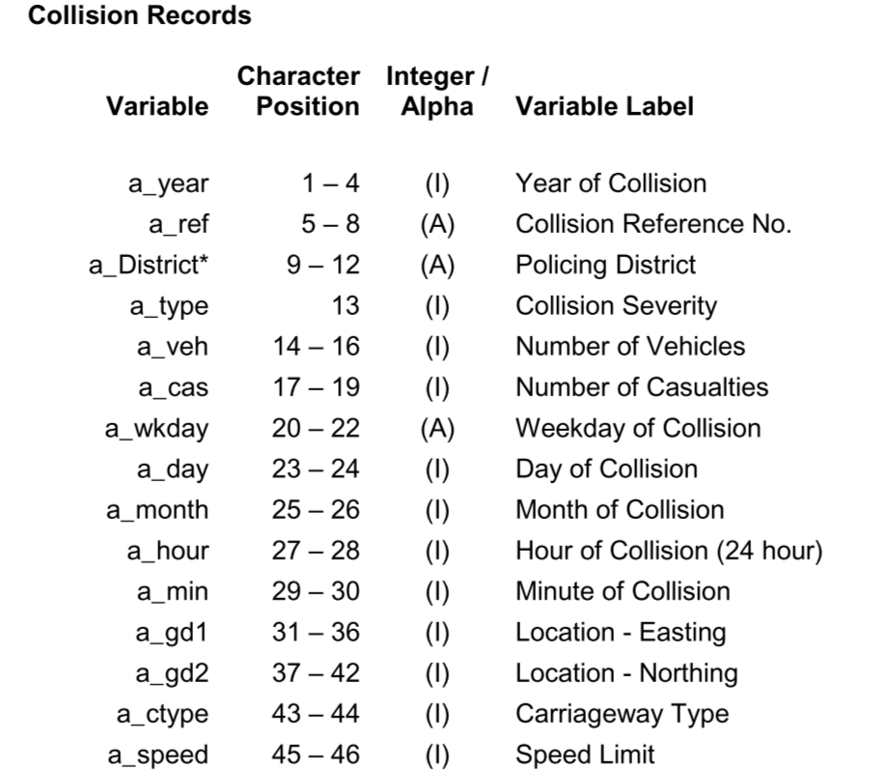
Figure 1: Basic attributes of the Collision dataset

Notes: In this dataset, as it is shown below in Figure 2, the records with the value of Slight Injury collision in the attribute of Collision Severity don not have any value of the some attributes like Junction Detail, Junction Control, Pedestrian Crossing – Human Control, Pedestrian Crossing – Physical Control, Light Conditions, Weather Conditions, Road Surface Conditions, Special Conditions at Site, Carriageway Hazard and Did a Police Officer Attend the Scene of the Collision, which is a quite struggle issues for the whole data set to mine some useful Knowledge but in my view, it does not matter because compared to Slight Collision, the Serious and Fatal collision is more worthy to pay attention to.
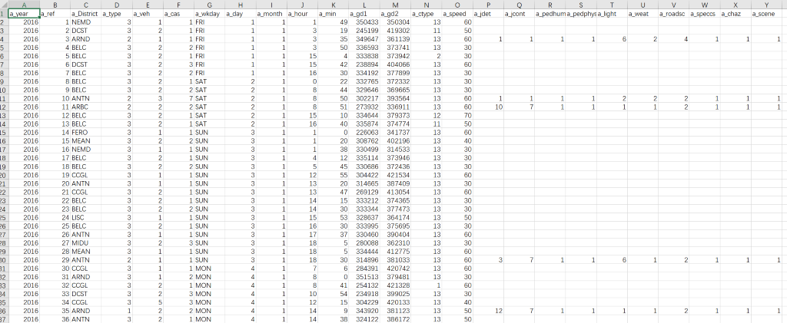
Figure 2: Raw Collision data

Vehicle2016.sav – The main focus of this file is vehicles involved in each collision. In details it includes vehicle type, manoeuvre at time of the collision, and data about the driver (age, sex) and so on. In details, this Vehicle2016.sav file consists of 11646 records and basically each of records has 17 attributes.

As it is shown below in Figure 3, there are some basic attributes of Vehicle dataset: 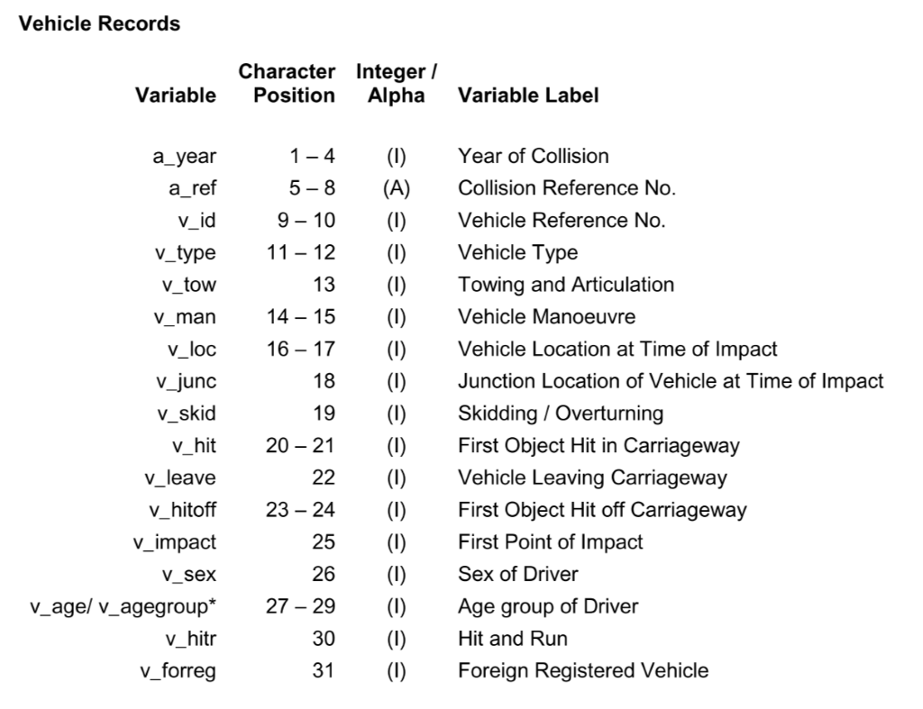
Figure 3: Basic attributes of the Vehicle dataset
Notes: In this dataset, as it is shown below in Figure 4, as same as Collision data, just the records of Vehicles in the Serious Collision Fatal Collision have whole data. In addition there are several missing data in the attribute of V_sex that explain the sex of driver.

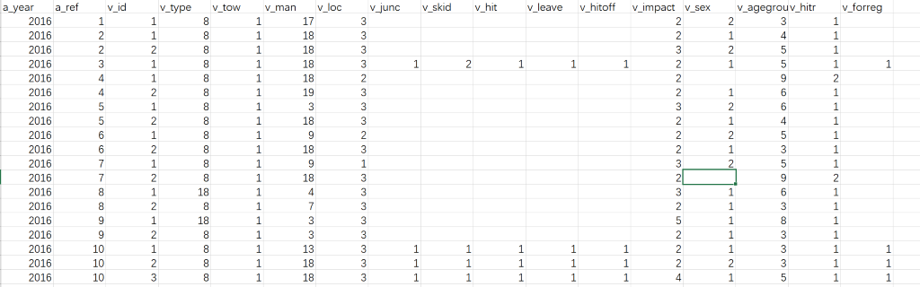
Figure 4: Raw Vehicle data

Casualty2016.sav – The main focus of this file is casualties resulting from a collision. In details, it includes age, sex, injury severity and whether a driver, passenger, pedestrian or cyclist and so on. Especially, this Casualty2016.sav file consists of 9592 records and basically each of records has 14 attributes.

As it is shown below in Figure 5, there are some basic attributes of Casualty dataset:
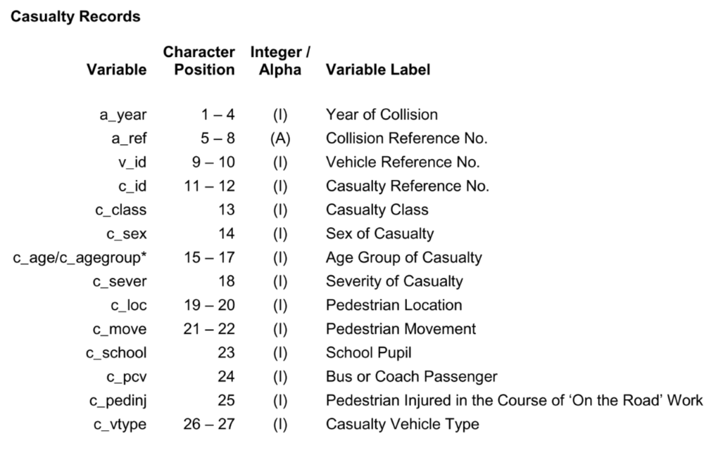
Figure 5: Basic attributes of the Vehicle dataset
Notes: In this dataset, as it is shown below in Figure 6, as same as Collision data, just the records of Casualty in the Serious Collision Fatal Collision have whole data. In addition, as it is shown in Figure 7, there are several values missing in the last attributes.
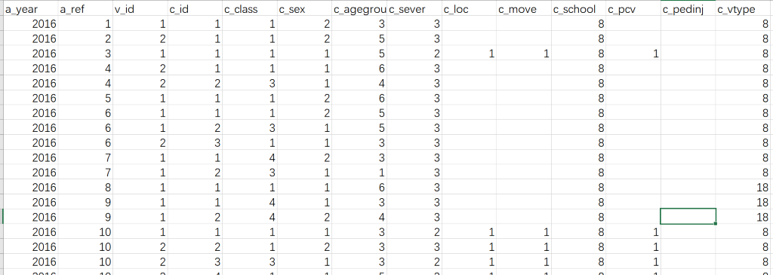
Figure 6: Raw Casualty data 1
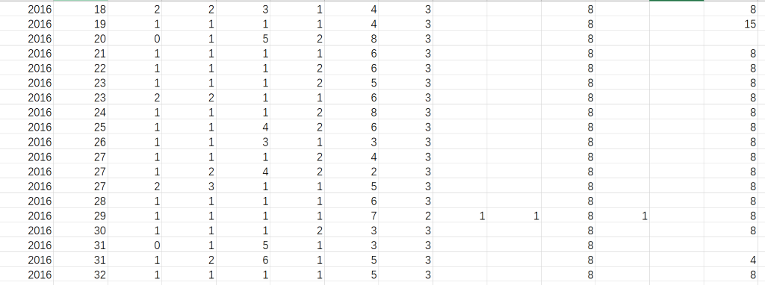
Figure 7: Raw Casualty data 2

Suitability for Analysis
The size of data is large enough to do this task: This dataset is supplied in three files and each file has at least 6000 records and the data of this dataset is of great data integrity and easily to split. In addition, the multiple attributes of each record are also the excellent advantage to analyse the relationships of the various factors.
On the other hand, as we seen, there are large part of records missing many values in some specific attributes and several values, not too much, miss in a attributes of the Vehicle and Casualty dataset. Facing these issues, I will work in the pre-process chapter to cope with these issues, which is not an unfortunate situation because the data in real always miss some part to some extent. Therefore, this sorts of dataset are quite suitable to analyse.

1.2 Data mining process
There are some common kinds of data mining process:
- The Knowledge discovery in databases (KDD) process [2] – this method commonly defined 5 stages: data selection, pre-processing of the raw data, transformation to make dataset acceptable to analyse, Data mining and the evaluation / interpretation.
- SEMMA [3] : there are five stages in this method: sample - collect and select dataset in order to establish model, exploration – seeking for some interest attributes from data visualization, modification – data cleaning and modifying as to do any analysis or mining properly, modelling – using various techniques of data mining for dataset to get some useful models, evaluation – assessing the usefulness and reliability of the generated models.
- Cross-industry standard process for data mining (CRISP-DM) [4]: it is seen as an open standard process model and currently, it is the common approaches and widely-used model [5] of data mining process.

2 Cross-industry standard process for data mining (CRISP-DM)
There is a cycle of 6 phases of the CRISP-DM as the Figure 8 shown below:
- Business understanding [4] – seeking for the requirement of goals of the project.
- Data understanding – in this stage, it is important to pay more attention to the available data for mining, which will help next step avoiding some unexpected issues.
- Data Preparation – this stage including data cleaning, changing and some other operations for the final dataset to analyse [6].
- Modelling [6] - selecting various techniques to build models for dataset.
- Evaluation [7] – assessing the data mining issues and business issues.
- Deployment [6] - reporting or deploying the results of the models.

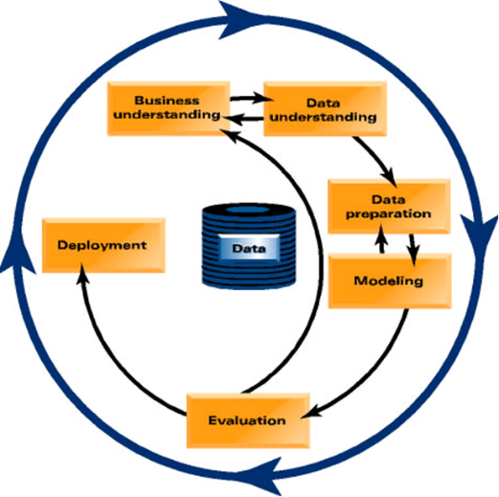
Figure 8: Crisp-DM Chart [7]
The specific business understanding for my data set, there are some business questions that would be answered relating my dataset:
- Which situations of junction control are more likely to bring about car crash to what extent?
- How to find the solution about the classification of the serious and fatal collision?
- According to the mining information of data in terms of junction details, light condition or some other factors, identify which area is more likely to result in the accidents and come up with some likely solutions.
- According to the casualty and vehicle data, are there some factors are more probable to car crash with the serious or even fatal injury collision?

3. Data understanding
At the data understanding stage, according to these 4 points of the business understanding, first of all, it is very significant to transform numerical data to the corresponding text data which can show all information in the dataset. What is more, I have mentioned there are some missing values in some attributes, which will be solved in the next stage as well. In addition, before the stage of modelling, it is very necessary to divide whole data set into two sub-datasets in order to easily use some techniques or algorithms to do a series of classification options in the modelling stage and so on. In the modelling stage, it is very necessary to do some works of post-processing of data set in order to reach the business understanding more closely.

4. The pre-processing of data set
In this stage, the main aim is to prepare data that can be directly used to import in the Weka or Tableau to do some works of visualization and modelling.
As I have mentioned some issues above, there are some steps of pre-processing of data set as following:
- Transform numerical data to the corresponding text data: according to the data guide of Northern Ireland Police Recorded Injury Road Traffic Collision Data [8] that is detailed document to explain the means and values of the attributes for the data set, the numerical values of Policing Area, Collision Severity and so on have been transformed to the corresponding text data as the Figure 9 shown:
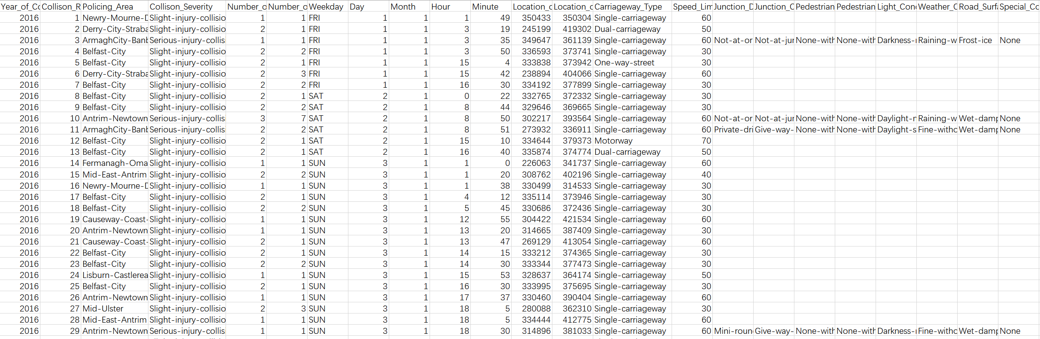
Figure 9: The Collision data set 2
- As we can see above, there are too many records with the value of Slight Injury collision in the attribute of Collision Severity don not have any value of the some attributes like Junction Detail, Junction Control, Pedestrian Crossing – Human Control, Pedestrian Crossing – Physical Control, Light Conditions, Weather Conditions, Road Surface Conditions, Special Conditions at Site, Carriageway Hazard and Did a Police Officer Attend the Scene of the Collision and these records are the most large part of the data set that means a large part of records of data set have missed many important values, which is a very struggle situation at the beginning. Fortunately, there are another 4 years data set provided by Police Service of Northern Ireland (PSNI). Therefore, the data set can be combined with the data of 2013, 2014, 2015 and 2017 to make the dataset with enough available records.
- After the combination of 5 years’ data, there are more than 30,000 records in the dataset and this step is to divide dataset into 2 dataset by the values of Collision Severity that one sub-dataset just consists of the records with the Slight injury collision of Collision Severity and another sub-dataset consists of remaining records with the whole important values of whole attributes. Therefore, there are totally 3 data sets of Collision: whole data set, sub-dataset with records of Slight injury collision and another sub-dataset with records of Serious and Fatal injury collision, which is quite convenient to do a series analysis.
- Changed the names of attributes to the understandable text data: Transformed the alternative number to the real means by the guidebook.
- Integrated the separated values to the one value by using the sign ‘-’ because in the *.arff file, the value must be one word.
- Transformed the file type to the *.arff in order to analyse this dataset in the Weka.
- Added the head content in the Collision.arff like ‘@RELATION’, ‘@ATTRIBUTE’ and ‘@DATA’, which is the Weka format.
- Corrected many mistakes in the Collison.arff. For example, I corrected the error about the data have not declared in the header, the data with wrong format and the data lost some values. In details, my dataset is about accident and there is an attribute named severity, and the data with the value named slight in the severity lose lager part values in the last attributes. Therefore, I decided to add the value ‘unknown’ because the data cannot have space value to import in the Weka.
- Similar to the steps of 1-8, the Casualty and Vehicle carry out the same processing to be able to import in the Weka.
- Especially, as the Figure 7: Raw Casualty data 2 has shown, there are several values missing in the last attribute. Because the missing values of the last attribute are not too much and of this attribute, there are large part of values are the ‘8’, so I changed all the missing values to the ‘8’ of this attribute.

5. Data Visualization and Description
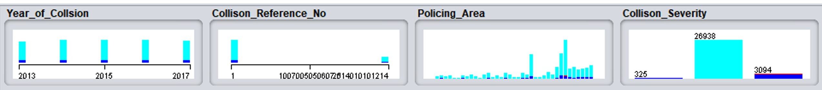
Figure 10: Data Visualization of Collision
- In the Figure 10, the year of collision shows there are 5 years’ data records in the data set and the number of each year is quite similar.
- The Collision Reference number [8] is to link with the data set of Vehicle and Casualty. Especially, because the data composed by different dataset of years and the reference number of each year’s data is quite different with each other, show the data in the chart of reference is not continuous.
- The chart of Policing Area [8] shows the number of collisions in each area and the chart shows during these 5 years, the Belfast has become the city with the most collisions more than 4,000 times and the Moyle is the least.
- The chart of Collision Severity [8] shows the large part of collision is slight injury collision, the serious one is middle and the fatal collision is least, which is quite common phenomenon can be predicted.
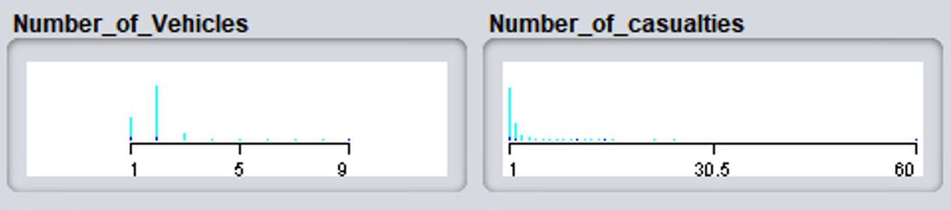
Figure 11: Data Visualization of Collision
- In the Figure 11, the chart of Number of Vehicles shows the vehicle number related in the collision. As we can see in the chart, the collision with most times involves 2 vehicles and it is more likely that the most part of collision is ordinary slight crash between two vehicles.
- The chart of Number of Casualties shows the number of casualties related in the whole collisions. In particular, the chart also conveys a information that most of collision involve one casualty during recent 5 years.
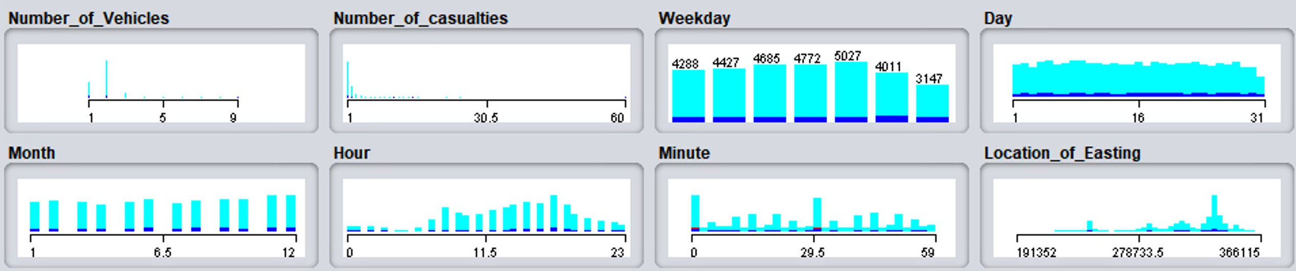
Figure 12: Data Visualization of Collision
- In the Figure 12, the chart of Weekday shows the number of collisions in each weekday. There is a slight increasing trend from Monday to Friday and in the weekend, there are less collisions. The reason of that is maybe the car stream reduced in the weekend.
- The chart of Day in a month shows the number of collisions in each day of a month.
- The chart of Month shows the number of collisions in each month of a year, which shows in the end months of a year, the number of collisions has increased slightly.
- The chart of Hour shows the number of collisions in each hour of a day, which shows in the morning and afternoon, there has been most of collisions and the collisions are most likely occurred during the 5 to 7 o’clock.
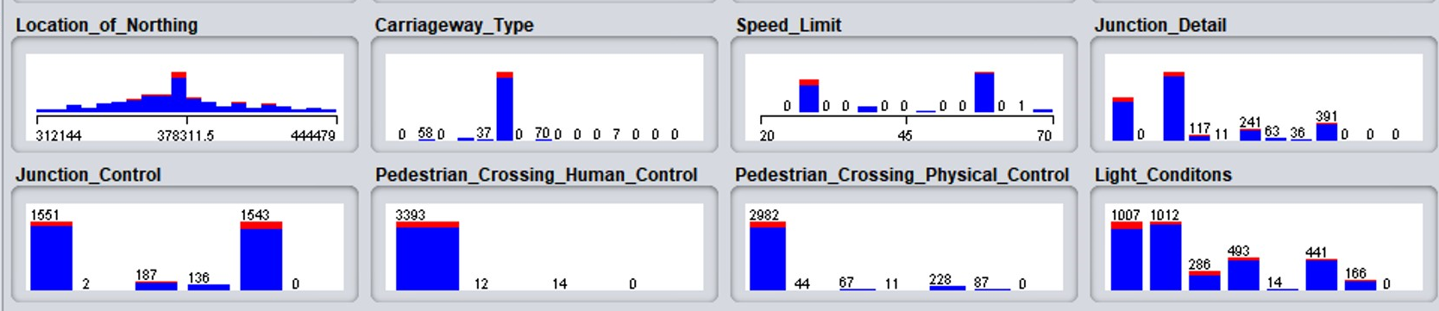
Figure 13: Data Visualization of Collision_SF
Note: In the Figure 13, I changed whole data set to the sub-dataset with records of serious and fatal injury collision of Collision Severity because for the following chart, the most records of whole data set are not usefulness missing a plenty of important values.
- In the Figure 13, the chart of Carriageway shows the collisions the types of carriageway such as one-way street, dual carriageway, motorway, single carriageway, not at or within 20m of junction, roundabout, mini roundabout, crossroads and so on. What can find in the chart is there is a type of carriageway with obvious most collisions that is single carriageway.
- The chart of Pedestrian Crossing Physical Control shows collisions occurring at the which type of physical control when pedestrian crossing the road. In the chart, we can clearly find that most collisions have occurred at the situation of none physical control within 50 meters.
- The chart of Pedestrian Crossing Human Control shows collisions occurring at the which type of Human Control when pedestrian crossing the road. In the chart, we can clearly find that most collisions have occurred at the situation of none human control within 50 meters, which is very similar to the last chart while if there is human or physical control, the probability of collision is extremely low.
- The chart of Speed Limit shows how the speed limit influences the collision. As we can find in the chart, the collisions have been occurred mostly at the speed from 25 to 30 and 55 - 60 km/h.
- The chart of Junction Details shows how the junction type influences the collision. In the chart, we can find that collisions are more likely occurred at the T or staggered junction.
- The chart of Junction Control shows how the type of junction control influences the collision. In the chart, we can find that collisions are more likely occurred at the give-way or none of junction control.
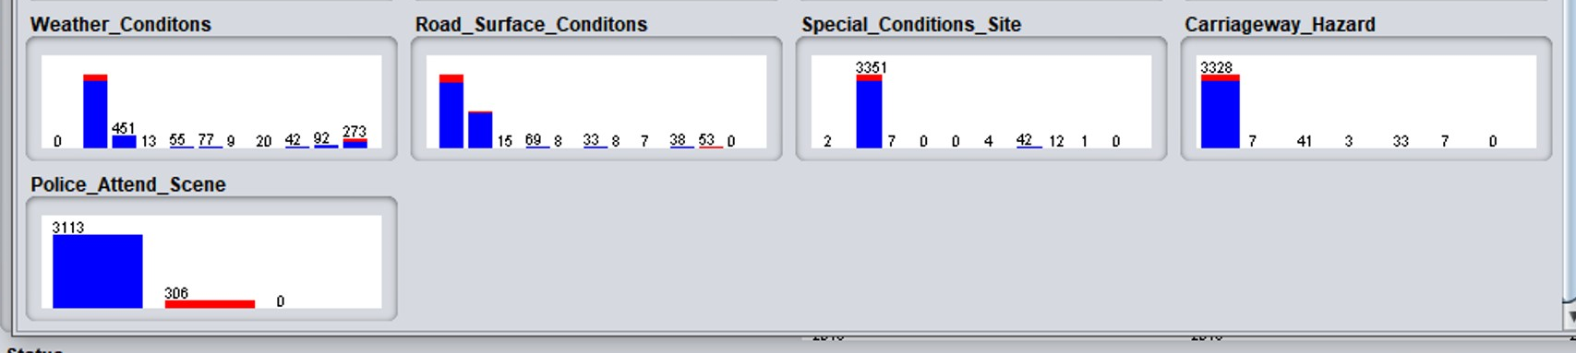
Figure 14: Data Visualization of Collision_SF
- In the Figure 13 and Figure 14, there are some charts of various conditions may influence the collision such as light conditions, weather conditions and road surface conditions. In particular, there is at least one value that seriously influences the number of collision such as the Daylight-street-lights-present and Daylight-no-street-lighting of light condition, the Fine-without-high-winds of weather condition, the Dry and Wet-damp of road surface condition and the none of special condition of site, in which we can find that most collision has been occurred at a very common situation not the snow weather or something else.
- The chart of Carriageway Hazard shows is there anything influences the collision like dislodged vehicle load in carriageway, any animal in carriageway, pedestrian in carriageway, involvement with previous collision and other object in carriageway. In details, we can find that in the chart, the most collisions have not met any objects in carriageway.
- The chart of Police Attend Scene shows did a police officer attend the scene of the collision and the chart shows most collisions are with the situation there is at least one police officer at the scene of collisions.
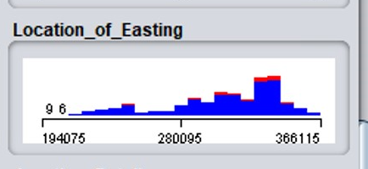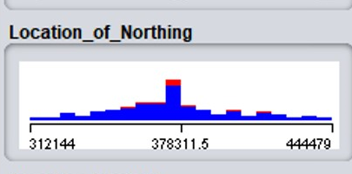
Figure 15: Data Visualization of Collision_SF
- The chart of Location of Easting and Location of Northing shows the location of the collisions, which is similar to the latitude and longitude and they are the Ordnance Survey Grid Reference [9]. Regarding to the location information, I have tried to import in the Tableau to display geographic information on the map, but I have not been successful because the Tableau could not display geographic information with Ordnance Survey Grid Reference. Therefore, I tried to use cluster techniques to visualize it in the Weka and the data visualization is as following:

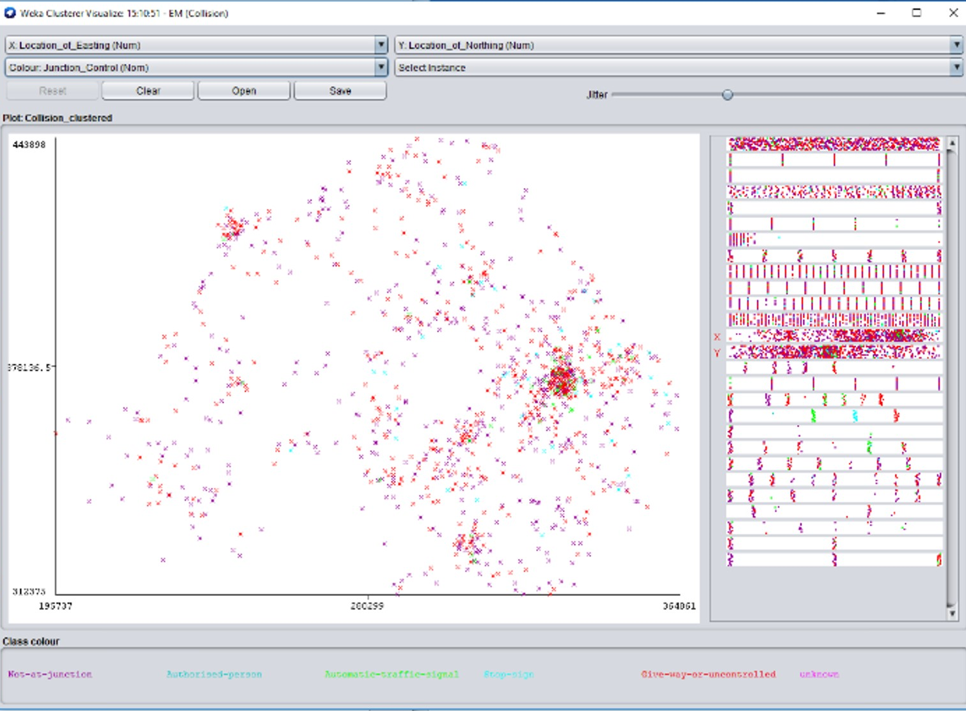
Figure 16: Data Visualization of Collision_SF Using Cluster Techniques
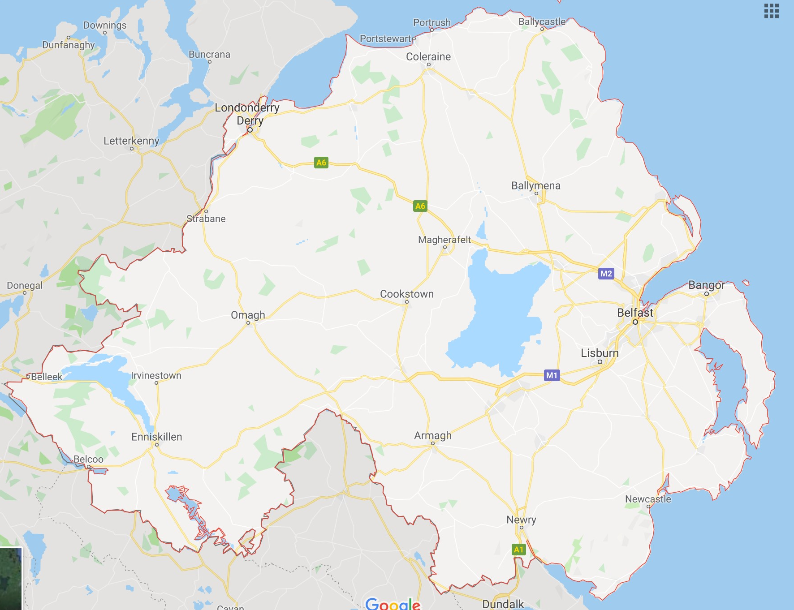
Figure 17: Google Map of Northern Ireland [10]
Note: as we can see in the Figure 15, this chart shows probably some geographic information of data set using the location information of Location of Easting for X-axis and Location of Northing for Y-axis. Besides, comparing to the Figure 16: Google Map of Northern Ireland [10], it is easier to find more geographic in formation of the data set. As we can see in the Figure 15 and Figure 16, a mostly number of collisions have been occurred during recent five years in the city of Belfast, Newry and Londonderry Derry.

6 Data post-processing
After the data visualisation in the Weka, there are some issues have been found:
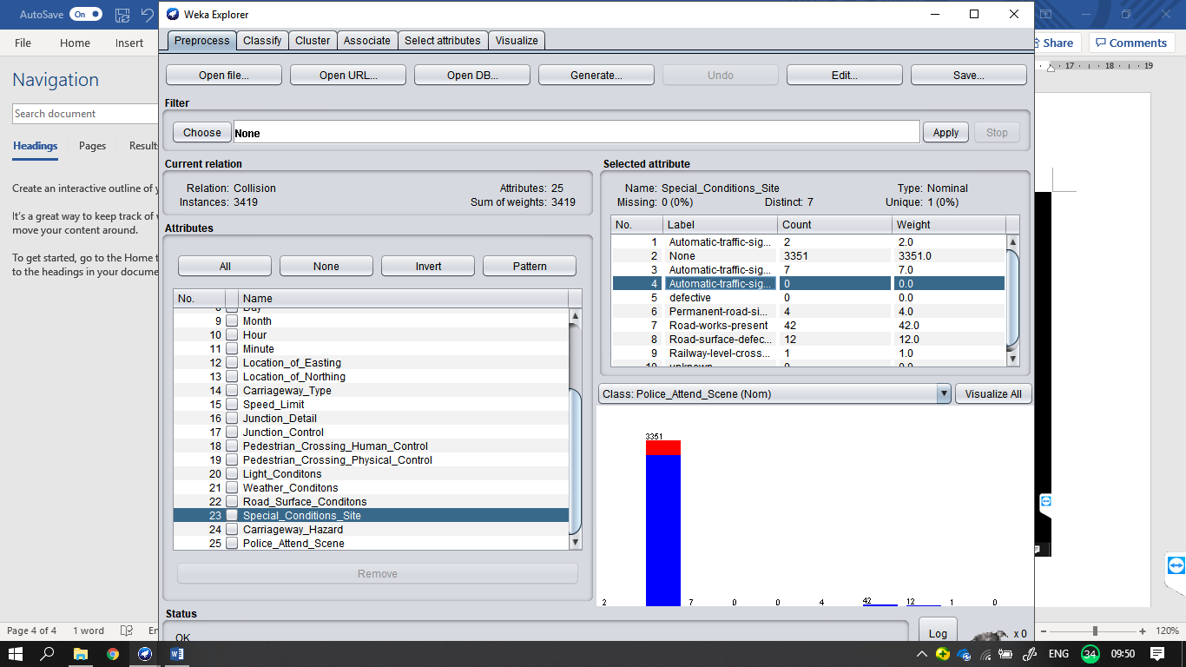
Figure 18: Data Information of Collision_FS
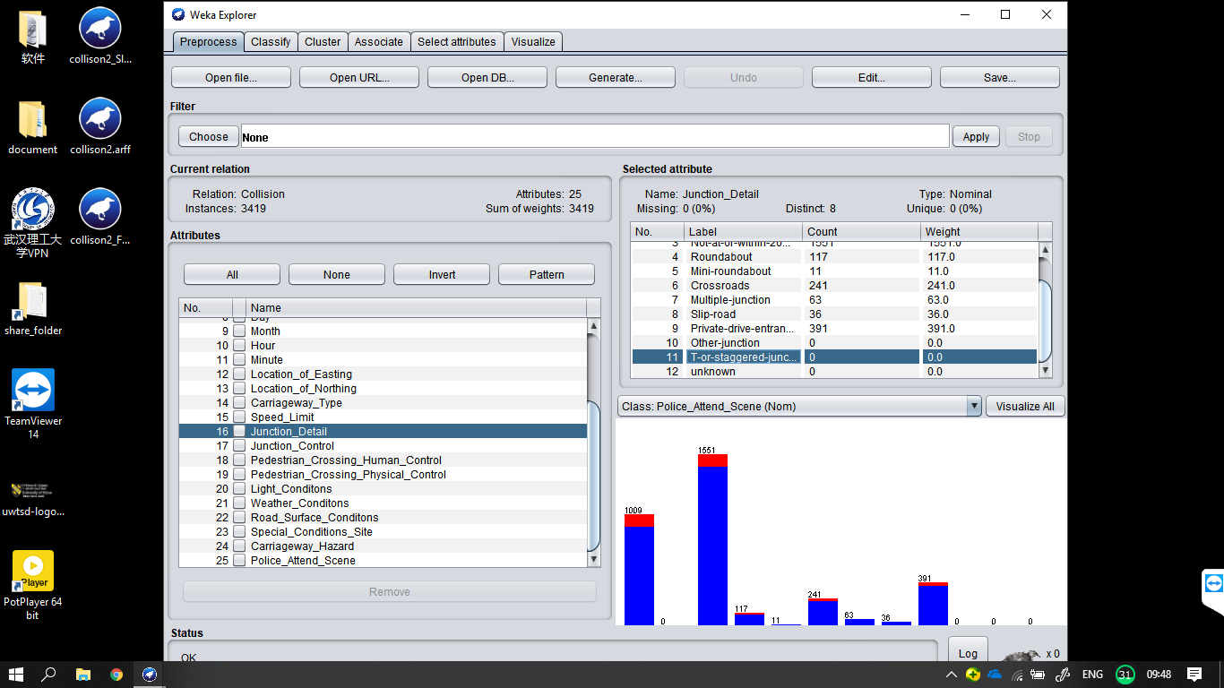
Figure 19: Data Information of Collision_FS
As we can find in the Figure 17 and Figure 18, there are some values of its attributes do not have any records in the data set, for example, in the data set, there are not any record with Other-Junction of Junction Details in the Figure 18. Therefore, the solution of this issue is to delete these values of attribute in the header of the Weka file.
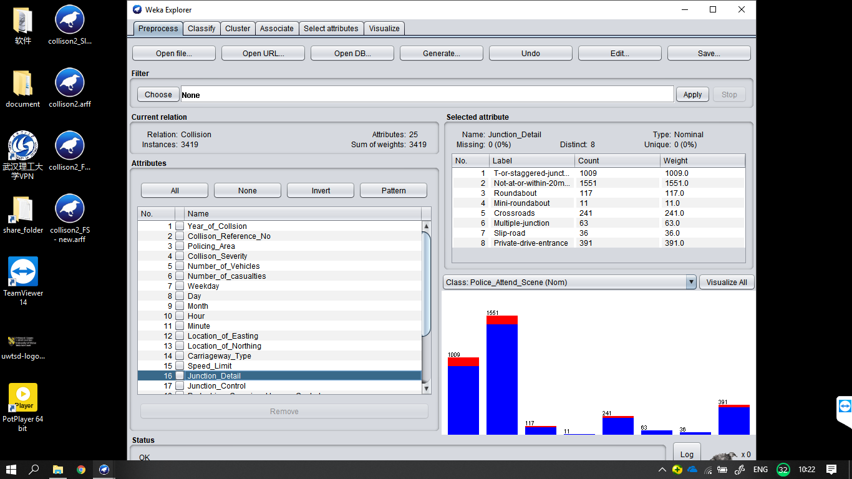
Figure 20: Data Information of Collision_FS_New
In the Figure 20, the dataset of Collision_FS_New is the outcome after post-processing.

7 Modelling of data set and analysis of it
In this stage, the data set will be used is Collision, Collision_FS_New, Collision_FS_New_Training and Collision_FS_New_Testing. The the data set of Collision_FS_New is of whole records with all important values and the data sets of the Collision_FS_New_Training and the Collision_FS_New_Testing are the sub-datasets from Collision_FS_New.

7.1 J48 testing for Junction Control with Cross-validation method
In the Weka, using data set of Collision which is of whole records more than 30,000 records chooses the Cross-validation with 10 folds, 15 folds, 20 folds in the Test options of classification for modelling. Furthermore, the summary and the results are as following:
Name | Time | Correct  Classification | Incorrect  Classification | Events | Folds
J48 | 0.53 | 99.1995% | 0.8005% | modelling | 10
J48 | 0.56 | 99.1896% | 0.8103% | modelling | 15
J48 | 0.56 | 99.2016% | 0.7939% | modelling | 20
Table 1: Junction Control – J48 Tree Model
Name | Time | Correct  Classification | Incorrect  Classification | Events | Folds
J48 | 0.53 | 93.7701% | 6.2299% | Re-evaluation | 10
J48 | 0.56 | 93.7896% | 6.2104% | Re-evaluation | 15
J48 | 0.56 | 93.7865% | 6.2135% | Re-evaluation | 20
Table 2: Junction Control – J48 Tree Evaluation
Summary of Cross-validation with 10 folds for modelling:
- Correctly Classified Instances 30114 99.1995 %
- Incorrectly Classified Instances 243 0.8005 %
- Kappa statistic 0.9614
- Mean absolute error 0.0038
- Root mean squared error 0.0456
- Relative absolute error 5.5187 %
- Root relative squared error 24.5309 %
- Total Number of Instances 30357
Confusion Matrix of Cross-validation with 10 folds modelling:
a b c d e f <-- classified as
1547 0 4 0 0 0 | a = Not-at-junction
0 0 1 0 1 0 | b = Authorised-person
0 0 141 0 46 0 | c = Automatic-traffic-signal
0 0 3 5 128 0 | d = Stop-sign
3 0 42 15 1483 0 | e = Give-way-or-uncontrolled
0 0 0 0 0 26938 | f = unknown

Detailed Accuracy By Class of Cross-validation with 10 folds modelling:
TP Rate FP Rate Precision Recall F-Measure MCC ROC Area PRC Area Class
0.997 0.000 0.998 0.997 0.998 0.998 0.999 0.997 Not-at-junction
0.000 0.000 ? 0.000 ? ? 0.487 0.000 Authorised-person
0.754 0.002 0.738 0.754 0.746 0.744 0.985 0.686 Automatic-traffic-signal
0.037 0.000 0.250 0.037 0.064 0.094 0.959 0.234 Stop-sign
0.961 0.006 0.894 0.961 0.927 0.923 0.995 0.926 Give-way-or-uncontrolled
1.000 0.000 1.000 1.000 1.000 1.000 1.000 1.000 unknown
Weighted Avg. 0.992 0.000 ? 0.992 ? ? 0.999 0.991
Summary of re-evaluation on test set of Collision_FS_New using the model from last one:
- Correctly Classified Instances 3206 93.7701 %
- Incorrectly Classified Instances 213 6.2299 %
- Kappa statistic 0.8907
- Mean absolute error 0.0321
- Root mean squared error 0.1266
- Total Number of Instances 3419
Detailed Accuracy By Class of re-evaluation on test set of Collision_FS_New
TP Rate FP Rate Precision Recall F-Measure MCC ROC Area PRC Area Class
0.999 0.001 0.999 0.999 0.999 0.999 1.000 0.999 Not-at-junction
0.000 0.000 ? 0.000 ? ? 0.919 0.006 Authorised-person
0.797 0.013 0.784 0.797 0.790 0.778 0.969 0.779 Automatic-traffic-signal
0.022 0.000 0.750 0.022 0.043 0.124 0.912 0.274 Stop-sign
0.975 0.091 0.898 0.975 0.935 0.880 0.977 0.955 Give-way-or-uncontrolled
? 0.000 ? ? ? ? ? ? unknown
Weighted Avg. 0.938 0.042 ? 0.938 ? ? 0.984 0.938
Confusion Matrix of re-evaluation on test set:
a b c d e f <-- classified as
1550 0 1 0 0 0 | a = Not-at-junction
0 0 1 0 1 0 | b = Authorised-person
0 0 149 0 38 0 | c = Automatic-traffic-signal
0 0 2 3 131 0 | d = Stop-sign
1 0 37 1 1504 0 | e = Give-way-or-uncontrolled
0 0 0 0 0 0 | f = unknown

7.2 J48 testing for Junction Control with Percentage Split method
In this case, percentage split method will be used
Name | Time: build/assess | Correct  Classification | Incorrect  Classification | Number of Leaves and size of tree | Percentage Split
J48 | 0.06/0.02 | 93.6317 % | 6.3683 % | 14/29 | 66 %
J48 | 0.05/0.02 | 93.2447 % | 6.7553 % | 14/29 | 45 %
J48 | 0.06/0.00 | 93.5673 % | 6.4327 % | 14/29 | 70 %

Table 3: Junction Control – J48 Tree Model
Summary with 66 % of percentage split method:
- Correctly Classified Instances 1088 93.6317 %
- Incorrectly Classified Instances 74 6.3683 %
- Kappa statistic 0.8874
- Mean absolute error 0.0361
- Root mean squared error 0.1408
- Relative absolute error 15.4311 %
- Root relative squared error 41.3689 %
- Total Number of Instances 1162
Confusion Matrix with 66 % of percentage split method:
a b c d e <-- classified as
557 0 0 0 0 | a = Not-at-junction
0 0 1 0 0 | b = Authorised-person
0 0 42 0 15 | c = Automatic-traffic-signal
0 0 2 2 37 | d = Stop-sign
0 0 12 7 487 | e = Give-way-or-uncontrolled

7.3 The results of J48 classification for data set
From Table 3: Junction Control – J48 Tree Model, it is found that the percentage of the split for the data to train and test do not certainly perform well with high numerical value that 66% of percentage split could achieve the highest correct classification. By contrast with the J48, the time used of JRip to build model and evaluate is more than J48 and the performance of correct classificaition is also not good than J48. Therefore, final adopting J48 to build classify model of the data set.

7.4 JRip testing for the serious and fatal collision with Percentage Split method
In this case, percentage split method will be used
Name | Time: build/assess | Correct  Classification | Incorrect  Classification | Number of Rules | Percentage Split
JRip | 0.21/0.00 | 90.7917 % | 9.2083 % | 1 | 66 %
JRip | 0.02/0.00 | 90.266 % | 9.734 % | 1 | 45 %
JRip | 0.22/0.00 | 91.3255 % | 8.6745 % | 1 | 70 %
Table 4: Collision Severity – JRip Tree Model
Summary with 70 % of percentage split method:
- Correctly Classified Instances 937 91.3255 %
- Incorrectly Classified Instances 89 8.6745 %
- Kappa statistic 0
- Mean absolute error 0.1683
- Root mean squared error 0.2817
- Relative absolute error 99.8356 %
- Root relative squared error 99.9949 %
- Total Number of Instances 1026
Confusion Matrix with 70 % of percentage split method:
a b <-- classified as
0 89 | a = Fatal-injury-collision
0 937 | b = Serious-injury-collision

7.5 The results of JRip classification for data set
Using JRip method to build classify model for collision severity to classify the values of fatal injury collision and serious injury collision, the probability of correctly classified instances is not very high and the time consumed also is not good than J48 by contrast.

7.6 Using cluster techniques:

In this case, the data set will be used is Collision:
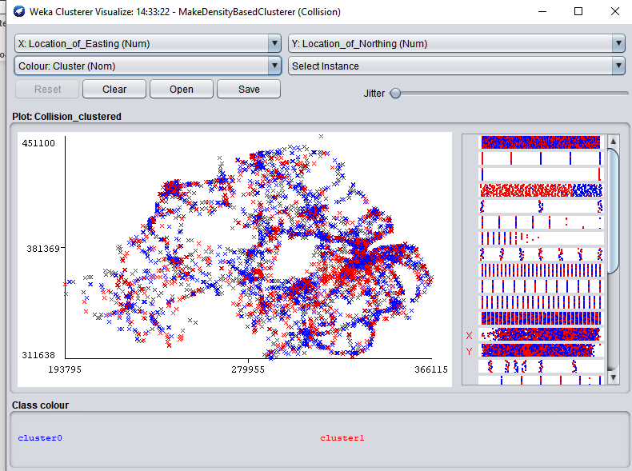
Figure 21: Cluster for data set
What can find in the Figure 21 is that the data set has be divided in two clusters using the MakeDensityBasedClusterer method.

8 Future Research
There are still many information can mine from the data set such as
- The information related to casualty, like how to reduce the number of casualties in terms of junction details, physical conditions, etc.
- The location information of this data set is grid conference which is difficult to use tableau to map data on the map, which just can use latitude and longitude, so the one of the future research is to find solution in order to make a good data visualization with geographic information of the data set.
- The information related to vehicles, etc.

References

[1] |  |  | OpenDataNI, "Police Recorded Injury Road Traffic Collision Statistics Northern Ireland 2016," 11 December 2017. [Online]. Available: https://data.gov.uk/dataset/4ddb6259-b47c-44e6-ac91-6d95dd527d26/police-recorded-injury-road-traffic-collision-statistics-northern-ireland-2016.
[2] |  |  | U. Fayyad, G. Piatetsky-Shapiro and P. (. Smyth, "From Data Mining to Knowledge Discovery in Databases," American Association for Artificial Intelligence, 2008.
[3] |  |  | A. Azevedo and M. F. Santos, "KDD, SEMMA and CRISP-DM: a parallel overview Archived 2013-01-09," in In Proceedings of the IADIS European Conference on Data Mining , Wayback Machine, 2008, pp. 182-185.
[4] |  |  | S. C, "The CRISP-DM model: the new blueprint for data mining," in J Data Warehousing , 2000, pp. 13-22.
[5] |  |  | "What IT Needs To Know About The Data Mining Process," 29 July 2015. [Online]. Available: https://www.forbes.com/sites/metabrown/2015/07/29/what-it-needs-to-know-about-the-data-mining-process/#2065f3a3515f. [Accessed 24 June 2018].
[6] |  |  | W. Vorhies, "CRISP-DM – a Standard Methodology to Ensure a Good Outcome," 26 July 2016. [Online]. Available: https://www.datasciencecentral.com/profiles/blogs/crisp-dm-a-standard-methodology-to-ensure-a-good-outcome.
[7] |  |  | "Google Map of the City of Northing Ireland,"
[8] |  |  | Police Service of Northern Ireland (PSNI), "Police Recorded Injury Road Traffic Collision Statistics Northern Ireland 2016," 11 December 2017. [Online]. Available: https://data.gov.uk/dataset/4ddb6259-b47c-44e6-ac91-6d95dd527d26/police-recorded-injury-road-traffic-collision-statistics-northern-ireland-2016.
[9] |  |  | Department for Transport, "Instructions for the Completion of Road Accident Reports from non-Crash Sources," STATS 20, 2011.
[10] |  |  | "Google Map of the City of Northing Ireland,"

Appendix
- The header of Collision.arff
@RELATION Collision
@ATTRIBUTE Year_of_Collsion numeric
@ATTRIBUTE Collison_Reference_No numeric
@ATTRIBUTE Policing_Area {Antrim-Newtownabbey, ArmaghCity-Banbridge-Craigavon ,Omagh,North-Down, Moyle, Larne, Fermanagh, Dungannon-South-Tyrone, Craigavon, Coleraine, Ballymoney, West-Belfast, North-Belfast,Banbridge, Ards, Strabane, Newry-Mourne, Newtownabbey, Magherafelt, Limavady, Foyle, Down, Castlereagh, Cookstown, Carrickfergus, Ballymena, South-Belfast, East-Belfast, Antrim-Newtownabbeyim-Newtownabbey, ArmaghCity-Banbridge-CraigavonghCity-Banbridge-Craigavon, Belfast-City, Causeway-Coast-Glens, Derry-City-Strabane, Fermanagh-Omagh, Mid-East-Antrim-Newtownabbeyim, Mid-Ulster, Newry-Mourne-Down}
@ATTRIBUTE Collison_Severity {Fatal-injury-collision, Slight-injury-collision, Serious-injury-collision}
@ATTRIBUTE Number_of_Vehicles numeric
@ATTRIBUTE Number_of_casualties numeric
@ATTRIBUTE Weekday {MON, TUE, WED, THU, FRI, SAT, SUN}
@ATTRIBUTE Day numeric
@ATTRIBUTE Month numeric
@ATTRIBUTE Hour numeric
@ATTRIBUTE Minute numeric
@ATTRIBUTE Location_of_Easting numeric
@ATTRIBUTE Location_of_Northing numeric
@ATTRIBUTE Carriageway_Type {One-way-streetSlip-road, One-way-street, Other-unknown, Dual-carriageway, Motorway, Single-carriageway, Not-at-or-within-20m-of-junction, Roundabout, Mini-roundabout, Crossroads, Multiple-junction, Slip-road, Private-drive-entrance, Other-junction, T-or-staggered-junction}
@ATTRIBUTE Speed_Limit numeric
@ATTRIBUTE Junction_Detail {T-or-staggered-juncton, Not-at-or-within-2unknownm-of-junction, Not-at-or-within-20m-of-junction,Roundabout, Mini-roundabout,Crossroads, Multiple-junction, Slip-road, Private-drive-entrance, Other-junction, T-or-staggered-junction, unknown}
@ATTRIBUTE Junction_Control {Not-at-junction, Authorised-person, Automatic-traffic-signal, Stop-sign, Give-way-or-uncontrolled, unknown}
@ATTRIBUTE Pedestrian_Crossing_Human_Control {None-within-50m, Control-by-school-crossing-patrol, Control-by-other-authorised-person, unknown}
@ATTRIBUTE Pedestrian_Crossing_Physical_Control {None-within-50-metres, Zebra-crossing, Central-refuge-no-control, Footbridge-or-subway, Pedestrian-phase-at-traffic-signal-junction, Non-junction-pedestrian-light-crossing, unknown}
@ATTRIBUTE Light_Conditons {Daylight-street-lights-present, Daylight-no-street-lighting, Daylight-street-lighting-unknown, Darkness-street-lights-present-and-lit, Darkness-street-lights-present-but-unlit, Darkness-no-street-lighting, Darkness-street-lighting-unknown, unknown}
@ATTRIBUTE Weather_Conditons {Fine-without-high-windsunknown, Fine-without-high-winds, Raining-without-high-winds, Snowing-without-high-winds, Fine-with-high-winds, Raining-with-high-winds, Snowing-with-high-winds, Fog-or-mist-if-hazard, Strong-sun-(glaring), Other, unknown}
@ATTRIBUTE Road_Surface_Conditons {Dry, Wet-damp, Snow, Frost-ice, Flood, Oil, Mud, Leaves, Slippery-(after-dry-spell), Other, unknown}
@ATTRIBUTE Special_Conditions_Site {Automatic-traffic-signal-partially-unknown-defective, None, Automatic-traffic-signalout, Automatic-traffic-signalpartially, Permanent-road-signing-defective-or-obscured, Road-works-present, Road-surface-defective, Railway-level-crossing-present, unknown}
@ATTRIBUTE Carriageway_Hazard {None, Dislodged-vehicle-load-in-carriageway, Other-object-in-carriageway, Involvement-with-previous-collision, Any-animal-in-carriageway-except-ridden-horse, Pedestrian-in-carriageway-not-injured, unknown}
@ATTRIBUTE Police_Attend_Scene {Yes, No, unknown}
@DATA

