Organisational Consultancy

Consultancy Report of Premier Inn London Brixton hotel
Student name: Oana Maria Colac
Student ID: 2021252
Module code BMIH6005
Lecturer name: Laurence Blake

Table of Contents
Executive Summary 3
Introduction 5
Scope and Analysis 6
Main Body 10
Findings & Results 17
Action Plan 21
Recommendations 24
Conclusion 25
References 26

Executive Summary
The ‘consulting report’ has collected and analysed relevant market information based on necessary market research from the organisational perspective of Premier Inn London Brixton hotel. The purpose of the consulting report is to assist the organisation in overcoming business issues by conducting in-depth market research. The identified business issues like skill shortages and service deficiency of the front-line and housekeeping staff of Premier Inn London Brixton hotel have been observed in the consulting report. The hospitality sector of the UK is experiencing a challenge in attracting talent to manage business operations. The skill shortages in the UK hospitality sector have affected the ‘quality of work’ due to an imbalanced skill set. The report has observed the ‘skill gap’ and ‘service deficiency’ of the front-line and housekeeping staff of Premier Inn London Brixton hotel. The guests are not allocated the rooms as per their requests. Moreover, guests are also not satisfied with the housekeeping services provided by the hotel. The amenities like poor wi-fi connection, elevator malfunctioning, and inadequate heating issues are the key complaints raised by the guests who have failed to attend by housekeeping and front-line staff. The guests have mentioned that a ‘one night stay’ is only recommended for Premier Inn London Brixton hotel due to major service gaps owing to the ‘skill gap’ and ‘service deficiency’. The lack of guidance and training for the front-line staff is affecting the service quality. The service gap existing between customer expectations and actual service is hampering the brand image. In consideration of the organisational performance, Whitbread Plc (owner of Premier Inn) has reported an annual loss of £1bn in the year 2021. However, in the year 2022, Premier Inn reported a pre-tax profit of around £307.4m. The statutory revenue of the company has increased in the year 2022 from £589.4m to £1703.4m. The adjusted loss in the year 2022 has been reduced from £635.1m to £15.8m. Moreover, UK accommodation sales have increased from 194% to 204% in the year 2022. The tourist groups like millennials and Gen Z are the top travellers in the hospitality industry. As per the market assessment report, it has been spotted that the millennial and Gen Z within the age group 18 to 34 used to represent 50% of the travellers within the year 2025 (Hutton, 2020). The hospitality industry is also experiencing a new trend ‘workation’ in the post-pandemic period.
Through a PESTEL and SWOT analysis, the report looks at Premier Inn UK's current situation and focuses on the main problems and opportunities it faces. The report also includes a TOWS analysis to figure out the best ways to deal with these problems and take advantage of these opportunities. A comprehensive overview of the various factors that influence Premier Inn's operations was provided by the PESTEL analysis. The hotel operates in a political climate that is stable, has a growing economy, a rising demand for affordable lodging, and a dedication to technology and sustainability. Premier Inn is well-positioned for future growth and success by adhering to legal regulations and maintaining high customer service standards (pestleanalysis, 2019). In addition, the report demonstrated that, despite some customers' negative experiences, Premier Inn has received mostly positive feedback overall. In order to provide its guests with the best possible experience, the hotel has made it a priority to address any negative feedback and continuously enhance its operations.
The analysis has led to a number of suggestions for meeting guest expectations and increasing front-line and housekeeping staff efficiency. Clear expectations and responsibilities, regular opportunities for employee development and training, effective delegation, and the implementation of technology are among these. These suggestions are based on theories like technological determinism and Herzberg's two-factor theory, which provide a comprehensive framework for increasing employee motivation and making use of technology to solve difficult problems. Based on Herzberg's two-factor theory, the recommendation for employee training and development states that motivators (such as recognition and achievement) and hygiene factors (such as job security and working conditions) influence employee motivation (Thant & Chang, 2021). Premier Inn can increase employee motivation and hygiene by providing regular training and development opportunities, resulting in a more productive and effective workforce. Moreover, the theory of technological determinism, which asserts that technology can be utilised to resolve complex issues like workforce inefficiency, serves as the foundation for the technology implementation recommendation. Premier Inn can increase the efficiency of its front-line and housekeeping staff by implementing technology solutions like automated scheduling systems, property management systems, and mobile applications. This will free up time for the company to concentrate on providing excellent customer service (Kummitha, 2020). This report's recommendations have the potential to better meet the expectations of Premier Inn UK hotel guests as well as significantly increase the efficiency of front-line and housekeeping staff. Premier Inn has the potential to strengthen its standing as a leading hotel operator and advance its position as a market leader by implementing these suggestions.

Introduction
The ‘consulting report’ will explore the relevant market information based on necessary market research from the organisational perspective of Premier Inn London Brixton hotel. The purpose of the consulting report is to assist the organisation in overcoming business issues by conducting in-depth market research. The business issues like skill shortages and service deficiency of the front-line and housekeeping staff of Premier Inn London Brixton hotel will be addressed in the consulting report. The hospitality sector of the UK is experiencing a challenge in attracting talent to manage business operations. The skill shortages in the UK hospitality sector have affected the ‘quality of work’ due to an imbalanced skill set. Moreover, the implementation of strategic management tools to analyse the business issues will be focused on in the report. Firstly, the PESTLE analysis will be implemented to address the impact of external business factors on the business decision making process. Secondly, the SWOT analysis is the strategic management tool that explores the key business strengths, weaknesses, possible threats, and unexplored opportunities. The SWOT analysis supports the organisation in undertaking strategic planning for achieving long-term goals. Thirdly, the TOWS analysis is a strategic planning technique that allows the organisation in minimising threats by taking advantage of unexplored opportunities in the external business environment. The TOWS matrix acts as a framework that helps to create, evaluate, and access business strategies. Moreover, the TOWS analysis helps to bridge the gap existing between strategic directions and the research process.

Scope and Analysis
In the United Kingdom, Premier Inn is a budget hotel chain with over 800 hotels and 72,000 rooms. The hotel's overall operation and success are greatly influenced by the front office and customer service offerings. This section provides an overview of the hotel's location, recent feedback, and a PESTLE, SWOT, and TOWS analysis of the hotel's current situation.
Location
The Premier Inn chain offers travellers affordable and convenient lodging options in a variety of UK cities.
Recent Feedback
The organisation recently faced criticism from different travellers and guests must also face positive feedback as well. The Premier Inn has received praise from numerous guests for its comfortable rooms, which feature soft beds, neat facilities, and high-quality sheets. Customers have praised the quality, variety, and affordability of the food served in the Premier Inn's in-house restaurants and bar areas. In addition, Premier Inn guests have consistently praised the friendly and helpful staff for their attention to detail and willingness to go above and beyond to make their stay enjoyable. On the other hand, when compared to more expensive hotel options, some guests have stated that Premier Inn rooms can be small and basic, lacking in space and amenities. Customers have also complained that the hotels can be noisy, especially in busy areas, which can make it hard for them to sleep. Additionally, it has been observed that some people complain about poor housekeeping, such as soiled rooms, omitted amenities, and shoddy upkeep, which can have an effect on their overall experience.
PESTEL Analysis
This section shall be implementing the PESTEL framework to analyse the external environment of the organisation appropriately.
Political Factor - In the UK, Premier Inn operates within a robust regulatory framework and a stable political climate. By encouraging tourism and offering tax breaks, the government helps the hotel industry. Premier Inn has a solid foundation for growth and expansion thanks to the favourable political climate (Achinas, et al., 2019).
Economic Factor - Premier Inn has a bright future ahead of it thanks to the expanding hotel industry in the UK. This growth is driven by the rise in affordable lodging options and consumers' rising disposable income. Premier Inn has the chance to expand its operations and increase its market share as a result of this economic expansion (David, 2019).
Social Factor - Premier Inn's market is expanding as a result of rising demand for affordable lodging options. The hotel has taken advantage of this trend by providing good food options, comfortable rooms, and reasonable prices. Premier Inn's chances of expanding in the future are bolstered by the rising popularity of budget hotels in the UK (Kolios & Read, 2018).
Technological Factor - Customers at Premier Inn can now book their rooms online and use their mobile devices to check-in. This has improved customer satisfaction by making it simpler for guests to book rooms and use the hotel's services. Additionally, the hotel is utilising technology to streamline and increase efficiency (Shatskaya, et al., 2020).
Environmental Factor - The Premier Inn has implemented environmental initiatives like water conservation and energy-efficient lighting. The hotel is committed to promoting sustainability and reducing its environmental impact. Not only does this help the environment, but it also lowers the hotel's operating costs (Thomas, et al., 2021).
Legal Factor - The health and safety regulations of the UK are all adhered to by Premier Inn. The hotel must uphold high customer service standards and ensure its guests' safety and well-being. The hotel's compliance with these regulations contributes to its reputation and success (Zahari & Romli, 2019).
SWOT Analysis
This analysis will help in understanding the internal environment of the business appropriately for analysing the reasons for both the positive and negative feedback in the business.
Strengths - Since Premier Inn has over 800 hotels across the UK, it is easy for a lot of customers to get to. Additionally, the organisation provides affordable lodging options, making it a popular option for budget-conscious travellers. The hotel has made a name for itself as a reputable brand in the sector thanks to its welcoming staff, delicious meals, and comfortable rooms. In addition, Premier Inn's strong brand recognition in the UK has contributed to the establishment of its reputation and the acquisition of new customers (Gowrea, 2021).
Weaknesses - Although Premier Inn's rooms are small and basic, some guests may find them to be affordable. Additionally, Premier Inn is highly dependent on the UK market, making it susceptible to changes in consumer preferences and economic downturns. Even though Premier Inn is a well-known brand in the UK, it doesn't have much of a global presence, which limits how much it can grow (Gowrea, 2022).
Opportunities - Expanding into international markets would boost Premier Inn's revenue and potential for growth. In addition, Premier Inn has a chance to expand its market share and increase its revenue thanks to the rising demand for budget-friendly lodging options. In addition, Premier Inn frequently has the chance to develop new services and products, such as extended-stay options and meeting rooms, which would draw in new clients and boost revenue (George, 2021).
Threats - Other budget hotel chains are competing with Premier Inn, which could affect its revenue and market share. Premier Inn's revenue and growth potential may be impacted by the ongoing economic downturns and shifts in consumer preferences. In addition, Premier Inn's profitability may be impacted by the changes in regulations, such as health and safety standards (Czinkota, et al., 2021).
TOWS Analysis
The TOWS analysis in this section will be helpful in understanding areas of issues in the business along with helping to create a proper action plan to take steps against the negative effects. A TOWS analysis can assist Premier Inn in developing a strategic plan to address its internal strengths and weaknesses, as well as its external opportunities and threats.
Opportunities can be seized by making use of strengths. For instance, Premier Inn's extensive portfolio of properties can be used to expand into international markets and boost revenue. It can also be used to develop new products and services like extended stay options and meeting rooms by leveraging its strong brand recognition and favourable reputation (Saleh & Zohry, 2022).
Threats can be reduced by addressing weaknesses. By investing in room renovations and upgrades, Premier Inn, for instance, can address its limited room options and provide a more premium experience for its guests. By expanding into international markets and diversifying its revenue streams, it can reduce its reliance on the UK market.
Utilising strengths and addressing weaknesses can reduce threats. By leveraging Premier Inn's strong brand recognition and positive reputation, for instance, it is possible to reduce competition from other budget hotels. By addressing its dependence on the UK market and investing in new products and services that provide a more premium experience for its customers, it can mitigate economic downturns and regulation changes (seanbeandies , 2019).
By addressing weaknesses and leveraging strengths, opportunities can be seized. For instance, in order to offer a more opulent experience to its guests, it can take advantage of the rising demand for affordable lodging by making investments in room renovations and enhancements. Utilising Premier Inn's strong brand recognition and favourable reputation can be leveraged to take advantage of the opportunity to enter international markets (Dandage, et al., 2019).
As a result, Premier Inn is a reputable budget hotel chain in the United Kingdom that provides travellers with low-cost lodging options. However, the hotel faces difficulties with regard to room cleanliness and customer service. Premier Inn has the potential to continue expanding and achieving success in the hotel industry if it addresses its threats and weaknesses as well as its strengths and opportunities.

Main Body
The hospitality industry is evidenced to grow at a CAGR of 3% within the year 2025 (Parliament, 2021). Moreover, the hospitality industry supports 7% of the UK’s employment (Araujo, 2019). However, the COVID-19 pandemic has hit hotel operations due to shutdowns and travel restrictions. The second wave of the COVID-19 pandemic has additionally domestic UK hospitality sector in the UK (BBC, 2020). However, hospitality investment is growing since 2021 due to the rising demand for tourists. The market assessment report has predicted the expansion of the hotels owing to the increasing number of travellers in London. The negative impact of Brexit formation on the recruitment strategy of the hotels can be spotted. As per ONS, the hospitality businesses around 38% operating in the accommodation and food sector are experiencing skill shortages (Baum, 2021). The vacancy rate in the UK hospitality sector has been reported around 11% after the Brexit formation (Statista, 2020). The hospitality sector of the UK is experiencing a challenge in attracting talent to manage business operations. The skill shortages in the UK hospitality sector have affected the ‘quality of work’ due to an imbalanced skill set (Hutton, 2020). The outcomes of the skill shortages are faulty workmanship, inconsistent service delivery process, customer dissatisfaction, and negative productivity (Becker, 2020). Hotel Operations encompass the activities that ensure the hotel continues its operations by delivering a positive experience to the guests. The streamlined hotel operations ensure effective integration by providing a seamless guest experience. Moreover, improving operational efficiency is key to guest satisfaction (Brownell, 2017). As per Chen (2019), Guest satisfaction reflects the measurement of the happiness and satisfaction of the guests from the services delivered by the organisation. The matching of the guest’s expectations with the services provided by the organisation ensures high guest satisfaction. Excellent customer service improves the relationship between the establishment and guests. Moreover, satisfied guests are likely to come back and become true brand ambassadors.
Premier Inn is one of the trusted hotel brands that have more than 72,000 rooms along with 800 hotels (Amadeus, 2022). The frequent deals with the customers and the proper location are the key strengths of the Premier Inn. Moreover, affordable pricing with quality services for budget travellers is the unique selling proposition of the hotel. The guests selecting the Premier Inn London Brixton hotel can access the tube station conveniently. The buzzing location beside the Brixton Village Market and The Ritzy cinema can give live experiences to the guests staying at the Premier Inn London Brixton hotel. The guests can get a friendly neighbourhood owing to the diverse shops and international restaurants. The location is close to public transport and also it is affordable as per the pricing deals. Furthermore, the amenities like free internet, a bar, highchairs, air conditioning, housekeeping, desks, etc. are provided to the guests. The rooms are spacious in comparison to the pricing strategy of Premier Inn. The guests can spend quality time at Canova Hall for tea (Poulston, 2020). Moreover, business class rooms are also available to business guests. Hence, a great location for easy accessibility to central London is the positive side of the hotel.
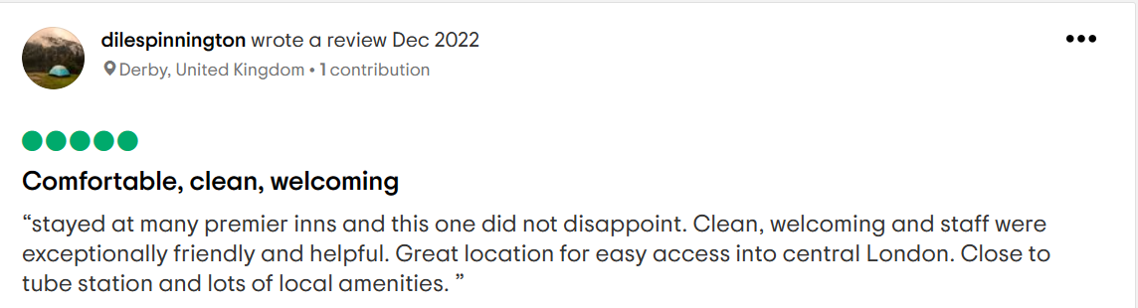
Positive Reviews
Source: https://www.tripadvisor.co.uk/Hotel_Review-g186338-d10225380-Reviews-Premier_Inn_London_Brixton_Hotel-London_England.html
However, the negative experience encountered by the guests is mainly related to the lack of housekeeping service and inefficient frontline staff. The guests are not allocated the rooms as per their requests. Moreover, guests are also not comfortable with the services provided by the hotel. The amenities like poor wi-fi connection, elevator malfunctioning, and inadequate heating issues are the key complaints raised by the guests. The guests have mentioned that a ‘one night stay’ is only recommended for Premier Inn London Brixton hotel due to major service gaps. The guests are not attended to efficiently by the frontline team of the hotel. Hence, the requests of the guests are not fulfilled (Research, 2022). As per the reviews, the guests have pointed out the inefficient staff that is not fixing up the washroom cleanliness. Moreover, uncleaned beds and rooms are a negative experience encountered by the guests.
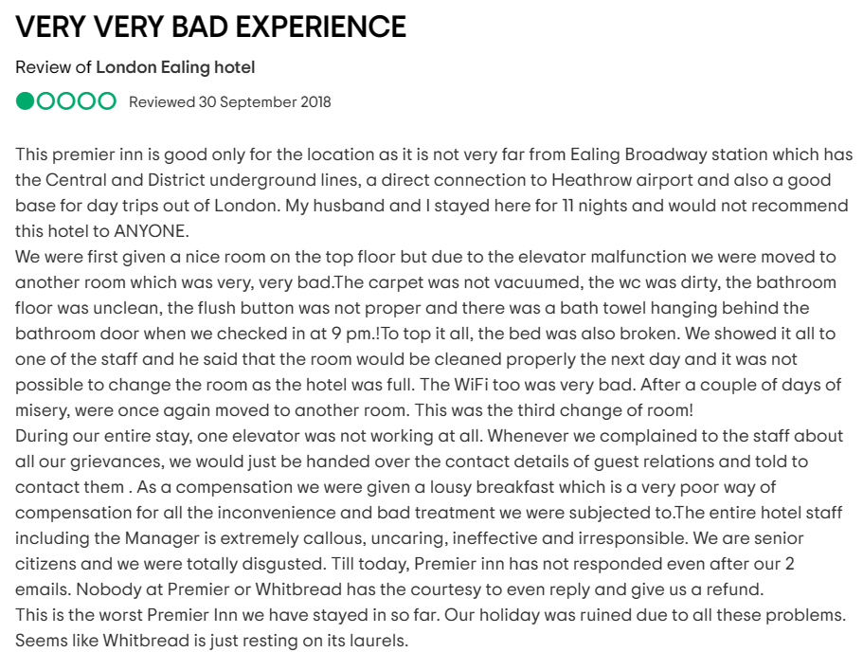
Negative Reviews
Source: https://www.tripadvisor.co.uk/ShowUserReviews-g12692256-d3199340-r620634006-London_Ealing_hotel-Ealing_Greater_London_England.html
In consideration of the organisational performance, Whitbread Plc (owner of Premier Inn) has reported an annual loss of £1bn in the year 2021. However, in the year 2022, Premier Inn reported a pre-tax profit of around £307.4m. The statutory revenue of the company has increased in the year 2022 from £589.4m to £1703.4m (Whitbread, 2022). The adjusted loss in the year 2022 has been reduced from £635.1m to £15.8m. The UK accommodation sales have increased from 194% to 204% in the year 2022. The organisational performance of Whitbread Plc is gradually developing with the increase in revenue and profits. Currently, Premier Inn is one of the strongest hospitality brands that have an integrated distribution strategy and value-based pricing for the guests (Camisón, 2020). Moreover, Premier Inn is investing in new hotels and bringing innovations to stand out in the competition.
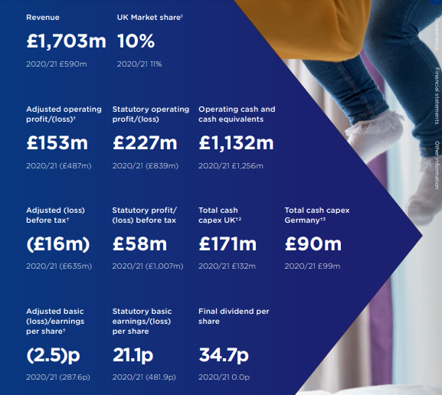
Annual Report of Premier Inn
Source: https://www.annualreports.com/HostedData/AnnualReports/PDF/LSE_WTB_2022.pdf
In consideration of the highly fluctuating market, Premier Inn is extending its business scale by expanding the German market. The external business challenges like climate change issues have been addressed by Premier Inn by undertaking a ‘Good sustainability program’. The stretchable targets like the net-zero Carbon target within the year 2040 have been undertaken by Premier Inn. Furthermore, diversity has been emphasised by forming 40% female representation in senior leadership roles (Kollewe, 2021). Premier Inn is making priority across the ESG agenda by embedding it into the business operations.
From the perspective of business issues, the front office and housekeeping department of Premier Inn London Brixton hotel is not functioning as per the basic hospitality industry standard. The front-line staffs managing the reservation, room allocation, and guests request are inefficient to meet the guest’s demands. Moreover, the housekeeping department is ineffective in ensuring the cleanliness and aesthetic appeal of the rooms and public areas (Chen, 2020). As per Chi (2020), Housekeeping reflects the department that essentially deals with cleanliness-related services to the rooms and public places in the hotel. The objective of the housekeeping department is to provide a clean and safe environment to the guests. The housekeeping department of the hotel has to ensure that the venue and sanitary area are clean and safe for accessibility to the guests (Chi, 2020). Furthermore, the housekeeping department has to replace the linens, restock the guest’s room, remove the garbage, and support the recycling process implement by the hotel. The Front office department is having direct contact with the guests as they support the guests during the checking-in and out process, billing, room allocation, and other special requests. The direct service encounter between the front office and guests is used to influence the brand image (Hemmington, 2020). Moreover, the key functions of the front office department of the hotel are to take care of the activities related to reservation, registration, check-in, check-out, bill settlement, special requests, etc. Barrows (2018), opined that the front office department of the hotel is deemed to be the face of the hotel. The first guest’s interaction with the front office team can influence brand perception. The hospitality industry is experience-driven and counts the importance of ‘service encounters’ (Baum, 2020). Hence, the front office department is the first point of contact that can enhance the positive experience for the guests. The guests used to share their requests with the front office staff of the hotel. Hence, staff efficiency in the front office department is important to fulfill the guest’s requirements.
The current landscape of the hotel industry has changed in the post-pandemic period. The changes in traveller’s behaviour and preferences have influenced hospitality operations. As per Hemmington (2020), the ‘safety’ perspective has brought key behavioural change among travellers. Despite the restrictions that are lifted in the post-pandemic period, people are preferring the safety aspects of the service providers. The preferences of people in opting for services that are safe and secure are observed in the present hotel industry (Sigala, 2021). Moreover, tourist types like millennials and Gen Z are the top travellers in the hospitality industry. As per the report, it has been spotted that the millennial and Gen Z within the age group 18 to 34 used to represent 50% of the travellers within the year 2025 (hospitality, 2020). The hospitality industry is experiencing a new trend ‘workation’ in the post-pandemic period. Workation is a combination of business and leisure trips that are encouraging travellers across the world in planning their trips by increasing the demand of the hospitality industry. Hence, personalised services to guests are imperative to the hospitality industry (Woo, 2018).
The inefficiency of the front office and housekeeping department of Premier Inn can be mitigated with strategic management techniques. O’Connor (2021), opined that ‘Service Blueprinting’ is an organised approach to visualise the customer touchpoints with the business.
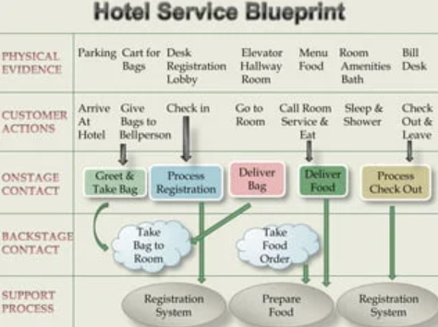
Hotel Service Blueprinting
Source: https://www.researchgate.net/
Service Blueprinting is a strategic management technique in the hotel industry that provides organised development process to map the guest’s experience (Ivanov, 2019). Moreover, the purpose of Service Blueprinting is to present a holistic picture of the service and experience of the hotel delivered to the guests by identifying the appropriate channels (Soteriades, 2019). The user experience and touch points of the hotel are planned with the help of Service Blueprinting. The key elements that help to develop a Service Blueprinting are the analysis of the physical evidence, expected customer action, desired employee action, designing of the support services, optional categories, and development of the customer scenario (Kozak, 2018). Moreover, service blueprinting helps the management of the hotel to map the expected customer behaviour by assessing the desired company’s action. The service blueprinting enhances the awareness among the staff about their responsibilities at the workplace (O’Connor, 2021). Hence, service blueprinting is a strategic move of the hospitality organisation to ensure the guests are receiving the desired service from the staff.
‘Staff Training’ is an effective measure to improve employee performance by focusing on maximum customer satisfaction (O’Connor, 2021). The upskilling process of the employees to attain the desired business outcomes can be spotted from the staff training. Staff Training is a returnable investment of the organisation to attain the desired productivity (Novative, 2023).
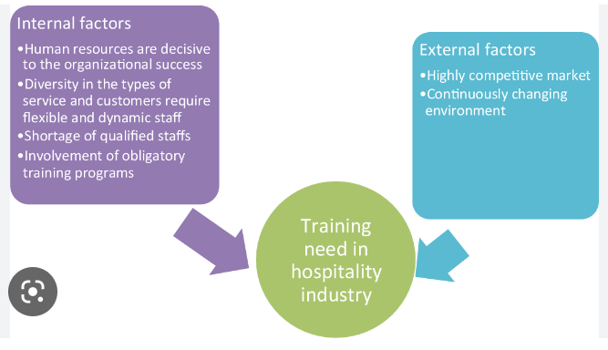
Staff Training
Source: https://www.semanticscholar.org/
The inefficiency of the frontline and housekeeping staff of Premier Inn can be overcome with staff training. The relevant topics like greeting the guests, assisting the guests in the check-in and check-out process, and maintaining cleanliness and hygiene can create awareness among the staff and also deliver the expected services to the guests (Ntounis, 2022). Sigala (2021), pointed out that staff training is effective to put the skills to better use and also to drive their specialisation in their work area. The lack of preparedness has a cascading effect on customer satisfaction and also increases the stress level of the employees (Wang, 2021). The comprehensive training programmes facilitate the managers and staff to attain the benchmark of quality services. Trained employees can create happy customers by generating a positive experience. In a study, it has been observed that well-trained employees can enhance the quality of service and makes the guests feel comfortable and cared for. Furthermore, staff training is considered to be an effective solution to overcome the high staff turnover issues and skill shortages in the hospitality sector (Spanaki, 2021). The staff training supports the employees to learn new skills and competencies. The guest’s complaints regarding the service inefficiency can be solved and managed through staff training.

Findings & Results
The report has observed the ‘skill gap’ and ‘service deficiency’ of the front-line and housekeeping staff of Premier Inn London Brixton hotel. The guests are not allocated the rooms as per their requests. Moreover, guests are also not satisfied with the housekeeping services provided by the hotel. The amenities like poor wi-fi connection, elevator malfunctioning, and inadequate heating issues are the key complaints raised by the guests which have failed to attend by housekeeping and front-line staff. The guests have mentioned that a ‘one night stay’ is only recommended for Premier Inn London Brixton hotel due to major service gaps owing to the ‘skill gap’ and ‘service deficiency’.
TOWS Analysis | Strengths (S)  - The positive financial performance of Premier Inn under Whitbread Plc has supported the business operations in the post-pandemic period. In the year 2022, Premier Inn reported a pre-tax profit of around £307.4m. The statutory revenue of the company has increased in the year 2022 from £589.4m to £1703.4m (Whitbread, 2022). The adjusted loss in the year 2022 has been reduced from £635.1m to £15.8m. The UK accommodation sales have increased from 194% to 204% in the year 2022. The organisational performance of Whitbread Plc is gradually developing with the increase in revenue and profits.  - The positive Brand Equity of Premier Inn can be spotted. Premier Inn is one of the trusted hotel brands that have more than 72,000 rooms along with 800 hotels. The frequent deals with the customers and the proper location are the key strengths of the Premier Inn. Moreover, affordable pricing with quality services for budget travellers is the unique selling proposition of the hotel. | Weaknesses (W)  - The front-line staffs managing the reservation, room allocation, and guests request are inefficient to meet the guest’s demands. The lack of guidance and training for the front-line staff is affecting the service quality. The service gap existing between customer expectations and actual service is hampering the brand image. Moreover, the housekeeping department is ineffective in ensuring the cleanliness and aesthetic appeal of the rooms and public areas (Chen, 2020).  - The inefficient housekeeping staffs are unable to meet the guest’s request. From the reviews, it has been spotted that the guests have pointed out the inefficient staff is not fixing up the washroom cleanliness. Moreover, uncleaned beds, linens, and rooms are a negative experience encountered by the guests at Premier Inn.
Opportunities (O)  - Digitalisation in the business has supported the hospitality business to attain greater operational efficiency. Presently, 6.92 billion people across the world are smartphone users. The active users of social media users reached 4.48 billion in the year 2021 (Statista, 2022).  - The targeted tourist group like millennials and Gen Z are the top travellers in the hospitality industry. As per the report, it has been spotted that the millennial and Gen Z within the age group 18 to 34 used to represent 50% of the travellers within the year 2025 (hospitality, 2020) | Strength/Opportunities Strategies  - Business Expansion and service upgradation for attracting the millennials and Generation Z customer groups can be effective for Premier Inn.  - Cross-selling the hospitality services like food and beverage, transportation, city tours, and other services can increase the business turnover of Premier Inn. | Weakness/Opportunities strategies  - Investment into the untapped market can drive the market share and increases the market value of Premier Inn.  - Conducting staff training and development programmes to reduce the skill gap and also to undertake upskilling activities (Lynch, 2019). Staff training is essential for Premier Inn to ensure the guests are receiving a superior value proposition.
Threats (T)  - The competitors like Holiday Inn, Easyhotel, and Ibis are also catering to the budget category segment (Barrows, 2019). Moreover, strong competition from Marriott and other independent hotel chains is also observed. Customers that are not satisfied with the value proposition of Premier Inn can switch to other brands in the same budget category segment.  - Economic fluctuation across the world is affecting the spending of customers on non-essential items (Lewis, 2019). Moreover, the rising inflation rate across the world is a negative macroeconomic trend that is impactful the hospitality business operations. | Strength/Threat Strategies  - Premier Inn has to engage multiple ‘customer engagement strategies through word-of-mouth marketing in digital channels (Kansakar, 2021). The social media networks like Facebook, Instagram, etc. can be used strategically to promote Brand Awareness among target groups across the world. The responsiveness of the marketing team to deal with the customer’s queries and grievances need to be active.  - Premier Inn can utilise ‘sales promotion’ techniques like attractive pricing deals, free personalised services, early bird discount offers, and redeemable schemes to create interest among the target groups (Grunig, 2019). Moreover, extensive competition can be overcome with an effective sales promotion technique as it develops a hedonic impact on the mind of the people. | Weakness/Threat strategies  - Improving the current appeal of the services to increase the brand reputation in the hospitality market (Ansoff, 2018).  - Focusing on sustainable business practices to encourage people across the world in selecting the Premier Inn for their accommodation needs (Bowman, 2019).

Action Plan
Number | Problem | Solution | Desired Outcome | Time Scale | Completion Date | Planned Budget
1 | Inefficiency of the frontline and housekeeping staffs | Providing the frontline and housekeeping staff with regular opportunities for training and development is the way to address this problem (Choi & Choi, 2021). Also, making it easier for people to talk to each other and giving staff members regular feedback to help them see areas for improvement and recognize good work. Additionally, completing work on time and to a high standard is ensured by effectively delegating tasks to the appropriate staff members. | The desired outcome will improve the customer experience by ensuring that tasks are completed effectively and efficiently, which will raise customer satisfaction. Employees will also feel more confident in their roles and better prepared to carry them out, which will boost morale and job satisfaction. The hotel will also save money and run more smoothly and effectively as a result of the staff's increased effectiveness (Hu, et al., 2022). | 5 months | 08/07/2023 | £15000
2 | Failing to meet guest expectations | The solution to this issue is analysing feedback from customers on a regular basis to find areas where expectations are not being met. Reviewing service on a regular basis to see if staff members are meeting guest expectations and where they can improve (Tuomi, et al., 2021). Additionally, reviewing and enhancing service standards to guarantee that customers receive the quality of service they expect. | As a result, guests will receive the level of service they expect and have their needs met promptly and effectively, which will improve the hotel's reputation and increase customer satisfaction. Employees will feel more confident in their ability to meet guest expectations and will be better equipped to provide excellent customer service, which will also improve employee morale and job satisfaction. Furthermore, increased customer satisfaction will result in increased customer loyalty and repeat business, laying a solid foundation for Premier Inn's ongoing success (Lv, et al., 2022). | 3 months | 15/05/2023 | £10000

Recommendations
The following recommendations can be made to reduce the inefficiency of the front-line and housekeeping staff and meet the needs of Premier Inn UK guests:
Employee training and development - To provide staff members with the knowledge and abilities they require to carry out their responsibilities in an effective and efficient manner, Premier Inn should make regular investments in training and development opportunities. Customer service, leadership, and technology training are all examples of this (Marinakou & Giousmpasoglou, 2019).
Employee feedback and recognition - Providing regular opportunities for employee recognition and encouraging employees to provide feedback on their work experiences. Staff members will feel valued and appreciated as a result, which can boost morale and job satisfaction.
Transparency in expectations and responsibilities - It is important to regularly communicate expectations and responsibilities to staff members. This will guarantee that each member of staff is aware of their role and how it helps meet guest expectations. Job descriptions, role definitions, and regular performance reviews are all ways to accomplish this (Becker, et al., 2019).
Technology implementation - Consider implementing automated scheduling systems, property management systems, and mobile applications as technology solutions that can boost employee productivity. Employees can use these tools to carry out their responsibilities in a more effective and efficient manner, freeing up time to concentrate on providing excellent customer service.
Effective delegation - Ensuring that tasks are effectively delegated and that staff members have a workload that is manageable. Time management and making sure employees have the resources and tools they need to do their jobs well are two ways to accomplish this (Madsen & Johanson, 2022).
It is important to understand that these recommendations are based on theories like Herzberg's two-factor theory, which says that hygiene factors like job security and working conditions and motivators like recognition and accomplishment have an impact on employee motivation. The hygiene factors and motivators that influence employee motivation can be improved by Premier Inn by providing regular opportunities for training and development, effective delegation, and employee feedback and recognition (Holston-Okae & Mushi, 2018). This will result in a workforce that is more efficient and effective. In addition, the theory of technological determinism, which asserts that technology can be utilised to resolve complex issues such as workforce inefficiency, serves as the foundation for the technology implementation recommendation (Hensmans, 2022).

Conclusion
Therefore, from the overall discussion, it can be concluded by saying that the aspects of customer service are a significant part of the front office department of Premier Inn hotels. The hotel is facing issues related to the inefficiency of employees in the front office department of the business and that is leading towards issues arising among the customers visiting the hotel who are not satisfied with the services they are getting. The findings and research have showcased how both external and internal aspects of the business tend to affect the processes of the business. Moreover, the main solution to resolving such issues is providing continuous training to employees, communicating with them regarding their job role transparently and also taking feedback from both the customers and the employees to implement changes and improvements. Moreover, the report has also provided an action plan as a consultancy as to how the issues can be resolved and what benefits can be achieved from them along with providing the total budget that will be required by the consultancy to implement such processes.

References
Achinas, S., Horjus, J., Achinas, V. & Euverink, G., 2019. A PESTLE analysis of biofuels energy industry in Europe. Sustainability, 11(21), p. 5981.
Amadeus, 2022. Premier Inn upgrades. [Online]
Available at: https://amadeus.com/en/insights/blog/premier-inn-upgrades-to-amadeus-hospitality-technology
[Accessed 25 11 2022].
Ansoff, H., 2018. Implanting strategic management.. London : Springer.
Araujo, C., 2019. The utilization of product development methods in hospitality organisations: A survey of UK industry. Journal of Engeering Design, 7(4), pp. 265-277.
Barrows, C. a. P. T., 2019. Introduction to management in the hospitality industry, study guide. London : John Wiley & Sons.
Baum, T., 2020. Skills and training for the hospitality sector: a review of issues. Journal of vocational Education and Training, 54(3), pp. 343-364.
Baum, T. a. H. N., 2021. Hospitality, tourism, human rights and the impact of COVID-19. International Journal of Contemporary Hospitality Management, 32(4), pp. 2397-2407.
BBC, 2020. Covid: 'A fifth' of hospitality sector jobs lost in 2020. [Online]
Available at: https://www.bbc.com/news/business-54972940
[Accessed 25 11 2022].
Becker, C., 2020. Service recovery strategies: The impact of cultural differences. Journal of Hospitality & Tourism Research, 15(5), pp. 526-538.
Becker, S., Demski, C., Evensen, D. & Pidgeon, N., 2019. Of profits, transparency, and responsibility: public views on financing energy system change in Great Britain. Energy Research & Social Science, Volume 55, pp. 236-246.
Bowman, C. a. A. D., 2019. Strategic management. London : Pearson .
Brownell, J., 2017. Striking a balance: The future of work and family issues in the hospitality industry. International Journal of Human Resources Development and Management, 28(5), pp. 109-123.
Camisón, C., 2020. Strategic attitudes and information technologies in the hospitality business: an empirical analysis. International Journal of Hospitality Management, 19(4), pp. 125-143.
Chen, B. T., 2020. Technological advances in hospitality and tourism. Journal of hospitality and tourism technology , 6(1), pp. 222-225.
Chi, C. a. G. D., 2020. Employee satisfaction, customer satisfaction, and financial performance: An empirical examination. International journal of hospitality management, 28(4), pp. 245-253.
Choi, M. & Choi, Y., 2021. Employee perceptions of hotel CSR activities during the COVID-19 pandemic. International Journal of Contemporary Hospitality Management, 33(10), pp. 3355-3378.
Czinkota, M. et al., 2021. Marketing Planning. Marketing Management: Past, Present and Future, pp. 43-90.
Dandage, R., Mantha, S. & Rane, S., 2019. Strategy development using TOWS matrix for international project risk management based on prioritization of risk categories. International Journal of Managing Projects in Business.
David, J., 2019. PESTEL analysis of the UK. Retrieved October, 30(12), p. 2019.
George, R., 2021. Tourism and Hospitality Marketing Planning. In Marketing Tourism and Hospitality: Concepts and Cases, pp. 149-182.
Gowrea, V., 2021. SWOT analysis of Premier Inn (Premier Inn SWOT). [Online]
Available at: https://howandwhat.net/swot-analysis-premier-inn-premier-inn-swot-analysis/
[Accessed 2022].
Gowrea, V., 2022. SWOT analysis of Premier Inn (Premier Inn SWOT). [Online]
Available at: https://www.howandwhat.net/swot-analysis-premier-inn-premier-inn-swot-analysis/
[Accessed 2023].
Grunig, J. a. R. F., 2019. Strategic management, publics, and issues. Excellence in public relations and communication management, 12(3), pp. 117-157.
Hemmington, N., 2020. From service to experience: Understanding and defining the hospitality business. The Service Industries Journal, 27(8), pp. 747-755.
Hensmans, M., 2022. The innovation pyramid: five approaches to strategic decision-making. Journal of Business Strategy, 43(4), pp. 229-238.
Holston-Okae, B. & Mushi, R., 2018. Employee turnover in the hospitality industry using Herzberg’s two-factor motivation-hygiene theory. International Journal of Academic Research in Business and Social Sciences, 8(1), pp. 218-248.
hospitality, U., 2020. Retaining Staff. [Online]
Available at: https://www.ukhospitality.org.uk/blogpost/1721400/325437/Retaining-Staff
[Accessed 22 04 2022].
Hu, F., Trivedi, R. & Teichert, T., 2022. Using hotel reviews to assess hotel frontline employees’ roles and performances. International Journal of Contemporary Hospitality Management.
Hutton, G., 2020. Hospitality industry and Covid-19. [Online]
Available at: https://commonslibrary.parliament.uk/research-briefings/cbp-9111/
[Accessed 05 06 202].
Ivanov, S. &. W. C., 2019. Robots, artificial intelligence, and service automation in travel, tourism and hospitality. London : Emerald Publishing Limited.
Kansakar, P. M. A. a. S. N., 2021. Technology in the hospitality industry: Prospects and challenges. IEEE Consumer Electronics Magazine, 11(3), pp. 60-65.
Kolios, A. & Read, G., 2018. A political, economic, social, technology, legal and environmental (PESTLE) approach for risk identification of the tidal industry in the United Kingdom. Energies, 6(10), pp. 5023-5045.
Kollewe, J., 2021. Premier Inn owner Whitbread swings to £1bn loss amid Covid lockdowns. [Online]
Available at: https://www.theguardian.com/business/2021/apr/27/premier-inn-whitbread-loss-covid-lockdowns-beefeater-brewers-fayre
[Accessed 08 02 2023].
Kozak, M. a. R. M., 2018. Measuring tourist destination competitiveness: conceptual considerations and empirical findings. International Journal of Hospitality Management, 18(5), pp. 273-283.
Kummitha, R., 2020. Smart technologies for fighting pandemics: The techno-and human-driven approaches in controlling the virus transmission. Government Information Quarterly, 37(3), p. 101481.
Lewis, P. a. T. H., 2019. The linkage between strategy, strategic groups, and performance in the UK retail grocery industry. Strategic Management Journal, 11(3), pp. 385-397.
Lv, X. et al., 2022. Artificial intelligence service recovery: The role of empathic response in hospitality customers’ continuous usage intention. Computers in Human Behavior, Volume 126, p. 106993.
Lynch, R., 2019. Strategic Management. 8th ed. London: Pearson.
Madsen, D. & Johanson, D., 2022. Strategic Management Accounting.. In Encyclopedia of Tourism Management and Marketing, pp. 262-264.
Marinakou, E. & Giousmpasoglou, C., 2019. Talent management and retention strategies in luxury hotels: evidence from four countries. International Journal of Contemporary Hospitality Management.
Novative, 2023. The Importance of Training & Development in Hospitality. [Online]
Available at: https://www.novative.com/en/hospitality-the-importance-of-training-development-in-hospitality/
[Accessed 08 02 2023].
Ntounis, N., 2022. Tourism and Hospitality industry resilience during the Covid-19 pandemic: Evidence from England. Current Issues in Tourism, 25(12), pp. 46-59.
O’Connor, P. a. M. J., 2021. Research on information technology in the hospitality industry. International Journal of Hospitality Management, 23(4), pp. 473-484.
Parliament, U., 2021. Hospitality industry and Covid-19. [Online]
Available at: https://commonslibrary.parliament.uk/research-briefings/cbp-9111/#:~:text=Hospitality%20industry%20in%20the%20UK,-The%20hospitality%20industry&text=In%202019%20the%20hospitality%20sector,6.9%25%20of%20total%20UK%20employment.
[Accessed 25 02 2022].
pestleanalysis, 2019. An Example PEST Analysis of The UK. [Online]
Available at: https://pestleanalysis.com/pest-analysis-of-the-uk/
[Accessed 3029].
Poulston, J., 2020. Hospitality workplace problems and poor training: a close relationship. International Journal of Contemporary Hospitality Management, 22(4), pp. 223-227.
Research, B., 2022. Hospitality Global Market Report 2022. [Online]
Available at: https://www.thebusinessresearchcompany.com/report/hospitality-global-market-report
[Accessed 19 07 2022].
Saleh, A. & Zohry, M., 2022. Towards A Sustainable Hotel Education (An Analytical Strategic Study at The Faculty of Tourism and Hotels, Mansoura University-TOWS Matrix as A Model). International Journal of Tourism, Archaeology and Hospitality, 2(1), pp. 45-74.
seanbeandies , 2019. PREMIER INN MARKETING AUDIT. [Online]
Available at: https://premierinnmarketing.wordpress.com/2014/02/14/tows-analysis/
[Accessed 2023].
Shatskaya, E., Samarina, M. & Nekhorosheva, K., 2020. PESTEL analysis as a tool of strategic analysis in international markets. Scope Academic House B&M Publishing, 12(7), p. 47.
Sigala, M. a. B. T., 2021. Trends and issues in tourism and hospitality higher education: Visioning the future. Tourism and hospitality research, 2(1), pp. 367-376.
Soteriades, M. a. D. I., 2019. Special events: A framework for efficient management. Journal of Hospitality Marketing & Management, 20(5), pp. 329-346.
Spanaki, M., 2021. Tourism in the post COVID-19 era: evidence from hotels in the North East of England. Worldwide Hospitality and Tourism Themes, 13(5), pp. 357-368.
Statista, 2020. COVID-19 impact on footfall of hospitality businesses in the UK 2020. [Online]
Available at: https://www.statista.com/statistics/1168471/covid-19-impact-on-hospitality-industry-footfall-uk/
[Accessed 23 03 2021].
Statista, 2022. Number of social media users in the world. [Online]
Available at: https://www.statista.com/statistics/278414/number-of-worldwide-social-network-users/#:~:text=How%20many%20people%20use%20social,almost%20six%20billion%20in%202027.
[Accessed 14 10 2022].
Thant, Z. & Chang, Y., 2021. Determinants of public employee job satisfaction in Myanmar: Focus on Herzberg’s two factor theory. Public Organization Review, 21(1), pp. 157-175.
Thomas, P., Sandwell, P., Williamson, S. & Harper, P., 2021. A PESTLE analysis of solar home systems in refugee camps in Rwanda. Renewable and Sustainable Energy Reviews, Volume 143, p. 110872.
Tuomi, A., Tussyadiah, I. & Stienmetz, J., 2021. Applications and implications of service robots in hospitality. Cornell Hospitality Quarterly, 62(2), pp. 232-247.
Wang, J., 2021. Issues, challenges, and trends, that facing hospitality industry. Management science and engineering, 3(1), pp. 53-58.
Whitbread, 2022. FY22 Results. [Online]
Available at: https://cdn.whitbread.co.uk/media/2022/04/FY22-RNS-FINAL-COMBINED.pdf
[Accessed 08 02 2023].
Woo, L. a. S. K., 2018. Importance of F&B operation in luxury hotels. International Journal of Contemporary Hospitality Management, 34(6), pp. 222-229.
Zahari, A. & Romli, F., 2019. Analysis of operation using PESTLE. Journal of external environmental analysis, 192(14), p. 104901.

