Marketing Plan
Tutpr Name : Luciana Suardi
Student Name: Iuliana Daniela Giurea
Student ID: 2226406

Table of Contents
Component A 3
Introduction 3
Situation Analysis 3
Conclusion 11
Component B 12
Slide 1: Component B: Presentation 12
Slide 2: Introduction 12
Slide 3: Situational analysis 12
Slide 4: Continue 12
Slide 5: Objectives 13
Slide 6: Strategy 13
Slide 7: Tactics 13
Slide 8: Action 13
Slide 9: Control and conclusion 14
References 15

Component A

Introduction
A marketing plan is essentially the advertising approach that companies use to promote their services or goods. Hilton Hotel has been chosen as the location for the current investigation. Finding the company's marketing opportunity in the present market is the goal of the Hilton Hotel's marketing plan. The management of the Hilton Hotel will get the marketing strategy, which will assist the business in seizing the possibilities. In this research, a SMART aim, a SWOT analysis, targeting ad segmentation, Bowman's strategy clock, the four Ps or marketing mix, and more will be presented.

Situation Analysis
Company: SWOT analysis (Micro analysis)
Strengths  Outstanding customer service, a wide-ranging worldwide presence, a broad network of hotels, and a strong brand awareness (Chaffey, and Smith, 2022). | Weaknesses  Weaknesses include the hotel sector's intense competitiveness, reliance on economic circumstances, the propensity for customers to perceive exorbitant pricing, and the use of third-party booking systems.
Opportunities  Opportunities include expanding into developing areas, providing individualised guest experiences through technology, and rising demand for premium and experiential travel. | Threats  Threats include the travel industry's economic downturns, new competitors, shifting consumer tastes and expectations, and potentially damaging effects of geopolitical events (Fahy, and Jobber, 2019).

Customers- Segmentation and targeting
Segmentation type | Criteria | Target segment of Hilton Hotel
Demographic | Age | 25-40
Demographic | Income | Middle
Demographic | Occupation | No occupational boundary is required to visit the Hilton Hotel. From Doctors, Engineers to students, anyone can visit the hotel.
Psychographic | Social status | Middle-class and upper-middle-class.
Psychographic | Hobby | People who prefer to spend time in luxury (Ferrell et al., 2021).
Psychographic | Lifestyle | People who prefer the use of technology in their regular life.
Behavioural | Personality | Compassionate.
Behavioural | Benefits sought | Individuals who are very keen to enjoy their holidays in a lavishing way.
Geographic | Region | Nigeria.
Table 2: Targeting and segmentation of Hilton Hotel
(Source: Self-developed)
Competitors: Perceptual positioning map, Bowmans strategy clock
Competitors
Several significant competitors in the hospitality sector, including Marriott International, InterContinental Hotels Group (IHG), AccorHotels, and Hyatt Hotels Corporation, compete with Hilton Hotel.
Map of perceptual positioning
A perceptual positioning map can show how clients view the Hilton Hotel in comparison to its rivals. You may plot variables like cost, opulence, facilities, and target market preferences to examine Hilton's placement in relation to its rivals (Jin et al., 2019).
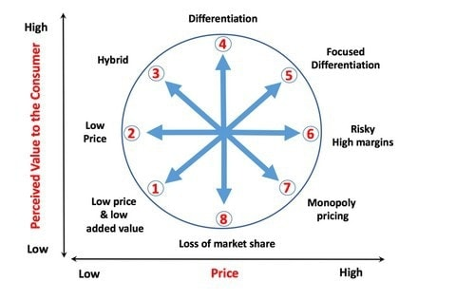
Figure: Bowmans strategy clock
Source: (Marketing91, 2019)

Bowman's Timer for Strategy
A competitive strategy evaluation tool that Hilton Hotel can use is Bowman's Strategy Clock. This model makes it possible to identify relevant tactics, such differentiation, low-cost leadership, or hybrid methods, to achieve a competitive advantage in the market by analysing the hotel's position in terms of price and perceived value compared to rivals.
Collaborators
Towards improving operations and widen its reach, Hilton Hotel has built strong B2B alliances, partnerships, and franchises.
B2B Partnerships: The Hilton Hotel works with a variety of companies, including airlines, corporate event planners, travel agents, and internet travel agencies. These connections promote reservations, draw business clients, and provide packaged travel deals (Huang, and Rust, 2021).
Partnerships: The Hilton Hotel enters into strategic alliances with businesses from a range of sectors, including the airline, credit card, and entertainment industries. These alliances frequently include joint loyalty programmes, co-branded credit cards, and special deals for clients.
Franchises: The Hilton Hotel also enters into franchise contracts that let independent hotel operators use the Hilton name. With this strategy, Hilton can swiftly and effectively increase its market share.
These B2B connections, alliances, and franchises support Hilton's expansion, market presence, and capacity to offer a wide range of services and advantages to its clients.
Climate: PESTLE (Macro analysis)
Political: Especially in various nations, government rules, taxation practises, and political stability may have an influence on Hilton Hotel operations.
Economic: Economic variables that affect the demand for hospitality services and have an impact on Hilton's financial performance include currency rates, GDP growth, and consumer spending habits.
Sociocultural: Social and cultural aspects, including as consumer preferences, travel patterns, and demography, have an impact on how Hilton designs its marketing campaigns and the experiences it offers its guests.
Technological: Hilton has the chance to improve operational effectiveness and provide individualised services thanks to developments in the hospitality sector's use of mobile applications, AI, and data analytics (Morrison, 2022).
Legal: For Hilton Hotel to maintain legal and moral operations, compliance with local and international laws, regulations, and employment practises is essential.
Environmental: As sustainability and eco-friendly practises receive more attention, Hilton must embrace environmentally conscious policies and lessen its environmental impact.
SMART Objectives
Specific: Increase the accommodation occupancy rate by 10% throughout the upcoming fiscal year.
Measurable: By adopting new menu options and promotions, increase food and beverage service revenue by 15%.
Achievable: Obtain sustainability certifications while implementing energy-saving measures to cut overall energy use by 20% (Diyanova et al., 2019).
Relevant: Increase customer satisfaction by receiving at least a 4.5 out of 5 rating from visitors.
Time- Bound: Launch a new loyalty programme over the next six months, and sign up 50,000 new members.
Strategy
The Hilton Hotel's value offer is based on its dedication to excellent quality, individualised service, and international knowledge. The company sets itself apart by providing opulent lodgings, customised experiences, and uniform standards across its extensive worldwide network. Through marketing and advertising initiatives that showcase Hilton's great service, customer reviews, and the unique advantages of its loyalty programme, this value proposition may be effectively communicated. Every Hilton visitor is guaranteed a unique and unforgettable experience thanks to the value proposition's delivery methods, which include thorough employee training, upholding high standards, ongoing innovation, and rapid resolution of guest complaints.
Tactics (Marketing Mix)
Product: Hilton Hotel provides a variety of upmarket rooms to guarantee that guests have a comfortable and memorable stay. Luxury rooms, suites, and speciality options are available to guests, each catered to their unique tastes and requirements. The Hilton Hotel also offers a variety of amenities to improve the overall visitor experience. These include rejuvenating spas, well-equipped gyms, and on-site eating options that provide a variety of gastronomic experiences. The Hilton Hotel aims to give its visitors a luxurious and enjoyable stay by providing these amenities and services (Tien et al., 2019).
Place: Placing its hotels in strategic locations, Hilton Hotel provides easy access and near proximity to important landmarks, airports, and business centres. The Hilton Hotel deliberately chooses premier sites to meet the demands of its visitors, whether they are in large cities teeming with cultural and entertainment attractions, well-liked tourist destinations renowned for their scenic beauty, or commercial centres humming with business operations. Hilton Hotel seeks to offer ease and accessibility by placing its hotels in these ideal locations, enabling visitors to easily explore their surroundings, attend crucial business meetings, or just enjoy their holiday without any transportation issues (Sun et al., 2019).
Price: The Hilton Hotel's price policy is consistent with its upscale status in the industry. It provides reasonable rates that change according to room types, packages, and seasonal demand, giving visitors the freedom to select lodgings that fit their needs and budgets. The Hilton Hotel also offers value through its loyalty programme by giving members access to exclusive privileges and incentives. Special offers and promotions raise the value proposition even further by enabling visitors to take advantage of distinctive experiences or extra benefits while visiting. Hilton Hotel aspires to create a compelling and alluring price structure for its visitors by fusing low pricing with extra value provided by loyalty programmes and special offers.
Promotion: In order to efficiently raise brand awareness, showcase its unique selling points, and let target audiences know about exclusive specials, Hilton Hotel uses a thorough marketing mix. The Hilton Hotel showcases its opulent lodgings and first-rate services to a large audience through advertising efforts, both online and offline. Utilising numerous online channels, such as social media and search engine marketing, are part of the hotel's digital marketing efforts to engage potential customers and direct traffic to the website. Initiatives in public relations aid in generating favourable media attention and brand recognition. Additionally, Hilton Hotel is able to directly engage with its target audience through direct marketing campaigns like email marketing and personalised offers, making sure customers are informed of unique specials and unheard-of discounts (Sun et al., 2019).
Action
Goals | Week 1-2 | Week 3-4 | Week 5-6 | Week 7-8 | Week 9-10
Developing marketing goals
Conducting marketing audit and research
Target audience identification
Developing budget
Identifying marketing strategies
Figure: Gantt Chart
Source: Self- Created
Control
Several important factors may be used to gauge the Hilton Hotel's success. First off, a rise in the number of new consumers might show how successful marketing campaigns were in luring and acquiring new customers. Second, customer satisfaction surveys, internet reviews, and sentiment analysis of social media may all be used to gauge favourable brand perceptions, which represent the Hilton Hotel's overall image and reputation. The capacity of the hotel to produce revenue and maximise profitability through successful marketing tactics, efficient operations, and strong customer loyalty is also demonstrated by a rise in earnings, which is a crucial statistic. The Hilton Hotel may determine its success in terms of client acquisition, brand perception, and financial performance by monitoring these factors (Barlow et al., 2021).

Conclusion
The marketing strategy for the Hilton Hotel must contend with issues including heightened competition, evolving consumer tastes, a shaky economy, and technological breakthroughs. In order to overcome these obstacles, Hilton could stand out by emphasising special products, utilising technology for individualised experiences, and remaining flexible in responding to shifting client wants. It is advised to invest in digital marketing platforms, diversify your target audiences, and use flexible pricing techniques. The success of Hilton will also be aided by data analytics, sustainability programmes, strategic alliances, and prompt consumer feedback responses. By resolving these issues and putting the suggested tactics into practise, Hilton Hotel may improve its standing in the competitive hospitality market, draw in more clients, and promote sustainable growth.

Component B

Slide 1: Component B: Presentation

Slide 3: Introduction
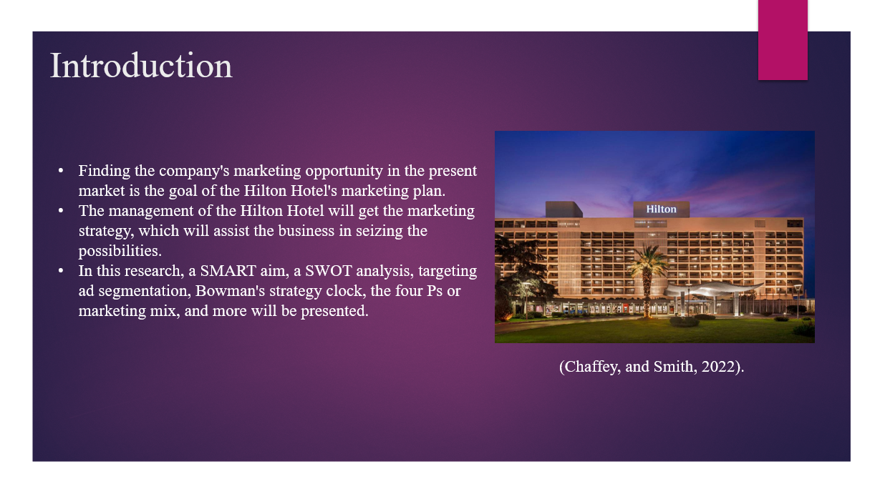
1. Finding the company's marketing opportunity in the present market is the goal of the Hilton Hotel's marketing plan.
2. The management of the Hilton Hotel will get the marketing strategy, which will assist the business in seizing the possibilities.
3. In this research, a SMART aim, a SWOT analysis, targeting ad segmentation, Bowman's strategy clock, the four Ps or marketing mix, and more will be presented.

Slide 4: Situational analysis
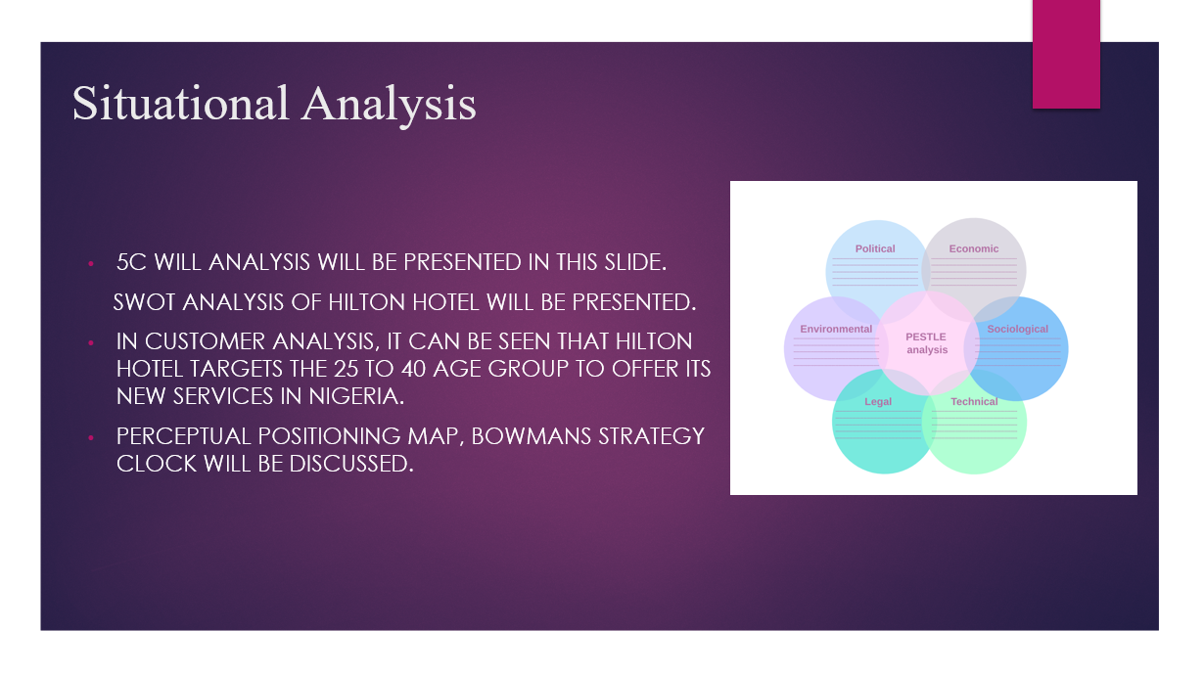
1. 5C will analysis will be presented in this slide.
2. SWOT Analysis of Hilton Hotel will be presented.
3. In customer analysis, it can be seen that Hilton Hotel targets the 25 to 40 age group to offer its new services in Nigeria.
4. Perceptual positioning map, Bowman’s strategy clock will be discussed.

Slide 5: Continue
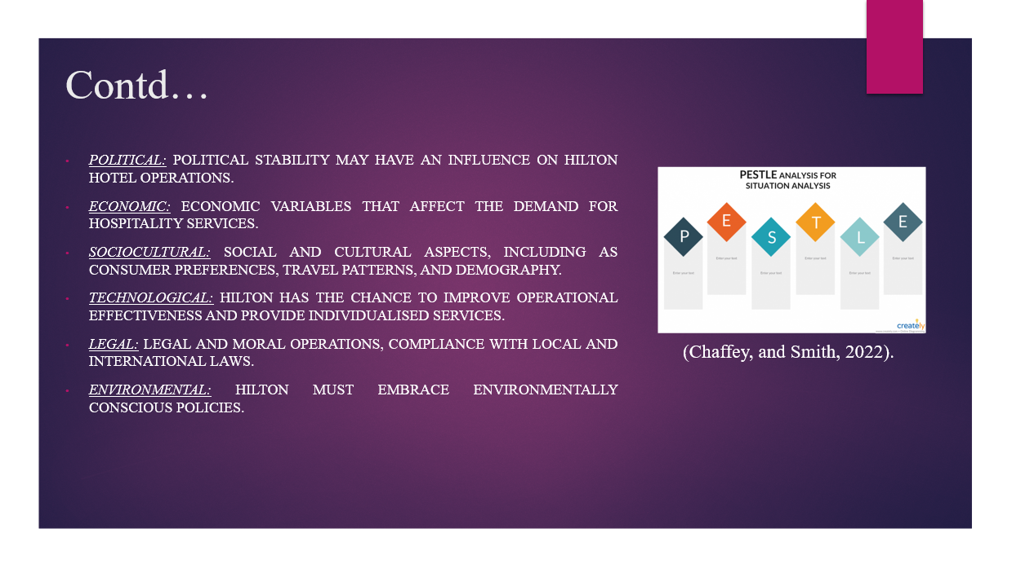
1. Political: political stability may have an influence on Hilton Hotel operations.
2. Economic: Economic variables that affect the demand for hospitality services.
3. Sociocultural: Social and cultural aspects, including as consumer preferences, travel patterns, and demography.
4. Technological: Hilton has the chance to improve operational effectiveness and provide individualised services.
5. Legal: legal and moral operations, compliance with local and international laws.
6. Environmental: Hilton must embrace environmentally conscious policies.

Slide 6: Objectives
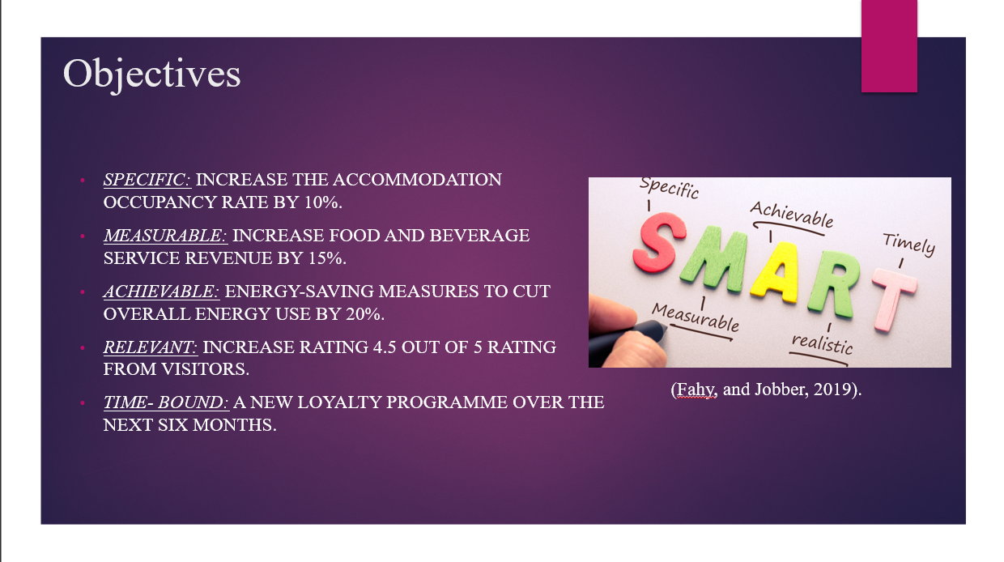
1. Specific: Increase the accommodation occupancy rate by 10%.
2. Measurable: increase food and beverage service revenue by 15%.
3. Achievable: energy-saving measures to cut overall energy use by 20%.
4. Relevant: Increase rating 4.5 out of 5 rating from visitors.
5. Time- Bound: a new loyalty programme over the next six months.

Slide 7: Strategy
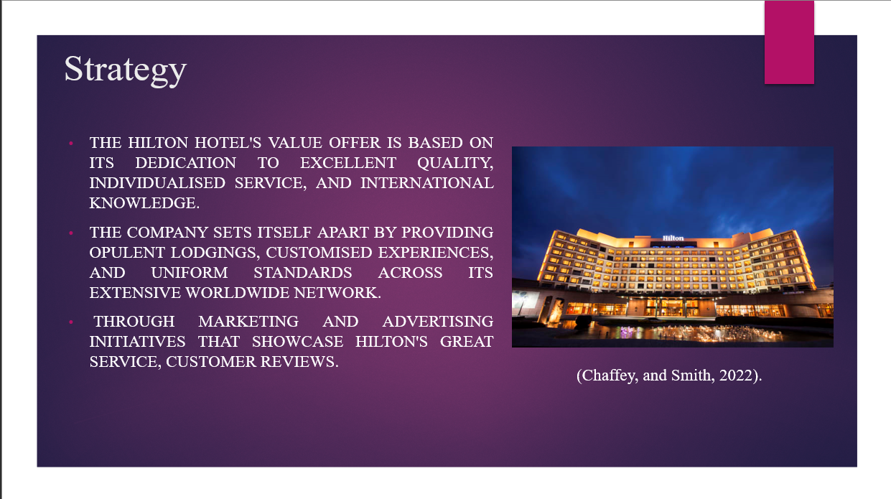
1. The Hilton Hotel's value offer is based on its dedication to excellent quality, individualised service, and international knowledge.
2. The company sets itself apart by providing opulent lodgings, customised experiences, and uniform standards across its extensive worldwide network.
3. Through marketing and advertising initiatives that showcase Hilton's great service, customer reviews.

Slide 8: Tactics
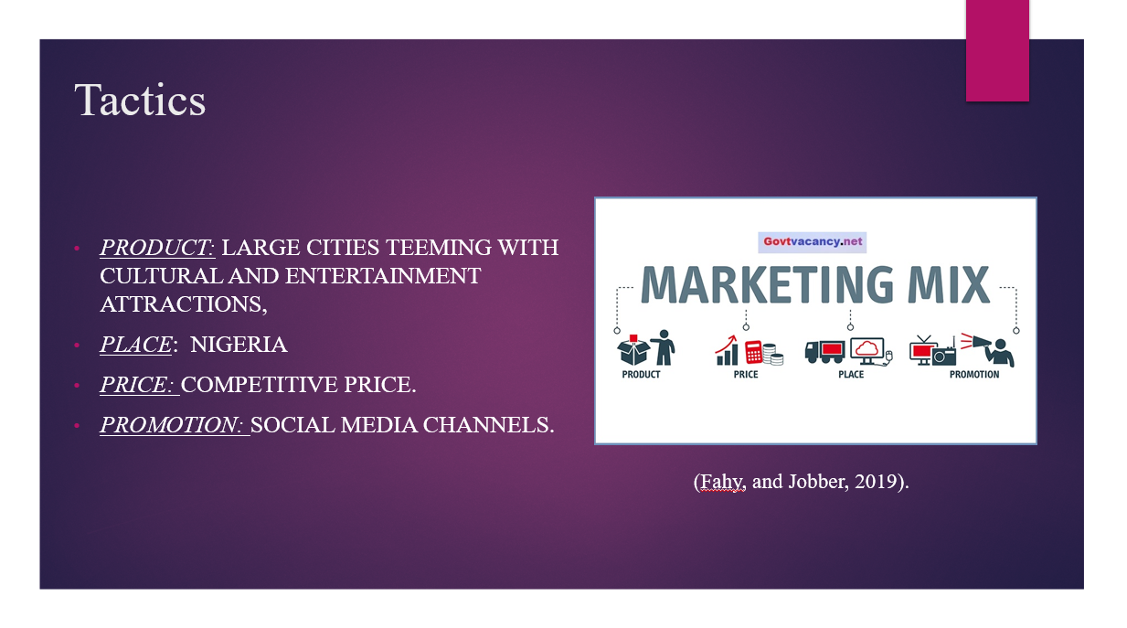
1. Product: large cities teeming with cultural and entertainment attractions,
2. Place: Nigeria
3. Price: Competitive price.
4. Promotion: Social Media channels.

Slide 9: Action
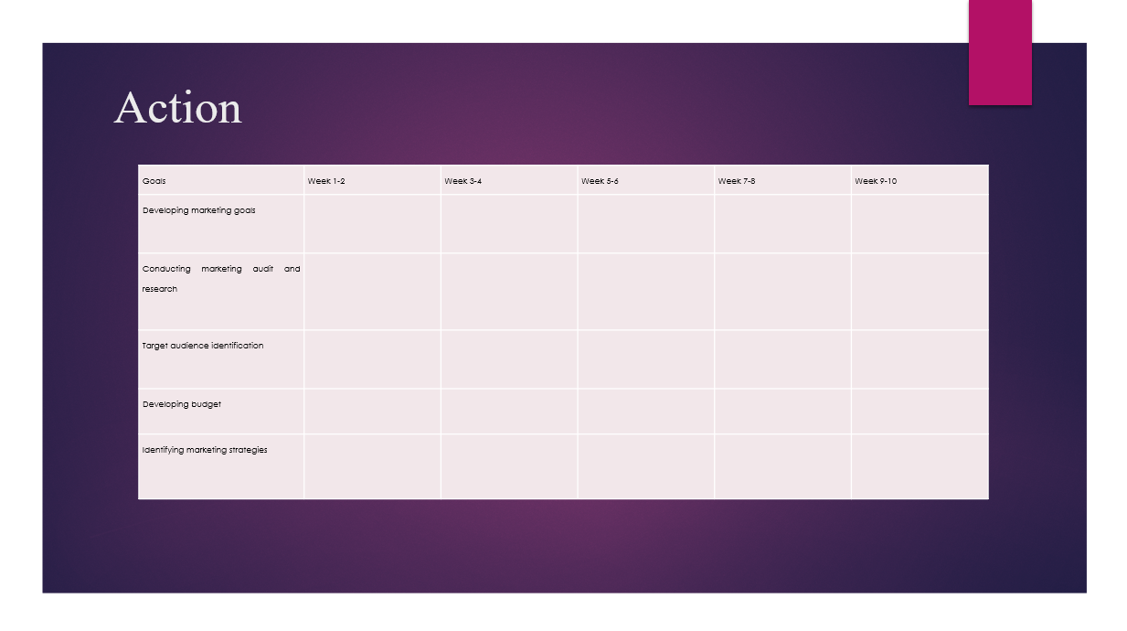
Goals | Week 1-2 | Week 3-4 | Week 5-6 | Week 7-8 | Week 9-10
Developing marketing goals
Conducting marketing audit and research
Target audience identification
Developing budget
Identifying marketing strategies
Figure : Gantt Chart of the marketing plan
(Source: Self-developed)

Slide 10: Control and conclusion
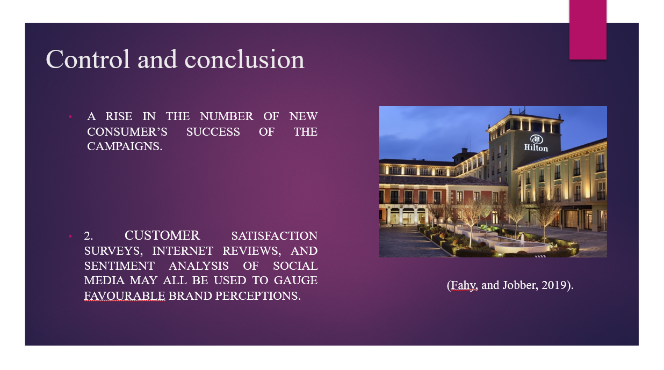
1. A rise in the number of new consumer’s success of the campaigns.
2. Customer satisfaction surveys, internet reviews, and sentiment analysis of social media may all be used to gauge favourable brand perceptions.
3. Data analytics, sustainability programmes, strategic alliances, and prompt consumer feedback responses will lead to success.

References
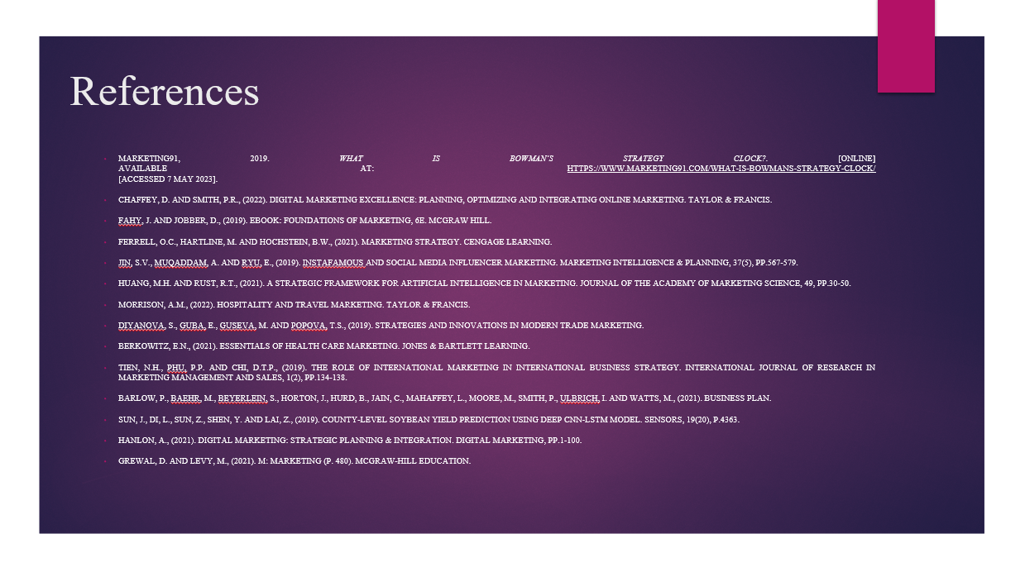
Barlow, P., Baehr, M., Beyerlein, S., Horton, J., Hurd, B., Jain, C., Mahaffey, L., Moore, M., Smith, P., Ulbrich, I. and Watts, M., (2021). Business plan.
Berkowitz, E.N., (2021). Essentials of health care marketing. Jones & Bartlett Learning.
Chaffey, D. and Smith, P.R., (2022). Digital marketing excellence: planning, optimizing and integrating online marketing. Taylor & Francis.
Diyanova, S., Guba, E., Guseva, M. and Popova, T.S., (2019). Strategies and innovations in modern trade marketing.
Fahy, J. and Jobber, D., (2019). EBOOK: Foundations of Marketing, 6e. McGraw Hill.
Ferrell, O.C., Hartline, M. and Hochstein, B.W., (2021). Marketing strategy. Cengage Learning.
Grewal, D. and Levy, M., (2021). M: marketing (p. 480). McGraw-Hill Education.
Hanlon, A., (2021). Digital marketing: strategic planning & integration. Digital Marketing, pp.1-100.
Huang, M.H. and Rust, R.T., (2021). A strategic framework for artificial intelligence in marketing. Journal of the Academy of Marketing Science, 49, pp.30-50.
Jin, S.V., Muqaddam, A. and Ryu, E., (2019). Instafamous and social media influencer marketing. Marketing Intelligence & Planning, 37(5), pp.567-579.
Marketing91, 2019. What is Bowman’s Strategy Clock?. [Online]
Available at: https://www.marketing91.com/what-is-bowmans-strategy-clock/
[Accessed 7 May 2023].
Morrison, A.M., (2022). Hospitality and travel marketing. Taylor & Francis.
Sun, J., Di, L., Sun, Z., Shen, Y. and Lai, Z., (2019). County-level soybean yield prediction using deep CNN-LSTM model. Sensors, 19(20), p.4363.
Tien, N.H., Phu, P.P. and Chi, D.T.P., (2019). The role of international marketing in international business strategy. International journal of research in marketing management and sales, 1(2), pp.134-138.

