Amy Robinson (Student Number: 30001126)
ECAD7003 Title: How a school develops one aspect of its SDP: a report that critically reflects on the actions, impact, and evidence base. (2,500 words)
Word count: 2,668 words

 | Target | What I have done in this assignment...
Target 1 | Please look at Academic Phrasebank | Being critical (manchester.ac.uk) which will help you develop a more critical/ academic style of writing. You should also check your use of the possessive apostrophe, avoid contractions and always proof read your writing carefully. | I have looked at the academic phrasebank to ensure I’m developing my criticality and academic style of writing. I’ve checked my use of possessive apostrophes and avoided contractions by proofreading my work.
Target 2 | You should refer to Harvard Ref (uwtsd.ac.uk) as you are making many errors with your referencing which you should address before your next assignment. | I have looked over the Harvard Referencing guide to ensure that no errors are made in relation to my referencing.

Introduction
The purpose of this assignment will be to critically evaluate how a school develops, implements, and reviews one aspect of its School Development Plan (otherwise known as an SDP). The school being studied in this assignment will be referred to as ‘School X’ due to BERA (2018) guidelines, which ensures anonymity for the school involved. School X is an English medium primary school based in South-West Wales, of its 566 pupils on roll 35.77% of these are entitled to eFSM (eligible for free school meals), significantly higher than the Welsh national average of 20% (Placement school, 2023). The school is in an area of deprivation and is within the top 10% of most deprived areas across Wales (Placement school, 2023). There are four current priorities in place for the school year 2023-2024 and of these four, the one being focussed on is the priority of increasing the amount of Welsh provision within the school to improve standards in Welsh. There is only one target for this priority, and that is for at least 15% of school activities to be delivered in Welsh, both inside and outside the classroom, and the success criteria for this is for standards in Welsh oracy to improve, due to the additional time dedicated to the development of the Welsh language (See Figure 1).

Literature review
Before looking specifically at School X’s SDP, it is important to understand what an SDP is and why schools have them. An SDP, sometimes referred to as an SIP (school improvement plan) is a school’s “strategic plan for improvement” (Welsh Government, 2014, p. 3), and it focuses on improving learner outcomes through a set of actions taken by the school. Schools SDPs typically span one to four years, with both short-term and long-term goals being set out within this timeframe. To understand why schools in Wales have SDPs, it is important to look back at their development. In 1999 Wales was granted devolution powers to develop its own education system and policies (Furlong et al., 2021). Since that time, there has been disappointment in national qualification results and declining Programme for International Student Assessment (PISA) results between 2006 and 2012 (See Figure 2). These results were a catalyst for the Welsh Government to bring Professor Graham Donaldson on board, and request for him to undertake a complete education review (Donaldson, 2015).
Further concerns arose around the education system in Wales when the findings of the annual review from Her Majesty’s Inspectorate for Education Training in Wales (ESTYN) was published for the year 2012 to 2013, where inadequacies were highlighted in a quarter of all schools being below the accepted level of planning and self-evaluation (OECD, 2014). The Welsh Government combatted these issues through the introduction of a series of SDP Regulations in 2014 (Welsh Government, 2014), designed to support schools in the creation of an evidence-based approach SDP.
Schools develop their SDP by creating an individualised vision, and implementing this in cyclical stages of regular self-evaluation, strategic planning, implementing the actions, and reviewing their success (See Figure 3) (Welsh Government, 2014). The self-evaluation is undertaken by reviewing performance through qualitative and quantitative data, and critically reflecting on this information. The purpose of school development has the learner as its focus, it aims to give the learner the best possible outcomes and experiences, regardless of background, aiming to achieve aspirations and high standards for all (Welsh Government, 2022). With Donaldson’s (2015) four purposes as the drivers for the Curriculum for Wales, it is clear that these are also fundamental to the creation and implementation of SDPs, as they ensure that schools are equipping young people with the skills and education needed to thrive in an “increasingly complex and rapidly changing world” (Donaldson, 2015, p. 28).
In 2017 the Welsh Government set out the ‘Cymraeg 2050’ strategy, which aims to have a million Welsh speakers in Wales by 2050 (Welsh Government, 2017). To support this strategy, guidance was given to schools around Welsh-medium provision, with information provided around what Welsh-medium education will look like over the next 10 years through the Welsh in Education Strategy Plans (WESP) (Welsh Government, 2021). Within this guidance it is clear that the Welsh Government are putting particular emphasis on opportunities to enjoy Welsh both inside and outside the classroom (Welsh Government, 2021), and to develop confident Welsh speakers in a range of contexts, aligning with one of Donaldson’s four purposes of creating “ethical, informed citizens who are ready to be citizens of Wales and the World” (Donaldson, 2015, p30).
Prior to the ‘Cymraeg 2050’ strategy, the Welsh Government published numerous other reports and guidance on the importance of the Welsh language in education; notably the Well-being of Future Generations in Wales Act (National Assembly for Wales, 2015) which laid out seven well-being goals, including the requirement for a thriving Welsh language and culture (Welsh Government, 2015). The concept of ‘cynefin’ ties in closely with the well-being goal and is now specifically incorporated into the Curriculum for Wales (2022); the term translates literally to ‘habitat’ however its meaning is more accurately reflected in the words ‘belonging’ and ‘community’ (Teacher A, 2024).
Welsh language education has been compulsory in Welsh schools since the Education Reform Act 1988, however until recently the allocated time has been dictated by each school (Jones, 2016). The 2021 guidance given by the Welsh Government stipulates that schools must now be categorised under either English-medium, transitional, or Welsh-medium, and that any schools that fall under the English-medium category must provide 15% of their learning through the medium of Welsh (Welsh Government, 2021). Estyn (2021) suggests that the learning and development of languages is most efficient when learners are immersed in the language. In English-medium schools full immersion is not possible, however research has been conducted into the effectiveness of a multi-sensory approach, as a way of successfully teaching languages to learners (Tavakoli and Jones, 2018). Matter et al. (2020) suggests that such approaches compromise of learning platforms and audio-visual engagement, all designed to aid the learning. With Ellis (2019) echoing the need for a multi-sensory approach, highlighting visual methods as being effective in increasing daily incidental language learning, such as bilingual signage and labelling of classroom items.

Developing an action point
From discussions with the headteacher in School X, they explained that they closely follow the Welsh Government’s (2014) school development cycle (See Figure 3), in which the first stage of the process is self-evaluation. Even though this is ‘stage one’ the headteacher made it clear that this process is ongoing and happens throughout the school year and should not only happen once a year. It was evident that the headteacher felt confident enough that if an aspect of their SDP needed changing part of the way through the year, that they would have the courage and conviction to do this. This displays excellent leadership skills, as the headteacher is willing to take ownership if they make a mistake and something needs amending, it also shows a willingness to adapt and listen to ongoing feedback. It was also evident from speaking with staff that the SDP is a collaborative process and is everyone’s responsibility, and that the school has adopted the Schools as Learning Organisations (SLO) model, which means that everyone takes responsibility for themselves and others, and that they are constantly learning and adapting (Se Figure 4) (Welsh Government, 2018).
In terms of the Welsh target, the school identified the incorporation of Welsh as a particular strength of theirs pre-Covid, with engagement and learning being at a high level. However, since Covid there was a decrease in the amount of Welsh being spoken by the learners, both in and out of class, and by their parents and wider community. The Welsh skills of the staff also decreased during Covid, as they felt they were also being deprived of the practice time usually given during the school day. The headteacher also felt it necessary to look at government targets when self-evaluating and setting targets, and as mentioned previously, the Welsh Government have advised that English-medium schools should be delivering 15% of their learning through Welsh, feeding into their ‘Cymraeg 2050’ target (Welsh Government, 2021).
The second stage of the SDP cycle is strategic planning, in which School X decided how best to tackle their target of improving standards in Welsh. It is unclear whether the School interrogated its stakeholders at this point in the process, however it would seem beneficial to do so, as stakeholders from different backgrounds and expertise may be able to provide numerous and contrasting ways in which to achieve a target. The school may not have questioned stakeholders at this stage, as they are involved further along in the process, however, this could be seen as an error as the stakeholders may want a say in how Welsh can best be brought in to impact them or their families; this in turn could affect levels of engagement, as stakeholders could be more inclined to engage if they have early involvement in the process (Freeman, 1984).
Specific targets were created for each priority area during the strategic planning process, and for the Welsh priority there was only one target of at least 15% of school activities to be delivered in Welsh. It could be argued that having a single broad target could feel overwhelming for staff trying to achieve this target and could have been more effective by having this target broken down into smaller, more achievable goals. Given this target is for Welsh to be used both inside and outside the classroom, there is uncertainty over how this can accurately be measured without smaller, measurable goals. To counter this, it could be argued that having a broad target allows the staff to implement the Welsh goals in personalised ways.
Moving on to the third stage of the SDP process and that of making improvement and action, School X implemented several concepts to meet their target. To address the decline in confidence of the staff in delivering Welsh, and to further enhance abilities, School X have monthly training and support, delivered by the ‘Welsh Champions’ of the school, who are a few fluent Welsh-speaking staff within the school. This training is not outsourced and therefore does not cost additional money to the school, and it also gives the Welsh Champions leadership opportunities to mentor and upskill their colleagues. The Welsh Champions are also visibly present within the school and are able to offer support to colleagues outside of the scheduled training hours, ensuring consistency and continuity.
Each class, from nursery to year 6, have adopted ‘daily drillio’ sessions, which are 5 to 10 minutes a day of Welsh words or phrases, used in a variety of settings. The Welsh Champions classrooms have Welsh signage, everything from the learners’ pencil cases to their chairs are labelled in Welsh to continuously provide opportunities for learners to be immersed in the language. It could be argued that some learners may initially find this overwhelming to be unable to understand the language around them, however Teacher C (2024) argued that although there was some initial apprehension, that the learners quickly understood and adapted to the information.
Reviewing impact is the final stage of the model and can be both formal and informal. A learning walk is an informal action that happens regularly, with staff and stakeholders walking around the school looking at evidence of good practice in Welsh and feeding back to work collaboratively and find “pockets of excellence” (Teacher B, 2024). Formal data analysis is found in the form of a book scrutiny; however, it could be argued that this is not the best way to review impact as it only measures what is in the pupils books, and not what they are learning outside of the classroom. Finally, impact is reviewed through questionnaires that measure whether there’s been an increased level of enjoyment out of learning Welsh. It is argued that the use of questionnaires can be unreliable, as there are a number of factors that can affect a respondent’s answer, such as response bias, where a learner may provide inaccurate or misleading responses due to social factors influencing them (Stake, 2010).

Reflection and evaluation
When reflecting upon School X’s priority of improving standards in Welsh, it is crucial to remember the school context and the community that it serves. School X is within a county that has 17% of residents able to speak Welsh, well below the national average of 29.2% (Pembrokeshire County Council, 2023) with only 1.21% of pupils speaking Welsh at home. (Placement School, 2023). Alongside being in a highly deprived area, the priority is not only a challenge within school and for the learners, but for their families and the wider community. Learners are getting little opportunity to practise their Welsh outside of the classroom, evidenced by the decline in Welsh during Covid, and as explained by Krashen (1985) the acquisition of language occurs when learners are exposed to input that is marginally beyond their current level of understanding. School X has begun to develop this theory with the Welsh Champions transforming their classrooms, however this now needs to be echoed across the school, as many classrooms that were observed were found to have significantly less Welsh immersion.
It appears that School X has made positive steps towards achieving their target, however an area that seems to be lacking is that of parental and community engagement in the Welsh language. School X could enhance their opportunity of achieving this target further by arranging opportunities for the community to get practice using the language, such as Welsh coffee mornings, Welsh lessons, or Welsh afterschool clubs. Getting parents and carers directly involved in the process and making them accountable for their own learning and their children’s, could be the improvement needed. The concept of ‘cynefin’ as previously mentioned, is echoed here, and is mirrored in the works of Bronfenbrenner (1979) who argued the importance of individuals’ sense of belonging coming from social interactions that fostered positive relationships.
The success criteria for the target is that standards in Welsh oracy improves, it could be argued that this is too broad of a success criteria, as it does not specify exactly how this will be measured. It could be that the school measures the improvement in oracy through its learning walks, however evidence and documentation of this has not been viewed. From observations, Welsh oracy tasks are carried out inconsistently and do not always provide enough opportunity for learners to develop one skill before moving on to the next. Karpicke and Roediger (2008) discuss the importance of spaced repetition (See Figure 5) as memory retention increases as the time elapsed increases; this means that learners need to be given opportunities to practice and recall new words and phrases multiple times, at increasingly longer intervals, before they can retain the information (Dinesh, 2022).

Conclusion
This research has increased my understanding of an SDP, in that it is a continuous cyclical process of being collaborative with staff, learners and all stakeholders. It has highlighted the importance of being able to self-reflect professionally and being able to adapt to changing environments. The awareness of the headteacher in being able to admit when a mistake has been made and correct it has had a profound impact on the way I shall view SDPs and professional development, and that accountability is crucial. I will use this newly developed understanding in my future career by ensuring that I am continuing my professional learning and looking for opportunities to do this.
The importance of the pedagogical strand of collaboration has also been evident through being willing to seek advice and support, and in responding to this feedback in a constructive and professional manner. Finally, within the leadership pedagogical strand, this research has highlighted how well School X provides support for developing formal leadership roles, by entrusting staff with professional responsibilities, and I shall look for these opportunities in my future career to prove and develop myself professionally.
References
British Educational Research Association. (2018) Ethical guidelines for educational research. 4th edition.
Bronfenbrenner, U. (1979). The Ecology of Human Development: Experiments by Nature and Design. Harvard University Press.
Dauncey, M. (2023). How did Wales perform in PISA 2022? [online] research.senedd.wales. Available at: https://research.senedd.wales/research-articles/how-did-wales-perform-in-pisa-2022/. (Accessed: 25/02/2024).
Dinesh, G. (2022). Spaced Repetition with Todoist. [online] Medium. Available at: https://gauthamdk.medium.com/spaced-repetition-with-todoist-3319663d34a2 (Accessed: 26/02/2024).
Donaldson, G. (2015) Successful Futures Independent Review of Curriculum and Assessment Arrangements in Wales.
Ellis, N. C. (2019) ‘Essentials of a Theory of Language Cognition’. The Modern language journal 103, pp.39–60.
Estyn (2021) Welsh language acquisition. Available at: https://www.estyn.gov.wales/system/files/202103/Estyn%20Welsh%20language%20acquisition%20E%2810%29.pdf (Accessed: 25/02/2024).
Freeman, R. Edward. (1984). Strategic Management: A Stakeholder Approach. Boston: Pitman.
Furlong, J. et al., (2021) ‘The reform of initial teacher education in Wales: from vision to reality’. Oxford review of education, 47(1), pp.61–78.
Jones, M. (2016) ‘Welsh-medium education and Welsh as a subject’. Research Briefing National Assembly for Wales.
Karpicke, J. D., & Roediger III, H. L. (2008). The critical importance of retrieval for learning. Science, 319(5865), 966-968.
Krashen, S. D. (1985). The Input Hypothesis: Issues and Implications. Longman Publishing Group.
Matter, A. L., Wiskow, K. M. and Donaldson, J. M. (2020) ‘A comparison of methods to teach foreign‐language targets to young children’. Journal of applied behavior analysis, 53(1), pp.147–166.
National Assembly for Wales (2015) Well-being of Future Generations (Wales) Act 2015. London: The Stationery Office. Available at: https://www.legislation.gov.uk/anaw/2015/2/contents/enacted (Accessed: 25/02/2024).
OECD (2014) Improving Schools in Wales: An OECD Perspective. OECD Publishing, Paris. Available at: http://www.oecd.org/education/Improving-schools-in-Wales.pdf (Accessed: 25/02/2024).
Pembrokeshire County Council (2023) Corporate strategy 2023-2028. Available at: Pembrokeshire in Context - Pembrokeshire County Council (Accessed: 26/02/2024).
[Placement school] (2023) [Placement school] school development plan 2021-2024. Pembrokeshire: [Placement school].
Stake, R. E. (2010). Qualitative research: Studying how things work. Guilford Press.
Teacher A. (2024) conversation with teacher in Placement school. [Placement school] 11 January.
Teacher B. (2024) conversation with teacher in Placement school. [Placement school] 11 January.
Teacher C. (2024) conversation with teacher in Placement school. [Placement school] 25 January.
Tavakoli, P. and Jones, R. (2018) An overview of approaches to second language acquisition and instructional practices. Cardiff: Welsh Government report number 12/2018. Available at: http://gov.wales/statistics-and-research/overview-approaches-second-languageacquisition-instructional-practices/?lang=en (Accessed: 25/02/2024).
Welsh Government. (2014) School development plans. Available at: School Development Plans Guidance Document (gov.wales) (Accessed: 09/02/2024).
Welsh Government. (2015) Well-being of Future Generations (Wales) Act 2015. Available at: 150623-guide-to-the-fg-act-en.pdf (futuregenerations.wales) (Accessed: 25/02/2024).
Welsh Government. (2017) Cymraeg 2050: A Million Welsh Speakers. Available at: Cymraeg 2050: A million Welsh speakers (gov.wales) (Accessed: 25/02/2024).
Welsh Government. (2018) Schools in Wales as learning organisations. Available at: WG35678 (gov.wales) (Accessed: 25/02/2024).
Welsh Government. (2021) Guidance on school categories according to Welsh-medium provision. Available at: WG43283 (gov.wales) (Accessed: 25/02/2024).
Welsh Government. (2022) School improvement guidance: framework for evaluation, improvement, and accountability. Available at: School improvement guidance: framework for evaluation, improvement and accountability - Hwb (gov.wales) (Accessed: 09/02/2024).

Appendices
Figure 1:

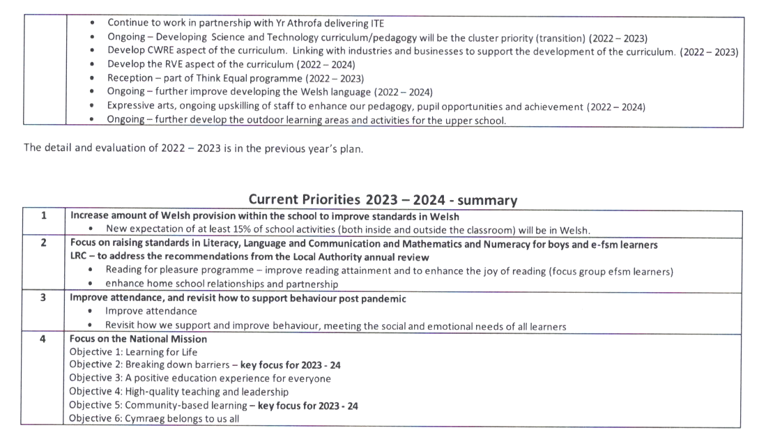
(Placement School, 2023)
Figure 2: Wales PISA scores 2006-2022

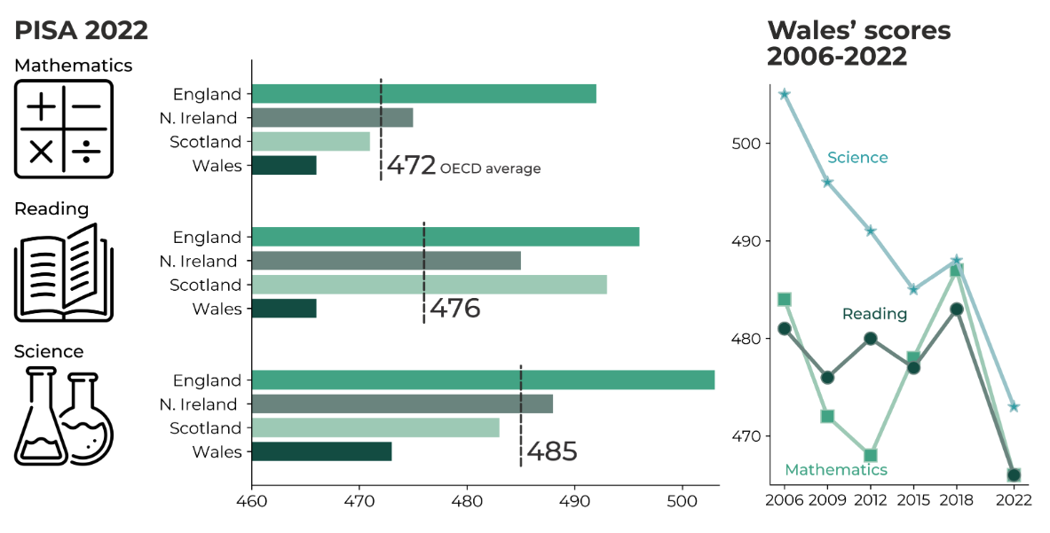
(Dauncey, M., 2023)

Figure 3: School development planning cycle
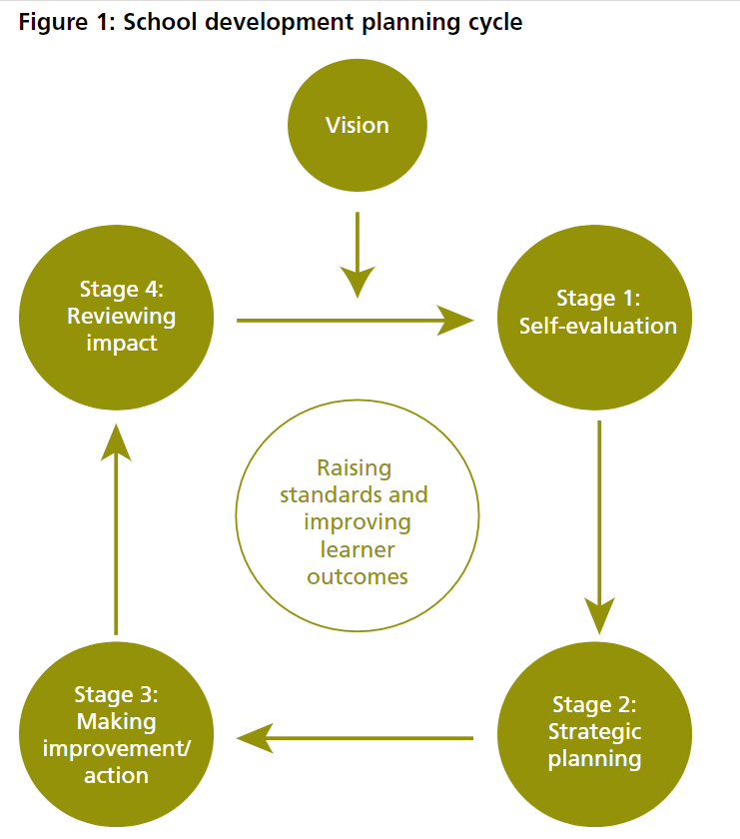
(Welsh Government, 2014)

Figure 4: Schools as learning organisations
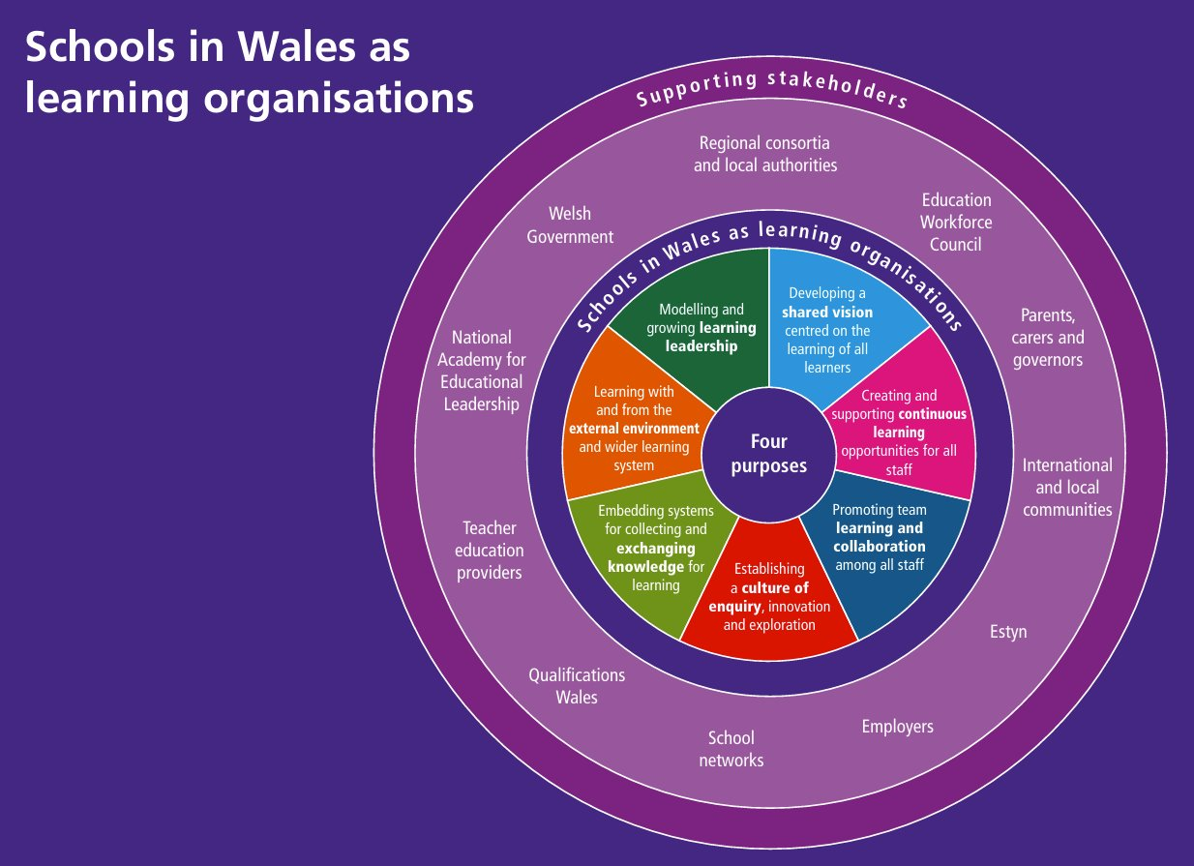
(Welsh Government, 2018)

Figure 5: spaced repetition

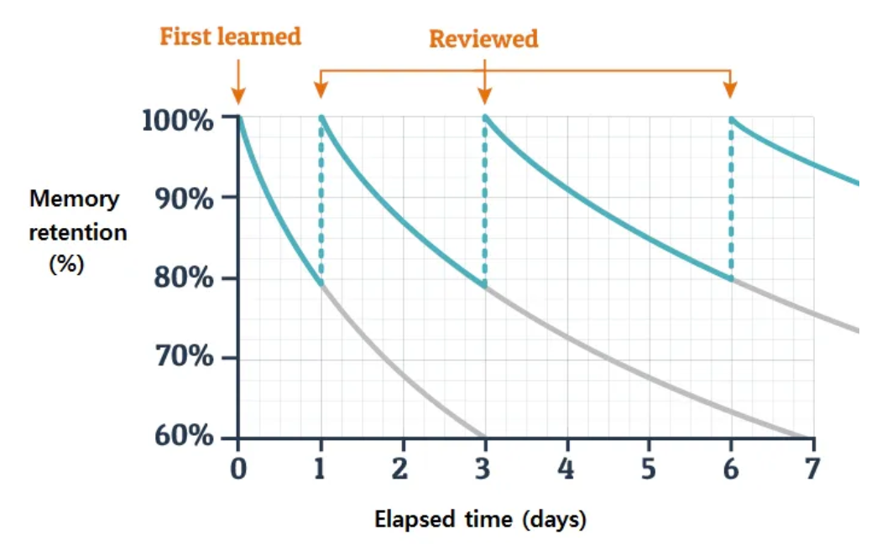
(Dinesh, 2022)

