Addressing staff Absenteeism mid-Cheshire

Student number 2028356
Student name: Joan Hird
Module code: 4004
2022
Lecture name: Dale Clarke

Table of Contents
The impact of the complex problem on employees and their organizations 3
Pestle analysis of the macro-environment factors 3
1: Political Factors 3
2: Economic Factors 4
3: Social Factors 4
4. Technological factors 4
5. Environmental factors 4
6. Legal 4
Cause and effect analysis of the complex problem 5
1: low staff morale 5
2: overworked staff 5
3: Staff Abuse 5
4: Budget cuts 5
5: Distance to work 5
6: Lack of trained staff 5
Evaluation of alternative solutions to absenteeism 7
References 9

The impact of the complex problem on employees and their organizations
THE Mid Cheshire Hospital NHS Foundation Trust (MCHT). Like many similar medium-sized districts
The general hospital trust has had a problem with staff absenteeism, this problem is caused by staff being sick with anxiety, stress, depression, and other psychiatric illness. These illnesses account for nearly a quarter of staff absences. Illness among managers has risen to 32.5 %. long working hours, Obesity, and a wide range of chronic diseases, in addition, relate to errors within the health care setting. Fatigue-related errors increase the risk of harm to patients. It has been found that Fatigued nurses are more likely to endanger others during their commute to and from work. During Covid, 85% of staff reported that they felt overworked due to long working hours. Rosekind et al (2010) support these findings estimated annual fatigue-related productivity losses for four employers were almost $2000 per employee. Covid has played a large part in staff absenteeism putting managers and staff at risk, self-isolating was introduced amongst staff as well as in the community. In the whole world, people were working from home. Social distancing was introduced, and the NHS staff took almost 7, 000 full – time days of sick leave.

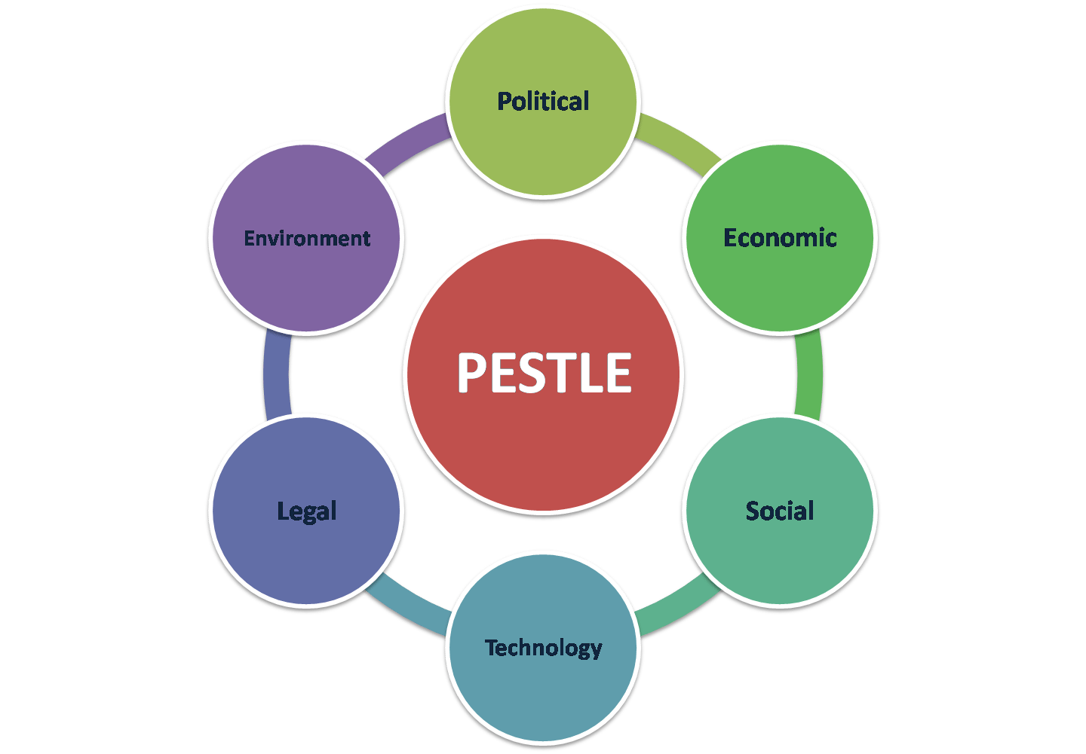
Pestle analysis of the macro-environment factors

Using the PESTLE Analysis, we will discuss the external factors https://advergize.com/insights/pestle-analysis-examples-to-unlock-business-growth/
1: Political Factors:
Brexit. Being a public institution a separation from European Union will have a deep impact on its functional Capacity nurses have to go back home. the Nursing and Midwifery Council (NMC) revealed that 51% of EU-trained nurses cited worries about Brexit as a key contributing factor to leaving the UK register. Political factors include tax policy, labor law environmental law, trade restrictions, tariffs, and political stability HTTPS.//en content is available to enter cc .by -SA 3.0 unless otherwise noted
2: Economic Factors:
Ever since the 2008 economic crash, the NHS has been facing multiply difficulties the entire UK felt the effects. Sickness absence costs the UK economy £12bn each year, and the rate of absenteeism is much higher among public than private-sector workers during the covid pandemic millions of workers around the world not only in the UK have reported as being ill in one way or another
Panic has set in amongst staff and patients face covering and socializing distance introduces
Putting stress on the existing workers MARKETING TUTOR.NET w.w.w.marketingtutor.net/

3: Social Factors:
Social factors that impact your health
Income. income, or how much money we have can determine where we live, the food we buy, and our recreational activities some staff goes on to develop obesity because of not eating at the right time or the right quality of food
The age of the UK population is increasing at a rapid rate people are living longer which has put a demand on the family, hospital staff, and Care workers. This has had a direct impact on staff absence and has now caused many workers to call off sick.
4. Technological factors: sickness absence in the NHS is higher than in the rest of the economy’s staff sickness rate rose from 3.8% in April 2019 this is the highest level at that time of the year in more than a decade, represents more than 1.4 million full-time (FTE) days lost in that month alone (by author Annabel Copeland http.w.w.w.kingsfund.org.uk)
5. Environmental factors: Air pollution from particulate matter and NO2 both products of combustion and fuel-burning is a proven risk factor for a long and expanding list of diseases faced by not only NHS Staff but by the general population a big reason for staff absence.
6. Legal: Ref www.marketingtutor.net yield Nurses and doctors all workers from other countries by law need to have a work permit to work in the UK, Scotland, and Ireland this puts pressure on the health services as they rely on these foreign workers to fill the gap present in the service

Cause and effect analysis of the complex problem
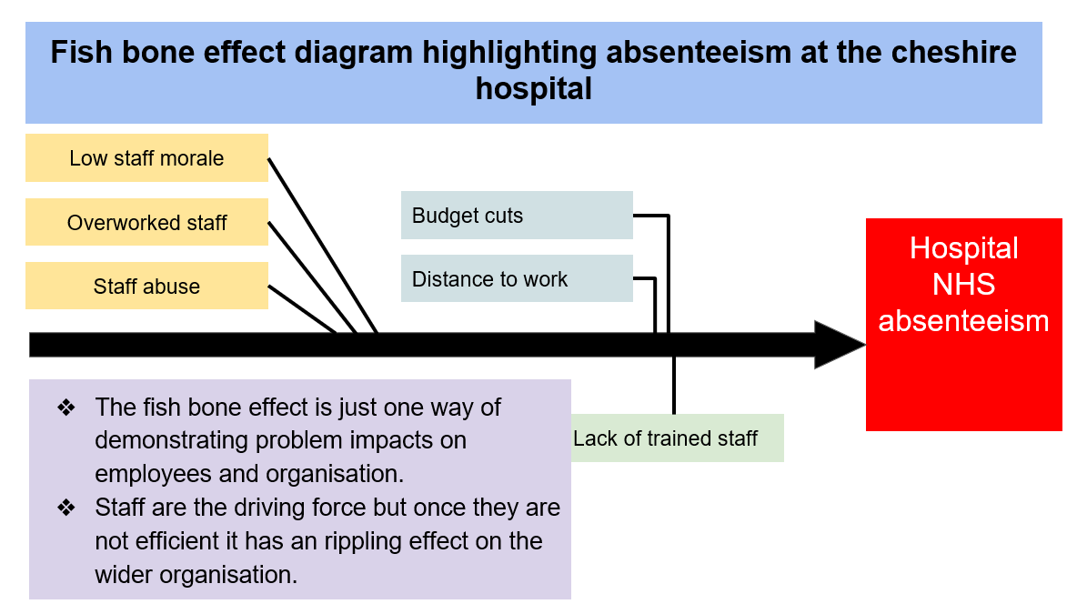
1: low staff morale: staff don’t feel supported by management
2: overworked staff: Illness among staff and manager puts pressure on the existing staff. At work making them feel tired and overwork (fatigue)
3: Staff Abuse, play a large part in staff absents they sometimes get physical and mental abuse by a member of the public. While on duty
4: Budget cuts, NHS cuts putting patients at risk., Funding cuts and staff shortages prevent hospitals from implementing recommendations by
Denis Campbell Health policy Editor Sat 26 Nov 2016, 2200, CMT
5: Distance to work, NHS staff sometimes have to travel a far way to work, finding accommodation near to work is sometimes difficult and cost-effective making it necessary for them to travel out of their area code
6: Lack of trained staff, 1 we do not have enough quality trained staff, so we rely on workers or doctors and nurses from other countries to fill the gap in the NHS. Brexit withdrawal agreement see doctors and nurses going back home. This shortage of trained staff impacts negatively on the existing staff and the quality of care given to the public. Staff feel overworked and fatigued,
There are three solutions to the problems number 1: create a clear attendance policy and set expectations number 2: provide support for existing staff to boost morale meet and great discuss

The PMI Table is used to decide the solution that is most suitable on a scale of 1to-5 5being the highest we work out the best solution
PMI Solution number1: create a clear attendance policy, set expectation
Create a clear attendance policy set expectations | The reputation of the trust could be jeopardized | Employ suitably trained staff to fill vacant positions
On a scale of 1 to 5, this is 4 | On a scale of 1 to 5, this is 2 | On a scale of 1 to 5, this is 4

PMI Solution: 2 provide support for all staff
Provide support for all staff | Staff feel overwork and fatigue | Provide in house counseling by a qualified psychologist
Mentally, physically, emotionally | Onset of obesity
1 to-5 this is 4 | 1 to 5 this is 1 | 1 to 5 this is 3 4-1+3=6s

PMI SOLUTION : 3 reduce workplace stress
Reduce workplace stress | Low morals do not feel supported by management | With qualified trained staff to fill vacant positions staff will feel less stress and more supported by management
On a ratio of 1 to 5, this is 3 | A ratio of 1 to 5this is 2 | Ratios 1to 5 this is 4
 |  | 3-2+4=5

Plan of action
Focus | Description | Time | Staff
create a clear attendance policy, set expectations | All staff signing in and out each shift | Starting on the 10 of 4 2022 | All managers and staff

monitor
Team leader | Line manager | H R | Management

Managers
The ultimate responsibility for managing attendance rest with the line manager and the key responsibility includes
Number 1: ensuring this policy is applied fairly to all employees
Number 2: supports employees to have regular attendance at work. And monitor the attendance accurately
Number 3: monitor and investigate the reasons behind the absences trends and pattern taking measures to alleviate them

Evaluation of alternative solutions to absenteeism
Absenteeism is a known problem within the NHS causing the trust Millions each year. To tackle such issues, we must explore the different solutions and their effectiveness in reducing staff absenteeism. Understanding the strengths and weaknesses of each solution is also important when implementing strategies within the NHS. According to Collier (2018), attendance policies should explain how to report absences, procedures in place surrounding absences, and policies for recording absences. Additionally, it should contain information about the consequences of repeat absences. Reiterating such policies will hopefully make staff more accountable and aware of repercussions when reporting their absences. This is supported by (Greenwood and Krol 2020) who found that staff who were more aware of the consequence were less likely to take time off work. However, Knowing the absences policy does not deal with factors that cause staff absenteeism such as depression and illnesses. For suggestions like this to be effective, we must first tackle the main issue. Hughes (2018) Investigates this further and found that programs that encourage employee health and wellbeing were more effective in reducing staff absences. In his research, he found that deflated, overworked staff deliver low-quality work and lack commitment. When health and well-being were put at the forefront and the program was implemented. There were significant improvements with an increase in productivity and improved staff retention. The mid-Cheshire hospital NHS foundation trust 2012 Launched a training program to assist with the management of long-term sickness absences. The key aims were to encourage positive attendance, staff feeling appropriately supported, and reduced reliance on bank staff. Findings that emerged, showed a 21% decrease between 2012 and 2014 in sick absences. The significant decrease in absences leads to a 0.9 million reduction in cost. Although these statistics present successes in the reduction of money spent it is difficult to calculate the known amount spent on agencies. The Launched training of the Mid Cheshire hospital staff reported ‘it was the best course done since been on the trust’ and they felt confident in the support offered by the trust. However, these findings are not generalizable to all staff, and cannot be assumed that all staff feels this way. Launching programs like this provide good evidence of the effectiveness of strategies put in place. Opposing this is the cost and time to conduct such training as staff will need to find the time to participate in such studies. This may be difficult with the existing pressure to care for patients.
To summarize strategies put in place to tackle the issue of staff absenteeism need to be reviewed to ensure they are effective in dealing with the factors that cause absences. In doing so this could cost the NHS a lot of money due to funding and the average cost of longitudinal studies conducted in the NHS. This does not take away from the fact that staff will constantly be under pressure and most factors will not reduce which means staff absenteeism with fluctuated throughout the years.

References
Greenwood, K, and Krol, N (2020) 8 ways managers can support employees’ mental health, Harvard business review 8 Ways Managers Can Support Employees’ Mental Health (hbr.org)
Hughes, L (2018) Implementing a workplace health and wellbeing program, High speed training. Accessed online How to Implement a Successful Workplace Wellbeing Programme (highspeedtraining.co.uk)
Collier, E (2018) Reducing Absenteeism in the workplace, Highspeed training. Accessed online Absenteeism in the Workplace | Causes & Ways to Manage it (highspeedtraining.co.uk)
Mid- Cheshire hospital foundation trust (2012) Case study: reducing long-term absenteeism. Information network portal. Health education northwest. PD
Ann Dixon, Julian Le Grand, john Henderson Sage journal of health service research and policy 155n 13558196 online
Denis Campbell Health policy Editor sat 26 Nov 2016,2200cmt

