
Optimisation of a high speed 3 cylinder using the Ricardo Wave engine developent software
M6X00408

January 1, 2020
UNIVERSITY OF WALES TRINITY SAINT DAVID, SCHOOL OF ENGINEERING

Abstract

The main emphasis of this study is to optimise performance characteristics of a super-sport motorcycle engine. The Triumph 675R Daytona engine will be used as the basis for this. Firstly, by means of reverse engineering acquired cylinder pressure, cam shaft and bench flow data, to extract valuable information about thermodynamic and mechanical properties of the engine. These will then be combined with readily available specifications of the motorcycle as input values into an engine simulation package in the form of Ricardo Wave. Then by meaning of logical and theoretical reasoning the model will be refined to truly reflect the true nature of the 675R engine. The result will then be validated against the original pressure data.
Contents
Acquired Data and Analysis 3
Ricardo Wave 5
Defining the Model 5
External Geometry 5
Mechanical Elements 6
Combustion Control 7
Combustion Variables 7
Experimental Case Runs and Findings 8
Final Results 11
Conclusion 12
References 13

Figure 1- Showing Acquire Triumph Cylinder Pressure, Volume and Burn Rate Data. 3
Figure 2- Showing Triumph Specification Sheet. 3
Figure 3- Showing Excel Engine Data Analysis. 4
Figure 4-Triumph Pressure/Volume and Mass Fraction Burnt per Crank Angle graph. 4
Figure 5- Showing engine harmonics calculations and Ricardo Wave Model. 5
Figure 6-Showing Engine and Valve Timing Modifications. 6
Figure 7- Showing MatLab Curve Fitted MFB and Its Effect on The Ricardo Model. 7
Figure 8-Showing Experimental Case Run Example. 8
Figure 9- Showing the Effect of Fuel to Air ratios on Combustion 8
Figure 10- Effect of changing Wiebe m Value 1.75-6.75 on the Burn Rate Curve and Pressure versus Volume. 9
Figure 11- Effects of changing the 50% MFB and Burn Duration. 9
Figure 12- Showing effect on Pressure versus Volume when Increasing the amount of Heat Transfer and Friction. 10
Figure 13- Showing a Comparison of the 10250 / 1300 Data and the Ricardo Wave Results 11

Acquired Data and Analysis

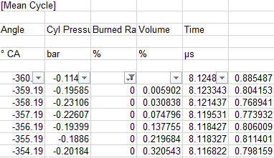
Figure 1- Showing Acquire Triumph Cylinder Pressure, Volume and Burn Rate Data.
As can be seen above data acquired from the Triumph 675R can be seen. This data has been collected by using known engine geometry, in addition to various sensors, such as a cylinder pressure sensor using a piezoelectric element. Though the data is very basic such as volume been denoted as a percentage of a swept volume and not total volume a lot of valuable information can be extracted by means of the following techniques.
By incorporating readily available specification sheet more information can be known about such things as engine geometry and ignition timing. The following techniques can be deployed to extract the true relationship between volume and pressure.
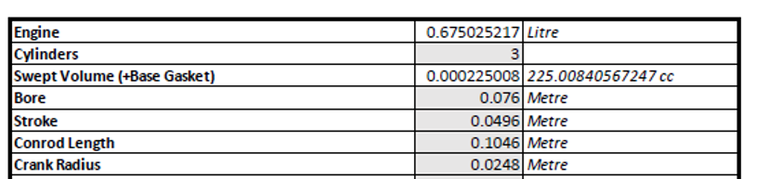
Figure 2- Showing Triumph Specification Sheet.
Equations for Finding the True Volume.

$${Volume}_{Swept}=\frac{Engine Capacity}{Number of Cylinders}$$

$${Volume }_{Clearance}=\frac{V_{Swept}}{(Compression Ratio-1)}$$

$${Volume}_{Total}=\frac{V_{Swept}}{100} ∙ V_{\%}+ V_{Clearance}$$

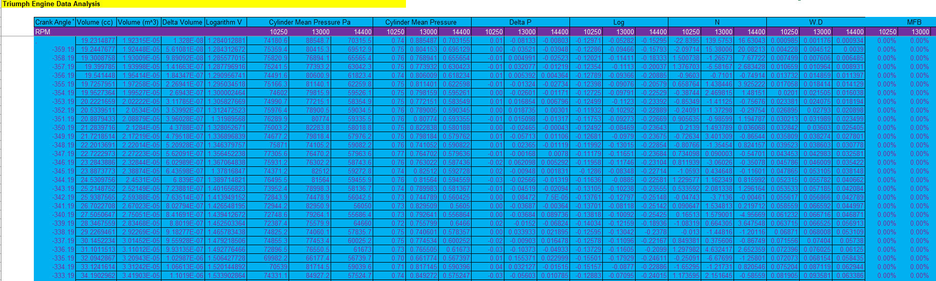
Figure 3- Showing Excel Engine Data Analysis.
Once the volume had been converted from a percentage to the actual volume per crank degree, the use of formula below and the original data the above spreadsheet can be created in excel. To then be converted in SI units.
$$PV^{n}=Constant$$
$$n=\frac{logP_{2}-logP_{1}}{logV_{1}-logV_{2}}$$
$$\frac{∆P}{θ}=P_{2}-P_{1}$$
$$\frac{∆V}{θ}=V_{2}-V_{1}$$
$$Workdone=P∙ ∆V$$
Though a lot of valuable information can be taken from the above calculations, for the purposes of this study the main area of interest was pressure, volume and mass fraction burnt (MFB). From these a pressure verses volume (P/V) graph can be created along with MFB per degree graph for further validation later on. Due to MBF illustrating the ignition characteristics and P/V highlighting the various thermodynamic interactions and mechanical properties of the system.
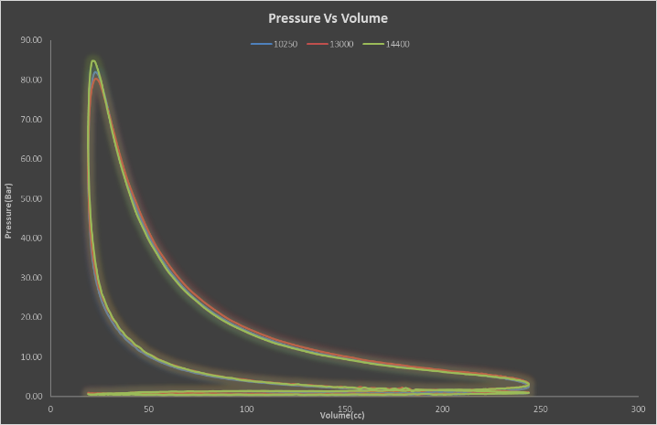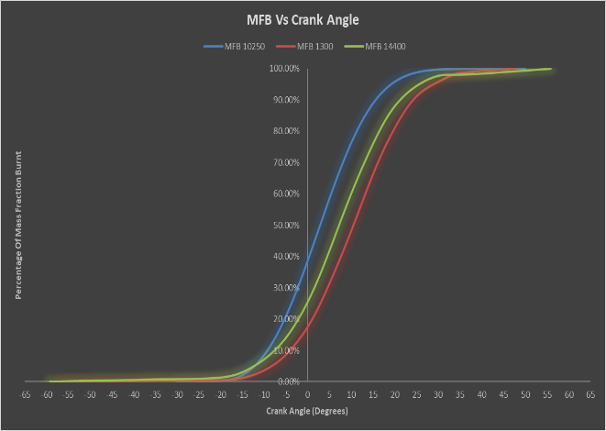
Figure 4-Triumph Pressure/Volume and Mass Fraction Burnt per Crank Angle graph.

Ricardo Wave

Ricardo wave is an advanced 1D computational fluid dynamics package. It utilizes work carried out by Claude-Louis Navier, George Gabreiel Strokes, Rudolf Clausis and Isaac Newton. By compiling together what is known as the Navier-Strokes equation and laws of thermodynamics. In other words, it uses the relationship between entropy of a gas in this case a blend of a fuel and air and the behaviour of a viscous fluids in terms of pressure. It also deploys various sub calculations to define combustion characteristics from such equations as the ideal gas law, enthalpy of formation and the energy needed for a reaction to take place. This software is used throughout industry as a means of analysing performance and acoustics.

Defining the Model

In basic terms Wave can be broken into four main areas, external geometry such as intake/exhaust system, combustion control for example MFB/AFR, the mechanical elements to engine corresponding to the valve timing/bore/stroke and the material properties within the engine defining friction/heat transfer.

External Geometry

In this study a model had already been created by (Williams, 2019). As a way of validating he had made reasonable assumption in creating the model, all ducts were checked to make sure there was no obvious restriction or opening, following this all junctions were recalculated to make sure the effects of ambient pressure and temperature had been accounted for correctly. Once the valve geometry and timing had been implemented the total lengths of the ducts was checked. This was done by assuming the geometry was set up for a harmonic pulse wave to arrive at the quoted peak torque around 11,750 revolution per minute (RPM).
$$L=\frac{330}{2} ∙ \frac{{Pulse}_{point}}{360} ∙ \frac{60}{RPM}$$

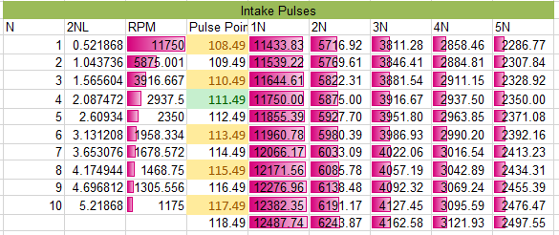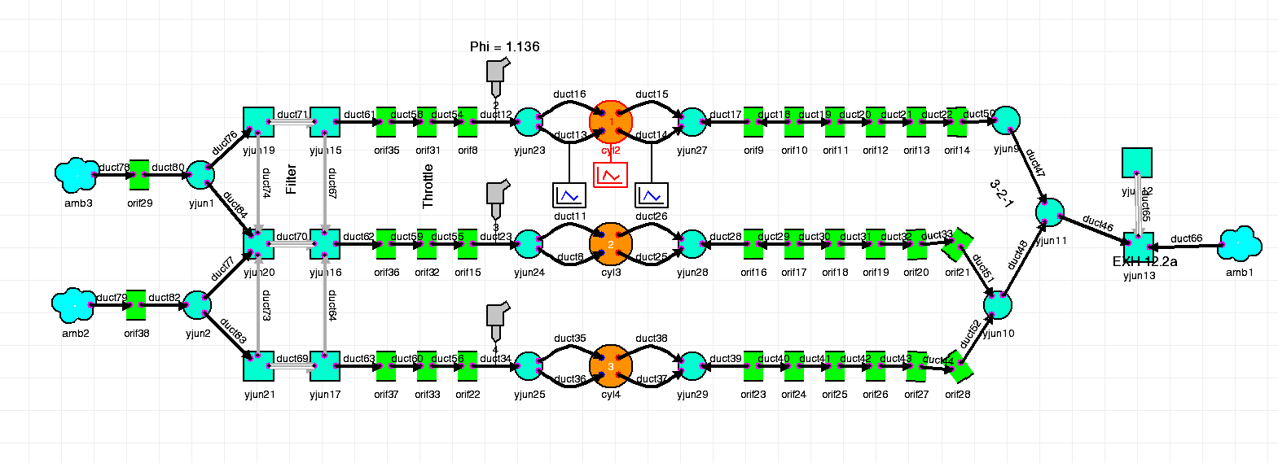
Figure 5- Showing engine harmonics calculations and Ricardo Wave Model.

Mechanical Elements

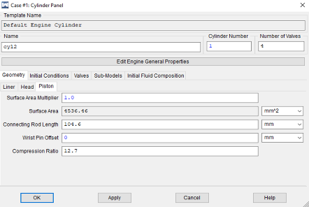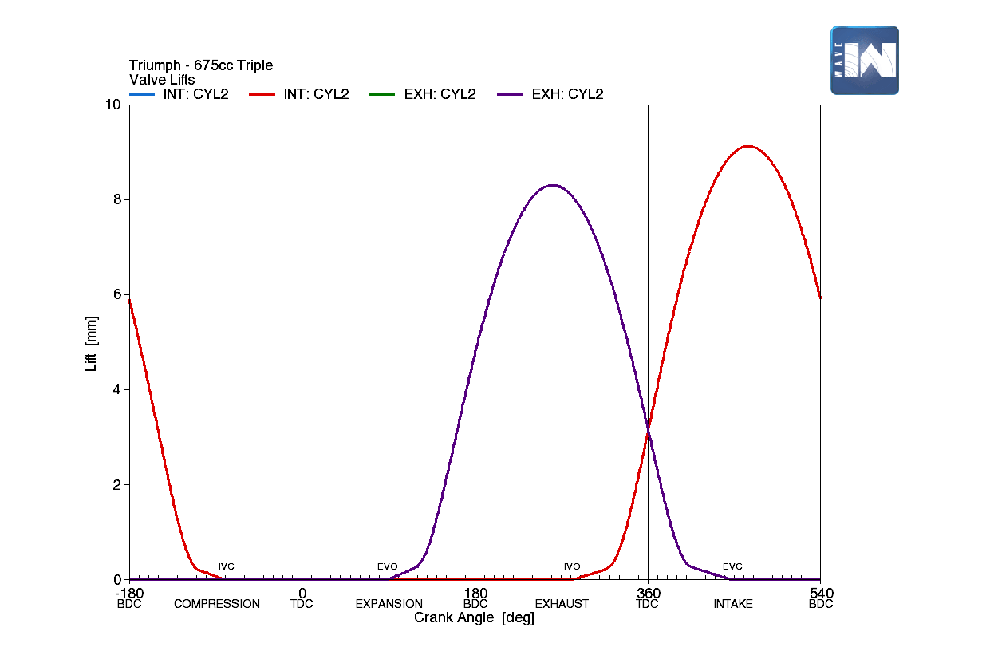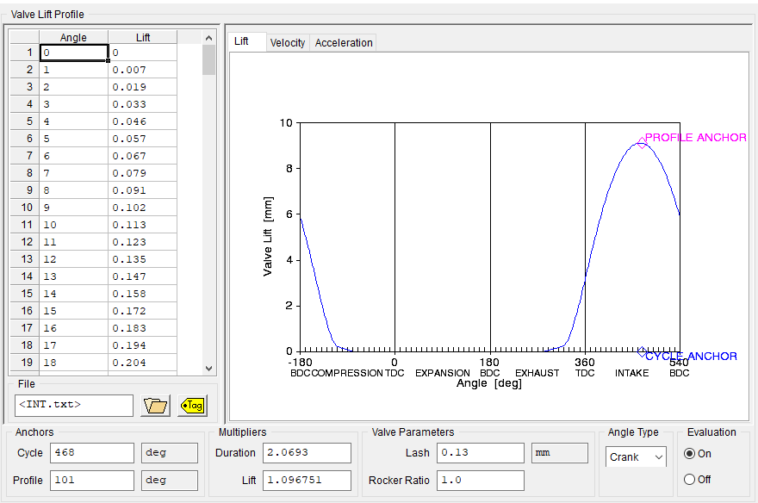
Figure 6-Showing Engine and Valve Timing Modifications.
By means of referring to Triumphs standard/race kit manual and specification sheet the bore, stroke and compression ratio were all defined. The manual also detailed valuable information regarding valve lift, valve clearances, valve head diameter, cam duration and max opening points. A lot of time was spent refining the lift profiles, due to this model been as realist as possible these setting would remain constant as with the real motorcycle (Triumph, 2013).

Settings in accordance with Triumph

- Valve clearance (Lash) In0.13, Ex0.19.
- Inlet Camshaft- M.O.P 108$°$ ATDC. 360$°$+ 108$°$ = 468$°$.
- Inlet max lift 9.4mm. Inlet lift data x 1.096751 (lift multiplier)
- Inlet opens at 1mm 27.25$°$ BTDC and closes 51.25$°$ ABDC at 1mm
- Inlet head diameter 31mm, Seat 30.3mm
- Pulse point around 111.49$°$ after M.O.P (calculated)
- Exhaust Camshaft M.O.P 108$°$ BTDC. 360$°$- 108$°$ = 252$°$
- Exhaust max lift 8.7mm. Exhaust lift data x 1.139257 (lift multiplier)
- Exhaust opens at 1mm 43$°$ BBDC and closes 23$°$ ATDC at 1mm
- Compression Ratio 12.7:1
- Engine Capacity 675.025217 cc
- Bore 0.076m. Stroke 0.0496m. Connecting Rod length 0.0496m

Due to differences between the Triumph manual and the valve lift profile many runs had to be made to fine tune the camshaft duration to correspond with what Triumph had specified. As can be seen above the valve lift profile can be seen with all the above setting in place. These setting boast a large overlap, which is to be expected in such a high revving engine. In agreement with (Heywood, 2018) this because at high engine speeds the exhaust valve should be closed much later on to prevent high pressure towards the end of the exhaust stroke, it also promotes a scavenging effect on the fresh charge mixture. This will be of benefit to a certain RPM before having a detrimental effect by drawing the mixture into the exhaust, causing a drop-in power and an increase in pollutants.

Combustion Control

In real life a motorcycle would be fitted with an engine management system which main job is to control combustion depending on RPM and engine load in its most basic form. Once upon a time this would have been done via carburettors and points where as now it controlled by an ECU telling the injectors how much fuel is required (values around 14.7:1 parts air to fuel) depending on the throttle opening which is controlled by ECU depending on rider input, then finally controlling how charge mixture is burnt by means of the ignition system. Wave does this in the same way baring the user has to define the condition surrounding combustion.

Combustion Variables

- Ambient pressure ({Pamb}1.065 Bar) and temperature ({Tamb} 293 K)
- Throttle opening
- 1/Air to fuel ratio ({FARD})
- Burn duration ({BDUR})
- 50% MFB ({THB50})
- Wiebe m exponent ({Wiebe})
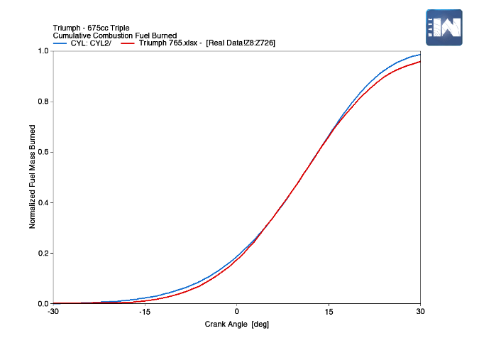
Initially a MatLab script was created to extract the exponent from the MFB (Williams, 2019). After the first few trials in Wave, it was noted that the value of m was not corresponding with the Wave prediction. Its was then thought to better understand the software more in-depth it would be advantageous to add more variables to the constants table, some can be seen above in inverted brackets. By means of increasing the about of cases then changing one variable into a set about of divisions throughout the cases, while keeping the all other variables constant it would be seen what effect that one specific thing has on the shape of Wiebe curve and the P/V diagram. The 50% MFB was calculated by interpolating the Excel data to find the exact crank angle this happened. This was done by the use of the forecast tool.
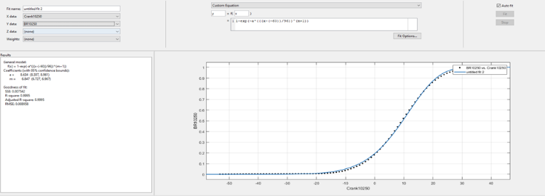
Figure 7- Showing MatLab Curve Fitted MFB and Its Effect on The Ricardo Model.

Experimental Case Runs and Findings

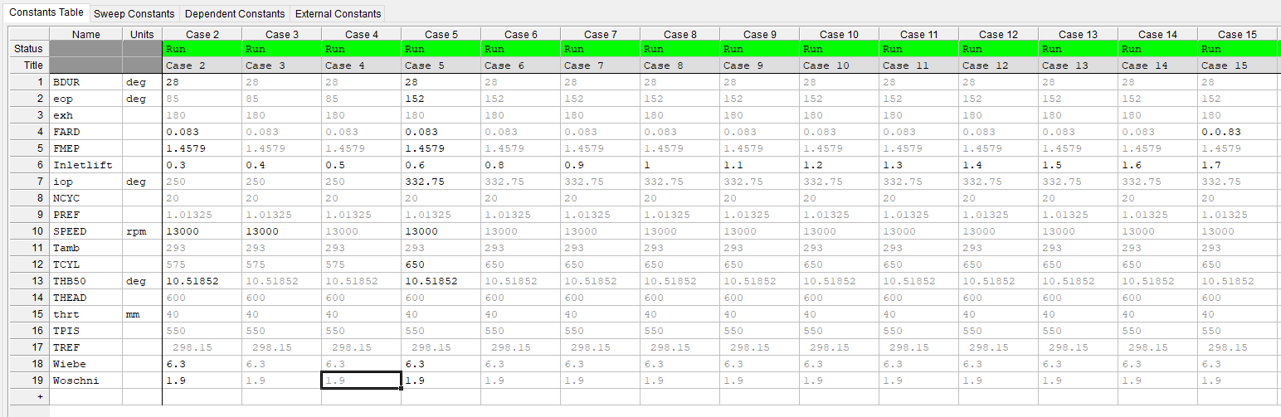
Figure 8-Showing Experimental Case Run Example.
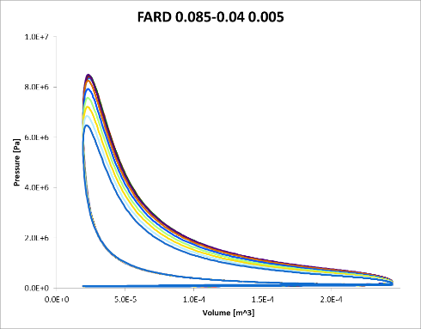
Figure 9- Showing the Effect of Fuel to Air ratios on Combustion
As it can be seen the AFR has a great effect on the pressure within the system. The increase in pressure as the ratio trends towards stoichiometric from extremely lean conditions is due to the increase in hydrocarbons and therefore there is more energy released from the reaction described by the energy of formation equation. This increase in heat energy and consequently pressure creates more work done on the system and is illustrated on the isothermal expansion where temperature remains constant and all energy is converted into work done. But in reality, there heat transfer through the surrounding of the combustion chamber.
$$∆H_{reaction}^{°}= Σ_{np}∆H_{f products}^{°}-Σ_{nr}∆H_{f reactents}^{°}$$

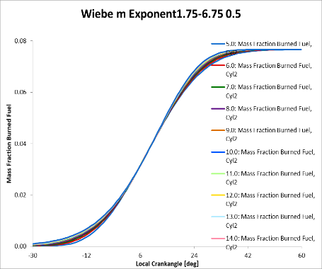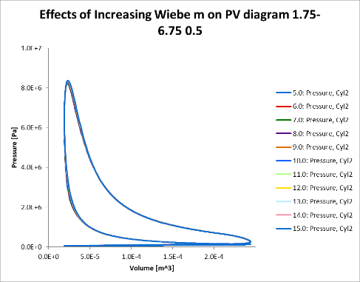
Figure 10- Effect of changing Wiebe m Value 1.75-6.75 on the Burn Rate Curve and Pressure versus Volume.
As to be expected the exponent in the MFB equation is just a mathematical property there to manipulate the shape of the curve. Many people agree with this such as (Gunter P. Merker, 2006) (Sara McAllister, 2011) the value is assumed constant with a value of two been assign. But as above by increasing the value you increase the rate of the fuel burned before and after TDC with the centre of the curve been controlled by the crank degrees 50% of the mass is burned. The PV Chart twists in a fashion around adiabatic compression to the left and right due to the stated change in the peaks and troughs in the MFB graph.
$$MFB=1-e^{-a^{(\frac{Crank Angke-Start of Combustion}{Burn Duration})^{(m+1)}}}$$

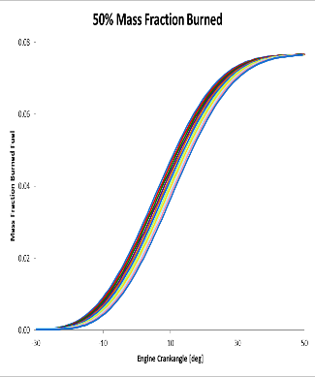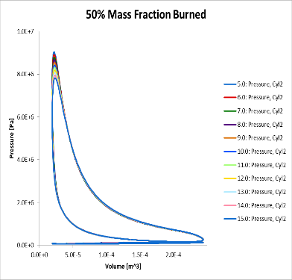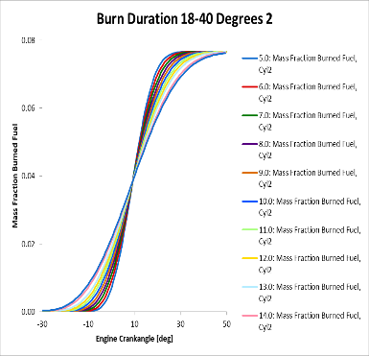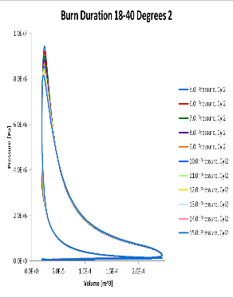
Figure 11- Effects of changing the 50% MFB and Burn Duration.
In Wave the 50% MFB can be thought as your ignition timing controlling where the spark happens. Hence why in the MFB graph the only the position changes in regards to crank angle, with the burn duration controlling the time this happens within. This is highlighted nicely if the MBF burn duration graph where 50% MFB is constant acting in some ways as a pivot the curve twists around as burn duration is increased. The effect of an earlier ignition point and shorter burn duration can be seen to have a similar effect by increasing peak pressure. The reasons for this are one an earlier ignition point allows the flame to propagate earlier releasing more heat energy, similarly in a shorter burn rate the steep gradient indicating more fuel been used in a smaller volume. If it wasn’t for the Triumph data to validate against these would have to be calculated so that peak pressure occurs after TDC so that work done by the system does not increase, in other words the gas force working against the compression stroke.
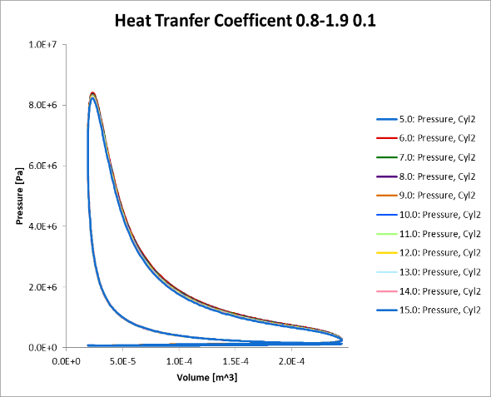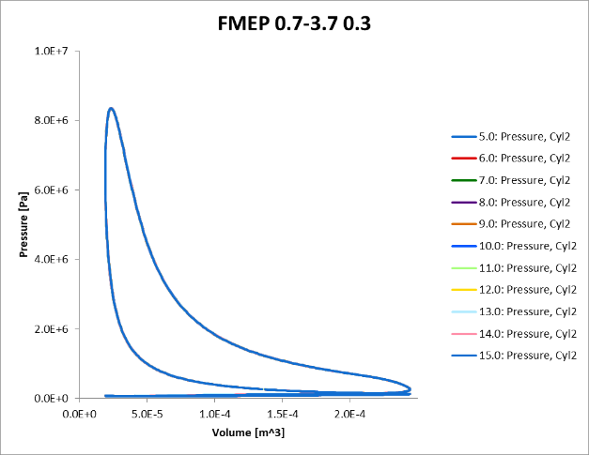
Figure 12- Showing effect on Pressure versus Volume when Increasing the amount of Heat Transfer and Friction.

The above cases regarding heat transfer coefficient and frictional mean effective pressure were studied to gain knowledge about losses from the system.
Since no information was available on the precise materials in which various engine components were made from it was assumed to use the heat transfer multiplier instead of mismatching many different values for thermal conductivity of the engine internals, this was also due to no knowledge of thicknesses of parts such as the cylinder liner’s or piston crown. The heat transfer coefficient only really had effect on peak pressure and the work done on the power stroke. Due to this is where there is the greatest difference in temperature within the cylinder and the surroundings. Increasing the rate in which this is lost to outside the system, decreases the work done and therefore the power.
For the same reasons regarding material properties or surface roughness a different means for calculating frictional losses had to be utilized. By means of the below equation the FMEP was calculated. FMEP is the theoretical mean effective pressure lost to overcome friction. By incorporating the Triumph data, dyno data and extracting the power and changing it into watts. Then Brake Mean Effective pressure away from the Indicated Mean Effective pressure.

$$MEP= \frac{Power output ∙Number of Power Stroke per Cycle }{Displacement ∙Number of revolutions per Second}$$

$$FMEP=IMEP-BMEP$$

Final Results

Once all previous experiments had been carried combined with the already defined geometry, valve dynamics and external conditions, the model was able be ran quite effectively. By the knowledge gained about correcting deviations in the MFB and other variables, it was fairly simple to adjust and produce data that correlated well with the original data.
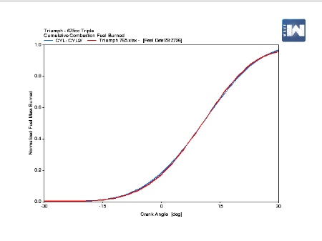
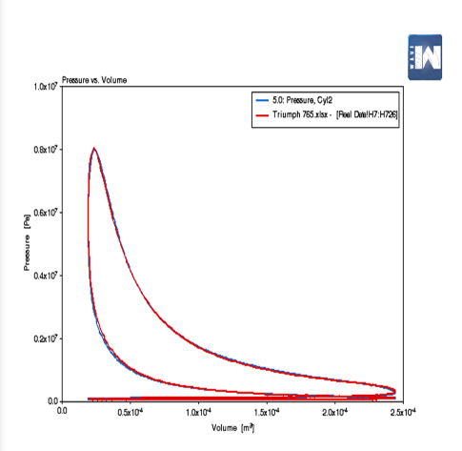
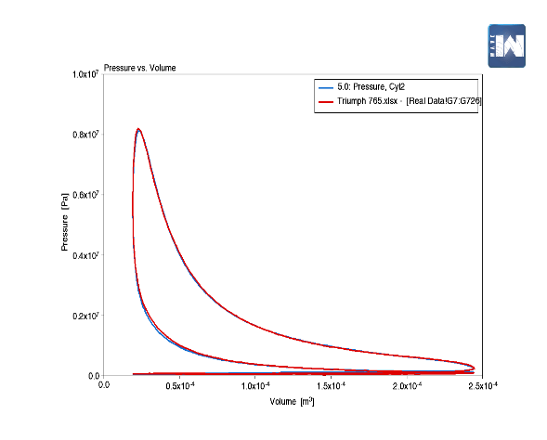

Figure 13- Showing a Comparison of the 10250 / 1300 Data and the Ricardo Wave Results
Both the 10250 and the 13000 data related well to the calculated data, with the MFB doing also. With peak pressure within less than one bar of the triumph data. This said both did deviate around the isothermal compression stroke into the adiabatic expansion. This was thought to be down to serval reasons some being the calculated data having a lower volumetric efficiency or possibly the fuel having a slightly lower calorific value. The point been the pressure did not rise by the same rate at this point. All other areas corollate well on the pumping cycle, exhaust opening and expansion.

Conclusion

In this study a lot of valuable knowledge has been gain about Ricardo Wave and the way it works. Reasonable results were made with good power and torque figure to back up the pressure data. This said there was not enough information readily available to truly duplicate the true nature of the Triumph 675R. But a great deal of what probably is happening inside this marvel of motorcycle can be taken away. An in terms of this bike competitor been able to get so much information from so little data just goes to prove how simply it would be to replicate a motorcycle to compete with its performance.

References
Gunter P. Merker, C. S. G. S. F. O., 2006. Simulating Combustion. Berlin: Springer.
Heywood, J., 2018. Internal Combustion Engine Fundamentals. 2 ed. New York: McGraw-Hill Education.
Sara McAllister, J.-Y. C. A. F.-P., 2011. Fundimentals of Combustion Processes. Berlin: Springer.
Triumph, 2013. Race Kit Manual. s.l.:Triumph Designs.
Williams, D. O., 2019. Ricardo Wave [Interview] (12 October 2019).

