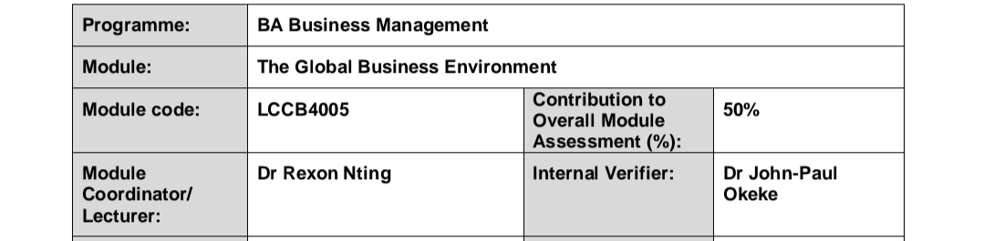
Assessment 2
Student Name: Andreea Gina Tabacaru
Student Id: 1914595
Lecturer: Hossein Shokri

Table of Contents
Introduction 3
Background of Next Plc 4
Changes in business model of Next Plc to self-regulate and adapt to the concerns of stakeholders 4
Identifying the changes using Porter’s Value Chain Model 4
Customer service 5
Suppliers’ relation 5
Workforce management 5
Infrastructure development 5
Analyzing the changes of business model of Next Plc to gain competitive advantage in the market of the UK 6
Porters five forces model of Next PLC 6
Threats of new entry 6
Bargaining power of suppliers 6
Bargaining power of buyers 7
Threats of substitute 7
Rivalry among competitors 8
Analysing the impact of competitive advantage through PESTLE factors 8
Political, economic, and social factors 9
Technological, legal, and environmental factors 9
Recommendations for achieving competitive advantage 10
Conclusion 10
Reference 11

List of Figures and Tables
Figure 1: Porters value chain model 5
Figure 2: Porter’s five forces model of Next Plc 8

Table 1: PESTLE analysis of Next Plc 8

Introduction
Understanding the business environment and its impact on the business model of Next Plc has been shown in this report. The report contains an overview of the company background of Next Plc. The discussion of this report focuses on the changes in the business model of the company in recent years. The changes have been analysed by Porter’s five forces model which demonstrates a clear overview of the impact of the changes in the business model. This discussion is followed by PESTLE analysis which provides a brief description of how the company is gaining a competitive advantage in the market. In the end, some recommendations for the company are also provided regarding the achievement of competitive advantage.

Background of Next Plc
Next plc is one the biggest clothing manufacturing brand in the United Kingdom, founded in 1864 by Joseph Hepworth. Worldwide the company has 700 retail stores of which 500 are inside the UK and the rest of the 200 are located in Asia, Europe, and the Middle East. Next Plc has three main channels of operations: Next Retail, the country’s largest retail stores chain of above 550 stores, Next Directory, an online shopping center with more than 3 million users and Next International, a chain of nearly 200 stores across the globe (Nextplc.co.uk. 2021). Last year, the company had revenue of 4266.2 million euros.

Changes in business model of Next Plc to self-regulate and adapt to the concerns of stakeholders

Identifying the changes using Porter’s Value Chain Model
Next Plc has gone through significant changes in the organisational model to cooperate with the dynamic business environment. The company was only concerned about profitability at the beginning of this century. But over the past few years, it has changed the business model to become more sustainable. The company focuses on delivering excellent design and better quality of the product (Elsner, 2014). The company made changes in four major sectors- customer service, suppliers’ relations, workforce management, and infrastructure development.
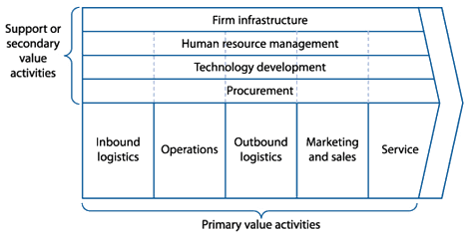
Figure 1: Porters value chain model
Source: Stephens, 2013
The above model describes the primary and secondary activities of an organisation. This model is used to identify the effectiveness of the activities. To analyse the activities of Next Plc, the changes in the core four functions have been described with the help of this model.

Customer service
The company believes in providing better service to the customers. Next Plc managed to offer an excellent customer experience online and offline. At the earlier period of this decade, the company was mostly concerned about only product delivery. But now it focuses on building interactive customer relations with successful value creation by last-mile delivery strategy (Melara et al., 2010). A well-structured outlet of unique designed products increased the sales of the company. The company now puts more focus on customization and customer satisfaction through online and offline channels.

Suppliers’ relation
Next Plc implemented the Next Code of Practice (COP) to conduct ethical practice with the suppliers globally. This concept was first used in 1998 to manage the global supply chain operations. As the company uses omnichannel logistics for supply chain management worldwide, maintaining works ethics becomes sometimes tough outside the UK (Choi, 2012). So, in recent years, the company developed the COP to cooperate with the covid pandemic.

Workforce management
The covid pandemic changed the typical 9-5 working culture as almost everything has gone virtual. Maintaining a huge workforce of 44193 employees became a challenge for the HR of this company. Next Plc is currently managing employees by using two prime software: Apparel magic and Fashion Flow since the beginning of the pandemic (Castillo, 2018). Though the company was using various tools like Blue Cherry Suite, deco network, printavo, etc. but the introduction of this two software accelerated the growth of the company.

Infrastructure development
Due to pandemic, most of the activities of Next Plc is conducted online. The company developed the interface of the website in a more user-friendly way. In recent years, the company used a cross-docking warehousing system to maintain product distribution. The introduction of office automation to use voice-controlled humane-machine increased production efficiency. The use of virtual mirrors in physical stores helped the company to implement augmented reality. The company is using eco-friendly products to promote green marketing as a part of environmental concern. Using Effluent Treatment Plant (EFT) technology for wastewater management satisfied the safe environment issue. On a whole, the company is having technological advancements in its infrastructures.

Analyzing the changes of business model of Next Plc to gain competitive advantage in the market of the UK

Porters five forces model of Next PLC
Porter's five forces model is a framework to understand the market competition and the forces that shape any change in the business model. It has been seen that Next Plc has done some significant changes in the past few years. Using the Porter five forces framework, it would be easier to understand which force is affecting the company mostly.

Threats of new entry
A new entry in the apparel manufacturing industry brings innovation, new ideas of production, and thus Next Plc faces great challenges. The entrance of new competition incites product innovation, fashion trend changes, and more customization (Takayasu et al., 2010). The company has put more focus on research and development to tackle the new entrance. Moreover, technological changes in production reduced costs that generated more profit. Also, the company has built economies of scale to lower the production cost.

Bargaining power of suppliers
Almost every company in the fashion industry buys raw materials from multiple suppliers. Marinating this huge supply chain flow is quite tough for the company. That’s why Next Plc uses omnichannel logistics as their supply chain management strategy. The company experimented with different raw materials to identify the cost-effectiveness of those raw products (Wigley, 2011). This enabled the company to reduce the number of suppliers in their supply chain that ultimately decreased the unethical supplier power over the company.

Bargaining power of buyers
The demand of buyers is everchanging with time. No buyer sticks to only one kind of trend rather focuses on different options. The buyers of Next Plc always had a trend to demand high fashionable products with low price. As the company has a huge outlet and variation of well-designed and fashionable products, bargaining power sometimes decreases (Rishi, 2011). But most of the time price sensitivity of buyers creates problems for the company. In this recent pandemic period, the company provided lots of discounts and promotional offers to satisfy the buyers' needs. Again, due to the last-mile delivery system, the company keeps a big influence over buyer power.
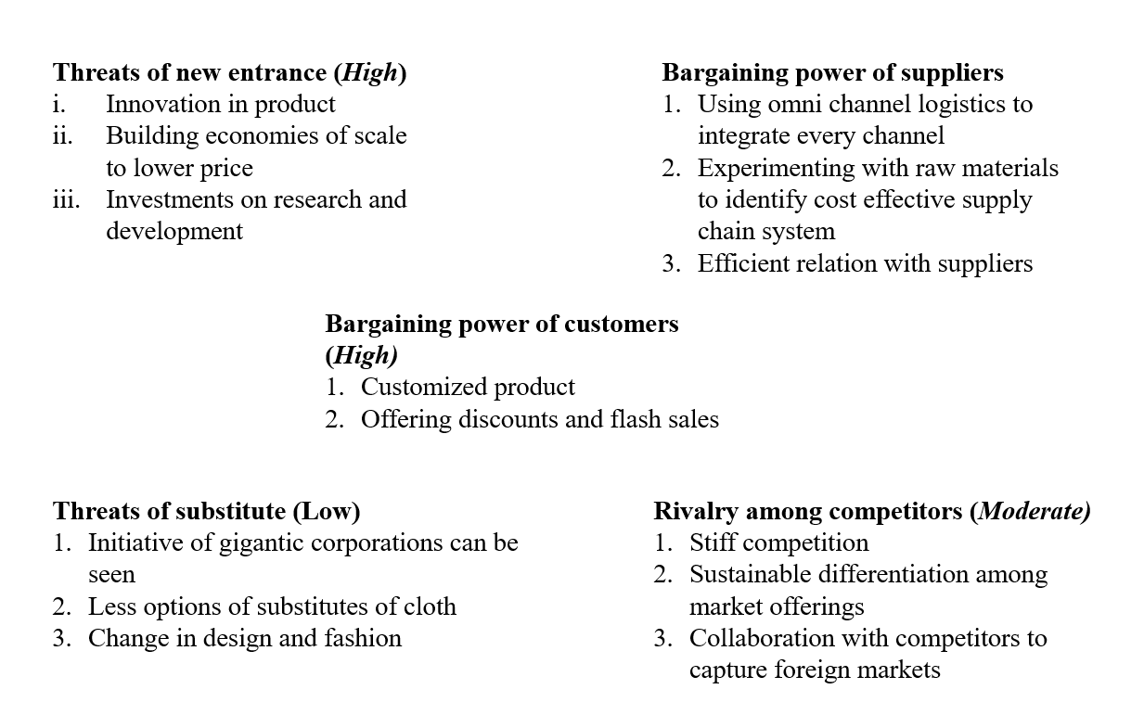
Figure 2: Porter’s five forces model of Next Plc
Source: own

Threats of substitute
Cloths have no substitute. A manufacturer can do changes in products of garments industry but can’t bring any substitute of cloth. But there can be substituted for products of a particular company. As Next Plc is the country’s largest apparel manufacturer, the company has fewer threats from substitutes. Whenever a substitute product enters the market, the company can easily bring significant product changes to attract customers (Jin and Cedrola, 2018). Again, the company developed the infrastructure to use better technology while facing new challenges in the market.

Rivalry among competitors
Arcadia Group, Debenhams, Marks, and Spencer are some biggest rivals of Next Plc in the UK. The company opened a sector for only women's clothing brands called Lipsy. This has created a sustainable product differentiation for the company. As the British people tends towards dynamic fashion designs, Next Plc brought up new product variants to defeat the competitors. As the competitors are very large, so they can’t take any unnoticed move (Stephens, 2013). Hence, it is easier for the company to understand the strategies of competitors.

Analysing the impact of competitive advantage through PESTLE factors
The PESTLE analysis will help to understand what Next Plc is doing to tackle external challenges to gain a competitive advantage in the market. Any particular change in the external factors can have a direct impact not only on Next Plc but also on the competitors of the same industry.
Political | Economic | social
1. Brexit issue  2. Change in government  3. Change in foreign market policy | 1. Lower interest rate  2. High investments in recent years  3. Fluctuation of foreign exchange rates | 1. High fashion trend  2. Changing behavior of local community regarding clothing
Technological | Legal | Environmental
1. Augmented and virtual reality  2. e-wallet system  3. office automation through artificial intelligence  4. Block chain supply system  5. Order fulfillment  automation | 1. New employment law  2. Foreign country legislations  3. Favourable retail business regulations in the UK | 1. Eco-friendly production  2. Bio-degradable packaging  3. Effluent Treatment Plant  4. High waste management system
Table 1: PESTLE analysis of Next Plc
Source: Own

Political, economic, and social factors
Since the declaration of Brexit, Next Plc had to go through extreme challenges in the foreign market. Conducting business in EU countries was so tough at that time that the profit margin dropped for almost every company in the UK. To defeat the competitors, change in the political environment is the biggest barrier in the retail industry. The banks of the UK reduced the interest rate as the inflation rate is 0.7% (GOV.UK. 2021). So, investing more in the company became easier for Next plc. After the Brexit issue, government intervention in the free market increased competition among the gigantic corporations. As Next plc has good infrastructure and resources, the company achieved a competitive advantage (Qazi et al., 2017). The British people have a high trend of fashion. The company has a wide range of product variations which generates a high market share. The unique design, high quality, and lower price of the products of Next Plc customers always (Rishi, 2011). Also, the company follows a premium pricing strategy to capture the market of the high class.

Technological, legal, and environmental factors
In recent years, mobile commerce has accelerated the growth of retail businesses. Virtual and augmented reality used in retail stores of Next Plc enhanced the growth. The use of Avametric in websites of the company helps customers to try clothing virtually (Thomassey and Zeng, 2018). Again, the company uses blockchain to inter-connect their intermediaries in supply chain management. These technological advancements enabled the company to gain a competitive advantage. Moreover, the regulations of business in the UK are in favor of the retail industry. In this regard, all the players of retail businesses get equal rights in the market. This has reduced illegal practices in business as every company gets an equal opportunity. Hence, there is very little competitive advantage in the legal environment. But echo-friendly production and the use of high waste management technology increased the market share of Next plc. As the people are now more concerned about the environment, the company uses Effluent Treatment Plant (EFT) for water wastes (Heeley, 2018). The company is moving towards zero waste by reducing, reusing, and recycling processes.

Recommendations for achieving competitive advantage
The success of a business depends on understanding customers' needs and proactive management that focuses on the ultimate business growth. The organisation needs to understand that they are giving solutions to a problem of customers rather than selling a product. With a history of nearly 157 years, Next Plc has achieved its base in the retail market of clothing in the UK. Now, the company can focus on making it sustainable instead of focusing on sales expansion. The anticipation of seasonal demands will help in this regard to produce fashionable clothes (Froud et al., 2017)). More engagement of online places is also necessary as most people have gone virtual. Constructive analysis of big data is needed for the company to understand and anticipate market demand. In the physical stores, the company can have robot assistants with artificial intelligence to help customers in purchasing. Moreover, automation in order fulfillment can be used to replenish the stock on regular basis. Cashier less payment or e-wallet system can help the company to reduce labor costs in physical stores. In a word, to cooperate with the dynamic environment, Next Plc has to put more investment on technological advancement, efficient production, and a strong distribution network.

Conclusion
The above discussion picturises the changes in the business model of Next Plc to gain a competitive advantage. The changes in the business model enabled the company to use different strategies in the pandemic period to make the production more sustainable. Porter’s five forces model and PESTLE analysis the company to understand which factors are affecting the company most in gaining competitive advantage. Focusing on research and development and eco-friendly production will help the company to sustain itself in the market. Moreover, the advanced technological implication will help in this regard. Overall, the company now needs to focus on sustainability to capture more market by overpowering the competitors.

Reference
Castillo, J., 2018. How interactions influence customer empowerment and satisfaction in the retail industry. Journal of Business & Retail Management Research, 12(04).
Choi, T., 2012. Fashion supply chain management. Hershey, PA: Business Science Reference.
Elsner, S., 2014. Retail Internationalization. Wiesbaden: Springer Fachmedien Wiesbaden.
Froud, J., Tischer, D. and Williams, K., 2017. It is the business model… Reframing the problems of UK retail banking. Critical Perspectives on Accounting, 42, pp.1-19.
GOV.UK. 2021. Business Regulation: Guidance And Tools. [online] Available at: <https://www.gov.uk/guidance/business-regulation-guidance-and-tools> [Accessed 7 March 2021].
Heeley, J., 2018. Environmentally conscious design and manufacture in the UK textile industry. Manchester Metropolitan University.
ILO., 2016. Sectoral Studies on Decent Work in Global Supply Chains. Geneva: ILO.
Jin, B. and Cedrola, E., 2018. Product Innovation in the Global Fashion Industry. New York: Palgrave Macmillan US :Imprint: Palgrave Pivot.
Massara, F., Liu, S. and Melara, R., 2010. Adapting to a retail environment: Modeling consumer–environment interactions. Journal of Business Research, 63(7), pp.673-681.
Nextplc.co.uk. 2021. Home. [online] Available at: <https://www.nextplc.co.uk/> [Accessed 13 March 2021].
Qazi, S., Miralam, M. and Bhalla, P., 2017. Organizational culture and job satisfaction: a study Of organized retail sector. Journal of Business & Retail Management Research, 12(01).
Rishi, B., 2011. Factors affecting shopping of apparels in organised retail stores. International Journal of Business Innovation and Research, 5(5), p.546.
Stephens, D., 2013. The retail revival. Ontario: John Wiley.
Takayasu, M., Watanabe, T. and Takayasu, H., 2010. New approaches to the analysis of large-scale business and economic data. Tokyo: Springer.
Thomassey, S. and Zeng, X., 2018. Artificial Intelligence for Fashion Industry in the Big Data Era. Singapore: Springer Singapore.
Wigley, S., 2011. A conceptual model of diversification in apparel retailing: the case of Next plc. Journal of the Textile Institute, 102(11), pp.917-934.

