

Student name: Erkan Paca
Student ID: 2010132

Module name: Public Health Policy (Assessment 2)
Module code: BMHP5013
Lecturer name: Dr Edward Goka

Table of contents
Contents
Table of contents 2
1. Introduction/ Background 3
2. Strategies 4
3. Public health policy 6
4. Theories 7
6. Ethical considerations 10
7. Recommendations 11
References 12

1. Introduction/ Background
In December 2019 the announcement was declared that new epidemic called and named as corona virus effecting the world globally. It was originated in Wuhan city of China spread from Huanan sea food market. Live animals were kept in that place to be slaughtered and sold to customers in non-hygienic places. Wilson (2020). SARS & COVID-19 triggered from coronaviruses both causing respiratory diseases which is transmitted from person to person by tiny droplets triggered when sneezed or coughed, it is also have the same consistency impacting on surfaces too. It can be very deadly if person have the virus, thus, they need to be ventilated and provided oxygen especially the elderlies and people who suffer from other related medical conditions. Healthline (2021). On the other hand, WebMD informs that coronavirus is a disease that can cause to have an infectious sinus, common cold through your nose and upper region of your throat. Many coronaviruses apparently are not that threatening. The COVID-19 is a communicable disease that emerges by SARS-CoV-2 infecting your lower and upper respiratory system causing an infection. (sinus, nose, throat, windpipe, lungs). It has been informed that this virus mutates which in fact did so. There are several types of variations now circulates to be more communicable and mortal. The variations that researchers pointed-out as alpha, beta, gamma, delta, omicron, lambda and Mu. Some of the symptoms caused by COVID-19 are, fewer, coughing, difficulty of breathing, feeling lethargic, headache, sore throat, congestion and runny nose, loss of tasting and smelling, nausea and diarrhoea. It can also cause to pneumonia, respiratory issues, heart conditions, liver problems, septic shocks and death. WebMD (2021).
UK vs China comparatives on Covid-19;
The effect of Covid-19 outbreak casualties in the UK was 335,877 and 41,501 fatality by January 31,2020 to September 2020.WHO (2020) in comparison to China figures was 90,402 confirmed cases, fatality of 4730 in the same periodic time span. In January 2020 China forced a lockdown in city of Wuhan and other provinces in Hubei to implement quarantine measure rapidly for coronavirus epidemic. In time, the China become the central point of Covid-19 and has try many approaches to control the disease. These plans of actions have worked fast and worked successfully with constructive organisation and systems focused action with high tech measures was taken to improve health restraining Covid-19. Maier & Brockmann (2020). Proper health preventative approaches such as detecting the virus as early as possible, ‘contact tracing’, community behaviours check, and forming many hospitals, finding and implementing the needed sources in timely manner, and using places like primary care centres as a treatment centres for coronavirus. This was an effective way to suppress the Covid-19. The Lancet (2020). Abrupt responsive measure has been implemented by government of China that when a person contracted with the virus, they need to self-isolate rapidly to trace people with PCR test wherever they are. Thus, they need to go through self-isolation process quickly, if not, they face fines. Public received regular PCR tests helped China almost free of Covid-19 contributed socioeconomical capacity and enough time for vaccine to be produced in future prophylaxis and controlling the virus. The BMJ (2021). 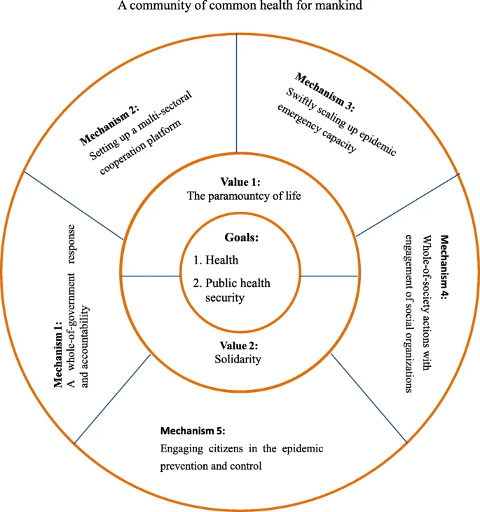

State response in the UK divided in three parts with ‘restriction’ as ‘trace of contact’, efficient hand washing, and its awareness, ‘delay’ as slowing down the ratio in order to gain time to minimise the epidemic whilst developing efficient tests, treatments and immunisation. Also ‘weakening’ stage that it is called herd community to allow people mixing in the communities to increase their strength against it. It would simply decrease the death rates via safeguarding the most vulnerable people in due course. However, this will not diminish the issues related with Covid-19. SAGE (‘Scientific Advisory Group of Emergencies’) involved in this positively to give advice and argumentative to steer the policies. Mc Conalogue & Knox (2020).

2. Strategies
As the cases arising on a daily basis globally and resulting to spread by person to person contact causing a concern within the communities as a communicable disease. Therefore, scientists to have a duty to monitor the disease and make an effort to slow-down the circulation of the spread disease. CDC (2020).
Gathered data regarding the cases of Covid-19; as each Covid-19 occurrence collected regularly by the virologists who are running public health surveillance in an organised manner to receive the data to analyse and elucidate the relevant information.
This monitoring will allow virologists to work-out the;
Incidence, (up to date occurrences over a periodic time duration)
Prevalence, (up to date occurrences over a specified location in timely manner)
Hospitalisation, (up to date occurrences which resulting hospital admission)
Deaths, (up to date occurrences causing death).
Globally, as of 4:14pm CET,29 December 2021, there have been 281,808,270 confirmed cases of COVID-19, including 5,411,759 deaths, reported to WHO. As of 3 January 2022, a total of 8,693,832,171 vaccine doses have been administered.
It is not only about the calculating each case in a numerical order. It will also give us the various facts and figures gathered to determine more information with regards to related diseases. Gathered information from medical records in a chart or table can provide us additional data regarding Covid-19 patients and the stream of their disease. This information can include demographical data such as age, race, ethnicity, or sex along with symptoms, treatments and the impact of medical outcomes. Thus, researchers can utilise the graphical information to determine who is likely to be affected from this disease critically. As well as the summary of that person’s medical treatment which was obtained from and how they have recuperated.
Immediately after the information gets collected by researchers, they evaluate the information in data visualisation to generate a clear images, tables, charts and graphics to build an information that can be understood and read easily by researchers and the public. As the new information becomes accessible explaining the facts of number of people hospitalised, and deaths over a period of time. This displayed information called epi-curve and this gets updated regularly. It can be difficult to know because of the delay processing when this person falls ill and when the cases is gathered. Therefore, it is difficult to know when the cases genuinely begin to decrease. Hence, the current epi-curve incidence may show as epidemic is diminishing despite being active. The clear picture would only be available once the epidemic is finished. CDC (2020).
The recommendation from Chinese government advising a ‘suppression’ policy is the only option at hand. Despite it was not the best model of option socially and politically. Suppression policy targets in reversing the epidemic advancement in place of ‘mitigation’ which stated minimising caseloads to lower levels to stabilise the circumstances positively. Hence the government policy was shifted from ‘delay’ to ‘suppressions’ transference.
Policies also had intention free-up available beds maximising the capacity if needed. The contract between the NHS and private hospitals was cancelled in adopting a strategy to work collaboratively between the two organisations. This explains the lack of available resources within the NHS, not investing enough for generating more hospital beds and hospitals for public need. Lawrence et al (2020).
Nightingale hospitals are generated in the UK to meet the demand for public by creating more beds temporarily. In order to meet the shortage of staff retired medical professionals were called back to support the current crisis. NHS debt written-off by government (historical debt) in due course. The Health Foundation (2020). Thus, this will enable NHS to gain back the confidence to deal with epidemic. Policies purposed to provide more protective equipment’s like PPE, ventilators to staff and the patients who are exposed to coronavirus directly. Calnon (2020a).

3. Public health policy
Preventative measures to minimise and control Covid-19; Distancing yourself physically by simply avoid large crowds, face masks especially when indoor areas because the virus it is very infectious, get vaccinated, frequent handwash with alcohol and soap, disinfect all the relevant exteriors, close your mouth and nose when sneezed or coughed. Even if you are immunised continue to wear a face covering indoors and outdoors. In order to prevent spread, avoid closer contacts with people because person may not have the virus but by just having personal conversation with someone can be risky due to the particles scatters around in the air as we speak. Also, saliva exchange is quite common to catch the virus directly. Regular testing is essential to prevent catching the disease. Herd community approach can protect people despite they were not immune, and it is particularly effective when the person vaccinated and protected. Set rules suggest to protect us from catching the virus such as, healthy eating, consume vitamins and regular outdoor activities, sufficient sleep pattern, no smoking or excessive alcohol intake, and get away from stressful situations.
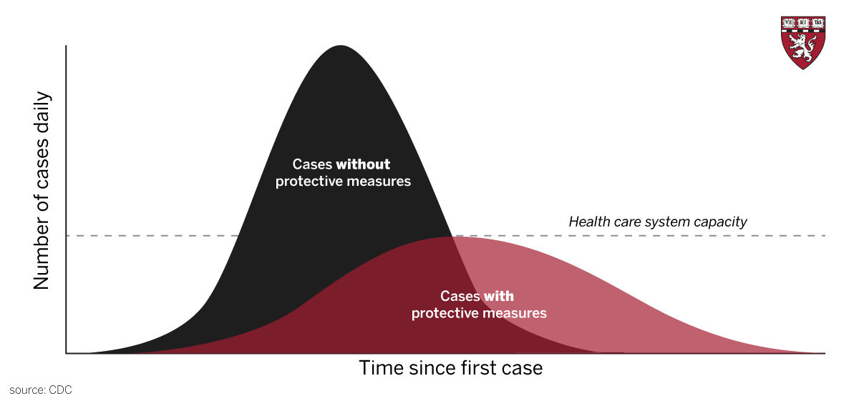
Harvard Health Publishing (2022).

4. Theories
Societal and health related forecasts;
Latest researched works on forecasters objectives to get Covid-19 immunisation have indicated that high percentage of men were more eager to receive immunisation (77.9%) compare to women (70.1%) specifically over men exceeding the age of 55. Neumann et al (2020). Some researched studies looked into the objectives of the community to receive immunisation with Covid-19 injection. A survey took place In Europe, including people from Denmark, France, Germany, Italy, Portugal the Netherlands and the UK have shown a good reaction from these countries %74. Neumann et al (2020). High level of reaction against the Covid-19 from Australia %86. Dodd et al (2020). Low level of participation on over adults %69 in the USA. Reiter et al (2020).
Conceptual ‘models’ of ‘health’ ‘beliefs’ and threat awareness are fundamental for acknowledging the components beyond decision-making by evaluating what encourages or demotivates people to embrace health-related behaviour. Health Belief Models is broadly utilised to understand the relation between why people behave in such a way within the use of health services. Founded in the USA in 1950’s by ‘social’ ‘psychologists’. Rosenstock (2011). This action plan investigates to determine and anticipate preventative health behaviour in line to follow with belief system. Particularly why people do behave differently when their health at stake in connection to health promotion for example getting a Covid-19 injection.
HBM; (HEALTH BELIEFS MODEL)
‘Perceived susceptibility’; I reckon that if don’t get immunised the possibility of me catching the virus will rise.
‘Perceived severity’; Even if I catch the virus, I doubt that, it will create a big problem for me.
‘Perceived benefits’; I reckon that Covid-19 injection would give me a protection efficiently to deal with any related side-affects about the disease.
‘Perceived barriers’; Having a vaccine is too costly it needs time and effort.
‘Cues to action’; The possibility that I get immunisation will be maximised which will depend on my GP’s advice.
‘Health Motivation’; I ensure that I eat healthy food following certain dietary.
TPB; (THEORY OF PLANNED BEHAVIOUR)
‘Attitude’; It is boring to get vaccinated it needs time and action.
‘Subjective norms’; Many of my friends will help me to get the Covid-19 injection.
‘Perceived behavioural control’; I have a free will to do so and I will get that jab, if I was offered vaccination next year.
‘Self-efficacy’; If I do the necessary measures (washing hands with alcohol) I will not need any vaccine.
BMC Public Health (2021). “The combined framework and the study calculations were utilised to craete the conceptual model” (see Fig. 1) and are described below;

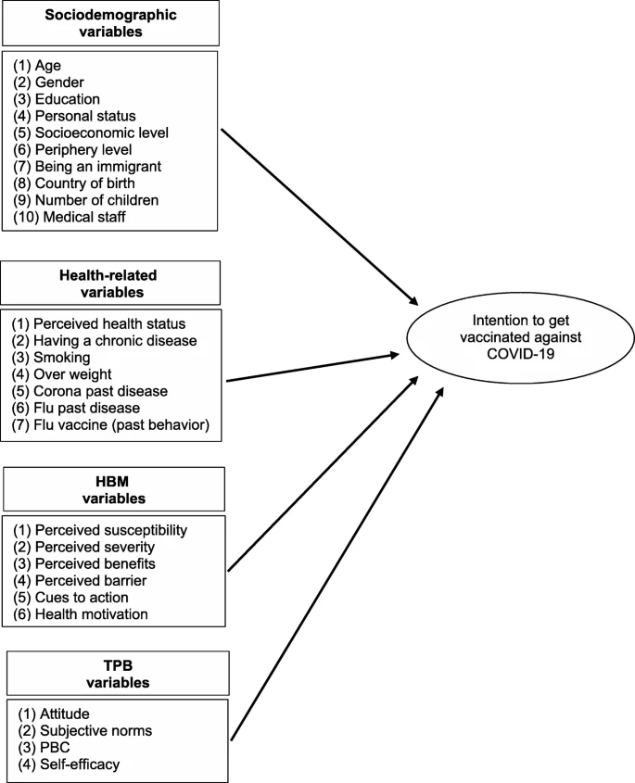

5. Impact of legislation and policies
The UK Health Security Agency (UKHSA) and Office of Health Improvement & Disparities (OHID) will make sure that the nation can response rapidly at greater scale to manage with pandemic and future threats. Enhancing their health so that everyone can have a healthy life and manage to deal with disparities.
ONS (Office of National Statistics) survey suggested that over %35 of 2.2 million people in the UK suffered from poor mental health as a confinement. ONS (2020)
The researched studies states that almost every country have introduced measures like social distancing policy and lockdowns. Especially people living with a long-term medical condition such as diabetes, hypertension, and respiratory ailments and other underlying medical issues was triggered by Covid-19, thus, these vulnerable group were asked to protect themselves by not being exposed to virus. PHE (2020).
According to social survey that was carried out of 70.000 people in relation to Covid-19, as a result of lockdowns more people living with health conditions suffered depression, anxiety and stress during the lockdowns. Fancourt et al (2020). More strict rules applied for public and people visiting UK, such as increased border control for people travelling to or from UK. Prohibiting public gatherings to two people maximum. 27 million of family members were sent-out letters to confirm continuation of social distance, limiting to shop, exercise and access medical necessities to a lower level to protect public from spreading. This time the information was forwarded to public in an instructional manner rather than advice. Power given to police to fine people not following the guidelines. Duffy (2020). 3 bn given to NHS for additional pressure to ease the winter impact to control the pandemic. Furlough scheme was introduced to help people not losing their job during the pandemic. UK state has helped millions of people economically to meet their financial needs. Vize (2020).

6. Ethical considerations
The Covid-19 epidemic is a progressive communicable disease as a ‘public health emergency’. State departments, medical professionals and the communities are working solidly to come up with an action plan to apply a master plan to minimise the advancement of the infection, to maximise the capacities that we already hold. Draw up a plan for future impacts and preventative measure. Vermont Ethics Network (2022). Properly placed prevention methods like masking, testing, large scale of contact tracing and selected isolations prevent lockdowns and will enable us to battle with the virus, restore the economy and safe guard the public.
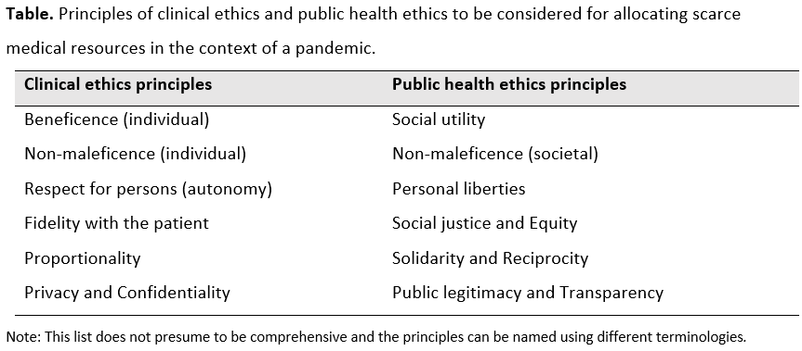
This Photo by Unknown Author is licensed under CC BY-NC
Public health professionals have a duty to plan for example, having to manage predictable ethical obstacles whilst the crisis occur such as Covid-19. Duty to safeguard people who are vulnerable to and their personnel, medical workers have a responsibility to care for patients are implanted within the concept of ‘beneficence’. Duty to guide, government organisations have a liability to provide a guideline for health system, and medical professionals duty for immunisation education and the distribution of the vaccination appropriately. The Hastings Centre (2021) Unity in between medical workers and the communities is a fundamental ethic reducing the fatality and the disease. Brody, Avery (2009.

7. Recommendations
In my report I have explored the Covid-19 comparatives with UK vs China approaches, strategies and policies with regard to Covid-19.
In summary, reacting fast to Covid-19 is essential to control the disease. Reaction that China have displayed was very fast by using advance technology such as artificial intelligence, testing and tracing people, properly implemented isolation methods along with proper hand washing, masking, distancing is all paid off for China. On the other hand, UK did not react that quickly and suffered the impacts consequently.
BMC Public Health (2021)
Based on the researched studies suggest the 10 main Covid-19 policy master plan which will work strategically managing Covid-19;
Equal dispersion of the vaccine with normalising restrictions on a bigger scale. More people get immunised will enhance reaching higher level of epidemic control, will permit us less face-masks and less distancing and lockdowns overall. Escandon et al (2021). Information provided below indicates us how we can act in future prospective dealing with Covid-19.

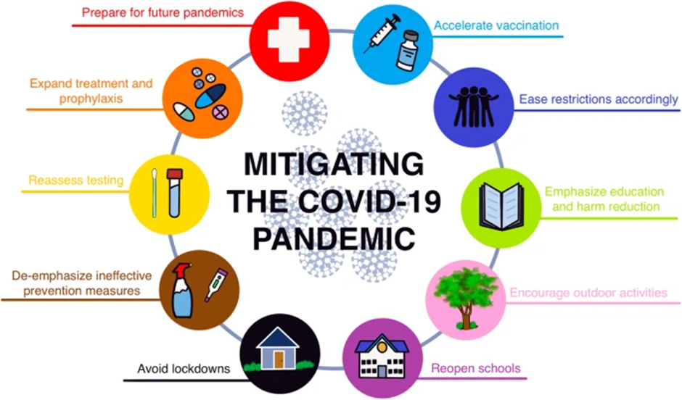

References
BMC Public Health (2021) Predicting intention to receive Covid-19 vaccine among the general population using the health model and the theory of planned behaviour model:
[Online]. Available at: https://10.1186/s12889-021-10816-7. Accessed (08/01/2022)
BMJ (2021) Covid-19: Why China sticking to “zero tolerance” public health measures: [Online]. Available at: https://doi.org/10.1136/bmj.n2756. Accessed (05/01/2022)
Brody H, Avery EN (2009) Medicine’s duty to treat pandemic illness: Solidarity and Vulnerability. Hastings Cent Rep. [Online]. Available at: https://doi.org/10.1353/hcr.0.0104. Accessed (10/01/2022)
Calnon M (2020a) Country Responses to the Covid-19 Pandemic: [Online]. Available at: www.cambridge.org/core/blog/tag/country-responses-to-the-Covid-19-pandemic. Accessed (05/01/2022)
Duffy B (2020) Life under lockdown: Corona virus in the UK: Policy Institute [Online]. Available at: https://www.kcl.ac.uk/news/life-under-lockdown-coronavirus-in-the-uk. Accessed (04/01/2022).
Dodd RH, Cvejic E, Bonner C et al (2020) Willingness to vaccinate against Covid-19 in Australia. Lancet Infectious Disease: [Online]. Available at: https://doi.org/10.1016/s1473-3099(20)30559-4. Accessed (07/01/2022).
Escandon K, Rasmussen AL, Bogoch II, Murray EJ, Escandon K, Popescu SV, et al (2021) Covid-19 false dichotomies and a comprehensive review of the evidence regarding public health, Covid-19 symptomatology, Sars-CoV-2transmission, mask wearing, and reinfection: BMC Infect Dis. [Online]. Available at: https://doi.org/10.1186/s12879-021-06357-4. Accessed (06/01/2022)
Fancourt D, Bu F, Wan Mak H & Steptoe A (2020) Covid-19 social study results release 24: [Online]. Available at: https://www.covidstudy.com/results/pdf. Accessed (09/01/2022)
Harvard Health Publishing (2022) Preventing the spread of the coronavirus: Harvard Publishing. [Online]. Available at: https://www.health.harvard.edu/diseases-and-conditions/preventing-the-spread-of-the-coronavirus. Accessed (09/01/2022).
Lawrence F, Gardside J, Pegg D et al (2020) How a decade pf privatisation and cuts exposed England coronavirus: Guardian. [Online]. Available at: https://www.theguardian.com/world/2020/may/31/how-a-decade-of-privatisation-and-cuts-exposed-England- coronavirus. Accessed (04/01/2022).
Mc Conalogue J, Knox T (2020) A hit trick of failures, part4: Civitas 2020. [Online] Available at: https://doi.org/10.35241/emeral dopenres.13726.1. Accessed (04/01/2022)
Neumann- Bohme S, Vaghese NE, Sabat I et al (2020) Once we have it, will we use it: European Survey of Willingness to be vaccinated against Covid-19. p.977-982. [Online] Available at: https://doi.org/10.1007/s10198-020-01208-6.Accessed (07/01/2022).
ONS (2020) Coronavirus and shielding of clinically extremely vulnerable people in England: [Online]. Available at: https://www.ons.gov.uk/peoplepopulationcommunity/healthandsocialcare/conditionsanddiseases/bulletins/coronavirusandshieldingofclinicallyextremelyvulnerablepeopleinengland/ Accessed (08/01/2022)
PHE (2020) Covid-19: Guidance on shielding and protecting people defined on medical grounds as extremely vulnerable: PHE. [Online]. Available at: https://www.gov.uk/government/publications/guidance-on-shielding-and-protecting-extremely-vulnerable-person-from-covid-19. Accessed (08/01/2022)
Rosenstock (2011) Why people use health services: Milbank Mem Fund Q. [Online] Available at: https://ncbi.nlm.nih.gov/pubmed/5967464. Accessed (08/01/2022)

Reiter PL, Pennell ML, Katz ML (2020) Acceptability at a Covid-19 vaccine among adults in the USA: How many people would get vaccinated. [Online]. Available at: https://doi.org/10.1016/j.vaccine.2020.08.043. Accessed (08/01/2022)
The Hastings Centre (2021) Ethical Challenges in the Middle Tier of Covid-19 Vaccine Allocation: Guidance for Organisational Decision Making: [Online]. Available at: www.thehastingscentre.org/ethical-challenges-in-the-middle-tier-of-covid-19-vaccine-allocation. Accessed (09/01/2022)
The Health Foundation (2020) Covid-19 policy tracker: A timeline of national policy and health systems responses to Covid-19 in England 2020. [Online] Available at: https://www.health.org.uk/news-and-comment/chartsandinfographics. Accessed (03/01/2022).
Vize R (2020) England new Covid-19 monitoring outfit: The Joint Biosecurity Center. BMJ 2020. [Online]. Available at: www.bmj.com/content/370/bmj.M2604. Accessed (05/01/2022).


