Financial Management for the Hotel Industry
Student Name: Robert-Cristian Matyas
Student ID: 2111528
BMIH5007
Lecturer: Dale Clarke

Introduction
This report is focused on the topic of financial management in the hotel industry. It compares financial management activities of two of the world’s biggest hospitality businesses, Marriot International Inc. and InterContinental Hotel Group in terms of revenue, growth potential, expansion opportunities, market position and corporate social responsibility commitments. And in the final section, it concludes with some recommendation for respective businesses.
Overview of the Companies
Marriott International, Inc. is an American multinational corporation which runs, franchisees, and contracts hotels, residences, as well as timeshares. It has its main office in Bethesda, Maryland. J. Willard Marriott and his wife, Alice Marriott, formed the business. According to the number of rooms that are available, the Marriott hotel chain is the biggest one in the world. It operates under 30 different brands, with 8,000 hotels and 1,423,044 rooms spread throughout 139 different countries and territories. Only 2,149 of these 8,000 hotels are directly managed by Marriott; the other 5,493 are owned and operated by third parties under franchise agreements (Marriott, 2022). Additionally, the corporation maintains twenty hotel reservation centres. In 1993, the Marriott Corporation separated into Marriott International, Inc., which is in charge of franchising and managing hotels, and Host Marriott Corporation, which is now known as Host Hotels & Resorts, which is in charge of property ownership. Since the original owners were devout Mormons, each guest is also given a copy of the Book of Mormon.
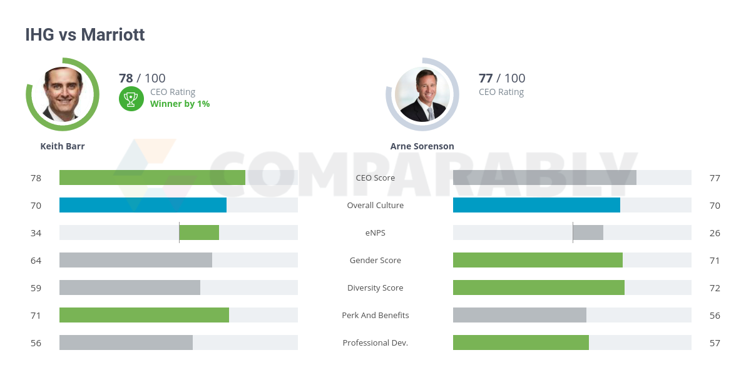
Source: Company annual report
Founded in 1946 by Juan Trippe, founder of Pan American World Airways, InterContinental Hotels & Resorts is a British fancy hotel chain. From 1998 on, it has been a member of the InterContinental Hotels Group. As of the following November 2020, there have been 210 InterContinental hotels with a total of over 71,045 rooms located all over the globe. Founded in 1953 and based in Windsor, England, InterContinental Hotels Group (IHG) has since expanded to become a global hospitality leader. The company has a stock market listing in London (InterContinental Group, 2019).

Financial Management of the Companies

Revenue Comparison
For understanding the revenue comparison of the two companies, let us look at the following table first:
Business Name | Revenue (In Billion)
Business Name | 2019 | 2020 | 2021
Marriott | 20.972 | 10.571 | 13.875
InterContinental Hotels | 3.456 | 1.757 | 2.318

Table 1: Last 3 years' revenue of Marriott Internationals and InterContinental (Google Finance, 2023).
Businesses till 2019 all over the world were going smooth until the shock of global pandemic changed the dimensions. In 2019, Marriott had a revenue of around $21B whereas in 2020- due to COVID-19 Pandemic effect, the revenue fall 49.59% for the company. Similar trend is seen in case of Hotel InterContinental Business as well. In the year 2019, the company registered a revenue count of around $3.456B and in the next year in 2020, it dropped down by almost 50% to $1.757B only.
However, in the post pandemic turnaround, businesses did good all over the globe. And consequently, in the year 2021, revenue for the Marriott International was reported around $13.857B which shows an around 31% increase from the previous year. In the same year, the InterContinental reported their revenue around $2.313B which also 31.9% increased from the previous year.
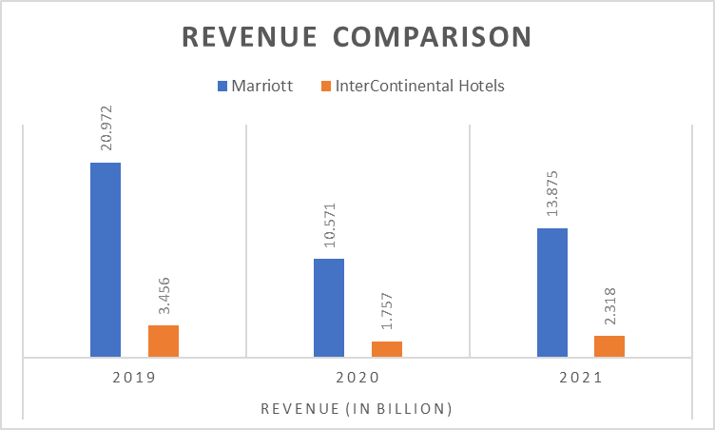

Growth Potential
The predicted future profitability of a firm, the amount of staff expansion, and the volume of production are all factors that contribute to a company's potential growth. The capacity for long-term expansion will determine the performance of a business (Fedman,2019). The capacity of a firm to grow through time is essential to the organization's overall success. It's helpful for financing investments, getting new personnel, and buying land, among other things (Cunill, 2018). In addition to this, it is a significant contributor to the success and expansion of enterprises. Followings are some of the growth potentials that these companies in hospitality business can exploit:
Possible Mergers and Acquisitions: The process of integrating firms via a wide variety of different sorts of transactions is referred to as mergers and acquisitions (M&A), which is a phrase that is often used (Ross et al., 2019). Marriott International Inc. is currently the largest hotel chain in the world. The company operates in 139 countries in the world as off today. Merging with local businesses and grasping the entire customer base of the region would certainly boost the growth of Marriott. The same goes for InterContinental. Relatively smaller in size, InterContinental operates in 100 countries around the world. Both the companies can suit themselves with strategic acquisitions of local profitable businesses.
Established Brand Growth: Both Marriott and InterContinental have their own brand value. And with the quality of their services, the brand value is supposed to increase day by day if maintained properly. Marriot offers 30 brands which is potential growth aspect of the company. And InterContinental have 17 brands offered to the service holders all over the world (Mathews, 2018).
Expansions: There are ample opportunities for both the companies to further expand their businesses into new geographic locations. World economy is moving towards industrialization, development and expenditures. People tend to save less, spend more for better services these days. And there are countries that come into the list of developing and middle-income nations each year. These newly developed countries can be good scope for expansion.
Market Position
An organization's positioning is crucial to its efforts to gain a market advantage. Through strategic positioning, a company may get its product or service in the minds of its target audience as having certain qualities. The mental picture might be based on actual experience or on how the product is perceived in relation to the market as a whole. As a result, positioning considers how customers see the offering.
There are four main benefits that guests may enjoy while staying at a Marriott hotel: convenience, personalization, savings, and recognition. The organization has made accessibility possible by offering several services and products. The company has set itself apart from the competition by emphasizing its quality and affordable price (George, 2021). Marriott markets itself as a provider of luxurious comfort at a reasonable price. Therefore, clients identify the company with luxury. Whereas its competition, Marriott International Inc., presents itself with an emphasis on affordability, IHG markets its image by concentrating its efforts on high-end markets such as major metropolitan areas, therefore raising the standard for the luxury hotel sector. IHG has also acquired brand awareness by hosting a handful of the world's most influential people (Johnson & Vanetti, 2019). InterContinental Hotels & Resorts have realized the rewards of smart branding by establishing its presence in the world's most exclusive areas and gaining the confidence of a number of the world's most influential people.
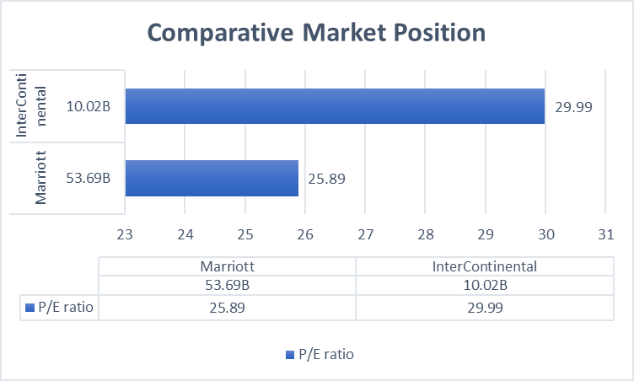

Commitment to CSR
Baker (2018), states that CSR refers to a company’s responsibility to promote the public good alongside the company’s financial goals. In order to have a beneficial effect on the environment, customers, workers, neighborhoods, participants, and every other member of the general public domain that might be deemed to be stakeholders, businesses should engage in corporate social responsibility (CSR). The process's ultimate objective is for the organization to take accountability of its actions and inspire good change via its operations (Barn, 2018).
CSR Practices of Marriott International Inc.
Marriott International Inc. invests in the health of local children and natural resources, and provides help and support during times of crisis, with the objective of encouraging resilience and promoting sustainable development in a variety of communities around the world.
- It is essential for the long-term sustainability and success of a society's young people that they have good health and a high level of vitality. Customers and employees of Marriott are encouraged to make charitable contributions to a group of organizations that are on the cutting edge of the fight to better the lives of children in every region of the world.
- "Serve Our World" is one of the core values upheld by Marriott International. Hotels and their workers in every corner of the world are actively striving to better the communities in which they are located by organizing volunteer efforts, participating in political campaigns, and donating both money and physical goods.
- When a disaster happens, Marriott conducts an assessment of the situation and arranges a response with existing relief organizations and accommodations throughout the world.
- Marriott participates in ecological projects such as coral regeneration, the protection of rainforests, and reforestation in order to increase the financial stability of the communities in which its hotels and houses are located and to boost their capacity to bounce back from adversity (Harris, 2016).
CSR Practices of InterContinental Hotel Group
Creating "Great Hotels That Guests Love" is intrinsically tied to taking care of the environment and the areas where personnel interact by doing the appropriate things in the appropriate way. This may be accomplished by carrying out the activities described in the previous sentence. When you manage a responsible firm, you simply have to accept things like this as the norm. The development of profitable businesses requires, among other things, the production of value for the community as a whole. To put it another way, this means that the quality of life in our communities and the natural surrounds will improve (Robert, 2019). The IHG Green Engage system is an online sustainability management tool that was developed by InterContinental. It educates hotels on how to reduce their negative impact on the environment by lowering their consumption of electricity and water, as well as the amount of waste they produce. Their strategy consisted of doing so in order to ensure that the natural environment would be preserved in its pristine state for future generations. The Hotel Group collaborates with academic institutions and groups all around the world via the IHG Academy to assist locals obtain marketable skills and boost their chances of finding job with one of the world's most successful hotel groups. They plan to let everyone in using this method of throwing open the doors. The following table shows a summary of CSR spendings of the two businesses in recent years:
Business Name | CSR Spendings (In Million)
Business Name | 2019 | 2020 | 2021
Marriott | 419.44 | 211.42 | 277.5
InterContinental Hotels | 69.12 | 35.14 | 46.36
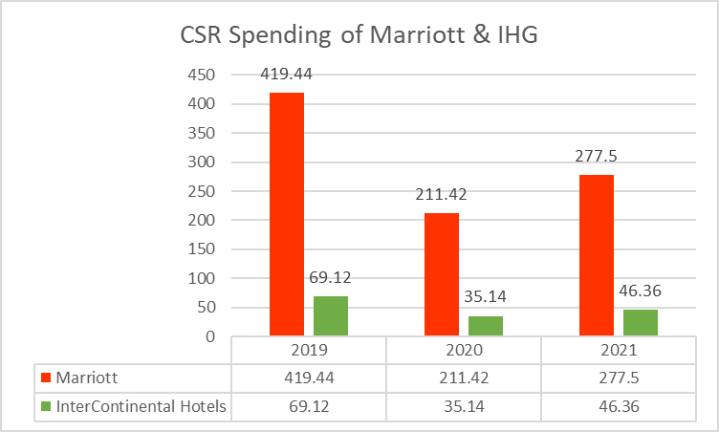
Source: Company annual report

Conclusion
Marriot International Inc. is the world’s largest hotel chain business which operates in more than 139 countries. The company has a market capital of around 54 billion USD in the American market and a good profitability as well. A relatively smaller but still market giant in the hotel business is InterContinental Hotel Group which is a British company and operates in more than 100 countries of the world. Both the companies saw an almost 50% revenue cut during pandemic and have recovered during post pandemic, both participates in the CSR through different activities and have growth potential.

Recommendation
Marriott has opportunities to grow through expansion in Japan, Turkey, Barbados, Mexico, and Georgia and some other south American countries. And as a matter of fact, it will be expanding its various brands in 120 different locations as well. And since it has a very good fame, it is rational to expand further for Marriott. The same goes for InterContinental as well. The business is good, popular and operates in more than 100 countries. In countries where their business hasn’t started yet, they can expand and exploit the opportunity in there. They can take advantage having the potential of growing by penetrating and exploring untapped markets (Bilgin et al., 2018).

Reference
Baker, C.R. (2018) Corporate Social Responsability (CSR): Practices, issues and Global Perspectives. New York: Nova Science Publishers.
Barn, J. (2018). The Effects of Corporate Ethicality, CSR Consistency, and CSR Fit. The Journal of Advertising and Public Relations, 20(3), 5–34. https://doi.org/10.16914/kjapr.2018.20.3.5
Bilgin, F.Z., Sriram, V. and Wuhrer Gerhard (2018) Drivers of Global Business Success: Lessons from emerging markets. Houndmills, Basingstoke, Hampshire: Palgrave Macmillan.
Cunill, M. (2018). The growth strategies of hotel chains: best business practices by leading companies. Haworth Hospitality Press. Google Finance. (2023, January 25).
Fedman, J. (2019) “Potential growth is slowing down.” Available at: https://doi.org/10.1787/9cbe8298-en. (2023, January 25).
George, R. (2021). Market Segmentation, Targeting, and Positioning. Marketing Tourism and Hospitality, 221–246. https://doi.org/10.1007/978-3-030-64111-5_7
InterContinental Group. (2019). About us. InterContinental Hotels Group PLC. Available at: https://www.ihgplc.com/en/about-us (2023, January 24).
InterContinental Group (2021). Annual report. Available at : https://www.ihgplc.com/en/-/media/ihg/annualreports/2021-annual-report/pdf/ihg_2021_annual-report.pdf (2023, January 26).
INTERCONTINENTAL HOTELS GROUP Common Stock (IHG: LON) Stock Price, Realtime Quote & News - Google Finance. Www.google.com. https://www.google.com/finance/quote/IHG:LONGoogle Finance. (2023, January 25).
Johnson, C., & Vanetti, M. (2019). Locational strategies of international hotel chains. Annals of Tourism Research, 32(4), 1077–1099. https://doi.org/10.1016/j.annals.2005.03.003
Marriott International Inc (MAR) Stock Price & News - Google Finance. Www.google.com. https://www.google.com/finance/quote/MAR:NASDAQHarris, C. (2016). Nurture - CSR-marriott. Csr-Marriott. https://serve360.marriott.com/nurture/
Marriott. (2022). About Marriott International | Corporate Information. Marriott.com; Marriott International. Available at: https://www.marriott.com/marriott/aboutmarriott.mi (2023, January 26).
Mathews, S. (2018). Marketing. Mcgraw-Hill Education.
Robert, S. (2019, November 5). InterContinental Hotels Group Corporate Responsibility. IHG. Available at: https://www.ihg.com/content/us/en/about/corporate-responsibility (2023, January 25).
Ross, S. A., Westerfield, R., & Jordan, B. D. (2019). Fundamentals of Corporate Finance (12th ed.). McGraw-Hill Education.
Yahoo Finance (2023). Marriott International, Income Statement. Available at : https://uk.finance.yahoo.com/quote/MAR/financials?p=MAR (2023, January 27).
Yahoo Finance (2023). InterContinental Hotels Group, Income statement. Available at : https://uk.finance.yahoo.com/quote/IHG/financials?p=IHG (2023, January 27).

