

Assessment 1 – Reading Task Template
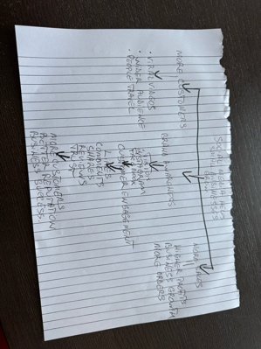
Upload your photo of your A3 in-class notes here:


1. Answer these questions using the sentence starters below
a. What is the main idea of the text?
The main idea is that social media helps businesses become popular and atract more customers, which can increase their sales and succes
b. What are two key points?
One key point is that many small businesses became successful after their video became viral on tik tok or instagram.
Another key point is that people are willing to travel long distances to see something they discovered on social media
c. What part of the text did you find most important? Why?
The most important part is the story about the Honywood Sandwhich Shop because it shows how one viral video brought people to try it from 3 hrs away
d. Was anything unclear or difficult to understand?
I was not sure about how social media algorithms are making some videos viral and some not
e. How did your group help you understand the text better?
My group helped me by discussing the main ideas, explaining difficult words and sharing opinions about the text
2. One sentence reflection
Question: What did you find challenging about this task?
The hardest part was identifying the most important part and summarising the text on my own.

