MANAGING PEOPLE

Student name: Diana Tincul

Student ID: 2028613

Module code: LCBB5004

Lecturer name: Dr.Terry Walcott

Table of content
Introduction 2
Part 1 2
Core behaviours for prominent HR professionals in the United Kingdom 2
How HR professionals throughout the global market will benefit from a professional map. 3
Part 2 4
Explanation of how considering the large rate of unemployment, the UK public sector is confronting a skills gap. 4
Long-term employment market trends in the UK to solve skills shortages in healthcare professions. 5
Conclusion 5
Reference 6

Introduction
Human resource professionals commit to focusing on tasks that make a significant contribution to people and enterprises. It also identifies by addressing challenges and opportunities that affect the functioning of the organisation. According to the HR professional, business culture may also play a role in employee retention. Thus, mapping a core behaviour has been accomplished using the CIPD method to better understand the notion. A professional map will also aid HR experts who are further categorised throughout the worldwide market. This helps to solve the fundamental challenges, such as environmental HRM, socially aware HRM, the three basic guidelines of being a good HR practitioner, and overall HRM wellbeing. Human resource planning demands the use of technology that enable managers to get insight into the characteristics that emerge from various HR activities. Thus, the establishment of such maps is critical to ensuring that HRM functions successfully and without stumbling blocks.

Part 1

Core behaviours for prominent HR professionals in the United Kingdom
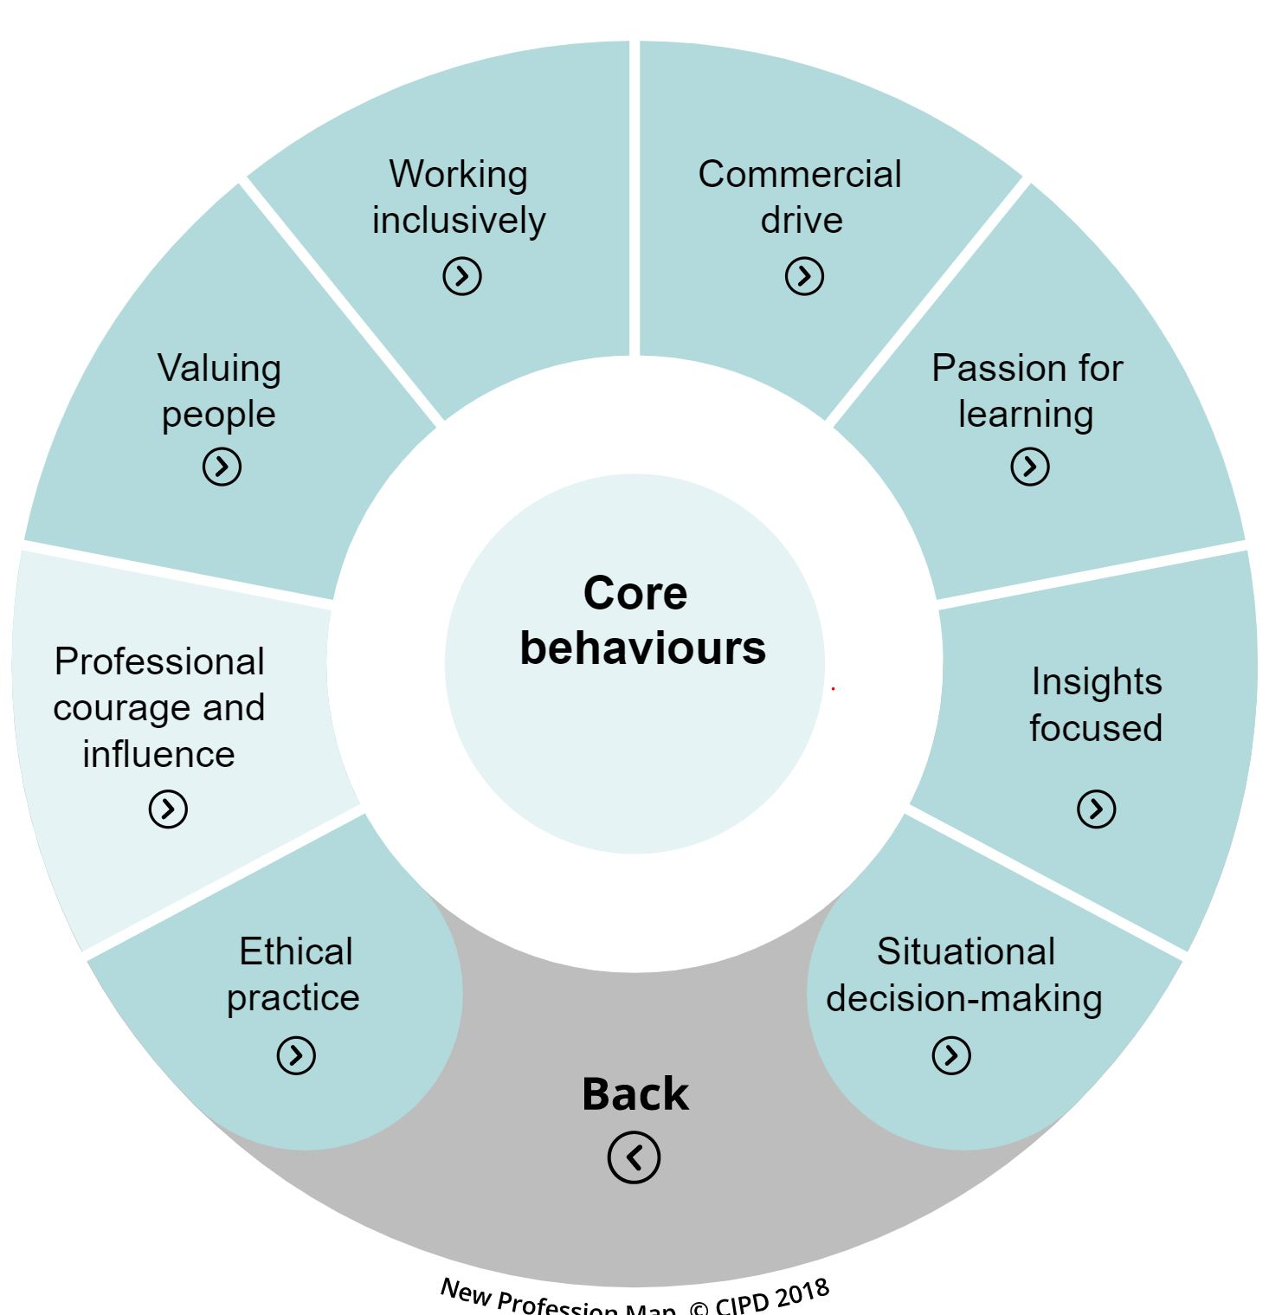
Figure 1: Core Behaviour
(Source: peopleprofession, 2022)
The HR professionals have helped in the functioning of the business with good management and interpersonal relationship. These are mostly inevitable which makes the process of generating most responsibilities and rights in the employees. This helps in constituting a partnership as an ethical practice. Through the post-modern mad new culture, this gives ambiguity and valued ethics are grown (O’riordan, 2022). Several roles depend on the HR professionals who were affected in the department in the business (Roper, and Higgins, 2020). Thus the problems that have impossible problems can adhere through the help of CIPD’s professional courage and influence. Through this, HR gets the confidence to give the solution to all the problems and can be a part of a smart business.
Most of the organisations in the UK are has managed to preserve and support most of the HR professionals. Thus these professional helps in conducting ethical work while managing the organisation and also valuing people. Thus the company has developed some HR skills to create an organisational ethical environment (Romanelli, 2018). This has effective management that helps in connecting the interpersonal relationship in the HR team. This will allow the human resource professionals, and employees as individuals, allowing you to collaborate more successfully. Supply specialised training on building good working inclusively digital or hybridized teams (Krupp, 2021). This will confidently utilise the wider range of platforms in virtual and app interactive with a core teamwork
The objective of the commercial drive includes offering a business-to-consumer and vendor attitude (Pepple, and Zhang, 2021). These also exhibit a dedication to delivering results that provide value to organisations. HR professionals must concentrate on the activities that add the most value to people and businesses. It also identifies identifying by addressing problems and opportunities that influence the organisation’s performance. The HR professional has also stated that corporate culture may contribute to employee effectiveness by allowing individuals to perform with a passion for learning. Because the company principles include cooperation, enthusiasm, transparency, honesty & responsibility, and full potential. Thus the employees may act professionally inside the organisation (Fareed, Ahmad, Salleh, and Saoula, 2020).
These ideals instil in a person’s personnel descriptive actions that result in effectiveness. HR professionals may share their insights and focus gleaned from contacts with people looking for work with top management. This will be encouraging them to adopt an international labour market viewpoint (Keegan, Brandl, and Aust, 2019). Thus with the supporting tools, the employees to participate in recruiters' activities which can conduct their experiments and assess them. The idea of situational decision-making is essentially making reasonable judgments or choices while taking into account the unique circumstance or environment. To assist in decision-making, a large numeral of data must be generated, investigated, and accumulated (Mohammed, and Quddus, 2019). Human resource planning necessitates technologies that allow managers to get knowledge of the characteristics that arise from diverse HR operations. This has excellent management, which aids in the connection of interpersonal relationships within the HR staff.

How HR professionals throughout the global market will benefit from a professional map
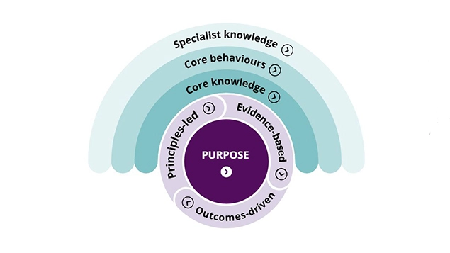\
Figure 2: CIPD MAP
(Source: people profession, 2022)

The core knowledge of an HR professional requires a high ability to execute the task on time. Human Resources examined should have the abilities and competencies to acquire all the HR strategies and knowledge. This core knowledge is essential to get ahead in their professions and determined these are the most significant. The requirement of core knowledge for a sustainable HR management system. This helps to address the main issues including the notions of environmental HRM, socially conscious Human Resource Management, the three bottom rules of being a good HR professional, and general welfare for HRM (Piwowar‐Sulej, 2021). Along with that a strategic application of HR focuses on the five components of the recruitment process and selecting the right candidates. This helps the HR performance to be assessed and paid accordingly. The payment can be in form of remuneration as HR also provides training and development for a better organisational flow.
With effective management and interpersonal relationships, HR experts have aided in the operation of the firm. These are typically unavoidable, which complicates the task of instilling the greatest obligations and rights in employees. Here the use of core behaviour is added to understand the idealogy of the HR professionals. This has excellent management, which aids in the connection of interpersonal relationships within the HR staff (Balconi, Fronda, Cassioli, and Crivelli, 2022). This will help human resource professionals and workers as individuals to cooperate more effectively. This gives HR the confidence to provide solutions to any challenges and to be a part of a smart business. Human resource professionals commit to focusing on tasks that bring the most value to people and enterprises. It also identifies by addressing challenges and opportunities that affect the functioning of the organisation.
HR professionals are required to interact effectively alongside top management and/or supervisors to achieve agreed organisational goals as strategic suppliers. A facility of expertise is a group of HR professionals who specialise in innovative HR technologies like training and education, process improvement, and pay and incentive. A unit that performs HR transactional services like recruiting and administration more productively and at a reduced cost is alluded to as support functions. Thus the implementation of specialist knowledge is important to make sure that the HRM is working effectively without any hurdles. Support functions refer to a unit that provides HR transactional services such as marketing and presidency more efficiently and at a lower cost.

Part 2

Explanation of how considering the large rate of unemployment, the UK public sector is confronting a skills gap.
The drop in employment has been witnessed by 466,000 (1.4 per cent) in the fiscal year that ended September 2021, mostly due to younger staff and primary professions. There has been a quiet growth of 0.9 per cent on average over the previous four years. With the sudden rise of the coronavirus, the pandemic has affected the economy, with limitations impacting the capacity of some enterprises to trade and the implementation of assistance systems. Thus the United Kingdom can up with a plan of Coronavirus Job Retention Scheme (CJRS) which gives support to all the affected people and also gives a new opportunity to work in two modes of operation such as remote and hybrid working (ONS, 2021).
It has also been seen that the current market number of vacancies has rapidly risen to approx of 1.2 million in the last three months since November of 2021. Employment is now also decreasing, lowering to 1.4 million is 4.2 per cent) in the third quarter ended in October 2021. Though unemployment is higher than it was before the outbreak, it is comparatively lesser than it was in the four years preceding the outbreak (1.5 million). Thus the rapid increasing vacancies and dropping unemployment may suggest a narrowing of something like the labour market since there are lesser persons to find jobs, perhaps adding to the difficulty in filling positions (Statista, 2022).
The demand for skills and the supply of skills is surely not aligned with each other. This gives birth to a mismatch of skills and employment (Brunello, and Wruuck, 2019). Thus the incompatibility scenario is unavoidable as well as demonstrates the good employment market. Some inconsistencies are more pervasive in particular parts of the economy and may signal fundamental difficulties. In the United Kingdom, there are witnessed an inventory of skills owned by persons. Thus even in work as well as someone who is jobless is included in the distribution of skills.
So the employment and skills shortage openings both show the need for skills. Now coming to the economic factor the shortage of skills is being divided into two parts. The first one is the external labour of the market where the shortage of skill is pointed to those candidates who lack the necessary skills, credentials, or experience for a position. Here the skill gap may also occur for those who left the job mid-way due to lesser knowledge of new skills. During the recruitment process, the employers must have the correct information o the candidate and which is the best place to offer (Du Toit, De Witte, Rothmann, and Van den Broeck, 2018).
In that case, if individuals are not wholly adapted to a contribution, thus sign up for a skills shortage, or whether they keep a vacancy. Thus employers need to understand the right skill, experience and qualifications must also come along and pre-register to improve the skills shortage vacancy (Osborne, and Norris, 2022).

Long-term employment market trends in the UK to solve skills shortages in healthcare professions.
The healthcare sector professions in the UK have witnessed a lot of changes in these few years the impact of Brexit and the outbreak of Covid 19 has scattered the economy and employment. Thus, the approach is a tipping point in terms of employment shortages, also providing lots of opportunities for candidates interested in nursing or pursuing a healthcare administration degree. Thus the sudden unsettling situation is brewing in all sections of the medical industry, and if it is not an overview of the issues, the situation will only worsen. As the official numbers decoded that presently there are 110,192 empty vacancies in the United Kingdom alone among all health sectors (

Bolton, 2022). The variables include approx of 41,234 nurses and around 19.56 per cent of doctors.
Thus the recommendation of concentrate on those who currently work in the business and have the necessary education and abilities to become nurses, radiology technicians, or paramedics. There were not enough individuals in those streams to cover the skills shortages right now. Thus the companies that are into health care must have a broader mindset and concentrate on young individuals who are contemplating this sector. Thus candidates must issue news to these consumers sooner than it has ever been. Therefore one must reassure additional youthful people to engage in the health care business. Thus, employers must grasp the appropriate skill, experience, and credentials, as well as come in and pre-register to enhance the skills shortage vacancies. Significantly larger encouragement will be intended to promote skilled members not to retreat prematurely, with top executives considerate of the painful events that much of the working population will have disappeared through after the pandemic and considering what enabling a comprehensive solution to continue to work might also stand to gain motivation and wellness in the long term. Thus the implementation of adequate instruction, apprenticeship, and welfare programs for new or unskilled people working in the organization (People management, 2022).

Conclusion
The abrupt emergence of the coronavirus seems to harm the government, with constraints affecting the ability of some businesses to commerce and the deployment of help systems. As a result, the United Kingdom can devise a Coronavirus Job Retention Scheme (CJRS) that assists all afflicted individuals while also providing new employment opportunities. The impact of Brexit and the breakout of Covid 19 has fragmented the economy and jobs in the UK's healthcare sector professionals during the last several years. As a result, both job and skill shortage vacancies demonstrate the demand for skills.

Reference
Balconi, M., Fronda, G., Cassioli, F. and Crivelli, D., 2022. Face-to-face vs. remote digital settings in job assessment interviews: A multilevel hyper scanning protocol for the investigation of interpersonal attunement. PloS one, 17(2), p.e0263668.
Brunello, G. and Wruuck, P., 2019. Skill shortages and skill mismatch in Europe: A review of the literature.
Du Toit, M., De Witte, H., Rothmann, S. and Van den Broeck, A., 2018. Contextual factors and the experience of unemployment: A review of qualitative studies. South African Journal of Economic and Management Sciences, 21(1), pp.1-11.
Fareed, M., Ahmad, A., Salleh, S.S.M.M. and Saoula, O., 2020. What makes HR professionals effective? Qualitative evidence from Telecom sector of a developing country. Revista Argentina de Clínica Psicológica, 29(5), p.200.
Keegan, A., Brandl, J. and Aust, I., 2019. Handling tensions in human resource management: Insights from paradox theory. German Journal of Human Resource Management, 33(2), pp.79-95.
Krupp, S., 2021. The work anywhere paradox: Love it or hate it, how leaders can optimize it.
Mohammed, D. and Quddus, A., 2019. HR analytics: a modern tool in HR for predictive decision making. Journal of Management, 6(3).
O’riordan, J., 2022. The practice of human resource management.
ONS, 2021. “Changing trends and recent shortages in the labour market, UK: 2016 to 2021”. Available at: https://www.ons.gov.uk/employmentandlabourmarket/peopleinwork/employmentandemployeetypes/articles/changingtrendsandrecentshortagesinthelabourmarketuk/2016to2021. (Accessed on: 25 July 2022)
Osborne, C. and Norris, E., 2022. Pre-registration as behaviour: developing an evidence-based intervention specification to increase pre-registration uptake by researchers using the Behaviour Change Wheel. Cogent Psychology, 9(1), p.2066304.
People management, 2022. “How the healthcare sector can attract and retain staff to avoid a widening skills gap”. Available at: https://www.peoplemanagement.co.uk/article/1751716/healthcare-sector-attract-retain-staff-widening-skills-gap (Accessed on: 25 July 2022)
peopleprofession, 2022. “Core behaviours”. Available at: https://peopleprofession.cipd.org/profession-map (Accessed on: 25 July 2022)
Pepple, D. and Zhang, C. eds., 2021. Financial and Managerial Aspects in Human Resource Management: A Practical Guide. Emerald Publishing Limited.
Piwowar‐Sulej, K., 2021. Core functions of Sustainable Human Resource Management. A hybrid literature review with the use of H‐Classics methodology. Sustainable Development, 29(4), pp.671-693.
Romanelli, M., 2018. Organizations and people for sustainability. Management Dynamics in the Knowledge Economy, 6(1), pp.117-128.
Roper, I. and Higgins, P., 2020. Hidden in plain sight? The human resource management practitioner's role in dealing with workplace conflict as a source of organisational–professional power. Human Resource Management Journal, 30(4), pp.508-524.
Statista, 2022. “Unemployment rate in England from May 1992 to May 2022”. Available at: https://www.statista.com/statistics/529475/unemployment-rate-england/#:~:text=The%20unemployment%20rate%20of%20England,had%20been%20since%20September%202015. (Accessed on: 25 July 2022)
Bolton, 2022. “The Biggest Skills Shortages in Healthcare”. Available at: https://www.bolton.ac.uk/blogs/the-biggest-skills-shortages-in-healthcare/ (Accessed on: 25 July 2022)

