MODULE TITLE: LEADING, MANAGING AND DEVELOPING PEOPLE

MODULE CODE: BMHR7008

Student number 0201743

Section 1

- In light of the above, critically evaluate the statement ‘culture eats strategy for breakfast’.

1.1 The term culture is frequently bounded around within organisations but too often take for granted. To answer the question we need to understand what we mean by culture, is it too simplistic to say that it is just a pattern of behaviours and beliefs (Willcoxson & Bruce, 2000)? What effect does culture have on strategy? Shouldn’t strategy be the one effecting culture? A 2017 paper Tran highlights the importance of building a positive organisational culture to enable stable growth and to achieving high levels of organisational effectiveness. Tran evaluates Google and Zappos for the purposes of the paper and identifies 8 points for positive growth based around organisational culture -
- A good company is a company run by a distinctive culture and subculture.
- Organisational culture is a key factor in every company’s everlasting success.
- Good leadership that creates a corporate culture with shared values boosts employees.
- Manager that are good coaches.
- Connection is key in relation to local culture and leadership.
- Culture is not fixed, it’s situational, historical, geographical, and environmental and should adapt accordingly.
- The better the culture the stronger the innovation and creativity with a common desire for company and career growth and development.
- Good working environments provide opportunity for human interaction (Tran, 2017).

Schein describes “culture and leadership as two sides of the same coin”, stating that elements of culture determine corporate strategy. Effective leadership within organisations must make the connection between that and culture facilitators to create maximise performance outcomes. He identifies 3 areas of an organisations culture, physical space and behaviours, referred to as “artifacts”, evaluating values and beliefs, and finally by understanding the assumptions associated with the values (Schein, 2009). The book is 11 years old yet it is clearly identifies the importance of linking leadership with culture. In 1980’s Schein discusses the importance of the physiological contract which is strongly linked to culture and expectation, the topic will be explored further in question 1.3 (Taylor, 2019).
The statement ‘culture eats strategy for breakfast’ features in chapter 2 of Bocks’, Google’s former Senior Vice President of People Operations, book which discusses the organisations culture which is based around; transparency, mission and voice. Google is a world leader in culture and Laszlo discussed the meaning that Google’s mission provides, likening it to revolutions which are based on ideas. It doesn’t refer to profit, stakeholders or goals instead it provides moral motives. However even in Google they have different levels of engagement and connection to mission.

In contrast to the positive story of Google and it’s huge success as an organisation, Lord Prior, chair of NHS England, criticised the culture within the NHS. He highlighted an unrealistic, target driven culture which is “disempowered” and of “learned helplessness” developing “bad behaviours” associated with such targets. He described the damaging culture as hierarchical control and top-down. He discussed further the attraction to work for the NHS has been associated with self worth but describes the internal behaviours as lacking in teamwork and engagement. A plan is being implemented to change the culture which encourages working together (Moss, 2019). This highlights the contrast and link between an effective culture and an ineffective culture, strategy and ultimately productivity.

Metro Bank creates the association between people as employees and people as customers. Their strategy to create engagement and satisfaction focusing on treating both in the same way. The organisation Chief People Officer is confident that this culture strategy will increase organisational performance by improved customer satisfaction (Webber, 2019).

  - Critically evaluate the statement “there has been a shift in mindset from ‘push’ to ‘pull’, explain what this means for businesses/organisations now and what this could mean for businesses/organisations in the future.

1.2 ‘Push’ and ‘Pull’ factors concern retention of talent within an organisation and define the reasons for leaving. They are one of four categories defined by Taylor, the other two, unavoidable where reasons such as retirement are beyond the control of the organisation and are not to do with dissatisfaction, and involuntary which relates to dismissal and redundancy auctioned by an organisation. Push and Pull factors are voluntary reasons for leaving an organisation. Push factors resignations relate to a problem within the organisation people are leaving, and hence push out. These can be problem such as differences with colleagues or line managers, they could be bored with work feeling unfulfilled and unengaged or just feel a disconnect with the culture of the organisation. High staff turnover is costly for organisations due to recruitment, retraining, and resource and lack of productivity during these processes. An article by Forbes reported that in the US in 2017 the cost of hiring a replacement due to turnover could cost organisations 33% of the annual salary of that employee (Hall, 2019).
Where ‘Pull’ factors affect a employees decision to leave they are generally happy in their current employment but make the decision to search for something better for reasons such as benefits, increased salary, flexibility, working location or improved career opportunities. People will also make a move for the benefit of being associated with a certain brand or high profile organisation such as Disney or Nexflix who are a strong example of ‘Pull’(Moss, 2019). These employees are enticed way, therefore organisation will not reduce turnover by focusing on job satisfaction and would send time more wisely understanding what employee’s value in their careers and enabling these initiatives (Taylor, Improving Employee Retention, 2019).

In an article Thomas describes the potential organisations have for control in this area. She highlights reducing ‘push’ factors by understanding the reasons that employees might be unhappy with the organisation. She also identifies the need for workforce planning to ensure that recruitment strategies are correct and organisations have the right people are in the right role at the right time. With regards to ‘pull’ she recommends evidence based retention strategies such as enhancing compensation and reward, career progressing in line with learning and development, supervision and engagement (Thomas, 2019). The CIPD echo this and discuss the need investigate the reasons why people leave, exit interview can be key here but should not be conducted by the employees line manager. This enables the exiting employee to feel more comfortable in providing a candid response. It is important to gathering data regarding job satisfaction from current employees, this enables organisation to obtain gage or employees feelings in a bid to resolve any problems before ‘push’. Efforts by organisation should then concentrate around engagement and motivation which will be explored further in 2.3 (CIPD, 2019). Well-being initiatives are also a hot topic and caring for the human element of the workforce (Silcox, 2016).
The importance of good management and their accountability are highlighted by Gallup which reports 70% of variance in team engagement (Pendell & Harter, 2019).

Tight labour market help to enable both push and pull factors for employees. Where vacancies for positions are higher than the number people searching for positions labour markets are tight. The opposite is true when labour markets are loose and thus the employer is at an advantage (Taylor & Wilkinson, Resource and Talent Planning, 2016). However in the current climate of uncertainty surrounding Brexit, in October The Guardian reported businesses putting a halt to recruitment plans as contracts were being lost due to Brexit. The article also reported 56,000 drop in employment in August 2019 meaning number of people in work had dropped to the lowest point in 4 years (Partington, 2020). This would imply that economically at the end of 2019 operating was becoming increasing more difficult for UK businesses. With the strike of the Corona virus and the closure and adaptation on so many organisations worldwide we will inevitably see 2020 not only faced with a global pandemic but also swiftly slide into a global economic recession, predicted by some to be worse that the Great Depression (Chan, 2020).

  - Identify four key areas of HRM that impact substantially on business/organisation culture. Explain your rationale for choosing those areas and put forward suggestions as to why these areas of HRM often fail to have the desired impact on business/organisation culture.

1.3 -Training and development is essential in today’s fast paces technological and disruptive world if organisations are to ensure productivity and success (CIPD, 2020). As advancements progress in all areas of work, we as HR professionals must prepare our organisations and our people for the future of work and lifelong learning. We have seen skill shortages in technological areas amongst others and must ensure that our employees feel that they are able to progress and develop their careers, which in turn should ensure our organisations retain the best talent with a happy workforce. This strategy will also build resilience with our organisations as highlighted by a Deloitte report earlier this month (Deloitte, 2020). Putting faith in our employees to progress and developing their skills will ensure they feel valued. This point is reinforced by a CIPD article from November. The article highlights the importance of acknowledging difference in individuals (Young, 2019). Training and development can fail if selection does not happen in a fair way. Some initiatives might be rolled out to the whole organisation or team and some may be more bespoke and not accessible to all.

Physiological contract plays a large part in an organisations culture and HRM has it part to play in this relationship. Although HR will administer the physical contract of employment the physiological contract is a much less tangible thing, Schein described it as the expectation between employers and employees and what each expects the other to deliver from the relationship. If organisations make changes which change expectations the employees may lose trust and loyalty and could also result in turnover, lack of commitment or just a general demotivation of individual or a wider team (Conway & Briner, 2009). The link between HR strategy and leadership to create psychological contracts which benefit organisations and their employees is identified in an article in the journal of Human Resource Management. The article states if leadership styles are out of sync with HR strategies the result can mean employees feel unfulfilled by the psychological contract and as a result performance is reduced (McDermott, Conway, Rousseau, & Flood, 2013). Therefore HR and leadership must align for effectiveness in connection to culture and progression of the business.

An organisations recruitment processes need to align with the culture and values of the business. Often organisations will try to hire people who seem to ‘best fit’ with the organisations culture, with many recruitment HR professional recruiting for attitude with the proviso that they will train for skills (Taylor B. , 2011). However this process can back fire as it can be extremely difficult to gain a true picture of an individual’s attitude after a few short encounters. This can also mean that ethical issues may be raised by the rational used for rejection of seemingly suitable candidates (Rumbles & French, 2016).

Performance management is an important mechanism of the HR function to enable feedback and for employees to understand what their responsibilities are. It provides the opportunity to set agreeable goals and the format to which they can be achieved. The performance process is designed to enable honest discussions and ensure that employee, organisation and line manager are aligned (Armstrong, 2016). However often the process would take place once a year and this is certainly not often enough if there is either a problem or praise to be given. There is a need for high levels of trust in line manager relationships to allow two way honest communications. If done poorly can create a negative experience for the employee (Kumar, 2017).

Holbeche stated that organisations should not promise more than they can deliver, they should be values based and involve everyone in any change management. This in turn should develop innovation and creativity enabling potential (Holbeche, 2005).

  - a) Evaluate David MacLeod’s four enablers of employee engagement in delivering sustainable high levels of engagement. What are the strengths of what David MacLeod puts forward and what weaknesses can you identify of his four enablers of employee engagement.
Briner suggests that the problem with engagement in definition, no one can agree what it is, there is no one agreed definition (Briner, 2020). However Macleod puts forward his four enablers highlighting the importance of strategic narrative for employee engagement, sharing an organisations vision. He stresses the importance of employees understanding to what extent their role plays a fundamental part. This is true in organisations such as ABER Instruments (ABER). As a manufacture of cell capacitance impedance monitoring systems in the midst of the turmoil of COVID 19 and the lockdown the business was forced to make some tough decisions (GOV.UK, 2020). The business sent all members of staff to work from home aside from the Manufacturing department. The employees who work in manufacturing are unable to work from home due to the nature of their work. When the government introduced lockdown the Manufacturing team were clearly concerned about their safety to continue working; however the leadership team made sure that all possible safety measures were implemented. There was also an element of misconception with regards to home working and how easy it might be. The Leadership team sent out clear messages and have done their best to keep information flowing. Part of that information was not only the importance of continuing to trade as a business but also vital information regarding how ABER product can play a vital part in viral vector production and aid in the production of a vaccine against the virus (ABER Instruments , 2020). Understanding the importance of the work the Manufacturing team were doing has been a driver for moral during this time of adversity that this pandemic has bought.
However if an organisation does not have strong and clear vision or if the leadership of the organisation doesn’t buying or follow the strategy then this will prove a weakness in employee engagement.
Engaging managers is the second enabler for employee engagement. The report defines the importance of the line manager relationship and refers to the phrase ‘people join organisations, but leave managers’ (HBR, 2018). The report highlight the line manager relationship as the most important at work and while it is true that line manager should lead by example and engage their teams the UK Working lives survey discusses general relationships at work and the strong effects they can have on work, the supported the positives form close working relationships such as line managers. Macleod reports 80% engagement relates to line manager while the UK Working Lives reports conflict at work at 19%, of those who reported conflict 1 in 4 stated they were likely to quite their job in the coming 12 months (Wheatley & Gifford, 2019). Macleod defines the part of line mangers in delivering the organisational message between values and behaviours, they also have the power to empower and motivate employees as represented in the AMO model below. The weaknesses here for organisations lie in a lack of skill or poorly trained line manager. Fairness and respect for employee wellbeing are key points and with a growing focus on wellbeing emphasised by the COVID 19 situation becomes a top priority for businesses (Seidl, 2020). In future literature we may also see the recent development with the surge of home working also affect the closeness and adaptation of this relationship.
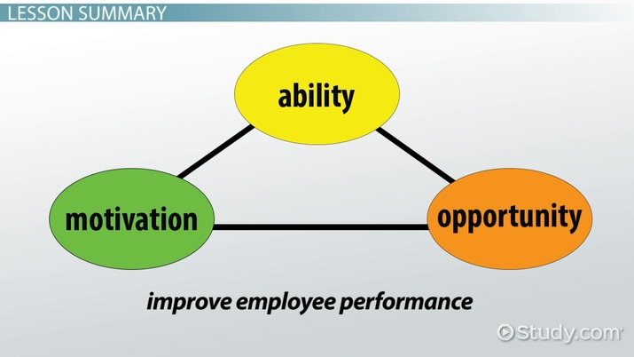
AMO Model
The third enabler is employee voice which engages employees by involving them in organisational decision making. CIPD defines employee voice as ‘the ability of employees to express their views, opinions, concerns and suggestions, and for these to influence decisions at work’ (CIPD, 2020). The factsheet highlights the fact the weak leadership reduces the quality of the communication. Macleod reinforces the sense of belonging and therefore to ensure this process works well within any organisation good processes to implement and strong, proactive leadership are required. While Purcell states that many managers find it hard to listen to employees in the Thought Piece Collection. Employee ownership is a perfect model to highlight the importance and success of voice. Through the very nature of the structure of the organisations that follow this model voice is ingrained, such as John Lewis Partnerships, Gripple and ABER Instruments (Employee Ownership Association, 2020).
The final enabler Macleod refers to is integrity and an organisation ability to act upon its values is key. For organisations and leaders to demonstrate an alignment with stated values such as environmental issues is essential for trust and engagement. Weaknesses will appear when the gaps between delivering on these values are high. Organisation such as Sports Direct are examples of when integrity is lost and leadership is shamed. Many of the unethical issues with regards to Sports Direct also resulted in law such as the working time directive being broken (Rodionova, 2016).

Section 2

2.1 b. Lucy Adams criticises the HR profession in her book ‘HR Disrupted, It’s time for something different’ (Adams, 2017). Drawing on relevant literature discuss whether the HR profession has gained credibility in the last five years, or whether it is losing ground as an executive member around the boardroom table. Put forward suggestions for improvement taking in to consideration different sectors and sized organisations.
The HR profession has introduced and pushed many news concepts to the future of working including flexible and remote working encompassing virtual team, and leading discussions around agility, the VUCA world and leading in unprecedented times. Often these concepts have been met with scepticism by leaders who have been resistant. However, given the current pandemic situation they have concepts that have set businesses up well to face the current challenges and organisations that have taken their HR professional seriously will have been better placed to face the current crisis (Swan & Chamorro-Premuzic, 2020).

HR’s role in adding value not only lies with finding great people but also the way those people are facilitated for example with flexible working , introduction and integration of technology and productivity in line with motivation. Wellbeing initiatives are central to ensure productivity and engagement by supporting physical and mental health issues (CIPD, 2019).

2.2 a. Milton (Friedman, 1970) believed making as much money as possible is a company’s only legitimate goal. One of Google’s core values, being ‘you can make money without doing evil’ (Bock, 2016) takes a broader perspective. Drawing on relevant literature discuss the ethical pitfalls of a purely capitalist approach in the current business climate. Put forward examples of progressive organisations who are setting the standard for ethical best practice.
Since the industrial age we have seen how strongly capitalism has had control over work both in the UK and globally. However an article in the Financial Times describes the behaviour of the East India Company (EIC) back in the 18th century as that of the ‘world’s first great multinational corporation’ (Dalrymple, 2019). The article continues to describe the ruthlessness of the EIC and its disregard for laws in the various countries in which it operated and likens it to the large multinationals of today, where organisations such as Starbucks, Google, and Amazon avoid paying taxes (Barford & Holt, 2013). Social media now enables news and views to share more widely than ever before and with this comes influence. The world is become much more in true with social responsibilities and with that comes corporate social responsibilities (CSR). With activist such as Greta Thunburg, 17, campaigning for climate change and appealing to the hearts of people globally (BBC, 2020). We have seen a change in employees want from the organisations that they work for and their conscience plays a big part in those decisions, especially for the younger generation. Tight labour markets, as discussed in section 1, have also enabled choice for employees who wish to work for organisation that align to their own ethical values. This seen a new type of organisation develop, B corporations. These businesses such as TOMS and The Body Shop balance profit and purpose (Gatenby, 2020).
CSR is big news when organisations are developing their corporate and employer branding, however as we saw in 1.4 it is important for employees to see actions on the claims organisations make to maintain engagement (CIPD, 2019). The CIPD discusses CSR further and connects the positive impact that CSR has on the environment, society and economy to organisation added value (CIPD). In the book Let my people go surfing the organisation Patagonia Inc discuses the importance of people and the ethical responsibilities that come with running a successful business and how they have made changes to source materials that are produced responsibly. This has come at a cost to the businesses profit margins, however Patagonia is now know globally as one of the respected environmentally responsible companies (Chouinard, 2016).
Employee owned organisation also have a an important role to play as they enable their owners to say what direction the business should be heading, highlighting responsibilities and controlling actions (Employee Ownership Association, 2020). At ABER 1% of the profits annually is distributed to charitable causes that are based within a 30 mile radius of any employee’s main place of work. The employees make the decisions as to where that money should be spent. The organisation also has an Environmental group which will hold others in the business to account for example if consumption of air miles is excessively high. The group will then offset this consumption in the correct ways for example by insuring over and above the accurate number of trees is planted! The organisation also has solar panels that run the business electricity supply and 2 electric car charge points, which are free for public use. All company vehicles are hybrid or fully electric. This model is the direct opposite of capitalism with all employees at ABER sharing 25% of the profit with the remainder (other than 1% to charity) staying within the business to enable development and growth.
2.3 b. Leaders in twenty-first century organisations have two competing challenges. Getting things done to meet today’s needs, whilst adapting what they do so that their business can thrive in the future (Heietz et al 2009). Discuss the emerging leadership models that are trend setting in this regard. In particular; consider the importance of the ‘follower’ and the diversity of challenges the most forward-thinking leaders are overcoming in order to excel.
Leading in a VUCA world is complex and COVID 19 has amplified this. In Deloitte’s 2019 human capital trends survey 81% of respondents stated the ability to lead a workforce combined with machines and managing remote working forced leading more quickly with 80% citing that there are of new issues and requirements on organisational leaders (Arkenberg, 2019).
Timms discusses 3 predictions for HR in 2020, one of this is autonomy. He views micro managing as a thing of the past and sees far greater value in empowerment to employees which was touched on in section 1. He highlights the opportunities this can bring for innovation and growth and by enabling employees to own problem and find ways to solve them. He also emphasises the need for individuals to take ownership of their development needs and the need to end performance management (Timms, 2019). This is something that ABER puts into practice, although we have reviews they are not in the traditional sense. We encourage honest conversations and encourage individuals to come forward with development ideas, both for themselves and innovation within the business. Although we have and R&D team this feedback often comes from wide across the business. Timms advice would be good for any leaders to take into account in light of the current pandemic crisis which has seen millions of employees forced to work from home and become more accountable for their work. The prediction highlights the reality of 2020 and leaders have been forced to enable this move. There is much discussion on this new way of working remaining the norm for many organisations (The Economist , 2020). People will have the empowerment to work from anywhere if working from home remains the norm so will models such as the 70 20 10 one below still work as well in the future? Will coaching and mentoring become more difficult or will technology make the transition seamless? Situational leadership may need to be explored further or is it a thing of the past giving way to empowerment?
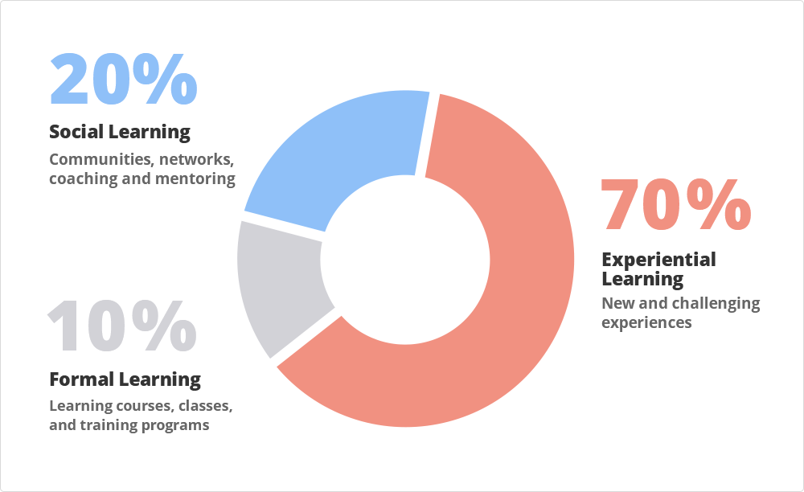
70 20 10 Model
Timms views are supported by Welsh comments in an article by McKinsey that discusses the importance of a continuous learning culture as discussed in section 1. He points to the importance of leaders to enable employees and not take charge in the traditional sense of leading or perhaps this was managing (McKinsey, 2019)? As organisation progress having a clear strategy around leadership is essential. In a journal article distributed leadership is reviewed and discusses the shift from behaviours of individual ‘autocratic’, transactional leaders to collective form of group leadership (Bolden, 2011). Marquet challenges the view that leadership comes from a few based at the top of a hierarchical structure. He discusses the importance of empowerment as does Timms but goes further to say that with more authority comes more effective leaders. Marquet’s leader model also incorporates technical competence and organisational clarity (Marquet, 2015).
2.4 a. A recent People Management article ‘Let’s start the human revolution – before AI takes over’ (People Management, 2019) stresses the need for empathy, teamwork and resilience going forward. Drawing on recent research explain the role of HR as ‘change agent’ in this AI revolution. Discuss how HR can take a lead role in managing this colossal evolution of the workplace.
Given the way the whole world has been turned on its head since the start of the year by the attack of the unexpected COVID-19 situation, never has the question of HR as change agent been so applicable. The VUCA world has been a hot topic in HR for some time. Much has been discussed about preparing for VUCA but little did anyone know just to what extent the true meaning was just around the corner (Harvard Business Review, 2014)! The changes that the world of working has seen over recent months are remarkable, and HR has been a huge fascinator of this. Agile is key to those who have adapted and Models such as Kotters 8 stage change will have in part had relevance for those experienced with it but the speed that change has had to be introduced (Rees & Hall, 2016). The Kubler-Ross change curve incorporates shock, denial, anger, frustration, acceptance, practice, realisation and integration and is a model often considered by professionals when communicating change. However in light of the rapid change that the globe has faced HR professional and leaders are at the heart of experiencing and supporting employees with these emotions following on from actions forced by the change (Wiggins, 2009).

