Title of the research project: Exploring the factors that influence eating behaviours among postgraduate students
Student Name: Sabina Khanam
Student Number: 1713883
Lecturer Name: Dr Zeno Leung
Module Code: LCHS7001
Module: Practice-Based Research
Assessment Component 2 - Written Research Report

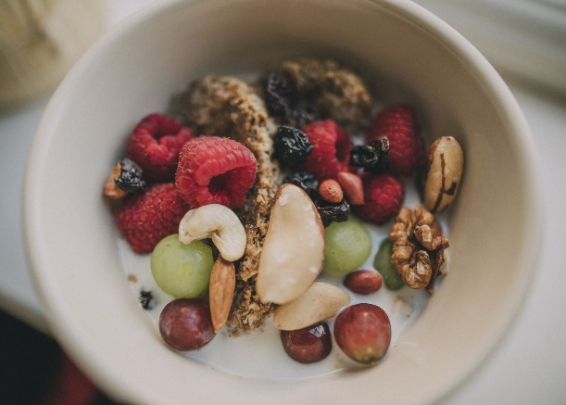

Contents
1. Introduction 3
2. Research Methodology 4
2.1. Research Method 4
2.2. Research Design 4
2.3. Target Population 4
2.4 Data Collection and Analysis…………………………………………………………. 5
3. Ethical Considerations………………………………………………………………………..6
4. Results 7
5. Discussion 11
6. Conclusion 12
7. Reference List 13
8. Appendix A – Ethical Approval Form. 17
Appendix B - Demographic characteristics table………………………………………18
Appendix C - Blank Questionnaire………………………………………………………..19
Appendix D - Transcript…………………………………………………………………….20

Introduction / Background to the study
Humans require food for the intake of energy and nutrition which outlines that our diet choice is an important factor that contributes in our choice of food. This can be determined under biological, economical, physical, social and psychological attributes (Faculty of Public Health, 2008).
Young student adults are experiencing a major change in their life when attending university as a postgraduate. This transition can become a vulnerable period with the development of unhealthy eating habits from having a different lifestyle from home. Many students can strive to modify to a healthy lifestyle (Hafiz and Gallagher, 2016). Addressing eating behaviours and determining a healthy lifestyle is key to maintaining an academic protocol. Adapting a poor diet can lead to ongoing development of diseases, long term habits and nutritional issues (Almoriae et al, 2024). It is becoming frequent in this nutritional transition affecting the population especially in developing countries whereby western dietary arrays are becoming normalized and integrated replacing the healthy foods (Karunanayake and Jayasooriya, 2020).
There have been many studies that indicate factors contributing to an unhealthy lifestyle in university.
Studies have indicated that in the first year of university students are more likely to gain weight with poor eating habits due to the pressures of studies. A study in Malaysia concluded that students would skips meals with consuming a unhealthy diet (Abubakar and Wafa, 2016).
In the developing countries there seems to be relatively less research in how students can maintain a healthy lifestyle while attending university. Kabir and Miah (2018) undertook a qualitative approach in a Bangladesh university concluding that individual, societal, campus related and environmental factors were all key aspects of their eating behaviour.
Similarly, a qualitative focus group was carried out in Belgium exploring the factors in what influences university students in their eating behaviours. The determinants outlined factored was the social networks, physical environment, individual factors and macro environment (Deliens et al, 2014). This outlines similarities in the outcomes obtained from both researches.
International students may suffer the most due to cultural differences, their extent to their dietary combination and the various influences of food choices available (Mensah and Lane, 2022).
The significance of these studies outlines the importance of knowing the factors that influence bad eating behaviours. As stated by Kowalkowska and Poinhos (2021) finding the factors that constitute eating behaviours is key to know the relationship in students eating behaviours. Therefore the rationale of conducting research this study will outline the importance of healthy eating and prevalence of factors that influence bad habits.
To further enhance on this topic this research report aim will be “exploring the factors that influence eating behaviours among postgraduate students in a public university via a focus discussion group”. The objectives are:
- To explore factors affecting eating behaviors of university students.
- To collect ideas and recommendations for developing healthy eating habits among university students.
Therefore, the research question will be “What factors influence eating behaviors among postgraduate students in a public university?”
Research Methodology
Research Method
The methodology used is Qualitative research which explores the meaning and experiences of a natural setting. As the research question aim is to understand factors that contribute to eating behaviours, ideally the understanding through words and descriptions is required that qualitative will achieve (Aveyard, 2019, p.61). Using grounded theory to analyse data collected allowing the researcher to compare and create themes from the transcript (Foley and Timonen, 2015). Although this approach is cost effective and found to incorporate human touch allowing to ask open questions freely, however the anonymity can become difficult and can be influenced by the researchers bias (Mwita, 2022).
Research Design
The research design is a focus group discussion with a certain number of designated students for data collection as data can be collected specifically using participants own words and descriptions. The aim is to establish their own experiences as a student as it allows in depth exploration of the topic. The advantages is that it is inexpensive and participants are more likely to deliver open responses. As the discussion is being established the participants can delve into broader ideas. However, it does rely on heavy input discussion to allow data collection to be produced, also the quality of the discussion relies on how professional the moderator is so that feedback is enabled (Leung, 2009).
Target Population
The target population was aimed at adults studying a postgraduate course in a university based in Birmingham, West Midlands with an ethnic background of only two ethnicities. Being diverse in age was ideal so that the research could not be deemed bias and creating enough information from participants experiences. The university was approached by the researcher in order to verify that this research will be carried out giving full approval. The Researcher attended a lecture to discuss what was intended for this research providing information sheets, the participants had known of the researcher as they were a lecturer which made the commitment stronger. Approval was then received by the participants by filling out a ethical approval form (Appendix A). Time for this approval was given 2 weeks so that participants could discuss any questions and confirm their interest within this delegated time. Participants who had any further questions could speak to the researcher at the end of the class for a one to one allowing inclusivity.
The inclusion was to include all ages who were adults above 18 years studying a postgraduate course with the exclusion of under 18 years due to the question aiming for postgraduates only.
Data Collection and Analysis
Out of 15 students in one postgraduate class only seven participants were recruited in the focus group as this would be ideal number for data collection this was used via a non-probability sampling technique. This is via convenience sampling as it was the most accessible to the researcher to gain and gather information (Etikan and Alkassim, 2015). Within this focus group there was a mixture of age range thus allowing experiences to be amplified allowing enough participants to talk freely (Acocella, 2011).
The seven participants filled out a small questionnaire prior to their focus group meeting to allow the researcher gain information of their profile background such as age, ethnicity and demographic characteristics (Appendix B). This allowed the researcher to enable further data collection to use for the evaluation. As shown out of the seven participants only four were under 24 years ranging up to 2 participants of over 40 years. This gave a good age range to allow individuals experiences, however majority were of Indian background and female compared to Bangladeshi ethnicity. One similarity that was identified from their profiles was all participants had a health and social care background degree or in that field.
On the day data collection was carried out it was during the participants lecture using their own lecture room so that they felt comfortable in their own usual environment at the university. It was a quiet room so that focus could not be disturbed, in their usual timetable. The main researcher who was the moderator asking the main questions had a colleague with them who wrote down notes, this was all explained with the focus group. Before the session started it was explained by the moderator what topic was being discussed about and clarifying if anyone had any questions before they started. Each participant had a number tag put on them so that the colleague could use the data using statistics and not by their name, allowing privacy and confidentiality. Chairs were set in a round circle so that everyone could visually see each other allowing the feeling of inclusivity with an audio tape set in the middle on the floor to record the discussion. A set questionnaire was used by the moderator as shown in Appendix C so that the topic would not go in a different direction, the focus was kept in line with the questions set overall the discussion lasted around 90 minutes. The moderator started off with an introduction outlining the first question and allowing all participants to involve in their experience to answer one at a time with each question.
The data analysis technique used would be thematic analysis which is the breakdown of data collected from the focus group into reading, coding and theming, this is commonly used in qualitative research. The goal is to improve reliability and precise thematic analysis (Saunders et al, 2023). The advantages of using thematic is that it can be easily accessible in forming an analysis in forming similarities and differences in texts. This in return allows the researcher to get a better understanding of the data collected, being more flexible. However, the disadvantages could be biased due to the researcher interpretating data to their own needs and can be a time consuming (Nowell et al, 2017).
Ethical Considerations
In modern research ethical considerations is a major component that is required in relation to the subject and researcher where mistreatment cannot be implied. As stated by Yip and Han (2016) ethical principles come under: respect for persons, no harm caused to participants, Justice on a societal level and confidentiality.
Resnik (2020) also described that ethical consideration as ‘norms of conduct’ which differentiates between suitable behaviour and undesirable behaviour. To further elaborate on ethics, everyone has human rights, rights to anonymity and dignity towards any research that is conducted, making sure that all studies are either voluntary, informed and safe for the individual taking part.
As the moderator had control of all questions during the focus group discussion on some occasions it was evident that the moderator gave their own opinion which would be deemed as unethical in research information and communication. The credibility may not have been to satisfactory as it could be an influence towards the participants thus allowing them to be more inclined to agreeing with the moderator rather than giving their own collaborative experience (Gomez and Jones, 2010, p. 200).
All participants signed an ethical form to notify that all data was confidential when collected this identified that all information will be kept private and no identities of the individuals will be exposed (Appendix A). During the discussion whereby all communication was recorded via an audio tape this was transported onto the computer. Before data was transferred onto the computer the researcher had to make sure that it was virus safe and the software was up to date, this does not allow third party to gain access if there was a virus. Sufficient care was undertaken by the researcher when transcribing the audio data onto a word document making sure that the notes taken from their colleague was similar to what was transcribed onto the word document from the audio tapes. Once the transcribed document was satisfactory uploaded onto Microsoft Word then the notes taken from the colleague was disposed of as this had evidence of conversations that had taken place. This allows privacy and confidentiality to be maintained at its highest level for the discretion of the participants.
Results
The demographic characteristics that emerged from the questionnaire before the discussion started as shown in Appendix B identifies in summary below:
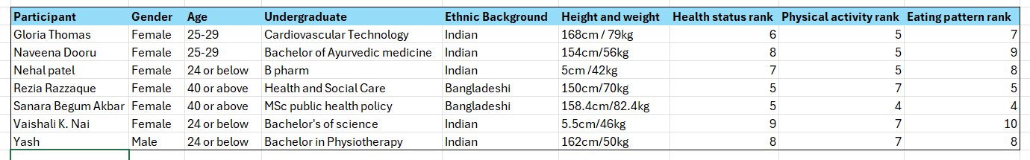

There were seven participants majority being female with an Indian ethnicity background. There was a mixture of age ranging from under 24 years to over 40 years, majority being in the age range of 24 an below. Majority had a background undergraduate degree from the health sector, and agreed overall that they felt that their health status was on a healthy scale. Half participants stated that they were physically active while the other half stated that they felt average active however, the eating pattern quality fluctuated within the participants. All participants agreed that they were overall felt healthier than normal.
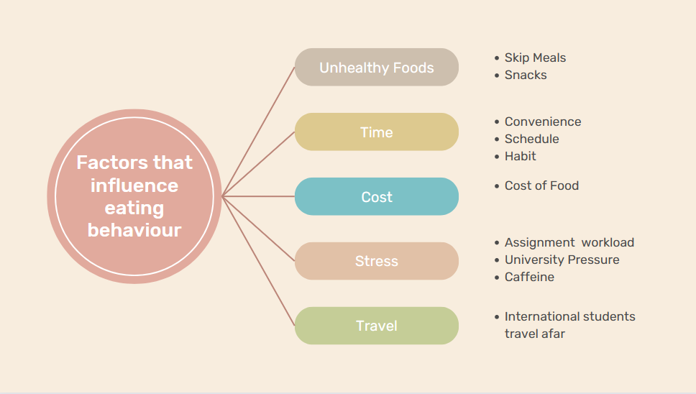

As shown above themes was generated in the coloured boxes from the discussion focus group transcript. These themes were implemented from the various quotes that participants stated from the bullet points shown next to the themes. A detailed breakdown of all the themes will be shown below extracting quotes from the transcript as shown in Appendix D. Themes has been generated by the transcripts which highlights in different colour coded areas.
Theme A: Unhealthy Foods
“I like eating chocolates”
“Snacks only when I am at work or uni”
“I eat snacks”
“Sugar Intake, more snacks”
“Sometimes I just skip breakfast” “Sometimes I skip that one then have lunch”
“I eat chocolate…… I know it is unhealthy but I just kind of got a sweet tooth”
“Vending machine……. I don’t think options there to have healthy food”
“Study has increased sugar intake” “I usually skip my breakfast”
“Yeah”
Quoted above are some are the transcripts taken that were used directly to indicate that unhealthy foods were a common theme as a factor that influenced eating behaviours. Snacks was used on a recurring basis under this theme as it was the increase of sugar intake which prompt this use. Skipping meals was also classed under unhealthy foods due participants mainly missing breakfast and going straight into lunch which is the most important meal of the day. Participants have established that due to university pressure the intake of snacks and unhealthy foods is more prominent while studying. “Yeah” quote was repetitive amongst participants who just agreed with the individual that was talking.
Theme B: Time
“If your busy, it depends on your schedule, job or university, so that impacts on what you have”
“Uni will pick something from vending machine”
“It becomes a habit aswell”
“I feel like I don't have time at home to snack because that at home I'm too busy doing housework”
Convenience, schedule and habit were categorised under Time as it was indicated form the transcript that due to time these factors altered their eating behaviours. Time was a pattern and recurred mainly from the international students that travelled afar.
Theme C: Cost
“Cost is very important because we all know without a job we are struggling to stay here”
“Too expensive for them”
These quotes states that cost is another factor that influences the eating behaviour due to the expensive items that are limited to buy. This then suggests that going for the quick cheap foods which are unhealthy creates a negative behaviour such as the consumption of caffeine.
Theme D: Stress
“the assignment and stressful time”
“because sometimes of the university life”
“it could be suppose im stress”
These quotes indicate that stress is a major factor which influences the negative eating behaviours in university life. Due to the coursework overload can lead to increased perceived stress which then effects the eating behaviours. It was identified that majority students agreed with stress that caused negative eating factors.
Theme E: Travel
“I travel from leicester during university days and fall behind”
“Everything is different….. us international student”
“many barriers….. very very hard to stay here….. it was the travelling”
“Lets say the main reason for that knowledge barrier is travelling aswell”
Travelling is the last factor that influences dietary behaviour especially noted by the international students who have to travel afar to the campus this leads to their schedule fluctuating resulting in bad choices of food. Participants travelling afar had a recurring pattern which impacted their eating behaviour as stated above from quotes, with majority agreeing.
Discussion
This report aim was to find the factors that influenced eating behaviours among postgraduate students in a public university via a focus group meeting. The relevance was to identify any discrepancies or emerge new research that can be obtained from this focus group. The results showed that five themes had been established from the results of the focus group consisting of unhealthy foods, time, cost, stress and travel.
In line with the research question there was a consistent pattern in participants consuming unhealthy foods which lead to one theme such as consuming chocolate and regularly consuming of snacks. Transcript elaborated that breakfast was missed majority of the time with snacks being more prominent. To support this the result build on current literature whereby another study carried out in the UK by Dodd and Woodfield (2015) among university students found that the prevalence of eating behaviour patterns was unhealthy foods. Ultimately this recognizes that unhealthy foods is a prominent factor which has been identified to be consistent across studies; a factor that is of no concern (Li et al, 2022). The risk factor of this can develop to obesity and long-term comorbidities (Yun and Quee, 2018).
In line with the research objective factors have indicated that there are consistent eating behaviours that are in line with recent research studies as indicated.
The results suggest that all the remaining factors used as themes have been characterised in studies amongst university life something that has been distinguished from previous studies (Jackson and Berry, 2009; Tam et al, 2017). To elaborate further majority of the participants with one being international voiced that ‘time’ with their busy schedules was a factor that altered their eating patterns, a similar study by Alakaam et al (2015) focusing on international students which identified this factor as an influence.
However, an expectation that was not identified in this research was the influence of social networks which is a prominent factor from previous studies that indicates family, friends and peers had been a factor (Deliens et al, 2014; Hilger and Loerbroks, 2017). Maybe this factor was not identified due to the small sample size of participants, if there were a larger group size then maybe this factor would have been identified as a theme.
In terms of limitations although the results were prominent, some factors could be classed as bias during the gathering of data. There were a small number of participants who were consistently using their voice during the discussion. Establishing a negative inclusivity whereby everyone should have been allowed to answer all questions this thereby indicates the results could have had a different evaluation. The moderator could have resolved this by prompting the silent participants with open questions so that the participants could start talking. Also, the moderator’s duty was to remain neutral at all times, however on certain occasions the moderator did voice their own opinion against the questions which could be deemed as bias as the moderator affects the strength of the overall discussion (Deliens et al, 2014).
The reliability of data is also impacted by a majority of females than male, this could impact the results as the discussion would have represented more of a female view, a recent study identified the same example by (Mollaei et al, 2023). Therefore, the results should be taken into consideration with certain limitations identified. Lastly , majority of the focus group discussion participants seemed as though they were already healthy individuals as shown in the transcript Appendix D, in relation to a study previously identified that their eating patterns may not reflect the wider student population (Amore and Buchthal, 2019).
Future studies need to take into account the professionalism of the moderator, require more background information on the participants and allow more individuals to attend a focus group to allow a more collaborative discussion.

Conclusion
This study was designed to explore the factors that influence eating behaviour among postgraduate students in a public university. It outlines that students have been influenced by factors such as stress, unhealthy foods, time, travel and cost played a vital role in the eating behaviours during university life. It identifies that knowledge needs to be incorporated into university students to enable a healthy regime such as allowing opportunities for a positive balanced diet. Interventions would be a crucial prospect to make aware of healthy eating habits taking into consideration the individuals, environmental and society this includes allowing healthy vending machines that are available at the campus. Promoting healthy eating amongst postgraduate students is critical to attain a healthy nutritional regime.
Overall, the results were conclusive to all previous studies that have been identified, however there needs to be a lot more support in healthy regime options for students for a continuous development of campus food environment. This will allow a positive step towards behavioural thinking and improve university students eating patterns.
Referencing
Abubakar, H., Shahril, B,R., Wafa, T,S,S,S. (2016) ‘Weight status, dietary intake and eating behaviour of Nigerian postgraduate students in UnisZA, Malaysia’, Malaysian Journal of Public Health Medicine, 16(3), pp. 45-51. Available at: https://d1wqtxts1xzle7.cloudfront.net/52136649/Abubakar_et_al._2016._MJPHM-libre.pdf?1489417781=&response-content-disposition=inline%3B+filename%3DWeight_Status_Dietary_Intake_And_Eating.pdf&Expires=1710163323&Signature=A3b7CPoKrlAyGNzbspoM-WpIw6fe08i~cSz9ratlv9Ohd0fJyzW1m5TkK6DB6vcAX5bxuFXRPTaSPIbzQqy-UBcPNYKfQ8LX2~OXCLco5G6olPcdQI4QVaxlNSUmOpQFiybOCxS2-vJGKgqjceau~dDvffYFKLy~AQtrwpydusa0kxsfZtDDMAtjrt9TqH1gp060-3n8aJJJonKvWbLuWw2rtDVRRxVgqCyf5xXDoLzTIw7vywHClOp3zfnNZbimlhcLxPYHUXI3wwOOFOrvmYu1mee9trZ1Ya3kqE~r7MK2eXRwritKeUyvSnszfRMr81UEJEyGM~iFXs~Btop1XA__&Key-Pair-Id=APKAJLOHF5GGSLRBV4ZA (Accessed: 12th March 2024)
Acocella, I. (2011) ‘The focus groups in social research: advantages and disadvantages’, Quality and Quantity, 46, pp. 1125-1136. Available at: https://link.springer.com/article/10.1007/s11135-011-9600-4 (Accessed: 15th arch 2024)
Alakaam, A,A., Castellanos, C,D., Bodzio, J., Harrison, L. (2015) ‘The factors that influence dietary habits among International students in the United States’, Journal of International Students, 5(2), pp. 104-120. Available at: https://files.eric.ed.gov/fulltext/EJ1060049.pdf (Accessed: 23rd March 2024).
Almoraie, M,N., Alothmani, M,N., Alomani, D,W., Al-armoudi, H,A. (2024) ‘Addressing nutritional issues and eating behaviours among university students: a narrative review’, Nutrition Research Reviews, pp.1-16. Available at: doi:10.1017/S0954422424000088 (Accessed: 12th March 2024).
Amore, L., Buchthal, V,O., Banna, C,J. (2019) ‘Identifying perceived barriers and enablers of healthy eating in college students in Huwaii; a qualitative study using focus groups’, BMC Nutrition, 5(16), Available at: https://doi.org/10.1186/s40795-019-0280-0 (Accessed: 23rd March 2024).
Aveyard, H. (2019) Doing a Literature Review in Health and Social Care. 4th Ed. Open University Press: London.
Deliens, T., Clary, P., Bourdeaudhuij, D,I., Deforche, B. (2014) ‘Determinants of eating behaviour in university students: A qualitative study using focus group discussions’, BMC Public Health, 14(1), 53, Available at: http://dx.doi.org/10.1186/1471-2458-14-53 (Accessed: 12th March 2024)
Deliens, T., Clarys, P., Bourdeaudhuij, D,I., Deforche, B. (2014) ‘Determinants of eating behaviour in university students: a qualitative study using focus group discussions’, BMC Public Health, 14(53), Available at: https://link.springer.com/article/10.1186/1471-2458-14-53 (Accessed: 22nd March 2024)
Dodd, J,L., Tanton, J., Woodfield, L., Mabhala, M. (2015) ‘Eating behaviours of British university students: A cluster analysis on a neglected issue’, Advances in Preventive Medicine, 639239, Available at: https://doi.org/10.1155/2015/639239 (Accessed: 22nd March 2024)
Eitkan, I., Musa, A,S., Alkassim, S,R. (2015) ‘Comparison on convenience sampling and purposive sampling’, American Journal of Theoretical and Applied Statistics, 5(1), pp. 1-4. Available at: https://d1wqtxts1xz https://d1wqtxts1xzle7.cloudfront.net/55796997/Comparison_Convenience_and_Purposive_Sampling-2016_4p-libre.pdf?1518575584=&response-content-disposition=inline%3B+filename%3DComparison_of_Convenience_Sampling_and_P.pdf&Expires=1710501799&Signature=eIhwYlcmO2hCA~s6CVVtaV8c5kDfdnLeGCbpWsl0cbtLAIGJpnpUMNjomxlbb5JkkZXfQCnE2t0m5OqjtjqLkyxskv-yxw~-liJSW5CK4H45O~hjxL20Dz05P3ZcjvqZi5l3KfRACNzW7yQZalQZBc0Q24QyHFHMMsOS0T64V-edzB~DjKdB3XF0m~nAjIDlPC1iIemqAcXGo~BRS5Kb9Xft0YzZXNnJ3S48OzOoQDLsHNid4Zo-PT-5ruq97lxJ8UYJ6FeMTpt8f0PJ~BE6YwIHpU2H0OR8Vqb97h~ODjuLButZpITk5QxVXlbR1TVmNDjUMT0HIHO0T7IQoEmEbw__&Key-Pair-Id=APKAJLOHF5GGSLRBV4ZA le7.cloudfront.net/55796997/Comparison_Convenience_and_Purposive_Sampling-2016_4p-libre.pdf?1518575584=&response-content-disposition=inline%3B+filename%3DComparison_of_Convenience_Sampling_and_P.pdf&Expires=1710501799&Signature=eIhwYlcmO2hCA~s6CVVtaV8c5kDfdnLeGCbpWsl0cbtLAIGJpnpUMNjomxlbb5JkkZXfQCnE2t0m5OqjtjqLkyxskv-yxw~-liJSW5CK4H45O~hjxL20Dz05P3ZcjvqZi5l3KfRACNzW7yQZalQZBc0Q24QyHFHMMsOS0T64V-edzB~DjKdB3XF0m~nAjIDlPC1iIemqAcXGo~BRS5Kb9Xft0YzZXNnJ3S48OzOoQDLsHNid4Zo-PT-5ruq97lxJ8UYJ6FeMTpt8f0PJ~BE6YwIHpU2H0OR8Vqb97h~ODjuLButZpITk5QxVXlbR1TVmNDjUMT0HIHO0T7IQoEmEbw__&Key-Pair-Id=APKAJLOHF5GGSLRBV4ZA (Accessed: 15th March 2024).
Faculty of Public Health (2008) Social, Behavioural and other determinants of the choice of diet. Available at: https://www.healthknowledge.org.uk/public-health-textbook/disease-causation-diagnostic/2e-health-social-behaviour/social-behavioural-determinants (Accessed: 14th March 2024)
Foley, G., Timonen, V. (2015) ‘Using Grounded Theory Method to capture and analyze health care experiences’, Health Services Reseaerch, 50(4), pp.1195-1210. Available at: https://doi.org/10.1111%2F1475-6773.12275 (Accessed: 14th March 2024).
Gomez, B., Jones, P,J. (2010) Research Methods in Geography. Blackwell Publishing Ltd: London.
Hafiz, A,A., Gallagher, M,A., Hill,J,A. (2016) ‘A qualitative study to explore the experiences of university students which influence eating behaviours when living away from home’, Proceedings of the Nutrition Society, 75, E194, Available at: doi:10.1017/S0029665116002093 (Accessed: 12th March 2024).
Hilger, J., Loerbroks, A., Diehl, K. (2017) ‘Eating behaviour of university students in Germany: Dietary intake, barriers to healthy eating and changes in eating behaviours since the time of matriculation’, Appetite, 109, pp. 100-107. Available at: https://doi.org/10.1016/j.appet.2016.11.016 (Accessed: 22nd March 2024).
Jackson, A,R., Berry, R,T., Kennedy, D,M. (2009) ‘The relationship between lifestyle nd campus eating behaviours in male and female university students’, Project Innovation Austin LLC, 43(3), Available at: https://go.gale.com/ps/i.do?id=GALE%7CA206687080&sid=googleScholar&v=2.1&it=r&linkaccess=abs&issn=01463934&p=AONE&sw=w&userGroupName=anon%7Ebc6b7fd5&aty=open-web-entry (Accessed: 22nd March 2024).
Kabir, A., Miah,S., Islam, A. (2018) ‘Factors influencing eating behaviours and dietary intake among resident students in a public university in Bangladesh: a qualitative study’, Plos One, 13(6), e0198801. Available at: https://doi.org/10.1371%2Fjournal.pone.0198801 (Accessed: 12th March 2024).
Karunanayake, D., Jayasooriya, M,S., Vimukthi, U. (2020) ‘Psychological impact on the eating behaviours of University students’, South Asian Journal of social studies and economics, 8(4), pp. 132-142. Available at: http://dx.doi.org/10.9734/SAJSSE/2020/v8i430225 (Accessed: 12th March 2024)
Kowalkowska, J., Poinhos, R. (2021) ‘Eating behaviour among university students: Relationships with age, physical activity, body mass index, waist to height ratio and social desirability’, Nutrients, 13(10), 3622, Available at: https://doi.org/10.3390%2Fnu13103622 (Accessed: 26th March 2024).
Leung, H,F. (2009) ‘Spotlight of focus groups’, Official Publication of the college of family physicians of Canada, 55(2), pp.218-219. Available at: https://www.ncbi.nlm.nih.gov/pmc/articles/PMC2642503/ (Accessed: 15th March 2024).
Li, X., Braakhuis, A., Li, Z., Roy, R. (2022) ‘How does the university food environment impact student dietary behaviours? A systematic review’, Sec Nutrition and sustainable diets, 9, Available at: https://doi.org/10.3389/fnut.2022.840818 (Accessed: 22nd March 2024).
Mensah, Z,F., Lane, E,K., Richardson,D,L. (2022) ‘Determinants of eating behaviour Black, Asian and Minority Ethnic (BAME) university students when living at and away from home: with the focus of the influence of food enculturation and food acculturation’, Appetite, 171, 105932, Available at: https://doi.org/10.1016/j.appet.2022.105932
Mollaei, S., Minaker, M,L., Lynes, K,J., Dias, M,G. (2023) ‘Perceptions and determinants of adopting sustainable eating behaviours among university students in Canada; a qualitative study using focus group discussions’, International Journal of Sustainability in Higher Education, 24(9), Available at: https://www.emerald.com/insight/content/doi/10.1108/IJSHE-11-2022-0373/full/html (Accessed: 23rd March 2024).
Mwita, K. (2022) ‘Strengths and weaknesses of qualitative research in social science studies’, International Journal of Research in Business and Social Science, 11(6), Available at: http://dx.doi.org/10.20525/ijrbs.v11i6.1920 (Accessed: 14th March 2024).
Nowell, S,L., Norris, M,J., Moules, J,N., White, E,D. (2017) ‘Thematic Analysis: Striving to meet the trustworthiness criteria’, International Journal of Qualitative Methods, Available at: https://doi.org/10.1177/1609406917733847 (Accessed: 18th March 2024).
Resnik, B,D. (2020) ‘What is ethics in research and why is it Important?’, National Institute of environmental health sciences, Available at: https://www.niehs.nih.gov/research/resources/bioethics/whatis (Accessed: 18th March 2024).
Saunders, H,C., Plessen, V,C., Kennedy, M,A., Leviton, C,L., Bernstein,L,S., King, R,J., Marx, M,C., Pogue, A,J., Saunders, K,R., Citters, V,A., Yen, W,R., Elwyn,G., Leyenaar, K,J. (2023) ‘Practical thematic analysis: a guide for multidisciplinary health services research teams engaging in qualitative analysis’, Research methods and reporting, 381, pp.1-10. Available at: https://doi.org/10.1136/bmj-2022-074256 (Accessed: 18th March 2024)
Tam, R., Yassa, B., Parker, H., O’Connor, H., Farinelli, A,M. (2017) ‘University students in campus food purchasing behaviours, preferences and opinions on food availability’, Nutrition, 37, pp. 7-13. Available at: https://doi.org/10.1016/j.nut.2016.07.007 (Accessed: 22nd March 2024).
Yip, C., Han, R,L,N., Sng, L,B. (2016) ‘Legal and ethical issues in research’, Indian Journal of Anaesthesia, 60(9), pp.684-688. Available at: https://doi.org/10.4103%2F0019-5049.190627 (Accessed: 18th March 2024)
Yun, C,T., Quee, S,K,D., Ahmad, R,S. (2024) ‘Dietary habits and lifestyle Practices among students in university Brunei Darussalam’, The Malaysian Journal of Medical Sciences, 25(3), pp. 56-66. Available at: https://doi.org/10.21315%2Fmjms2018.25.3.6 (Accessed: 23rd March 2024).

APPENDIX A: ETHICAL APPROVAL FORM
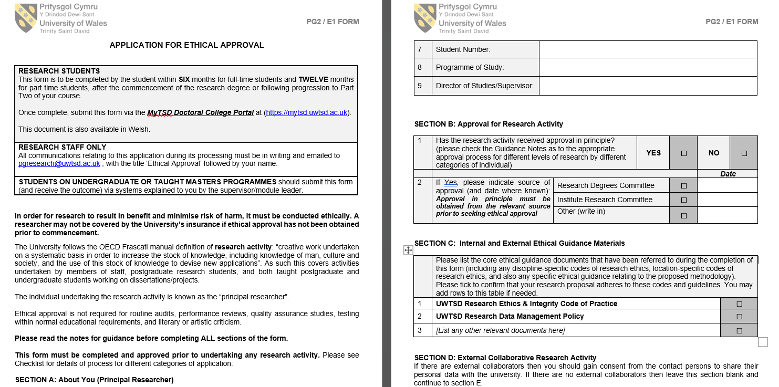
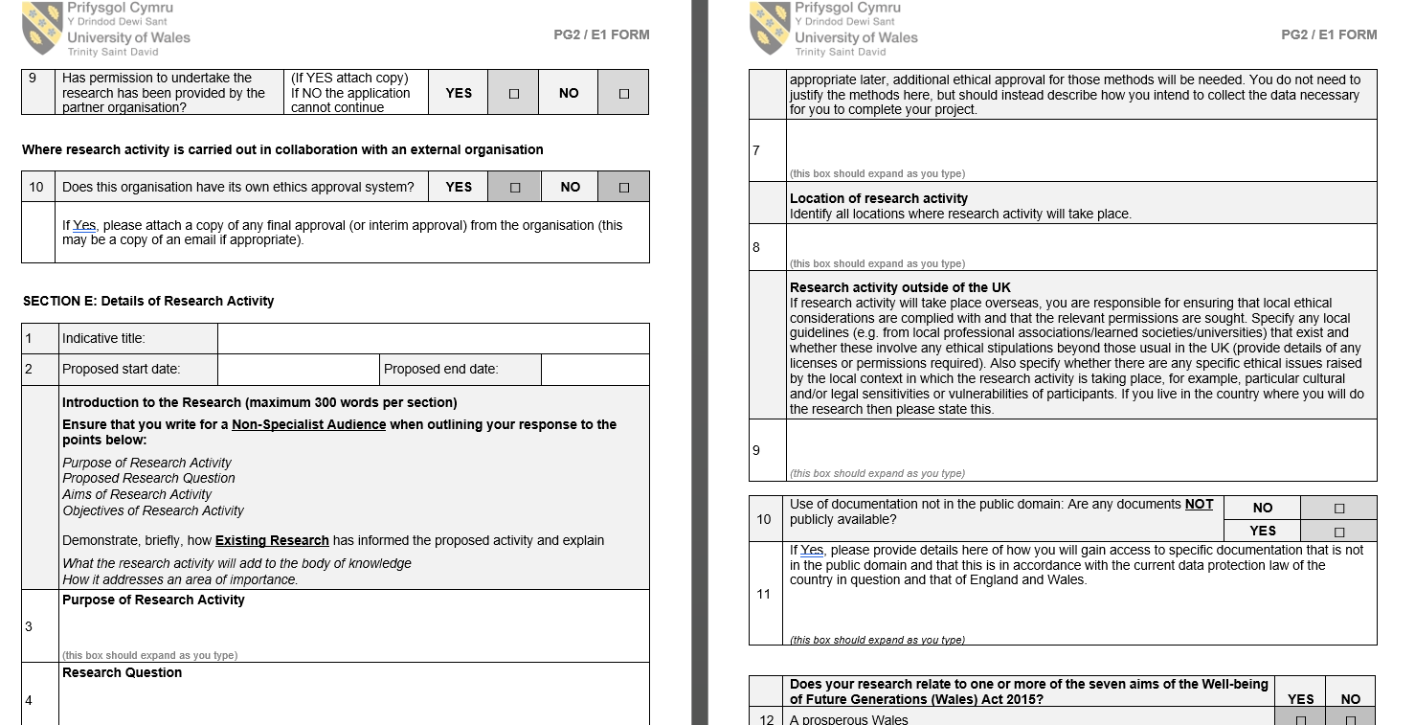
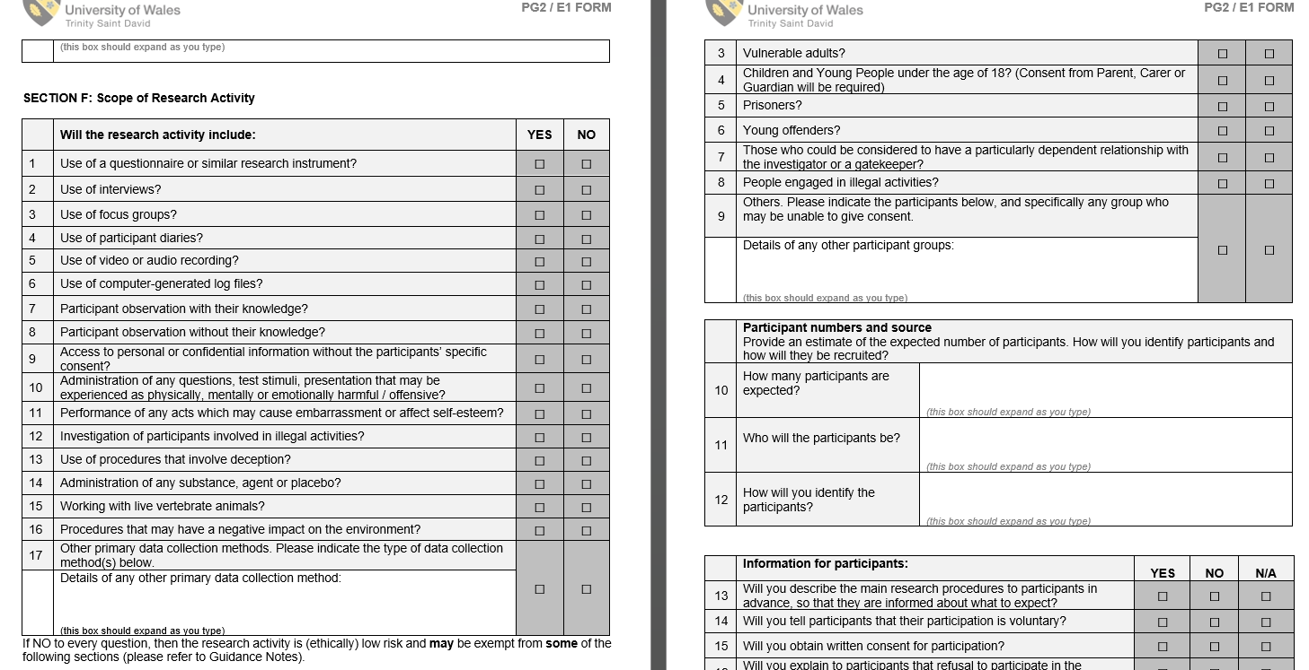

APPENDIX B- Demographic Characteristics Table
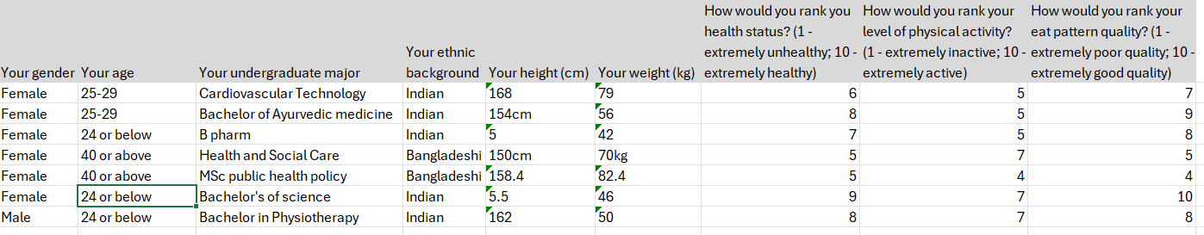

APPENDIX C- Blank Questionnaire
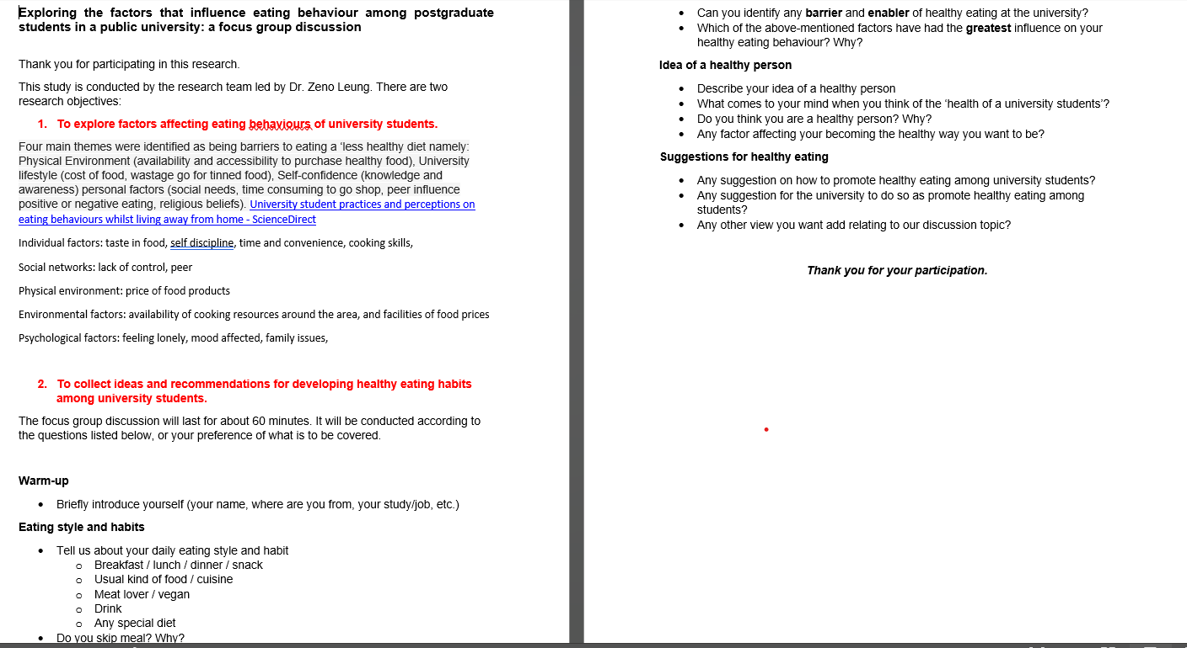

APPENDIX D- Transcript
Focus Group Discussion – Eating Behaviours (Group B, Mar 6, 2024)
Coding | Transcription | Coding
Time  Unhealthy  Time  Time  Unhealthy  Unhealthy  Time / Convenience  Convenience - Time  Time  Healthy  Snacks – Unhealthy Food  Time  Healthy  Boredom snacking  (Snacks)  Healthy  Healthy breakfast  Time  Healthy Breakfast  Unhealthy  Healthy  Unhealthy  Stress  Juice (Healthy)  Unhealthy  Time / Convenience  Healthy  Lunch  Unhealthy  Mixed diet (unhealthy)  Unhealthy  Unhealthy  Stress  Healthy  Skip  Healthy  Snacks - Unhealthy  Snacks  Skip - unhealthy  Unhealthy  Snacks  Stress  Unhealthy  Time / Convenience  Unhealthy  Travel  Time  Unhealthy  Unhealthy  Habit - Time  habit  No sugar  More water  Habit - time  Unhealthy  Unhealthy vending machine  Unhealthy  More options healthy food  Stress  coffee  consistency  Physical activity  social  Herbal  Healthy diet  Mindful eating  Healthy diet  Healthy diet  healthy  healthy  consistency  husband  Mood  State of mind  International students  culture  International students  sleep  Work pattern  Time  Negative impact  Mood  hormone | Sanara  Today we are going to be participating in a group discussion on eating behaviours in postgraduate students.  Zeno Leung  Thank you for your participation and we hope to explore factors that are gonna be affecting eating behaviours for university students which are yourselves.  0:7:17.870 --> 0:7:23.90  Zeno Leung  And then we're gonna collect the ideas and recommendations for developing healthy eating habits among university students.  Zeno Leung  Umm.  Sanara  I was gonna say there's no right or wrong answer, so just feel comfortable enough to express yourselves freely and just start off softly by introducing ourselves and just introduce yourself.  0:7:41.70 --> 0:7:54.180  Zeno Leung  So my name is Rez and I don't More health until she came in six, which I completed and I decided to do the Masters and just to give me a more options in the future.  0:7:54.590 --> 0:8:3.440  Zeno Leung  And so I'm currently on my second term and hopefully got one more term left and let's see, hopefully I that's it.  0:8:3.730 --> 0:8:4.420  Zeno Leung  Thank you.  0:8:4.550 --> 0:8:6.580  Zeno Leung  Yeah, I myself Naveena Dooru.  0:8:7.330 --> 0:8:9.520  Zeno Leung  I did my graduation in Arabic medicine.  0:8:9.690 --> 0:8:16.440  Zeno Leung  I, which is Indian medicine and now I'm doing my masters here in term two and yeah, I'm taking part in the discussion.  0:8:16.760 --> 0:8:17.760  Zeno Leung  Umm, that's me.  0:8:17.770 --> 0:8:20.760  Zeno Leung  OK, Gloria Thomas, I finished my Amazon card.  0:8:21.140 --> 0:8:27.370  Zeno Leung  Technology and and the second term student in the university and I'm taking part of this.  0:8:27.620 --> 0:8:29.170  Zeno Leung  Yeah, I don't know.  0:8:29.400 --> 0:8:32.300  Zeno Leung  This section my name is Nehal Kalpeshkumar.  0:8:33.340 --> 0:8:35.530  Zeno Leung  I was completed my pharmacy.  0:8:36.200 --> 0:8:42.590  Zeno Leung  I I'm running part of this discussion and let's see research.  0:8:43.900 --> 0:8:44.830  Zeno Leung  Thank you.  0:8:45.80 --> 0:8:48.590  Zeno Leung  My name is Vaishali and I'm taking part of this discussion.  0:8:49.820 --> 0:8:53.260  Zeno Leung  I am, yes, and I did my best lesson.  0:8:53.510 --> 0:8:58.880  Zeno Leung  If that happens and then again I'm doing this in public and lovely.  0:8:58.890 --> 0:9:4.620  Zeno Leung  Thank you for sharing and we'll just discuss eating style and habits of 1 at a time.  Sanara  If you could just briefly describe your daily routine, what you eat for breakfast, lunch, dinner, maybe snacks, and what type of food do you prefer, whether it's vegan or you like your proteins, what type of drinks?  0:9:18.570 --> 0:9:20.480  Zeno Leung  Any special dietary requirements?  0:9:20.490 --> 0:9:26.280  Zeno Leung  And if you skip meals, maybe give a reason why and then start.  0:9:26.290 --> 0:9:32.450  Rez  OK, so my daily routine, habit wise eating habit wise, I don't have breakfast.  0:9:32.460 --> 0:9:44.50  Zeno Leung  I'll be honest and simply because I don't have the time and get the kids ready for school and also rushing in the morning, taking them school and because I work as well, so I don't really get time to have breakfast.  0:9:44.250 --> 0:9:52.760  Zeno Leung  So when I do come into whether it's you near work, my breakfast is literally a cappuccino and maybe a biscuit, which is not very healthy, I know.  0:9:52.810 --> 0:9:54.300  Zeno Leung  But at the time, it's convenient.  0:9:55.880 --> 0:9:56.970  Zeno Leung  Lunch.  0:9:57.500 --> 0:10:5.800  Zeno Leung  If I'm at work, I'll have a sandwich or in uni will pick something up from the vending machine or pop to the cafe again.  0:10:5.860 --> 0:10:9.40  Zeno Leung  Same with work of make a sandwich and have it work.  0:10:9.100 --> 0:10:11.450  Zeno Leung  But if I'm home, I don't have lunch.  0:10:13.150 --> 0:10:14.220  Zeno Leung  Please call up work.  0:10:14.230 --> 0:10:16.200  Zeno Leung  I mean, at home I don't tend to have lunch.  0:10:16.210 --> 0:10:20.820  Zeno Leung  I'll just have my dinner that evening, which consists of protein.  0:10:23.260 --> 0:10:25.700  Zeno Leung  From veg not a lot, but should I have more?  0:10:26.250 --> 0:10:34.0  Zeno Leung  Uh, and that's it, basically, and snacks only when I'm at work or uni.  0:10:34.10 --> 0:10:35.400  Zeno Leung  Otherwise, at home I don't know.  0:10:35.610 --> 0:10:40.420  Zeno Leung  I feel like I don't have time at home to snack because that at home I'm too busy doing housework.  Zeno Leung  So in the kids out cooking for the kids.  Zeno Leung  But here at work, because I'm sitting down doing work, I just tend to munch simply because I can.  Zeno Leung  Same with work, but at home I do not slack slack at work I mean, I'm sorry.  Zeno Leung  So you're very busy at all?  Zeno Leung  Yeah, at home I find.  0:10:58.10 --> 0:10:58.620  Zeno Leung  I'm very busy.  0:10:58.630 --> 0:11:6.530  Zeno Leung  I don't really get to sit down and because I'm sitting here and it's a good thing because if I was snacking here and home wouldn't be very good, would it not?  0:11:6.540 --> 0:11:6.940  Zeno Leung  Very healthy.  0:11:8.120 --> 0:11:18.410  Nehal  I'm I'm making a healthy disease twice a day, like broccoli soup and soap and healthy snacks like dinner.  0:11:18.800 --> 0:11:19.290  Zeno Leung  Yeah.  0:11:19.340 --> 0:11:21.290  Zeno Leung  So sometimes I have breakfast.  0:11:21.300 --> 0:11:21.500  Zeno Leung  Yeah.  0:11:22.210 --> 0:11:23.280  Zeno Leung  In breakfast?  0:11:23.610 --> 0:11:29.0  Zeno Leung  No, I I bring two girl and salad also.  0:11:29.50 --> 0:11:33.290  Zeno Leung  OK, so like a light breakfast, but you focus more on like, dinner and a lunch.  0:11:33.300 --> 0:11:33.700  Zeno Leung  Yeah.  0:11:33.710 --> 0:11:35.20  Zeno Leung  So you prepare that yourself?  0:11:35.80 --> 0:11:38.40  Zeno Leung  I I have very, you know.  0:11:38.100 --> 0:11:38.640  Zeno Leung  Yeah.  0:11:38.710 --> 0:11:47.850  Zeno Leung  So I I bring a normal lunch like salad and soup and that's something that fills you, but it's healthy, but it sounds of it. It's healthy.  0:11:48.360 --> 0:11:50.630  Zeno Leung  Do I'm in breakfast.  0:11:50.640 --> 0:11:57.770  Zeno Leung  I I sometimes I I read a lot and yeah.  0:11:57.900 --> 0:11:59.10  Zeno Leung  Gregory yeah.  0:11:59.20 --> 0:12:0.30  Zeno Leung  Jacquees.  0:12:0.740 --> 0:12:1.880  Zeno Leung  What's jaggery juice?  0:12:3.60 --> 0:12:4.380  Zeno Leung  Hello please.  0:12:5.500 --> 0:12:6.100  Zeno Leung  It's a good day.  0:12:6.220 --> 0:12:9.890  Zeno Leung  To come to the games should change sugar cane juice.  0:12:10.180 --> 0:12:11.450  Zeno Leung  That's quite good as well.  0:12:12.30 --> 0:12:19.200  Zeno Leung  I this movie like Mango smoothie healthy smoothie for example, you're quite health conscious in.  0:12:19.250 --> 0:12:23.970  Zeno Leung  Ohh yeah, but not regular days and twice twice a day.  0:12:23.980 --> 0:12:24.980  Zeno Leung  Yeah, ohh.  0:12:24.990 --> 0:12:28.570  Zeno Leung  In two or three days in week in week. Yeah.  0:12:28.610 --> 0:12:30.420  Zeno Leung  OK, so it depends, yeah.  0:12:31.30 --> 0:12:38.600  Zeno Leung  If you're busy, depends on your schedule, job or university, so that impacts on what you have.  0:12:38.650 --> 0:12:39.270  Zeno Leung  OK, lovely.  0:12:40.250 --> 0:12:44.470  Zeno Leung  Yeah, I usually start meeting with a cup of coffee without coffee.  0:12:44.480 --> 0:12:45.430  Zeno Leung  I cannot like.  0:12:45.480 --> 0:12:48.190  Zeno Leung  I'll be like, you know, in some other world.  0:12:48.260 --> 0:12:55.170  Zeno Leung  So yeah, I usually skip my breakfast and like I'll be having directly my lunch at 1:00 o'clock like that.  0:12:55.680 --> 0:13:1.940  Zeno Leung  And yeah, it's like with it's not a daily like diet plan or something.  0:13:1.950 --> 0:13:3.670  Zeno Leung  I'll go with whatever I get.  0:13:3.800 --> 0:13:8.30  Zeno Leung  And yes, sometimes I snack like.  0:13:8.100 --> 0:13:9.490  Zeno Leung  Yeah, I like eating chocolates.  0:13:9.500 --> 0:13:14.800  Zeno Leung  And also it's like mixed everything not after regular diet plan mixed, yeah.  0:13:17.420 --> 0:13:24.260  Zeno Leung  OK, my breakfast is old old snake, and you're good.  0:13:24.270 --> 0:13:27.300  Zeno Leung  I added some are good and some bad and some fruits are that.  0:13:27.670 --> 0:13:28.820  Zeno Leung  That's my breakfast.  0:13:28.990 --> 0:13:32.330  Zeno Leung  Sometimes I skip that one and to take this my lunch time.  0:13:32.710 --> 0:13:37.860  Zeno Leung  It's because the some of the duty or some of the missing.  0:13:38.280 --> 0:13:40.420  Zeno Leung  Yeah, the assignment and stressful time.  0:13:40.570 --> 0:13:48.700  Zeno Leung  Ohh, it's skipping the lunch time is always rice and some no curries and some vegetables there.  0:13:49.130 --> 0:13:54.920  Zeno Leung  And in dinner only I take a two piece of brown bread and some some.  0:13:54.930 --> 0:13:57.60  Zeno Leung  Maybe it's my own eyes.  0:13:57.110 --> 0:13:57.430  Zeno Leung  Alina.  0:13:57.550 --> 0:13:59.400  Zeno Leung  Otherwise, there's some curd.  0:13:59.410 --> 0:13:59.900  Zeno Leung  Salad.  0:14:0.670 --> 0:14:10.50  Zeno Leung  I take it after snacks is not necessary, but in university I will take some, otherwise we will sleeping because of sleeping.  0:14:10.120 --> 0:14:10.910  Zeno Leung  Yeah.  0:14:11.170 --> 0:14:15.180  Zeno Leung  Otherwise you got more time, so you eat them before going home.  0:14:15.440 --> 0:14:17.690  Zeno Leung  I never take any snacks from mine.  0:14:17.740 --> 0:14:19.130  Zeno Leung  No coffee maybe.  0:14:19.980 --> 0:14:24.400  Zeno Leung  I didn't like too much sugar, but in I take my note.  0:14:25.400 --> 0:14:28.650  Zeno Leung  I just not added sugar in teas.  0:14:28.840 --> 0:14:31.210  Zeno Leung  I straight away that without sugar.  0:14:33.440 --> 0:14:33.830  Zeno Leung  Perfect.  0:14:33.840 --> 0:14:45.260  Zeno Leung  OK ohh usually in my breakfast I take only milk and sometimes I take a fruits and sometimes I just skip the breakfast and directly do your lunch.  0:14:45.430 --> 0:14:51.880  Zeno Leung  And in lunch, I take a chapatis and also some kind of curries and all.  0:14:52.70 --> 0:14:58.600  Zeno Leung  And in dinner, I take a light dinner like a rice and all that kind of things.  0:14:58.610 --> 0:15:2.430  Zeno Leung  I and I eat chocolate whole little bit and no.  0:15:2.770 --> 0:15:5.60  Zeno Leung  OK, too much. Yeah.  0:15:5.70 --> 0:15:10.930  Zeno Leung  Yeah, I know it's unhealthy, but I'm just kind of got a sweet tooth.  0:15:10.940 --> 0:15:11.770  Zeno Leung  Yeah.  0:15:11.840 --> 0:15:15.470  Zeno Leung  Yeah, it's like those next too much hold.  0:15:15.480 --> 0:15:18.210  Zeno Leung  I eat snacks and talk like that all the time.  0:15:18.220 --> 0:15:20.130  Zeno Leung  Or is it maybe when you're busy?  0:15:20.460 --> 0:15:25.500  Zeno Leung  Yeah, because sometimes of the university life.  0:15:25.510 --> 0:15:27.330  Zeno Leung  The Do you think that?  0:15:27.380 --> 0:15:27.870  Zeno Leung  Yeah.  0:15:27.910 --> 0:15:32.260  Zeno Leung  On to having like sugar intake, more snacks.  0:15:34.910 --> 0:15:39.90  Zeno Leung  Yash, in the morning I took a bread, butter and two or three.  0:15:40.90 --> 0:15:46.310  And Omega-3 wow, you need to wake up with the oh.  Ohh, made foods snacks and I skipped my lunch and I took like the white and vegetables.  0:15:54.220 --> 0:15:58.100  Zeno Leung  Every dinner depends on the university or job.  0:15:58.110 --> 0:15:59.350  Zeno Leung  Great job city.  0:16:0.200 --> 0:16:1.150  Zeno Leung  You're quite conscious.  0:16:1.160 --> 0:16:2.720  Zeno Leung  And do you cook yourself? No.  0:16:4.580 --> 0:16:5.530  Zeno Leung  I don't go.  0:16:6.370 --> 0:16:7.540  Zeno Leung  OK, perfect.  0:16:7.550 --> 0:16:8.690  Zeno Leung  Thank you for sharing.  0:16:8.780 --> 0:16:9.150  Zeno Leung  Hello.  0:16:9.660 --> 0:16:13.170  Zeno Leung  Uh, I heard that some of us skip some meals.  0:16:13.640 --> 0:16:15.510  Zeno Leung  And what are the main reason?  0:16:15.520 --> 0:16:18.30  Zeno Leung  I I heard about being too busy.  0:16:18.40 --> 0:16:29.40  Zeno Leung  And what are the other reasons that make us skip some new either breakfast or I travel from Leicester during university days and fall behind  0:16:29.50 --> 0:16:29.400  Zeno Leung  Yeah.  0:16:29.460 --> 0:16:37.150  Zeno Leung  During university I skip breakfast due to time constraints, I came from London, so it's two for me.  0:16:37.200 --> 0:16:42.120  Zeno Leung  I see understand from less to yeah. Sorry.  0:16:42.180 --> 0:16:42.390  Zeno Leung  Yeah.  0:16:43.470 --> 0:16:45.210  Zeno Leung  Let's we are yours.  0:16:45.220 --> 0:16:48.640  Zeno Leung  Me to Mr yeah, that's all I think.  0:16:49.500 --> 0:16:51.910  Zeno Leung  And yeah, what I was gonna take another reason.  0:16:51.920 --> 0:16:56.190  Zeno Leung  I do miss breakfast is if I'm not working or haven't got you either.  0:16:56.200 --> 0:17:2.490  Zeno Leung  Like weekends, because I tend to go to the gym, so I'll go early in the morning and I'll eat before I go gym on.  0:17:2.500 --> 0:17:4.290  Zeno Leung  The poster might never. How?  0:17:4.350 --> 0:17:7.170  Zeno Leung  That's another reason not missed breakfast in the weekend because I like to go in.  0:17:7.180 --> 0:17:17.240  Zeno Leung  The first thing in the morning when I wake up, so when I come back I'll I wouldn't say breakfast is more of a lunch because by the time I'm back about 12 I'll have a lunch but never eat breakfast.  0:17:17.250 --> 0:17:20.940  Zeno Leung  Before gym, I see that's another reason I'm misspoke. Christ.  0:17:23.820 --> 0:17:24.760  Zeno Leung  It's like OK then.  0:17:24.890 --> 0:17:28.150  Zeno Leung  So we'll discuss them like the changing eating behaviour.  0:17:28.160 --> 0:17:35.270  Sanara  So do you feel as though since you've started your postgraduate studies that you're eating habits have changed?  Zeno Leung  Yes, yes, of course.  0:17:37.430 --> 0:17:40.340  Zeno Leung  This thing they have.  0:17:40.600 --> 0:17:42.680  Zeno Leung  So negative, negative.  0:17:42.690 --> 0:17:43.880  Zeno Leung  Definitely, definitely.  0:17:44.960 --> 0:17:46.360  Zeno Leung  Didn't it's all the same.  0:17:46.420 --> 0:18:1.120  Zeno Leung  That is lucky, I think, because we're sitting there and we even though our brains are working hard on our study is but yet at the same time you have the urge to eat as well and snack while you're listening to someone, otherwise you just can't stop fiddling around.  0:18:1.350 --> 0:18:2.960  Zeno Leung  And so not in a positive way.  0:18:2.970 --> 0:18:5.300  Zeno Leung  Definitely negative way, because we're just snacking all the time.  0:18:5.310 --> 0:18:7.100  Zeno Leung  I find that's not just that everybody snacking.  0:18:7.370 --> 0:18:11.350  Zeno Leung  Everyone brings their own food and going in their bags they decrease about the biscuits out.  0:18:11.850 --> 0:18:23.60  Zeno Leung  I think it's become a routine as well because this morning I because I usually bring my cappuccinos with me and I nearly forgot it and I literally went back in the house to get it because I thought I need to have my cappuccino.  0:18:23.70 --> 0:18:24.250  Zeno Leung  Otherwise, if I'm home, I would have.  0:18:24.260 --> 0:18:27.370  Zeno Leung  It doesn't bother me, but it's just become a habit as well. I think.  0:18:27.380 --> 0:18:29.230  Zeno Leung  What it is, it becomes a habit as well.  0:18:29.320 --> 0:18:30.110  Zeno Leung  So what you're doing?  0:18:30.120 --> 0:18:31.490  Zeno Leung  You know, you keep it the same.  0:18:31.500 --> 0:18:34.50  Zeno Leung  Happy as opposed to what you would do at home?  0:18:34.240 --> 0:18:35.850  Zeno Leung  It's like 1 certain room for you.  0:18:35.860 --> 0:18:37.170  Zeno Leung  You want certain room for home?  0:18:37.420 --> 0:18:39.670  Zeno Leung  Well, personally, that's what I think for yourself.  0:18:39.720 --> 0:18:41.860  Zeno Leung  But do you think like for example, could be coffee?  0:18:41.870 --> 0:18:42.300  Zeno Leung  That's yeah.  0:18:42.310 --> 0:18:42.970  Zeno Leung  Stimulant.  0:18:42.980 --> 0:18:46.340  Zeno Leung  So do you think you need to stimulate in order to do you know what?  0:18:46.350 --> 0:18:48.430  Zeno Leung  Honestly, I don't think I need it.  0:18:48.480 --> 0:18:51.390  Zeno Leung  I just think it's become happy because I'm not really.  0:18:51.470 --> 0:18:53.300  Zeno Leung  I'm not a hot drinker.  0:18:53.460 --> 0:18:55.630  Zeno Leung  I've never have been because I'm not into Lightroom.  0:18:55.850 --> 0:18:57.230  Zeno Leung  Have coffee first thing in the morning.  0:18:57.240 --> 0:19:2.280  Zeno Leung  I'll be honest with you, if I was a working or studying, I I don't need to have hearings.  0:19:2.350 --> 0:19:2.610  Zeno Leung  Yeah.  0:19:2.620 --> 0:19:3.360  Zeno Leung  So I don't think it is.  0:19:3.370 --> 0:19:6.680  Zeno Leung  I think it's just become a hobby and I just feel like everyone else is having enough.  0:19:6.690 --> 0:19:7.180  Zeno Leung  Kind of thing.  0:19:7.190 --> 0:19:8.290  Zeno Leung  Oh yeah, be nice to have a little.  0:19:8.300 --> 0:19:10.260  Zeno Leung  How about for anybody else? Anything different?  0:19:10.270 --> 0:19:11.260  Zeno Leung  Yeah, I have.  0:19:11.270 --> 0:19:13.590  Zeno Leung  I have also in previous my.  0:19:15.330 --> 0:19:17.760  Zeno Leung  Days have now taken every day.  0:19:17.830 --> 0:19:18.710  Zeno Leung  Coffee or tea?  0:19:18.720 --> 0:19:20.70  Zeno Leung  Anything without sugar.  Gloria  If I started with university life, I changed my that the tea or coffee, whatever I have it in the morning time and evening time I started the only warm water because one also that sugar, I totally remove the sugar from the university times because sugar is things are feeling sleepy on the time.  0:19:41.480 --> 0:19:43.290  Zeno Leung  That's I am totally take out the sugar.  0:19:43.500 --> 0:19:44.950  Zeno Leung  You've improved your.  0:19:45.160 --> 0:19:53.390  Zeno Leung  Yeah, it's it's maybe, I don't know that, but I feeling I personally I'm feeling that I have a feeling very sleepy.  0:19:53.400 --> 0:19:59.620  Zeno Leung  So I take it with this sugar from today and taking too much water on the you wanna city time?  0:20:0.30 --> 0:20:2.10  Zeno Leung  Yeah, you know, I'm not here.  0:20:2.330 --> 0:20:3.10  Zeno Leung  Too much time.  0:20:3.20 --> 0:20:3.570  Zeno Leung  Water.  0:20:3.580 --> 0:20:5.900  Zeno Leung  That's university time or taking a lot of water.  0:20:6.110 --> 0:20:6.780  Zeno Leung  Can I just?  0:20:6.850 --> 0:20:12.650  Zeno Leung  Yeah, that's all I've got to mention them with the hot drink, like the cappuccino that I have, because I never finished it.  0:20:12.960 --> 0:20:18.110  Zeno Leung  I just realized the reason I have is because I like to wear my biscuits in it, not to change the cause.  0:20:18.120 --> 0:20:19.930  Zeno Leung  I don't like having biscuits just on his own.  0:20:19.940 --> 0:20:24.670  Zeno Leung  I like to dip it into a hot drink and actually when I just thinking I never finish it off.  0:20:25.10 --> 0:20:27.130  Zeno Leung  It's really always I've got half a cup left.  0:20:27.280 --> 0:20:28.100  Zeno Leung  I just use it.  0:20:28.160 --> 0:20:31.680  Zeno Leung  I like to have it with my biscuits and I don't like having captured.  0:20:31.690 --> 0:20:39.610  Zeno Leung  Like now I'm OK just to have it, but first thing in the morning, I don't know why I like to do my biscuits and you notice before you even do anything.  0:20:39.620 --> 0:20:40.440  Zeno Leung  I know.  0:20:40.570 --> 0:20:43.710  Zeno Leung  Yeah, I never finish up my heart tree. Umm.  0:20:46.350 --> 0:20:51.520  sanara  Does anybody feel as though they eat healthier whilst becoming, you know, while studying?  0:20:51.530 --> 0:20:55.210  Zeno Leung  Do you think not in Union? But?  0:20:55.220 --> 0:20:56.50  Zeno Leung  He asked Jose.  0:20:56.100 --> 0:21:0.20  Zeno Leung  Unless you're making it at home yourself, it's limited in it, cause not you got.  0:21:0.30 --> 0:21:0.490  Zeno Leung  Not really.  0:21:0.500 --> 0:21:1.250  Zeno Leung  Got a healthy choice?  Have you and like the vending machine, the cafe?  0:21:4.860 --> 0:21:8.180  Zeno Leung  And if you're gonna go out tonight into town, it's a too much time.  Not gonna make it back, so I don't think the options there to have healthy food.  0:21:12.150 --> 0:21:17.370  Zeno Leung  You feel as though there's like barriers or the like, enablers like the vending machine.  0:21:17.380 --> 0:21:18.770  Zeno Leung  Yeah, definitely.  0:21:18.780 --> 0:21:19.40  Zeno Leung  Yeah.  0:21:19.50 --> 0:21:20.210  Zeno Leung  Encouraging you to have.  0:21:20.300 --> 0:21:20.720  Zeno Leung  Yeah.  0:21:20.760 --> 0:21:21.920  Zeno Leung  Yeah, like snacks.  0:21:21.930 --> 0:21:23.670  Zeno Leung  The unhealthy foods.  0:21:24.380 --> 0:21:30.510  Zeno Leung  So the barriers you would say is there's not enough option option within the campus.  0:21:30.520 --> 0:21:31.410  Zeno Leung  Yeah.  0:21:31.460 --> 0:21:32.550  Zeno Leung  That everybody.  0:21:32.610 --> 0:21:33.380  Zeno Leung  Yeah, you.  0:21:34.500 --> 0:21:44.40  Zeno Leung  And doing that, what do you think is the greatest influence on your eating behaviour whilst studying, which I think is the?  0:21:47.410 --> 0:21:47.870  Zeno Leung  The moment.  0:21:50.360 --> 0:21:51.790  Zeno Leung  You like influences.  0:21:51.800 --> 0:21:55.910  Zeno Leung  You have it so it could be like negative.  0:21:55.920 --> 0:22:0.580  Zeno Leung  It could be, I suppose I'm stress, obviously positive, probably.  Obviously eating it wakes you up or having your hot drinks so so you can concentrate more.  Obviously, if you're feeling hungry and like you're not gonna really be able to concentrate on your work, I suppose that keeps you kind of alert as supposed.  Then, then again, sugar makes you quite hyper and active doesn't mean for some people, for doesn't it?  0:22:19.710 --> 0:22:23.940  Zeno Leung  So probably in the aspect maybe anybody else.  0:22:28.820 --> 0:22:31.590  Zeno Leung  OK, let's move on to the next question, OK.  0:22:33.790 --> 0:22:35.880  Zeno Leung  Who idea of a healthy person?  0:22:35.890 --> 0:22:46.190  Zeno Leung  So if you could describe your idea of what you think is a healthy person's to mind balanced diet, be native and making it continue.  0:22:46.200 --> 0:22:47.270  Zeno Leung  Consistency.  0:22:47.460 --> 0:22:53.10  Zeno Leung  WHO definition which is app for a healthy person physically, mentally and physically healthy?  0:22:53.120 --> 0:23:1.710  Zeno Leung  Yes, for into physical activities and eat healthy healthy floor comma balance, it's gotta be balanced out.  0:23:1.720 --> 0:23:3.510  Zeno Leung  Yeah, and be consistent as well.  0:23:3.520 --> 0:23:6.160  Zeno Leung  So it's not just the food, it's also social.  0:23:6.170 --> 0:23:9.450  Zeno Leung  Social media this, and you're gonna social activity?  0:23:9.460 --> 0:23:12.820  Zeno Leung  Yeah, to ask for the healthy lifestyle.  0:23:12.830 --> 0:23:14.210  Zeno Leung  Let's say I'm being consistent.  0:23:14.220 --> 0:23:15.810  Zeno Leung  Actually, what's?  0:23:16.100 --> 0:23:16.360  Zeno Leung  Yeah.  0:23:16.370 --> 0:23:22.740  Zeno Leung  What kind of diet do you think a healthy person would have ohss food, things specific email?  0:23:22.750 --> 0:23:31.280  Zeno Leung  Regular day I I I drink a herbal tea and detox water and green tea.  0:23:31.350 --> 0:23:45.280  Zeno Leung  This is a good for our blood and stimulate the mind well and I I have one skin problem so it's good for me for for blood circulation hydration like keep yourself hydrated.  0:23:45.790 --> 0:23:46.940  Zeno Leung  OK, that's true.  0:23:47.50 --> 0:23:53.340  Zeno Leung  Like I want we usually see in our like I did my graduation in Indian medicine.  0:23:53.350 --> 0:24:0.20  Zeno Leung  So what we usually see like a plate should be full of like everything like proteins, carbohydrates, everything mixed.  0:24:0.60 --> 0:24:4.170  Zeno Leung  So mindful eating is one of the major factor which leads to healthier lifestyle.  0:24:4.180 --> 0:24:9.230  Zeno Leung  I think wonderful eating now I think as well portion is the big thing.  0:24:9.270 --> 0:24:19.940  Zeno Leung  Obviously, having all your nutrients as well your carbohydrates, your protein, your sweets as well, but you put portion is very important not to all the emails you have, the size of your.  0:24:20.130 --> 0:24:32.660  Zeno Leung  Yeah, that's that's very important to balance out as well because we could easily, even though sometimes people miss one meal, but they'll have that one meal, but they'll overeat on that one meal because then that it all day, so all the compensated. Yeah.  0:24:32.670 --> 0:24:33.700  Zeno Leung  So that's not good as well.  0:24:34.70 --> 0:24:38.810  Zeno Leung  And that brings me back to back 18.  0:24:38.820 --> 0:24:43.930  Zeno Leung  Happy as in four as Muslims throughout the year, one month is different for us because we fast.  0:24:44.380 --> 0:24:54.310  Zeno Leung  So that's a big change in our routine in even having physically are mentally because we can't eat between sunrise and sunset.  0:24:54.360 --> 0:24:56.300  Zeno Leung  So that does affect us in so many ways.  0:24:56.310 --> 0:25:3.510  Zeno Leung  Yes, spiritually were there, but maybe, you know, physically even more tired because we're not getting the nutrients.  0:25:3.580 --> 0:25:9.380  Zeno Leung  But obviously for a lot of people is different probably about a week or two, our body adjust to be and then we can we feel OK.  0:25:9.390 --> 0:25:14.460  Zeno Leung  But again, that does is so different to what it would be in the living most in the in that year.  0:25:14.710 --> 0:25:17.170  Zeno Leung  So that has a big impact on our routine and everything.  0:25:19.250 --> 0:25:19.720  Zeno Leung  Thank you.  0:25:19.730 --> 0:25:31.20  Zeno Leung  So what is more important than that food we all the foods we need, all the food for like wage or non veg, that's whatever.  0:25:31.110 --> 0:25:32.100  Zeno Leung  Leafy vegetables?  0:25:32.110 --> 0:25:36.340  Zeno Leung  What fruits and everything is we need include the Vatsal.  0:25:36.350 --> 0:25:37.80  Zeno Leung  So main thing.  0:25:37.330 --> 0:25:38.740  Zeno Leung  Yeah, yeah, yeah.  0:25:38.750 --> 0:25:40.980  Zeno Leung  So it's like a balance. Yeah.  0:25:41.50 --> 0:25:41.490  Zeno Leung  Perfect.  0:25:41.500 --> 0:25:46.260  Zeno Leung  And can I just ask and do you think that you are healthy person?  0:25:47.580 --> 0:25:48.610  Zeno Leung  You know you are.  0:25:49.550 --> 0:25:52.220  Zeno Leung  We're not totally kind of, OK, you know?  0:25:52.730 --> 0:25:52.930  Zeno Leung  No.  0:25:53.400 --> 0:25:57.720  Zeno Leung  Still, I'm saying, like, you're not happy about.  0:26:0.530 --> 0:26:8.760  Zeno Leung  4060% maybe I'm still working at it like I have my days where because I do like to go so I'm active because I go gym probably five days a week.  0:26:8.930 --> 0:26:11.200  Zeno Leung  I still working on my food habit in.  0:26:11.250 --> 0:26:32.310  Zeno Leung  It varies because I have moments where if I set myself a goal like ohh, I wanna use lose this amount of weight, I'll be good to my diet and then when I have achieved that I just got back to jumping together, get comfortable and then when I feel like we're probably gonna be away and then I'll go back to eating healthy again and think I'm gonna not have chocolate and I'll go for a month or two without having it.  0:26:32.680 --> 0:26:35.30  Zeno Leung  And then when I achieve my gold, I'll go back to having chocolate.  0:26:35.40 --> 0:26:40.790  Zeno Leung  So I suppose I shouldn't do that because if I be consistent then I'll be more healthy.  0:26:40.800 --> 0:26:42.350  Zeno Leung  But I suppose yeah.  0:26:42.360 --> 0:26:44.230  Zeno Leung  Consistency is the thing that is important.  0:26:44.240 --> 0:26:46.720  Zeno Leung  Needs to be very implemented.  0:26:49.210 --> 0:26:54.660  Zeno Leung  Was there any factors that you think affects you becoming the healthy version of health?  0:26:55.550 --> 0:26:57.440  Zeno Leung  She helped to become a healthier person.  0:26:59.470 --> 0:27:7.380  Zeno Leung  Yeah, obviously our like when I'm at home, usually when I don't good, I mean I'm not at good at cooking.  0:27:7.510 --> 0:27:10.660  Zeno Leung  So usually, like my husband has me in cooking and all.  0:27:10.670 --> 0:27:12.620  Zeno Leung  So he's also, like, very conscious.  0:27:12.910 --> 0:27:15.920  Zeno Leung  So it's depends upon the person whom we are with.  0:27:17.210 --> 0:27:22.380  Zeno Leung  So they're an influence eating habits, then my.  0:27:22.450 --> 0:27:24.660  Zeno Leung  That's the state of mind also.  0:27:24.790 --> 0:27:35.940  Zeno Leung  And from that, we are in a university in, in, in international students, along with the living in alone now in here.  0:27:36.90 --> 0:27:36.380  Zeno Leung  Yeah.  0:27:36.390 --> 0:27:39.760  Zeno Leung  So different from my country and the culture is different.  0:27:39.810 --> 0:27:46.960  Zeno Leung  Everything is different and families not, because that's a totally, totally mind, us international student.  0:27:46.970 --> 0:27:51.900  Zeno Leung  Yeah, many barriers, you know, very, very, very hard to stay here.  0:27:52.660 --> 0:27:54.750  Zeno Leung  It was the traveling?  0:27:54.760 --> 0:27:55.880  Zeno Leung  Yeah, just talking.  0:27:55.890 --> 0:27:57.330  Zeno Leung  Your health, isn't it?  0:27:57.340 --> 0:27:59.650  Zeno Leung  Yeah, when they sleep cycle also.  0:27:59.720 --> 0:28:0.940  Zeno Leung  Yeah, yeah.  0:28:1.420 --> 0:28:5.310  Zeno Leung  During my turn back I have doing did my night night shift.  0:28:5.320 --> 0:28:14.380  Zeno Leung  So I wake up in 12:00 o'clock noon, so I don't get you sleep because you're working and then can't follow up every day.  0:28:14.390 --> 0:28:15.240  Zeno Leung  Aguilar regular.  0:28:15.520 --> 0:28:16.120  Zeno Leung  Yeah.  0:28:16.180 --> 0:28:17.590  Zeno Leung  You think this I can suggest.  0:28:17.740 --> 0:28:19.250  Zeno Leung  So it's also.  0:28:19.260 --> 0:28:29.110  Zeno Leung  Yes, please keep the breakfast at the there whenever we take a wake up and that way we have the, the maybe it's 1:00 o'clock or two o'clock Father time.  0:28:29.240 --> 0:28:34.890  Zeno Leung  Let's say the main reason for that knowledge barrier is travelling as well, isn't it? Yeah.  0:28:35.50 --> 0:28:42.30  Zeno Leung  That's time consuming, so it's sometimes I work on night shift day shift evenings.  0:28:42.40 --> 0:28:45.900  Zeno Leung  So that's why that's the work balance Need.  0:28:45.910 --> 0:28:47.620  Zeno Leung  It always tell you need.  0:28:48.210 --> 0:28:48.580  Zeno Leung  Yeah.  0:28:48.590 --> 0:28:49.420  Zeno Leung  And then you working.  0:28:49.430 --> 0:28:53.260  Zeno Leung  Also, you wait two days for you, Nai, and also good for a job.  0:28:53.310 --> 0:29:0.450  Zeno Leung  All these things will you will impacts and then negative way I would say negative way only Gloria has positive down.  0:29:0.740 --> 0:29:0.960  Zeno Leung  OK.  0:29:1.400 --> 0:29:5.310  Zeno Leung  Yes, but also I see your mute as well.  0:29:5.680 --> 0:29:12.150  Zeno Leung  Sometimes when you're down, but then as well they say what you eat, what you eat as well kind of have effect on your mood as well.  0:29:12.160 --> 0:29:15.570  Zeno Leung  But then vice versa as well, because when you feeling down, I feel like when I feel a bit down.  0:29:15.580 --> 0:29:17.90  Zeno Leung  Yeah, I do tend to munch a lot.  0:29:17.420 --> 0:29:19.70  Zeno Leung  So sometimes it's your mood as well.  0:29:19.80 --> 0:29:22.700  Zeno Leung  If you're feeling uplifted, you feel more positive and think ohh no, I'm not gonna have that.  0:29:22.710 --> 0:29:29.410  Zeno Leung  That's not good for me, but the feeling that you just all the things that are bad for you just to compensate that feeling and you'll just have it.  0:29:29.460 --> 0:29:35.830  Zeno Leung  And so I think as women with the whole and the hormones, when women strain as well, email really.  0:29:35.840 --> 0:29:37.380  Zeno Leung  Oh yeah. Sorry.  0:29:37.390 --> 0:29:39.300  Zeno Leung  Yeah, you know this.  0:29:41.390 --> 0:29:41.880  Zeno Leung  Yeah.  0:29:41.890 --> 0:29:43.130  Zeno Leung  Something like wouldn't want.  0:29:43.480 --> 0:29:44.550  Zeno Leung  What time of the month?  0:29:44.560 --> 0:29:45.960  Zeno Leung  Yeah, I feel more peckish.  0:29:46.110 --> 0:29:48.680  Zeno Leung  No, I do wanna eat more biology and.  0:29:48.690 --> 0:29:49.100  Zeno Leung  Yes.  0:29:49.120 --> 0:29:50.360  Zeno Leung  And I'm just like, you know what?  0:29:50.370 --> 0:29:51.260  Zeno Leung  Yeah, it doesn't matter.  0:29:51.310 --> 0:29:54.610  Zeno Leung  It's enough for a week and I'll be fine, but you can't help it as well.  0:29:54.620 --> 0:29:55.370  Zeno Leung  Really, it's true.  0:29:55.380 --> 0:29:56.360  Zeno Leung  Do you all feel the same? No.  0:29:56.370 --> 0:29:57.480  Zeno Leung  Do you stack a bit? Yeah.  0:30:1.310 --> 0:30:1.860  Zeno Leung  Thank you.  0:30:4.750 --> 0:30:12.260  Zeno Leung  Is there any other views that you want to add relating to the topic that we're discussing and you're the factors that you think we may have missed out?  0:30:15.570 --> 0:30:18.890  Zeno Leung  All sports activity and physical activity.  0:30:18.900 --> 0:30:26.70  Zeno Leung  It's very similar to healthy, healthy and I thought about it for a healthy person or something like that.  0:30:26.80 --> 0:30:30.560  Zeno Leung  Active this is very part of physical activity is very important.  0:30:31.230 --> 0:30:34.610  Zeno Leung  You have to do exercise and all, but that's true.  0:30:34.660 --> 0:30:35.390  Zeno Leung  We we can't.  0:30:35.400 --> 0:30:47.630  Zeno Leung  We can't forget stuff like if you have an illness, if your medication no big factor, because if you're on steroids, for example, because my husband's on steroids, he's illness for his Crohn's disease and that makes it more eat more.  0:30:47.700 --> 0:30:51.830  Zeno Leung  So sometimes you quite healthy, so you know you are the side effects of the medication.  0:30:52.140 --> 0:30:55.200  Zeno Leung  The medication feels like you can't eat.  0:30:55.480 --> 0:30:59.250  Zeno Leung  Some people don't eat, so that's a big has a big impact as well.  0:30:59.600 --> 0:30:59.910  Zeno Leung  Yeah.  0:30:59.920 --> 0:31:0.790  Zeno Leung  Medication as well.  0:31:0.900 --> 0:31:4.70  Zeno Leung  There's a saying they need to make food your medicine before medicine becomes.  0:31:4.80 --> 0:31:4.340  Zeno Leung  Yeah.  0:31:4.570 --> 0:31:6.240  Zeno Leung  Yeah, that's a real I want.  0:31:6.940 --> 0:31:7.150  Zeno Leung  I've had.  0:31:7.320 --> 0:31:9.930  Zeno Leung  I have also thought I I taking medicine before the course.  0:31:9.940 --> 0:31:14.400  Zeno Leung  Yeah, breaking up one hour gap is, is there?  0:31:15.30 --> 0:31:18.600  Zeno Leung  I have medicine then after one hour I take the food.  0:31:18.730 --> 0:31:21.220  Zeno Leung  That meal time is also waiting like that.  0:31:21.230 --> 0:31:21.500  Zeno Leung  Really.  0:31:21.510 --> 0:31:35.770  Zeno Leung  Yeah, this is very struggling things and the cost, cost and availability is also discussing yesterday, but the cost is very important because we all know without a job we are struggling to stay here.  0:31:36.80 --> 0:31:38.0  Zeno Leung  It's a definite things is that works.  0:31:38.10 --> 0:31:39.520  Zeno Leung  And yeah, yeah.  0:31:39.560 --> 0:31:44.220  Zeno Leung  Do you think there's anything that the university could put in place to improve your health?  0:31:44.230 --> 0:31:45.640  Zeno Leung  Do you think females?  0:31:46.60 --> 0:31:48.120  Zeno Leung  They no, I don't.  0:31:48.130 --> 0:31:51.150  Zeno Leung  Those cause it's healthy, more healthy food maybe.  0:31:55.30 --> 0:32:9.530  Zeno Leung  I think I think, I think air providing lot of sweet drinks, some sugary things, drinks are here instead of that the give some fresh juice juices like that.  0:32:10.290 --> 0:32:17.340  Zeno Leung  Yeah, price was not the that is not a matter, but giving it healthy, healthy options.  0:32:17.400 --> 0:32:22.210  Zeno Leung  Do you know that some things say that you know when you know cause like in my son's school great time.  0:32:22.340 --> 0:32:27.470  Zeno Leung  Sometimes they provide like apple, like you gotta have an app like a fruit through the support you would be through.  0:32:27.480 --> 0:32:34.80  Zeno Leung  So if you know when we get a break in the common room, if they had like a a table and just apple or we just something this help yourself.  0:32:34.90 --> 0:32:38.440  Zeno Leung  You know, so that will encourage someone just to instead of having a biscuit or crease my thing.  0:32:38.450 --> 0:32:39.670  Zeno Leung  OK, let me go and get Apple.  0:32:39.840 --> 0:32:40.360  Zeno Leung  That's true.  0:32:41.160 --> 0:32:43.160  Zeno Leung  Just little things and that's not that would help.  0:32:43.170 --> 0:32:46.800  Zeno Leung  Too expensive for them to implement and not one of your favourites?  0:32:46.950 --> 0:32:47.290  Zeno Leung  Yeah.  0:32:47.300 --> 0:32:48.690  Zeno Leung  Definite anybody else?  0:32:49.90 --> 0:32:50.10  Zeno Leung  Any other ideas?  0:32:50.40 --> 0:32:52.830  Zeno Leung  Now, maybe more probably.  0:32:52.840 --> 0:32:53.150  Zeno Leung  Yeah.  0:32:53.160 --> 0:32:55.660  Zeno Leung  A little, uh.  0:32:56.30 --> 0:33:1.500  Zeno Leung  A session where they can discuss about more healthy eating cause that everyone has that knowledge.  0:33:1.570 --> 0:33:2.800  Zeno Leung  Not everybody knows.  0:33:2.870 --> 0:33:10.90  Zeno Leung  Some people might think what they eating is OK because they're physically not feeling it or you know, they feel like, ohh, I'm not feeling ill.  0:33:10.100 --> 0:33:12.500  Zeno Leung  But later on in life, obviously that will have effect on them.  0:33:12.550 --> 0:33:14.980  Zeno Leung  So also gaining knowledge as while knowing that.  0:33:15.130 --> 0:33:16.0  Zeno Leung  What would for you?  0:33:16.10 --> 0:33:17.20  Zeno Leung  How can affect you?  0:33:17.30 --> 0:33:19.520  Zeno Leung  How it's better for you and what's not good for your courses?  0:33:19.530 --> 0:33:21.150  Zeno Leung  Yeah, not even just a lot.  0:33:21.160 --> 0:33:23.140  Zeno Leung  Of course, they literally just a day. Nutritional.  0:33:23.150 --> 0:33:23.390  Zeno Leung  Yeah.  0:33:23.430 --> 0:33:24.800  Zeno Leung  Yeah, just formation.  0:33:25.20 --> 0:33:25.400  Zeno Leung  Yeah.  0:33:25.640 --> 0:33:26.850  Zeno Leung  Yeah, Patel information.  0:33:26.900 --> 0:33:29.930  Zeno Leung  OK, they can be or some little little campaign.  0:33:29.940 --> 0:33:35.330  Zeno Leung  They could be then just teach you a bit of healthy eating that would help that cost effective.  0:33:35.520 --> 0:33:35.840  Zeno Leung  Maybe.  0:33:35.920 --> 0:33:39.40  Zeno Leung  We could you be surprised.  0:33:39.50 --> 0:33:44.870  Zeno Leung  The things that people don't know, we assume that people know things, but when you ask them, sometimes they don't know and it's the simplest thing then that's OK.  0:33:44.940 --> 0:33:48.620  Zeno Leung  It's because they've not been 20, and sometimes you do know, sometimes you need a prompt.  0:33:48.630 --> 0:33:49.410  Zeno Leung  Yeah. Reminder.  0:33:49.420 --> 0:33:49.700  Zeno Leung  Yeah.  0:33:49.710 --> 0:33:58.540  Zeno Leung  Motivations that as well, it's true in the sample, but yeah, you know and ask any other questions to be missed anything.  0:34:0.550 --> 0:34:0.980  Zeno Leung  Alright then.  0:34:0.990 --> 0:34:2.0  Zeno Leung  Nothing good then.  0:34:2.470 --> 0:34:2.940  Zeno Leung  Thank you.  0:34:2.950 --> 0:34:4.560  Zeno Leung  But you have to have one more question.  0:34:5.60 --> 0:34:6.700  Zeno Leung  Second would be have one question.  0:34:6.710 --> 0:34:7.370  Zeno Leung  I'll go on then.  0:34:7.640 --> 0:34:8.100  Zeno Leung  What's your?  0:34:11.560 --> 0:34:12.710  Zeno Leung  You wanna hear you but you.  0:34:13.430 --> 0:34:14.60  Zeno Leung  Thank you.  0:34:14.290 --> 0:34:15.680  Zeno Leung  Like this one?  0:34:15.970 --> 0:34:17.580  Zeno Leung  Ohh really feel what's your?  0:34:17.590 --> 0:34:18.440  Zeno Leung  You can go to.  0:34:18.570 --> 0:34:20.200  Zeno Leung  What's your breakfast?  0:34:20.430 --> 0:34:30.760  Zeno Leung  Ohh I I I skip breakfast these days unless I'm at home uni days I skip it, but if I'm at home then cause my husband's home I'm I make breakfast for him so I'll make it for myself as well.  0:34:31.440 --> 0:34:32.590  Zeno Leung  But yeah, I'd have.  0:34:34.820 --> 0:34:35.500  Zeno Leung  This is my husband.  Zeno Leung  That lunch is when the kids come back from school, so we'll have, like, rice and Curry and then evening or we just have something like maybe toasties or something like that.  Zeno Leung  But it's a lot of snacking, but I do feel as though studying has increased my sugar intake, less physical activity just because it's a time constraints you're trying to manage your life. UNHEALTHY / TIME  Zeno Leung  Yeah, like with children.  0:34:57.240 --> 0:34:57.820  Zeno Leung  And children.  Zeno Leung  And it's so complicated.  Zeno Leung  But yeah, so I do feel as though there's lots of values, and if we did have a lot ohh tunities for like fresh fruit and campaign stuff probably would help. HEALTHY  Zeno Leung  So yeah, that's it.  0:35:10.250 --> 0:35:11.370  Zeno Leung  Thank you for your help.  0:35:12.370 --> 0:35:13.110  Zeno Leung  Thank you everybody.

