

Reflective Portfolio

Student:
Alberto Castillo Rodriguez
2020319

Lecturer:
Richmond Lamptey
BMSW 4005

Module:
PROFESSIONAL AND CAREER DEVELOPMENT
BMSW4005
TABLE OF CONTENTS

INTRODUCTION 3
THE MOCK INTERVIEW 4
REFLECTION 4
FEEDBACK 4
SWOT ANALYSIS 5
PERSONAL DEVELOPMENT PLAN (PDP) 6
HOSPITALITY INDUSTRY 7
SKILLS REQUIRED TO BE AN EFFECTIVE MANAGER 7
ADCQUIRING AND IMPORTANCE OF MANAGER SKILLS 8
ASSESSMENT OF CONCEPTS 9
CAREER DEVELOPMENT 9
CAREER DEVELOPMENT PROCESS 9
SELF-AWARENESS 10
THE JOHARI WINDOW 10
LEARNING STYLES 11
KOLB’S 11
HONEY & MUMFORD’S 11
NEIL FLEMING’S 12
UK EMPLOYMENT LAW 13
EMPLOYMENT RIGHTS 13
CONCLUSION 15
APPENDIX 16
REFERENCES 18

INTRODUCTION

This report will discuss about my own skills and competences. Starting for a reflection and feedback of my mock interview and following by the tools I used to do this study such as SWOT analysis and a Personal Development Plan (PDP) learned during this module.

It also will analyse the skills to be an effective manager in hospitality industry, which is the industry I have been working for 23 years now, how are they acquired and what makes them important.

Finally, this study will assess the concepts I have learned from this module such as setting goals and objectives, the Johari window, the learning theories of Kolb, Neil Fleming and Honey & Mumford, the self-awareness methods, and the UK employment law.

THE MOCK INTERVIEW

REFLECTION

This interview has been a new experience to myself since I’ve never had an online interview. However, I’ve had two interviews face-to-face this year, one was for a Food & Beverage Manager in a hotel and the other one for a General Manager in a restaurant. I didn’t pass both to the next stage and I didn’t get proper feedback from none of them either. I prepared my CV carefully before I applied for these jobs but missing the cover letter though, I didn’t know it was so important. After the preparation for this interview, I know how to go to an interview, I must go there ready to get asked so many questions and with some homework done about the company you are going to apply to, so I will respond the questions quickly, without doubting the answers. I went to these interviews very confident but not ready for them.

FEEDBACK

Giving feedback is testing particularly when the assessment of a worker execution reflects holes among wanted and anticipated execution (Alam and Signh, 2019). This mock interview has provided me a feedback frame (reference to appendix) that other interviewers didn’t, which will help me to improve for future performances. However, I did good performance since my score was 76% and the minimum to be hired was 70%.

SWOT ANALYSIS

In this section this paper is analysing my own skills and competences using the SWOT analysis. This is an analysis to identify my internal factors such as Strengths and Weaknesses, as well as my external factors of Opportunities and Threats (Hung, 2013). It also will help anyone to decide future goals, that’s why I’m applying this analysis in this study.

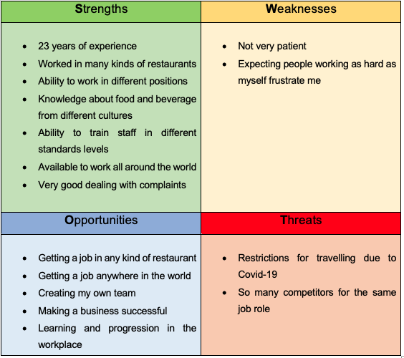
Table 1. SWOT analysis

PERSONAL DEVELOPMENT PLAN (PDP)

Personal development plans (PDPs) are being utilized perpetually much of the time by associations. A PDP is an evaluation tool utilized by the worker to consider, to record the abilities s/he has been chipping away at and to introduce his/her arrangements for additional turn of events (Beausaert, Segers, and Gijselaers, 2011).

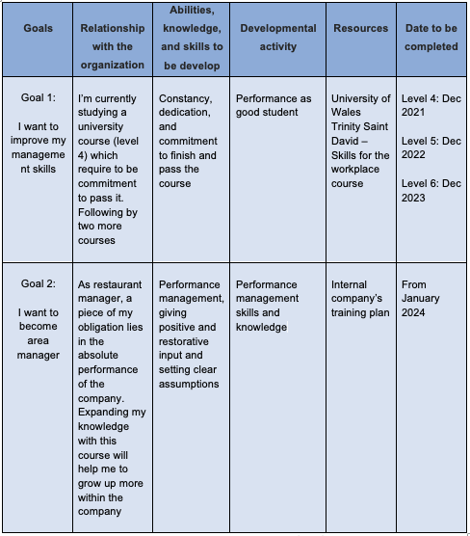
Table 2. Personal development plan (PDP)

ANALYSIS OF THE SKILLS

HOSPITALITY INDUSTRY

My ‘chosen’ industry was the hospitality one. I wrote chosen in quotes because I did not really choose it. When I was 17 years old, I did quit the college and I started working with my dad in his restaurant. However, I chose to continue working in this industry.

The French word 'hospice' has been adjusted to shape the word 'hospitality' that implies dealing with the voyagers (Soeg Jobs, 2021).
The actual business dates to the old Greek occasions and even before that. It was around 40 BC as shown by experts when friendliness organizations for social and severe parties were a genuine ordinary quirk.

It was about this chance that Greeks created warm showers that were planned for recuperation and loosening up. These warm showers should be the start of what we know as cutting-edge Spa. Then, came the Romans who gave comfort to voyagers on government sites. Here, comfort and delight were the names of the game.

The current modern hospitality industry is a massive of a sector raking in trillions of US Dollars in revenue each year (Soeg Jobs, 2021). Even though most present hospitality businesses feature clients' knowledge and accommodations like TV, minibars, en-suite baths, they gratify alike purpose as old ones however with further developed services.

Nowadays, engineers, inventors, artists, and administrators are attentive of the flavour of the visitor as specified by their wishes. So, hospitality businesses analyse recent trends to illustrate improved rules and give contemporary standards to work on the particular pleasure while customers are in them.

SKILLS REQUIRED TO BE AN EFFECTIVE MANAGER

According to Beenen, Pichler, Livingston, and Riggio (2021), managers outline how people go through their periods and regardless of whether they are understanding happiness or depression, accomplish satisfactory or gravely, or are solid or debilitated. Lamentably, there are crowds of average and tremendously bad managers out there, and huge holes among awesome and the most exceedingly awful.
Overseeing people is intrinsically requesting and distressing. Managers should organize and supervise crafted by others with regards to obliged assets, changing requests and assumptions, and maybe most fundamentally, testing relational trades. Since managers burn through a large portion of their work hours in relational trades, managerial interpersonal skills (MIPS) are indispensable to being an "acceptable manager".

Managers should have the option to exhibit a variety of skills in request to boost their adequacy and occupation fulfilment. Humility, patience, passion, and mindset are four ranges of abilities that will essentially help managers in achieving these abilities.
- Humility is simply the limit of managers to try not to put themselves before others, and not feel headed to be prevailing over the team members that they manage.
- Patience implies that managers exhibit resilience, sympathy, certainty, empathy, receptiveness, and readiness to delegate and believe the abilities of those they manage.
- Passion addresses a compelling enthusiastic longing, responsibility, drive, interest, excitement, and concentration to finish jobs for a predetermined number of significant objectives.
- Mindset addresses managers' inclinations toward convictions that elements, for example, knowledge and character are unchangeable, or that these elements can be sustained and created (development outlook).

ADCQUIRING AND IMPORTANCE OF MANAGER SKILLS

Whether working in a restaurant, a lodging or for an employment organization on different invigorating schedules, you should figure out how to deal with various individuals and go about collectively and a unified front, whether you have an individual inclination. Cooperation is a critical expertise and working in lodging assists you with completely getting a handle on and ace it. Dealing with a representative who will conform to the current circumstance is a gust; and those follow-ups when you are adaptable don't get undetected, whether you are working in hospitality or another industry.

Simultaneously, you figure out how to quietly offer yourself and the administrations of the brand you work for, all piece of client care and valuable across a scope of circumstances. Working in hospitality in a split second helps you to think sharp witted and tackle the circumstances that current themselves quickly, inventively, and direct (TempTribe, 2019). When working in accommodation, you foster an incredible capacity to screen your consideration, focus on and simply finish things. You can foster that large number of abilities in the wake of committing yourself to the business for simply a brief time frame; and they will serve you for the remainder of your life.

ASSESSMENT OF CONCEPTS

CAREER DEVELOPMENT

Careers are simply the most common way of acquiring and further developing your abilities with the goal that you can take care of your business better and progress to better positions. Careers can be a chance to arrive at our potential through formal and casual learning and improvement.

CAREER DEVELOPMENT PROCESS

In anyone’s life there is a personal development process. To start with this process, you should ask yourself questions such as who am I? What is imperative to me? What do I esteem more? Do my own advantages identify with professions? How would I find support? How would I learn? Then divide these questions in a process that consists of four factors:

1. Discover yourself 2. Explore options
3. Make choices 4. Take action

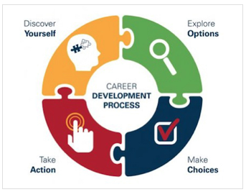
Fig 5: Personal development process model

SELF-AWARENESS

According to Mannarini (2009), the term awareness is definite as “a condition of being conscious of something.” It monitors that the appearance self-awareness implies the state of being cognisant of oneself.
There are numerous self-awareness tools that you can apply to yourself to accomplish a more significant level of information.
Below you will find a few of these methods and learning theories that I have learnt in this module.

THE JOHARI WINDOW

The Johari window was produced by Joseph Luft and Harry Ingham. The Johari window is a helpful heuristic for understanding and creating parts of relational correspondence. According to Cipriani (2004) portrays it as “a disclosure/feedback model of self-awareness, an information processing tool.” Meanwhile Luft's unique item on the Window was distributed in 1961, it has been deciphered in numerous ways and adjusted to different employments.
The Johari Window is a quadrant, portrayed by Luft as “A illustrative standard of awareness in social interactions” (Luft, 1961). It centres around information about an individual (or gathering of individuals) with two aspects: self and other, and two qualities: known and not known. This outcomes in four unique quadrants inside the bigger quadrant, as can been seen underneath. Every quadrant has a name mirroring the aspects and qualities (Lowes, 2020).

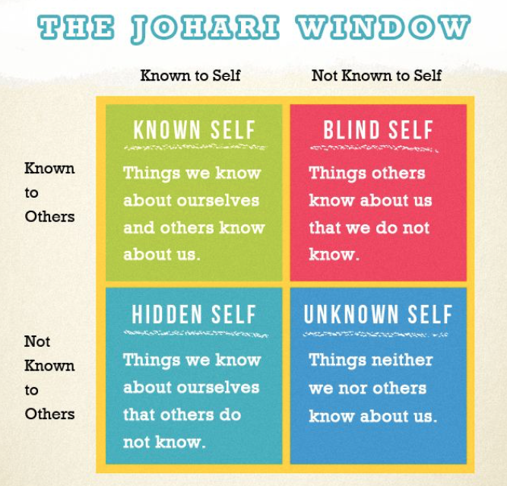
Fig 1: The Johari Window

LEARNING STYLES

Learning styles allude to a capacity of challenging and tested speculations that plan to characterise differences in individuals’ learning. The abundant theories stake the suggestion that individuals can be settled by their 'way' of learning yet contrast in how the planned types must be categorised, ordered, and surveyed. A usual impression is that individuals vary by the technique they learn.

KOLB’S style: Kolb developed a theory of experiential learning. His hypotheses concerning favoured learning styles, the need to finish four learning stages in succession (substantial experience, intelligent perception, theoretical conceptualization, and dynamic experimentation), and mixes of favoured learning styles in quadrants.

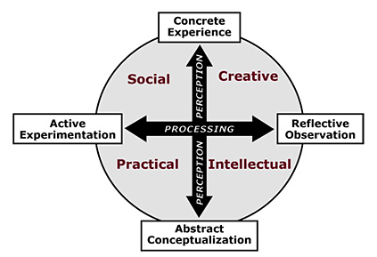

Fig 2: Learning Styles defined by Kolb's Experiential Learning Theory

As restaurant manager, both myself and my team we’re learning everyday through the Kolb’s model. Every day we try dishes and wines for us to learn more about what we’re selling. Then we discuss about the item we have tried. I also provide the team the specs for the dish and the wine’s characteristics. Apart from this, we also have our sommelier and our head chef which explain us deeper about the products and resolve any doubts we can have.

HONEY & MUMFORD’S style: Kolb's (1984) experiential learning hypothesis and his model of learning styles are the establishments for the learning styles model created by Honey and Mumford (1992). The Honey and Munford Model - Learning Styles Questionnaire - LSQ - sets up taking in styles from the techniques utilized by students to catch and change data. They are Activist, Reflector, Theorist and Pragmatic (Dantas and Cunha, 2020).

- Activist students learn best in circumstances of substantial activity, where experimentation, learning by committing errors and being right is leaned toward.
- Reflectors share a way of discovering that lean towards a blend of perception and thinking to learn. They think about numerous conceivable outcomes and suggestions in a demonstration prior to taking a choice.
- Theorists are more alright with gaining from logical models and speculations. These students need to comprehend the rationale behind the activities.
- Pragmatics students apply to rehearse scientific information to make new things and take care of issues.

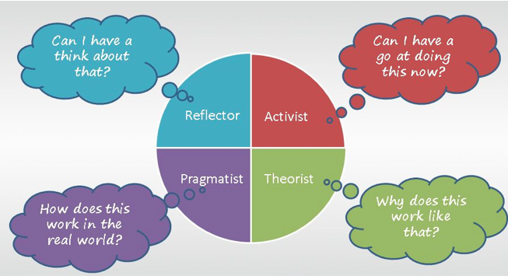

Fig 3: Honey & Mumford’s learning style

NEIL FLEMING’S style: Fleming's VARK model (now and then VAK - an abbreviation for the Visual (V), Auditory (A), and the Kinaesthetic (K) tactile modes) which gives the students a shape of their learning types, in view of the tangible modes which are engaged with learning. This model developed before Neuro-linguistic programming (NLP) models. In NLP the faculties are parted into three gatherings (Visual, Auditory and Kinesthetic) which are alluded to as Representational Systems (rep frameworks). This term identifies with the reality the mind utilizes the faculties to fabricate our inside portrayal, or model of our general surroundings (Sreenidhi and Tay, 2017).
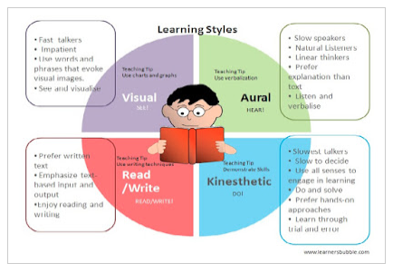

Fig 4: Neil Fleming’s learning style

UK EMPLOYMENT LAW

The employment law is a legislation to regulate the relationship between the employers and employees. In the UK, hospitality industry has consistently been short waged, generally viewed as short gifted and short position, and without any custom of unionization and aggregate trading (Ioannou and Dukes, 2021). So, it has for quite some time been viewed as an area where businesses partake in a wide privilege to decide agreements singularly and where staffs are more defenceless and needing the law's insurance.

EMPLOYMENT RIGHTS

In the employment rights you can find different factors, nine to be exact. I will briefly explain about them.

- Recruitment: The Equality Act 2010 makes it unlawful for employers to victimize work candidates and existing ones due to a 'locked feature,' such as age, disability, race, or sexual orientation among others.
- Employment contract: rights given to employees by the ERA (Employment Rights Act 1996) include: dismissal (notice and reason), redundancy payments, unfair dismissal and disclosures and detriment are the most important.
- Data protection: it’s about keeping safe value information and making sure it’s using securely and legally
- Pay and Holiday entitlement: a full-time employee is entitling to 28 days per year. The rules extend to employees covered by the Working Time Regulations 1998.
- Working Time: the limit of the working hours per week is 48 hours, regulated by the Working Time Regulations 1998.
- Health and Safety at work: employees must meet the health and safety requirements to guarantee a harmless operative atmosphere by the Health and Safety at Work act 1974 (HSWA).
- Discrimination: legislated by the Equality Act 2010. Also, there is a code of practice on employment and other non-statutory regulation from the Equality and Human rights Commission.
- Discipline and grievance: Companies and employees must do everything they can to determine disciplinary and complaint issues themselves and in case major should utilize an outsider.
- Dismissals and redundancies: No acting is committed to inappropriate excusal. It is a part of the law of agreement got based on what is known as the ‘common law.'

CONCLUSION

From this report I have discovered that I should be more wide-awake and investigate details of any angles even more obviously. By perceiving my deficiencies and how to conquer the interviews as it permits me to know myself better. Instructions to move toward myself in a future interview and figure out how to sell my image on a CV was extremely engaging as I was stressed over it would have been a particularly fundamental CV. The mock interview permitted me to escape my usual range of comfortability and become whoever I needed to demonstration my best capacities. Getting a new line of work was similarly enjoyable as finding something that spoke to myself and where I thought my characteristics were most appropriate.

APPENDIX

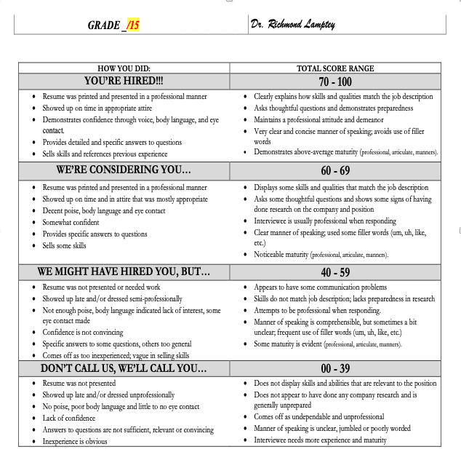

REFERENCES

Alam, M. and Singh, P. (2019). ‘Performance feedback interviews as affective events: An exploration of the impact of emotion regulation of negative performance feedback on supervisor–employee dyads’. Human Resource Management Review’. Vol 31, Issue 2. Available at: https://doi.org/10.1016/j.hrmr.2019.100740 [Accessed: 30 Nov 2021]

Bartz, D. E., and Bartz, D. T. (2017). ‘Humility, Patience, Passion, and Mindset: Attributes of the Effective Manager’. International Journal of Business and Social Science. Vol. 8, Number 11. Available at: http://ijbssnet.com/journals/Vol_8_No_11_November_2017/6.pdf [Accessed: 20 Nov 2021]

Beausaert, S., Segers, M. And Gijselaers, W. (2011) ‘The use of a personal development plan and the undertaking of learning activities, expertise-growth, flexibility and performance: the role of supporting assessment conditions’, Human Resource Development International. Vol. 14, Issue 5, pp. 527-543. Available at: https://doi.org/10.1080/13678868.2011.620782 [Accessed: 20 Nov 2021]

Beenen, G., Pichler, S., Livingston, B. and Riggio, R. (2021). ‘The Good Manager: Development and Validation of the Managerial Interpersonal Skills Scale’. Frontiers in Psychology. Available at: https://doi.org/10.3389/fpsyg.2021.631390 [Accessed: 20 Nov 2021]

Cipriani, J. (2004). ‘Johari Window’. Adapted by Julia Cipriani with permission from the author, Alan Chapman. Available online at: http://www.richerexperiences.com/wp-content/uploads/2014/02/Johari-Window.pdf [Accessed: 23 Nov 2021]

Dantas, A. L. and Cunha, A. (2020) ‘An integrative debate on learning styles and the learning process’. Social Sciences & Humanities Open. Vol 2, Issue 1. Available at: https://doi.org/10.1016/j.ssaho.2020.100017 [Accessed: 23 Nov 2021]

Hung, Kam (2013) ‘Understanding China's Hotel Industry: A SWOT Analysis’, Journal of Chinese Tourism Research. Vol. 9 Issue 1, pp. 81-93. Available at: https://web-p-ebscohost-com.ezproxy.uwtsd.ac.uk/ehost/detail/detail?vid=0&sid=786d8e54-683e-48cd-8a89-1e67ccd96cb0%40redis&bdata=JnNpdGU9ZWhvc3QtbGl2ZQ%3d%3d#AN=85765446&db=hjh [Accessed: 19 Nov 2021]
Ioannou, G. and Dukes, R. (2021). ‘Anything goes? Exploring the limits of employment law in UK hospitality and catering’. Industrial Relations Journal. Vol 52, Issue 3, pp. 255-269. Available at: https://doi.org/10.1111/irj.12329 [Accessed: 30 Nov 2021]

Lowes, R. (2020) ‘Knowing You: Personal Tutoring, Learning Analytics and the Johari Window’. Frontiers in Education. Available at: https://doi.org/10.3389/feduc.2020.00101 [Accessed: 23 Nov 2021]

Luft, J. (1961). The Johari Window: A graphic model of awareness in interpersonal relations.’ Hum. Relat. Train. News. 5, 6–7. Available at: http://www.convivendo.net/wp-content/uploads/2009/05/johari-window-articolo-originale.pdf [Accessed: 22 Nov 2021]

Mannarini, S. (2009). ‘A method for the definition of a self-awareness behaviour dimension with clinical subjects: A latent trait analysis’. Behaviour Research Methods. 41 (4), 1029-1037. Available at: https://doi:10.3758/BRM.41.4.1029 [Accessed: 30Nov 2021]

Soeg Jobs (2021) ‘Historical background of the hospitality industry – a fascinating journey’. Available at: https://www.soegjobs.com/hospitality-industry-historical-background/#:~:text=History%20of%20Hospitality%20industry%20also%20shows%20us%20some,or%201960s%20when%20a%20proper%20structure%20was%20formed [Accessed: 20 Nov 2021]

Sreenidhi, S. K. and Tay, C. H. (2017) ‘Styles of Learning Based on the Research of Fernald, Keller, Orton, Gillingham, Stillman, Montessori and Neil D Fleming’. International Journal For Innovative Research In Multidisciplinary Field. Vol 3, Issue 4, p 18. Available at: https://www.researchgate.net/profile/Sree-Nidhi-S-K/publication/317305325_Styles_of_Learning_VAK/links/59314ae0a6fdcc89e7937e2f/Styles-of-Learning-VAK.pdf [Accessed: 23 Nov 2021]

TempTribe (2019) ‘9 transferable skills you gain from working in hospitality’. Available at: https://www.cv-library.co.uk/career-advice/start/transferable-skills-working-in-hospitality/ [Accessed: 21 Nov 2021]

