International Entrepreneurship

A Report About International Entrepreneurship And Government Polices Involvements
MODULE NAME: International Entrepreneurship
Project Name: International Entrepreneurship part one
Student Name: Gao shipeng
Student Number: 1703277



Table of Contents
A Report About International Entrepreneurship And Government Polices Involvements 1
Executive Summary 3
1.0 Background 3
1.1 Definitions of Entrepreneurship 3
1.2 Significance of Entrepreneurship 4
1.3 Entrepreneurship and International Entrepreneurship 4
1.4 Qualifications for Being Entrepreneurs 4
2.0 Main Body 5
2.1 PEST Influences on International Entrepreneurial Activities 5
2.1.1 Political Factor 5
2.1.2 Economic Factor 5
2.1.3 Social Factor 5
2.1.4 Technical Factor 6
2.2 The Nature of Entrepreneurship 6
2.2.1 Factor-Driven Economies 7
2.2.2 Efficiency-Driven Economies 7
2.2.3 Innovation-Driven Economies 7
2.3 An Analysis of Five Contrasting Regions of Entrepreneurial Activities and Government Roles 7
2.3.1 The Authority of GEM Resources 7
2.3.2 Botswana in Africa 7
2.3.3 Brazil in Latin America 8
2.3.4 Canada in North America 9
2.3.5 France in Europe 10
2.3.6 South Korea in Asia 11
3.0 Recommendations 12
4.0 Conclusions 13
5.0 References 13

Executive Summary
This report adopts the angel of international entrepreneurship, critically analyzes the factors that might influence the conduction of entrepreneurial activities. Entrepreneurship is becoming increasingly important for the economic development, which is considered as the soul to corporations and the noticeable progress of global communities. This report first defines what is entrepreneurship and its importance as well as implications in the current world. The the concept of international entrepreneurship is introduced, which is more frequently mentioned with the closer economic contacts of different nations. The challenges and opportunities of international entrepreneurship can be reflected by a wide range of factors, including political, economic ,social, legal, technical and legal ones. This report takes advantage of PEST framework to analyze some key international causes that play a role in the engagement of international entrepreneurship campaigns. Also, this report introduces the three stages for the evolution of entrepreneurship in a certain region, based on the differences of factor-driven economies, efficiency-driven economies and innovation-driven economies. This report critically analyzes the situation of government involvements in 5 contrasting regions in the global community, with the assistance of data on the GEM website concerning key profiles and documents. At the end of the report, on the basis of the 5 regions and targeted entrepreneurship theories, recommendations and conclusions are gained in order to offer instructive directions and measures for promoting the prevalence of international entrepreneurship.

1.0 Background

1.1 Definitions of Entrepreneurship
Entrepreneurship has many definitions either in narrow or broad senses, and one of the most popular definitions of it is the one put forward by Stevenson(2013), that entrepreneurship is the pursuit of opportunities without a regard to resources that are being restricted. Although the details in various definitions concerning entrepreneurship can be distinguished, the importance of seizing opportunities as soon as possible has never changed(Anderson,2015). And entrepreneurs who fully discover and recognize these opportunities are considered to be always believing the values of these chances, so they would contribute whatever they can to achieve their intentions, in a strongly determined way.

1.2 Significance of Entrepreneurship
Entrepreneurship is important not only in its economic values but also in many other dimensions of the social development(Katila,2012). To start with, the most conspicuous contribution of entrepreneurship activities is its promoting influences on driving societies to make economic progress, by means of more corporations, more job chances, more innovative products and so on. It is the fact that entrepreneurship has brought much convenience for the local inhabitants and significantly improved the economic status of the domestic country. Secondly, entrepreneurship has played a role in communicating the ideology, culture properties and other distinctions of a certain region to many other nations across boundaries(Belicove,2012). For instance, international enterprises that are specialized at entertainment industries, such as dramas and music, would be beneficial to improve the cultural influence of its parent country during the process of wide international trades.

1.3 Entrepreneurship and International Entrepreneurship
International entrepreneurship is the process by which business activities are conducted without the limitation of national boundaries(Audret,2002), and it is increasingly prevalent in a world which is highly economically globalized and connected. International entrepreneurship is an effective way to explore new markets with potentials, natural resources that are more sustainable and cheap, human resources that are more efficient and less costly. International entrepreneurship is often mentioned with international enterprises, both of which put plenty of emphasis on innovations and ambitions. International entrepreneurship is considered as a way to improve the economic powers and international status of a certain region in the current world.

1.4 Qualifications for Being Entrepreneurs
Given the being extraordinary of entrepreneurs, there arouse many contradictions about the identifications of being entrepreneurs. There can be concluded three models for the identifications of entrepreneurs. In the first model, there are two kinds of human beings for entrepreneurs, which are entrepreneurs and non-entrepreneurs(Drucker,1993).This theory believes that the traits of entrepreneurs can not be developed despite of later efforts. In the second model, it is more positive, since everyone can be an entrepreneur if he wants and is willing to pay efforts and time(Shane,2003). In the third model, human beings can be divided in to instinctive entrepreneurs who occupy some potentials for entrepreneurs when they were born, and potential entrepreneurs who can be cultivated into entrepreneurs if they pay enough attention to the traits and techniques of being entrepreneurs.

2.0 Main Body

2.1 PEST Influences on International Entrepreneurial Activities
Due to the increasing sophistication of international entrepreneurship, which has spread its influence worldwide. It is not hard find out that apart from economic factors, there are many other causes that might pose a severe influence on the development of international entrepreneurial activities, and several most noticeable factors are politics, economy, social norms and technical advancements.

2.1.1 Political Factor
Political factors are one of the most far reaching influences that make a big difference for the operation of international enterprises as well as domestic entrepreneurial activities. To start with, the stability of political parties in a certain country is more than critical for the steady entry of international commercial corporations. And most macro economic polices are closely related to the political atmosphere of a certain country, since on some tense occasions, it is very likely that economic interests can be subordinates and tools for political status(Hisrich,2011). Political factor can play an important role in the operation and transfer of international entrepreneurial activities.

2.1.2 Economic Factor
The economic factors that influence the performance of entrepreneurial activities mainly come from the adjustments to a different economic system for international enterprises. To start with, international commercial corporations have to get used to a different currency system, in terms of both currency values and the fluctuations of exchange rates internationally. Secondly, the development of banking systems in different regions can express variously distinguished features, which might pose chances or difficulties for the international corporations to explore their financing channels. Thirdly, the tendency of macro economic policies in different regions can express different features, such as conventional or liberal, thus adding uncertainties for the successful operation of international enterprises in a new market.

2.1.3 Social Factor
Social norms and attitudes have been playing an important role in the operating process of international enterprises and domestic entrepreneurial activities(Catherine,2016), such as the perception of citizens towards the values of international entrepreneurial activities and their willing to get engaged in these commercial activities. Among the social factors, gender issues and ethical problems are two of the most sensitive ones.

2.1.3.1 Gender Issues
Gender inequality has always been considered as the barrier in the work place, and it is a noticeable problem as well in the employer-employee relationship of international enterprises. The extent of gender discrimination in different countries can vary(Scott,2000), for instance, India is a country where this problem can be deeply rooted. And on this occasion, there might be barriers which intervene the hiring and other human resources cultivation of international enterprises in a different places.

2.1.3.2 Ethical Problems
Despite of the great economic values brought by the extraordinary performance of international corporations, the ethical problems contributed by them can be complex as well. For instance, it is worth noting that some international enterprises which are from developed countries have posed dangers for the environment in some developing regions, by means of pollution and waste(Brush,2003). Also, there has been voice that international corporations take advantage of and even squeeze the cheaper labor force in host countries in order to double or triple their interests. These negative consequences generated during the development of international corporations have become powerful powers against from their moving forward.

2.1.4 Technical Factor
Technical advancement is also an important role in the operation of international enterprises in another region, particularly when it comes to the comparison between poor developing regions and highly developed countries(Black,2010). It is the fact that developed economies can occupy more advanced technology, equipment and managing talents, which determines their fundamental advantages in processing innovations. However, some developing regions can be very disadvantaged for technology, and if international enterprises choose to operate in these regions,they have invest much on introducing new technology and human resources as well.

2.2 The Nature of Entrepreneurship
There are three stages for entrepreneurship in a certain region, respectively factor-driven economies, efficiency-driven economies and innovation-driven economies. The higher stage, the more advanced of the development of entrepreneurship.

2.2.1 Factor-Driven Economies
Factor-driven economy is the first stage of entrepreneurship, where growth is achieved on a basis of unskilled labor force and a load of natural resources(Navila,2013). Usually the important indicators for this economy are health-care system, various infrastructure and so on.

2.2.2 Efficiency-Driven Economies
Efficiency-driven economies are the second stage for the evolution of entrepreneurship, which put emphasis on the efficiency of producing commodities as well as the qualities of products(Carlen,2016). And the important indicators in this economy are labor market efficiency, market size and so on.

2.2.3 Innovation-Driven Economies
Innovation-driven economy is the most advanced format for entrepreneurship for now, and usually developed countries belong to this type. The important indicators in this economy is the sophistication of commercial activities and an emphasis on creative developments.

2.3 An Analysis of Five Contrasting Regions of Entrepreneurial Activities and Government Roles

2.3.1 The Authority of GEM Resources
GEM framework is one of the most authoritative resources that provide information about the social attitudes and government commitment in the operating process of international entrepreneurial campaigns and other domestic entrepreneurial activities(GEM,2018). GEM includes 100+ economies in the global communities, and it provides data that is gained from interviews, surveys and other research channels. This part is going to take advantage of the information from the GEM website, in order to critically evaluate the information concerning social attitudes and government polices for entrepreneurial activities.

2.3.2 Botswana in Africa
Economic Evaluation

Botswana is located in Africa, which is a factor-driven economy. The population of Botswana is 2.1 million, with total GDP 12.9 million. The figure below shows the social attitudes and government polices concerning their treatment of international entrepreneurship activities from the GEM website.

Figure 1 1: Highly Insufficient 5: Highly Sufficient
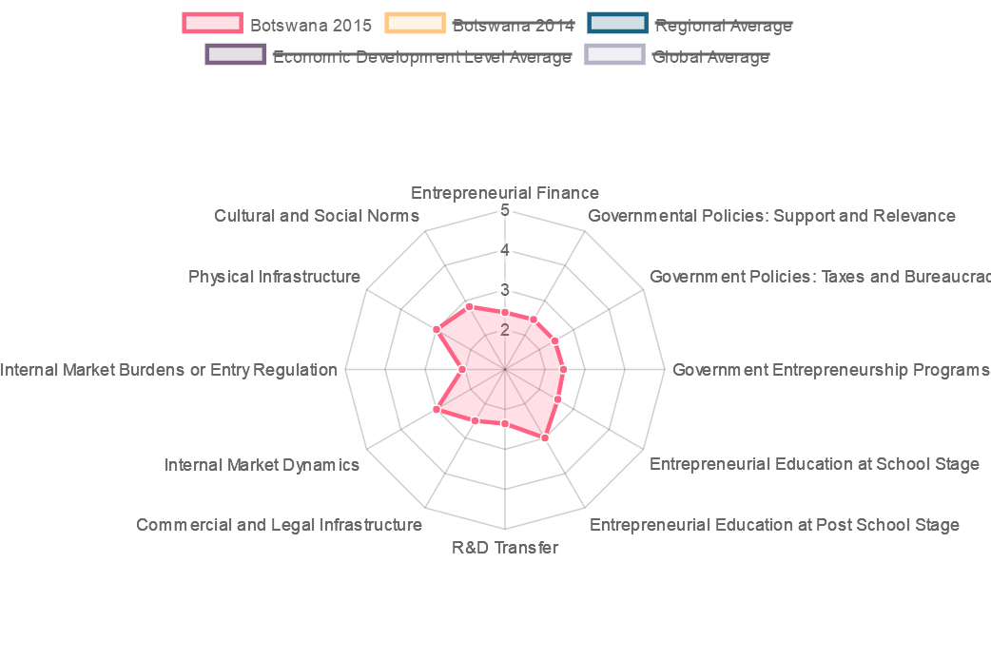
Source: http://www.gemconsortium.org/country-profile/44
Political Evaluation
As interpreted in the figure above, it can be found out that Botswana provides a dynamic internal market for the operation of international corporations. And the physical infrastructure provided by Botswana is relatively good compared to other indicators. Despite of these advantages, there stand out several shortcomings of Botswana concerning an insufficient support for international enterprises. To start with, the government policies in Botswana do not generate enough support for the blossom of international entrepreneurial activities. And this can be reflected by burdens from taxes and bureaucracy issues, as well as an insufficient amount of entrepreneurship programs. Secondly, Botswana does a poor job in the indicator of internal market burdens or entry regulation, which indicates that the standards and conditions for the entry of international business might be too hard. Also,Botswana is still adviced to introduce more entrepreneurship programs in order to help cultivate and make prevalent about the spirits of international entrepreneurship. What is more, the government of Botswana is highly suggested to widen and strengthen its educations about introducing the benefits and techniques of entrepreneurship activities as well as campaigns.

2.3.3 Brazil in Latin America
Economic Evaluation

Brazil is a country that is located in Latin America, which belongs to one of the efficiency-driven economies. The population of Brazil is 204.5 million, with the GDP per capital $8,670. The figure below interprets the social norms and government polices of Brazil concerning its treatment and attitudes for international entrepreneurship activities.

Figure 2
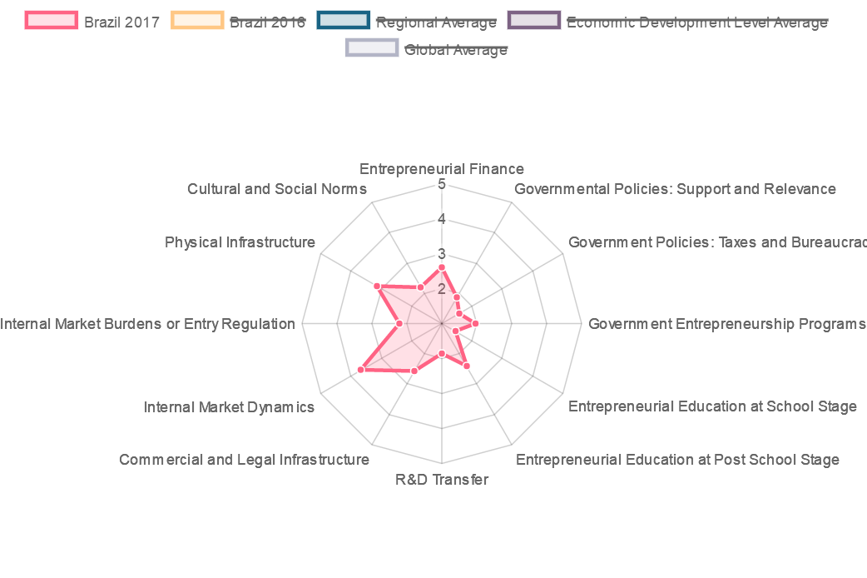
Source: http://www.gemconsortium.org/country-profile/46

Political Evaluation
As interpreted in the figure above, it can be seen that Brazil is good at providing a dynamic internal market for the operation of international enterprises. And compared to other indicators, Brazil does a good job in providing infrastructure, in terms of physical, commercial and legal perspectives. However, Brazil is still very insufficient in other indicators. For instance, Brazil does not enjoy a strong financing channel for the financing activities of international corporations, which would negatively decline the activeness as well as the confidence of newly arriving international corporations. Also, the taxes and some bureaucracy issues have posed difficulties and threats for the development of international entrepreneurship, which would be negative for their financial performances. And there are not sufficient amount of entrepreneurship programs that can help encourage the prevalence of international entrepreneurial activities. Moreover, Brazil does a poor job in providing effective entrepreneurial education at school age as well.

2.3.4 Canada in North America
Economic Evaluation
Canada is located in North America, and its economy is innovation driven, which is the most advanced stage of entrepreneurship as mentioned. The population of Canada is 35.8 million, and its total GDP is &1552.4 billion according to the most recent data in the year of 2017. The GDP per capital of Canada is $43,332. The figure below shows the entrepreneurial behaviors and attitudes of Canada according to the findings on GEM website.
Figure 3
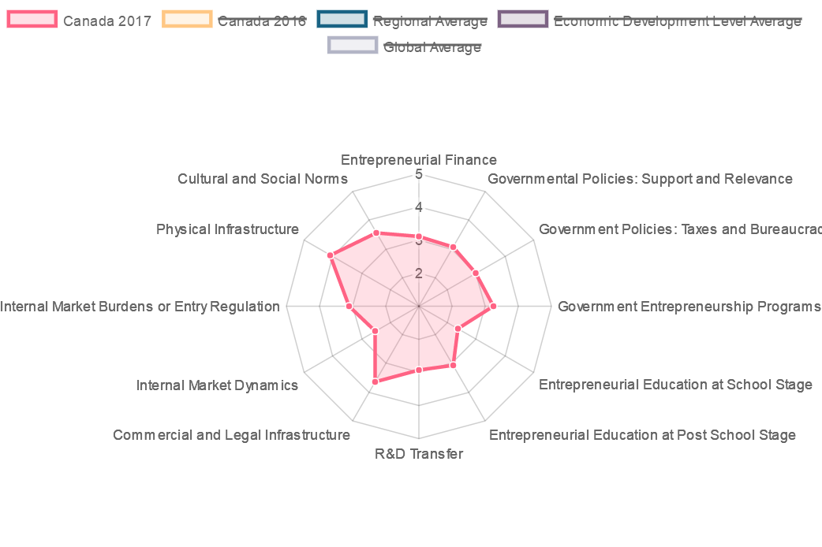

Source: http://www.gemconsortium.org/country-profile/49

Political Evaluation
As interpreted by the figure above, it is not hard to find that Canada does a great job in providing a sound infrastructure system, physically, commercially and legally, which lays a solid foundation for the birth and blossom of international entrepreneurial activities. What is more, it can be worth noting that the cultural and social norms of Canada deeply confirm the values of international entrepreneurship, which provides a harmonious and suitable social atmosphere for the development of international entrepreneurship activities. And Canada provides a strong financing channel for the development of entrepreneurship, which is very conducive to encourage their activeness and confidence as well. It can also be noticed that there are sufficient amount of entrepreneurial programs in Canada as well, which helps to cultivate and enhance the awareness towards the importance of entrepreneurship activities.However, compared to these star factors, Canada still has to spend efforts on proving a potent and dynamic internal market regime.

2.3.5 France in Europe
Economic Evaluation
France is a developed country that is locate in the continent of Europe, and it belongs to an economy that is innovation-driven. The population of France is 64.3 million, and its total GDP is $2421.6 billion with its GDP per capital $37,675. The figure below shows the social attitudes and government policies about their treatment towards the entrepreneurship behaviors both internationally and domestically.
Figure 4
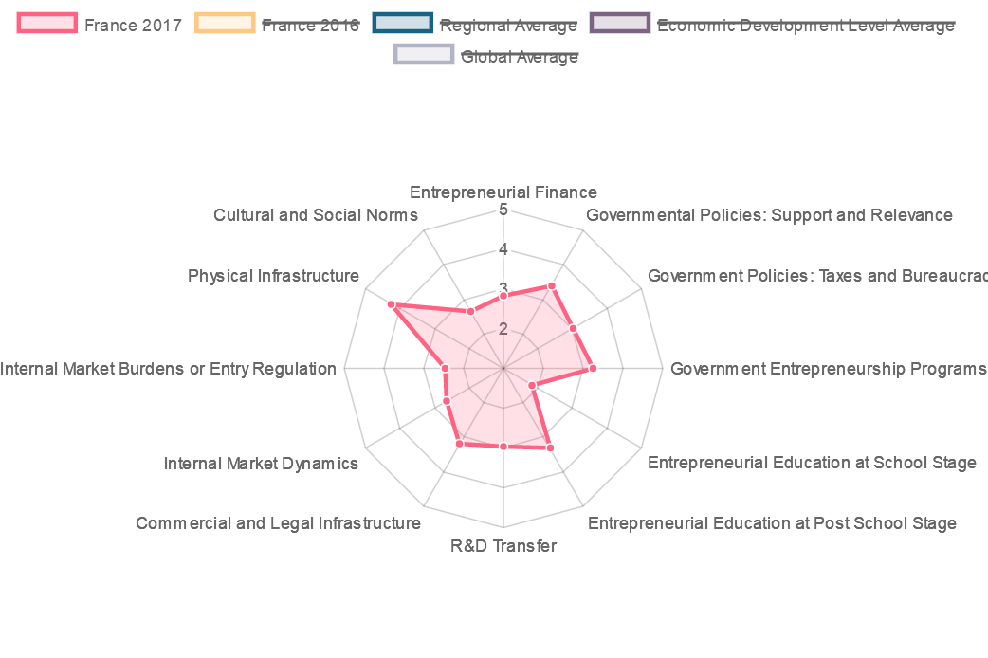
Source: http://www.gemconsortium.org/country-profile/62
Political Evaluation
From the figure above, it is not hard to find out the fact that France has done a great job in providing a sound physical structure, but it does not same well in providing commercial and legal infrastructure. Besides, according to the data in the last year of 2017, France is not efficient enough in terms of internal market burdens or entry regulation, which might make a negative influence on the activeness of international enterprises. Compared to other countries such as Botswana and Canada as mentioned above, it can be found out that France does a better job in setting up government policies that are supportive for the blossom of international entrepreneurial campaigns as well as domestic entrepreneurship activities. For instance, France provides a good market and economic atmosphere for the development of international enterprises, in terms of government entrepreneurship programs, taxes polices and bureaucracy activities. However, it is worth noting that France is suggested to improve its education about the importance and implications of entrepreneurial activities by investing more on relative educational programs. But the government does a relative good job in providing investments concerning the research and development perspectives.

2.3.6 South Korea in Asia
Economic Evaluation
South Korea is a country that is located in Asia, and it is an economy that is innovation driven. It is the fact that South Korea is one of the most developed economies in the region of Asia,and its role is increasingly important in a world which is highly economically globalized. The population of South Korea is 50.6 million, and its total GDP is $1376.9 million, with its GDP per capital $27,195.The figure below interprets the government involvement and social attitudes towards the birth and prevalence of entrepreneurial activities in South Korea.

Figure 5
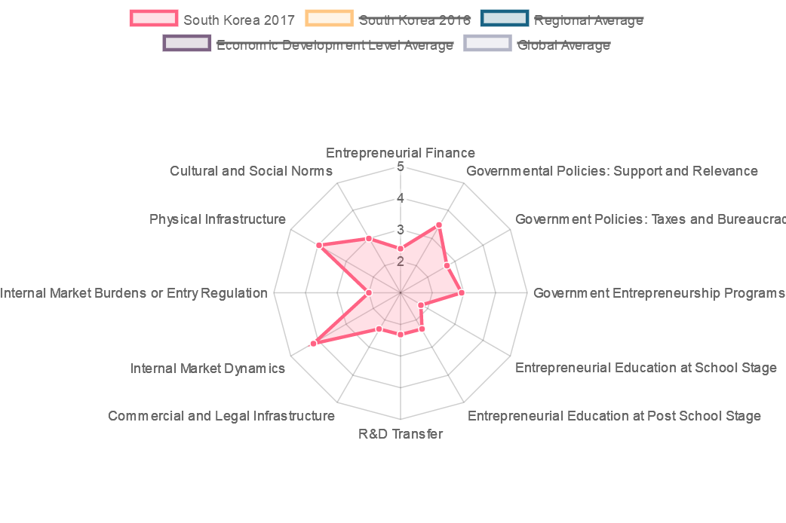
Source: http://www.gemconsortium.org/country-profile/125
Political Evaluation
As interpreted in this figure, it is not hard to find out the fact that South Korea has done a great job in providing an dynamic and beneficial internal market, which is conducive for the development and blossom of international corporations. Moreover, South Korea provides excellent physical infrastructure for the development of international commercial corporations. But it can also be worth noting that South Korea does not do an equally good job in providing international corporations commercial and legal infrastructure. Moreover, the government of South Korea is suggested to improve a entrepreneurship education both at school and post school stage. It is reflected from this figure that South Korea has done relatively good job in terms of government support and relevance, taxes and bureaucracies, as well as entrepreneurship programs. What is more, it is not hard to find out that South Korea still needs improvement in terms of Research and Development Transfer, which indicates that the government is adviced to invest more on business researches in order to promote innovative development.

3.0 Recommendations
This report takes advantage the angel of international entrepreneurship, critically analyzes the distinctions, significance and implications of international entrepreneurship in the currently world where different nations are closely connected in terms of economic communications. From the analysis about the government polices and social attitudes for the development of international entrepreneurship campaigns in 5 contrasting regions in the global communities, there come up several recommendations for the quick blossom of international entrepreneurship development. To start with, it is not hard to find out that all innovation-driven economies are usually developed regions,which keep making continuous progress in providing sound and potent infrastructure systems. Also, they pay much attention to improving the efficiency of internal markets as well as the entry standards and regulation for international commercial corporations. What is more, it is important to provide international commercial corporations with sound financing channels, in order to save the troubles of them. As for government polices, it is critical for them to pay attention to release the taxes burdens for international business corporations, as well as a transparent and fair political structure for the business operation. Moreover, it is conducive for the development and prevalence of international commercial corporations if relative educations are encouraged and required by the governments.

4.0 Conclusions
This report stands on the perspective of international entrepreneurship, combined with the opportunities and challenges about the development of international entrepreneurship activities, critically analyzes the factors that might influence the development of international commercial business, respectively political, economic, social, technical perspectives. Given the increasing complexity of international business, the government encouragement has been playing an important role in the promotion of international entrepreneurship. After the analysis about 5 contrasting regions in different continents with different developing levels, it is not hard to find out the fact that a sound infrastructure system, a convenient financing channel, a conducive and flexible tax regime, as well as a fair and stable political environment is more than critical to spread the spirits of international entrepreneurship.

5.0 References
Anderson,C.(2015). What is Entrepreneurship. Journal of Innovation Development.

GEM Website Resources, (2018). Accessed on
http://www.gemconsortium.org/country-profile/125

Katila,M.(2012). How Entrepreneurship Perform. Journal of Strategic Entrepreneurship.

Stevenson,C.(2013). What is Entrepreneurship. Harvard Business Review.

GEM Website Resources, (2018). Accessed on
http://www.gemconsortium.org/country-profile/62

Belicove,E.(2012). How to Conduct your Business. Journal of Business Ethics.

GEM Website Resources, (2018). Accessed on
http://www.gemconsortium.org/country-profile/49

Audret,C.(2002). The Science of Business And Technology. Journal of Business Ethics.

Drucker,P.(1993). Innovation and Entrepreneurship: Principles and Practices. New York: HarperPress.

GEM Website Resources, (2018). Accessed on
http://www.gemconsortium.org/country-profile/46

Shane,C.(2003).A General Theory of International Entrepreneurship. Northamton Press.

GEM Website Resources, (2018). Accessed on
http://www.gemconsortium.org/country-profile/44

Hisrich,Robert.(2011). The Implications of Entrepreneurship. Journal of Innovative Development.

GEM Website Resources, (2018). Accessed on
http://www.gemconsortium.org/about/news

Catherine,C.(2016). Why everyone has to be an entrepreneur? Journal of Entrepreneurship.

GEM Website Resources, (2018). Accessed on
http://www.gemconsortium.org/report

Brush,C.(2000). The Education of Entrepreneurship. Journal of Innovative Management.

Black,L.(2010). The Difference for Entrepreneurs and Capitalists. Journal of Innovative Entrepreneurship and Innovation.

Scott,S.(2000). The Venture of Entrepreneurs. Journal of Academy Review.

William, S. (2000). The Evolution of Entrepreneurship. Journal of Innovative Development and Technology Advancements.

GEM Website Resources, (2018). Accessed on
http://www.gemconsortium.org/data

