

Student name: Rebeca Daniela Serban
Student ID: 2331907
Module name: Changemakers: Building your Personal Brand for Sustainable Employment
Module code: BMHP5015
Lecturer name: Caroline Salami

Contents
Introduction 2
A) Analysis of Personal Employability Skills Required 4
Example in Practice 6
B) Evaluation of My Own Skills 6
Strengths 6
Areas for Development 7
Feedback from Others 7
Reflective Example (Gibbs Cycle) 7
Qualifications and Experience 7
C) Building a Personal Brand and Professional Identity 8
Personal Values 8
Promoting My Professional Identity 8
I intend to further my career identity by: 8
Participation in professional networks such as: 8
Unique Selling Point (USP), My USP is the combination of: 8
Relevant Theory 8
Action Plan and Timeline 9
Conclusion 11
References 11

Component 2 Report: Employability, Personal Development and Career Planning
Teaching Assistant (SEN) – Health and Social Care Education Sector

Introduction

The role of a Teaching Assistant (Special Educational requirements, or SEN) in the UK education, health, and social care sectors is examined in this research. This role is vital in helping children and young adults with a variety of requirements, many of which are complex. I picked this position because it reflects the abilities and experiences I have previously gained from working as a teaching assistant and because it closely reflects my personal values of compassion, inclusivity, and empowerment (Bradwell, M. et al. 2024) My education in health and social care has improved my knowledge of person-centred practice, communication, and safeguarding—all of which are crucial in SEN settings.
I am especially drawn to this position because it provides a significant chance to assist students who are at risk, encourage self-sufficiency, and support their academic and emotional growth. Because it fosters transferable abilities like teamwork, resilience, reflective practice, and professional communication, it also offers a solid basis for my long-term goal of advancing into leadership within the health and social care sectors (Webster, R. et al. 2013)
The examination of the job description and person specification was guided by a recent job opening from Indeed and LinkedIn.

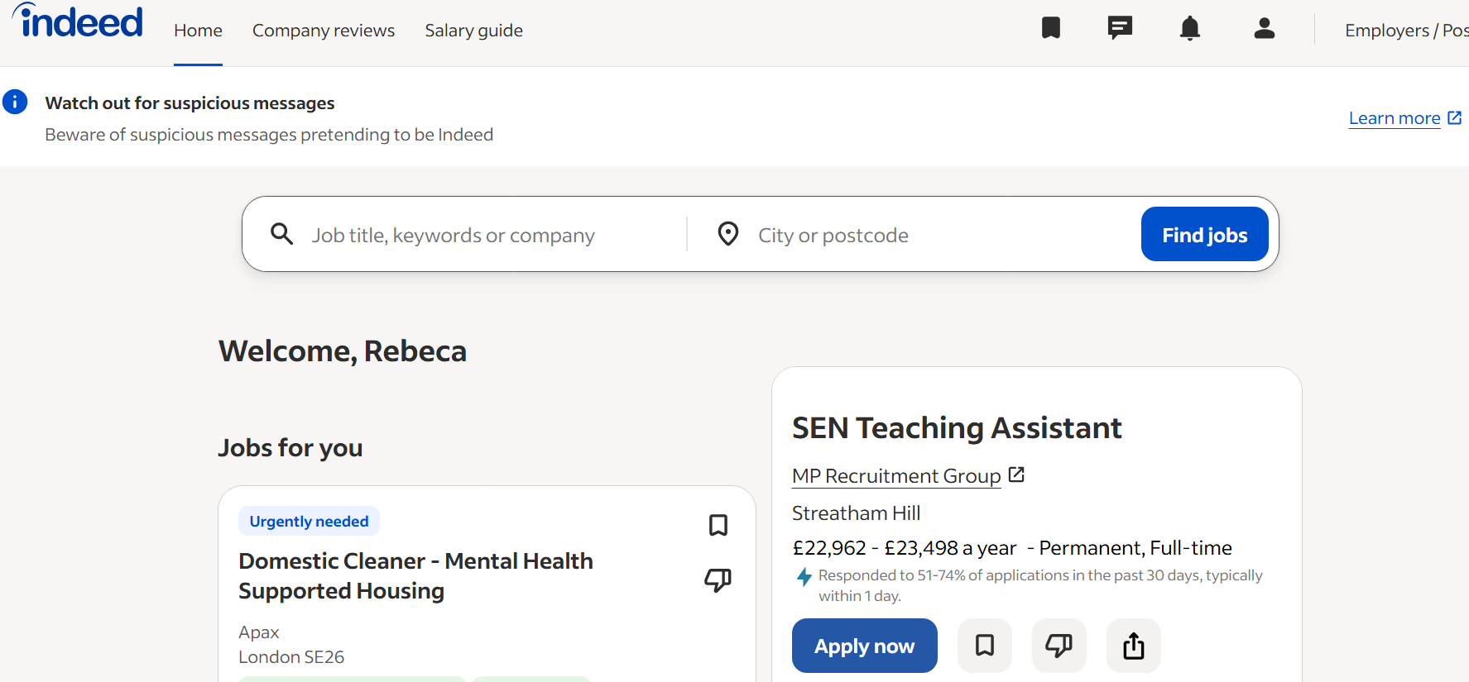
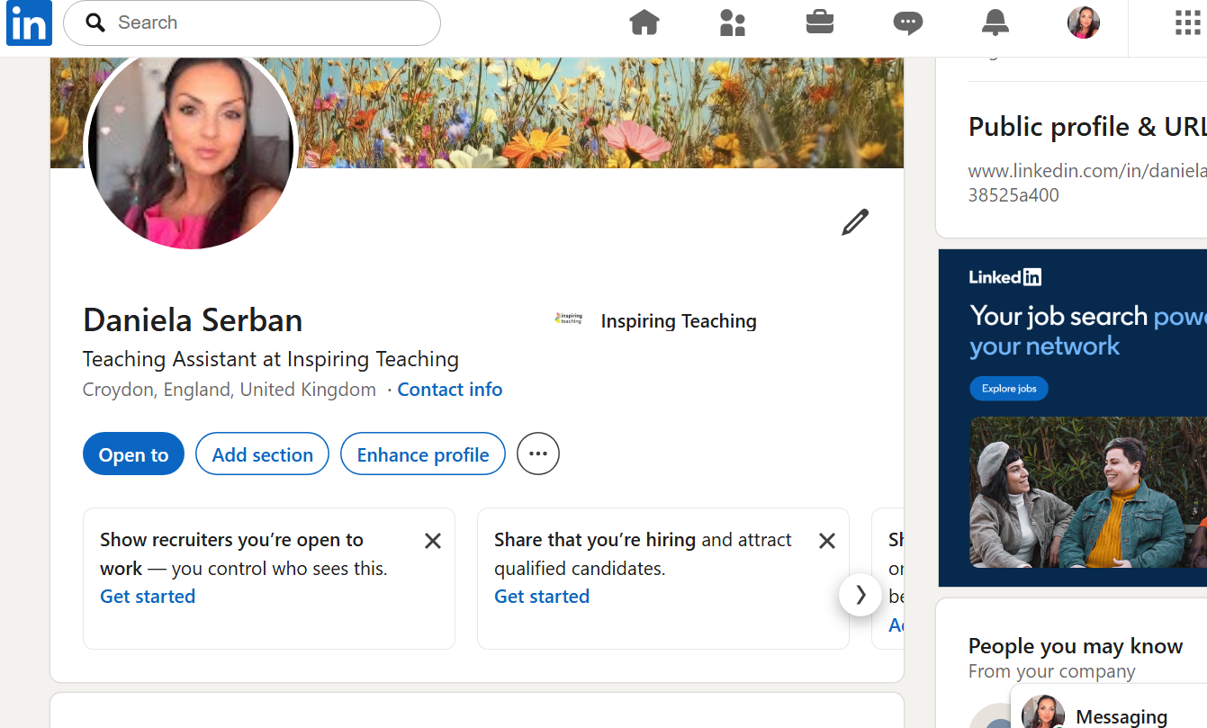
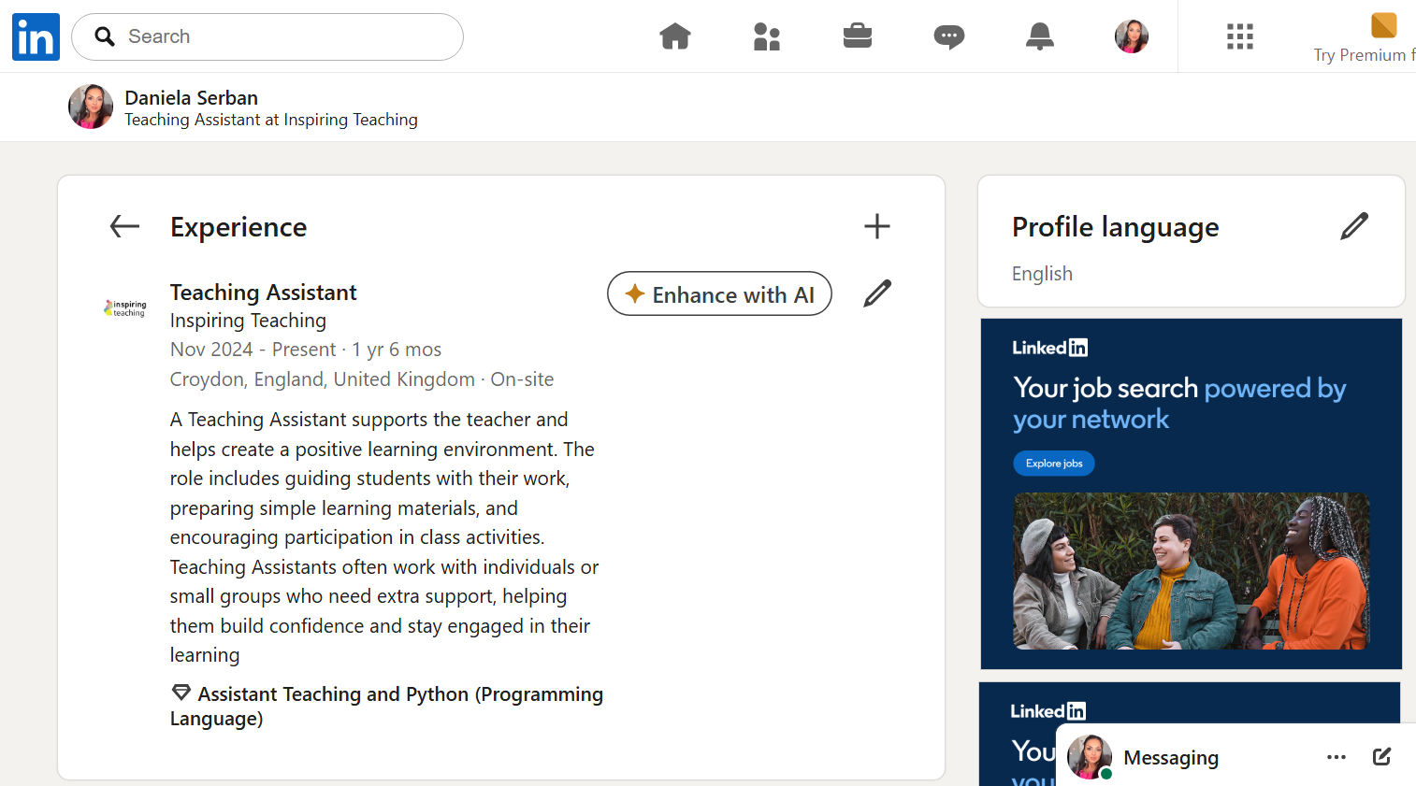
This report will investigate the employability skills needed for the position, assess my own abilities and areas for improvement, examine my professional identity and personal brand, and provide a well-organised action plan to help me advance in my career.

A) Analysis of Personal Employability Skills Required
A combination of technical, behavioural, and interpersonal skills are needed for the Teaching Assistant (SEN) position. Supporting students with special needs, putting behavioural methods into practice, encouraging independence, and making sure safeguarding protocols are followed are all important duties, according to the job description (Indeed, 2025). These duties closely correspond with the NHS 6Cs (compassion, communication, competence, and courage) and the Skills for Care Core Skills Framework (Baillie, L. 2017)
-Communication Skills
A key component of the job is communication. Teaching assistants must effectively cooperate with teachers, SENCOs, and outside experts, communicate properly with students, and modify their language to suit various requirements. According to the Skills for Care Framework, communication is a fundamental skill, emphasising the value of empathy, clarity, and active listening. For instance, patience, visual cues, and simpler instructions could be needed to support a student with autism. Accurately documenting observations and safeguarding concerns are examples of writing abilities that are necessary for effective communication.
-Emotional Intelligence and Empathy
Emotional intelligence, or the capacity to identify emotions, react correctly, and establish trustworthy relationships, is necessary when working with sensitive learners. This is consistent with the 6Cs approach and the NHS value of compassion. Supporting students who struggle with anxiety, behavioural issues, or emotional dysregulation requires emotional intelligence. Even under difficult circumstances, a teaching assistant must maintain composure, patience, and support (Chadwick, D. 2017)
-Teamwork and Collaboration
Teachers, SENCOs, pastoral teams, and outside organisations like social workers or speech-language pathologists collaborate closely with teaching assistants. Good teamwork abilities guarantee that students receive consistent help and foster a supportive learning atmosphere. Collaboration is emphasised as a crucial employability skill in the Employability Skills Framework. Respecting others' duties and being aware of professional limits are also essential components of effective teamwork.
-Digital Literacy
Because of the usage of online learning platforms, digital safeguarding systems, and electronic record-keeping, digital competency is becoming more and more crucial. Teaching assistants need to be proficient with online behaviour tracking tools, Microsoft Teams, and CPOMS. Through supportive technology like visual learning aids or communication applications, digital literacy also promotes inclusive education.

-Safeguarding Knowledge
It is crucial to comprehend safeguarding laws, such as Keeping Children Safe in Education (KCSIE). Teaching assistants are required to identify abuse indicators, adhere to reporting guidelines, and uphold professional boundaries. In all educational and care environments, safeguarding is a moral and legal obligation. Confidentiality, professional behaviour, and adherence to safeguarding standards are emphasised in the job description (Clark, M.T. et al. 2023)
-Resilience and Adaptability
It can be emotionally taxing to support students with complicated needs. Teaching assistants can handle difficult conduct, adjust to shifting circumstances, and uphold professionalism when they possess resilience. The NHS 6Cs place a strong focus on bravery and dedication, which are both pertinent to this position. When reacting to unforeseen developments, like schedule modifications or behavioural issues, adaptability is also crucial (Watterson, L.2013)
-Use of Theory
• Teaching assistants acquire abilities through experience, reflection, conceptualisation, and experimentation, according to Kolb's Learning Cycle..
• The Employability abilities Framework emphasises the value of transferable abilities like teamwork, communication, and problem-solving.
• Examples of how Teaching Assistants use their talents in practice can be described using the STAR Model.

Example in Practice
It could be necessary for a teaching assistant to use emotional intelligence to defuse a tense situation. For instance, the TA may employ comfort, grounding strategies, and calm communication when a student is upset. This exhibits skill, empathy, and clear communication. It also embodies the values of Skills for Care and the NHS 6Cs (Chadwick, D. 2017)

B) Evaluation of My Own Skills
I performed a skills audit, a SWOT analysis, and considered comments from instructors and supervisors in order to assess my abilities.

Strengths
• Communication: I establish good relationships, modify my vocabulary, and speak effectively with students. My work as a teaching assistant has improved my capacity for task explanation, comprehension support, and effective nonverbal communication.
• Patience and empathy: My innate patience and empathy enable me to establish trust with students and promote their mental health.
• Teamwork: I work well with educators and support personnel, fostering a supportive learning atmosphere.
• Motivation and commitment: According to Maslow's Hierarchy, my desire for career advancement is a reflection of my requirements for self-actualization. I'm dedicated to lifelong learning and development.
• Reflective practice: I consider my experiences on a daily basis in order to enhance my work. I can determine what worked and what needs improvement through reflection.

Areas for Development
• Advanced SEN techniques include trauma-informed therapy, sensory control methods, and autism-specific therapies.
• CPOMS and online behaviour tracking are examples of digital safeguarding systems.
• Leadership abilities to advance into management positions in the future.
• Self-assurance in controlling actions, particularly under stressful circumstances.

Feedback from Others
My abilities in communication, empathy, and reflective practice have been emphasised by lecturers and supervisors. They have motivated me to learn more about SEN interventions and behaviour management. The significance of gaining confidence in facilitating small group activities and assisting students with complicated needs has also been highlighted in feedback.

Reflective Example (Gibbs Cycle)
One student grew overwhelmed during a class exercise and declined to take part. I helped them by giving them space and reassuring them. I was able to see the value of proactive tactics and the necessity of more training in emotional regulation techniques after giving the incident some thought. Gibbs' approach, which promotes assessment, analysis, and action planning, is consistent with this reflection. I understood that I could have stopped the escalation earlier by using sensory aids or visual cues.

Qualifications and Experience
• Level 4 and Level 5 Health and Social Care studies
• Experience as a Teaching Assistant
• Training in safeguarding, communication, and equality and diversity
• Experience supporting learners with additional needs
These experiences serve as a solid basis for the Teaching Assistant position and show my dedication to professional growth.

C) Building a Personal Brand and Professional Identity
My personal brand is focused on professionalism, empathy, and lifelong learning. These principles are consistent with the inclusive education philosophy and the NHS 6Cs.

Personal Values
• Respect
• Compassion
• Integrity
• Commitment to safeguarding
• Dedication to lifelong learning

Promoting My Professional Identity

I intend to further my career identity by:
• A strong, tailored CV
• A professional LinkedIn profile that showcases my skills, training, and background

Participation in professional networks such as:
• Skills for Care
• SEN support groups
• Local authority education networks
• CPD communities

Unique Selling Point (USP), My USP is the combination of:
• Teaching Assistant experience
• Health and Social Care knowledge
• Strong reflective practice
• Dedication to helping students who are at risk

Relevant Theory
• The Career EDGE Model emphasises the value of experience, introspection, and emotional intelligence.
• Social Capital Theory highlights the importance of professional exposure and networking.

Action Plan and Timeline
In order to advance into a Teaching Assistant (SEN) position and ultimately become a leader in the health and social care industry, creating a well-organised action plan is crucial. Using the SMART framework to make sure each goal is Specific, Measurable, Achievable, Realistic, and Time-bound, the plan below contains short-, medium-, and long-term objectives. Setting attainable goals boosts motivation and confidence, which is consistent with Bandura's theory of self-efficacy (Swann, C. et al. , 2021)
The chart also lists the necessary resources, probable obstacles, and solutions. This guarantees that the strategy is practical and in line with my academic obligations, long-term job goals, and personal circumstances.

Goal | Actions Required | Timeline | Resources Needed | Success Indicators
Complete Level 5 Health & Social Care | Participate in tutorials, finish homework, and attend all lectures. | 0–6 months | Study resources and assistance from the university | All assessments passed; Level 5 completed
Gain experience in SEN settings | Apply for volunteer or part-time positions at charity or educational institutions. | 0–12 months | DBS check, applications, references | Getting a job or a part-time position
Improve SEN knowledge (Autism, ADHD, Trauma‑informed practice) | Finish CPD courses (such as Behaviour Management and Autism Awareness). | 0–12 months | Online CPD platforms, funding | Certificates obtained; increased self-assurance
Learn how to protect yourself online. | Discover Teams, CPOMS, and online tools for measuring behaviour. | 6–18 months | Access to training and school orientation | Using digital systems with confidence
Develop your ability to manage behaviour. | Attend training, observe seasoned employees, and practise de-escalation skills. | 6–18 months | CPD courses and mentoring | Positive comments from managers
Create a powerful professional persona. | Join professional groups, update your CV, and create a LinkedIn profile. | 0–6 months | Laptop, internet access | Active LinkedIn profile; networking activity
Secure full‑time Teaching Assistant (SEN) role | Apply for vacancies, prepare for interviews, gather references | 12–24 months | Job search platforms, interview prep | Job offer received
Complete SEN qualification (Level 3/4) | Enrol in a recognised course and finish the tasks. | 1–3 years | Finances and study time | Qualification achieved
Develop leadership skills | Participate in leadership courses, look for mentorship, and assume responsibility | 2–4 years | CPD financing and mentorship | Proof of leadership responsibilities
Advance to the position of Senior TA or Learning Mentor | Apply both internally and outside; exhibit proficiency | 3–5 years | Strong recommendations and experience | Promotion attained

My professional goal is to become a Teaching Assistant (SEN) and advance into leadership in health and social care education, and this action plan offers a methodical means to do it. My short-term goals are to finish Level 5, obtain SEN experience, and expand my expertise via CPD classes. By taking these actions, I will be able to fulfil the role's fundamental requirements and gain confidence in my ability to assist students with special needs (Webster, R., et al. , 2013)
My medium-term goals are to finish a specialised SEN qualification and land a full-time teaching assistant job. My expertise will grow as a result, and I'll be ready for increasingly challenging tasks. With further CPD and coaching, I hope to advance into a Senior TA or Learning Mentor position in the long run. This methodical approach guarantees ongoing improvement and supports my goal of becoming a manager in the health and social care industry (Nash, C., et al. , 2017)

Conclusion
I've been able to think carefully about my career path and the abilities I've gained from both my academic studies and my work as a teaching assistant thanks to this report. I've been able to better grasp the technical and interpersonal skills needed for the Teaching Assistant (SEN) position by analysing how well these requirements match my own values of compassion, inclusivity, and dedication to helping vulnerable students. It has been very important to assess my strengths and areas for improvement because it has shown me how far I have already come and what particular abilities I need to improve in order to comfortably take on this role (McVittie, E. 2005)
I now have a better understanding of my long-term goal to advance into leadership in the health and social care sectors thanks to this approach. The action plan I created is more than simply a set of chores; it's a practical road map that represents my drive, my aspirations for development, and my conviction that learning never stops. It has made it easier for me to see how every action I do, such as finishing CPD, obtaining SEN experience, or developing my professional identity, advances my goal of being the practitioner and leader I want to be (McMurray, S., et al. , 2016)
All things considered, this task has given me more self-assurance, a stronger sense of purpose, and a clear path forward for my future growth.

References

- Baillie, L. (2017) “An exploration of the 6Cs as a set of values for nursing practice,” British journal of nursing (Mark Allen Publishing), 26(10), pp. 558–563. Available at: https://doi.org/10.12968/bjon.2017.26.10.558.
- Bradwell, M. and Bending, H. (2024) “‘I’m just a TA’; From mixing paints to managing safeguarding and class teaching: An exploration of teaching assistant’s perceptions and roles in school,” Management in education, 38(3), pp. 120–124. Available at: https://doi.org/10.1177/08920206211057344.
- Chadwick, D. (2017) “Care, Compassion, Courage, Commitment, Communication and Competence: The 6 Cs,” Journal of perioperative practice, 27(10), pp. 209–211. Available at: https://doi.org/10.1177/175045891702701001.
- Clark, M.T. et al. (2023) “Knowledge Mobilisation in Safeguarding Adults and Children for Healthcare in England,” Health & social care in the community. Edited by C. Bradbury Jones, 2023(NA), pp. 1–25. Available at: https://doi.org/10.1155/2023/6080695.
- McMurray, S., O’Neill, S. and Thompson, R. (2016) “An innovative model for professional development,” Journal of research in special educational needs, 16(S1), pp. 145–149. Available at: https://doi.org/10.1111/1471-3802.12139.
- McVittie, E. (2005) “The role of the teaching assistant: An investigative study to discover if teaching assistants are being used effectively to support children with special educational needs in mainstream schools,” Education 3-13, 33(3), pp. 26–31. Available at: https://doi.org/10.1080/03004270585200301.
- Nash, C., Sproule, J. and Horton, P. (2017) “Continuing professional development for sports coaches: A road less travelled,” Sport in society, 20(12), pp. 1902–1916. Available at: https://doi.org/10.1080/17430437.2017.1232414.
- Suprastayasa, I.G.N.A. et al. (2024) “THE EFFECT OF PROFESSIONAL SKILLS AND PERSONAL QUALITIES TOWARDS EMPLOYABILITY WITH JOB-SEEKING SKILLS AS MODERATING VARIABLE,” Conhecimento & Diversidade, 16(42), pp. 601–616. Available at: https://doi.org/10.18316/rcd.v16i42.11782.
- Swann, C. et al. (2021) “Updating goal-setting theory in physical activity promotion: a critical conceptual review,” Health psychology review, 15(1), pp. 34–50. Available at: https://doi.org/10.1080/17437199.2019.1706616.
- Watterson, L. (2013) “6Cs + principles = care,” Nursing standard, 27(46), pp. 24–25. Available at: https://doi.org/10.7748/ns2013.07.27.46.24.s28.
- Webster, R., Blatchford, P. and Russell, A. (2013) “Challenging and changing how schools use teaching assistants: findings from the Effective Deployment of Teaching Assistants project,” School leadership & management, 33(1), pp. 78–96. Available at: https://doi.org/10.1080/13632434.2012.724672.
- Webster, R., Blatchford, P. and Russell, A. (2013) “Challenging and changing how schools use teaching assistants: findings from the Effective Deployment of Teaching Assistants project,” School leadership & management, 33(1), pp. 78–96. Available at: https://doi.org/10.1080/13632434.2012.724672.

