

Master of Business Administration
Module Name: International Business Concepts
Module Code: LCMB7034
Assignment Title
ALDI Market Entry Strategy India
Assessment Type: Report
Student Name: Artiben Rupeshkumar Shailar
Student ID: 2532580
Lecturers:
Akshay Narayanan
Mansoob Murshed

Contents
1. Introduction 3
1.1 Business and Market Context 3
1.2 Report Purpose and Approach 3
2. Global Strategy and Configuration 3
2.1 ALDI International Business Model 3
2.2 Bartlett and Ghoshal Classification 3
2.3 Global Competitive Configuration 4
3. Indian Market Strategic Appraisal 5
3.1 Indian Grocery Market Context 5
3.2 Political Environment 6
3.3 Economic and Market Environment 8
3.4 Legal and Regulatory Environment 9
3.5 Cultural and Consumer Environment 11
3.6 Dunning OLI Strategic Analysis 12
4. Entry Strategy and Recommendations 13
4.1 Historical Entry Mode Pattern 13
4.2 Entry Mode Alternatives India 14
4.3 Recommended Indian Entry Strategy 15
4.4 Conclusion and Recommendations 16
5. Reflective Learning Account 16
5.1 Description 16
5.2 Feelings 17
5.3 Evaluation 17
5.4 Analysis 18
5.5 Reflective Conclusion 18
5.6 Future Action Plan 19

1. Introduction

1.1 Business and Market Context
ALDI is a worldwide discount grocery chain that specializes in cheaper prices, private-label products and easy store management. It has an international model that emphasizes cost control and provides essential products at affordable prices. The chosen market is India, where there was no important formal retail presence at the assessment date. The retail industry is thriving in India with its growing purchasing power, urbanization and evolving purchasing habits, making it an attractive market opportunity (Alonso 2022).

1.2 Report Purpose and Approach
This report critically observes the viability of ALDI in entering the Indian market and looks into an appropriate entry strategy. Firstly it looks at ALDI's international strategy based on Bartlett and Ghoshal's model. It then assesses political, economic, legal and cultural environment for entering India. The ownership advantage of ALDI is assessed using Dunning's OLI framework, location advantage of India is assessed and internalisation benefits are assessed. Last but not least, alternative entry modes are compared, and a suitable one recommended for India.

2. Global Strategy and Configuration

2.1 ALDI International Business Model
The discount grocery concept of ALDI is based on low prices, simplified operations and effective retail cost control. Fewer products and therefore a high percentage of private label products make the business more manageable and aid in a smooth purchasing, stocking and distribution process. This gives ALDI a competitive edge as they can focus on less products and have consistent quality and value. It also has long-term supplier relationships in its international sourcing, for instance ALDI is implementing traceable sourcing and long-term partnerships in its cocoa supply chain (Chatterjee 2017).

2.2 Bartlett and Ghoshal Classification
Bartlett and Ghoshal's model measures international strategy against two conflicting factors: global integration and local responsiveness. ALDI has the potential to be mainly directed towards the global strategy field, as its competitive model relies on efficiency, standardization and coordinated purchasing. The widespread use of this idea throughout Europe, the USA, Australia and China shows that the general discount concept is applicable to very different markets (Liao & Le 2017).
But ALDI is not perfect, nor is it a wholly global company. Local responsiveness is required due to variation of food preferences and regulations between countries, and also customer expectations. This, however, presents an important strategic dilemma. Excessive standardisation can diminish the relevance of ALDI to local consumers, and excessive adaptation can make things more complex and less low-cost (Elg & al. 2020).
ALDI can thus be positioned primarily in the global strategy quadrant, but not far from the transnational direction as shown in Figure 1. In India, there would be a need to shift towards local responsiveness. “ALDI would have to ensure that they retain its efficient discount model, and they would need to tailor their products, sourcing and assortment to Indian conditions,” said Pralaya. Thus it may be better to go for a more transnational balance for India entry.
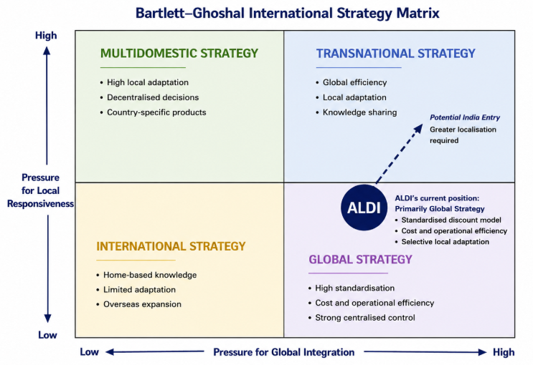
Figure 1: ALDI Strategic Position Within Bartlett–Ghoshal Matrix

2.3 Global Competitive Configuration
A combination of international scale and co-ordinated sourcing creates value at ALDI, due to their geographic configuration. The company has a presence in many European countries and in key markets such as the USA, Australia and China. This wide network offers experience with managing a variety of consumer markets and maintaining a familiar discount offer. Scale also contributes to an increase in purchasing power. For instance, ALDI says it leverages its size and purchasing power in international cocoa sourcing, and its combined sustainability projects show coordination between the ALDI SOUTH and ALDI Nord (ALonso 2022).
These capacities could be leveraged in negotiations with suppliers, development of private labels, quality control, and cost-effective operations for the expansion of Indian markets. International scale is no guarantee of success, however. A very standardised approach may not work well for India due to the fragmentation in its grocery market and the wide variety of consumer preferences. ALDI would therefore be faced with a conundrum: keeping the business simple would help it preserve its cost edge, whereas more localisation would boost the likelihood that Indian consumers would embrace the products. The best way it could do this would be to pass through its own core procurement and cost-management functions, and selectively bring over the elements of its model that relate to the customer (Neelesh Hundekari & al. 2022).

3. Indian Market Strategic Appraisal

3.1 Indian Grocery Market Context
ALDI has a big, but very fragmented, grocery opportunity in India. The grocery market consists of traditional kirana stores, which accounts for approximately 91% of the market and hypermarkets, supermarkets, e-commerce and quick commerce which serve different customer needs. With an expected 85% share even by 2030, kirdas are expected to continue to hold a significant share of the market even if there is significant growth.With a projected 85% share by 2030, market size does not necessarily ensure easy access for ALDI. But, there's a growing demand for digital groceries. As represented in Figure 2, the online grocery market in India is worth $8.82 billion and will expand by 44.9% per year from 2025 to 2030. By 2025 quick commerce GMV is also projected to reach more than $10 billion, which will add to the convenience of the urban customer base. Thus, its low price strategy has a potential, but to compete with the kiranas, supermarkets and digital platforms, it will require certain places, price and an assortment of products that is relevant to the local audience rather than being a clone of the European model (India online grocery market size report, 2021-2028 s.a.).
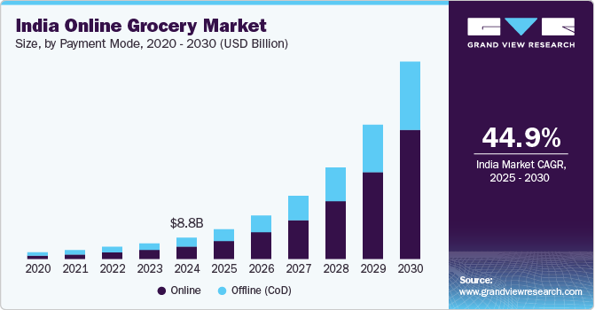
Figure 2: Growth Outlook for India Online Grocery Market

3.2 Political Environment
The political landscape in India poses opportunities and severe limitations for ALDI. Government policy on foreign investment in retail is the main problem. India has multiple brand retail (MBR) structure which allows foreign direct investment up to 51% through the government route subject to certain conditions. This is relevant to ALDI for its stores sell products in a number of different brands and categories. This framework may restrict the freedom enjoyed by ALDI to replicate a fully controlled international operating model unlike a market that will not introduce restrictions on foreign ownership (Masharu & Nasir 2018).
Figure 7 shows this problem by linking the FDI framework in India with investment considerations, along with sources and states level considerations. Importantly, the policy has always given individual states and UTs autonomy whether to adopt the multi-brand foreign retail or not in their respective territories. Thus, there is no uniformity in permission to access the market on a national level in India. The move adds to ALDI's location-selection challenge and could hamper its rollout nationally. It also makes the ability to know the politics and regulations in the first markets an important skill in choosing initial markets.
Opportunities also come about through government policy. The digital and retail infrastructure is evolving in India, making new channels for engaging consumers possible.The digital and retail infrastructure is rapidly growing in India, enabling new channels to reach consumers. For instance, the total value of online retail transactions in India hit around $80 billion for FY2026, with quick commerce accounting for 17% of all online retail sales and expanding at approximately 120% YOY. This, however, also helps domestic digital players as better infrastructure is good for both ALDI and its competitors (IBEF 2024).
Politically, India is an attractive market as foreign retailers can invest in India, but it is a market of complexity. Ownership restrictions and government approval and varying state-level implementation limits ALDI's strategic flexibility. Hence, ALDI must not assume that the India market is one where its international organization can be replicated. A well-considered and legally sound entry agreement, coupled with effective local knowledge, would be a more viable option for expansion (Petropoulos & al. 2025).
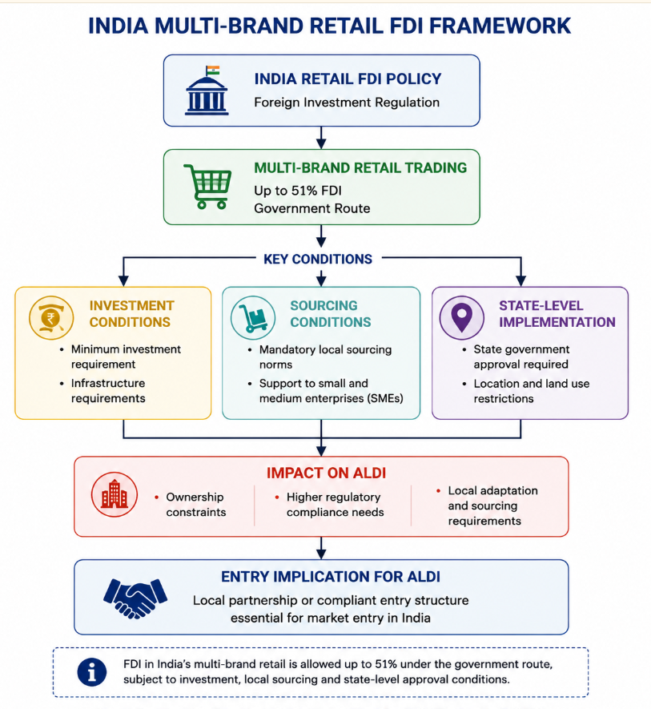
Figure 7: Indian Retail FDI Framework Affecting ALDI

3.3 Economic and Market Environment
India has great potential to become a massive market for ALDI, but that should not be equated to easy market success. India's real GDP growth stood at 6.5% in FY24/25 and the IMF had projected it above 6% in the coming years. This encourages increasing consumption and offers value retailers opportunities. ALDI should not only look at the national growth figures, however, but also at how Indian households buy groceries (Miller & al. 2026).
The fact that price sensitivity fosters a very special relationship with ALDI's discount model. Indian grocery transactions continue to be dominated by small, frequent transactions. Kirana stores typically sell small packets of food worth ₹100 – ₹200 to approximately 230 million households in the low to middle income category. In 2025, grocery sales accounted for approximately 91% of sales through Kirana outlets and are projected to be about 86% of sales by 2030. This is a challenge and an opportunity. ALDI's low-price appeal will appeal to consumers who are looking for value, but its traditional store economics model might not be able to compete with the low operating cost grocery stores in their neighbourhoods which offer convenient locations, local assortments and established relationships.
Retail, organised and digital, is still a good offer for cities, however. Quick commerce accounted for a GMV of over $10 billion in 2025, with over 30 million monthly users, and its GMV was over 80% in metro markets. As seen in Figure 4, e-grocery demand in India has been picking up pace since the beginning of COVID-19 and has been quite high even thereafter. The figure is based on 2020 data and for this reason should not be used to indicate the current market size, but illustrates an important structural change in grocery shopping behavior towards digital. This trend is backed by newer data which shows that fast commerce accounted for ~70% of total online grocery in FY2026, which was around $13–14 billion (AI 2026).
In comparison to ALDI's struggles against a conventional supermarket only, competition is more complicated. Kirans are the strong players for all daily purchases, whereas convenience and speed is the key to win in quick commerce. The grocery market in India will expand from around ₹55.9 trillion in 2025 to a projected ₹84.3 trillion by 2030, hypermarkets outpacing traditional supermarkets, according to Redseer. This is an uplifting boost to ALDI's value-based offering. But the best bet appears to be to target certain urban segments of the population in India and not the entire population. ALDI would have to have low prices and local sourcing, suitable pack sizes and convenient access and protect the operating efficiency behind the discount advantage.
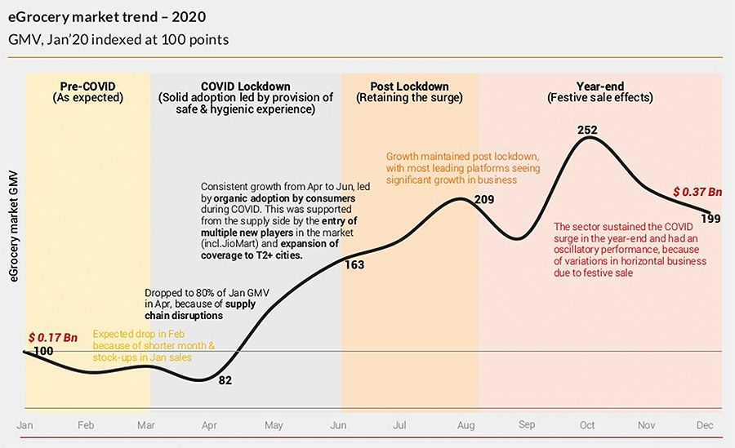
Figure 4: Evolution of India eGrocery Market Demand

3.4 Legal and Regulatory Environment
One of the most formidable challenges in the Indian context would be the country's regulatory framework, which would pose the biggest hurdle in replicating ALDI's existing international business model. Multi-brand retail FDI is restricted with regard to foreign ownership, and requires government approval, as discussed above. This is crucial as ALDI generally has a high level of control over purchasing, private labels, pricing and over the store. This might lead to a conflict between regulatory compliance and ALDI's ‘regular business model' if an entity is established to diminish ownership control (Kundgir 2024).
Food regulation would also logically impact on ALDI's strategy of private labelling. Figure 5 indicates that there are several regulators whose influence can be felt on the market and FSSAI is a crucial one for a grocery retailer. India has specific laws on packaging, food marketing and advertising, safety, licensing and labelling and display. In addition, amendments were made to the Labelling and Display Regulations in March 2026, all of which show that compliance rules are still evolving. ALDI would then be required to have Indian compliant packaging and product information for its private-label product range as opposed to just importing products designed for the European market.
Another compliance challenge with packaged products. The Legal Metrology regime in India includes information on relevant pre-packaged commodities including the name of the manufacturer, packer/importer, country of origin, product name, net quantity, MRP and ‘consumer-care’ details. The demands may lead to higher localization and packaging expenses for ALDI. However, the production of local products can help to mitigate some of the dependence on imported ranges and promote a more India-specific range (Siddique 2021).
Competition regulation is also a consideration in choosing an entry mode. ALDI could be subject to assessment under the India Competition Commission framework in case of a significant acquisition and/or combination and combinations that have an appreciable adverse effect on competition could be modified or blocked. Additional operating duties would be compliance with consumer regulations, employment and tax regulations.
In general the legal landscape doesn't preclude ALDI's entry, but it undermines the argument for simply replicating ALDI's current foreign-market business model. Ownership, products and sourcing and control of operation are all impacted by the regulatory burden. Therefore a legally compliant structure involving ALDI's core operating knowledge and robust regulatory and sourcing experience in India would be more appropriate and this constraint should directly impact on entry-mode decision that will be discussed later in the report (Hardaker 2018).
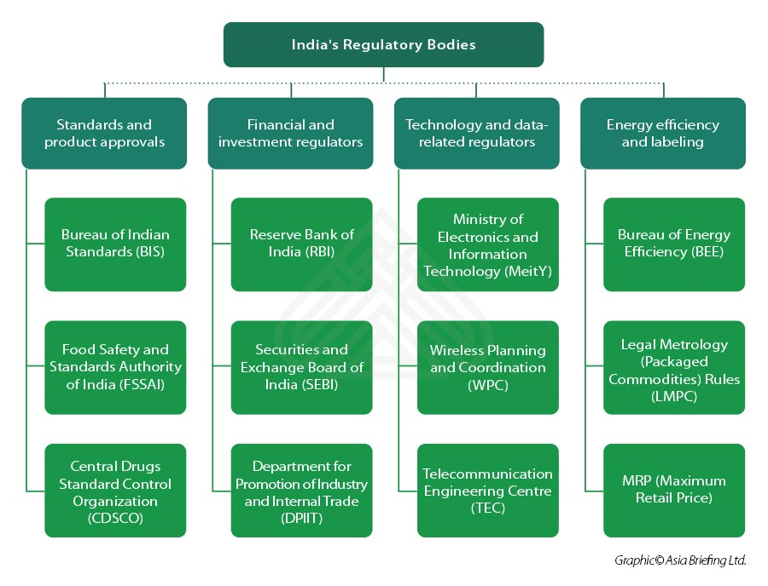
Figure 5: Key Regulatory Bodies Governing Indian Markets

3.5 Cultural and Consumer Environment
Indian grocery behaviour is variable and this presents opportunities and challenges to ALDI. As illustrated in Figure 6, the grocery market in 2025 was dominated by kirana stores, which accounted for approximately 91% of the market and will continue to dominate the market with 85–86% by 2030. This indicates that consumers in India still prefer to shop at their local store for small quantities and the convenience of regular visits despite the rise of supermarkets and e-commerce. According to Redseer, the typical mass-market household spends ₹100–200 on groceries, a figure that is well suited to the convenience that local kiranas are providing (Singh 2026).
As its main argument is about buying products that are not expensive, price sensitivity may be a factor that will work in ALDI's favour. This fit has been growing as a result of food price rises.This fit has been tightening due to the rise in food prices. Out of the 2015 consumer research conducted by PwC, 63% of the Indian consumers expressed worry over increasing food prices which resulted in actions like shopping around for discounts, switching retailers and purchasing certain products in bulk amounts. But low prices aren't necessarily sufficient. By the end of 2025, the number of users of quick-commerce platforms had already hit c. 33 million per month, reflecting the growing appreciation of many urban consumers both for speed and convenience and for having the lowest price.
Localisation of the products is similarly crucial. There are significant regional, religious and household variations in food preferences in India. Vegetarian diets are also still significant in many areas of the consumer market and the demand for meat is very diverse, as are demands for other food categories. There is also a big need for adaptation in the strategies of food companies in recent years, for instance, McDonald's launched a vegetarian protein product that was targeted towards the Indian market. There is also an urban-rural preference difference as urban consumers are more willing to try new products, while most of the rural consumers are more loyal to the familiar brand (Goyal Singh 2007).
The differences pose a threat to ALDI's model of limited assortment. The standardised range is very narrow might not be meaningful, but too localised would make ordering and stock management more complicated and less competitive. With the aim of putting the most effective range of products on the shelves, ALDI should therefore select a small number of products but localise their product categories, pack sizes, vegetarian products, regional favourites and their private brands to meet the local market demand. This would maintain the efficiency of ALDI's discount model in India, yet make it more accepted culturally.
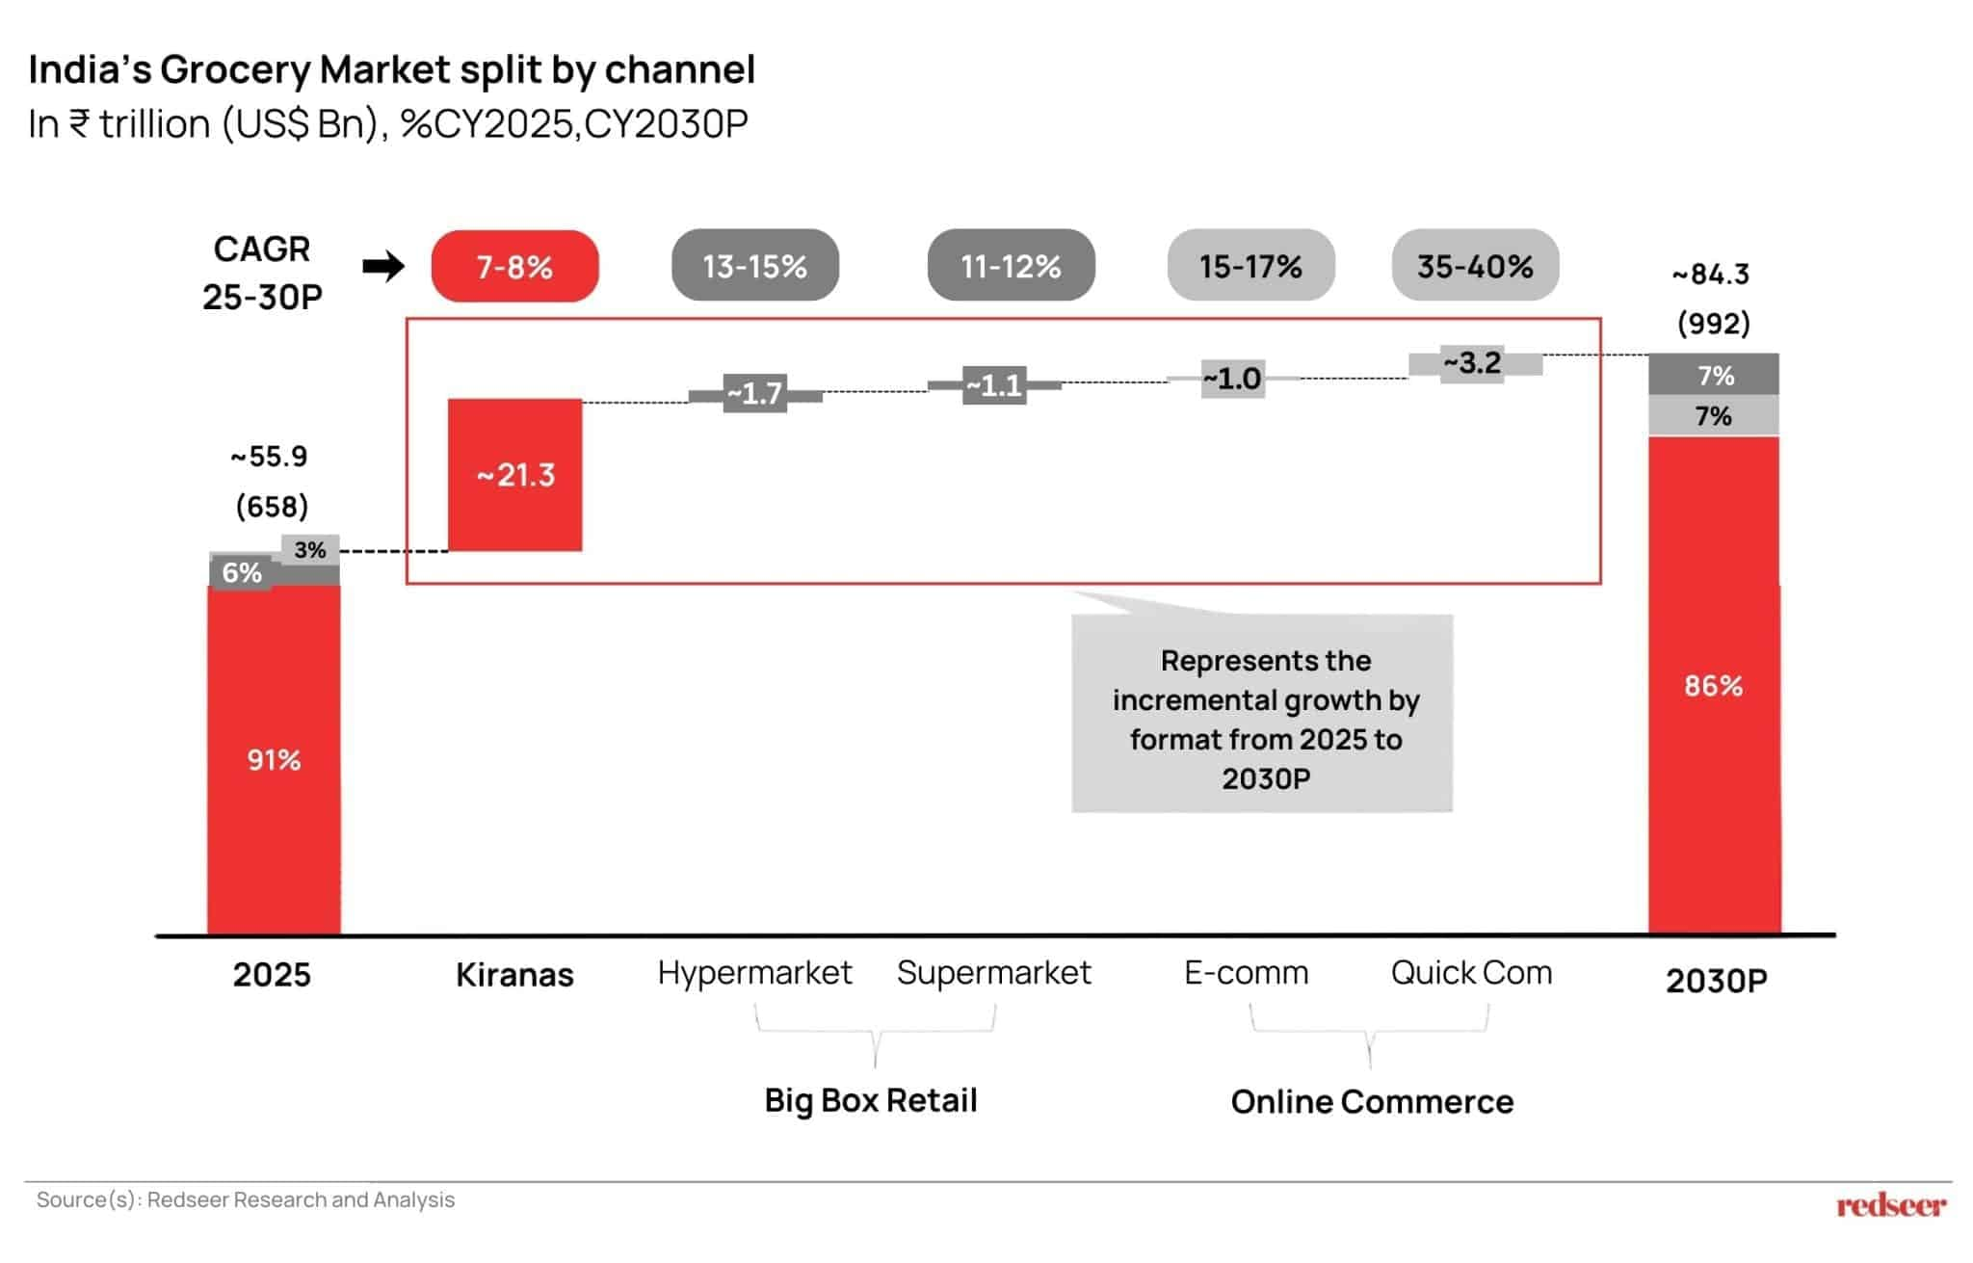
Figure 6: India Grocery Market Structure Across Channels

3.6 Dunning OLI Strategic Analysis
The OLI (other locations) framework of Dunning is helpful to synthesise the preceding analysis and determine if there is a compelling strategic rationale for ALDI's presence in India. Ownership, location and internalisation benefits are taken into account, but only as a package when it comes to the question of the acceptability of foreign expansion.
Ownership Advantages. ALDI's best ownership advantage is being able to run a very efficient discount retail operation. It is also global, with operations in Europe, the USA, Australia and China, thus having the experience to share its retail expertise in different markets. It's also crucial that it's not too hard to procure. ALDI has proven to be coordinated in its international sourcing, long-term supplier relationships and purchasing power to maintain product quality and price control. It can, for instance, boast of traceable sourcing and long-term cooperation within its international cocoa programme, or explicitly mentions the use of its scale and purchasing power throughout the supply chain, as done by ALDI. These capabilities can be useful to ALDI in terms of creating competitively priced private label products in India. But these ownership benefits do not excuse the liability of being foreign. ALDI has little direct experience in India's highly decentralized retail system, the regional food variety and complexity of the regulatory framework (Wortmann 2019).
Location Advantages. India provides good demand conditions but has significant structural challenges. The grocery market is huge and will continue to grow, and the organised formats and quick commerce are gaining momentum. However, Figure 6 shows that there is still a significant dominance of kiranas. With the traditional stores holding onto approximately 85% of grocery sales in India, the size of the population cannot be equated with a readily available modern-retail market for ALDI. The discount proposition of ALDI is a strong match for price-sensitive consumers, and urbanisation and the rise of online retail may provide early growth in metropolitan centres. However, India suffers from regulatory constraints, cultural differences and significant local rivalry, impacting its location benefit. The market is indeed appealing, but it is just for an adapted operating model (Singh & Kanojia 2024).
Internalisation Advantages. ALDI too has good reasons to maintain significant control of its operations. Direct control is a way of safeguarding its private-label standards, procurement practices, pricing discipline and lean operating system. Over-reliance on an external partner may reduce such capabilities. In India, however, there are also some drawbacks in complete control as local knowledge plays an essential role in regulation and sourcing, while selection of property and consumer adaption relies on it.
The OLI analysis thus yields an overall, although mixed, positive result. ALDI has excellent ownership skills, while India has some valuable location opportunities but these are not enough to establish a business similar to ALDI without modification. The most successful strategy would be to have a core discount system controlled by ALDI, with access to the Indian regulatory, sourcing and consumer knowledge. This aids a gradual and localized approach to entry instead of an immediate and full-scale, controlled entry and it underpins the entry-mode comparison in the following section (Wolniak & al. 2024).

4. Entry Strategy and Recommendations

4.1 Historical Entry Mode Pattern
It is clear that, when it has decided to expand outside of its home country, ALDI has preferred to keep the control of its retail model, although in different ways as it has seen fit. It made its first big step outside its home country when it purchased Hofer in Austria in 1968, and subsequent growth in the United States in 1976, the United Kingdom in 1990 and Australia in 2001 were primarily achieved through the establishment of ALDI-operated stores. ALDI's strategy in an unknown market is to debut in China through the Tmall Global platform in 2017 and then launched stores in pilot cities in Shanghai in 2019. The product sourcing for ALDI is distributed throughout Europe, North America, Asia, Australia and South Africa, which provides product diversification and purchasing flexibility (see Figure 7). From these examples it can be inferred that ALDI usually safeguards its price, private labels and store management, and can try a market without investing too much. The central teaching for India is that it should not emulate one historical mode without much deliberation. ALDI must maintain its core discount system, but minimise the risk of entry by offering stage learning and local knowledge (S. Skordili 2013).
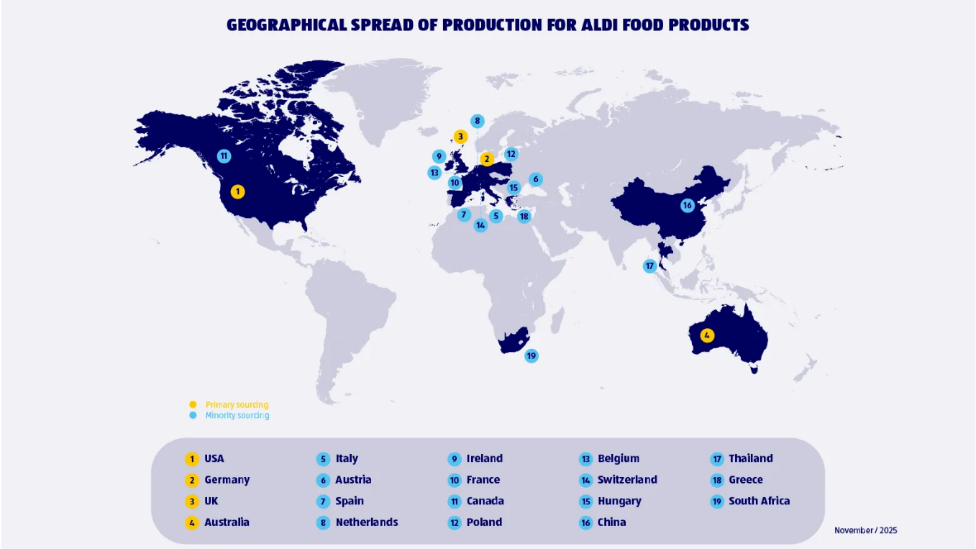
Figure 7: Geographic Distribution of ALDI Product Sourcing

4.2 Entry Mode Alternatives India
For India three realistic gateway options can be considered: A 100 percent greenfield subsidiary would provide ALDI with the highest level of control over the pricing, private labels, procurement and store operations. This is not the right choice for multi-brand retail though, as India has a maximum foreign direct investment limit of 51% in multi-brand retail stores via the government route. A large acquisition would also provide speed, proximity to stores, and access to suppliers, but would also have the same foreign ownership limitation as a foreign subsidiary, and integration costs would reduce ALDI's ability to maintain its lean operating model (Briefing 2012).
A joint venture with an Indian partner is thus more feasible. ALDI may be able to maintain the foreign equity cap and the local partner may add local regulatory insights, access to property, supplier networks and knowledge of the local consumer market. The problem of shared control can make for disagreement on things like assortment, sourcing and rates of growth. If no significant equity stake is given, the financial risk is reduced as well, but ALDI's ability to control the customer experience is also lowered.
Overall the joint-venture option offers the optimum balance. It gives up control, but it is more suited to regulatory regime in India and less risky than a large-scale investment. This also helps to facilitate a gradual scaling up post the market validation (Petropoulos & al. 2025).

4.3 Recommended Indian Entry Strategy
ALDI must start in India in a gradual manner with a good retail or distribution partner from India. This is a direct consequence of the previous OLI and PELC analysis. While cost control and procurement and private labels are strong ownership advantages for ALDI, the fragmented grocery structure in India and the diverse food preferences add value to local knowledge. A joint venture would thus enable ALDI to safeguard its core operating system and share the political, financial and market risk (Sinha & Kar 2009).
The first phase should be aimed at regulatory preparation, local supplier development and consumer research as indicated in the Figure 8. The second phase should involve a limited number of stores in one carefully chosen urban market with a localised but limited line-up. The third phase is to assess customer acceptance, supply chain efficiency and financial return prior to expansion.
Local sourcing should be at the heart of the strategy as not only does it lessen exposure to imports, but it also gives both freshness and relevance to the products marketed to Indian consumers. The success of local sourcing to ensure the continuity of ALDI's international model has already been demonstrated in Australia with 97% of fruit and vegetables being sourced from Australian farms. Similarly, ALDI needs to adjust pack sizes, vegetarian ranges and regionals without increasing the complexity of the assortment in India. Expansion should only happen when there are clear performance targets (Wood & al. 2021).
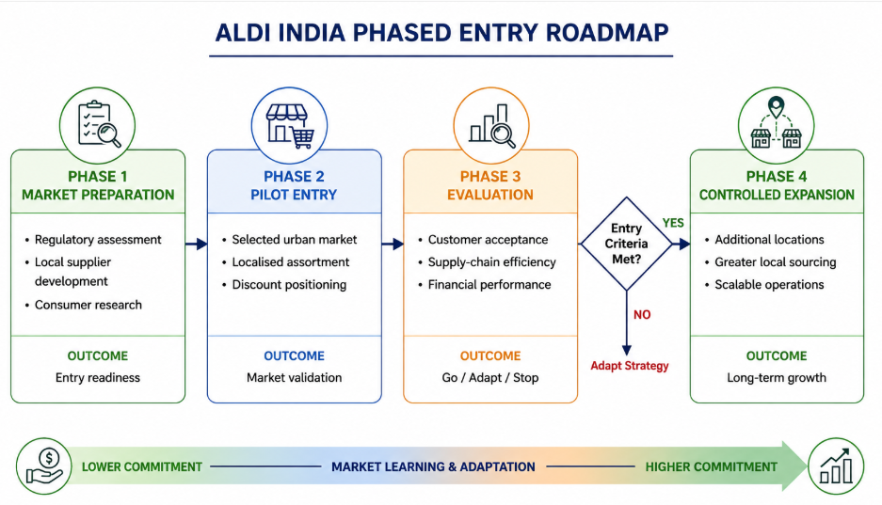
Figure 8: ALDI Phased Market Entry Roadmap India

4.4 Conclusion and Recommendations
India is a good market for ALDI but it must be done at the right places. Growing demand for organised retail, price-sensitive consumers and strong grocery growth are available on the market. But due to the dominance of Kirana, the competition from quick commerce, the regulatory restrictions and regional differences, it is risky to implement the standardised model of ALDI directly. In this context, ALDI should therefore approach the market through a stealthed joint venture, with locally sourced products and limited product adaptation. The one thing that should remain its forte is the affordable operating system and pack sizes, vegetarian offerings and regional staples should be changed to meet the Indian demand. The expansion beyond the pilot market should be based on customer acceptance, efficient supply chain, and sustainable store economics. The strategy allows ALDI sufficient flexibility to safeguard their business model, and at the same time benefit from local knowledge to lower the liability of "foreignness" Therefore, India should be introduced through the process of developing it in an orderly, evidence-based and incremental manner (Rahim & al. 2022).

5. Reflective Learning Account

5.1 Description
Firstly I gained an understanding of the main task and then chose a company and target market that enabled a strong international business analysis. ALDI was picked as it has a well-established international discount retail model, whereas India was chosen as it has a very large grocery market and some important regulatory and cultural considerations. The design of the research was designed by dividing the work into three parts: company strategy, market environment and OLI analysis and entry mode evaluation. For theories, I have used academic sources and for company evidence, I have used ALDI corporate. For retail, I have used Indian government sources and for FDI regulation, I have used industry reports for market trends. For this, I used Bartlett and Ghoshal to understand ALDI's international strategy and then the Dunning's OLI to relate the strengths of the company with the market conditions and entry in India (Rajput & al. 2012).

5.2 Feelings
At the onset, I was reasonably confident as ALDI and India seemed like a perfect company-market fit. But I was less confident when I began delving into the issue of Indian retail regulation, as the rules with regard to multi-brand retail, foreign ownership and the implementation of the rules at the State level were more intricate than I had thought. I was also wondering if a few of the market stats were up-to-date and accurate. I was more cautious in the choice of evidence due to these concerns. I started to look around for information from government, company and industry sources rather than going with my first choice. As the research became more structured, my confidence grew, as I was able to see stronger connections between the theory, evidence and the final recommendation (Phillips & al. 2020).

5.3 Evaluation
There were a number of aspects of my research process that were successful. Official ALDI information enabled me to gain an insight into the international model of the company, while the information from the Indian government was helpful in confirming the legal position on foreign retail investment. Academic literature gave me the ability to not dismiss the frameworks as merely definitions. The concept of global integration and local responsiveness proved useful when I took it to ALDI. Industry reports were also useful as it gives an idea about the competition between kirana, supermarket, e-commerce and quick commerce in India (Shankar Maheshkumar & al. 2025).
The process of research was also flawed, however. Certain market reports provided varying data regarding the size and growth of the Indian grocery retail market, making it difficult to compare. I also located some older online resources which were readily understood but are not relevant for contemporary analysis. Initially I was taking all kinds of information from India which was not directly applicable to ALDI. I later narrowed this down to evidence that affected pricing, sourcing, regulation, consumer behaviour or entry mode. This helped to narrow down the final analysis and lessen the description of unnecessary items.

5.4 Analysis
The most significant learning experience was to grasp that going global is not a size thing. In my initial stages I thought that the market for ALDI in India would be automatically interesting due to the large population and expanding food and grocery market in the country. It was the lectures and reading that shook me out of the complacency of making that assumption.
This strength of standardisation that Bartlett and Ghoshal demonstrated at ALDI is an efficiency, but can also be a weakness in a market that is more responsive to the local. I thus started to perceive ALDI as a business which required selective adaptation (Raymond s.a.) rather than merely it being another one of the businesses that simply replicates its existing model.
Dunning's OLI framework built upon my thinking. Both the effectiveness of procurement and the ability to develop and produce private label products and reduce costs were seen to be ownership advantages that justified international expansion. The location study revealed that India has regulatory challenges as well as retail structures that are fragmented and significant cultural challenges. The internalisation made another trade off. A direct control would safeguard ALDI's operating model, while local knowledge would be beneficial for regulation, sourcing and customer behaviour (Kaltenecker & al. 2025).
The most significant shift in my last verdict was due to entry-mode theory. Originally, I felt that a 100% purchase would be the most effective since it would give ALDI the most control. I studied Indian retail regulation and the importance of local knowledge and I realised this wasn't somewhere I was prepared to take a chance and it wasn't quite appropriate. In the end, the evidence made me more of a believer in a phased joint venture approach.
This process also sharpened my thinking process. I didn't take the positive evidence from the market, I took the negative evidence from the market. The strong growth in grocery was offset by the ongoing supremacy of kiranas and quick-commerce competition, for instance. This was useful for me to get beyond description and towards a more evidence-based strategic judgement.

5.5 Reflective Conclusion
This assignment had the greatest impact on my understanding that entering a foreign market is not just about growth and that there has to be a balance. I learned that there are so many ways that a market can seem like a good business idea, and yet have a lot of legal, cultural and operational issues. In addition, promoting increased awareness on the use of theories for decision making and not just for explanation (Francioni & Martín 2024).
Developed more research skills and analytical abilities due to paying attention to the quality of sources, current evidence, conflicting information. I also became better at linking one section of the report with another. I did see, however, that my initial research was too general and descriptive and was a waste of time. I would structure my evidence around the key strategic questions at the outset, if I did the same again. This would let me end my arguments quicker and even more focused.

5.6 Future Action Plan
I will begin my research earlier, develop a research plan, and gather the sources for future MBA assignments. My first action will be to build an evidence matrix with separate columns for the issue, source, key finding, reliability and strategic implication. This will ensure I do not gather information that will not be used to analyse the data (Hansen & al. 2021).
It will also be useful to consult peer-reviewed articles, company reports and official government publications over general websites or market summaries. If there is more than one source that cites a number, I will compare at least two reliable sources and explain why there is a difference rather than select the number that supports my argument. I will also link theory to evidence earlier on and ask what each model helps me to decide.
I will make an effort to look for evidence that will counter my initial impression as I improve my critical analysis. This will minimise confirmation bias and improve my judgement. I will also break the assignment down into weekly research and writing goals to ensure that analysis, referencing and editing don't come as a last minute task. These actions will help to facilitate a better academic performance and careful decision making in the professional life of the future (Swaryandini & al. 2025).

Reference List
AI, M. 2026. Quick commerce is reshaping India e-commerce growth. Multibagg AI. URL: https://www.multibagg.ai/market-pulse/articles/quick-commerce-reshapes-india-ecommerce-cms2291nl46as0zp5lsjd0pgn. Accessed: 8 August 2026.
Alonso, T. 2022. Strategy study: How Aldi became a global supermarket giant. URL: https://www.cascade.app/studies/aldi-strategy-study. Accessed: 8 August 2026.
Briefing, I. 2012. Foreign direct investment in India’s single and multi-brand retail. URL: https://www.india-briefing.com/news/foreign-direct-investment-indias-single-multibrand-retail-5232.html/. Accessed: 8 August 2026.
Chatterjee, S. 2017. Two efficiency-driven networks on a collision course: ALDI’s innovative grocery business model vs Walmart. Strategy & Leadership, 45, 5, pp. 18–25. URL: https://doi.org/10.1108/sl-06-2017-0057. Accessed: 8 August 2026.
Elg, U., Hultman, J. & Welinder, A. 2020. Competing corporate sustainability perceptions in a global retail organization. International Journal of Retail & Distribution Management, ahead-of-print, ahead-of-print. URL: https://doi.org/10.1108/ijrdm-03-2020-0112.
Francioni, B. & Martín, O.M. 2024. International market, network, and opportunity selection: A systematic review of empirical research, integrative framework, and comprehensive research agenda. Journal of international management, 30, 5, pp. 101174–101174. URL: https://doi.org/10.1016/j.intman.2024.101174.
Goyal, A. & Singh, N.P. 2007. Consumer perception about fast food in India: An exploratory study. British Food Journal, 109, 2, pp. 182–195. URL: https://doi.org/10.1108/00070700710725536.
Hansen, C., Steinmetz, H. & Block, J. 2021. How to conduct a meta-analysis in eight steps: A practical guide. Management Review Quarterly, 72, 1. URL: https://doi.org/10.1007/s11301-021-00247-4. Accessed: 8 August 2026.
Hardaker, S. 2018. Retail format competition: The case of Grocery Discount Stores and why they haven’t conquered the Chinese... De Gruyter Open. URL: https://www.researchgate.net/publication/328030825_Retail_Format_Competition_The_Case_of_Grocery_Discount_Stores_and_Why_They_Haven. Accessed: 8 August 2026.
IBEF 2024. E-commerce in India: Industry overview, market size & growth| IBEF. URL: https://www.ibef.org/industry/ecommerce. Accessed: 8 August 2026.
India online grocery market size report, 2021-2028 s.a. URL: https://www.grandviewresearch.com/industry-analysis/india-online-grocery-market. Accessed: 8 August 2026.
Kaltenecker, E., Okoye, K. & Szymanski, M. 2025. From OLI to OLIN: Understanding the internationalization process of elite business schools. International Journal of Emerging Markets, pp. 1–23. URL: https://doi.org/10.1108/ijoem-06-2024-1059.
Kundgir, B.R. 2024. FDI in multi-brand retail in India: Myths and realities. ShodhKosh: Journal of Visual and Performing Arts, 5, 7SE, pp. 273–275. URL: https://doi.org/10.29121/shodhkosh.v5.i7SE.2024.6177. Accessed: 8 August 2026.
Liao, T.-S. & Le, U.-M. 2017. R M B R A dynamic global integration and local responsiveness framework: Understanding strategic movements of multinational enterprises. International Review of Management and Business Research, 6, 4. URL: https://irmbrjournal.com/papers/1513074054.pdf. Accessed: 8 August 2026.
Masharu, U. & Nasir, M.A. 2018. Policy of foreign direct investment liberalisation in India: Implications for retail sector. International Review of Economics, 65, 4, pp. 465–487. URL: https://doi.org/10.1007/s12232-018-0306-y. Accessed: 8 August 2026.
Miller, D., Sänger, F., Moulton, J., Am, J.B., Konstantin Habernoll & Schmutzler, R. 2026. State of Food and Beverage: The choices CPG leaders can make to renew growth. URL: https://www.mckinsey.com/industries/consumer-packaged-goods/our-insights/state-of-food-and-beverage. Accessed: 8 August 2026.
Neelesh Hundekari, Jain, S., Dhall, K. & Singh, A. 2022. Creating a competitive advantage for India in the global textile and apparel industry. URL: https://www.kearney.com/industry/consumer-retail/article/creating-a-competitive-advantage-for-india-in-the-global-textile-and-apparel-industry. Accessed: 8 August 2026.
Petropoulos, F., Akkermans, H., Aksin, O.Z., Ali, I., Babai, M.Z., Barbosa-Povoa, A., Battaïa, O., Besiou, M., Boysen, N., Brammer, S., Brandon-Jones, A., Briskorn, D., Browning, T.R., Buijs, P., Centobelli, P., Chiarini, A., Cousins, P., Cudney, E.A., Davies, A., Day, S.J., de Koster, R., Dekker, R., Denicol, J., Despeisse, M., Disney, S.M., Dolgui, A., Duong, L., El-Qallali, M., Fahimnia, B., Fakhredin, F., Gershwin, S.B., Ghamat, S., Giannikas, V., Glock, C.H., Godsell, J., Govindan, K., Hannibal, C., Haug, A., Hernaus, T., Hsuan, J., Ivanov, D., Jahre, M., Johansson, B., Kalidoss, M.S., Kanellopoulos, A., Kannan, D., Karul, E., Katsikopoulos, K.V., Begüm Kilic-Ararat, A., Kolisch, R., Koppenberg, M., Kumar, M., Kuo, Y.-H., Kusiak, A., Lewis, M.A., Lim, S.F.W.T., Limère, V., Liu, J., Maghazei, O., Marić, M., Meissner, J., Meuwissen, M., Micheli, P., Nanayakkara, S., Nur Özdemir, B., Papadopoulos, T., Pavelin, S., Perera, S., Phillips, W., Prak, D., Pun, H., Qazi, S.A., Ramanathan, U., Reiner, G., Reitsma, E., Roehrich, J.K., Sanders, N.R., Sarkis, J., André Schmid, N., Schmidt, C.G., Schroeder, A., Selviaridis, K., Seuring, S., Shi, C., Son, B.-G., Spring, M., Squire, B., der Valk, W. van, van Donk, D.P., van Houtum, G.-J., Wilhelm, M., Wynstra, F. & Zheng, T. 2025. Operations &amp; supply chain management: Principles and practice. International Journal of Production Research, pp. 1–184. URL: https://doi.org/10.1080/00207543.2025.2555531.
Phillips, P.W.B., Castle, D. & Smyth, S.J. 2020. Evidence-based policy making: Determining what is evidence. Heliyon, 6, 7, pp. e04519. URL: https://doi.org/10.1016/j.heliyon.2020.e04519.
Rahim, M.M., Kuruppu, S.C. & Islam, M.T. 2022. Social auditing in the supply chain: Business legitimisation strategy rather than a change agent. Meditari Accountancy Research. URL: https://doi.org/10.1108/medar-06-2021-1322.
Rajput, N., Kesharwani, S. & Khanna, A. 2012. FDI and Indian retail sector: An analysis. Journal of Business Administration Research, 1, 1. URL: https://doi.org/10.5430/jbar.v1n1p53.
Raymond, D. s.a. MIR series in international business internationalization of business cases on strategy formulation and implementation. www.academia.edu. URL: https://www.academia.edu/38566464/MIR_Series_in_International_Business_Internationalization_of_Business_Cases_on_Strategy_Formulation_and_Implementation. Accessed: 8 August 2026.
S. Skordili 2013. The sojourn of Aldi in Greece. Journal of Business &amp; Retail Management Research, 8, 1, pp. 68–80. URL: https://www.researchgate.net/publication/288772848_The_sojourn_of_Aldi_in_Greece. Accessed: 8 August 2026.
Shankar Maheshkumar, Kedar, Sadanand Karlekar & Govind Gosavi 2025. Foreign direct investment in Indian retail sector. 15, 7, pp. 2249–7137. URL: https://doi.org/10.5958/2249-7137.2025.00039.3. Accessed: 8 August 2026.
Siddique, H. 2021. Aldi Sud Company (international marketing plan). URL: https://medium.com/@hammadsiddique499/aldi-sud-company-international-marketing-plan-556f124b2f63. Accessed: 8 August 2026.
Singh, C. 2026. Quick Commerce vs Kiranas vs hypermarkets, who will win the Indian grocery market? URL: https://redseer.com/articles/quick-commerce-vs-kiranas-vs-hypermarts-who-will-win-the-indian-grocery-market/. Accessed: 8 August 2026.
Singh, S. & Kanojia, M. 2024. Growth of Retail Marketing in India. IJFMR240219013, 6, 2. URL: https://www.ijfmr.com/papers/2024/2/19013.pdf. Accessed: 8 August 2026.
Sinha, P.K. & Kar, S.K. 2009. Insights into the growth of new retail formats in India. Retailing in the 21st Century, pp. 119–140. URL: https://doi.org/10.1007/978-3-540-72003-4_8.
Swaryandini, G., Graham, J., Griffith, S., Grilo, V., Ruzzante, F., Zhang, X., Yeung, S.K., Mangiarulo, M., Basarkod, G., Ng, C., Parker, P., Tangen, J., Saeri, A., Grundy, E., Slattery, P. & Noetel, M. 2025. Systematic review and meta-analysis of educational approaches to reduce cognitive biases among students. Nature human behaviour, pp. 10.1038/s41562–025–02253-y. URL: https://doi.org/10.1038/s41562-025-02253-y. Accessed: 8 August 2026.
Wolniak, R., Stecuła, K. & Aydın, B. 2024. Digital transformation of grocery in-store shopping-scanners, artificial intelligence, augmented reality and beyond: A review. Foods, 13, 18, pp. 2948. URL: https://doi.org/https://doi.org/10.3390/foods13182948.
Wood, B., Williams, O., Nagarajan, V. & Sacks, G. 2021. Market strategies used by processed food manufacturers to increase and consolidate their power: A systematic review and document analysis. Globalization and Health, 17, 1, pp. 1–23. URL: https://link.springer.com/article/10.1186/s12992-021-00667-7. Accessed: 8 August 2026.
Wortmann, M. 2019. Aldi and the German model: Structural change in German grocery retailing and the success of grocery discounters. Competition & Change, 8, 4, pp. 425–441. URL: https://doi.org/10.1080/1024529042000304446. Accessed: 8 August 2026.

