Module Code & Title: LCLM 5005 - Organisational Culture
Assignment Title: 2. Component 1 Organisational Culture: Individual Report
Student ID: 2417886 Lecturer
Name: Dr Mustakkima Afrin
Table of Contents
Introduction 1
The organisational culture of Toyota 1
How organisational culture helps shape the company’s structure and decision-making at Toyota 2
Toyota’s culture shapes the company’s structure 2
Toyota’s culture shapes the decision-making of the organisation 2
Relevant framework to identify various types of culture in Toyota 3
Deal and Kennedy's Corporate Culture Model 3
The way Toyota uses the influence of organisational culture to adapt to its external environment 5
Discuss if Toyota’s organisational culture is a barrier to effective functioning in this organisation 7
The impact of organisational culture on organisational performance of Toyota 8
Conclusion 9
Reference list 10

Introduction
As per Mullins and Christy (2016), organisational culture is the set of beliefs, values and norms of behaviour of employees to interact with each other. It is linked with a range of components, which are leadership styles, traditions, purpose and communication style to manage the operation of the organisation (Elsmore, 2020). Toyota was established in 1937 and operates in 35+ countries all over the world (Toyota, 2024). The organisation has SUVs, trucks, sedans and luxury brand cars. It has an 11.5% market share globally, and the profit rate of the company grew by 5.5% (Toyota, 2024).
This assessment aims to draft an individual report to critically assess the culture and context of Toyota by recommending an appropriate management information system to drive performance. So, the report will highlight the culture of Toyota and show the way its culture helps to shape the structure nads decision making of the company. Deal and Kennedy's Corporate Culture Model will be discussed to illustrate the type of organisational culture of Toyota to manage operations. The report will state the influence of the organisational culture of Toyota on adapting to its external environment. Whether the organisational culture of Toyota barrier to effective functioning in this organisation and the impact of organisational culture on organisational performance will be stated in this report.

The organisational culture of Toyota
To manage operations, a range of organisational cultures is used by Toyota to maximise performance and achieve organisational goals efficiently. These cultures are discussed below:
Kaizen – Continuous improvement or kaizen culture, is followed in Toyota to eliminate waste in the organisation. The organisation empowers employees to improve daily operation process, which supports the organisation in solving quality issues by pausing production to ensure efficiency (Verbickas, 2021). This culture enables the organisation to operate by finding waste, solving problems and looking for mistakes without failure, but solve it quickly.
Go and See – In Toyota, the Go and See culture is followed, which is named Genchi Genbutsu. Under this culture, the organisation’s leaders and employees directly identify problems of the organisation by observing actual facts of the organisation. It supports the organisation in making decisions practically by visualising the situation and analysing root causes that are causing barriers in the operation. This culture allows the organisation to operate based on real-time data and manage operations efficiently.
People & Teamwork – The organisation also uses teamwork and a people culture where the organisation ensures a workplace environment where teamwork is prioritised, and diverse opinion is values to make any decision for the organisation (Mullins and Christy, 2016). Therefore, respect to propel and a collective work culture allow the organisation to introduce new models of cars and meet customers' needs efficiently.
Problem solving and autonomy – To ensure long-lasting and sustainable growth for the organisation, Toyota uses problem-solving and an autonomy culture. This culture allows staff and employees of the company to pause production to take the correct action plan and solve problems of production (Kwisthout, 2020). It gives employees autonomy, saves time and ensures operational efficiency for the organisation.

How organisational culture helps shape the company’s structure and decision-making at Toyota
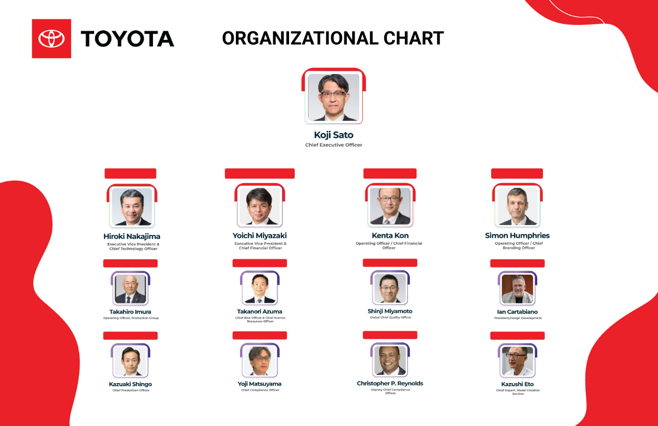
Figure 1: Toyota’s organisational structure.
Source: (Template.net, 2026).

Toyota’s culture shapes the company’s structure
Toyota uses a teamwork culture which shapes its organisational structure in a flat structure to operate smoothly. The organisation manager and leader use small teams who perform their tasks, make decisions and improve the quality of manufactured cars of the organisation (Browning, 2021). This enables the organisation to achieve strategic goals of maximising profit and growth rate of the organisation. Problem-solving and an autonomy culture help the organisation to shape its company structure to find the root cause of issues at the visiting location and ensure car quality (Su, Baird and Munir, 2022). It enables employees to solve problems of car manufacturing, adjust processes, pause production under error and test innovations to ensure productive performance. Teamwork and people culture of the organisation shape the company structure to be collaborative and team-centric in completing new car design and achieving targeted production (Gonzalez Torres et al., 2024). It integrates employees to work with company values and manufacture high-quality cars to sustain itself in the industry.

Toyota’s culture shapes the decision-making of the organisation
Toyota's continuous improvement culture shapes the company structure to make centralised decisions, which supports the organisation in strictly controlling car quality (Verbickas, 2021). This helps the organisation to offer high-quality cars and manage operational flow smoothly. Genchi Genbutsu culture influences decision-making to be data-driven, real-time, and situation-based. This increases the best-fit decision for the organisation, which reduces operational errors and supports long-term growth (Samson and Bhanugopan, 2022). Yet, the problem-solving culture influences decision-making, giving employees authority to make decisions without waiting for higher management. It increases awareness among employees, develops leadership traits among employees and contributes to accurate decisions to manage any problems of the organisation (Mullins and Christy, 2016). This culture reduces the blame tendency among employees and contributes to solving any errors, which increases employee engagement and supports overall efficiency of the organisation. Kaizen culture also influence decision making of Toyota to improve performance by eliminating waste (Verbickas, 2021). From this, the employees have the authority to make centralised decisions, and it saves a huge amount of time to solve errors. It reduces time waste, saves inventory from waste by production halts, and supports data-driven decision-making to progress production with accuracy. As Toyota practice centarlised decision making culture to control quality, it also empowers employees to make frontline decisions to tackle defects or errors in production (Samson and Bhanugopan, 2022). This empowers employees to solve problems, make decisions, and take action to prevent production errors. This is called the Toyota Way, which supports operational control, eliminates waste and collectively achieves targeted goals for the organisation.

Relevant framework to identify various types of culture in Toyota

Deal and Kennedy's Corporate Culture Model
Deal and Kennedy's Corporate Culture Model is a framework that categorises organisational culture in four different types (Umbrex, 2026). It guides organisations to make accurate and fast decisions based on the emerging situation. It allows organisations to analyse risk and speed of feedback in managing company operations or activities efficiently (Mullins and Christy, 2016). The four cultures of the model are Work Hard/Play Hard, Tough Guy/Macho, Process culture and Bet-Your-Company (Umbrex, 2026). The model is discussed below:
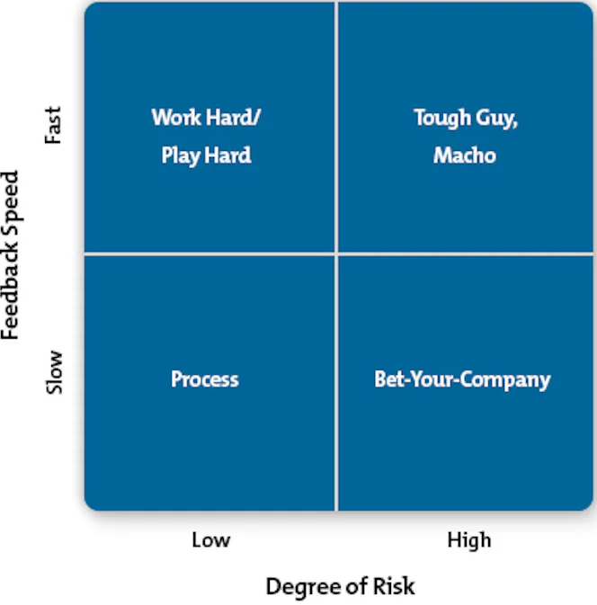
Figure 2: Deal and Kennedy's Corporate Culture Model.
Source: (Mindtools, 2024).
Work Hard/Play Hard: This culture highlights low risks and gives fast feedback, as it shows team-based incentives, customer focus and training with celebration of funds (Umbrex, 2026). The strength of this culture is continual improvement, high morale and long-service ethics. The risk of this culture is that it resists change and superficiality. The culture fits best in retail, sales teams, consumer marketing and call centre businesses.
Tough Guy/Macho: The tough guy or macho culture refers to the culture that focuses on immediate results, individuals thrive on personal wins, and failure to succeed shows immediately. Under this culture, rapid trial-and-error, preference and bold decision-making are seen. The strength of the culture is decision-making, speed, and resilience under pressure (Ferrell, 2021). Hence, the risk of this culture is high with fast feedback, which leads to poor sharing of knowledge, burnout and volatility. Sports and entertainment businesses are fit to use this culture.
Process culture: The process culture relies on consistency, uniformity of processes and slow feedback with low risks for the organisation (Umbrex, 2026). It is highly bureaucratic and focuses heavily. Government administration, finance service, and regulated offices use this culture.
Bet-Your-Company: This culture of bet your company is high risk and slow feedback that focuses on technical excellence and takes a long time to pay off a decision. This focus on the future and need for deliberation are useful for the company of aerospace, pharmaceuticals and oil exploration.
Types of culture in Toyota from the model: Toyota uses a Work Hard/Play Hard culture to manage the operation of the organisation. The organisation gives fast feedback, and its kaizen culture reduces operating risks. The ultimate balance of the company, with strict quality of cars and people centricity help to achieve goals. The employees have the authority to make decisions halting production, which saves time and supports continuous improvement (Uhl-Bien, Piccolo and Schermerhorn, 2023). Also, the culture faces the risk of resistance to change, and Toyota tackles the risk by giving job security, empowerment, and training with direct communication (Umbrex, 2026). Therefore, this culture supports team activities and respect for members, which aligns with Toyota’s core culture of teamwork (Mullins and Christy, 2016). This increases quick problem solving, develop high-quality cars with EV integration to meet customers' needs. This culture motivates employees with recognition, and Toyota motivates employees to make decisions in complex situations, halting production (Elsmore, 2020). It aligns with the core culture of Toyota. This culture generates low risk and fast feedback, supporting continuous improvement of processes. This contributes to growth and overall goal achievement for the organisation. Also, Toyota uses a process culture with its Toyota Production System (TPS). It supports quality control for cars, attention to detail and the assembly line in manufactured cars. The culture of slow feedback with low risks allows the organisation to standardise processes for car manufacturing (Umbrex, 2026). Instead of trial and error, the company uses TPS to manufacture high-quality cars, which increases global recognition, sales and contributes to a 11.5% market share globally of the organisation (Toyota, 2024). So, the Work Hard/Play Hard culture and process culture support Toyota to ensure disciplined and productive performance of the organisation. This culture helps the company to eliminate waste and motivate employees, which supports long-term growth of the organisation.

The way Toyota uses the influence of organisational culture to adapt to its external environment
Toyota is using organisational culture to adapt to its external environment by using its ‘Toyota Way’ culture. It helps the organisation to solve operational problems, foster teamwork and meet global market demands with car production (Uhl-Bien, Piccolo and Schermerhorn, 2023). This influence of culture to adopt external environment is presented below:
Kaizen culture for technology adoption – Toyota uses Kaizen culture for continuous improvement of operational processes and to eliminate waste (Verbickas, 2021). This culture enables the organisation to adopt a technology of electrification by shifting to EV-based car production. It optimises energy use, shifts the company to green energy, and supports problem-solving to operate sustainably by transitioning to EV models of cars. Hence, EV integration increases investment for the company to develop updated cars. Yet, it reduces carbon emissions, minimises oil or gas use and supports the sustainable goal achievement of Toyota (Gonzalez Torres et al., 2024). The organisation uses its website to connect with global customers, and the use of digital tools such as Facebook, Instagram, and email for marketing allows it to adapt to updated technology to improve its production and connect with a larger audience (Wanyama, 2023). Website and social media promotion support the organisation to collect feedback from customers, which helps to launch new product lines, improve features and integrate continuous improvement in production.
Decentralised agility to empower employees – Toyota’s flat structure with centarlised decision making support the organisation's car quality control. Yet, the organisation uses a decentralised agility culture to empower employees to make decisions based on situational errors without waiting for higher management (Ferrell, 2021). It allows local employees to make decisions quickly, halt error production and take action based on emerging trends to manufacture cars efficiently. This supports the organisation in testing innovations like SUVs, trucks, sedans and luxury car models under the EV system. This helps the organisation to engage employees, drive productivity and adapt to customer-centric trends to grow in the industry (Mullins and Christy, 2016). This culture might increase conflict between regional and cross-functional teams of Toyota to design EVs with different designs. However, the collective mindset without blaming each other and valuing diverse insights of the employee allows the organisation to develop productive and motivated employee which support organisational goals and achievements.
Collaboration culture to adapt transparent supply chain - Toyota’s collaboration culture allows the organisation to adapt a transparent supply chain, partnering with suppliers. The organisation practises transparency in communicating with suppliers, which helps the organisation to source inventory at low costs and maintain the quality of cars (Wanyama, 2023). The organisation partners with multiple suppliers and sets prices for inventory according to their car models, with a double check after delivery. It reduces delays and supports continuous improvement of new units of car production of the organisation during global disruption. This ensures uniform quality standards, a transparent supply chain and helps operational efficiency of the organisation (Ferrell, 2021). Besides, the company pays off supplier payments on time and inspects product quality before car delivery, which supports the organisation in managing the supply chain efficiently.

Discuss if Toyota’s organisational culture is a barrier to effective functioning in this organisation
For effective functioning, Toyota’s organisational culture creates a barrier to its process functioning from Deal and Kennedy's Corporate Culture Model, with agility, go and see with decentralised operation, and consensus with autonomy friction. Toyota’s process culture focuses on maintaining car quality, and it increases barriers to adapting new processes to manufacture innovative cars (Wanyama, 2023). The company integrates into EV manufacturing, and process culture creates barriers to adapting new processes in functioning, which clashes with the operating factor of the organisation. Therefore, the rigid process culture works as a barrier to effective functioning for the organisation to enter in fast paced updated, software-technology-based car manufacturing process. Alternatively, the go-and-see culture restricts the decentralised functioning of Toyota (Su, Baird and Munir, 2022). The organisation prefers its managers to go to the physical space where the employees get confused when any issue occurs, and the decentralised culture could not be adopted by all employees. It increases barriers, confusion and struggle to manage time to achieve targeted production. Another culture of autonomy increases barriers for effective functioning at Toyota. The organisation gives authority to employees to make decisions and take action, halting production without waiting for top management (Mullins and Christy, 2016). It clashes with the consensuses decision making process, which is slower. It results in inefficiency in operations and overall productivity of the organisation. Along with that, Deal and Kennedy's Corporate Culture Model’s Work Hard / Play Hard culture is used by the organisation, which does not fit with Toyota as the company does not practice fast feedback with lowering operational risk (Umbrex, 2026). It is mainly a sales-based organisation where immediate reinforcement and sustained motivation are not practised. Employees work hard and play contrast, which risks taking shortcuts to company-targeted unit achievement. It increases barrier flow of effective functioning at ten organisation. The employees of the organisation and leaders' close adaptation and focus are a must for effective functioning. Toyota’s small team and long-term goal achievement increase barriers for the organisation to resolve challenges and ensure smooth functioning of the organisation. So, Toyota’s organisational culture hinders its smooth functioning and operation to sustain itself long in the industry.

The impact of organisational culture on organisational performance of Toyota
The Kaizen culture of Toyota helps the organisation to achieve operational efficiency with continuous improvement. This benefits Toyota by reducing waste, minimising costs of production and streamlining the manufacturing of cars (Verbickas, 2021). This supports the organisation in obtaining a higher profit margin with a 5.5% profit growth rate in the industry (Toyota, 2024). Toyota’s higher management makes centralised decisions about new car models, car production units, and the operational process. This slows down employees' task completion and makes the organisational structure rigid. This affects operational flow and the productivity of the organisation greatly. Toyota’s culture of transparency and supply chain management benefits the performance of the organisation (Uhl-Bien, Piccolo and Schermerhorn, 2023). Clear communication, partnership with multiple suppliers, and negotiating to reduce inventory costs are practised by the organisation. This helps the organisation to achieve a resilient and stable supply chain of the organisation. It also allows the organisation to build long-term supply chain relationships and manage the supply chain transparently. The go-and-see culture of the organisation stifles innovation within the organisation (Su, Baird and Munir, 2022). This reduces employees problem solving skill and wastes time in production till engineers come to check the issue physically. It reduces employees' innovative thinking and affects overall productivity for Toyota. Toyota’s teamwork culture supports the organisation to ensure employee engagement, which contributes to the higher performance of the organisation (Mullins and Christy, 2016). The organisation practices long-term employment, gives job security and provides training for skill development of employees. Besides, the company builds mutual trust and takes employees' insights to solve certain problems. This increases employee morale, empowers employees to work long-term, and ensures productive performance of the organisation. Therefore, Toyota offers employees exclusive technology-based education and training, and empowers employees to solve problems, and celebrates employees' achievements. This increases employee engagement and generates an 11.5% market share for the organisation (Toyota, 2024). A waste reduction culture with a focus on achieving efficiency helps the organisation obtain higher performance, reducing operating expenses. This increases productivity and overall growth of the organisation (Ferrell, 2021). In Toyota, employee performance pressure is high, and the aggressive expansion increases employee workload. This affects accuracy in production, which reduces the performance of the organisation. Besides, intense pressure for performance and the cost-cutting concept result in employee burnout, which directly affects organisational performance of the organisation. Toyota focus on sustainable operations in the area of EVs, teamwork, and problem-solving, and this helps the organisation to maximise performance, increase market share, expand operations and drive profit growth efficiently.

Conclusion
In closing remarks, the report is about Toyota recommending an appropriate management information system to drive performance. To manage operations, a range of organisational cultures is used by Toyota, which are continuous improvement or kaizen culture, the Go and See culture, teamwork and a people culture, problem-solving and an autonomy culture. Toyota uses a teamwork culture, which shapes its organisational structure in a flat structure to operate smoothly. Deal and Kennedy's Corporate Culture Model, Toyota uses a Work Hard/Play Hard culture to manage the operation of the organisation. Also, Toyota uses a process culture with its Toyota Production System (TPS). It supports quality control for cars, attention to detail and assembly lines in manufactured cars. Toyota uses a Kaizen culture, which enables the organisation to adopt a technology of electrification. Toyota’s collaboration culture allows the organisation to adopt a transparent supply chain, partnering with suppliers. Toyota’s higher management makes centralised decisions about new car models, car production units, and the operational process. This slows down employees' task completion. Toyota offers employees exclusive technology-based education and training and empowers employees, which increases employee engagement and organisational performance. Toyota should arrange technology training for employees, make democratic decisions, and promote an agile structure. This would help the company to reduce operational rigidity and increase organisational performance efficiently.

Reference list
Browning, L.D. (2021). Organisational Narratives and Organisational Structure. Journal of Organizational Change Management, 4(3), pp.59–67.
Elsmore, P. (2020). Organisational culture : Organisational change? London, [England] New York, New York Routledge.
Ferrell, O.C. (2021). Business. New York, Ny: Mcgraw-Hill Education.
Gonzalez Torres, T., Gelashvili, V., Herrera-Enriquez, G. and Martinez-Navalon, J.-G. (2024). Organizational Culture and Climate: New Perspectives and Challenges. Frontiers Media SA.
Kwisthout, J. (2020). Relevancy in Problem Solving: A Computational Framework. The Journal of Problem Solving, 5(1). doi:10.7771/1932-6246.1141.
Mindtools (2024). Deal and Kennedy’s Cultural Model. [online] Mindtools. Available at: https://www.mindtools.com/avnhbho/deal-and-kennedys-cultural-model/ [Accessed 6 July 2026].
Mullins, L., and Christy, G. (2016). Management & Organisational Behaviour (Eleventh ed., Always learning).
Samson, K. and Bhanugopan, R. (2022). Strategic human capital analytics and organisation performance: The mediating effects of managerial decision-making. Journal of Business Research, 144, pp.637–649. doi:10.1016/j.jbusres.2022.01.044.
Su, S., Baird, K. and Munir, R. (2022). Organisational resilience: The role of organisational culture from an organisational life cycle perspective. International Journal of Manpower, 44(3), pp.403–421. doi:10.1108/ijm-11-2021-0631.
Template.net (2026). Free Toyota Motor Organizational Chart Template. [online] Template.net. Available at: https://www.template.net/edit-online/544175/toyota-motor-organizational-chart [Accessed 16 July 2026].
Toyota (2024). New Cars, Trucks, SUVs & Hybrids | Toyota Official Site. [online] Toyota.com. Available at: https://www.toyota.com/ [Accessed 6 July 2026].
Uhl-Bien, M., Piccolo, R.F. and Schermerhorn, J.R.J. (2023). Organizational Behavior. Wiley Global Education.
Umbrex (2026). Deal & Kennedy Corporate Culture Types | Org Culture. [online] Independent Management Consultants. Available at: https://umbrex.com/resources/frameworks/organization-frameworks/deal-kennedy-corporate-culture-types/ [Accessed 6 July 2026].
Verbickas, D. (2021). Research On Kaizen Implementation in Industrial Companies. Mokslas - Lietuvos ateitis, 13(0), pp.1–16. doi:10.3846/mla.2021.14340.
Wanyama, R. (2023). Dynamic Capability and Adaptive Strategies. Navigation business environments for long-term success. GRIN Verlag.

