Assessment Feedback Sheet

Student No./Name: Kemsley Mathias
Module: Advanced Training Methods
Module Code: SHSS6089

Personal Evaluation – to support your academic progress please complete the section below BEFORE submitting your work.
What do you consider to be the best aspects of this work? |  |  | Design of the training program.
Which aspects do you consider could have been improved in this piece of work? |  |  | The analysis of evidence-based research on the topic.
What have you found most satisfying whilst undertaking this submission? |  |  | The results obtained at the end of the 6 week period.
ASSESSMENT CRITERIA | Learning  Outcomes |  | GRADE
 |  |  | Poor  0-25% | Unsatisfactory  26-39% |  | Satisfactory  40 – 49% | Good  50 – 59% | Very Good  60 – 69% | Excellent  70 – 85% |  | Exceptional  86– 100% |  | %
Rationale for use of training method | 1,2 |  |  |  |  |  |  |  |  |  |  |  | 20
Programme design following best practice | 2 |  |  |  |  |  |  |  |  |  |  |  | 20
Critical evaluation of effectiveness of training method | 1,2 |  |  |  |  |  |  |  |  |  |  |  | 35
Evaluation of use of technology for monitoring and enhancement | 1,3 |  |  |  |  |  |  |  |  |  |  |  | 15
Engagement with the process and professionalism | 2 |  |  |  |  |  |  |  |  |  |  |  | 10
It is expected that students will present work that is proof read and follows the School Reference Guide and Assessment Checklist. Therefore a range of 0 – 10 marks will be deducted for non-completion of any of the points on the checklist below.
TUTOR COMMENTS:

Submission date: 20/03/20 |  | Return date: 17/04/20  (at least within 4 weeks) |  |  | Tutor: Geraint Forster |  |  |  |  | Mark:

The effects of cluster set training upon strength and power on the bench press

Client profile
The client I have chosen is a 22-year-old, university student, His stature is 176 centre meters in height and weighs 82 kilograms in weight. My client is an experienced training fanatic, he has been training since the age of 16 years of age and has gained 6 years of experience and knowledge, he would be classed as a highly trained athlete. While the majority of his training is performed through CrossFit based training, he has a desire to maintain and develop his strength. In relation to bench press my client has experienced a plateau in regards to his one repetition max. Therefore, taking part in the cluster set training program should in theory aim to break through the plateau and ultimately gain a new personal best one rep max. Gaining power on the back of these would be a bonus for my client, as he says it would but him in good stead when returning into the CrossFit environment.
Cluster set training background
Cluster set training consists of broken up reputations with prescribed rest within the working sets, the rest within the working sets can range from 15-30 seconds to allow resynthesise of ATP, this enables the performer to obtain a great chance of higher power output, peak barbell displacement and peak barbell velocity (Haff et al, 2003). Cluster set training aids development of power-generating capacity, it is also shown to affect a reduction in repetition-induced tiredness, (Lawton T, et al, 2004). A big aspect of cluster set training is the rest period as adding 15 to 30-seconds within working reps of a set will enable the individual to refill his phosphocreatine stores (PCr), Whereas normal working sets result in greater PCr exhaustion, therefore eventually results in an increased production of lactic acid and lactate due to the athlete having to use more of his muscle glycogen. (Frobose et al,1993) recommended that the adaptive response that promotes muscular growth is reliant on the overall work production or volume load of the training sessions than the degree of the load. Therefore, has shown to promote greater neural adaptations. Taking the results from his literature, cluster set training seems to let the individual to train with a greater intensity. This ultimately amplifies the potential training incentive affecting neural adaptations. (Denton, J. 2006) research found that when the introduction of short inter rep rests ranging from 20 to 130 seconds has been shown to improve the reduction velocity of the bar and also improve the decrease of power output between reps in the bench press exercise compared to a continuous repetitions scheme and traditional training. (MORALES-ARTACHO, A.J, et al, 2018) researched the comparison between cluster set training and traditional training on the bench press. In their study cluster training program involved 6 sets of 3 × 2 repetitions which included (30 seconds rest every 2 repetitions and 4 minutes 30 seconds between sets). Traditional training used 6 sets of 6 non-stop repetitions with 5 minutes rest intervals between sets. The outcome suggested that 3 weeks of muscle power training that included cluster set training in their rescheme would achieve a greater efficiency at inducing velocity and power adaptations precise to the training weight. (Iglesias-Soler, et al, 2014) discovered that cluster-set training enables the athlete to achieve a greater number of repetitions and improved sustainability of mechanical performance. Cluster set training, unlike Traditional training, was not affected by absolute load, suggesting an improvement of training volume with high absolute loads. The 6-week period for the training program was chosen due to the chance of the client becoming over-trained. By performing the same resistance training protocol over a long duration, without and change can cause overtraining. This can ultimately lead to the athlete’s performance to decline and maybe take weeks over even months even to get one’s strength and power back on track. That being said making sure the program was for 6 weeks, with 5 weeks’ worth of training stimuli, allowed the client to get adequate adaptation via strength and power, but reduces the chance of over training and declining performance. (Stone, M., et al, 1991)
However there has been studies to show that cluster set training provides no significant change in strength or power, due to the literature providing data on the matter or the research hasn’t been researched and developed enough to provide a certain answer. (Tufano, JJ, Brown, et al. 2017) stated that cluster set training allows an athlete to acutely lessen tiredness, which in result increases performance by allowing the athlete to maintain constant strength and endurance throughout the session with a lack in fatigue. However, he claims that the research of cluster set training is still pretty much unknown and it is hard to determine its true benefits.

Methodology
Training program
The training program for the client consists of a 6-week program which is split up into a week of testing his one rep max at the start of the program and then at the end. The rest of the program includes a 5-week cluster set program that progressively increases training load while decreases training volume. In figure 1, the training program does not include the first proper week of the program after the first of testing. Before week 1, the client performed one session of two sets of 4x4 at 70-75% of his tested one rep max and then 2 sets of 3x3 of 80% and an open set which he could remain or increase/decrease the weight he performed. Going onto the program on figure 1, my client performed the weekly workout twice in the week, he chose to perform them on a Tuesday and Saturday, to maintain consistency within his practice. As well as optimising recovery in-between training sessions. As shown on figure 1, the volume of the program progressively decreases while the training intensity of weight increases. This will lead into week 6, where the client will perform a second test of his 1 rep max, in aspiration to increase the weight of his previous 1 rep max. In the training program where it has a plus is where the client will re rack the weight and time a 30 second rest interval, before un racking the weight again to perform the rest of the set. When the training load progressively becomes heavier the client is recommended to have a spot with him to enable that reassurance of preforming each set with safety if he needs it. Week 5, or week 4 on figure 1, is a challenging week. The client will have to be physically ready as well as mentally, because without the correct mindset it will be hard to complete this week, and it I crucial in preparation in creating a new one rep max lift.

Figure 1
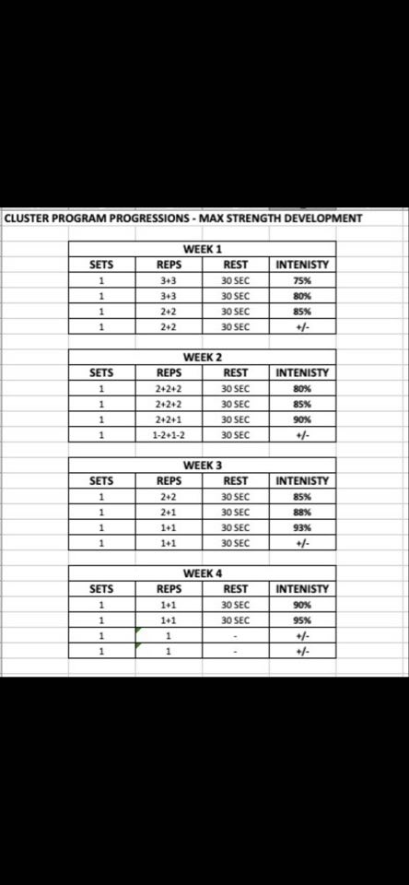

Technology
The use of the keiser machine, which can test for power output on pressing and pulling mechanics. This becomes useful for this training program as power output can be measured from the start to the end of the training program to determine if clusters set training can improve power output. The client had to perform 5 repetitions on the machine on week 1 and week 6. Each repetition became more resistant and required maximum effort on every single rep to allow a fair and reliable test.
Results
Power Output
The first week of the program was testing week on the Keiser press machine. The client performed 5 repetitions on the machine, while the resistance gradually increased each repetition. The results are measured in Peak Power watts.
Week 1 results: 1st rep – (L hand) 334, (R Hand) 335.
2nd rep – (L Hand) 390, (R Hand) 375.
3rd rep – (L Hand) 307, (R Hand) 336.5.
4th rep – (L Hand) 337, (R Hand) 328.5
5th rep – (L Hand) 238, (R Hand) 276.
Week 6 results: 1st rep – (L Hand) 437, (R Hand) 445.
2nd rep – (L Hand) 475.5, (R Hand) 471.5.
3rd rep – (L Hand) 501.5, (R Hand) 499.5.
4th rep – (L Hand) 509, (R Hand) 503.
5th rep – (L Hand) 492.5, (R Hand) 488.5.
Comparing both test results from week 1 and the finally week, week 6. There is a clear difference in peak power wattage. The average peak power wattage of week 1 was (L Hand) 321.2 & (R Hand) 330.2. The average peak power wattage for week 6 was (L Hand) 483.1 & (R Hand) 481.5. Comparing both weeks displays a 161.9 (L Hand) & 151.3 (R Hand) increase in peak power wattage over the 6-week period. (Denton, J. 2006) described that cluster set training improves the reduction of power output which is evident here as peak power has increased throughout the cluster set training block. Therefore, one can assume that the use of cluster set training may aid in power development within the bench press movement, which will be crucial in the aid for strength development and achieving the outcome goal of the program at achieving a new personal best.
Most studies have displayed that in order to improve power output, they say individuals should train with the velocity and resistance that optimises their mechanical power output (Newton, R, et al., 1994) However, (HARRIS, G, et al, 2000) (McBRIDE, J, et al, 2002) proposes that it is essential to use substantial training loads to fully recruit and to effusively train fast-twitch muscle fibres and motor units. In the training program the majority of the program is performed under heavy training load which is over 80% of the individual’s one rep max. Therefore, training under these circumstances allows greater recruitment of fast-twitch muscle fibres, which produce more power output than slow-twitch muscle fibres and to be accountable for an increase dynamic athletic performance (Lynch, G., et al, 2000). This is evident in the study as power has increased through the training program under the heaving training load stimuli and is evident that fast twitch motor unit recruitment was achieved.

Strength
Week 1 - The first session was the 1 rep max testing on the bench press, my client predicted a 140 kg bench, however he lost a considerable amount of body weight therefore did not have the certainty that he could achieve that. When looking at figure 2, the client performed 4 warm up sets, with ascending weight load with descending repetitions to keep him feel fresh and unfatigued. My clients last warm up set was 126kg which is 90% of his predicted 140kg Max. He then had an open weight set to try repetition on before his max, he performed 130kg and he said it felt heavy. Then for his 1 rep max he performed 135kg with a Rate of perceived exertion (RPE) of 9. Therefore, the testing for week 1 was done with a 135kg bench.
Week6 - My client had to perform another 1 rep max bench press, to determine if cluster set training was useful in development of strength while bench pressing. My client followed the same procedure in figure 2 for his final 1 rep max. He had a warm up set on 132.5. Then he had performed 140kg has his 1st attempted and he completed that with a 7 RPE. His 2nd attempt was at 142.5 and he completed this as well with an RPE of 9, and he left it there. Looking at week 1 to week 6 my client increased his bench press by 7.5kg as a result of performing cluster set training. That is a huge increase for 6 weeks and it wouldn’t have been possible if my client hadn’t have bought in to the program and was as regimented as he was.

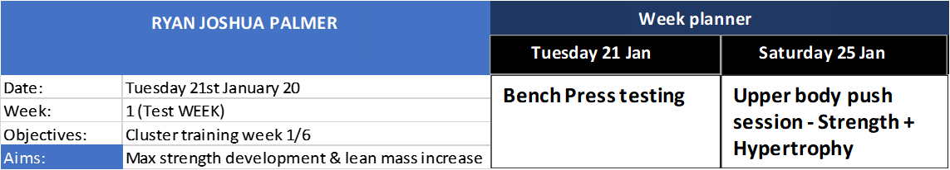
Figure 2 - This is a sample template of what my client would’ve received before for his sessions.
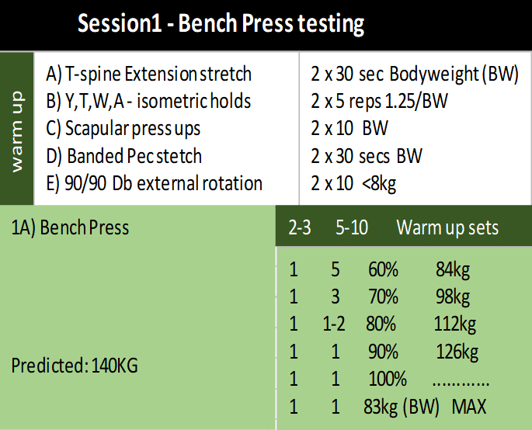

Critical evaluation
The topic of cluster set training has been researched with mix messages as the outcome. During my training program which implemented the use of cluster set training, my client who is an experienced athlete performed a new personal best one rep max bench press, as well as increase his overall peak power wattage in both left and right hand. Baring this in mind, the literature on this topic is fairly new. The training program itself was well designed, it allowed the athlete to perform high percentages of his 1 rpm for reps and sets, which he wouldn’t have been able to do if he was performing the set in traditional continuous repetition scheme. As the majority of the program was performed over the training load of 80% of 1 rep max, (Adams, K., et al. 1992) researched that training at that training load will ultimately increase maximum muscular strength and in turn also result in improved the development of power in athletic performance. Looking back on this study there was a few implications that made it more difficult than it should’ve been. The lack of research on the topic made the results very unpredictable and was uncertain about the outcome. However, both strength and power increased throughout the training program and also multiple studies implying that cluster set training is more beneficial over traditional continuous set training, as the inter rest period along with the heavy training load allows greater fast twitch recruitment as well as strength development. Therefore, I would implement this definitely into future training programs whenever the lifting progressions hit a plateau. If I were to do this again, I would research if longer or shorter rest periods could create about greater results in peak power wattage and increase the clients one rep max bench.

Word count: 2261

References:
- Adams, K., OʼShea, J., OʼShea, K. and Climstein, M., 1992. The Effect of Six Weeks of Squat, Plyometric and Squat-Plyometric Training on Power Production. Journal of Strength and Conditioning Research, 6(1), pp.36-41.
- Denton, J. and Cronin, J., 2006. Kinematic, Kinetic, and Blood Lactate Profiles of Continuous and Intraset Rest Loading Schemes. The Journal of Strength and Conditioning Research, 20(3), p.528.
- FROBÖSE, I., VERDONCK, A., DUESBERG, F. and MUCHA, C., 1993. [Effects of various load intensities in the framework of postoperative stationary endurance training on performance deficit of the quadriceps muscle of the thigh]. Zeitschrift Fur Orthopadie Und Ihre Grenzgebiete, 131(2), pp. 164-167.
- HAFF, G.G., WHITLEY, A., MCCOY, L.B., O'BRYANT, H.S., KILGORE, J.L., HAFF, E.E., PIERCE, K. and STONE, M.H., 2003. Effects of Different Set Configurations on Barbell Velocity and Displacement During a Clean Pull. The Journal of Strength & Conditioning Research, 17(1), pp. 95–103.
- HARRIS, G., STONE, M., O'BRYANT, H., PROULX, C. and JOHNSON, R., 2000. Short-Term Performance Effects of High Power, High Force, or Combined Weight-Training Methods. The Journal of Strength and Conditioning Research, 14(1), p.14.
- Iglesias-Soler, E., Carballeira, E., Sánchez-Otero, T., Mayo, X. and Fernández-del-Olmo, M., 2014. Performance of Maximum Number of Repetitions with Cluster-Set Configuration. International Journal of Sports Physiology and Performance, 9(4), pp.637-642.
- Lawton T, Cronin J, Drinkwater E, Lindsell R, Pyne D. The effect of continuous repetition training and intra-set rest training on bench press strength and power. J Sports Med Phys Fitness 44:361–367. 2004.
- Lynch, G., Hinkle, R. and Faulkner, J., 2000. Power Output of Fast and Slow Skeletal Muscles of MDX (Dystrophic) and Control Mice After Clenbuterol Treatment. Experimental Physiology, 85(3), pp.295-299.
- McBRIDE, J., TRIPLETT-McBRIDE, T., DAVIE, A. and NEWTON, R., 2002. The Effect of Heavy- Vs. Light-Load Jump Squats on the Development of Strength, Power, and Speed. The Journal of Strength and Conditioning Research, 16(1), p.75.
- MORALES-ARTACHO, A.J., PADIAL, P., GARCÍA-RAMOS, A., PÉREZ-CASTILLA, A. and FERICHE, B., April, 2018-last update, Influence of a Cluster Set Configuration on the Adaptations. Available: https://journals.lww.com/nsca-jscr/Fulltext/2018/04000/Influence_of_a_Cluster_Set_Configuration_on_the.6.aspx [Mar 26, 2020].
- Newton, R. and Kraemer, W., 1994. Developing Explosive Muscular Power: Implications for a Mixed Methods Training Strategy. STRENGTH AND CONDITIONING JOURNAL, 16(5), p.20.
- Stone, M., Keith, R., Kearney, J., Fleck, S., Wilson, G. and Triplett, N., 1991. Overtraining: A Review of the Signs, Symptoms and Possible Causes. The Journal of Strength and Conditioning Research, 5(1), p.35.
- Tufano, JJ Brown, L. and Haff, G., 2017. Theoretical and Practical Aspects of Different Cluster Set Structures. Journal of Strength and Conditioning Research, 31(3), pp.848-867.

