Assignment 1 & 2: Cloud Based Web Services
- Ava Kennedy 2003924
ACCA6024: Cloud Based Web Services

Table of Contents

1 Table of Contents 2
2 Introduction 3
2.1 Foreword 3
3 Requirements 4
4 Design 6
4.1 Potential Designs Approaches 6
4.2 Final Design of Website 8
4.2.1 Products Section 8
4.2.2 Account Creation 11
4.2.3 Login system 11
4.2.4 Courses Page 12
4.2.5 Using the admin page 13
5 Documentation 16
6 Testing 16
7 Demonstrative Video 17
8 Conclusion 18
9 References 19
10 Appendices 19
10.1 Appendix A: User Manual 19
10.1.1 Standard Users: 19
10.1.2 Admin User: 27

Introduction
This report aims to provide an extensive overview of the web application designed and developed for Premium Tuition, covering the user requirements and design of the web application and the testing of the website and its API.

Foreword
Some figures may be unclear due to their size. Full Miroboard here: https://miro.com/app/board/uXjVNILhzpI=/?share_link_id=489935685587.

Requirements
In order to design a website that suited the needs of Premium Tuition a set of user requirements were created for both standard user accounts and an admin account [figures 1 & 2].
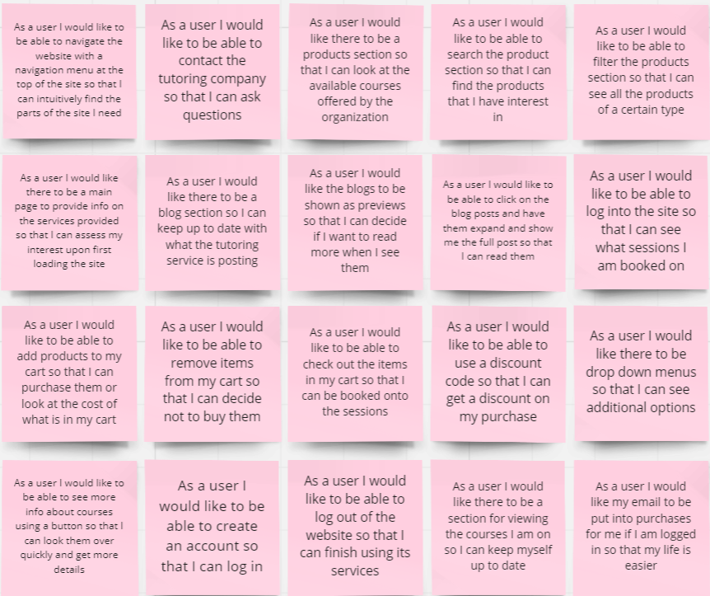
Figure 1 User requirements for standard users
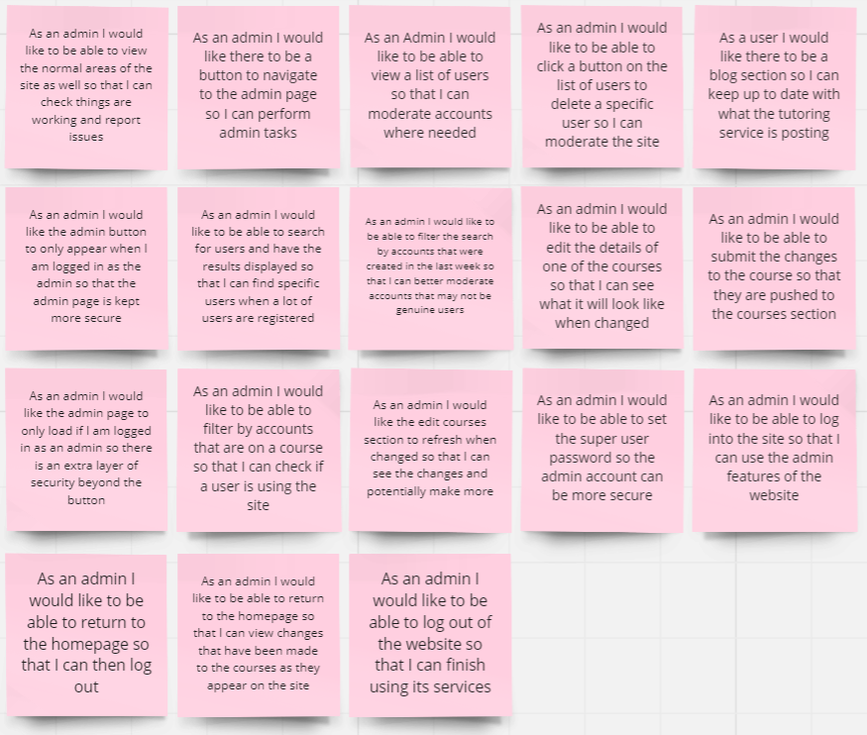
Figure 2 User requirements for an admin user
These user requirements stories were used to build a list of key features for the web application. The requirements and therefore features focussed on the experience of the users and how they would operate the web application. The following key requirements were defined:

- A Home page, so that the landing page of the web application can be appealing and useable.
- A Navigation Bar with dropdowns, for moving throughout the website.
- A Products Section to display the courses the user could buy.
- A cart that the user can add items to and make a purchase from.
- A blog section for the user to read from and to help with site engagement.
- Previews of the blogs
- An account creation process allowing users to make their own accounts.
- A user login system
- A user courses section so that users can view the courses they have purchased and revoke their purchases of courses.
- Alerts to let users know when they have completed certain user tasks successfully.
- An admin page that an admin user can access.
- Searching for users on the admin page
- Moderating user accounts
- Editing courses

Design

Potential Designs Approaches
To look at potential options for the design the user requirements were placed into user story maps, these broke down the requirements into user tasks that could then be designed and implemented into the web application. [see figures 3 and 4]
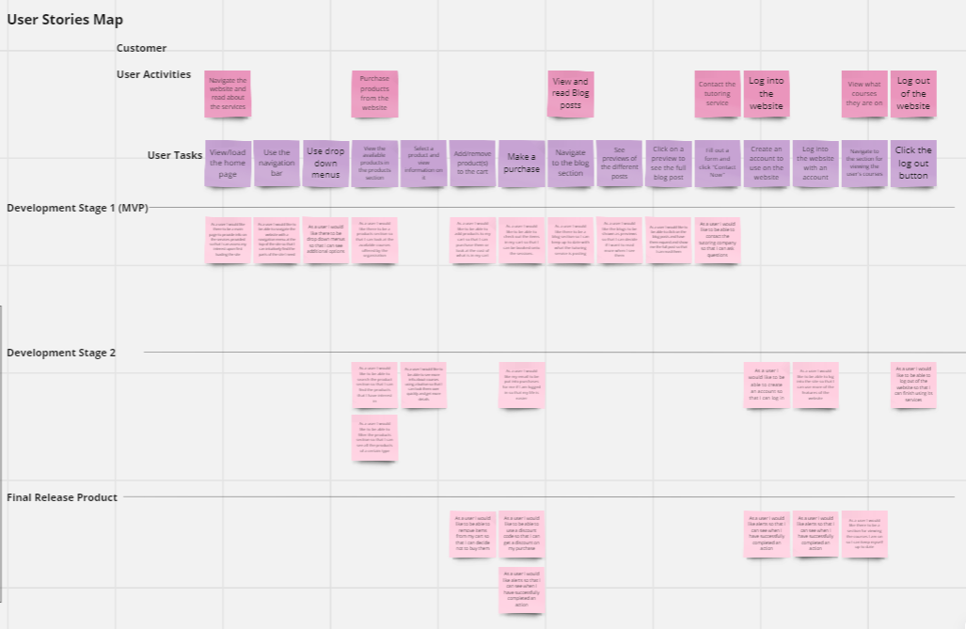
Figure 3 User stories map: Standard User
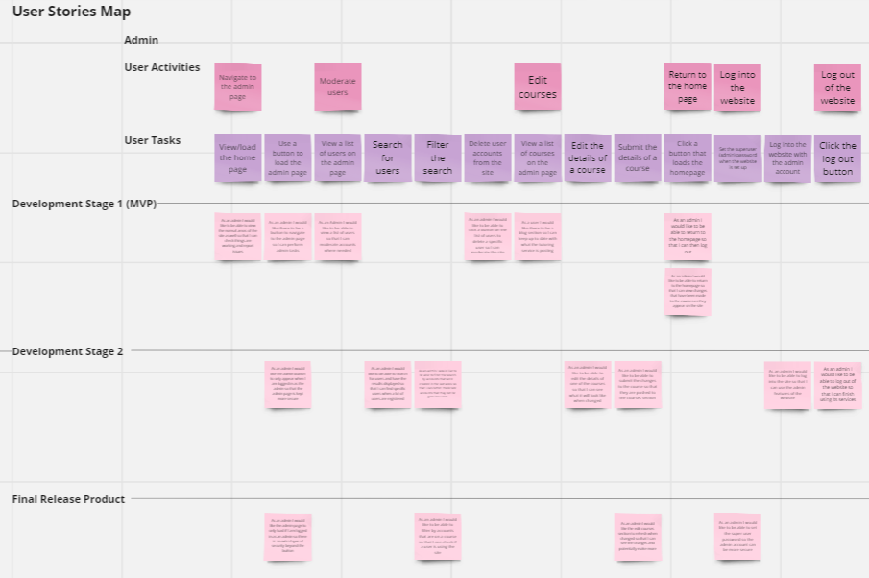
Figure 4 User Stories map: Admin User
At this stage in the design process the final appearance and specific design of the website was still flexible. Several possible designs were considered, different ways in which the user could complete their user tasks. Some of these ideas were conceptualised so they could be better considered. One example of this is the “Account” drop down [figure 5]
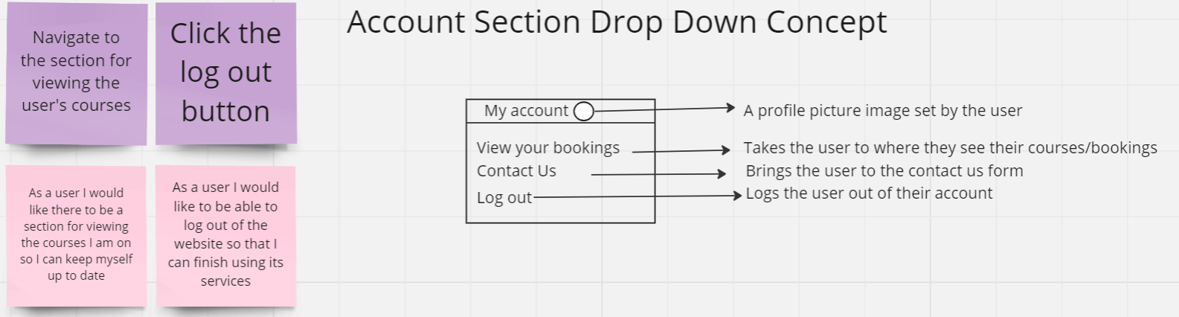
Figure 5 Initial concept for the account drop down
This was the first concept for the drop down used for activities that relate to a user being logged in. A similar design was used for the final design of the website, but it differed in crucial ways to this initial design. The profile picture was excluded from the final design as this was deemed to be out of scope. Additionally, “view your bookings” was replaced with “My Courses” to properly reflect the direction the design of the products section had taken, since the courses page focussed on the details of that course rather than a time or date when it would occur, like a booking would.
Another area of the website that needed to be considered was the navigation bar. The initial design idea for the navbar only included the products section, blog section and one of the contact us links. Notably it did not include the account drop down, which as can be seen in [figure 6] was included in the website title as well, which in this design was only the name of the website in a title font, which was later replaced in the final design by Premium Tuition’s own website logo design.
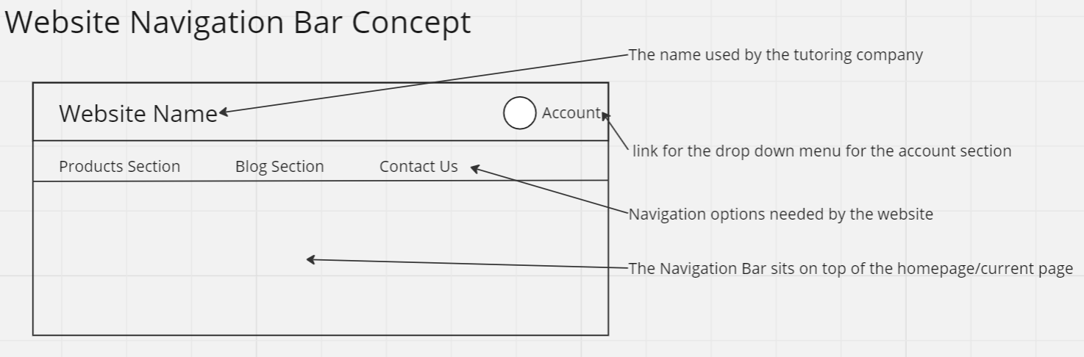
Figure 6 The initial concept for the website's navigation bar
As is evident in the final design of the webpage, this design was replaced by a navigation bar that also contained a link to the home page, account drop down, and the user’s cart, where purchases could be made.
Perhaps what changed most drastically in the design of the website was the products page, the initial design for the products page [figure 7] which was initially designed to hold a very large number of products.
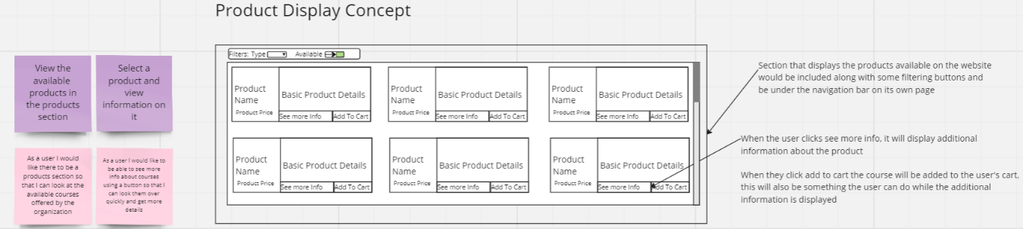
Figure 7 Initial concept for the product section
This approach was changed in the final design, as it was determined that accommodating for such a vast number of products was out of scope, the webpage was unlikely to need to display any more than 9 products, moreover, on release the client, Premium Tuition, only needed to display 3. This approach to design was much better suited to areas of the website where a great wealth of information would need to be displayed, such as the user list displayed on the admin page. Still there was a need for scalability in the products section.
Other designs were also considered for the admin’s use of the site, initially the designs leant towards there being multiple admin users. However, given the functionality of the site that design quickly moved towards one superuser performing all the admin operations of the site. This not only greatly reduces the possibility of a malicious user escalating their user privileges but is also a system that is more in line with the requirements of the webpage.

Final Design of Website
The final design of the website was one that could best fulfil the user requirements. The final design for the website consists of three views. The main view, where the home page, products section, blog section and the navigation bar are all displayed. As well as two secondary views, one to display the courses a logged in user has purchased and one to function as the admin page. This setup allows the website to function primarily on a single page, without the page needing to be refreshed.

Products Section
The products section on the website is where the user can view information on and purchase courses it is accessible from the navigation bar on the home page [figures 8 & 9].
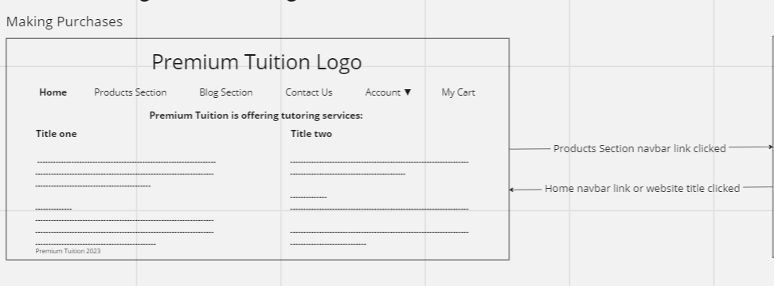
Figure 8 Navigating to the products section
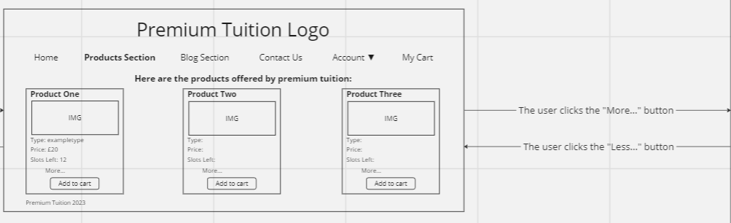
Figure 9 The products section
The products page was designed with user friendly containers each one acting as a small table displaying information on a course as well as providing the user with a means to purchase them. Any number of courses can be displayed in this way, although at present Premium Tuition only has three.
The products displayed here also have a description, extra detail that can be accessed using buttons [figure 10]. This was included in the design as it kept the page readable and user friendly.
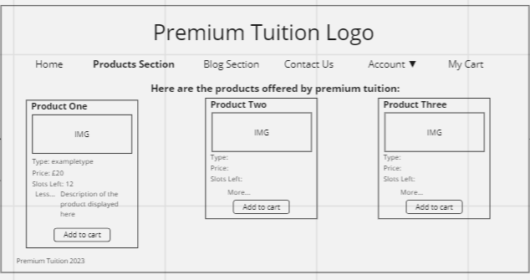
Figure 10 Viewing more info on a course
This is part of the way in which the products section was designed, with the experience of the end user in mind. In the same way, the buttons to add the course to the cart are still accessible when the description is being displayed [figure 11].
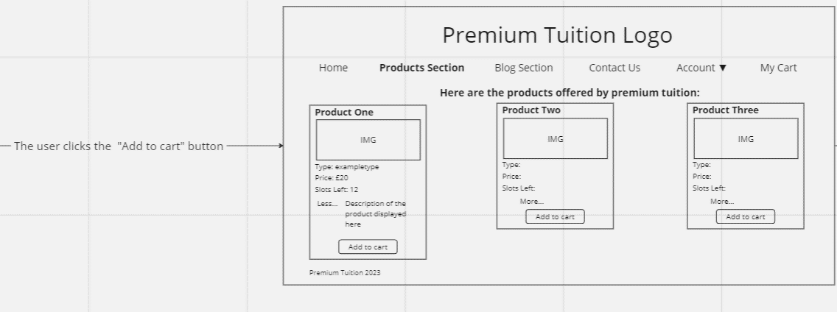
Figure 11 Adding a course to the cart
The cart is easily accessible from the products page, since it is included in the navigation bar, it is from here a user can view the items that they have decided upon and confirm their purchase [figures 12 & 13].
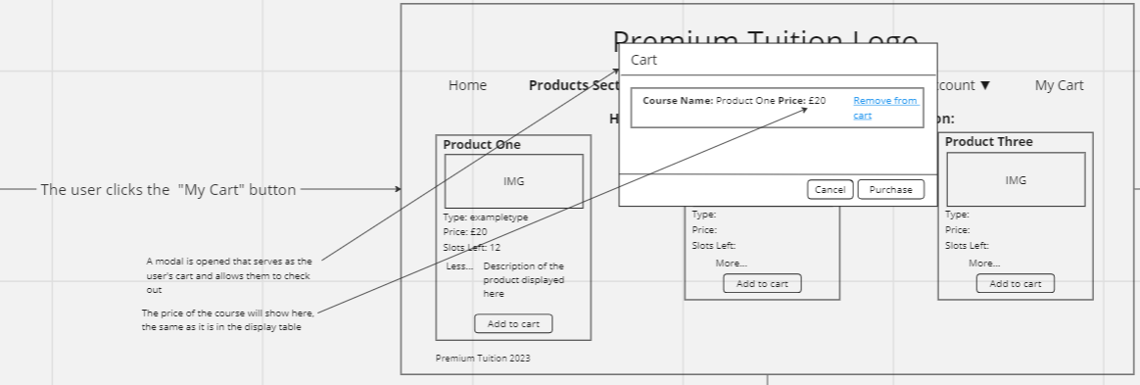
Figure 12 Viewing the cart
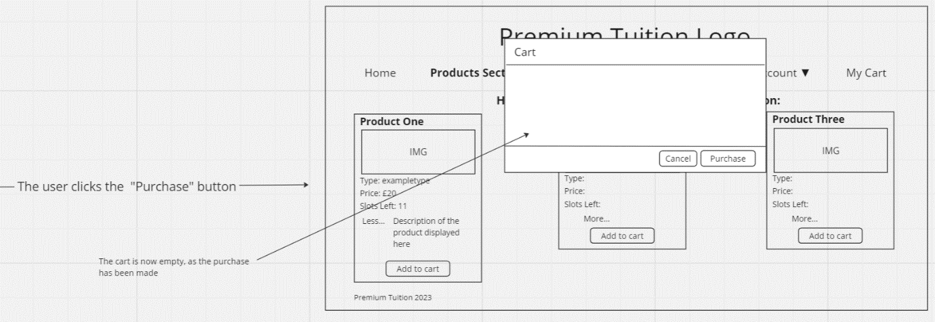
Figure 13 Making a purchase
The website is designed in such a way that the user is aware that a purchase has been successful.
Since a user may not always wish to purchase the items, they have placed in the cart, the website is also designed with the functionality to both cancel purchases and have items removed from the cart [figures 14 and 15].
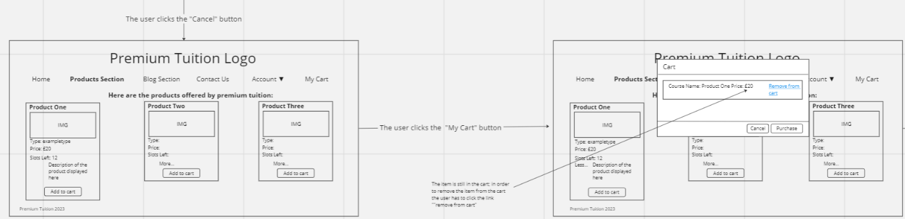
Figure 14 Cancelling a purchase and reopening cart
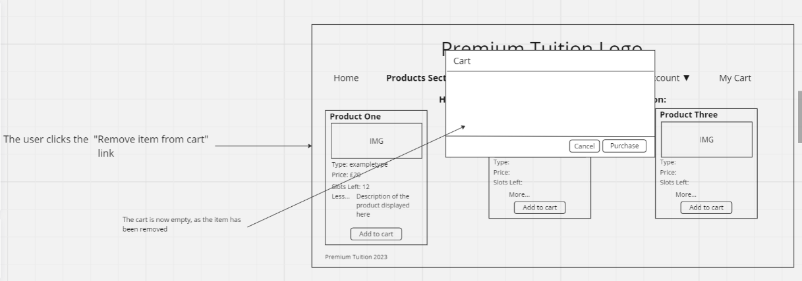
Figure 15 Removing an item from the cart
The user can see that the items is no longer in their cart, additionally, if there were two items in the cart only the one they click on will be removed, rather than having an “empty cart” button for instance. The website design allows for a user to remove a specific item over removing all items because it allows users to have an easier time when purchasing products and would not lead to mistakes such as adding the wrong product lead to all products needing to be removed.

Account Creation
Account creation is an important function of the website and should be simple and easy for the users to complete. For this reason, the following designs were implemented for navigating to, and using the account creation system [figures 16 & 17].
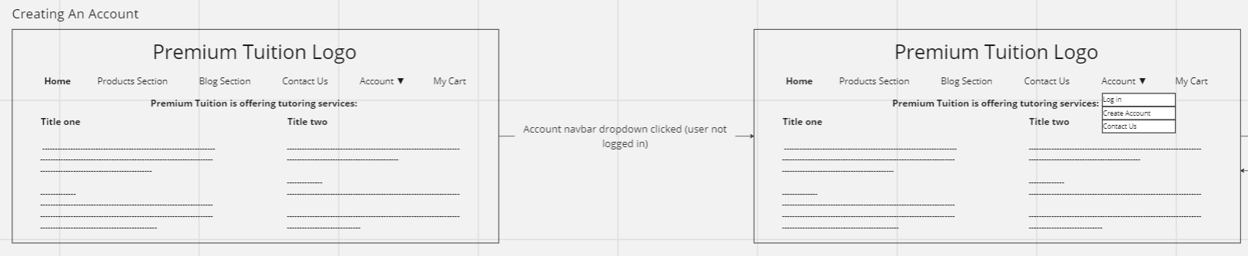
Figure 16 Account drop down clicked (no user logged in)
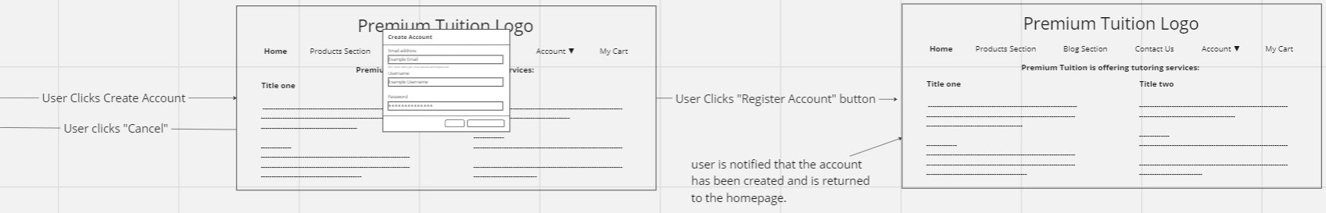
Figure 17 User account created

Login system
Users that already have accounts need a way to log in, in the same drop down as the account creation option there is also a log in option. Not only is this also in the place that users are most likely to look, any user creating an account will have seen it when creating an account. Upon selecting it users will be shown the modal to log in [figures 18 & 19]
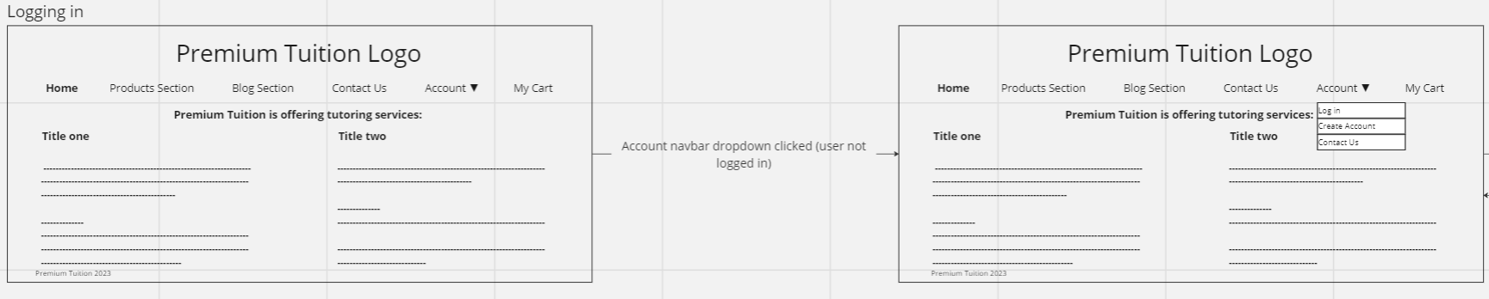
Figure 18 Account drop down opened (no user logged in)
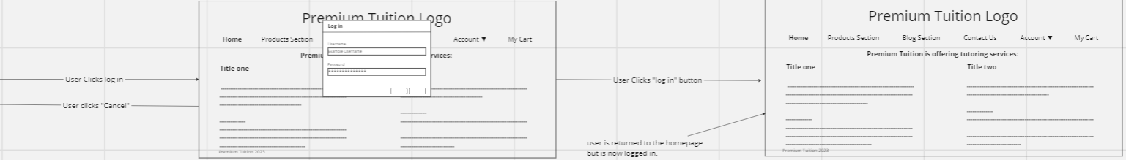
Figure 19 User logs into the website
Once a user is logged in and made aware of it when redirected to the homepage, they can then access the same account drop down, which now contains options suited to a user that is logged in, such as the ability to log out [figure 20].
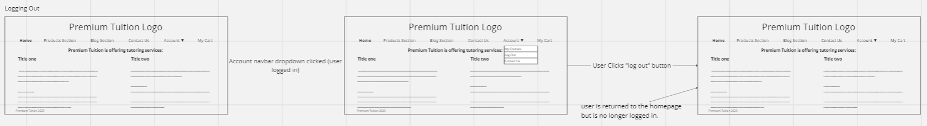
Figure 20 User logs out of the website
Once a user is logged out, the site will return to how it was, and they will no longer have access to the user specific content, like the courses page.

Courses Page
When a user is logged in, one of the services they have access to is the courses page from this view the user can view and leave their courses [figures 21 and 22].
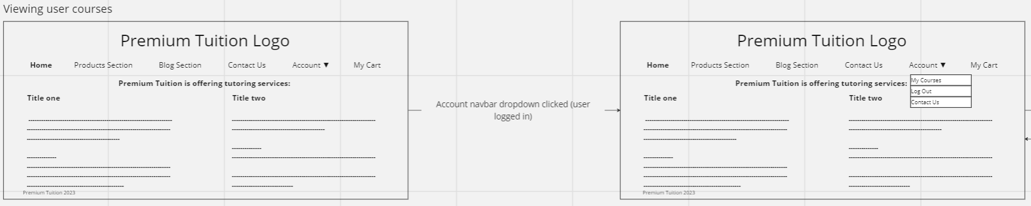
Figure 21 Account drop down clicked (user logged in)
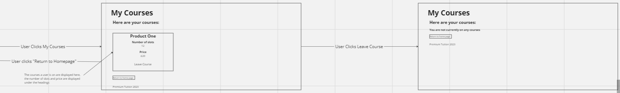
Figure 22 Courses page opened, user leaves a course
The courses page was setup this way, as a separate view to ensure that the user could only access it when they were logged in, and to increase the security of the information of the users who access it. It is a function first design and allows users to leave courses that they no longer wish to take part in

Using the admin page
The admin page is a view that handles all of the admin features, it was designed with the admin user in mind rather than the standard users that most end users would be. When the admin user is logged in there is an extra button on the home page that leads to the admin page [figure 23].
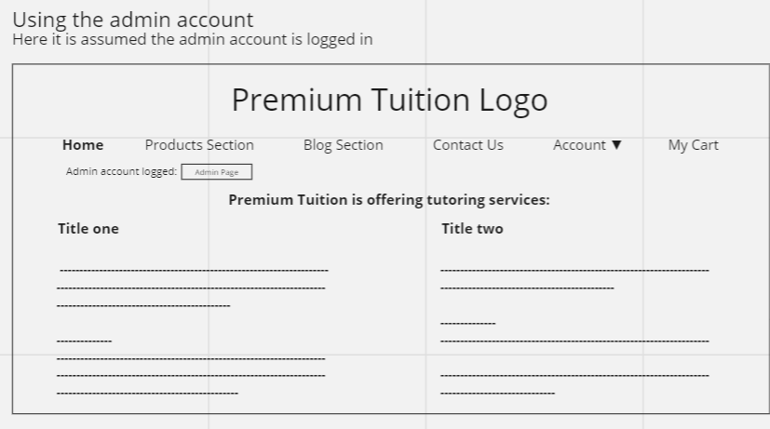
Figure 23 The home page, when the admin is logged in
This was designed this way because it meant that the navigation to the admin page was entirely separate from the actions of standard users, which is a more secure approach to the admin tasks.
The admin view is a page which has two functions, the observation and moderation of users, and the adjustment of course details [Figure 24].
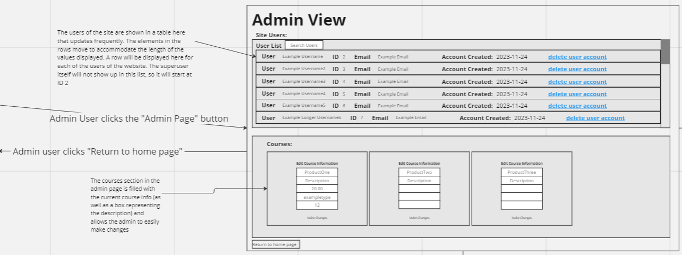
Figure 24 The admin page
The admin page is set up in a function first manner as that more closely matches the requirements of an admin account. The view is set up with a user list and courses section both displayed at once and uses a simple button to allow the admin user to return to the homepage.
The courses section is where the admin would make changes to the information of the courses available on the website [figure 25 & 26].
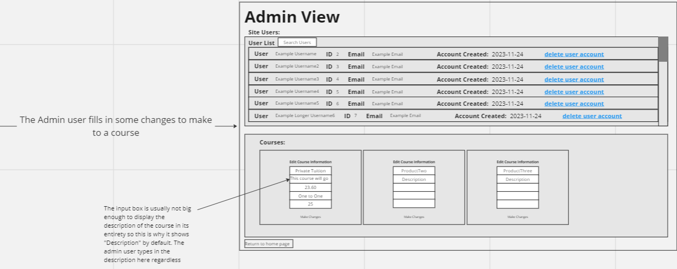
Figure 25 The admin user fills in changes to a course
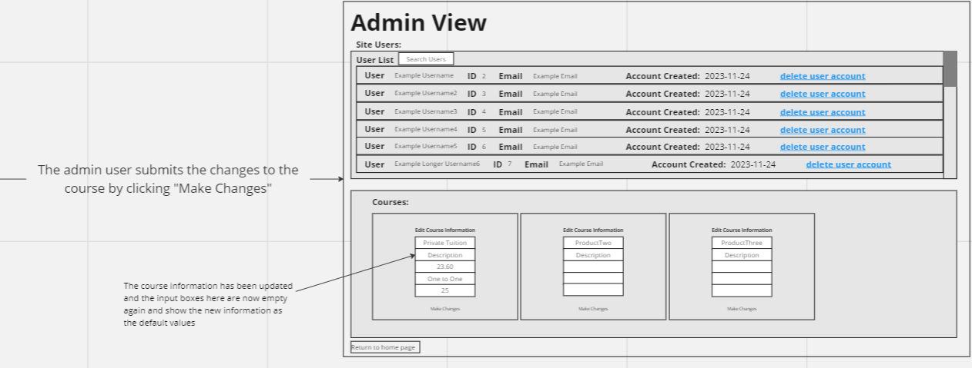
Figure 26 The changes to the course are submitted
The approach to the updating of information for the courses was one that allowed an admin user to make changes to the courses that varied in scale, only the fields the admin user enters information into will be updated, and the current information is shown where the admin enters those changes. Additionally, since the course information section refreshes when it is used to make changes it can be used to make iterative changes to courses.
The other aspect of the admin page, the user list, is designed in a way that allows an admin user to easily search through and moderate user accounts [figure 27].
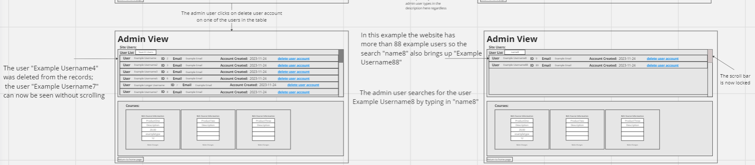
Figure 27 The admin page being used to remove a user and search for users
The userlist was designed to allow the admin to easily moderate users by clicking a link next to their information that removes their account from the system. This design focuses on ease of use for the admin.

Software Testing
The following template was used to develop software tests to test the functionality of the web application and its API:
Test Case Id | Test Scenario | Pre-conditions | Test Steps | Expected Result | Actual Result
[1] [2]
The following tests were developed:
Test Case Id | Test Scenario | Pre-conditions | Test Steps | Expected Result | Actual Result
1 | Purchasing a course | Account logged in | Add a course to the cart  Purchase the course | The web application makes a request to the API and the API updates the database | The web application makes a request to the API and the
2 | Removing a course from the cart | Course has been placed in cart | Remove the course from the cart  Click purchase to ensure it was removed properly | The web application makes no requests to the API as there is nothing in the cart, the database is not updated | The web application makes a request to the API to purchase nothing, the database refuses the request, no purchase is made.
3 | Logging into an account | Account is already created | Enter Account Details  Click log in and log into the account | The web application makes a request to the API and the API logs the user in, the webpage changes based on this | The web application makes a request to the API and the API logs the user in, the webpage changes based on this
4 | Creating an account | N/A | Enter Account details and click create account | The web application makes a request to the API and an entry is added to the database for that account | The web application makes a request to the API and an entry is added to the database for that account
5 | Logging in as an admin | N/A | Enter superuser account details when logging in | The web application makes a request to the API and the API logs the user in as a superuser, who can now access the admin functions | The web application makes a request to the API and the superuser is logged in.
6 | Editing course information | Admin account is logged in and on the admin page | Enter the course information to be updated Select “make changes” | The web application makes a request to the API and updates the information stored on the course | The web application makes a request to the API and updates the information stored on the course
7 | Revoking a course | User is logged in and a course has been purchased | Navigate to “my courses” Click “revoke course” | The web application makes a request to the API and the purchase is deleted | The web application makes a request to the API and the purchase is deleted
8 | Admin deletes user | Admin user is logged in and on the admin page | Click on “delete user” next to the target user | The web application makes a request to the API and the user is deleted | The web application makes a request to the API and the user is deleted

Known Bug Documentation

Blog Page and Drop-Down Bug
When a blog is accessed from the blog page the account drop down is no longer accessible to the user unless the page is refreshed.

Purchasing Alert Bug
When a purchase is made directly after a previous purchase the alert for the purchase being made will not be displayed this can also be avoided by refreshing the page.

Demonstrative Video
https://clipchamp.com/watch/ioZvvGO9gqG
https://youtu.be/FKOGHA7laRw

Conclusion
In conclusion, the report provides a comprehensive overview of the design, development, and testing of a web application for Premium Tuition. The focus on user requirements, design approaches, and the final implementation reflects a meticulous process aimed at meeting the needs of both standard users and administrators.

References
[1] Rajkumar, ‘How to Write Test Cases: Test Case Template With Examples’. Accessed: Jan. 14, 2024. [Online]. Available: https://www.softwaretestingmaterial.com/test-case-template-with-explanation/
[2] L. Baresi and M. Pezzè, ‘An Introduction to Software Testing’, Electron. Notes Theor. Comput. Sci., vol. 148, no. 1, Art. no. 1, Feb. 2006, doi: 10.1016/j.entcs.2005.12.014.

Appendices

Appendix A: User Manual
The following is a manual intended to instruct end users of the website and covers both the use of the admin account and the creation and use of standard user accounts.

Standard Users:

Account Creation
To create an account a user should first navigate to the “Account” drop down menu on the navigation bar [Figure 28].
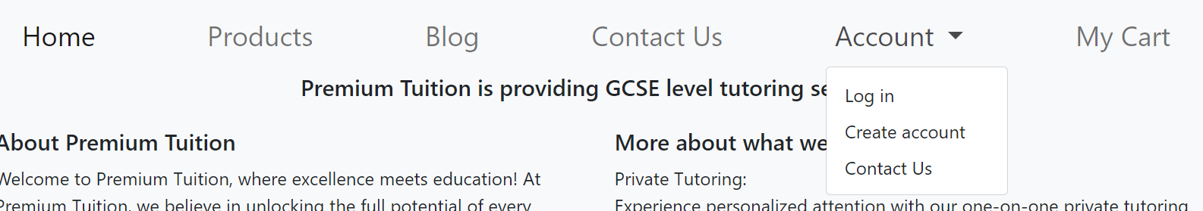
Figure 28 Navigating to account creation

The user can then select the option to create an account, they will then be prompted to enter an email address as well as a username and password. Note that a user’s username must be unique [Figure 29].
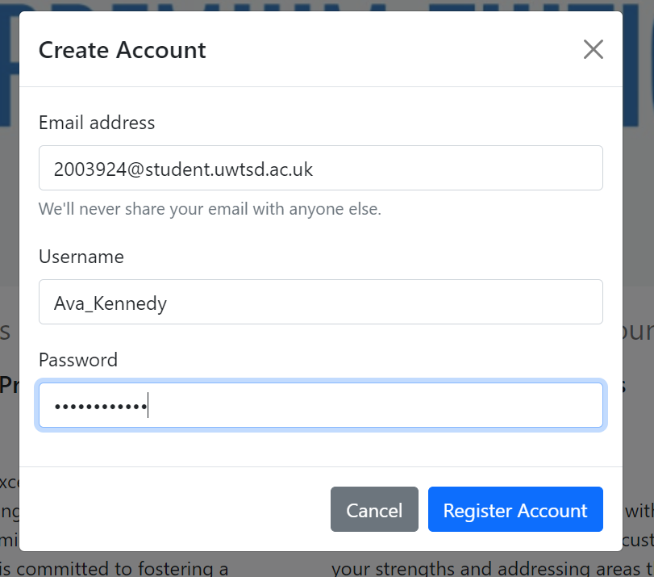
Figure 29 Entering account details

If account creation is successful, then the user will be alerted that their account was registered successfully.

Logging Into the website
Users can log into the website by accessing the same dropdown that is used for account creation [Figure 30].
Figure 30 Navigating to log in
The user should then select the option for logging in, at which point they will be prompted to enter their username and password, thought notably not their email address [Figure 31].
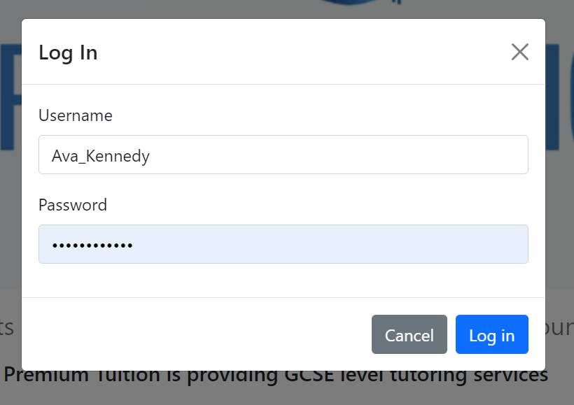
Figure 31 Entering information for log in
Once the user has entered their details and clicked “log in” they will be alerted that they have successfully logged in, assuming their details were correct.

Logging Out of the website
When a user is logged in, the account drop-down displays some new options; this includes the “log out” option, which replaces the “log in” option [Figure 32].
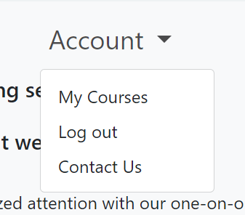
Figure 32 New drop down options
Once the user clicks this button, they will be logged out, and the drop-down menu will once again display its default contents [Figure 33].
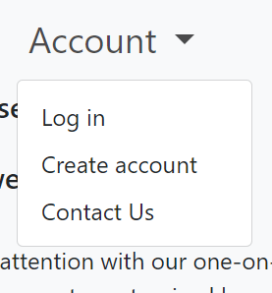
Figure 33 Default drop down options

Purchasing Products
The current products offered by Premium Tuition are courses, however there is room for this to expand. To purchase a course the user should select the “products” option on the navbar, which will display the products section [Figure 34].
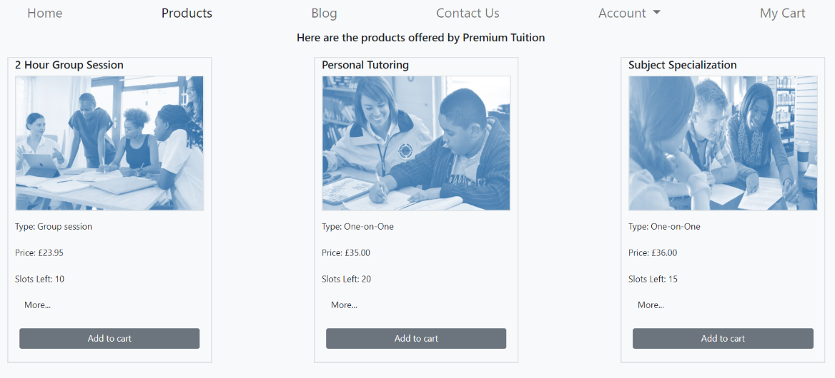
Figure 34 Product Page
The user can then add courses to their cart, by clicking on the “Add to cart” buttons. Once a user has added items to their cart they can click on the “My Cart” option in the navigation bar [Figure 35].
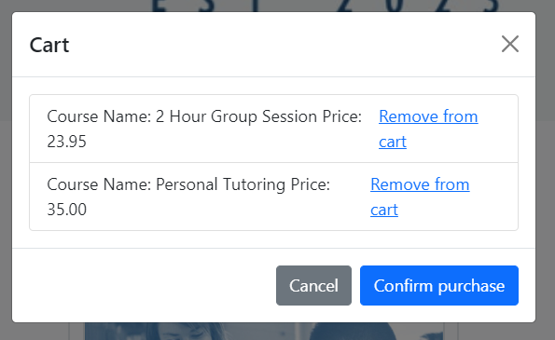
Figure 35 The cart with items in it
To purchase the courses in their cart the user must then click the “Purchase” button. The user will then be told that their purchase was a success. The user can also remove items from their cart by clicking the available “remove from cart” links [Figure 36].
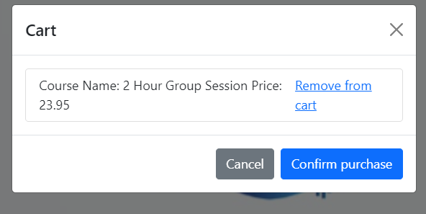
Figure 36 The cart after an item was removed

It is worth noting that a user cannot buy two of the same courses, this is because there is a limited number of spaces on a course each week.
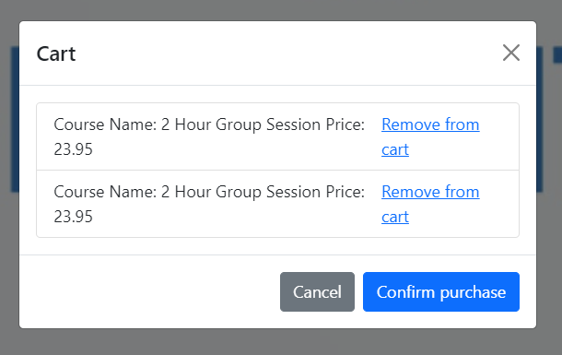
Figure 37 Two of the same product in the cart
In the above example clicking the “Confirm purchase” button would alert the user that they cannot book onto the same course twice [Figure 37], but if a different product were available, it would perform the purchase multiple times.

Viewing courses
To view their courses a user must navigate to the “Account” dropdown while logged in, when they do one of the options presented will be “my courses” [Figure 38].
Figure 38 My courses option
When a user selects this option, they will be taken to a page where their courses will be shown. From here the user can view the courses they are on and are given the option to leave them [Figure 39].
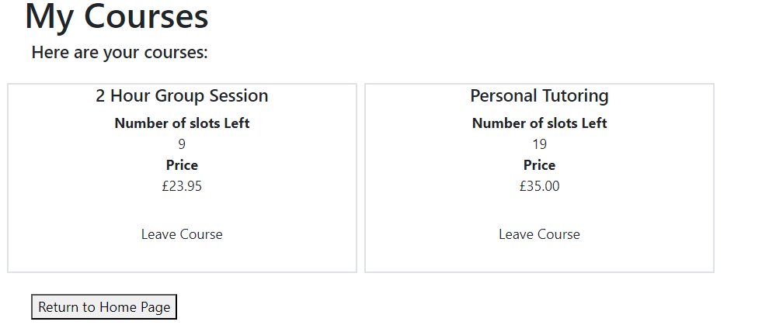
Figure 39 The user courses page

Leaving courses
Users can leave their courses by clicking the “leave course” button on the course they wish to leave. After they do so their registration to the course will be undone [Figure 40].
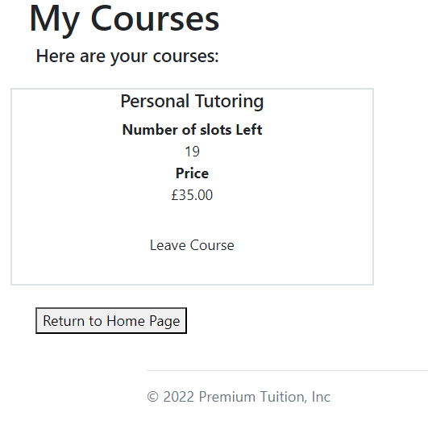
Figure 40 The user course page after one of the courses has been left

Contacting Premium Tuition
To contact Premium Tuition from their website a user can navigate to the drop down “Account” and click “contact us” or select “contact us” in the navigation bar [Figure 41].
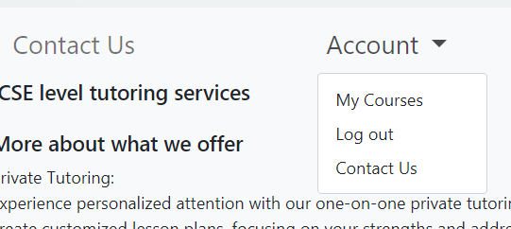
Figure 41 Both ways of contacting Premium Tuition
Once the user does so, they will be prompted to enter their email and a message and then can send the message by clicking “send” [Figure 50].
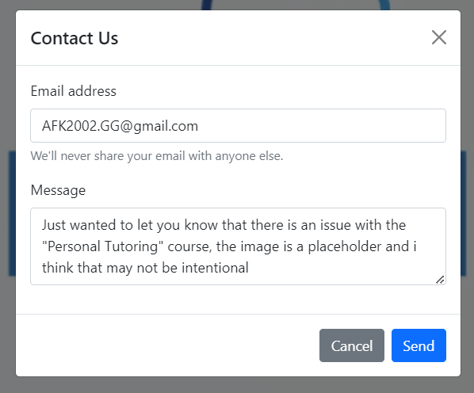
Figure 42 Example of a message about to be sent

Reading Blog Posts
To read a blog post the user must first navigate to the blog section by clicking the “Blog” button in the navigation bar [Figure 43].
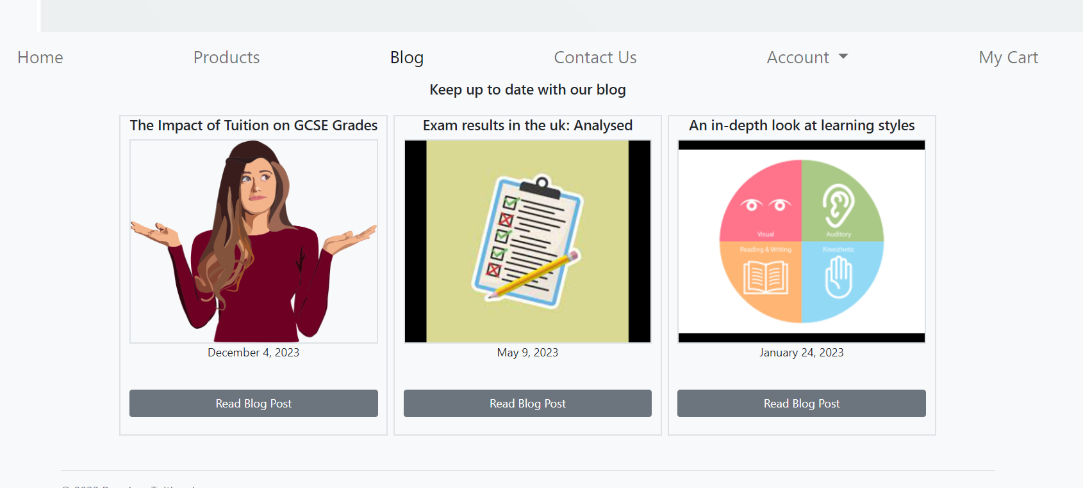
Figure 43 The blog Page
The user can then view the names and dates of the different blogs, and when they have selected one to read click “Read Blog Post” doing so will open their chosen blog and allow them to read it [Figure 44].
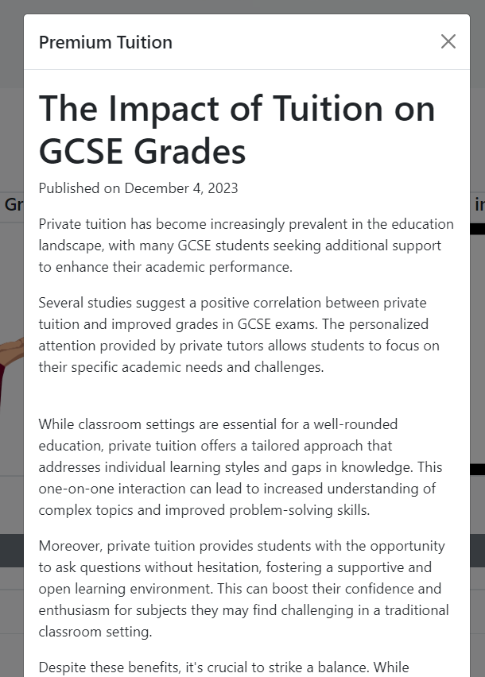
Figure 44 One of the blogs after being opened

Admin User:

Logging In with the Admin Account
If the user logging in is an admin, they should enter the password that was set for the superuser when the application was set up and the username “superuser” [Figure 45].
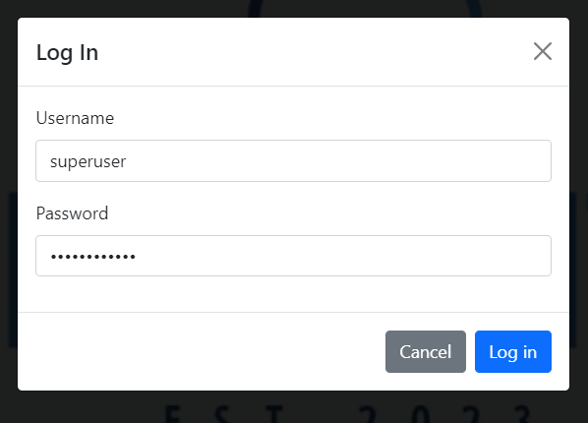
Figure 45 Admin account being logged in
This will log them into the admin account allowing them to perform the tasks associated with the account. It is worth noting that the admin account is not set up to be used as a normal account, and this is not something that is recommended.

Accessing the Admin Page
To access the admin page the admin user should click the “Admin Page” button that appears under the navigation bar when the admin account is logged in [Figure 46].
Figure 46 Homepage with admin page button
This will take them to the admin page, where the admin functions of the website are performed.

Viewing and moderating site users
After navigating to the admin page, the admin will see a list of users titled “user list” this list will contain all the user accounts on the site excluding the admin account [Figure 47].
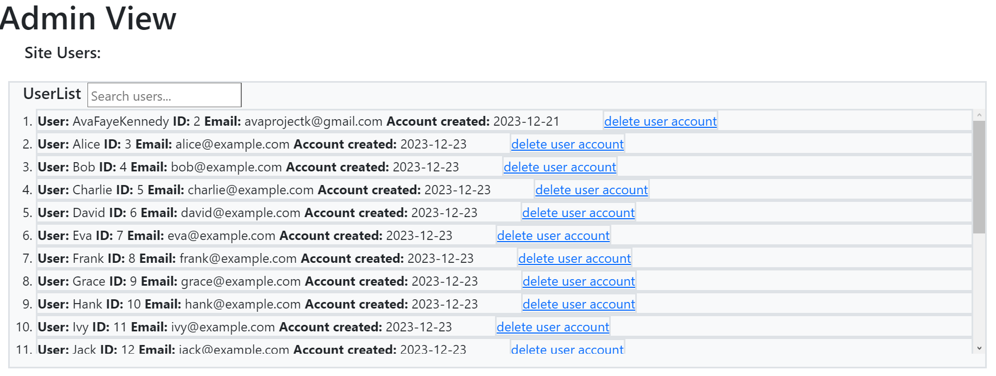
Figure 47 The user list in the admin view
To moderate a site user, the admin can delete their account, by clicking the “delete user account” link. This should be done if the admin has confirmed beyond reasonable doubt that the user is malicious in some way.
For example, they could delete the user “Jack” for attempting to gain admin access without authorisation and the accounts “Bob” and “Eva” for being the same user creating new accounts and trying to avoid a ban [Figure 48].
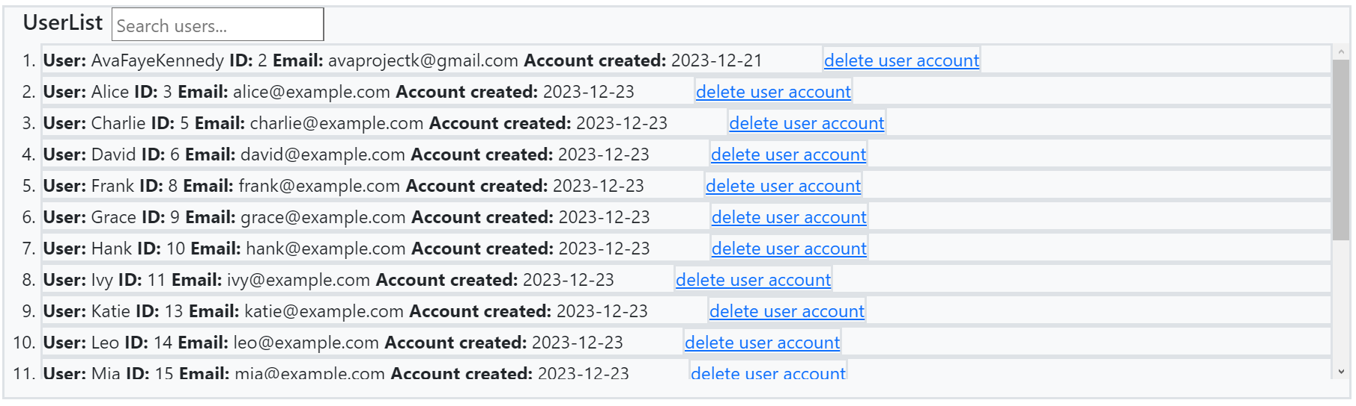
Figure 48 User list after example malicious accounts have been removed

Searching for site users
While on the admin page, the admin user can search for user accounts by username, they do this by entering what they want to search for into the search bar. The user list will then display any users whose username contains what was entered into the search bar. This search is not case sensitive [Figure 49].
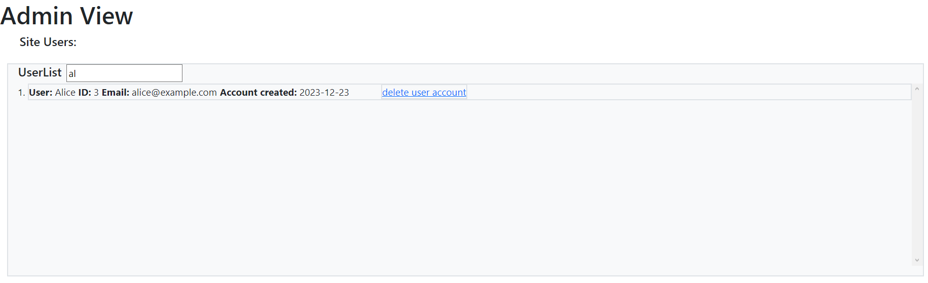
Figure 49 The search function being used

Viewing/Editing Course Information
The admin page also shows the admin information on the courses currently available on the site [Figure 50].
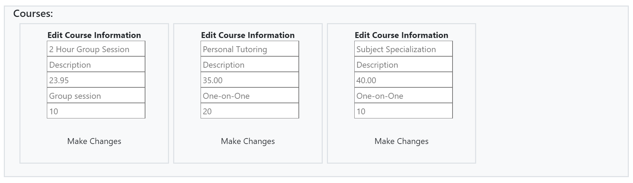
Figure 50 Information on courses shown on the admin page
The admin can then make changes to a course by first typing those changes into the text fields that correspond to what they want to change, which is evident as the default text in the fields is the current information [Figure 51].
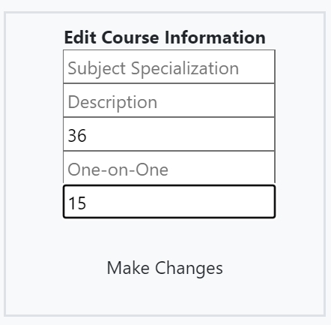
Figure 51 Changes being made to a course
The admin user can then click the “Make Changes” button, which will submit the changes, as evidenced by the fact that the text fields will empty, and the default text will now show the new information [Figure 52].
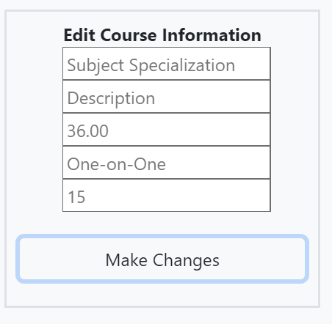
Figure 52 Changes made to the course being submitted

