3/24/2025 LDE Assignment 1

E-Portfolio
Module Name: Learning In the Digital Era Module Code: ACCA 4025

Student Name: Francisca Lerka Fernandes
Student ID: 2510888
Group: 2

Lecturer’s Name: Koushik Modak

E-Portfolio Link: https://sites.google.com/view/francisca-e-portfolio/welcome

University of Wales Trinity Saint David
LONDON CAMPUS

Table of Content
Introduction 3
Task 1: Essential Academic and Employment Skills 3
A) Report on Essential Academic and Employment Skill 3
B) Evaluation of Task 1(A) based on Similarity report 4
Task 2: Collaborative Mind Map and Individual Poster 5
Mind Map 5
Poster 6
Task 3: Virtual Collaboration and Scribbr 7
Report on Virtual Collaboration 7
Task 4 9
A) E-Portfolio Creation and Evaluation 9
B) Illustrative Review of E-Portfolio tool Selection. 9
Conclusion 9
References 10
References for Task 1 10
References for Task 3 10
E- Portfolio 11
Task 1: 11
Task 2: 11
Task 3: 13
Task 4: 14

Introduction
The CertHE Computing Skills for Workplace project is aimed at acquiring the necessary academic and professional skills needed to be successful in the modern world of computing. It identifies such core skills as communication, teamwork, problem-solving, and digital literacy that are critical both in studying and in the workplace. The first task determines necessary skills that make a person career-ready, whereas the second task focuses on teamwork by using an academic poster and collaborative mind map on the premise of Life is a Team Sport. The third task exemplifies the application of automatic referencing solutions such as Scribbr in order to promote academic honesty and effectiveness in research. These activities combine both theoretical and practical knowledge and, therefore, assist students in attaining confidence, flexibility, and professionalism. The project eventually equips the learners to work successfully in teamwork and technology-based work settings, which is increasingly significant in the attainment of academic and professional success as a team to achieve success.

Task 1: Essential Academic and Employment Skills

A) Report on Essential Academic and Employment Skill
In a rapidly changing profession like computing, educational and occupational achievements lie in the ability to excel at required transferable skills that underpin the performance in education and work environments. The most important of them include communication, problem-solving, time management, teamwork, and digital literacy [1]. Good communication enables the computing professionals to simplify the technical details, write code, and cooperate with the clients and co-workers. Equally, problem-solving improves analytical ability such that people can be in a position to debug programs and create effective algorithms to satisfy real-life requirements [2].
Time management is also critical in maintaining balance of coursework, project deadlines, and lifelong learning, which is a fundamental skill in an aggressive IT environment. Experience Teamwork helps in software development projects where the cooperation of programmers, designers and testers will be successful [3]. Adaptability is also a factor because professionals should upgrade skills on a regular basis in accordance with the new technologies of cloud computing, AI, and cybersecurity, among others [4].
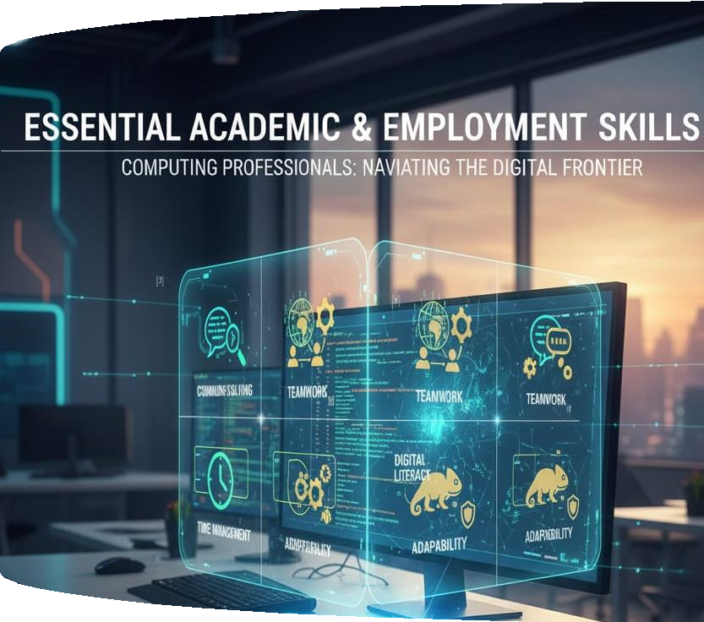
Lastly, all these skills are supported by digital literacy, which helps learners to make use of online resources, research databases, and teamwork tools. In the case of computing students, the skills accumulated through learning this skill enable them to be employable and are a stepping stone to lifelong career development. Through the enhancement of these competencies, graduates will be able to join the current digital labor force without fear and be a productive force when it comes to technological innovation.

B) Evaluation of Task 1(A) based on Similarity report
My Turnitin similarity score after handing in my summary was 0% and this shows that I was writing with a majority of my work and that I have cited the appropriate sources. To get the score further down, I may be more effective in paraphrasing source materials and not using long quotations. I would also verify every reference to make sure that I am using the IEEE guidelines of formatting. Assessment according to the Generic Assessment Criteria I would rate myself at 85% since my summary is well structured, critically understood the necessary skills and correctly referenced.
Nevertheless, I will be able to enhance my visual design and paraphrasing in further submissions to reach higher academic level.

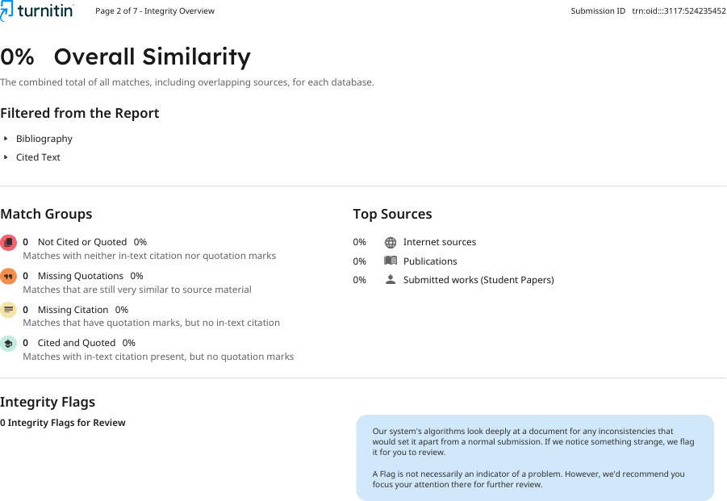

Task 2: Collaborative Mind Map and Individual Poster

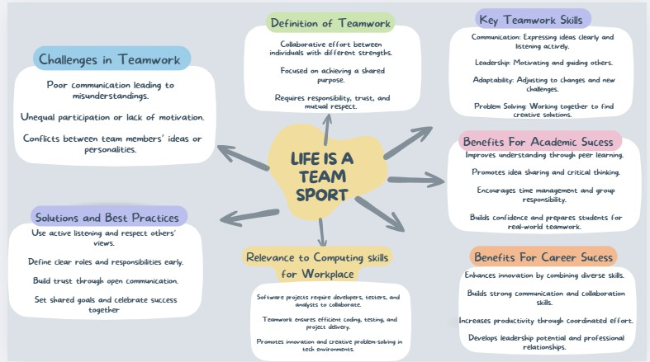
Mind Map

Poster
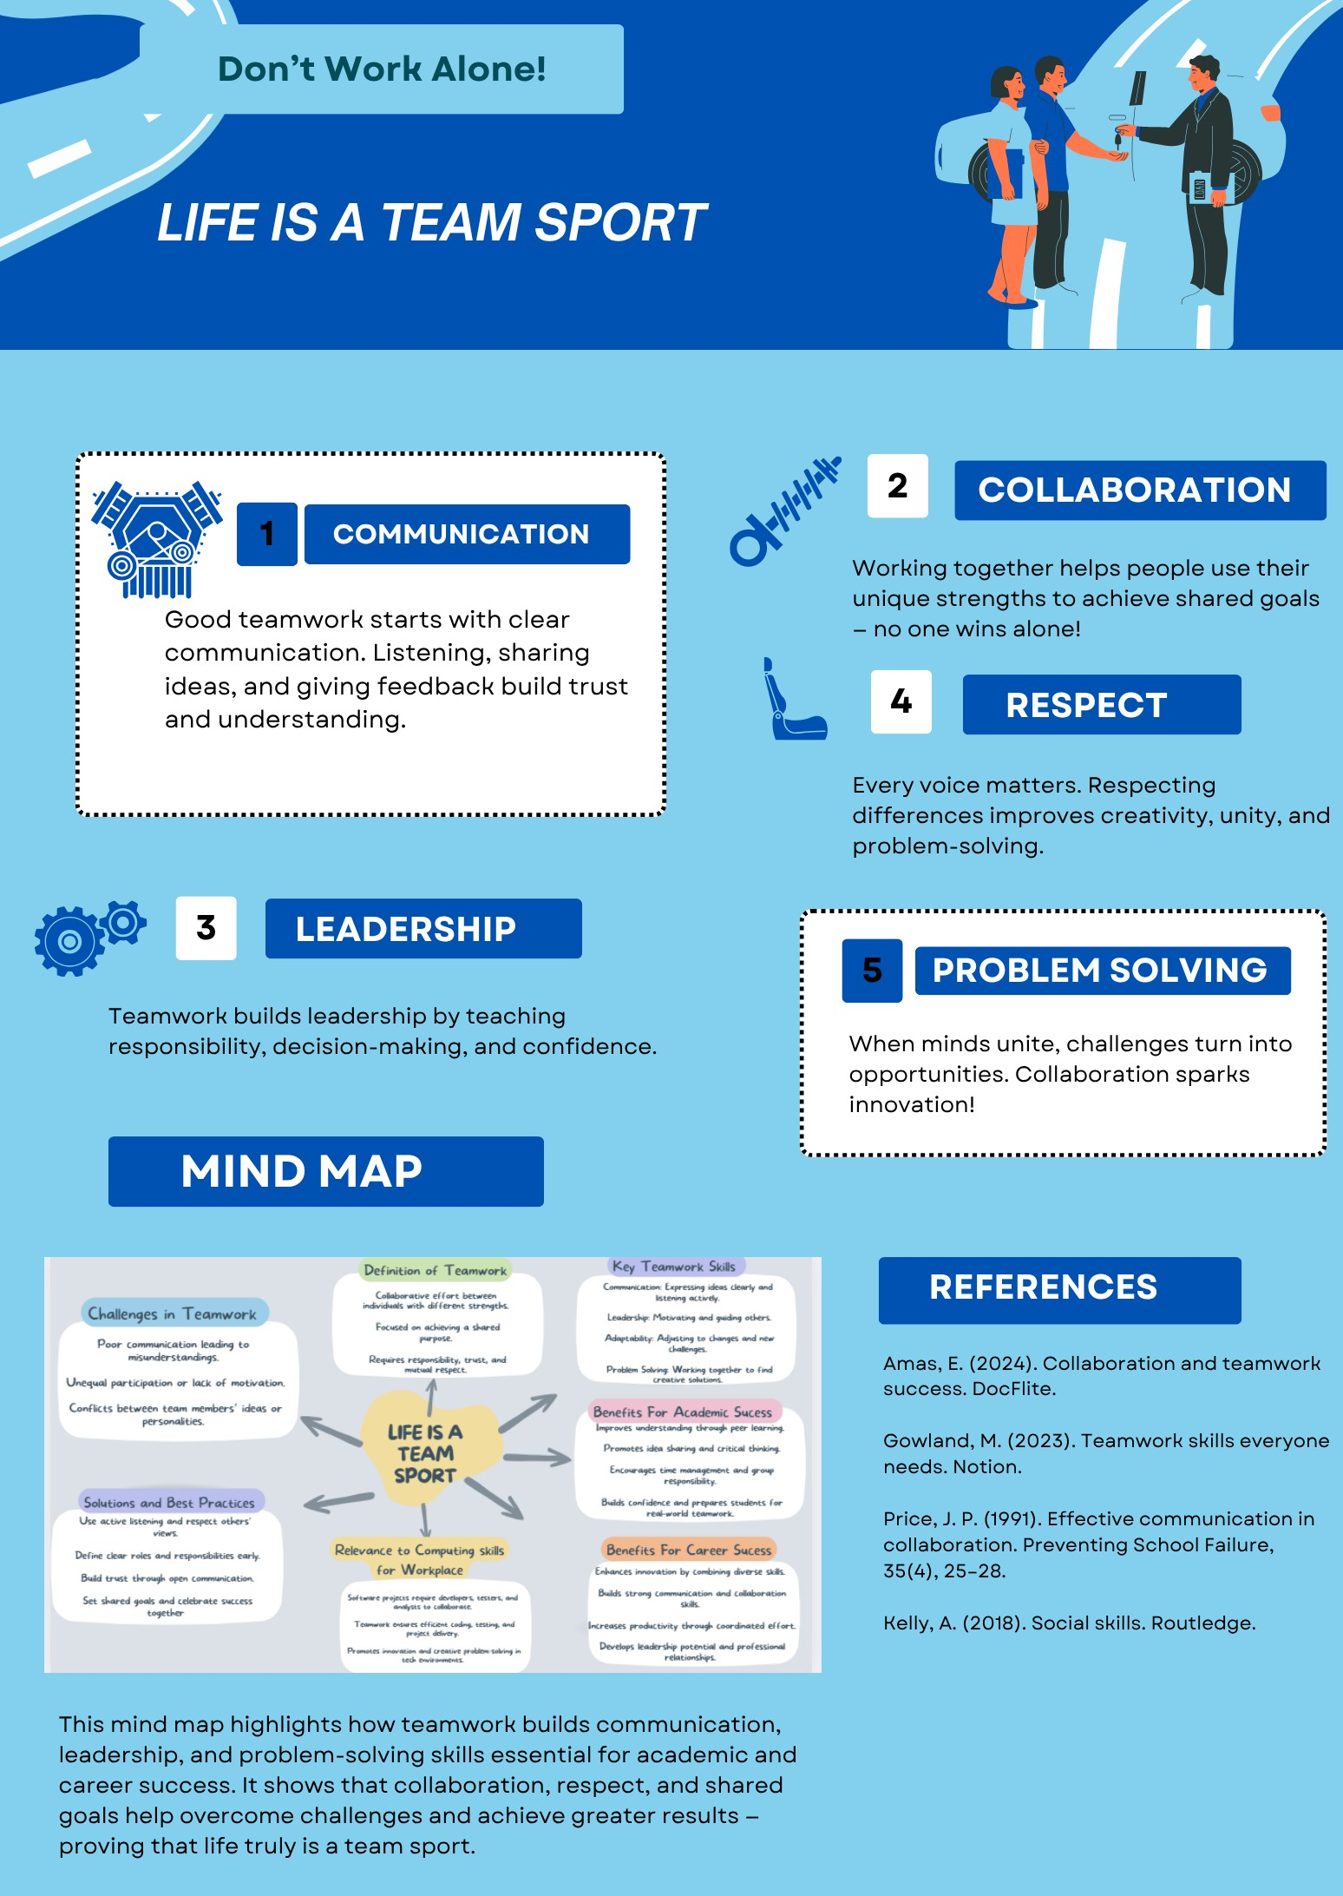

Task 3: Virtual Collaboration and Scribbr

Report on Virtual Collaboration

Summary
Virtual collaboration has been introduced as a paradigm of fundamental concern to computing professionals by the growing global work teams and remote working conditions [5]. It allows geographically spread people to cooperate through digital tools like Microsoft Teams, Slack, or cloud-based code repositories, which expands the flexibility, the access to specialized expertise, and the efficiency of resources.
According to studies carried out on virtual teams, there is an opportunity that high performance is attained by organizations that have a group of people scattered in the organization, in case expertise is matched well to the task of an organization regardless of cost of coordination [6].
Global talent accessibility is one of the key advantages of virtual collaboration access—allowing remote involvement, computing companies can combine experts across geographic borders, speeding up the innovation process and breaking the geographical boundaries. An example is the virtual work research whereby digitally empowered virtual teams enable firms to access expertise beyond their national boundaries. Another tool that can facilitate asynchronous work and documentation that can be used to support productivity, knowledge sharing, and continuity in software development cycles is collaboration tools [7].
Nonetheless, virtual collaboration also presents different problems: the lack of trust, social cues, communication problems, cultural and time dispersion, and the coordination issues mediated by technology. An example is the research on virtual teams that has pointed out that even in dispersed teams, adding value may be achieved, but that with over 30-50 percent of the participants being away, the coordination load may tend to overwhelm the advantages [8]. Technology can have both a positive and a negative effect: the ability to work collaboratively can be achieved, but it may also pose obstacles in case of poor adoption of tools or in a situation when the members of a team are not digitally competent.
To make the most out of using virtual collaboration in computation, organizations ought to invest in a robust digital platform, facilitate effective communication guidelines, foster virtual social bonding, delegate distinct roles, and educate the team in technical and soft skills. Remote computing teams can be used to achieve innovation, agility, and the challenges of virtual work inherent in remote computing.

Step-by-step process of using Scribbr with visuals
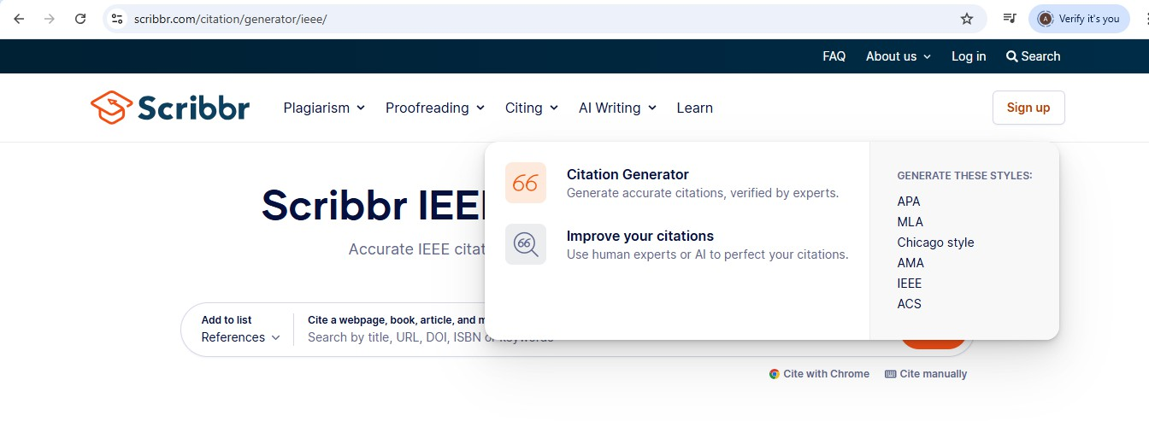
Step 1: I used the Scribbr reference generator to import the selected articles directly into my project document.

Step 2: Generate In-text Citation
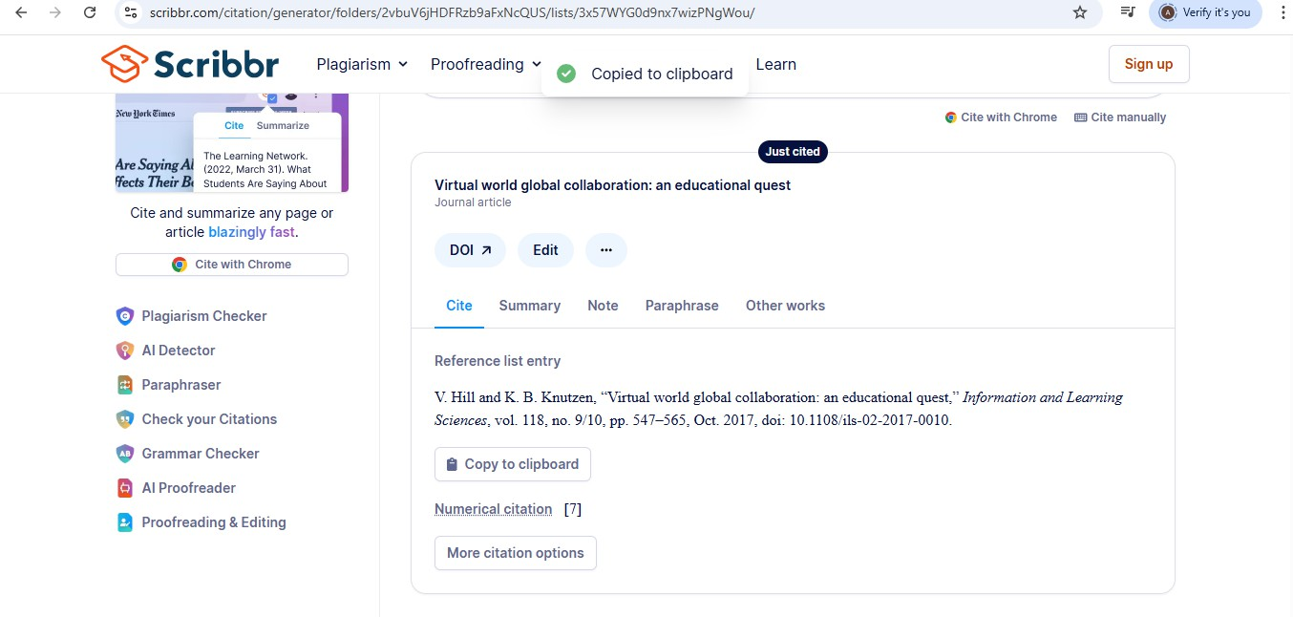

Step 3: Complete Reference list
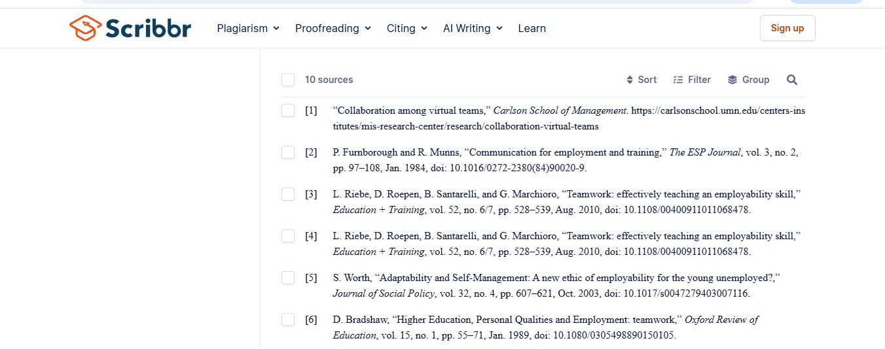

Task 4

E-Portfolio Creation and Evaluation
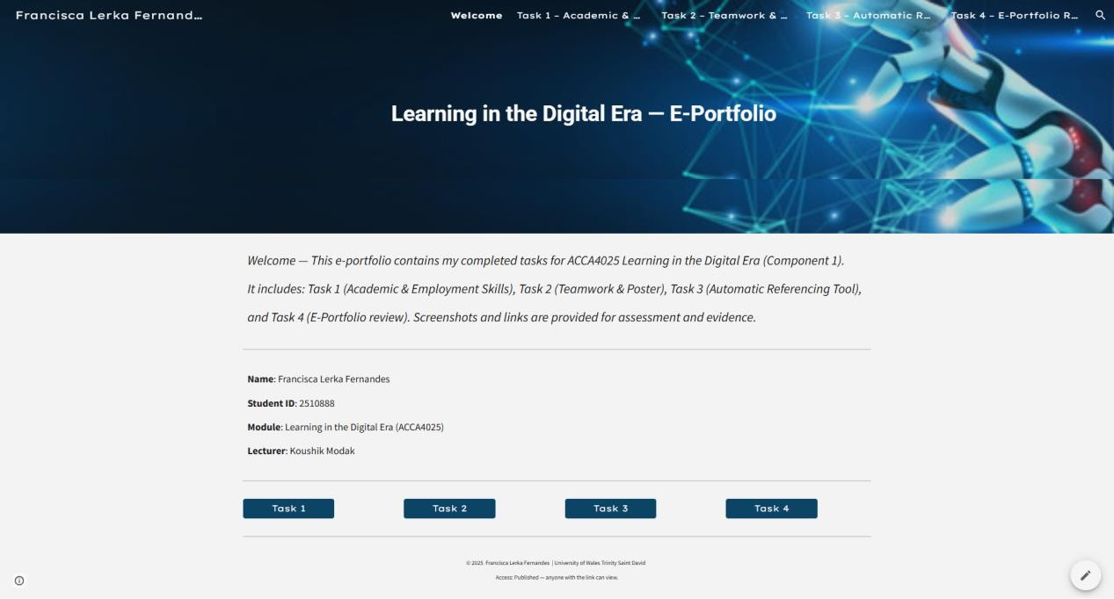

B) Illustrative Review of E-Portfolio Tool Selection.
I designed my e-portfolio with Google Sites due to the fact that it is a free, easy-to-use, and cloud-based site where an individual can easily design without having to write any form of code.
Google Sites are compatible with other Google applications like Drive and Docs, which made it easy to add pictures, screenshots, and documents to every assignment.
The drag-and-drop structure allowed me to vividly arrange the content of all tasks 1-4 and pre-existing templates made the look of all assignments professional and consistent.
In general, Google Sites was the most effective and the most convenient tool to create an academic e-portfolio that can demonstrate my learning achievements and my digital skills.

Conclusion
The project has reinforced the knowledge on important academic, group, and digital skills that help to achieve success in the world of education and work. It revealed that professional excellence can only be achieved through communication and teamwork as well as critical thinking as a support to technical knowledge. The mind map and the teamwork poster promoted teamwork, leadership, and flexibility, whereas Scribbr was used to enhance the accuracy of the research and the efficiency of references. All the activities were a part of gaining confidence in handling academic tasks and getting ready to deal with career-related issues in the future. Another critical aspect of the project that was noted is the value of lifelong learning and the capacity to put computing skills into practical and real-life applications. Altogether, the Computing Skills for Workplace project has achieved success due to the success in integrating academic training with professional growth that provided students with the necessary competencies to survive in a competitive and technologically driven world.

References

References for Task 1

[1] | P. Furnborough and R. Munns, "Communication for employment and training," The ESP Journal, vol. 3, no. 2, p. 97–108, 1984.
[2] | L. Riebe, D. Roepen, B. Santarelli and G. Marchioro, "Teamwork: effectively teaching an employability skill," Education + Training, vol. 52, no. 6/7, p. 528–539, 2010.
[3] | S. Worth, "Adaptability and Self-Management: A new ethic of employability for the young unemployed?," Journal of Social Policy, vol. 32, no. 4, p. 607–621, 2003.
[4] | D. Bradshaw, "Higher Education, Personal Qualities and Employment: teamwork," Oxford Review of Education, vol. 15, no. 1, p. 55–71, 1989.

References for Task 3

[5] | V. Hill and K. B. Knutzen, "Virtual world global collaboration: an educational quest," Information and Learning Sciences, vol. 118, no. 9/10, p. 547–565, 2017.
[6] | "Collaboration among virtual teams," Carlson School of Management, [Online]. Available: https://carlsonschool.umn.edu/centers-institutes/mis-research-center/research/collaboration-virtual-teams.
[7] | "The role of virtual collaboration in digital transformation," Lucid, 17 September 2025. [Online]. Available: https://lucid.co/blog/virtual-collaboration-in-digital-transformation.
[8] | A. Tan and A. M. Kondoz, "Barriers to virtual collaboration," in Barriers to Virtual Collaboration, 2008.

E- Portfolio

Task 1:
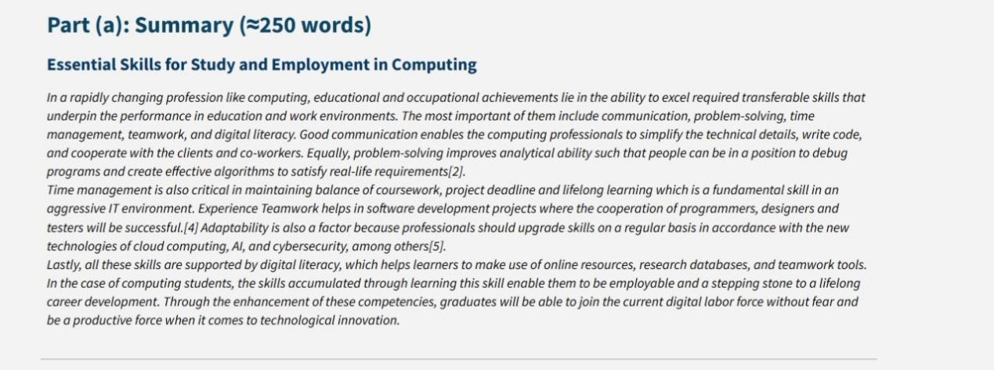

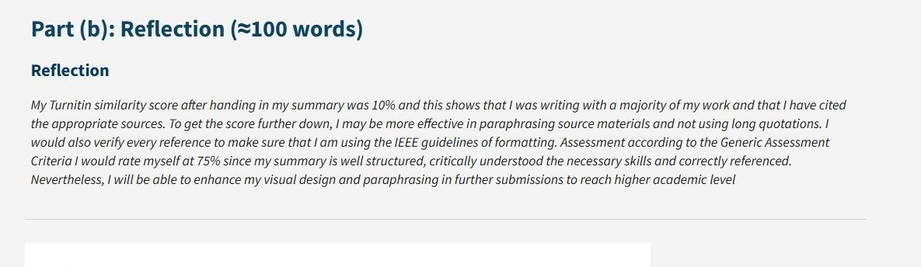

Task 2:
MIND MAP:
https://uowtsd-
my.sharepoint.com/:f:/r/personal/2510888_student_uwtsd_ac_uk/Documents/lde
_13-10-25%20learning%20and%20digital%20era?csf=1&web=1&e=HPh0pw
POSTER:
https://uowtsd-
my.sharepoint.com/:f:/r/personal/2510888_student_uwtsd_ac_uk/Documents/lde
_13-10-25%20learning%20and%20digital%20era?csf=1&web=1&e=HPh0pw

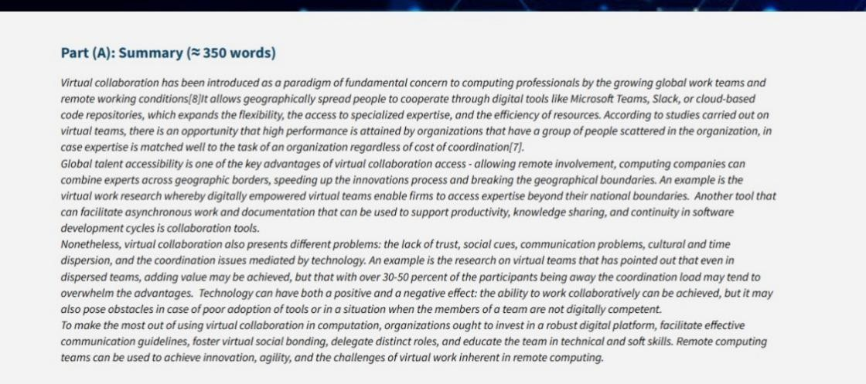
Task 3:

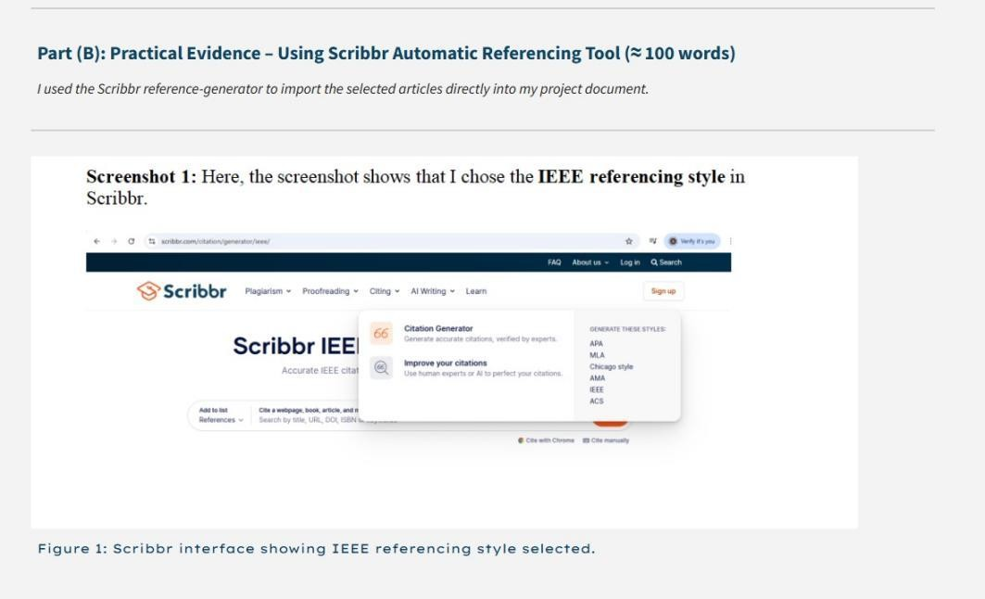

Task 4:
E-PORTFOLIO REVIEW

Task 1:

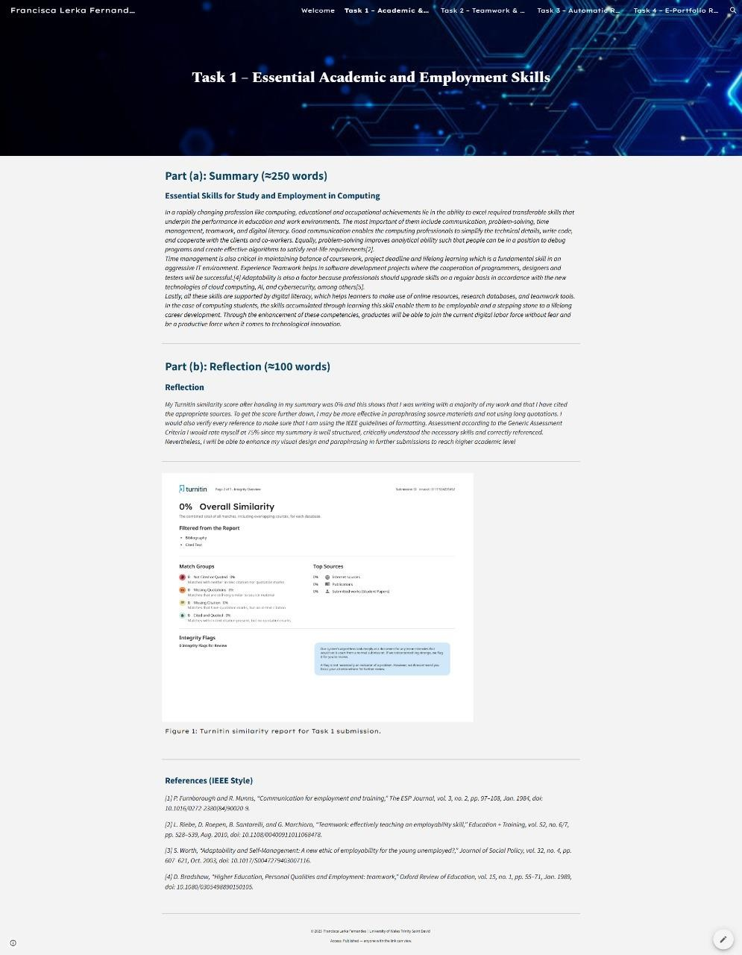

Task 2:

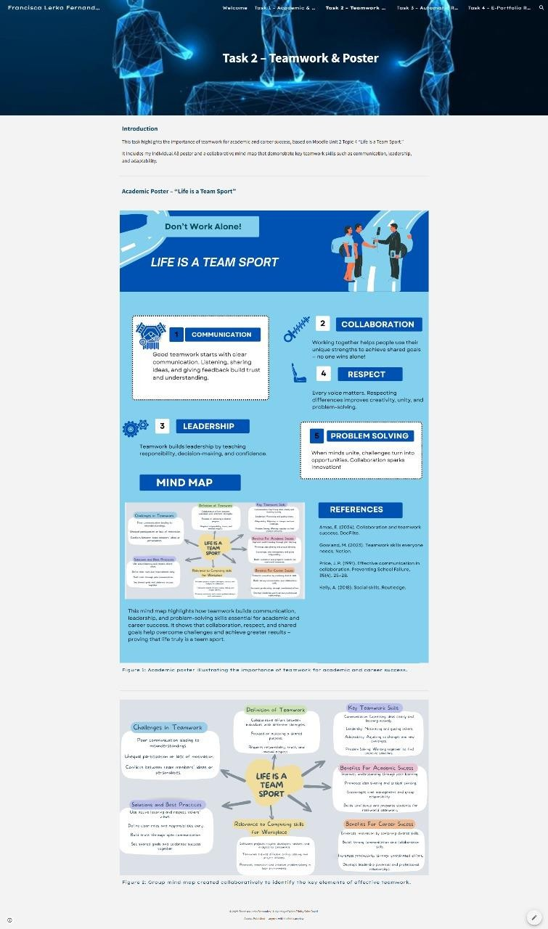
Task 3:

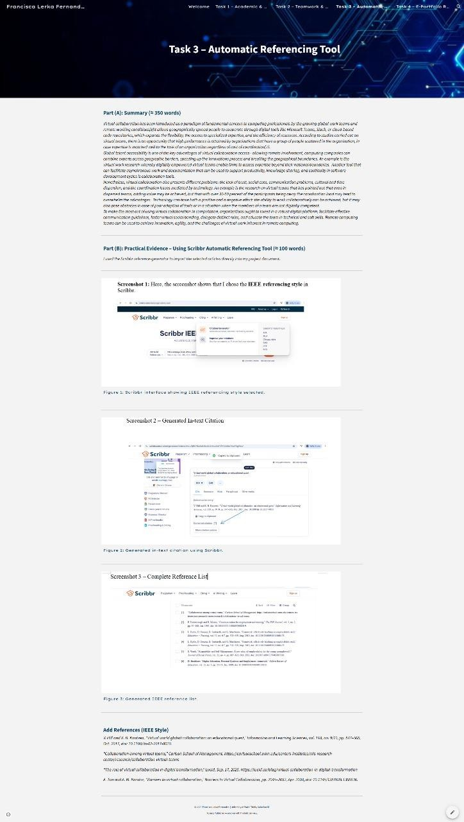
Task 4:



