Information Engineering
Level 4 – Assignment 2

Iuliana Maria Gherasim
Student ID : 1919760

Table of Contents
Introduction 2
Task 1 2
Entity Relationship Diagram – ERD 2
Task 2 4
Tables 4
Relationship Diagram 6
Menu 6
Forms 7
SQL query 8
Reports 9
Conclusion 9

Introduction

According to the assessment brief, this report provides the database for Universal Sports, a sport company to keep the records in it. The database is created in the MC Access software application and stores all the information. This report provides the database in 3 normal form that reduces the data redundancy and keep the data consistent. Logical design is introduced in this report and implement it into the database. Also, the database is designed to make the work easier and to extract the result by using SQL queries. And the last, but not least, this report provides the primary key and foreign key to make the relationship between the entities.

Task 1

Entity Relationship Diagram – ERD

This logical diagram shows the relation with the tables by using primary and foreign key relationship. In the given below diagram, this ERD has the tables that are connected in relationships such as one-to-one or one-to-many.
To complete this project, it was needing a total of 9 tables to be created, to hold the data for each entity such as Branch Office, Holiday Details, Leave Details, Staff Company Details, etc. As mentioned already above, all the relationship are mentioned in the below diagram accordingly to the requirements.
Following, is much easier to create the MC access as this diagram provided a clearer picture of the database and is required just to be implemented.
Firstly, few more information needs to be provided, to create a better understanding of the database.
- Primary key – is used to identify unique data, which means that the same table, cannot have the same information and it cannot be null also.
- Foreign key – is used to maintain the relationship between two tables, so it allows to the primary key to migrate to this table and also, can be more than just one.
One of the most important things in the database, is to maintain the relationships between two tables and to identify the data as fast and logic as possible. (TutorialPoint, 2020)
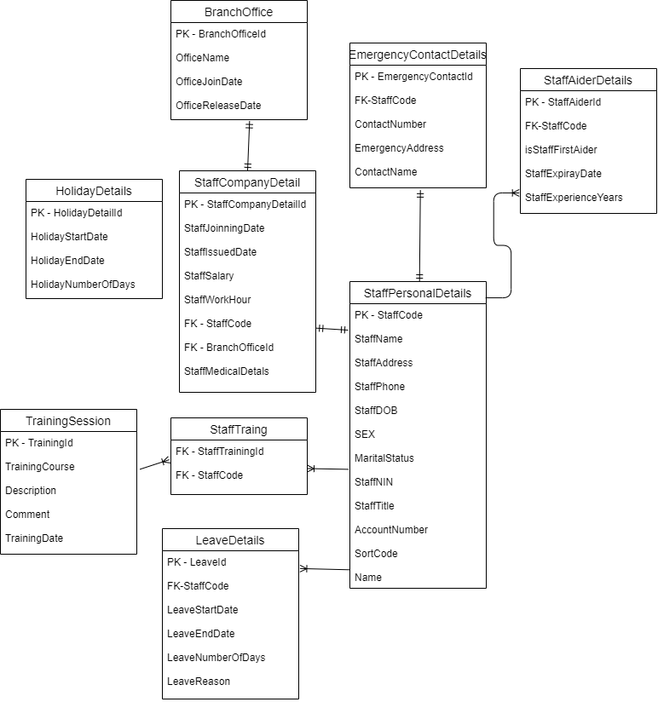

The above diagram has the following relationships implemented, one to many, one to one and many to one, and have the capacity to connect data between tables successfully.
The degree relationship identified in this ER diagram, is the ternary relationship because we have more entities part of one relationship, such as the Staff Personal Details that need to split and create relationship between more categories as Training, Leave, Aid and Emergency. But also, it was identified the unary relationship between the Staff Training and the Training Session because it is the entity who is doing the relationship. (Learning, 2020)

Task 2

Tables

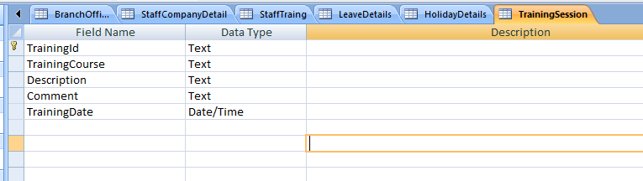




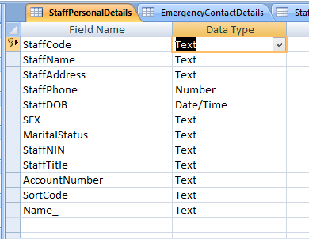

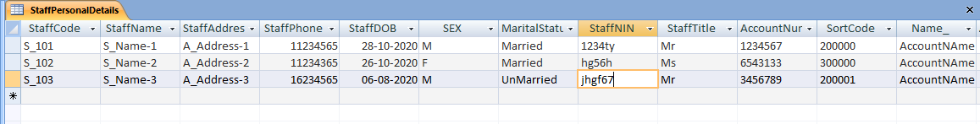
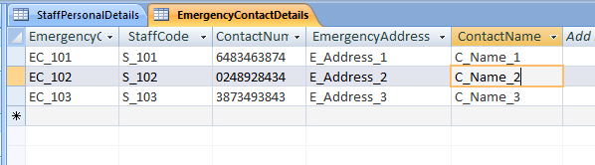
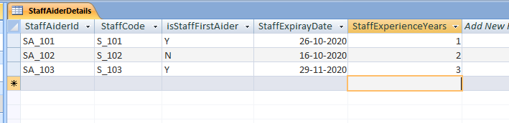
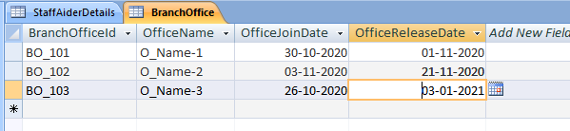

Relationship Diagram

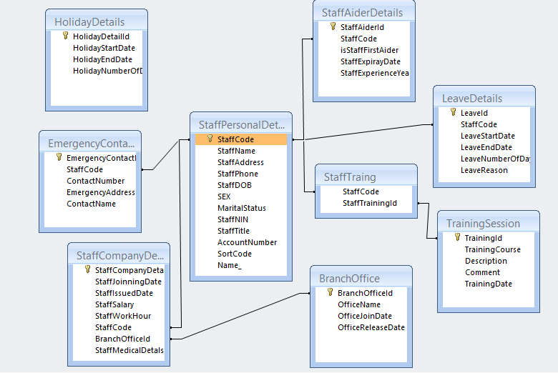

Menu



Forms

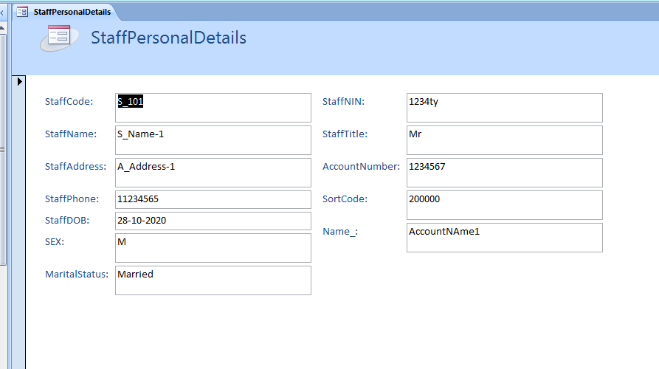
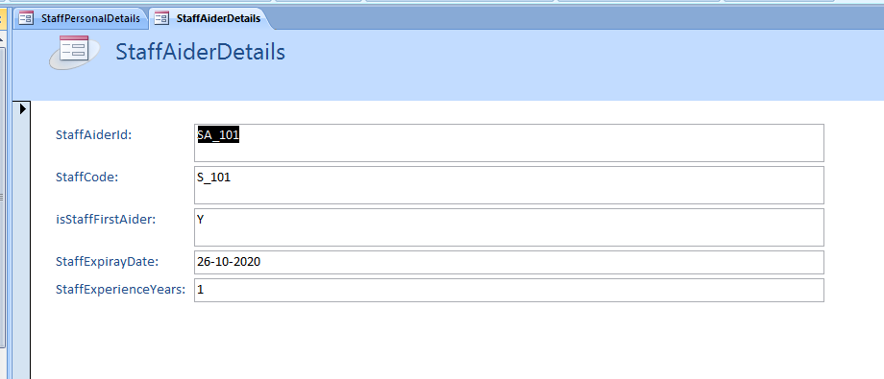
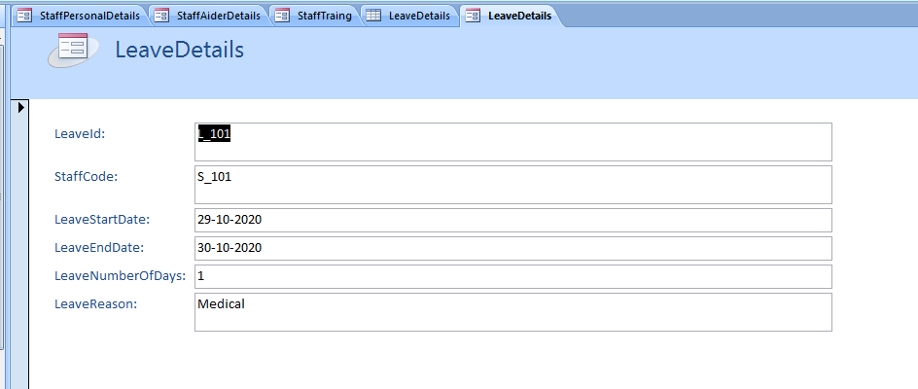

SQL query



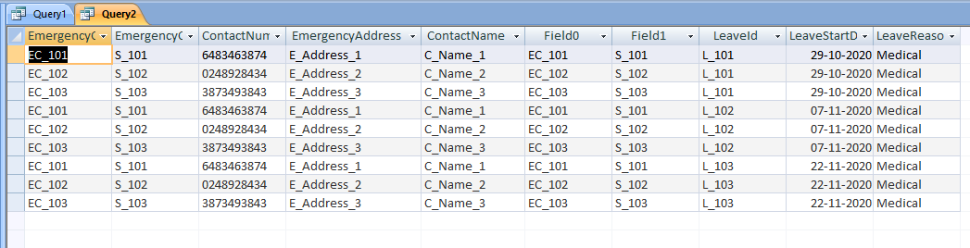





Reports

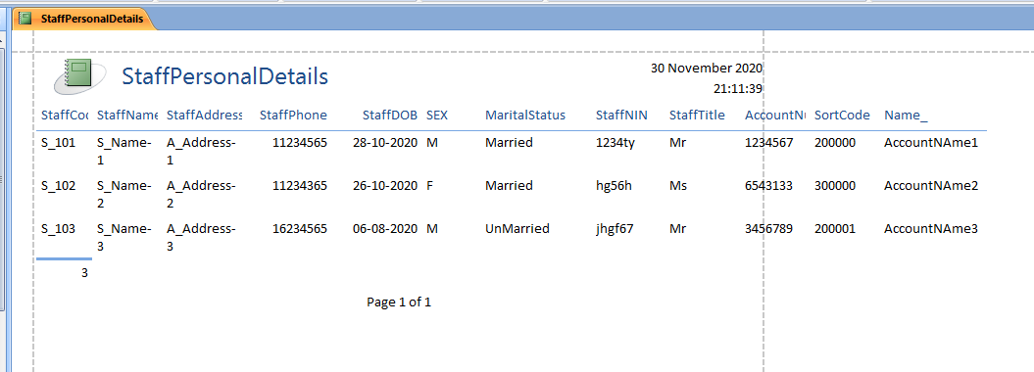

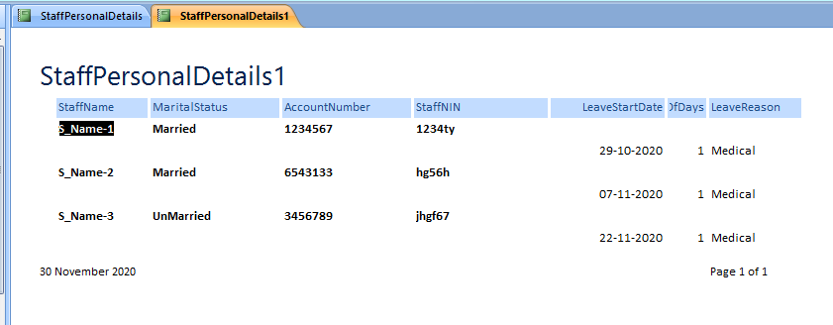

Conclusion

MS Access software is used to develop the sports database with including tables. This report concludes the ERD, 3 normal form, relationship diagram and SQL queries, forms, reports. It uses the primary key for creating the unique records in the table. Tables are connected with the help of primary and foreign key. This database is made in the 3 normal form in consistent state.
Having the opportunity of completing this task created me an understanding of how easier can be to create a data base and to keep track of all the records, in only one place.

References
Learning, S., 2020. [Online]
Available at: https://sielearning.tafensw.edu.au/toolboxes/Database_Administration/content/models/e_r_model_relationships.htm
TutorialPoint, 2020. [Online]
Available at: https://www.tutorialspoint.com/difference-between-primary-key-and-foreign-key-in-database

