
Module: Strategic Management for SMEs Module code: BMSW6104 Student name: Corina Berco Student ID: 1918420 Lecturer name: Eric Osei Assignment title: Lexis Language Learning social enterprise

Executive summary

In our community, for years there is a language issue/barrier, as not, all the children and adults, know the language that their parents or grandparents (who were not born in the UK) spoke in their childhood. Many of the children born in the UK, where we have communities of over a million Romanians, are no longer learning today the Romanian language in an educational system. We are strongly advised in the nurseries and schools to speak the native language at home with our children, but how many of us do so? This is a problem in the community that the enterprise addressed.
Lexis language learning social club can help children and adults should learn the language and the culture of the country of their ancestors, meet new people, develop active communication, and informal learning, and increase language skills (writing and reading) through innovative games and workshops delivered by our highly trained teachers.

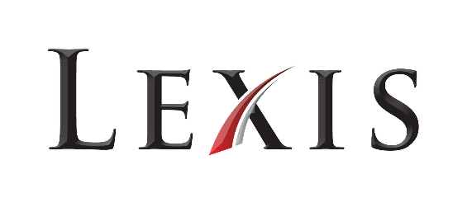
‘Don't forget where you come from, learn Romanian!’

Table of contents

Executive summary 1
Introduction. 3
1. Social enterprises sector. 4
2. Strategic intent. 5
3. External environmental analysis (macro environment). 6
3.1. PESTEL analysis. 6
4. Internal environmental analysis (micro environment). 8
4.1. Porter’s 5 Forces. 9
4.2. VRIO analysis. 10
4.3. SWOT analysis. 11
5. Stakeholder analysis. 12
6. Strategy formulation. 13
6.1. Ansoff Product-Market Mix. 14
6.2. BCG Growth-Share Matrix. 14
7. Sustainable strategy. 15
8. Strategy implementation. 16
8.1. Balanced Scorecard. 16
9. Organizational structure. 17
10. Change management theory - Lewin’s Three-Step Model. 18
Recommendation. 19
Conclusion. 20
References. 21
Appendix I: SWOT Analysis. 24
Appendix II: Stakeholders analysis. 25
Appendix III: Ansoff Product-Market Mix. 25
Appendix IV: Number of co-ops and turnover by sector. 26

Introduction.
This report presents a strategic plan for a social enterprise that will help children and adults from the Romanian community, to learn the Romanian language. The report comprises all the important steps of environmental analysis, which help the business to point out its opportunities and threats toward the competition in the market, as well as what aspects can influence its performance and what should be changed.
A social enterprise is trying to make a change to a community, to chosen people, or the world in general. How can someone know that its social enterprise will make a difference? External analysis can relate if it is valuable for a community, or should the enterprise change something to bring that value and sense of purpose.



Lexis - the total stock of words in a language (Oxford languages dictionary)

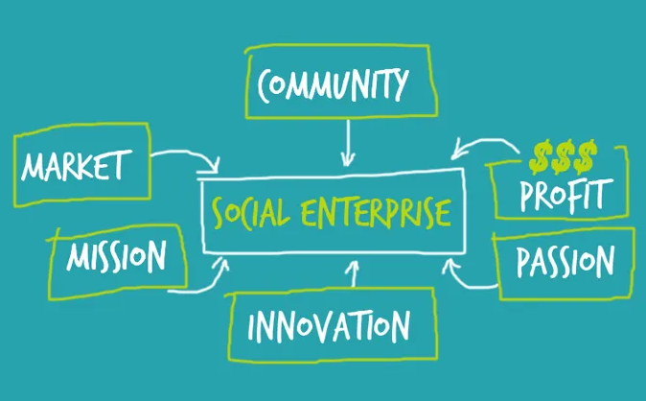
Social enterprises sector.
Social enterprises are businesses that run for social or environmental purposes. There are over 100,000 social enterprises that are active in the UK, which contribute about £60 billion to the UK economy and provide a job to over two million people (Social Enterprise UK).
Social enterprises are impacting the economic sector, as well as society and the environment in a positive way (Indeed Editorial Team, 2021). These can be found in every sector of the Uk economy, producing and selling products and services to millions of customers, supplying local community resources, and managing arts organizations, cafes, restaurants, cleaning agencies and so many other types of businesses. Social enterprises provide as well high-quality public services, and a third part of the community healthcare providers are social enterprises (Social Enterprise UK).

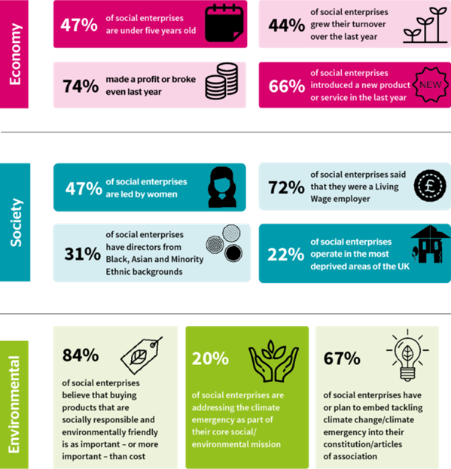

Source: Facts and Figures | Social Enterprise UK

Strategic intent.
Lexis language learning is offering people from the Romanian community the possibility to learn the Romanian language. A wide spectrum of methods offered by the club’s teachers has customers of all ages.
Social enterprises can be Non-profit and Pro-profit. Lexis is in the pro-profit subsector. It is very important to add value to the community, but at the same time to sustain the existence of the enterprise, profit generation is as well extremely important. The profit is used to reinvest in the business, in helping to achieve its social mission (CFI Team, 2022).
Vision Statement - describes the future of the organization and of the industry or environment in which the organization plan to make a change (Taiwo and Lawal, 2016). It inspires and motivates. It outlines WHERE the organization wants to be (Bowen, 2018). Lexis’ Vision – To improve the Romanian language of adults and children from the community by providing effective teaching techniques,
Mission Statement - Describes what an organization wants to do now and HOW to get to the point it wants to be (Taiwo and Lawal, 2016).
Lexis’ Mission – 1) To earn profit in exchange for adding value to the community and the Romanian nation itself. 2) To deliver the best quality of services to improve customer satisfaction. 3) To reinvest more than 50% of the revenue in the improvement of the enterprise (books, tablets, writing boards). 4) To offer employment and training opportunities.
SMART objectives.
The SMART method was initially developed by Doran in 1981 to write effective management goals (Ishak et al, 2019). Today, it is used by all sizes of organizations all over the world. SMART is a simple but effective model that, if applied correctly helps managers to set clear goals that define exactly what needs to be fulfilled, and when (Bjerke and Renger, 2017). The method presents five aspects that make an objective smart. Specific - Measurable – Achievable – Realistic - Time-related
Lexis language learning objectives:
- Increase revenue by 15% by planning to open an additional classroom in the same building, where more customers will have lessons, by the end of 2023.
- Teacher training to ensure excellent teachers in every classroom.
- Training new methods of teaching the Romanian language suitable for children of all ages and adults in the next 2 months.
- To increase customers by 20% by recruiting additional staff by the end of 2023.

External environmental analysis (macro environment).
By conducting an external environmental analysis, an organization points out the essential threats and opportunities in the competitive environment. It analyses how competition in this environment can grow and what implications it has for the threats and opportunities an organization is confronting (Jay and Hesterly, 2018). Environmental analysis is necessary for developing a sustainable competitive advantage and identifying a business’s opportunities and threats (Yüksel, 2012). It is very difficult and sometimes impossible to control external factors.

PESTEL analysis.
PESTEL framework is one of the tools for analyzing the macro environment of an organization and allows identification of the circumstances within which the company performs. It provides large data from which the organization can identify the main factors of change (Johnson et al., 2008). PESTEL stands for Political, Economic, Socio-demographic, Technological, and Ecological, which directly or indirectly affect the performance of the business. It presents a general idea about the macro-environmental conditions of the organization (Yüksel, 2012).
PESTEL analysis for the Lexis language learning social club was conducted to determine management strategies for the future. Some of the factors are linked to each other and can affect the enterprise either positively or negatively.
According to Yusop (2018), Political factors consider the political situation of the country. There are some questions to consider – How stable is the political situation in the market? What impact has local laws and rules had on businesses? What taxes and fees are to be considered? Shatskaya et al. (2016) suggested that it is very important to be well-informed about potential political changes because some of them can have significant consequences on the business.
Lexis’ Political factors as funding grants can affect the enterprise positively as if the funding grant grows, the enterprise will afford to invest more in the business which will lead to its further development and growth. At the same time, if the government change, and the new law is implemented as an increased tax policy, it may affect the enterprise negatively, forcing the business to cut its working hours, and reduce staff.
According to Matovic (2020), Economic factors have a serious influence on the profitability of the business. What finances do banks offer? Are interest rates or exchange rates going to change? All these aspects influence labor prices and quality as well as the inflation rate.
Lexis’ Economic factors as the disposable income of customers can dramatically affect the financial side of the enterprise as families can choose to spend less or nothing on education, because of inflation. Labor costs can be higher in years so it might be difficult to keep all the teachers, paying their wages, which can lead to redundancy. Inflation as well can force the enterprise to cut the costs of teaching materials, such as laptops, tablets, and books.
Social factors have a specific meaning as they have a direct impact on how markets understand customers and what directs them (Yusop, 2018). Level of education, demographic structure, national culture, life, and pension insurance, are just some aspects that influence the overall assessment of the social factors. The standard of living, which is expensive, with increased prices for bills and food, can influence how people spend their resources, not investing any more in additional education.
Social factors and demographic change may affect customer needs which can negatively affect the business. Over the years people can change their perception about learning their native language, accepting learning only English.
Nowadays, as everyone is aware of the intensive use of IT tools, Technological factors are of specific importance. How can innovation and the level of technology development influence the business? How can the enterprise implement that new technology in its activities, and will it be successful? (Shatskaya et al., 2016).
Technological factors can be favorable for every type of industry, as technology, which is always changing, eases the work of a business, giving access to an enormous amount of information and opportunities. On the other hand, the new way of delivering services, online learning became very popular after the Covid pandemic, so people get used to this type of education. Lexis social club can lose customers that will choose schools that offer online language courses, which are highly competitive.
Environmental factors are considered the human attitude to natural resources, the importance of recycling, and air, soil, and water pollution (Çitilci and Akbalık, 2020). Natural disasters and weather conditions can influence business activity.
Environmental factors such as weather conditions can cause operational damage in a particular period of the year. Energy consumption regulation can have a negative impact on the financial part of the enterprise, as now the energy price is very high, the government might advise the business to reduce the energy consumption, to minimize the cost. This decision can lead to fewer working hours, and the use of fewer electrical devices.
Matovic (2020) Legal factors are current and future consumer protection, employee well-being, and regulatory agencies, which can affect the business in areas such as competition, employment, health, and safety. If the law of how a social enterprise operates is changing, implementing new licenses and permits can make the business close or difficult to obtain those licenses. Additional costs and knowledge might pause the business from operating which will cause financial loss.
Changing legal factors such as health and safety legislation may affect positively the enterprise, as there may appear a need to install new security systems and types of equipment that will create a more confident and safe environment for customers. Happier and more productive staff, that will feel well fare in the workplace. Contradictory, additional licenses and permits required to operate may affect the business negatively, as it might slow down the activity because of the need to obtain various approval documents from the government.
All these factors should be considered when developing a business strategy, as they affect how a business operates, and its cost implication.

Internal environmental analysis (micro environment).
The micro environment is all internal factors of an organization that impacts its decision-making and performance (Johnson et al., 2008). The analysis of the micro environment of an organization contains the resources and abilities carried by the organization.
Jay and Hesterly (2018) stated that internal environmental analysis helps a business to determine its organizational strengths and weaknesses and to understand which of its resources and abilities are possible to be sources of competitive advantage and which of them are less possible to be sources of such benefits. Internal analysis is very useful in identifying areas within the organization that needs to be improved and changed.

Porter’s 5 Forces.
Porter’s 5 Forces framework was initially developed to assess the profit perspective of different types of industries (Johnson et al., 2008). It is used to analyze the industry’s structure which is very valuable for any organization. Porter’s 5 Forces framework helps industries to determine different factors that are affecting profitability and organizational strategies (Grundy, 2006).
Lexis language social club Porter’s 5 Forces analysis.
Competitive rivalry within an industry is high
- Numerous language clubs in the community
- Lower prices, better condition
In this century language learning industry is very competitive. No matter how big the language school is, where it is based, and what type of services it offers, the competitive rivalry among existing competitors is high.
The threat of new entrants is moderate
- Differentiation / reduce the price, discounts
Entry barriers
- Need for specialist knowledge
- Attract people to use services (difficulties in building customer loyalty)
- Government policies
Lexis language learning social club has loyal customers, but it should as well worry about new competitors, as they may offer better services.
The bargaining power of buyers is very high
- Differences between competitors (various types of books, flexible learning hours, evening, and weekend)
- Discounts for families (more than 3 people)
Buyers of the service are customers who are the most important for the existence of any business. As people can choose from many different services of different language schools at different prices.
The bargaining power of suppliers is moderate
- Language schools
- The low range of services provided
- High costs
As it is not easy to change the supplier, as there are not many competitive language learning clubs in the area, with the same services as Lexis has, therefore it can be hard for them to propose a new, unique product.
The threat of Substitute services is high
- Competitors from another industry with a better price for their services
- Availability of substitutes
Even if the substitutes' price is more expensive, they are still a threat to the business. As they can have higher quality services and better conditions that will complement the price. This aspect is very valuable for the customer (Dobbs, 2014). It might be easy for Lexis language club’s customers to switch to other substitutes because of the low switching cost.
Whether in an organization all five forces are high, then the industry is not tempting to compete in, as there can be too much competition, and too much stress, to accept fair profits (Johnson et al., 2008).
  - VRIO analysis.
VRIO is the primary technique for conducting internal analysis, that combines two theoretical structures: the positioning and the resource-based view (Jay and Hesterly, 2018). Lynch (2018) defined the VRIO framework, as a system for evaluating the competitive resources of an organization. Four essential questions will help a business to analyze the resources or abilities to determine its competitive possibilities.
It is a strategy that begins by questioning each resource asking if it is valuable. After answering this question, the next one comes to examine rarity, imitation, and organizational competencies (Lynch, 2018).
After evaluating the business resources of Lexis language social club, the conclusion is:
- a good reputation on the market;
- the introduction of special learning methods;
- flexible work schedule/weekends;
- innovation and technology.
The social club has a lot of customers which are very satisfied with the results of their learning, and in their turn, they advise us to their friends and colleagues. There was a situation where the schedule was fully booked with customers months ahead. Then, without any doubt, the enterprise has a Valuable service.
Although the enterprise has much to offer to customers, there a more language clubs and foreign language courses to attend. So, the enterprise does not have a Rare service. The enterprise should research again the competitive market of language learning and see what changes should be done to improve service by implementing new techniques to become rare.
It is very difficult to start a language learning social club. But is not hard to employ trained lecturers to deliver the languages to the customers. A lot of language clubs have the same structure with similar services. Therefore, it is easy to Imitate. For the enterprise to become inimitable strategic planning should be implemented, as well as an external analysis, to see what weaknesses Lexis social club has. New teaching methods should be introduced, as well as the best prices and services.
The enterprise has good revenue last year and a good reputation in the Romanian community. It has a good organizational structure, with improving services, so Lexis language learning social club is well Organised.
The language learning social club has a Competitive parity service. As it is Valuable, not Rare, Easy to imitate and well utilized by the enterprise.

SWOT analysis.
The SWOT analysis is a method used to evaluate organizations’ products or services to make the correct decision on the best development strategy (Sabbaghi and Vaidyanathan, 2004). It is a good way of assessing the overall situation of an organization so that a development plan can be created in which to consider the strengths, remove weaknesses, efficiently utilize the opportunities that have arisen, and allow the possible threats to be confronted (Sarsby, 2016).
Based on the SWOT analysis of Lexis language learning social club (see Appendix I), the enterprise has very powerful Strengths, that the business has already as a competitive advantage, as a favorable location of the business, a wide variety of books of all ages, innovative techniques of teaching a language, and an important factor as high-quality service, its price and value. Internal Weaknesses that the enterprise might consider improving are finance, and parent involvement, which may affect the enterprise’s profitability and future development. Good Opportunities, that the business can take advantage of are, target markets, the opportunity to expand online classes in the future, or credit for prior learning. Some of the Threats that can negatively affect the business from outside are political and economic factors, competitors, poor management strategy, and reduced funding.
Now the enterprise can evaluate the results to decide if to use its strengths to take advantage of the opportunities and improve the service. It can be decided as well that the weaknesses and threats should be addressed before making any changes to the existing services.

Stakeholder analysis.
Friedman and Miles (2006) pointed out that the organization itself is an association of stakeholders and its objective is to manage stakeholders’ interests, needs, and opinions. Olander and Landin (2005) defined stakeholders as individuals who have an interest in the business, and who have an active or passive influence on the decision-making and implementation process within the organization. Freeman (2010) in his turn, defined stakeholders as any group or individual who can influence or are influenced by the accomplishments of the organization's goals.
The first step is to identify stakeholders that have any influence or are affected by the business. Some of them might have the power to influence it, change it, block or advance the business. Some of these may be interested in enterprises’ activity, while others may not be involved and not care at all about it. Who has low or high power, or who has low or high interest? After the stakeholders are identified, map out the stakeholders’ position in the matrix, regarding each other, and how they influence the business. (see Appendix II for a detailed explanation)
Customers and funders have high power - low interest. These stakeholders should be kept informed with little information, even if sometimes they are not interested in the actual result. Customers have an indirect stake in the service of the enterprise as they are giving their money for provided services. Funders are important stakeholders, without their support usually, business performance is not possible.
Management, employees, and the local community have high power – high interest. These stakeholders are the most important to the success of the enterprise. They should be engaged in all activities and keep them always satisfied. Management is directly connected to employees, as they are responsible for all the changes within the business. Employees have a direct stake as they earn money for their living in this business. Local communities depend on social club services, that have a clear purpose to help the community in learning the Romanian language.
Low power – high interest. Suppliers need to be informed but they don’t have any influence on the enterprise, they are very helpful. They are interested in keeping the business close as it brings supplier's profit. They provide the enterprise with all the necessities to operate. Competitors do not have influence, but they are very interested in business as competition in the market.
Government authorities are mapped in the low power - low interest category in the matrix as they allow the business to sell the service, and benefit in their turn from the taxes they receive. Potential customers that might have an interest in buying language learning services. For these stakeholders, the best is to monitor them and there is no need to give them too much information.

Strategy formulation.
Every organization should choose its strategy formulation carefully and regularly to avoid mistakes. Barney and Hesterly (2019) defined the strategic management process as a consecutive set of analyses and options that can increase the chance that an organization will choose an appropriate strategy, one that causes competitive advantage and high profitability. In his turn, Lynch (2018) defined strategic management as the identification of the aim of the business and the plans and steps to accomplish that aim.
The organizational strategy covers three main aspects, internal resources, the external environment in which the organization function, and its’ capability to add value to the work it does.

Ansoff Product-Market Mix.
 | Existing service | New service
Existing  market | Lexis Language learning club
New market
The Ansoff Matrix is a business framework that helps an organization to improve revenue and profitability, structuring ideas and organizing objectives (Meldrum and McDonald, 1995).
According to the Ansoff Matrix, Lexis Language Learning Club is an enterprise that fits the best into the market penetration category. It is an existing service in the already existing market. But for a business to grow, it should move to product development. The enterprise should market a new service to the existing customer and develop new techniques of teaching to replace the existing ones, then advertise them to the existing customer. (See Appendix III for a detailed explanation)
How can the enterprise sell more of its service to existing customers? The market penetration strategy is intended to increase service sales by attracting more potential customers that know about the social club’s services. This strategy means assertive marketing and promotion actions, such as social media advertising. The idea is that the current customers are very valuable to the business, and if they receive high-quality services and are happy about it, they will recommend services to their family and friends.

BCG Growth-Share Matrix.
The Boston Consulting Group Growth Share matrix, considered one of the most popular strategic tools in business, was formed in 1970 by Bruce Doolin Henderson to help business organizations for the improvement of the skills to manage the business successfully and profitably (Kader and Hossain, 2020). It is a simple portfolio planning matrix that proposes that organizations should have a great balance of products within their field. It is beneficial for an organization to reach a balance between the four categories of products a company has (Hax and Majluf, 1983). BCG matrix split the business products into four categories:
1. Question Marks – products that have a high growth rate but a low market share.
2. Stars – products that have a high growth rate and a high market share.
3. Cash Cows – products that have a low growth rate and a low market share.
4. Dogs – products that have a low growth rate and a low market share.
Lexis language learning social club is in the Stars category as it achieved a large market share in a fast-growing market. It has great opportunities for the growth and benefits of the enterprise. Being in this category places the company as the leader in the business, but it needs support for promotion a placement. Stars tend to make good profits from their business, the same time consuming a lot of cash to their high growth rate (Kader and Hossain, 2020). It needs more attention and investment to maintain its Star status.

Sustainable strategy.

Environmental concerns in recent years became very frequent, and a lot of businesses choose to follow sustainable strategies. It is a group of steps that a business should consider to reduce the negative impact on the environment and the community (Gov.uk, 2022). If it is implemented correctly, sustainable strategies must benefit the company and its employees as well.



Invest in solar panels to reduce energy costs

Lexis Language Learning Sustainable strategy
Improve Employee welfare
Encourage our employees and customers to reduce air polution



Reduce water consumption
Reduce paper waste


Contribute to food loss, by working in partnership with other enterprises in the community

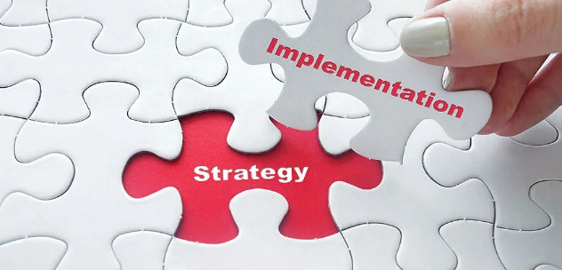
Strategy implementation.
Strategy implementation is plans combined all together to make a strategy to reach the organization’s goals and objectives.
The strategy implementation process pays attention to the achievement of the strategy by approaching Who, Where, and How goals can be achieved (Andrews et al., 2009).
Strategy implementation is very important to an organization because it deals with action rather than just some planned ideas. It allows a team to understand that the strategies presented by the management are applicable (Haberberg and Rieple, 2008). It is a step-by-step process that needs to be paid attention to very carefully. It depends on several factors, such as employees, resources (financial, and non-financial), systems, and workplace culture, which can lead to competitive advantage and improved performance.

Balanced Scorecard.
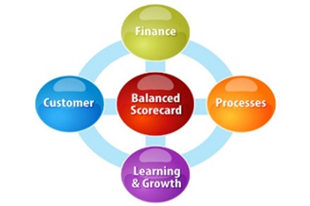
The Balanced Scorecard developed by Kaplan and Norton (1990) is strategic planning and performance management structure, that provides a perfect solution for facing four perspectives: financial, business processes, learning and growth, and customers (Chavan, 2009).
Kaplan and Norton (2005) state that a balanced scorecard can be used as a strategic management system to manage strategy in the long term. The aim of the balanced scorecard is to guide, control and challenge the entire organization to achieve an ordinary conception of the future (Chavan, 2009). Its process transforms vision into strategy, plans, and set goals.
Balanced scorecard analysis was conducted as strategic planning by setting the objectives, measuring them, setting targets, and stating the initiatives. It follows financial and non-financial measures to conclude the business’s effectiveness and when there is a need for change.

Organizational structure.
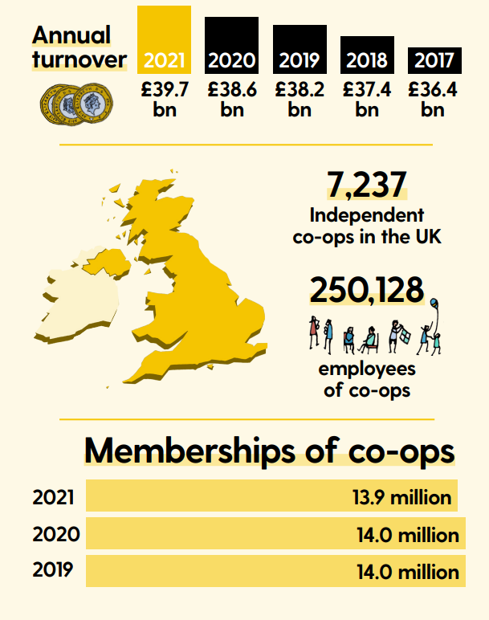
Lexis language club has a cooperative legal structure, one that is the most common form of social enterprise that helps in creating a more democratic economy. Initially, a cooperative enterprise runs as a business but is more engaging and democratic in its ownership models (Moran, 2021). It is an open membership, and anyone with an interest in business, customers, or suppliers, can join the cooperative (Co-op economy, 2021).
Statistics show that there are 7,237 independent co-ops in the UK by 2021, that are operating in all areas of industries, with a turnover of £39.7 billion (Social Enterprise UK, 2017).
Source:https://www.uk.coop/sites/default/files/2021-06/Economy%202021_0.pdf
According to data, there are 13.9 million memberships of co-ops with 250,128 thousand employees in the UK. The number of social enterprises in the Education sector has increased by 2,504 in 2021, with a total turnover of £549.7 million (see Appendix IV).
The organizational structure is a process that points to how some activities are directed to accomplish the goals of an organization (Quain, 2019). These organizational activities can be rules, responsibilities, or roles. Every business should have an organizational structure as it allows them to stay efficient and focused (Ahmady et al., 2016).
Lexis has a flat organizational structure, which is very common among many start-up businesses, as they are usually small companies with few employees. It is a simple structure, where the top manager controls the work of the employees not grouped into specific functions, which gives a lot of autonomy to the employees (Quain, 2019). It has low departmentalization or none as it is in the Lexis language learning social club. Companies with this type of structure have a very high speed of implementation which determines the success of the business. The owner/ manager has direct wide spans of control. This type of structure is very advantageous for the business as it is cost-efficient, encourage good communication, and faster decision-making (Ahmady et al., 2016).
OWNER - MANAGER

ACCOUNTING/FINANCE

TEACHER 1
TEACHER 2
TEACHER 3
DRIVER

10. Change management theory - Lewin’s Three-Step Model.
Lewin’s three steps model is used in organizations for managing change which appears in the transformational period from the actual situation of the organization to the desired one (Kaminski, 2011). The theory focuses on people inside and outside the organization because they are the main point of change management (Petrov, 2017).
There is always a need for change in a business that will bring improvement and profitability. Change should start from top management/owner and continue to every employee. As each of these mentioned is an important stakeholder with High power - High interest in enterprises activities.


In the first Lewin’s stage, Unfreezing the need for change is achieved through introducing new teaching methods suitable for children and adults. Increasing the range of services and offering high-quality services at a price ratio. Teachers have a positive attitude regarding the change and are very receptive to the proposed new training opportunities. The change itself is beneficial to all stakeholders involved in this change, as it will lead to more customers that will bring value and profit to the social club, respectively higher wages.
During the second stage, Change, the decision about training all staff is influenced by enterprise management. The conclusion is to offer training to all staff in the next 3 months. Therefore the social club will provide Romanian language teaching at the highest level, with the implementation of new teaching methods.
In the final stage, Refreezing makes the change permanent. It becomes continuous, developing new considerations and possibilities, and initiating the new social relationship. It is a considerable competitive advantage.

Recommendation.
Setting clear goals is necessary for anyone involved in growing the business’ profit, and achieving any professional goal. By creating a plan, carrying out specific actions, and maintaining persistence no matter what the situation. It's not easy, but it's worth the effort.
New innovative services are strongly promoted and hopefully will attract an important number of customers. Lexis social club will promote a marketing strategy to make known the company's services as well as the development of penetration strategies.
As customers are the most important in a business's profitability, the enterprise will adopt an approaching strategy to maintain already existing customers and attract new ones. As customers are always looking for something new, the enterprise will always improve and diversify the services, offering quality services, including customer requirements and needs, to keep high profitability of the company's activities, as well as customer satisfaction.
Launching a blog for example is a simple action. Publishing interesting and useful content is the real challenge, as nowadays blogging is one of the best ways to build authority and create a consistent public over time. Lexis can become an important voice in the business field and a way to attract customers.
- Market penetration by expanding the customer base;
- Service development (selling new products to known customers);
- Diversification (development of new products for new markets).

Conclusion.
Overall the main aspect for a company is not only to choose a strategy but it should be implemented properly, to benefit the business. Every stakeholder is important in adopting and applying organizational strategy, as well as internal and external factors which may affect the business positively or negatively.
For future development of the objectives of the enterprise, a development plan was described by implementing new services, and outlining the strengths and weaknesses, in comparison with the competition. To obtain a better share of the market, a development strategy was proposed by trying to develop unique innovative services against the competition, with the implementation of promotions and discounts for loyal customers.
To summarise, one of the most important aspects of the strategic analysis is to point out exactly where the business is on the market to further develop the appropriate strategy that will enhance profitability and success.

References.
- Ahmady, G.A., Mehrpour, M. and Nikooravesh, A. (2016) ‘Organizational structure’, Procedia-Social and Behavioral Sciences, 230, pp.455-462.
- Andrews, R., Boyne, G.A., Law, J. and Walker, R.M. (2009) ‘Strategy formulation, strategy content and performance: An empirical analysis’, Public Management Review, 11(1), pp.1-22.
- Barney, J.B. and Hesterly, W.S. (2019) Strategic management and competitive advantage: concepts and cases, 6th edn. England: Pearson Education Limited.
- Bjerke, M.B. and Renger, R. (2017) ‘Being smart about writing SMART objectives’, Evaluation and program planning, 61, pp. 125-127.
- Bowen, S.A. (2018) ‘Mission and vision’, The international encyclopedia of strategic communication, pp. 1-9.
- CFI Team (2022) Social Enterprise. Available at: Social Enterprise - Overview, How It Works, and Types (corporatefinanceinstitute.com) (Accessed: 3rd November 2022).
- Chavan, M. (2009) ‘The balanced scorecard: a new challenge’, Journal of management development.
- Çitilci, T. and Akbalık, M. (2020) ‘The importance of PESTEL analysis for environmental scanning process’, Handbook of research on decision-making techniques in financial marketing. IGI Global, pp. 336-357.
- Co-op economy (2021) A report on UK’s co-operative sector. Available at: Economy 2021_0.pdf (uk.coop) (Accessed: 5 November 2022).
- Dobbs, M.E. (2014) ‘Guidelines for applying Porter's five forces framework: a set of industry analysis templates’, Competitiveness review.
- Freeman, R.E. (2010) Strategic management: A stakeholder approach. Cambridge university press.
- Friedman, A.L. and Miles, S. (2002) ‘Developing stakeholder theory’, Journal of management studies, 39(1), pp. 1-21.
- Gov.uk (2022) Sustainable support strategy. Available at: Sustainable Support Strategy - GOV.UK (www.gov.uk) (Accessed: 21 November 2022).
- Grundy, T. (2006) ‘Rethinking and reinventing Michael Porter's five forces model’, Strategic change,15(5), pp.213-229.
- Haberberg, A. and Rieple, A. (2008) Strategic management: Theory and application. Oxford University Press.
- Hax, A.C. and Majluf, N.S. (1983) ‘The use of the growth-share matrix in strategic planning’, Interfaces, 13(1), pp. 46-60.
- Indeed Editorial Team (2021) What is a social enterprise? (With features and examples) Available at: What is a social enterprise? (With features and examples) | Indeed.com UK (Accessed: 3rd November 2022).
- Ishak, Z., Fong, S.L. and Shin, S.C. (2019) ‘SMART KPI management system framework’, 9th International Conference on System Engineering and Technology, pp. 172-177.
- Jay, B. and Hesterly, W. (2018) Strategic Management and Competitive Advantage: Concepts and Cases, Global Edition. Pearson Education, pp. 27.
- Johnson, G., Whittington, R. and Scholes, K. (2008) Exploring corporate strategy. Text and cases. Prentice Hall Higher Education.
- Kader, M.A. and Hossain, H. (2020) ‘An analysis on BCG growth sharing matrix’, International Journal of Economics, Business and Accounting Research (IJEBAR), 4(01).
- Kaminski, J. (2011) ‘Theory applied to informatics-Lewin’s change theory’, Canadian Journal of Nursing Informatics, 6(1).
- Kaplan, R.S. and Norton, D.P. (2005) The balanced scorecard: measures that drive performance’, Harvard business review, 83(7), pp. 172.
- Lynch, R. (2018) Strategic Management, 8th edn. Pearson Education, Limited, Harlow, United Kingdom.
- Matovic, I.M. (2020) ‘PESTEL analysis of external environment as a success factor of startup business’, ConScienS, pp. 96.
- Meldrum, M. and McDonald, M. (1995) The Ansoff Matrix. In: Key Marketing Concepts. Palgrave, London.
- Moran, J. (2021) Which is the best structure for a social enterprise? Available at: Which is the best structure for a social enterprise? | Rogers Spencer (rogers-spencer.co.uk) (Accessed: 4 November 2022).
- Olander, S. and Landin, A. (2005) ‘Evaluation of stakeholder influence in the implementation of construction projects’, International journal of project management, 23(4), pp. 321-328.
- Petrov, P. (2017) ‘Conceptual Model of a Three-step Approach for Change Management while Implementing Modern Educational Technologies’, Practice and Theory in Systems of Education 12 (4): 195-203.
- Quain, S. (2019) Simple Organizational Structure. Available at: Simple Organizational Structure (chron.com) (Accessed: 20 November 2022).
- Sabbaghi, A. and Vaidyanathan, G. (2004) ‘SWOT Analysis and theory of constraint in information technology projects’, Information Systems Education Journal, 2(23).
- Sarsby, A. (2016) SWOT analysis. Lulu. com.
- Shatskaya, E., Samarina, M. and Nekhorosheva, K. (2016) ‘PESTEL Analysis as a tool of strategic analysis in international markets’, Scope academic house B&M publishing, pp. 47.
- Social Enterprise UK (ND) Available at: All about Social Enterprise | Social Enterprise UK (Accessed: 10 October 2022)
- Social Enterprise UK (2017) Start your social enterprise Available at: Start-your-social-enterprise-guide-1.pdf (socialenterprise.org.uk) (Accessed: 5 November 2022).
- Taiwo, A.A. and Lawal, F.A. (2016) ‘Vision and mission in organization: Myth or heuristic device?’, The International Journal of Business & Management, 4(3).
- Varvasovszky, Z. and Brugha, R. (2000) ‘A stakeholder analysis’, Health policy and planning, 15(3), pp.338-345.
- Yüksel, I. (2012) ‘Developing a multi-criteria decision making model for PESTEL analysis’, International Journal of Business and Management, 7(24), pp. 52.
- Yusop, Z.B.M. (2018) ‘PESTEL analysis’, COMRAP, pp. 34.

Appendix I: SWOT Analysis.

INTERNAL FACTORS
STRENGTHS  - Children and adults learn the language and the culture of the country of their ancestors.  -Location of premises.  - Price, value, and high quality of services.  - Increase language skills (writing and reading).  - Games and workshops.  - A wide variety of books for all ages.  - Community involvement. | WEAKNESSES  - The habit to communicate in English  - Lack of finance  - Lack of parent involvement.  - Timetable. There are not enough hours.
EXTERNAL FACTORS
OPPORTUNITIES  - Business/ service development.  - Innovation and technology development.  - Target markets.  - Expand online classes.  - Credit for prior learning.  - Hire more teachers and train properly. | THREATS  - Political and economic effects.  - Competition.  - Innovation and technology.  - Poor management strategy.  - Reduced funding.

Appendix II: Stakeholders analysis.
High power - Low interest (keep satisfied)      Customers Funders | High power - High interest  (manage/involve)    Management Employees    Local community  
Low power - Low interest (minimum effort)    Government Potential authorities customers   | Low power - High interest  (keep informed)      Suppliers Competitors

Appendix III: Ansoff Product-Market Mix.

 | Existing service | New service
Existing  market | Market penetration  - Market our existing services to our existing customers.  - We want to increase our revenue by promoting our services by changing the way our teachers teach the language | Product development  - Market a new service to the existing customer.  - We tend to develop new techniques of teaching to replace the existing ones, then advertise them to the existing customer.
New market | Market development  - Market our existing range of services in a new market.  - The services remain the same, but it is marketed to new customers.  - Exporting the services to a new region/area. | Diversification  - Market completely new services to new customers.  - Remain in the language learning industry or  - There is no industry or of this field, or market experience.

Appendix IV: Number of co-ops and turnover by sector.

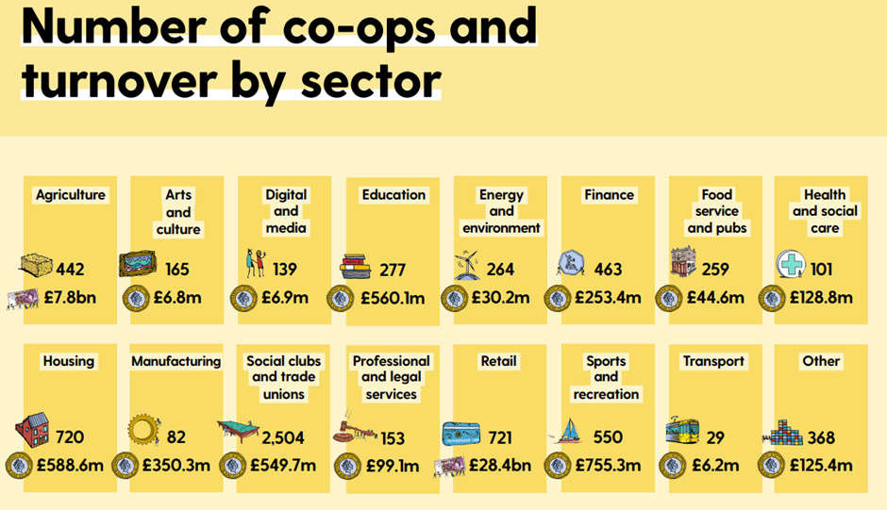
Source: https://www.uk.coop/sites/default/files/2021-06/Economy%202021_0.pdf

