
Module Name: Enterprise Development and Commercial Innovation
Module Code: BMBS5000
Assessment 1: Mind Map & Value proposition Canvas Academic Interview
Student Name: Ieuan Robson
Student Number: 2510045
Lecturer: Chris Wilkin
Deadline: 19th October 23;59

Mind Map - CAREPLATE - MindMeister Mind map
VPC - *The Value Proposition Canvas - Official Template from Strategyzer - v2.1.pdf

AI Acknowledgement
I acknowledge the use of River
Free Value Proposition Canvas Generator | River
Customer Value Propistion as a prompt
I acknowledge that I have use ofCanva
Search business model canvas - Canva
To help design a business canvas model using a template
I confirm I have not used any generated AI text as my own work.
I confirm that I have copies of my own drafts, notes and other resources, that I have used before, and afte. I acknowledge may be asked to provide evidence.

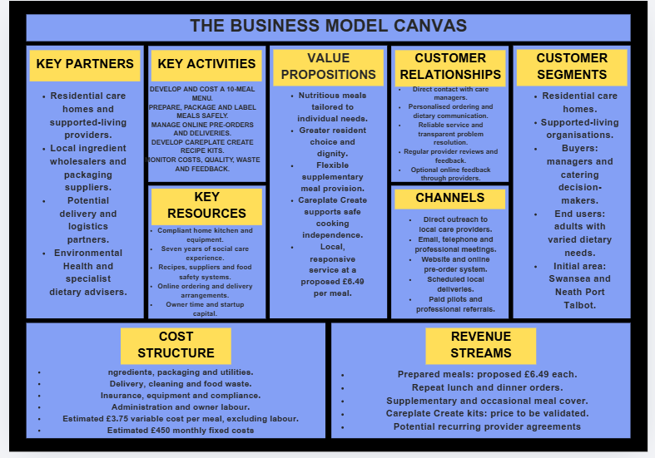
Appendix A – Business Model Canvas

Appendix C – Problem/Solution Fit
- Product: Careplate Create Kit
- Feature: Pre-measured ingredients and a simple recipe card
- So What: Residents cab cook a meal themselves, with support if needed
- So What: Staff spend less time planning meals and shopping
- So What: Residents build cooking skills and chose what they eat
- So What: More independence and dignity, which is the aim of supported living
- Product: Careplate Prepared Meals
- Feature: 10-meal menu delivered ready to eat
- So What: No cooking needed on busy or short-staffed shifts
- So What: Staff have more time for direct personal care, rather than cooking in the kitchen
- So What: Residents still get a choice of proper nutritional meals
- So What: Providers meet care goals without hiring extra support/kitchen staff

Appendix D – The Link between Demand and Revenue

Appendix E – Total Revenue Hill

Appendix F – Price Elasticity of Demand (PED) Is Careplate Elastic or Inelastic
Factor | Careplate | Effect
Substitutes | Staff can cook in-house, or buy supermarket meals, other competitors like apetito or local caterers | Elastic
Percentage of income | Meals are a regular cost from tight often council funded budgets | Elastic
Luxury/Necessity | Food is a necessity. But bought in meals are an optional extra | Mixed
Addictive/Habit | Residents get uses to familiar meals and menus get planned around them | Inelastic
Time period | Menus are fixed in short term, however providers can switch in the long term | Short: Inelastic  Long-term: Elastic

Appendix G – 5 Whys
Root Cause: there is no affordable way to offer every resident individual meal choice. Careplate’s answer: ready meals, plus Create kits.
Problem: Residents in supported living often have little choice or control over their meals.
Finding the root cause behind the problem Careplate solves
Why? 1 | Staff tend to cook the same few meals for everyone in the house.
Why? 2 | They have limited time the plan, shop and cook between care tasks.
Why? 3 | Cooking competes with personal care, medication and activities on busy shifts.
Why? 4 | Small supported-living houses don’t have dedicated kitchen staff.
Why? 5 | Funding manly covers care and support hours, not catering.

Appendix H – Bowmans Strategy Clock
Careplate
High Price
Low Price
Low Perceived Value
84
High Perceived Value
74
3
14
24
54
64
44ccc4

Careplate Route 3, Hybrid
A moderate £6.49 a meal with high perceived value, local, freshly made, with a choice of 10 ready to heat meal, plus create kits.

Appendix I – PESTLE Analysis
Environmental
Wales has banned single-use plastics such as polystyrene food containers. Local delivery keeps food miles low.
Mixed
Legal
Council food business registration, a food hygiene rating that must be displayed in Wales, and full allergen labelling.
Threat (cost)
Technological
Cheap online ordering, invoicing and food-safety logging apps make a one-founder business workable.
Opportunity
Economic
Food inflation slowed to 1.7% in June 2026, easing ingredient costs. Provider budgets remain tight.
Mixed
Social
Wales's 65+ population is projected to grow 44% by 2039, with rising expectations of independent living.
Opportunity
Political
Welsh policy puts voice, choice and control at the centre of care, and has funded 44 supported-living schemes.
Opportunity

Overall: the outside environment favours Careplate, but legal compliance and packaging will add start-up costs.
Sources: Welsh Government (2026); ONS via Grocery Gazette (2026); Age Cymru (2021); Food Hygiene Rating (Wales) Act 2013

