Repairing the Ocean: A Reflective Journey into Sustainable Jewellery Design

College: University of Wales Trinity Saint David
Major: Art & Design
Student: XIAOXIAOZHOU

Introduction
I. What am I really trying to understand through this work?
1.1 Project Background
1.2 My personal motivation
1.3 My core research question
1.4 Summary of the Work
II. What ideas, images, or worlds kept calling me back?
2.1 Reasons for choosing to study marine biology
2.2 Artist Analysis and Design Concepts
2.3 On the Selection of Materials
III. When did the work start speaking back to me?
3.1 Initial sketches
3.2 Materials Testing
3.3 Changes to the design
IV.What is the work saying now?
4.1 The Meaning Behind Jewellery Design
4.2 The Significance of Material Selection
4.3 The Meaning of Jewellery
4.4 Self-assessment
V. How the project has changed my design approach
5.1 The Shift in Design Thinking
5.2 A Shift in the View of Materials
5.3 Changes in Creative Approaches
5.4 Directions for Future Research
5.5 Conclusion

Introduction

Recently, many countries around the world have begun to address problems in the sea. Plastic pollution, abandoned fishing nets (ghost nets), marine noise pollution and coral bleaching caused by climate change have all damaged marine environments and are now threats to the living environment of marine life. Although the general public can learn about the environmental problems through news reports, documentaries and social media, this information is often presented visually only. After being exposed to the environment for a long time, people may feel exhausted and lose the desire to pay attention or act.

As a student of art and design, I have begun to think: Can art provide an alternative path for science communication that will arouse people's interest in marine environmental problems once again? I believe that, compared with posters, documentaries or promotional videos, jewellery as an art form worn on the body is closer to the wearer. It is not only for decoration but also for telling stories, expressing emotions and inspiring people to take action in society. Therefore, by means of continuous jewellery design, I hope to present the marine ecological crisis in an artistic way that can be felt, worn and experienced..

The theme of this graduation design is "Repairing the Ocean", and the four jewellery works included are: the Broken Sea Turtle Pendant, the Transparent Soundwave Blue Whale Pendant, the Thermochromic Coral Earrings and the Broken Dolphin Pendant. Each work addresses a different environmental problem, such as plastic pollution, marine noise pollution, global warming and damage to marine ecosystems; eco-friendly resins, recycled metals, thermochromic materials and digital interactive technology are combined to explore the expressive possibilities of jewellery for ecological protection.

The five contents of this reflection report are: the reasons for conducting this graduation design; sources of ideas for the design; the process of creation; results achieved; and personal gains. Through design practice, I will continue to deepen my understanding of the relationship between people and nature, materials and emotions, art and society, etc.

I. What am I really trying to understand through this work?
1.1 Project Background

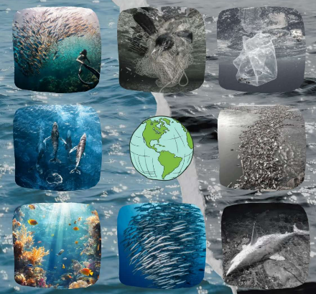
The subject of my graduation design is related to the environmental problems in the ocean. The ocean is an important part of the global ecosystem and supports a wide range of marine biodiversity. However, marine ecosystems are increasingly affected by climate change, pollution, habitat degradation and other human activities (IPCC, 2022).Recently, there have been many news reports about marine pollution; large amounts of plastic waste, old fishing nets and industrial pollutants continue to enter the ocean, and more and more marine life is being threatened with extinction. Among them, sea turtles, whales, dolphins and coral reefs are some of the most direct witnesses to changes in the marine environment. (Figure 1) They can show us how healthy the ocean ecosystem is and also tell us about other problems caused by people living near the sea.
Figure1.ocean issues

Based on my study of related materials and documentaries, most of the campaigns for marine conservation use documentary photography or statistics to arouse the public's interest through genuine pictures. Although this way can spread the news quickly, it may not leave a deep impression on people's hearts and minds about nature. If the same set of pictures is shown repeatedly, people will lose interest in them and stop paying attention to the problems of the environment. Therefore, I have begun to think about whether art and design could provide an alternative form of expression that is softer but also long-lasting.

Jewellery has long been regarded as one of the art forms most intimately connected to the human body. It has been used for decoration, and at the same time, it has also carried culture and emotions. Jewellery is relatively small-scale compared with large-scale installations or public art; therefore, it can be worn every day by many people and continuously create new forms of social interaction through wearing. Therefore, I wish to use jewellery as a way to present the serious problem of marine pollution in a more intimate and moving manner.

At the same time, the ideas of green design have also been applied to this project. I hope that the parts can help promote environmental protection and also carry the spirit of sustainability by choosing eco-friendly materials and production processes, etc. Therefore, I have finally chosen eco-friendly resin, recycled metal and digital interactive technology as my main design language, hoping to create a more intimate relationship between people and nature through these materials.

1.2 My personal motivation

Rather than focusing solely on the design and aesthetic appeal of jewellery, I am more concerned with the message a piece conveys and whether it can truly influence the viewer’s thinking. Design can be connected to wider social and environmental issues rather than being concerned only with appearance and commercial value (Papanek, 1982).

At first, I was interested in marine life rather than jewellery. When I first saw pictures of sea turtles caught in old fishing nets, whales that had died due to plastic pollution, and widespread coral bleaching, I was deeply moved. These pictures have shown me that even small changes in our lives can cause damage to other living things.

However, I did not want to reproduce these sad pictures; instead, I hoped for a work of art that would move people's hearts. I started to think about whether, through the medium of jewellery, which is delicate and emotionally resonant, one could inspire people to take action on these problems themselves and feel motivated rather than overwhelmed by a large-scale display.

In the course of my studies, I have come to learn that my main interest lies not in marine pollution alone, but in the gradual deterioration of the relationship between people and nature. I started to think that the first problem this project wants to solve is not 'How to design eco-friendly jewellery?', but rather 'How can we help people feel closer to the sea again through jewellery?'.

Consequently, I gradually defined the core concept of the entire collection: ‘Repair’.

'Repair' here does not refer to fixing a broken piece of jewellery; rather, it refers to restoring harmony between people and nature that has been lost over time. It is necessary to restore the ecological environment of the sea and raise public awareness about environmental issues at the same time. Therefore, I hope that each work can show the coexistence of 'breakage' and 'repair', and thus both address the environmental crisis and offer a glimmer of hope for change in the future.

1.3 My core research question

I hope to explore whether sustainable jewellery can go beyond its original purpose of decoration and serve as a form of art for raising public awareness about environmental problems.

To answer this question, I have further identified several specific areas of research:

How can jewellery tell environmental stories through its materials?
Can interactive design enhance public engagement with marine conservation?
Can sustainable materials satisfy both environmental principles and aesthetic requirements?
Can art serve as a new means of environmental communication?

These questions run throughout the entire creative process and continually influence the direction in which the works develop.

1.4 Summary of the Work

In response to the research questions outlined above, I ultimately completed a series of four jewellery pieces.

The Shattered Turtle Pendant addresses the problems of discarded fishing nets and plastic pollution by using a broken turtle shell, stitched-together fishing nets, and an interactive QR code to explore the connection between restoration and hope.

The Transparent Sound Wave Blue Whale Pendant addresses marine noise pollution by enclosing sound wave patterns in transparent, eco-friendly resin and employs chip technology to explore the potential of digital jewellery.

Thermochromic Coral Earrings use thermochromic materials to show how corals change colour when they are stressed by high temperatures due to climate change, and thus help people feel the effects of rising sea temperatures on life in the ocean.

The Shattered Dolphin Pendant is made by combining recycled metal and crystals to show the current damage to dolphin habitats, but at the same time, it also hopes that life can be restored and rebuilt.

The four works address various problems in the marine environment, but they are all under the general theme of 'Repairing the Ocean' and seek to evoke stronger emotions in people for nature through jewellery.

II. What ideas, images, or worlds kept calling me back?

2.1 Reasons for choosing to study marine biology

At all times during the construction of this project, I have repeatedly thought about marine life. Sea turtles, whales, coral reefs and dolphins have appeared in both my first drawings and later works. This repetition is not accidental; rather, each of these animals represents a different type of marine ecological crisis, and together they present a full picture of my understanding of the ocean.

A Sea Turtle marks the beginning of this whole series. Among all the cases of marine pollution, the pictures of sea turtles injured or dead after swallowing plastic and being trapped by discarded fishing nets have left a deep impression on me. Therefore, I consider sea turtles to be symbols of plastic pollution and the problem of 'ghost nets'.

The blue whale, meanwhile, represents another, relatively hidden environmental issue: marine noise pollution. Compared to plastic waste, noise pollution is much harder for the public to perceive directly, yet it affects the navigation, communication and migration of cetaceans. I therefore hope to make this invisible pollution visible by visualising sound wave patterns.

Coral symbolises global climate change. Coral bleaching is a slow-moving yet irreversible ecological crisis; I have therefore chosen thermochromic materials so that the artwork continuously changes colour in response to temperature fluctuations, transforming environmental change into an experience that viewers can perceive in real time.

2.2 Artist Analysis and Design Concepts

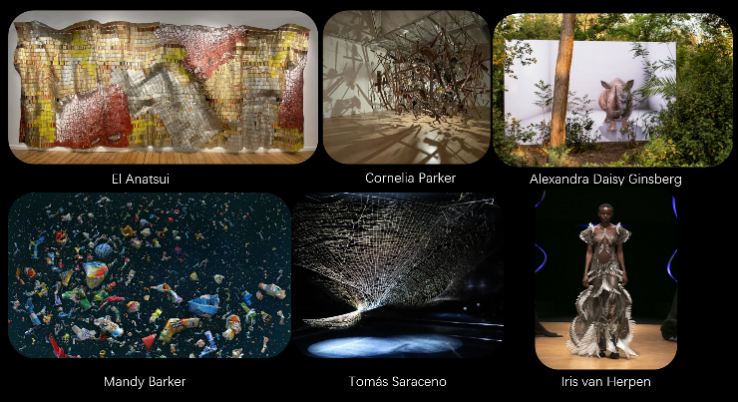
Throughout my research, I have continually drawn inspiration from artists who explore the relationship between ecology, materials and technology, such as Tomás Saraceno, Studio Drift and Iris van Herpen. Their work has made me realise that art can not only depict nature, but also prompt us In my studies, I have continuously been inspired by artists who explore the connection among ecology, materials and technology, such as Tomás Saraceno, Studio Drift and Iris van Herpen. （Figure.2）Through their works, I have come to know that art does not need to represent nature; rather, it can inspire people to think about how we live in nature.
Figure.2 Aerist‘s work

to rethink the relationship between humans and nature.Tomás Saraceno combines scientific research, ecosystems and artistic practice, emphasising the interdependence between humans and the natural environment. This made me realise that my work should not merely reproduce marine animals, but should, through design, guide the audience to rethink their own connection with the marine ecosystem.

Studio Drift has integrated the laws of nature and digital technology to create works; I have been inspired by this to explore how interactive technologies, such as QR codes and chips, can be applied to jewellery design so that these pieces are both beautiful and continuously convey environmental information.

Iris van Herpen's experiments with materials and organic shapes have inspired me to move away from conventional jewellery structures, creating marine life in forms that are more fluid, transparent and lifelike, thus making the visual language of my works closer to the fluidity of the sea.

Although these artists have not directly changed the form of my work, they have inspired me to explore various ideas and gradually formed my own concept of design: jewellery is no longer just an object; it can also be used to express emotions and convey messages about life, nature, technology and society.

2.3 On the Selection of Materials

Material selection should consider not only appearance, but also function, processing and environmental impact (Ashby and Johnson, 2014).Given that I have chosen endangered marine animals as the subject matter for my works, I have been thinking about how to use materials in this context. At first, I thought of materials as means to achieve a particular shape for the jewellery; for instance, metal was used to build a structure and resin was employed to give it a transparent quality. Through my studies and experiments, I have gradually come to understand that materials can affect both the appearance and construction of a work of art, but they may also serve to express ideas. Therefore, I started to think about the following problem: If my work deals with problems such as marine pollution, climate change and ecological damage, should the materials used in this work also reflect these environmental concerns?

Materials can influence not only the physical properties of a designed object, but also the way people experience and interpret it (Karana, Pedgley and Rognoli, 2014).Therefore, instead of selecting the traditional material for jewellery directly, I have been exploring other materials to determine their visual effect, workability, durability and suitability for the theme. Ordinary resin, acrylic, silicone, metal, recycled materials, thermosensitive materials and discarded fishing nets were all considered. Thus, I learned that the selection of materials should not be based solely on how aesthetically pleasing they are; at the same time, we need to consider whether they can help us express the ideas of our works.

I have selected recycled metal, eco-friendly resin and old fishing nets for the sea turtle pendant. Recycled metal has a certain weight and solidity, so it can be used to build the main structure of the sea turtle's body; at the same time, the idea of 'recycling' itself is closely related to resource circulation and environmental protection. A clear resin can be used to create a visual effect of seawater and to enclose simulated marine debris. For me, this way of "freezing pollution in jewellery" is especially meaningful because it makes the invisible problem of pollution visible. Discarded fishing nets have two meanings: they are the harm done to marine life, but in this work, they are also used to repair the turtle's damaged shell and thus express both destruction and recovery. This change in the meaning of the material is now a general visual system for all of the 'Repair' works.

For the Blue Whale pendant, I will pay close attention to the transparency of the material and the interior space. I use eco-friendly resin to create a transparent body and place a structure based on sound waves inside it. Given that marine noise pollution is inherently invisible, I wish to convert this 'invisible pollution' into a visual language that can be observed by using transparent materials and an internal sound-wave structure. At this time, the material is no longer just a carrier of form; rather, it serves as a connection between the 'invisible problem' and the 'visible piece of jewellery'.

I have used some temperature-sensitive materials in these coral stud earrings. Unlike my other works, this one does not show changes in the environment by means of fixed materials; instead, I want the material itself to respond to heat. Coral bleaching is caused by higher-than-normal sea temperatures, so a change in colour can indicate that the ecosystem has been altered. Through this experiment, I have come to understand that the material itself can be used as a type of 'interactive language' and does not need to be added on top.

The 'Broken Dolphin' pendant is mainly made of recycled metal and crystal. A broken metal structure shows that the marine environment has been damaged; at its core is a crystal representing life, hope and recovery. The materials used in this work are different from those in the sea turtle section; rather than 'repair', they aim for 'life that continues after damage'. Therefore, I have learned that, although the materials are the same, various stories can be told by altering their arrangement and combination.

Based on the above experiments with materials, I have gradually corrected my initial ideas about jewellery materials. In the past, I was more concerned about whether a material could achieve a particular shape; now, however, I am interested in learning what that material can do on its own. Is there an ecological problem here? Can the audience feel the theme of the work through their sense of touch, sight and other changes in materials?

Therefore, the materials I finally selected were not chosen solely for their visual effects; instead, I aimed to have each material serve a particular purpose in telling the story. Recycled Metal signifies recycling and reuse; Eco-friendly Resin represents seawater, transparency and trapped pollution; Discarded Fishing Nets symbolize harm and healing; Thermosensitive Materials are associated with environmental changes; Crystal is a symbol of life and hope. Together, these materials constitute my material language and provide a unified conceptual connection among the four pieces of jewellery.

Looking back at this time, I believe that the material experiments have been very successful in this project. They helped me change my mind about designing jewellery inspired by marine life and began to explore how to address environmental problems related to the sea in my work through materials. Thus, my Design Thinking has moved away from merely creating beautiful objects and now seeks to explore how various materials and ideas can affect people's lives.

III. When did the work start speaking back to me?

3.1 Initial sketches

In the beginning of the project, I did not know what the final form of the four parts would be; therefore, I carried out many visual studies to see how other artists had integrated environmental problems into their works of art. At first, my designs concentrated more on the external shapes of marine life, such as the shell of a sea turtle, the outline of a whale, the branch-like structure of coral, and the slender body of a dolphin. However, after several rounds of sketching and comparing, I came to understand that if I were to simply convert the animals into jewellery shapes, the works would likely remain at the level of 'animal-themed jewellery' and fail to convey the environmental issues that concern me.

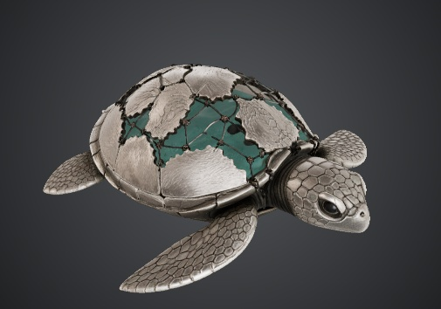
Therefore, I started to experiment with 'dismantling' and 'reassembling' animal bodies. For example, in the design of sea turtles, instead of creating a whole, symmetrical shell, I tried to separate the shell into pieces and connect them with fishing nets. As a result, I have come to know that fragmentation itself can be used as a design language. A fishing net is no longer just a tool; now, it can also be used to create damage and serves as a bridge connecting the broken parts of a turtle to help repair them. Therefore, the same element has two meanings: 'destruction' and 'repair'.（Figure.3）
Figure．3 Turtle design

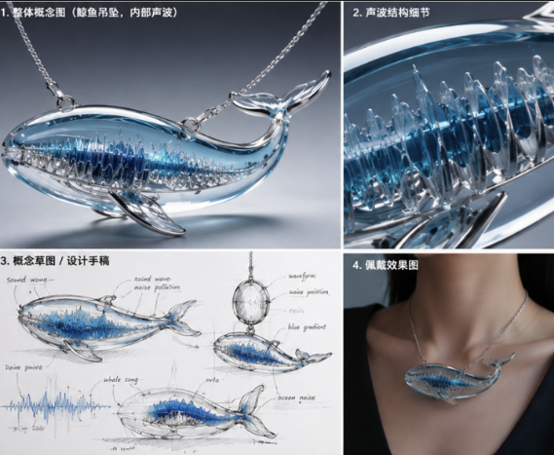
Designs of blue whales have gradually moved from being literal to abstract. At first, the drawings were mainly about the shape of the whale; however, since marine noise pollution cannot be seen directly, I thought that showing just the whale was not enough to present this problem. Therefore, I started try about sound and waves, and added patterns of sound waves to the whale's body.（Figure.4） Therefore, a clear structure has been built to show the degree of marine noise pollution.
Figure．4 Whale design

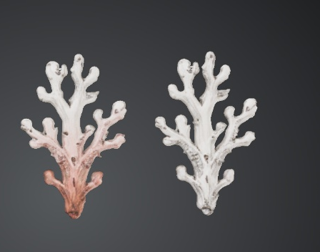
The design of the coral stud earrings stems from reflections on the issue of ‘rising ocean temperatures’. Coral bleaching is an ongoing process, so I did not want the piece to merely depict white coral statically; rather, I wanted the piece itself to undergo a transformation. This idea ultimately led me to choose thermochromic materials, which allow the colour to change with temperature. Consequently, the colour of the coral stud earrings also shifts with temperature, better illustrating the process of coral bleaching and making the colour changes an integral part of the piece’s expression of ocean temperature fluctuations. （Figure.5）
Figure．5 Coral design

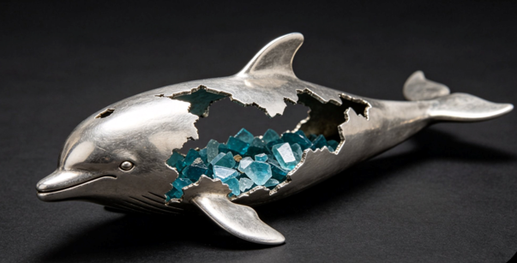
For the dolphin design, I had originally intended to incorporate the ocean into the dolphin’s body to highlight issues surrounding its habitat. However, I felt this approach was too conventional and lacked aesthetic appeal, so I chose to depict the dolphin’s body in a fragmented form, with the central section filled with crystals. This symbolises how marine litter is causing the loss of the dolphin’s habitat, leading to its death. （Figure.6）
Figure．6 dolphin design

Through the sketch studies carried out during this phase, my focus gradually shifted from ‘how to design jewellery featuring marine animals’ to ‘how to enable the jewellery itself to tell an environmental story and interact with the wearer to some extent’. My initial sketches were not simply plans for the final jewellery pieces. They became a way for me to think through the problems and possibilities of the designs. Schön (Schön 1983) suggests that practitioners can develop their understanding through reflection during the process of making and doing.This also marked a significant turning point in the design thinking behind the entire project.

3.2 Materials Testing

Based on the above Design ideas, I have begun some material tests. Working directly with materials can help designers develop a deeper understanding of their physical qualities and limitations (Sennett, 2009).The selection of materials for this project should also be in line with the idea of the work. Given that my research topic is environmental protection, I hope to find materials that can meet both the demands for shape and production, as well as align with the theme of 'Repairing the Ocean'.

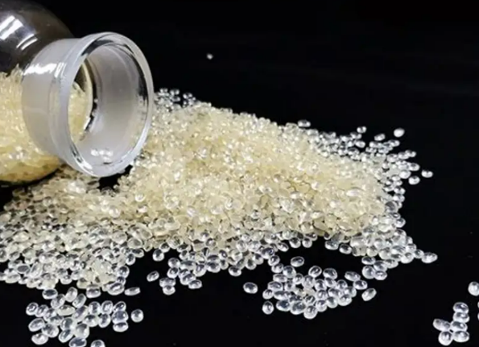
At first, I thought about using ordinary resin, acrylic, silicone and other kinds of plastic. Standard resin has good transparency and flexibility; therefore, it is suitable for creating shapes of marine life, but it does not align well with the project's green goals. Therefore, I have been researching eco-friendly resins to find one that is both visually appealing and easy to use sustainably. （Figure.7）
Figure．7 Environmentally friendly resin

Finally, eco-friendly resin was selected as the material for the sea turtle and blue whale parts. It can be made into a model of seawater and has been used to contain waste and sound-wave patterns. For instance, in the sea turtle pendant, I wanted to enclose simulated marine waste in the resin and change pollution from a picture on the surface of the work into a visual memory 'frozen' in the material. A blue whale model is used to create a space with transparent resin, and thus, sound wave patterns seem to float inside the whale's body; this represents the invisible noise pollution in the ocean.

I started using recycled metal in the dolphin section. Resin does not have the same weight and texture as recycled metal; therefore, it cannot be used to create a broken body effect. Recycled metal can also be used to promote environmental protection by reducing waste; thus, the material itself contributes to the idea of sustainability rather than being used solely for creating art.

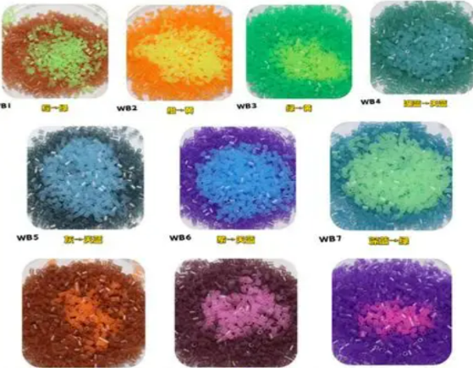
I have also studied thermochromic materials in my free time. Thermochromic materials can change colour according to changes in temperature; therefore, they are relatively easy to use and add a sense of novelty to the coral earrings. Although there are some technical problems with this material, such as colour stability and control, it can still be used to present the idea of 'environmental change' more directly.( Figure.8)
Figure．8 Thermally sensitive materials

Through making and experimentation, I was able to understand the physical qualities and limitations of different materials. This process showed me that making itself can become a form of thinking (Adamson, 2007). At this time, I learned that the materials are not just selected after the Design is finished; they can also affect the direction of the Design proactively.

3.3 Changes to the design

There was a considerable difference between the first Design and the finished product at this time. Most of these modifications were not caused by errors in the original design, but rather because the actual materials, structure and how the piece would be worn continuously presented new problems for my design.

One of the places where these changes can be observed more clearly is the turtle pendant. The original Design was relatively complete, and the turtle shell had a more regular shape; however, after starting production, I found that a full shell could not express the ideas of 'fragmentation' and 'repair' as effectively. Therefore, I gradually increased the distance between the fragments of the shell and concentrated the broken parts in the upper part, leaving the structure at the bottom unchanged. Thus, the tortoise will still have a typical animal shape and show the damaged parts. A small area is left at the bottom for a printed QR code, and this interactive design element can be placed inconspicuously without drawing attention.

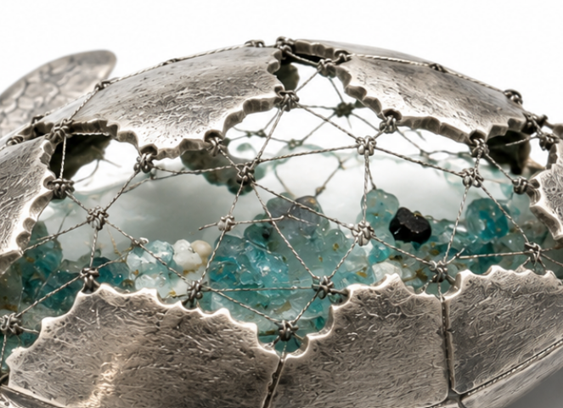
The Design of the fishing net has been modified several times. At first, I thought about using a coarse mesh; however, then there would be too many details in the picture. Therefore, I selected a fine-mesh one to create a better-looking junction at the meeting point of the sections on the tortoise's shell. Thus, the new idea will be closer to the old one. ( Figure.9)
Figure．9 Details of the connections in the ‘tortoise-shell’ fishing net

Blue whale pendants have also gradually moved away from simple animal shapes to become more transparent and abstract. Soundwave patterns can be added to the whales, and these patterns will not disrupt the general form of the work.

Due to the limitations of the temperature-sensitive material, the coral stud earrings have been modified. At first, I wanted to use glass to show the shape of coral; since glass turns red when it reaches its melting point and then becomes white after cooling, this could be compared with coral bleaching, but this idea was too abstract for people to understand, so I did not use it. Therefore, I selected thermochromic materials to design the coral stud earrings and created a colour-changing effect that can be easily observed by the audience to convey the environmental message of the work.

Therefore, I am now aware that the Design process does not proceed in a straight line from sketch to completion. In fact, at all times, materials, structure, function and concept are interrelated; thus, the final work has been achieved through repeated experiments, errors and corrections.

IV.What is the work saying now?

4.1 The Meaning Behind Jewellery Design

I have finished four works and my ideas about jewellery design have changed slightly. At first, I thought that jewellery should be beautiful to look at and convenient to wear, and the idea of the environment was just a general concept for these works. However, in the course of this project, I have come to learn that a concept does not need to be added to a work; instead, it can be contained within the form, materials and how it is worn by people.

Objects can have meanings beyond their practical functions, and these meanings can change according to their social and cultural contexts (Appadurai, 1986). The four works address various problems in the marine environment, but all of them express the environmental crisis through changes in animal bodies. Fragmented sea turtles and dolphins are 'damage', sound waves inside a blue whale are 'invisible pollution', and temperature-sensitive corals are 'ongoing environmental change'.

Therefore, I hope that the audience will be able to experience four different environments rather than just four marine animals. Jewellery here serves as a carrier for small stories, and large-scale problems in nature are transformed into personal experiences that can be worn and felt.

4.2 The Significance of Material Selection

In the final work, the material itself becomes an integral part of the expression of meaning.
Eco-friendly resin is selected due to its transparency and lightness; at the same time, it is more in line with the theme of environmental protection, reduces harm to the environment at the material level, and can preserve pollutants and sound waves visually inside it. Recycled metal can also be used to represent recycled materials and connect with the idea of 'repair' in the work of art.

At the same time, thermosensitive materials have also moved away from the fixed state of traditional jewellery. They can change according to changes in the environment of the pieces, and thus the materials themselves can take part in telling the story of that place.

Therefore, I have come to learn that green materials do not need to be ugly. On the other hand, if the physical attributes of a material are closely related to the idea of a work of art, they will serve multiple functions simultaneously: aesthetics, function and narrative.

4.3 The Meaning of Jewellery

This project has also led me to rethink the very nature of jewellery.

Jewellery has traditionally been regarded as a way to decorate oneself, show off one's social status and wealth, etc., but my works aim to explore other possibilities for communication outside of these purposes.

For example, the QR code on the back of the turtle pendant extends the piece from physical jewellery to the digital world; the idea of a chip embedded in the blue whale pendant explores how jewellery can be linked with environmental data; and the thermochromic coral changes colour according to fluctuations in the environment and thus alters the wearer's sense of touch.

Therefore, in my project, jewellery will no longer be limited to being looked at; instead, it will serve as a link between people and their surroundings and convey information.

4.4 Self-assessment

Based on the results of this study, I believe we have achieved a certain level of conceptual clarity in the project. Although the four works focus on plastic pollution, ocean noise, global warming and habitat destruction respectively, 'Repairing the Ocean' brings them together to give the whole series a unified visual and conceptual system.

At the same time, I am aware that there are still some deficiencies in this work. For example, some of the interactive functions are still at the concept stage; in particular, the real-time ocean data monitoring function of the blue whale pendant needs further electronic support. In addition, a closer connection should be established between the change in colour of the thermochromic material and actual sea temperature.

Therefore, I believe that the current work is closer to an exploration of design concepts and artistic practice than to a fully commercialized, technically mature end product.

It is not necessarily a defect; rather, it has shown me where I need to improve in the coming days.

V. How the project has changed my design approach

5.1 The Shift in Design Thinking

The main change brought about by this project is that I have begun to move away from a 'form-driven' way of designing and started using a 'concept-driven' method.

In the past, I would first think about what shape the work should have, which colours to use, and how to make it look good. However, in this project, I started with a question: What do I want the audience to see? How do I wish for them to feel? Why does it need to be that way?

Therefore, form is no longer the beginning of design; rather, it serves as a means to express ideas.

5.2 A Shift in the View of Materials

In the past, I have regarded materials merely as means to achieve a design goal, but now, through this project, I have come to know that they also have their own language.

For example, fishing nets are not only materials for construction but also symbols of marine pollution; recycled metals can be used to create works that embody the ideas of circular economy and ecological civilization; and transparent resins can hold pollutants and sound waves to reveal hidden information.

Therefore, in the future, when selecting materials, I will give more weight to their origin, texture, life cycle and cultural and environmental values.

5.3 Changes in Creative Approaches

Gradually, during the course of creation, I have learned to view failure and revision as necessary steps in the design process.

For example, the structure of the turtle pendant, the density of the fishing net, the colour of the resin, and the colour variation in the coral earrings have all been changed multiple times. Therefore, I now know that design is not a one-time event but a cycle of repeated tests, feedback and revisions.

I have started to pay more attention to interactive Design as well. QR codes, temperature-sensitive functions and microchips have shown me that the jewellery of the future will have both physical and digital attributes.

5.4 Directions for Future Research

Looking ahead, I hope to further develop three areas.

Firstly, Technology. I plan to carry out further research on sensors, chips and real-time environmental data to enable the Blue Whale pendant to respond to actual ocean data. Secondly, Materials. I will continue to search for more sustainable and traceable jewellery materials, such as a wider range of recycled metals, bio-based materials and recycled plastics, and explore their application in fine jewellery craftsmanship. Thirdly, Public Participation. I plan to further develop QR codes, AR, digital displays and donation systems to allow the audience to experience the work in a more active way, rather than just observing it. I hope that in the future, these works will not only inform the public that 'the sea is in trouble', but also offer solutions to this problem.

5.5 Conclusion

Over the course of the project, I have come to learn that 'Repairing the Ocean' aims to restore not only the health of the sea but also the distance people have grown apart from nature.

The four pieces of jewellery address marine environmental problems by means of fragmentation, sound, temperature and materials, and explore the possibility of 'restoration' through the use of fishing nets, resin, recycled metal, temperature-sensitive materials and digital technology.

This project has given me a new idea of the limits of jewellery design. Jewellery can be worn as ornaments, but they can also tell stories, carry messages, connect people, and sometimes draw attention to social problems. To me, what is most important is not the production of four works of 'jewellery about marine animals', but rather the attempt to show that a small piece of jewellery worn near the body can also address a large-scale problem in the environment, society and the future.

This has also been my main take-away from this project: I have moved away from designing objects to designing relationships among people and their surroundings.

Appadurai, A. (ed.) (1986) The Social Life of Things: Commodities in Cultural Perspective. Cambridge: Cambridge University Press.
Adamson, G. (2007) Thinking Through Craft. Oxford: Berg.
Ashby, M.F. and Johnson, K. (2014) Materials and Design: The Art and Science of Material Selection in Product Design. 3rd edn. Oxford: Butterworth-Heinemann.
Chapter 3: Oceans and Coastal Ecosystems and Their Services. Cambridge: Cambridge University Press.
Karana, E., Pedgley, O. and Rognoli, V. (eds.) (2014) Materials Experience: Fundamentals of Materials and Design. Oxford: Butterworth-Heinemann.
Sennett, R. (2009) The Craftsman. London: Penguin.
IPCC (2022) Climate Change 2022: Impacts, Adaptation and Vulnerability.
Papanek, V. (1982) Design for the Real World: Human Ecology and Social Change. 2nd edn. London: Thames & Hudson.
Schön, D.A. (1983) The Reflective Practitioner: How Professionals Think in Action. New York: Basic Books.

