Programme: BA (Hons) Leadership and Management Skills in the Workplace
Module: Project Management (LCLM5003_BIRM)
Lecture Full Name: Sayed Navid Nasirpourosgoei
Sylene Angela Cedeno Pincay
2330431



Contents
Part A – Project Proposal Poster 3
Reopening of the Highway 5 Coquihalla 3
Part B- Reflective Report 4
Feedback from the Lecturer and peers 4
Strengths 4
For improvement 5
In conclusion 5
Part C- Project Management Plan 6
1. Introduction 6
2. Project description: Reopening of Highway 5 7
Objectives 7
Deliverables 8
3. Scope 10
4. Work breakdown structure (Globerson, 1994) 11
Project: Reopening of Highway 5 11
5. Quad Chart 12
Quad Chart – Rebuilt Highway 5 (Coquihalla Bridge) 12
1. Purpose 12
2. Customer / Stakeholders 13
Primary Stakeholders: 13
Stakeholders Interest: 13
Budget Overview 13
3. Desired Results (Deliverables & Outcomes) 14
Deliverables: 15
Expected deliverables: 15
4. Measures of Success (Performance Indicators) 15
Key indicators 15
Chad Chart 16
5. Gantt Chart 17
Explanation of the Gantt Chart for the Highway 5 17
7. Stakeholders' involvement 18
RACI Matrix 19
8. Allocation of resources 20
9. Risk Analysis 21
10. Conclusion 23
11. References 24

Part A – Project Proposal Poster

Reopening of the Highway 5 Coquihalla
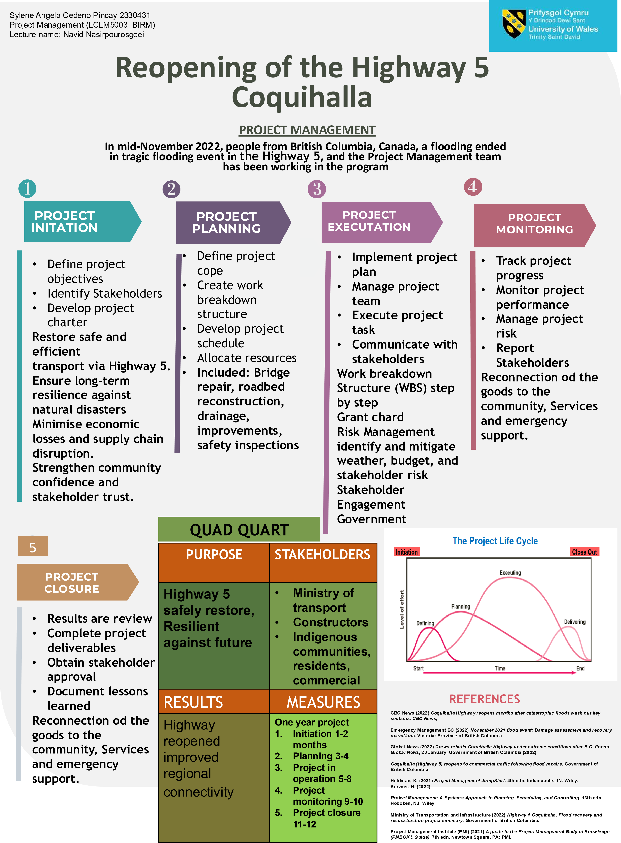

Part B- Reflective Report

Feedback from the Lecturer and peers

After receiving feedback from my tutor and peers on my Project Management presentation, I have taken notes and have had the time to carefully reflect on both the positive aspects and the areas that require improvement. The feedback has been extremely valuable in helping me understand my strengths as a presenter and the elements I need to improve to deliver a more comprehensive and professional final project plan (Apperson et al., 2006; Lowry, 1999; Mantei, 2000; Susskind, 2025).

Strengths
One of the main strengths highlighted by both my tutor and colleagues was the clarity and organisation of my poster. They appreciated that their layout was easy to follow and that the information flowed logically from one section to the next. I was pleased to hear that the audience found my explanations straightforward and my language clear, which made the technical details of the project easier to understand. This shows that I succeeded in my goal of making the presentation accessible to everyone, regardless of their background knowledge in project management. Research indicates that an individual’s capacity for problem-solving is a significant strength in professional environments (Smith, 2023)

Another strength mentioned was my communication style during the presentation. The feedback noted that I maintained good eye contact, used confident and appropriate body language, and spoke in a calm and engaging tone. These presentation skills helped me connect with the audience and keep their attention throughout. My inclusion of the key project management concepts, such as the project life cycle and the quad chart, also received positive feedback. This demonstrated that I had a solid understanding of fundamental theories and was able to apply them effectively in my presentation. (Thelwall, M. and Kousha, K., 2008)

For improvement
However, several important areas for improvement were also identified. The most significant feedback was that some key components of the project plan were missing. My lecturer and peers pointed out that I had not included essential elements such as the budget, risk analysis, and stakeholder mapping. These are critical aspects of any project management plan, and their absence made my project appear incomplete. Including these sections in the final version will not only make my project more comprehensive but also demonstrate my understanding of project planning and evaluation in real-world contexts.
Another area for improvement was the lack of visuals and images in my presentation. My peers suggested that including charts, diagrams, and images would make the poster more engaging and visually appealing. For the final project, I plan to include visuals such as a stakeholder map, a risk matrix, a work breakdown structure and budget charts to help illustrate the key points and support audience understanding.

Additionally, my lecturer mentioned the absence of in-text citations. Academic referencing is essential to demonstrate research and credibility. I will make sure to include citations from relevant project management sources, such as the PMBOK Guide or academic journals, to strengthen the academic quality of my work.

Nisonger, T.E., 2004. The benefits and drawbacks of the impact factor for journal collection management in libraries. The Serials Librarian, 47(1-2), pp.57-75.

In conclusion
The feedback I received was very constructive and will guide me in improving my final project plan. I will build upon my strengths, such as clear communication and logical structure, while addressing the missing elements like budget, risk analysis, and stakeholder mapping visuals. By implementing these improvements, I aim to produce a well-rounded, professional, and academically sound final project plan.

Part C- Project Management Plan

1. Introduction

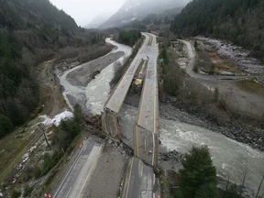
In the middle of November 2022, people from British Columbia, Canada, experienced a historic and tragic flooding event.
Caused by floods triggered by a series of atmospheric rivers, which brought an unprecedented amount of rainfall to the region.

The floods and mudslides had a devastating impact on citizens, First Nation communities, and businesses, with the massive damage to highways, agriculture production and infrastructure across southern British Columbia causing massive losses to different stakeholders. (Ahmed, 2025)

The Government of Canada remains steadfast in its commitment to be there throughout the long-term recovery, providing funding and support to the recovery through the Canadian Red Cross, which has been matched by the Federal and Provincial Governments, bringing the total amount raised to $90 million. (Kneebone, 2007)

The Highway 5 (also known as the Coquihalla Highway), which serves as a critical corridor connecting the Lower Mainland to the rest of Canada, was severely damaged. The disruption of this highway resulted in significant economic losses, supply chain interruptions, and community isolation. (Globerson & Zwikael, 2002)

This Project Management Plan (PMP) sets out a structured approach to the reopening of Highway 5. It outlines the scope, methodology, resource allocation, stakeholder involvement, and risk management strategies. The goal is to ensure that the highway is safely restored, resilient against future. A goal without a timeline is just a dream (Robert Herjavec, 2020)

2. Project description: Reopening of Highway 5

Objectives
- Restore safe, efficient transportation via Highway 5. (Li, Hard & Bochner, 2013)
- Minimise economic disruption by re-establishing supply chain routes. (Olaleye et al., 2024)
- Integrate disaster-resilience measures into the reconstruction process. (Paton & Johnston, 2017)
- Ensure timely competition within budget and stakeholder expectations. (Sanyaolu et al., 2023)

S.M.A.R.T. goals table for the highway 5
S  Specific | Definition: Clear and detailed to eliminate ambiguity  In this project management re-built the Coquihalla bridge, complete structural engineering assessment.  (Garrish, 2005).
M  Measurable | Definition: A quantifiable way to track progress and determine success.  Application: Track project success using key performance indicators (KPIs)  - Completion of project phases (design, procurement, construction, inspection)  - 100% adherence to budget and schedule milestones  - Risk assessment and mitigation plan competition at each life cycle phase.  - Quality control metrics: load testing, safety inspections, and material certifications.
A  Achievable | Realistic with a clear action plan, given current tools and team. (Rosenman et al., 2015)  Application:  - Use of experienced engineers, construction managers, and local contractor  - Continuous monitoring through project management software  - Regular progress review and issue resolution meetings.
R  Relevant | Definition: Aligned with organisational goals, community needs, and government priorities.  Application: This project directly supports the restoration of a critical transportation corridor essential for trade, emergency response, and regional connectivity in British Columbia. It aligns with the provincial and federal infrastructure recovery strategies and strengthens resilience against future climate-related disasters. (Sanyaolu et al., 2023)
T  Time-Bound | - Project Initiation 1-2 months  - Planning 3-4 months  - Project operation 5-8  - Project monitoring 9-10  - Project closure 11-12 months

Deliverables
- Fully operational Highway 5, including repaired bridges and road sections
- Drainage and slope stabilisation systems installed
- Safety inspections and certification for reopening
- Final project report submitted to stakeholders

All project has a start and end date; this is an example of the project life cycle.
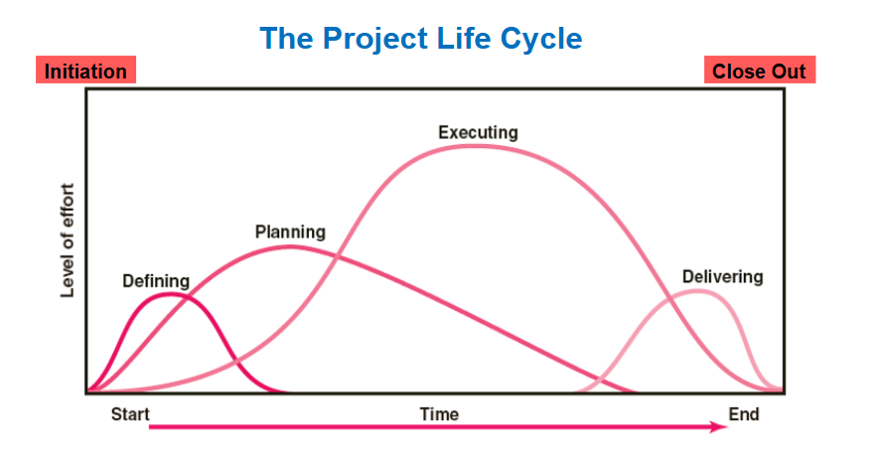
Project Life Cycle for the reopening of Highway 5
(Westland, 2006)

Highway 5 supports over 3,000 commercial vehicles daily under normal circumstances. Its reopening, therefore, serves as a lifeline for industries ranging from agriculture to healthcare. While rebuilding other infrastructures is necessary, prioritising Highway 5 provides the fastest route to economic recovery and social stability.
The project will be implemented using hybrid methodologies. PRINCE2 principles will guide governance, ensuring that the project remains aligned with stakeholder expectations and strategic objectives. Simultaneously, Agile practices will be employed in certain construction phases, enabling flexibility in addressing unforeseen challenges such as weather delays or supply shortages.
Key stakeholders involved in the Highway 5 – Coquihalla flood recovery included the BC Ministry of Transportation and Infrastructure (MoTI), the constructor Kiewit and Emil Anderson, as well as local communities, Indigenous communities, and the general public whose lives and economies were impacted by the closures. The project also involved the federal government in providing funding for repairs and engineering firms that designed the new structures.
Success will be measured through defined key performance indicators (KPIs). These include reopening at least 90% of the highway capacity within on year, ensuring compliance with Canadian safety and environmental standards, and keeping project expenditure within the approved budget envelope. The plan also accounts for environmental sustainability,
incorporating eco-friendly construction practices and community consultations to minimise social disruption. (Goodland, 1995)

Ultimately, the reopening of Highway 5 is not just about restoration but also future proofing. The design and engineering works will incorporate advanced materials and technologies that improve durability against floods and landslides, aligning the project with adaptation goals.
The scale of destruction that we faced and the work ahead of us – to be able to reconnect people to jobs, to be able to reconnect our supply chains, to be able to allow people to go about their lives again (Jennifer Fraser, Executive Project Director, Highway Reinstatement Program, 2022)

3. Scope
The scope of the Highway 5 reopening project is both extensive and highly specific. It covers planning, design, procurement, construction, and quality assurance phases necessary for restoring the corridor. The primary Scope activities include:
Scope management is critical. A change control board will be established to evaluate any scope modifications, ensuring that only essential changes are implemented to prevent budget inflation and schedule delays. This strict control mechanism aligns with PRINCE2’s “Manage by stages” maintaining project alignment with strategic objectives. (St. Peter et al., 1999), (Jaziri, El-Mahjoub & Boussaffa, 2018)

Inclusions
- Reconstruction of damaged bridges and road segments. (Singh et al., 2002)
- Roadbed stabilisation and slope reinforcement. (Vdovin, Bulanov & Mavliev, 2022)
- Drainage system upgrades to manage heavy rainfall. (Prakash et al., 2016)
- Installation of safety measures (guardrails, signage, monitoring). (Pearson et al., 2011)
- Quality assurance and safety inspections. (Elassy, 2015)
Exclusions
- Reconstruction of damaged bridges and road segments
- Roadbed stabilisation and slope reinforcement
- Drainage system upgrades to manage heavy rainfall
- Installation of safety measures (guardrails, signage, monitoring)
- Quality assurance and safety inspections
Constrains
- Limited seasonal working window due to weather
- Budgetary limitations from provincial and federal funding
- Environmental restrictions to protect ecosystems

4. Work breakdown structure (Globerson, 1994)

Project: Reopening of Highway 5
- Project Planning
  - Stakeholder
  - Environmental and safety approvals
  - Procurement of contractor and materials
(Pellerin & Perrier, 2019)
- Design & Engineering
  - Bridge design
  - Roadbed stabilisation plan
  - Drainage system design
(Buede & Miller, 2024)

- Construction
  - Bridge reconstruction
  - Road repairs and resurfacing
  - Drainage systems installation
  - Safety measures (guardrails, signage)
(Sawhney, Riley & Irizarry, 2020)

- Quality Assurance & Testing
  - Structural inspections
  - Environmental compliance checks
  - Safety audits
(Bures, Cerny & Ahmed, 2018)

- Handover & Closure
  - Final stakeholder review
  - Project closure report
(Klaber & Macdougall, 2009)

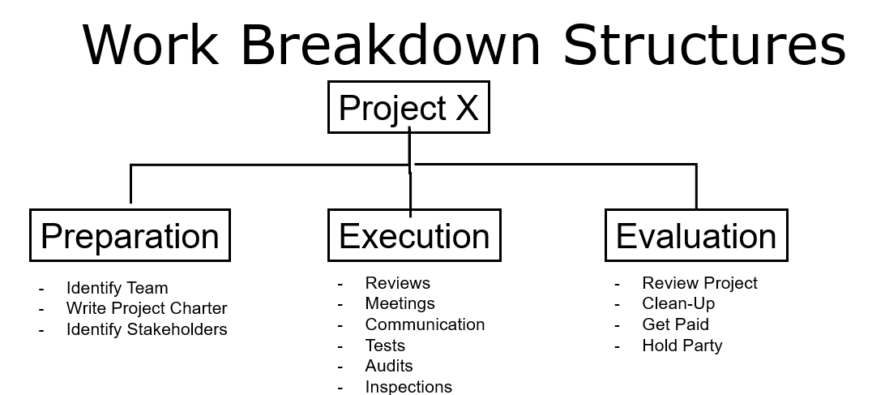
(Haugan, 2001)

5. Quad Chart

Quad Chart – Rebuilt Highway 5 (Coquihalla Bridge)

Purpose
The purpose explains why the project exists, its mission, background, and intended impact.
Detailed Explanation:
After the November 2022 flooding disaster, sections of Highway 5 (Coquihalla) were destroyed, isolating communities and disrupting one of British Columbia’s key transportation corridors (Government of British Columbia, 2023).
The project’s purpose is to rebuild the Coquihalla Bridge and restore full highway functionality, improving resilience to future natural disasters while supporting economic recovery and mobility (Infrastructure Canada, 2023)

Scope: Includes reconstruction of damaged bridges and road sections, installation of drainage and slope stabilisation systems, completion of safety inspections and certifications, and submission of final project report. (Woodcock, 2014)

Strategic Importance:
The Coquihalla corridor supports supply chains, tourism, and emergency services, making its restoration critical to provincial infrastructure recovery (Transportation Investment Corporation, 2023)

Customer / Stakeholders
This project involves collaboration among government, community, and industry stakeholders.

Primary Stakeholders:
- Government of British Columbia – Ministry of Transportation & Infrastructure: Project sponsor and policy regulator (Gov. of BC, 2023)
- Infrastructure Canasa: Federal funding and program oversight
- Local municipalities and communities: Depend on the highway for mobility and economic access.
- Commercial transport and logistics industries: Require highway reopening to restore
- Environmental agencies and First Nations groups: Ensure ecological sustainability and cultural consideration (BC Environmental Assessment Office, 2023)

Stakeholders Interest:
- Timely reopening of Highway 5.
- Reliable and climate-resilient infrastructure
- Compliance with environmental and cultural standards (Natural Resources Canada, 2023)

Budget Overview
The project is co-funded by the Government of British Columbia and Infrastructure Canada through disaster recovery and infrastructure resilience programs (Government of British Columbia 2023).

The budget covers engineering design, construction, environmental compliance, safety certification, and reporting activities.
Cost Control and Monitoring
Budget performance will be monitored monthly through Earned Value Management (EVM) metrics and financial tracking systems. Any cost deviations exceeding 10% will trigger a review and corrective action process. (Christensen, 1998)

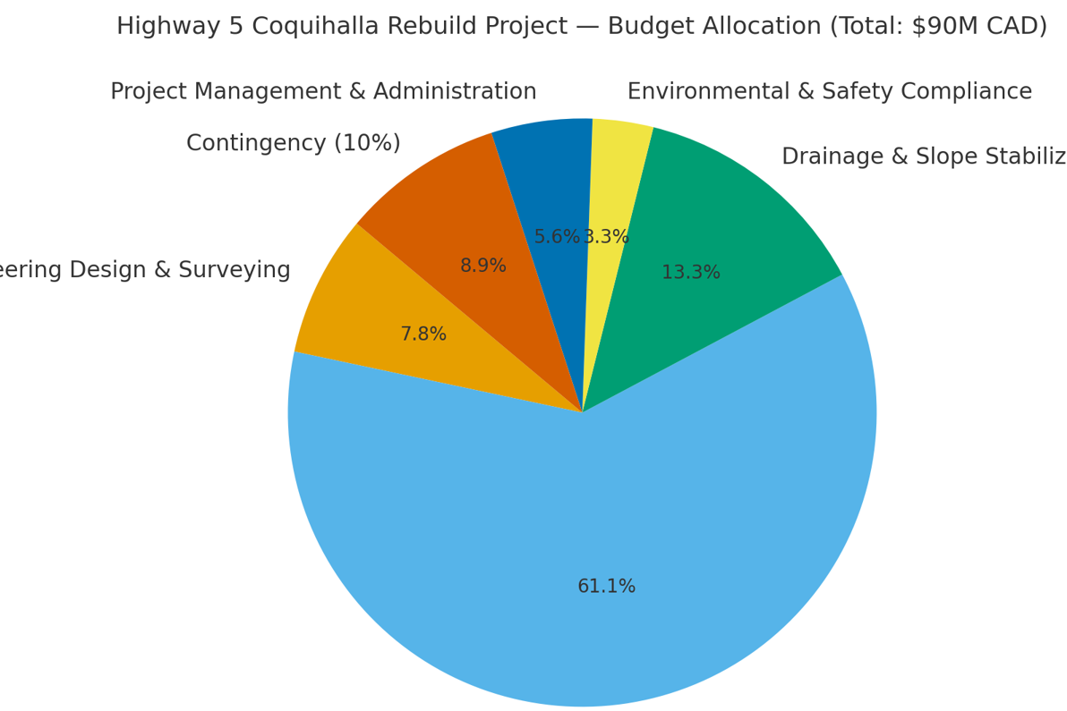

Desired Results (Deliverables & Outcomes)

The project aims to produce safe functional and climate-resilient transportation infrastructure while restoring community connectivity. (Kennedy & Corfee-Morlot, 2012)

Deliverables:
- Fully operational Highway 5 with all bridges and road sections rebuilt.
- Drainage and slope stabilisation systems installed.
- Safety inspections and certification completed for reopening
- Final project report delivered to all stakeholders (Gov, of BC, 2023)

Expected deliverables:
- Reconnected communities and re-established freight mobility
- Reduced risk of future flood-related damage through improved drainage systems.
- Enhanced public safety and long-term reliability of critical infrastructure (Infrastructure Canada, 2023)

Measures of Success (Performance Indicators)
Success will be evaluated using quantifiable performance measures based on project management best practices (Project Management Institute [PMI], 2021.

Key indicators
- Schedule: Completion within a 12-month timeline.
- Budget: Adherence to approved funding and cost controls.
- Quality & Safety: Successful certification following structural and environmental testing.
- Sustainability: Installation of climate-resilient drainage and slope systems.
- Stakeholders Satisfaction: Positive evaluations from local communities, government partners, and industry users (PMI, 2021; GOV. of BC, 2023)

Chad Chart

Objectives | Restore Highway 5, enhance resilience, minimise economic losses, and ensure safety.
Schedule | 12-month project timeline with phased milestones (planning, design, construction and reopening
Resources | Skilled workforce, heavy machinery, provincial/federal funding, and local suppliers.
Risk | Weather delays, budget overruns, environmental constraints, stakeholder conflicts.

Gantt Chart
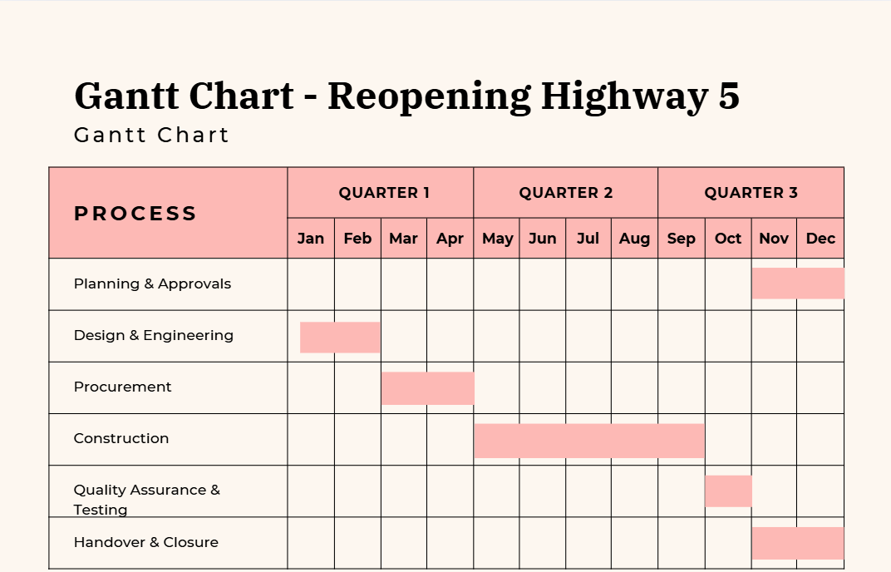
(Wilson, 2003)

Explanation of the Gantt Chart for the Highway 5
- Planning & Approvals from Nov to December the planning and Stakeholder consultation and approval must be done.
- Design & Engineering from January to end of February the final designs must be approved
- Procurement from March to end of April the contracts must be awarded and confirm.
- Construction from May to end of September the bridges & road sections must be completed
- Quality Assurance & Testing from the beginning of October until the end of October the Inspections must be passed.
- Handover & Closure from November to end of December the Highway 5 must be reopened and safety restore.

7. Stakeholders' involvement
Key stakeholders include:
- Provincial Government of BC – funding, oversight, policy approval.
- Federal Government of Canada – disaster recovery funding and transport policy alignment.
- Contractors and Engineers – execution of design and construction.
- Local Communities – users of the highway, impacted by disruptions.
- Businesses and Supply Chain Operators – dependent on the corridor for goods movement.
(Kavaratzis, 2012)

Category | Examples | Role/Interest
Primary Stakeholders | Ministry of Transportation & Infrastructure (BC), Infrastructure Canada | Project sponsors and decision-makers; provide funding and policy oversight
Secondary Stakeholders | Local municipalities, First Nations groups, environmental agencies | Affected by project outcomes; provide input and regulatory compliance
Internal Stakeholders | Project management team, engineer, contractors, inspectors | Responsible for planning, execution, and monitoring of project deliverables
External Stakeholders | Local communities, commercial freight operators, travellers, media | Impacted by highway access, construction timelines, and safety outcomes.

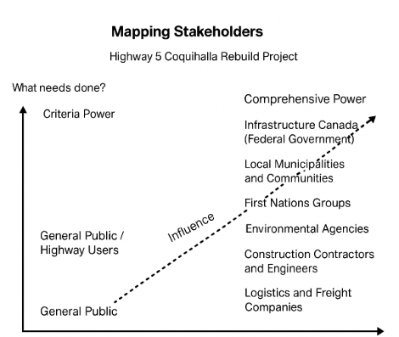

RACI Matrix
The RACI Matrix is a structured project-management tool used to define and clarify roles and responsibilities among all stakeholders in a project (Project Management Institute [PMI], 2021). (Hartono, Cahyo & Immawan, 2024)

For the Highway 5 Coquihalla Project, it ensures that every task such as design, construction, safety inspection, and communication, has an explicitly assigned owner to improve accountability and coordination.
The Ministry of Transportation and Infrastructure (BC) serves as the Accountable party for the key decisions and outcomes, providing governance and ensuring the project meets safety and quality standards (Government of British Columbia, 2023).
Infrastructure Canada acts as a Consulted federal partner, overseeing funding and compliance with national recovery objectives. Construction contractors and engineers are responsible for executing the technical work, while environmental agencies and First Nations groups are consulted to ensure regular compliance and cultural consideration. Local communities, logistics companies, and the general public remain informed of the progress, detours, and reopening timelines. (Yu, 2020)

By defining these relationships, the RACI Matrix enhances communication, transparency, and efficiency, aligning all contributors toward a shared goal of rebuilding Highway 5 safely, sustainably, and on schedule (PMI, 2021)

Task | Responsible | Accountable | Consulted | Informed
Bridge Repair | Contractor | Project Manager | Engineers | Government
Budget approval | Finance team | Provincial Government | Federal Government | Public
Safety Inspections | Engineers | Project | Local | Communities
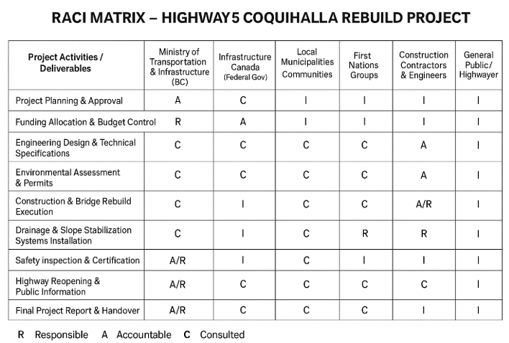

8. Allocation of resources
Human Resources
- Project Manager
- Civil and Structural Engineers
- Environmental Specialists
- Contractors, construction workers, safety inspectors
Financial Resources
Estimated budget: CAD 350 million (sourced from provincial and federal disaster recovery funds).

Material Resources
- Heavy machinery (excavators, cranes, paving machines)
- Construction materials (concrete, asphalt, steel)
- Safety equipment (barriers, signage)

9. Risk Analysis

- Environmental risk:
- Recurrence of flooding or adverse weather events. Mitigation includes scheduling work during historically drier months, investing in temporary flood defences, and ensuring rapid response protocols

- Financial Risk:
Inflation and supply chain price fluctuations may increase project cost. Mitigation involves forward contracting with suppliers and maintaining a contingency reserve of 15

- Stakeholder risk:
Conflicting interests between the provincial government, local communities and businesses.
Mitigation includes transparent communication strategies and stakeholder
engagement

- Technical risk:
Failures in engineering design or construction errors. Mitigation requires strict quality
control standards, peer reviews, and third-party audits.

- Resource Risk:
- Limited availability of skilled labour or specialised equipment.
- Mitigation includes early recruitment and forming partnerships with national and international contractors

10. Conclusion
The reopening of Highway 5 after the 2022 British Columbia floods exemplifies strategies for infrastructure recovery and resilient project delivery. Applying PRINCE2 governance alongside Agile flexibility, the project integrates theory and practice to deliver a safe, efficient, and climate-resilient transportation corridor (Globerson & Zwikael, 2022; PMI, 2021). It S.M.A.R.T objectives, emphasising safety, timeliness, stakeholder and governmental priorities (Li, Hard & Bochner, 2013; Sanyaolu et al., 2023).

Comprehensive scope control and a rigorous change-management process project against cost overruns and schedule delays, reflecting PRINCE2’s principle of managing by stages (St Peter et al., 1999). The hybrid methodology allows centralised, critical in post-disaster environments (Rosenman et al., 2015). Sustainability measures, including improved drainage, slope stabilisation, and eco-friendly materials, promote long-term climate adaptation rather than mere restoration (Goodland, 1995; Paton & Johnston, 2017).

Active Stakeholder engagement among the BC Ministry of Transportation, Infrastructure Canada, local municipalities, First Nations, and industry partners ensures transparency and shared accountability (Kavaratzis, 2012; Government of British Columbia, 2023). Use of the RACI Matrix clarifies roles, aligns priorities, and optimises decision-making (Hartono, Cahyo & Immawan, 2024).
Ultimately, the Highway 5 Reinstatement Project transcends physical reconstruction, revitalising economic connectivity, social cohesion, and environmental stewardship. By embedding resilience, adaptability, and stakeholder inclusivity, it serves as a model for sustainable disaster recovery infrastructure in Canada, reinforcing public confidence in project management’s capacity to deliver transformative outcomes under crisis conditions (Jennedy & Corfee-Morlot, 2016).

11. References
Brayshaw, D. and Hassan, M.A., 2009. Debris flow initiation and sediment recharge in gullies. Geomorphology, 109, pp.122–131.
Buede, D.M. and Miller, W.D., 2024. The engineering design of systems: Models and methods. John Wiley & Sons.
Bures, M., Cerny, T. and Ahmed, B.S., 2018. Internet of things: Current challenges in the quality assurance and testing methods. In: International Conference on Information Science and Applications, Singapore: Springer Singapore, pp.625–634.
C Environmental Assessment Office., 2023. Environmental assessment and permitting of infrastructure projects in BC. Government of British Columbia.
Christensen, D.S., 1998. The costs and benefits of the earned value management process. Journal of Parametrics, 18(2), pp.1–16.
Eaton, B. and Moore, R.D., 2010. Chapter 4: Regional hydrology. In: R.G. Pike, T.E. Redding, R.D. Moore, R.D. Winkler and K.D. Bladon (eds.) Compendium of forest hydrology and geomorphology in British Columbia. Land Management Handbook, Vol. 66. B.C. Ministry of Forests and Range, pp.85–109.
Environment Canada, 2021a. Monthly climate summaries. Environment and Climate Change Canada, Government of Canada. Available at: https://climate.weather.gc.ca/prods_servs/cdn_climate_summary_e.html [Accessed November and December 2021].
Garrish, C., 2005. Website Forays. British Columbia History, 38(2), p.36.
Goodland, R., 1995. The concept of environmental sustainability. Annual Review of Ecology and Systematics, 26, pp.1–24.
Government of British Columbia, 2023. Coquihalla Highway flood recovery project update. Ministry of Transportation and Infrastructure. Available at: https://news.gov.bc.ca.
Haugan, G.T., 2001. Effective work breakdown structures. Berrett-Koehler Publishers.
Infrastructure Canada, 2023. Disaster mitigation and adaptation fund: British Columbia flood recovery. Government of Canada. Available at: https://infrastructure.gc.ca.
Kavaratzis, M., 2012. From “necessary evil” to necessity: stakeholders' involvement in place branding. Journal of Place Management and Development, 5(1), pp.7–19.
Kennedy, C. and Corfee-Morlot, J., 2012. Mobilising investment in low carbon, climate resilient infrastructure.
Klaber, R.E. and Macdougall, C.F., 2009. Maximising learning opportunities in handover. Archives of Disease in Childhood – Education and Practice, 94(4), pp.118–122.
Kneebone, R.D., 2007. Following the money: Federal and provincial budget balances with Canada's major cities. Commentary – C.D. Howe Institute, (249), pp.1–10.
Li, Y., Hard, E.N. and Bochner, B.S., 2013. Planning actions to preserve and enhance highway functionality. Journal of Urban Planning and Development, 139(3), pp.197–205.
Natural Resources Canada, 2023. Climate resilience and infrastructure adaptation. Government of Canada. Available at: https://natural-resources.canada.ca.
Olaleye, I., Mokogwu, V., Olufemi-Phillips, A.Q. and Adewale, T.T., 2024. Transforming supply chain resilience: Frameworks and advancements in predictive analytics and data-driven strategies. Open Access Research Journal of Multidisciplinary Studies, 8(02), pp.85–93.
Paton, D. and Johnston, D., 2017. Disaster resilience: An integrated approach. Charles C Thomas Publisher.
Prakash, S., Mitra, A.K., Pai, D.S. and AghaKouchak, A., 2016. From TRMM to GPM: How well can heavy rainfall be detected from space? Advances in Water Resources, 88, pp.1–7.
Project Management Institute (PMI), 2021. A guide to the project management body of knowledge (PMBOK® guide) (7th ed.). Project Management Institute.
Project Management Institute (PMI), 2021. A Guide to the Project Management Body of Knowledge (PMBOK® Guide) – 7th Edition. PMI Global.
Project Management Institute (PMI), 2021. Reconnecting roads after massive flooding. Available at: https://www.pmi.org/business-solutions/case-studies/reconnecting-roads-after-massive-flooding.
ProjectManager.com, 2023. 10 best project management quotes. Available at: https://www.projectmanager.com/blog/10-best-project-management-quotes.
Rosenman, E.D., Ilgen, J.S., Shandro, J.R., Harper, A.L. and Fernandez, R., 2015. A systematic review of tools used to assess team leadership in health care action teams. Academic Medicine, 90(10), pp.1408–1422.
Sanyaolu, T.O., Adeleke, A.G., Efunniyi, C.P., Akwawa, L.A. and Azubuko, C.F., 2023. Stakeholder management in IT development projects: Balancing expectations and deliverables. International Journal of Management & Entrepreneurship Research, pp.2664–3588.
St. Peter, R.F., Reed, M.C., Kemper, P. and Blumenthal, D., 1999. Changes in the scope of care provided by primary care physicians. New England Journal of Medicine, 341(26), pp.1980–1985.
Vdovin, E.A., Bulanov, P.E. and Mavliev, L.F., 2022. Physical and mechanical characteristics of soil stabilized with quicklime for road bed. Construction of Unique Buildings and Structures, (105), p.10503.
Westland, J., 2006. The project management life cycle: A complete step-by-step methodology for initiating, planning, executing & closing a project successfully. Kogan Page Limited.
Williams, J.L., McCarley, N.G., Haynes, J.M., Williams, E.H., Whetzel, T., Reilly, T., Giddens, M. and Bailey, L., 2016. The Use of Feedback to Help College Students Identify Relevant Information on PowerPoint Slides. North American Journal of Psychology, 18(2).
Wilson, J.M., 2003. Gantt charts: A centenary appreciation. European Journal of Operational Research, 149(2), pp.430–437.
Woodcock, K., 2014. Model of safety inspection. Safety Science, 62, pp.145–156.

Web sources
British Columbia Ministry of Transportation and Infrastructure, 2022. BC flooding: What does the road to recovery look like for our highways? Available at: https://www.tranbc.ca/2022/05/10/bc-flooding-what-does-the-road-to-recovery-look-like-for-our-highways/.
British Columbia Ministry of Transportation and Infrastructure, 2025. Highway 5 flood recovery project update. Available at: https://news.gov.bc.ca/releases/2025TT0095-000834.
CBC News, 2022. Coquihalla Highway fully reopened 13 months after atmospheric river devastation. Available at: https://www.cbc.ca/news/canada/british-columbia/coquihalla-highway-fully-reopened-13-months-after-atmospheric-river-devastation-1.6689371.
Government of British Columbia, 2021. 2021 flood road recovery projects – Highway 5. Available at: https://www2.gov.bc.ca/gov/content/transportation-projects/bc-highway-flood-recovery/2021-flood-road-recovery-projects-highway-5.

