Nathan Willis (2103532)
2103532@student.uwtsd.ac.uk
Artificial intelligence assignment 1

Contents
Logistic Regression and Support Vector Machines 2
Introduction 2
Logistic Regression (LR) 2
Applications of Logistic Regression 2
Support Vector Machines (SVM) 2
Linear and Non-linear SVM 3
Applications of SVM 3
Conclusion 3
Hyperparameter Tuning 4
Logistic Regression 4
Linear SVM 4
Conclusion 5
Analysis and Interpretation 5
Performance Metrics Recap 5
Interpretation of the Data 7
Model Comparison 8
Trade-offs Between Precision and Recall 8
Actionable Insights and Recommendations 8
Model Deployment 8
Feature Engineering and Data Preprocessing 8
Conclusion 9

Logistic Regression and Support Vector Machines

Introduction
Logistic Regression (LR) and Support Vector Machines (SVM) are two fundamental classification algorithms in machine learning. Both are widely used for solving binary classification problems, where the goal is to categorize data points into one of two classes. Despite their differing methodologies and applications, both techniques offer unique advantages and are integral to the toolbox of data scientists and machine learning practitioners. This paper provides an in-depth exploration of LR and SVM, covering their underlying principles, applications, and a comparative analysis to highlight their respective strengths and weaknesses[1].

Logistic Regression (LR)
Logistic Regression is a statistical method used for binary classification. Despite its name, LR is not a regression algorithm but a classification technique[2]. It is based on the logistic function, also known as the sigmoid function, which transforms its input into a value between 0 and 1, making it ideal for probability estimation.[3]

Applications of Logistic Regression
- Medical Diagnosis: Logistic Regression is extensively used in medical diagnosis to predict the probability of a patient having a specific disease based on medical tests and demographic information. For example, it can predict the likelihood of heart disease based on factors like age, cholesterol levels, and blood pressure.[4][1]
- Credit Scoring: In finance, Logistic Regression is used to assess the creditworthiness of loan applicants. By analysing historical data, the model predicts the probability of an applicant defaulting on a loan, helping banks and financial institutions make informed lending decisions.[5][4]
- Marketing: Companies utilize Logistic Regression to predict customer behaviour, such as the likelihood of a customer responding to a marketing campaign or churning. This information helps tailor marketing strategies to target the right audience and improve customer retention.[6]
- Binary Classification: Logistic Regression is suitable for various binary classification tasks, including email spam detection, fraud detection, and employee turnover prediction. It provides a simple yet effective way to classify data points into two distinct categories.[3]

Support Vector Machines (SVM)
Support Vector Machines (SVM) is a supervised learning algorithm used for both classification and regression tasks. It works by finding the optimal hyperplane that maximizes the margin between different classes. For linear data, this hyperplane is a straight line, but for non-linear data, SVM can use kernel functions to map data into higher-dimensional spaces where a hyperplane can separate the classes.[7]

Linear and Non-linear SVM
- Linear SVM: For linearly separable data, SVM finds the hyperplane that maximizes the margin between the two classes. The margin is defined as the distance between the hyperplane and the nearest data points from either class, known as support vectors[8].
- Non-linear SVM: For non-linearly separable data, SVM uses kernel functions to transform the data into a higher-dimensional space. Common kernel functions include the polynomial kernel, radial basis function (RBF) kernel, and sigmoid kernel. These transformations allow SVM to find a hyperplane that can effectively separate the classes in the transformed space[8].

Applications of SVM
- Text Classification: SVM is widely used in text classification tasks, such as spam detection, sentiment analysis, and document categorization. By transforming text data into numerical feature vectors, SVM can classify texts with high accuracy, handling the high-dimensional nature of text data effectively.[9]
- Image Classification: In computer vision, SVM is employed for image classification tasks, including handwritten digit recognition, face detection, and object classification. The ability to handle complex patterns and variations in image data makes SVM a robust choice for visual recognition.[10]
- Bioinformatics: SVM is used in bioinformatics to classify biological data, such as gene expression profiles, protein sequences, and microarray data. It helps in predicting protein functions, identifying disease genes, and classifying cancer types based on gene expression patterns.[11]
- Financial Market Analysis: In finance, SVM is used for stock price prediction, financial news classification, and fraud detection. By analysing historical price data, news articles, and transaction details, SVM can identify patterns and make predictions about future market movements.[12]

Conclusion
Logistic Regression (LR) and Support Vector Machines (SVM) are both prominent supervised learning algorithms used for classification tasks, but they have distinct characteristics and applications.
Logistic Regression is a statistical method that models the probability of a binary outcome based on one or more predictor variables. It uses the logistic function to transform linear combinations of the predictors, ensuring the output is a probability between 0 and 1. LR is particularly valued for its simplicity, interpretability, and effectiveness in cases where the relationship between the predictors and the outcome is approximately linear. It performs well when the dataset is linearly separable and when the dimensionality is not excessively high.
Support Vector Machines is a more complex and versatile algorithm that aims to find the optimal hyperplane which separates data points of different classes with the maximum margin. SVMs can handle both linear and non-linear classification tasks by using kernel functions to project data into higher dimensions. This makes SVM highly effective for datasets with complex boundaries. However, SVM can be computationally intensive, particularly with large datasets and when using non-linear kernels.
In summary, while Logistic Regression is preferred for its simplicity and interpretability in linearly separable data, SVMs are chosen for their flexibility and performance in handling more complex, high-dimensional data. The choice between LR and SVM often depends on the specific nature of the dataset and the classification problem at hand.

Hyperparameter Tuning

Logistic Regression
Pre-tuning:
- Training Data: Accuracy: 0.8059, Precision: 0.6645, Recall: 0.5420, F1 Score: 0.5971, AUC-ROC: 0.8534
- Test Data: Accuracy: 0.8112, Precision: 0.6784, Recall: 0.5490, F1 Score: 0.6069, AUC-ROC: 0.8437
Post-tuning:
- Training Data: Accuracy: 0.8055, Precision: 0.6638, Recall: 0.5405, F1 Score: 0.5959, AUC-ROC: 0.8534
- Test Data: Accuracy: 0.8112, Precision: 0.6784, Recall: 0.5490, F1 Score: 0.6069, AUC-ROC: 0.8436
For Logistic Regression, hyperparameter tuning did not significantly change the performance metrics. The accuracy, precision, recall, F1 score, and AUC-ROC values remain nearly identical, suggesting that the initial model was already well-optimized[13].

Linear SVM
Pre-tuning:
- Training Data: Accuracy: 0.8010, Precision: 0.6529, Recall: 0.5336, F1 Score: 0.5873, AUC-ROC: 0.8487
- Test Data: Accuracy: 0.8102, Precision: 0.6843, Recall: 0.5294, F1 Score: 0.5970, AUC-ROC: 0.8391
Post-tuning:
- Training Data: Accuracy: 0.8008, Precision: 0.6526, Recall: 0.5329, F1 Score: 0.5867, AUC-ROC: 0.8488
- Test Data: Accuracy: 0.8102, Precision: 0.6843, Recall: 0.5294, F1 Score: 0.5970, AUC-ROC: 0.8393
Similar to Logistic Regression, the hyperparameter tuning for the Linear SVM model also resulted in minimal changes to the performance metrics. The accuracy, precision, recall, F1 score, and AUC-ROC values are nearly the same before and after tuning.

Conclusion
The minimal changes in performance metrics suggest that both the Logistic Regression and Linear SVM models were already performing optimally with their default hyperparameters. Hyperparameter tuning did not significantly enhance their performance, likely because the models had already reached their performance limits for this particular dataset. The high AUC-ROC values for both models indicate strong overall performance in distinguishing between the classes. To further improve model performance, one might consider exploring more advanced models or additional feature engineering.

Analysis and Interpretation

Performance Metrics
The performance metrics for both Logistic Regression and Linear SVM, before and after hyperparameter tuning, provide a comprehensive overview of their efficacy:

Logistic Regression (Pre-Tuning) 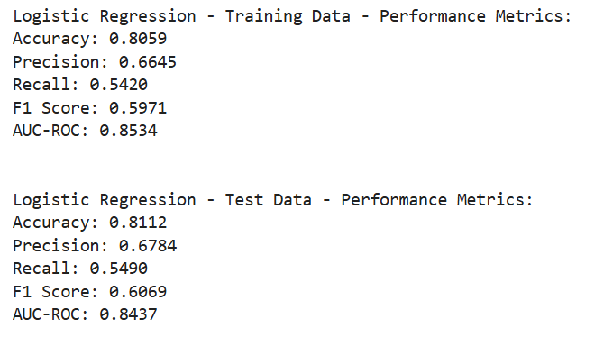Logistic Regression (Post-Tuning) 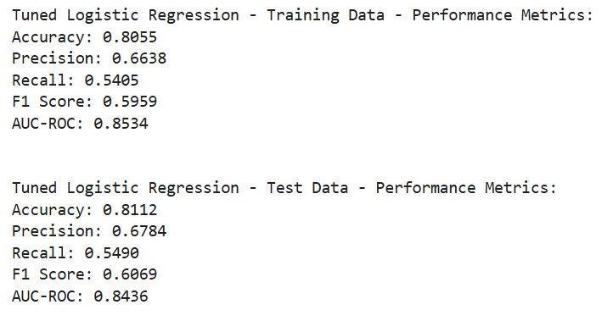
Linear SVM (Pre-Tuning) 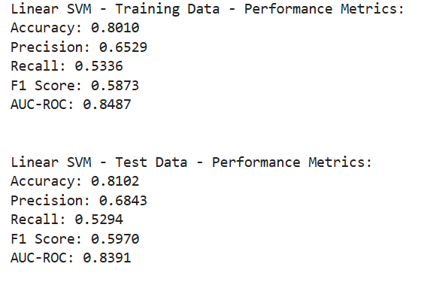
Linear SVM (Post-Tuning) 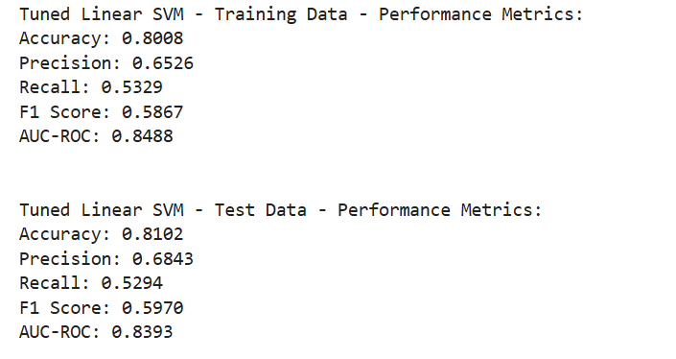

Interpretation of the Data
The consistent performance metrics between pre-tuning and post-tuning models for both Logistic Regression and Linear SVM suggest that the initial models were already well-optimized. Hyperparameter tuning did not lead to significant changes, indicating stability and reliability in their predictions[13]. However, there were less C values used for the hyper parameter tuning for the SVM due to the long processing times associated with it.

Model Comparison
Both models exhibit comparable performance, with Logistic Regression slightly outperforming Linear SVM in recall and F1 score, while Linear SVM shows marginally higher precision. The high AUC-ROC values for both models indicate strong overall performance and good discrimination between classes[14].

Trade-offs Between Precision and Recall
Precision reflects the model's ability to minimize false positives. Higher precision in the Linear SVM model indicates fewer false positive errors. Recall, on the other hand, measures the model's ability to capture all positive cases. The slightly higher recall of Logistic Regression suggests it is better at identifying actual positives, albeit with more false positives. The F1 scores, representing a balance between precision and recall, are similar for both models, indicating balanced performance.[15]

Insights into the data

Feature Engineering and Data Preprocessing
To address customer churn, companies can implement targeted onboarding and engagement programs to retain new customers. Personalized welcome packages, frequent check-ins, and tailored offers can help improve retention for newer customers. Flexible pricing plans or discounts for customers with higher monthly charges can also help reduce churn. Providing value-added services or bundling options can justify higher costs and enhance customer retention. Encouraging customers to opt for longer-term contracts through incentives such as discounts, loyalty programs, or additional benefits can increase customer commitment and reduce churn rates. Investing in improving service quality, particularly in areas identified as significant predictors of churn, can enhance customer satisfaction and loyalty. Providing excellent technical support, robust online security, and reliable services can lead to better customer retention[16].
Given the similar performance metrics, both Logistic Regression and Linear SVM are viable for deployment. The choice between them should be guided by the specific context and requirements. If minimizing false positives is crucial, such as in fraud detection, Linear SVM may be preferred due to its higher precision. However, if capturing all positive cases is more critical, such as in medical diagnosis, Logistic Regression might be the better choice due to its higher recall. Further improvements can be achieved through feature engineering and data preprocessing. Identifying and removing redundant or irrelevant features can reduce overfitting and improve generalization. Applying transformations to capture non-linear relationships can also enhance model performance. Techniques like SMOTE (Synthetic Minority Over-sampling Technique) or adjusting class weights can help balance the training data.[17]
Exploring more advanced algorithms or ensemble methods can potentially achieve better performance. Techniques like Random Forest, Gradient Boosting, or XGBoost combine multiple models to improve accuracy and robustness[18]. For complex, high-dimensional data, neural networks or deep learning models might offer better performance. Ensuring robust model validation through techniques like cross-validation is essential. K-Fold Cross-Validation, where the dataset is divided into K subsets and the model is trained and tested K times, provides a more reliable estimate of model performance[19]. Continuing to refine hyperparameters using methods like Randomized Search or Bayesian Optimization can help explore a wider parameter space efficiently.

Conclusion
The analysis indicates that both Logistic Regression and Linear SVM models perform well, with high accuracy, precision, recall, F1 scores, and AUC-ROC values. The minimal changes post-hyperparameter tuning suggest that the initial models were already well-optimized. The decision to choose one model over the other should be guided by the specific context and objectives, such as the relative importance of precision versus recall. Further improvements can be pursued through feature engineering, advanced algorithms, and rigorous validation techniques. The insights from the data highlight key factors influencing customer churn, providing actionable recommendations to improve customer retention. By implementing these insights and recommendations, the chosen model can provide reliable and accurate predictions, leading to actionable outcomes and better decision-making.

References
References
[1] P. Bassey, "Logistic Regression Vs Support Vector Machines (SVM)", Axum Labs, https://medium.com/axum-labs/logistic-regression-vs-support-vector-machines-svm-c335610a3d16 (accessed Dec 12, 2024).
[2] P. Raj, "Why Is Logistic Regression Called “Logistic Regression” And not a Logistic Classification?", Medium, https://medium.com/@praveenraj.gowd/why-is-logistic-regression-called-logistic-regression-and-not-a-logistic-classification-5a418293040d (accessed Dec 12, 2024).
[3] M. P. LaValley, "Logistic Regression," Circulation, vol. 117, no. 18, pp.2395–2399, 2008. doi: 10.1161/CIRCULATIONAHA.106.682658. Available: https://doi.org/10.1161/CIRCULATIONAHA.106.682658
[4] S. W. Menard, Logistic regression: From introductory to advanced concepts and applications, Sage, 2010.
[5] Z. Hua, et al., "Predicting corporate financial distress based on integration of support vector machine and logistic regression," Expert Syst.Appl., vol. 33, no. 2, pp.434–440, 2007.
[6] C. Constantin, "Using the Logistic Regression model in supporting decisions of establishing marketing strategies," Bulletin of the Transilvania University of Brasov.Series V: Economic Sciences, pp.43–50, 2015.
[7] H. Xue, Q. Yang and S. Chen, "SVM: Support vector machines," in The top ten algorithms in data mining, Chapman and Hall/CRC, 2009, pp. 51–74.
[8] S. Ghosh, A. Dasgupta and A. Swetapadma, "A Study on Support Vector Machine based Linear and Non-Linear Pattern Classification," 2019 International Conference on Intelligent Sustainable Systems (ICISS), 2019. doi: 10.1109/ISS1.2019.8908018.
[9] F. Colas and P. Brazdil, "Comparison of SVM and some older classification algorithms in text classification tasks," IFIP International Conference on Artificial Intelligence in Theory and Practice, 2006.
[10] M. A. Chandra and S. S. Bedi, "Survey on SVM and their application in image classification," International Journal of Information Technology, vol. 13, no. 5, pp.1–11, 2021.
[11] F. Markowetz, "Support vector machines in bioinformatics," Master's thesis, University of Heidelberg, 2001.
[12] L. Cao and F. E. Tay, "Financial forecasting using support vector machines," Neural Computing & Applications, vol. 10, pp.184–192, 2001.
[13] P. Schratz, et al., "Hyperparameter tuning and performance assessment of statistical and machine-learning algorithms using spatial data," Ecol.Model., vol. 406, pp.109–120, 2019.
[14] G. Naidu, T. Zuva and E. M. Sibanda, "A review of evaluation metrics in machine learning algorithms," Computer Science On-line Conference, 2023.
[15] L. Torgo and R. Ribeiro, "Precision and recall for regression," Discovery Science: 12th International Conference, DS 2009, Porto, Portugal, October 3-5, 2009 12, 2009.
[16] "How to reduce customer churn rates | Stripe." https://stripe.com/gb/resources/more/how-to-reduce-churn-rates-7-strategies-and-how-to-apply-them (accessed Dec 12).
[17] V. Rattan, et al., "Analyzing the application of SMOTE on machine learning classifiers," 2021 International Conference on Emerging Smart Computing and Informatics (ESCI), 2021.
[18] T. Kavzoglu and A. Teke, "Predictive Performances of ensemble machine learning algorithms in landslide susceptibility mapping using random forest, extreme gradient boosting (XGBoost) and natural gradient boosting (NGBoost)," Arabian Journal for Science and Engineering, vol. 47, no. 6, pp.7367–7385, 2022.
[19] J. Brownlee, "A Gentle Introduction to k-fold Cross-Validation", MachineLearningMastery.com, https://www.machinelearningmastery.com/k-fold-cross-validation/ (accessed Dec 12, 2024).

