[Date]
University of Wales Trinity Saint David
london campus
Assessment 1
Analysing and Solving Problems
Module Name: Analysing and Solving Problems
Module Code: ACCA4019_LON
Student Name: Dzhenifer Oleksandra Safutina
Student ID: 2514100
Group: 2
Lecturer’s Name: Adam Philpot

Contents
Introduction…………………………………………………………………………………………….3
Deconstruct the problem…………………………………………………………………………..3
Variables identification………………………………………………………………………………4
Proposed solution……………………………………………………………………………………..5
Reflection and justification………………………………………………………………………….6
Conclusion……………………………………………………………………………………………….8
References……………………………………………………………………………………………….8

Introduction
Finding a convenient time for meetings during college group project activities becomes difficult owing to the differing academic schedules, part-time jobs and personal engagements of students. During the course of a group project, the process of effective communication and meeting becomes very crucial since coordination among various members becomes necessary. It thus becomes increasingly difficult when students find themselves busy at different times. The problem results in the absence of meetings, delays in the completion of tasks within a project and also the distribution of tasks amongst members of the group in an unbalanced manner. For instance, while one member of the group can be free in the afternoons, another might be engaged with his job at that time. Similarly, a student might have classes when others in the group can meet. When such a convenient time is not found before the deadline set in a week, then the group will miss out on completing their task. Thus, the objective of the present assignment is to examine the problem and come up with a solution that will allow scheduling the meetings of the project group. The suggested solution implies determining proper meeting times according to the availability of all group members, reducing schedule conflicts and organizing meetings prior to the corresponding project deadline. In order to solve the problem, it is necessary to break it down into separate components through determining the requirements, constraints and variables. Next, MoSCoW technique will be applied to prioritize the requirements. It will also be offered to draw a logical flowchart to show how possible meeting times can be assessed.
Deconstruct the problem
The first stage of solving the problem is to break the overall problem into smaller and more manageable components. The main problem is that students in a college computing course are experiencing difficulties in arranging group project meetings. This problem can be divided into several related issues.
First, each group member may have a different timetable. Academic activities such as lectures and practical classes may make some periods unavailable. Second, some students may have part-time jobs, which can create additional restrictions on their availability. Third, students may have personal commitments that also need to be considered. Finally, all meetings need to take place sufficiently early to allow the group to complete its weekly project tasks before the deadline.
The main requirements of the proposed solution are therefore to collect the availability of all members, identify common available time slots, check for timetable conflicts and compare potential meeting times with the project deadline. These requirements can be prioritised using the MoSCoW technique.
Priority | Requirement | Explanation
Must have | 1. Determine the availability of all members of the group  2. Find the time which available for all the necessary participants  3. Check the project fulfilment time  4. Check the conflicts in the timetable | 1. A suitable meeting cannot be selected without knowing when participants are available  2. The main goal is to determine the general meeting time  3. The selected meeting must take place before the corresponding weekly deadline  4. Academic and other important obligations must not overlap with the meting
Should have | 1. Consider part-time labour obligations  2. Consider personal commitments | 1. This can reduce the likelihood of schedule conflicts  2. Where possible, personal availability should also be taken into account
Could have | 1. Provide an alternative meeting time  2. Evaluate the available options | 1. Several suitable options can be provided if more than one slot is available  2. The system can rank options according to the number of conflicts or preferences
Won’t have | 1. Schedule meetings after the deadline | 1. The meeting after the deadline would not support the required project result
The MoSCoW analysis demonstrates that identifying common availability and checking the deadline are essential requirements. These requirements are classified as (Must have) because the solution would not achieve its main purpose without them. Consideration of part-time work and personal commitments is classified as (Should have) because these factors are important but may be managed differently depending on the circumstances of the group. Additional features, such as ranking several possible meeting times, are considered (Could have) because they can improve the solution but are not essential to its basic operation.
Variables Identification
Several variables are required to logically represent the problem.
Variable | Description
Number of members | Represents the number of students who must attend the meeting
Student availability | Represents the period during which an individual student is available
Meeting duration | Represents the required duration of the group meeting
Meeting date | Presents the date on which the meeting can take place
Meeting time | Presents the estimated start time of the meeting
Timetable conflict | Indicates whether the proposed meeting coincides with another commitment
Project deadline | Represents the last date or time by which the corresponding project task should be completed
Work commitment | Represents periods when a student is unavailable due to part-time work
Personal commitment | Represents other periods when the student cannot attend
These variables allow the problem to be represented in a structured way. The proposed meeting time can be evaluated against the availability of each member, potential conflicts and the project deadline. A meeting slot should only be accepted when the required conditions have been satisfied.
Proposed Solution
The proposed solution is based on a logical scheduling process. The process begins by collecting relevant information from each group member. This includes their available times, academic timetable, work commitments and other important commitments. The project deadline and required meeting duration are also collected. Once this information has been collected, possible time slots are examined. Each potential slot is compared with the availability of all group members. If one or more required members are unavailable, that slot is rejected and the next available slot is examined. If all required members are available, the proposed time is then checked for conflicts. A conflict may occur if the meeting overlaps with a lecture, another important academic activity or a previously identified commitment. If a significant conflict is identified, the time slot is rejected. The next stage is to check the project deadline. The proposed meeting must occur sufficiently before the deadline to allow the group to complete any required tasks. If the proposed meeting occurs after the deadline, it is rejected. Once the time slots satisfy all the criteria, it becomes possible to establish that a time slot is appropriate for a meeting. In case there is more than one appropriate time slot, the alternatives can be compared. The group will have to pick either the earliest appropriate time for a meeting or the alternative which suits the members’ preference the most. Therefore, the solution can be defined as a series of logical decision making processes. The complexity of the task is reduced to several decision making steps.
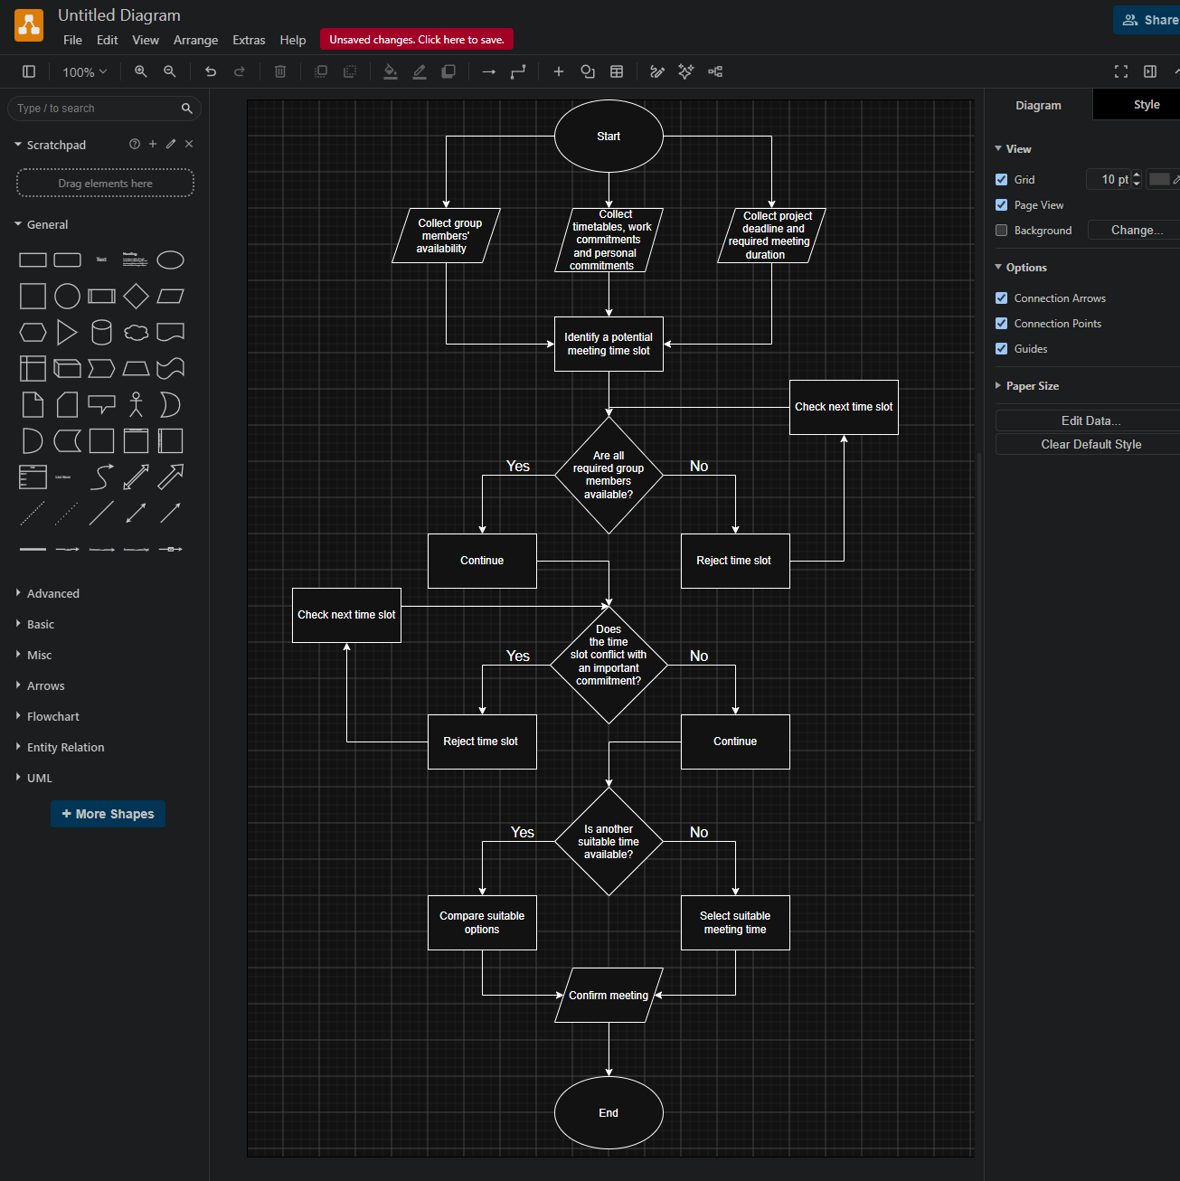The flowchart should use standard flowchart symbols. An oval can be used for (Start) and (End), rectangles can represent processes such as collecting information, and diamonds can represent decision points. Arrows should demonstrate the direction of the process.
The first step is to collect the availability of all group members. Each member provides information about the times when they are available for a meeting. This information is necessary because the proposed solution is intended to identify a time that accommodates all required participants.
Step two involves getting information on potential conflicts. Conflicts here include lectures, practicals, work, and other personal activities. The objective of this step is to avoid booking a meeting at a time when one of the members of the group cannot be present. The third step is to gather the deadline of the project and the meeting time. This meeting time is necessary as the student might be available for just a short while. For instance, a student may be available from 2:00 p.m. but unavailable from 2:30 p.m. as the student has another assignment from 2:30 p.m. onwards. The process then identifies a potential meeting slot. The first decision point asks whether all required group members are available. If the answer is (No), the proposed time is rejected. The process then moves to another potential time slot. If the answer is (Yes), the process continues to the next decision. The second decision point checks for conflicts. Although all members may initially appear to be available, the solution should verify that the proposed time does not overlap with an important commitment. If a conflict exists, the time slot is rejected. If no significant conflict exists, the process continues. This brings us to the third criteria which evaluates whether the meeting can be held before the project deadline. An appropriate meeting should definitely take place before the project deadline since the main objective of holding the meeting is for the successful completion of the project. A meeting that takes place late is not helpful.
After a time slot has passed all three decision points, the process checks whether additional suitable options are available. If several suitable times exist, the group can compare the alternatives. For example, the group may prefer the earliest available time because it provides more time to complete the project after the meeting.
Reflection and justification
Abstract thinking- Abstract thinking was used to focus on the essential characteristics of the scheduling problem rather than on the individual circumstances of a particular student. The problem contains many possible details, such as different lectures, jobs and personal commitments. Instead of designing a separate solution for every student, these details were represented using general variables such as availability, conflicts and deadlines. This ensures that the solution can apply to other individuals. For instance, there may be a group with three individuals while others with five people in the same. It might happen that their schedules differ from each other, but still the same logic can be applied to find a suitable meeting time. Abstract thinking therefore helped to simplify the problem while retaining the information necessary for solving it.
Sub dividing- The problem was also subdivided into smaller components. The original problem of (students being unable to organise meetings) is broad and contains several separate issues. It was therefore divided into collecting information, identifying availability, checking conflicts, checking the deadline and selecting a suitable time. Subdividing the problem made the solution easier to analyse. Each stage could be considered independently before being combined into a complete logical process. This approach also helped to identify the decision points required in the flowchart
Justification of the solution- The suggested solution solves the stated problem's key objectives, namely, verifying group members' availability, detecting schedule clashes, and arranging meetings prior to the project deadline. Flowcharts are useful in visually representing the process of decision making and structuring it into steps. However, frequent meetings may help in improving communication and task allocation within the group, although the schedule cannot guarantee equal participation of all the group members.
Availability data accuracy is the key to success of the proposed solution. In case students misreport their schedule, schedule clashes are inevitable. One more limitation is that there might be no moment when everyone will be available due to lectures, working, or personal matters. Moreover, the proposed solution makes an assumption that schedule remains unchanged; however, some changes might occur. Lastly, having chosen the appropriate schedule time does not guarantee successful project completion.
There are a number of assumptions in the proposed solution, such as providing all students with the current availability information, knowing the deadline for the project and its duration, and willingness to attend the meeting. The assumptions simplify the problem statement and allow creating a general scheduling solution.
Conclusion
This assessment examined the problem of organising group meetings for students with different schedules and commitments. The problem was analysed using the MoSCoW technique, variables and a flowchart to develop a structured scheduling solution. The proposed approach helps identify suitable meeting times, reduce timetable conflicts and ensure meetings are held before project deadlines. Although the solution has some limitations, it provides a logical and practical method for improving group meeting organisation.
Reference
1. Understanding the MoSCoW prioritization | How to i... - Atlassian Community, The MoSCoW prioritisation model, explained — BiteSize Learning
(MoSCoW prioritisation technique)
2. System Analysis | System Design - GeeksforGeeks (systems analysis)
3. Project Management Plan: Steps, Components & Examples [2026] • Asana (project scheduling and planning)

