Managing Digital Identities
BMSP 5004
Assignment 1
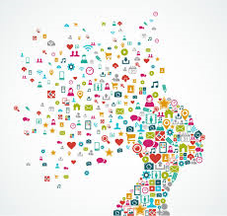

Tutor:
Anthony Burns
Student:
Claire Davies

Introduction
So many people use social media on a day-to-day basis these days, this gives them their own digital identity, this is your personal data that you have input into a computer yourself and this then creates your very own digital footprint. Your digital footprint can be used to give people an idea of who you are and what you are about. There are many different social media platforms on the internet that are used on a daily basis by your everyday person and also by many famous and influential people, social media is often used to promote people and what they are about. We are going to take a look at how 2 different famous people use these social media platforms and which platforms the use to portray themselves and whether they are using it to their advantage and using it wisely and in a professional manner or whether they are not making the most of them and using them in a poor manner and how they could improve on how they are portraying themselves to everyone on the internet.

(Kingdom Economics, 2018).

Greta Thunberg - Positive
One person that seems to be using social media well is Greta Thunberg. Greta is a 16 year old environmental activist from Sweden. She has raised a lot awareness as an environmental activist on climate change and is now recognised internationally from the campaigns she has organised. A lot of this seems to be done via the use of different social media platforms, we will take a look at how Greta Thunberg is portraying herself and getting her message across and whether she is using the various platforms wisely. From some research it would appear that Greta uses a few different forms of social media like Facebook, Twitter and YouTube, this report will look at which ones she uses and if they are all being used to her advantage.
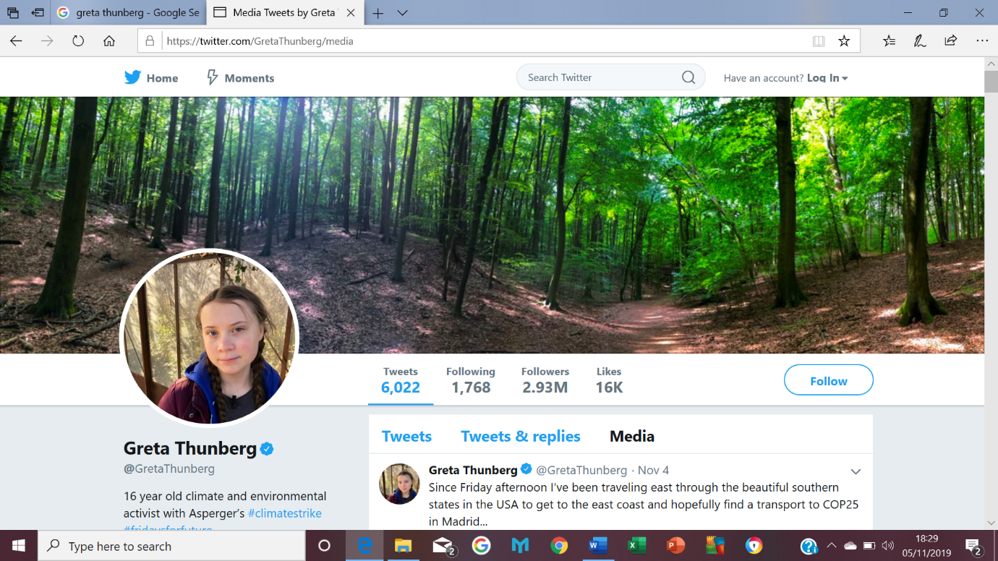
(Thunberg, 2019).
Twitter seems to be a very popular social media platform amongst the younger generation, as we can see from Greta’s profile she has 2.93 million followers. This would seem to imply that she is using Twitter wisely to get across her views and what she is about.
So, what is Twitter and what is it used for?
“Twitter is an online news and social networking site where people communicate in short messages called tweets. Tweeting is posting short messages for anyone who follows you on Twitter, with the hope that your messages are useful and interesting to someone in your audience. Another description of Twitter and tweeting might be microblogging. Some people use Twitter to discover interesting people and companies online, opting to follow their tweets.” (Gil, 2019).
So from that short description of what Twitter is about we can see why Greta would use this form of social media, as it would seem to be an easy way to communicate and interact with fellow people and also to raise awareness world wide about her campaigns. It would appear that with having the people followers she has that this is one platform she is definitely using wisely. Twitter allows the use of hashtags, what is a hashtag you may ask? Well a hashtag is symbol # used to put before a specific word or phrase, this makes searching for things far easier. For instance when Greta uses #climatestrike on her twitter posts, so anyone interested can click on the link at will be take straight to the climate strike page:
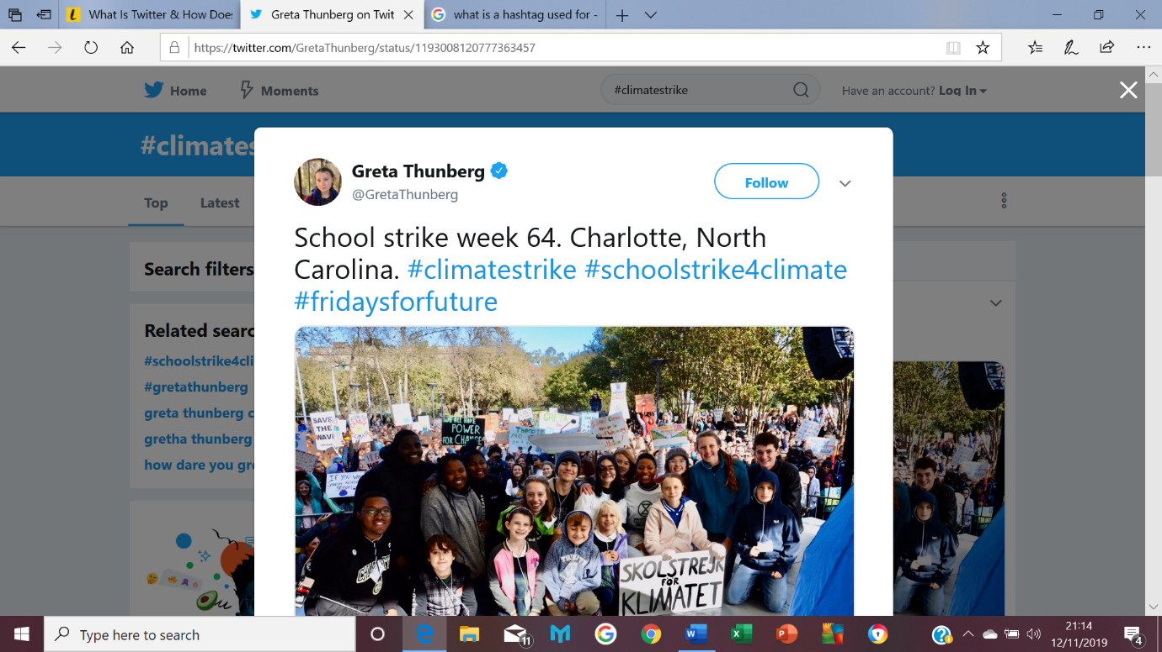
(Twitter, 2019).
By using hashtags on Twitter this has helped Greta to reach out to people all over the world, and to raise awareness on her concerns for the environment.
Facebook is another platform that Greta Thunberg uses, this isn’t dissimilar to Twitter, she has as many followers on Facebook as she does Twitter. Both social media platforms allow you to express your views, this can be done by written statuses, posts, videos, use of hashtags. But by using more than one platform she is reaching out to more people as not everyone uses Twitter but they may use Facebook and vice versa.
So it would seem that the more social media platforms you use, and if you use them correctly you can express who you are and what you are about and you have total control over what people see and read about you.
Why use Social Media Platforms?
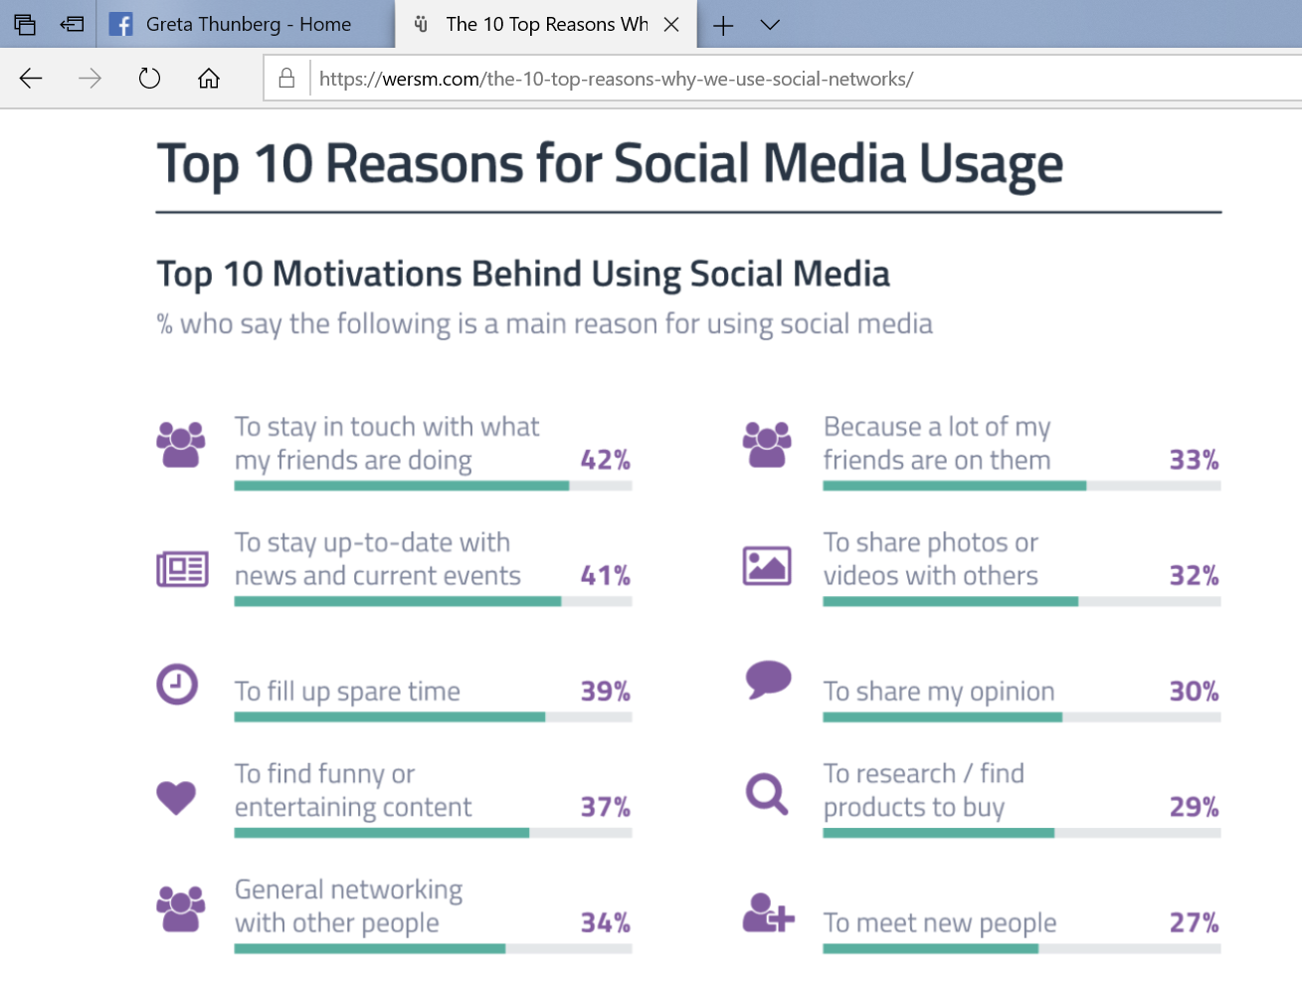
(Desreumaux, 2018).
There are a few video’s of Greta on YouTube taking part on TV shows such as Ellen, where she is getting her message across to YouTube viewers. Although Greta may not be responsible for putting these on YouTube it is a platform that is used to her advantage. Papers such as The Guardian have uploaded video’s of Great when she has passionately talked about climate strike at conferences. It would appear that Greta herself doesn’t use YouTube but still has plenty of media coverage on there through the help of other people. So, if you were to search for Greta on YouTube you wouldn’t be disappointed, her video’s really get her message across and show the world how passionate she really is and it also shows how many people are actually behind her and have the same beliefs.
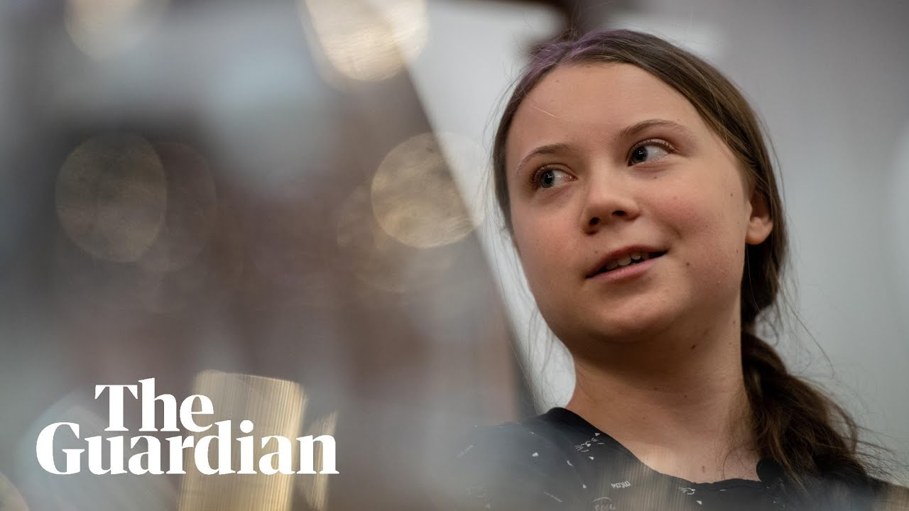
(Guardian, 2019.).
From viewing a few of Greta Thunberg’s social media pages it would appear that she falls into a few of the categories above: General networking with people, News and current event, To share her opinion, Sharing photo’s and video’s of the protests she has been a part of.

“Greta Thunberg's Digital Rise Calls Back to a Pre-Digital Era. The climate activist's ability to dominate social media is powerful—and surprisingly similar to what young people did in the 1960s.” (Ellis, 2019).
So all in all it would seem that Greta Thunberg is one of many people that is using social media wisely. Maybe it’s because she is young and has a better grasp of social media, but her passion and drive for her beliefs are what’s making her known on social media and in the news. It’s possible that because of her good use of social media, this could be the reason she has a vast amount of followers and is getting her message out clearly worldwide.

Amanda Bynes- Poor

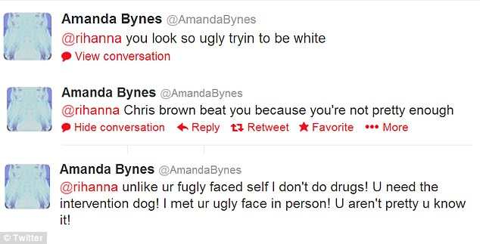
Amanda Bynes is an American actress, Amanda started acting at a very young age she appeared in many films, including: Hairspray, She’s the Man and What a Girl Wants. So where do we start with this, it would seem that a few years ago Amanda Bynes was one celebrity that wasn’t seen to be using social media very wisely. Back in early 2013 Amanda was using her Twitter account to cyber bully Rhianna, she would maliciously tweet about Rhianna on her Twitter account, this wasn’t just a one off incident..
“Twitter war: Amanda posted numerous offensive comments about the singer's appearance, race and being a victim of domestic violence before deleting them”
(White, 2013),

Cyber bullying or any form of bullying is by far never acceptable! But it would appear that Amanda Bynes would constantly use her social media platforms to continue to cyber bully Rhianna. Not only would this be visible for Amanda’s followers to see but also Rhianna’s followers. This is not a very good example to be setting Twitter users/followers. Seeing a grown person behave in this way could influence the Twitter audiences. Many people are easily influence by what they see and read on the internet and we can see in the quote below that with technology being easily available this makes online bullying far easier for people. Amanda Bynes was quite a big tv personality from a very young age and many teens could possibly find her to be an influential figure and wouldn’t see anything wrong with her online activities.

“With mobile technology being so freely available it is an ongoing issue and one that is relentless. It has been well documented that cyber bullying has resulted in tragic events including suicide, and self-harm and clearly, more needs to be done in order to protect vulnerable children and adults from online bullying.” (BullyUk, 2019).

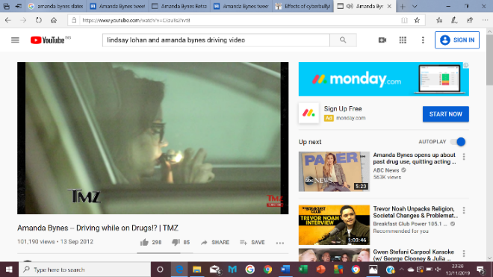
YouTube is another social media platform where you can fine a lot about Amanda Bynes, from news paper articles to video’s of her. When researching Amanda on different social media platforms, the 2 that stood out the most was Twitter and YouTube. On YouTube you are able to just search her and find anything related to her. One of the video’s that seemed rather interesting and isn’t a great use of social media would be the one where she is lighting up and illegal substance (joint) while driving her car.
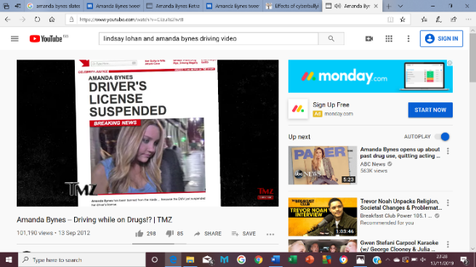
(TMZ, 2012).

These aren’t very good images or video’s to have plastered over social media. This is an indication of how social media is being used incorrectly and whilst these videos are available on YouTube for the entirety of the world to see, it isn’t setting a good example. Quite often these videos and stories may not go into detail and give you all the facts behind why these people use social media in the way that they do, but it seems to be giving out the wrong impression. A lot of the younger generation use these social media platforms on a daily basis, and some may be very impressionable. So when they come across articles about famous people smoking illegal substances or cyber bullying, they may then think that it is ok for them to do the same because they have seen it been done on social media.

Conclusion

From looking at these two very different famous people and how they use social media, it is clear that social media platforms can be used wisely while also being used badly. It also shows that no matter what you age is social media is a big part of life and how people see you, but tat is down to how you portray yourself on the different social media platforms that you use. Most of them are used in the same way, the main difference is the people that use them. So as you can see from the report you have a young teenager that uses her social media platforms for the greater good and to send out messages far and wide around the world about climate change, while you have someone older and more famous (in her day) that has used social media for bullying and has been shown now media platforms to be breaking the law. So when it comes down to it, social media platforms are there for everyone to use, how you use them is down to you! It’s easy to be drawn in and influenced by what you see on social media, but you are responsible for how use that and how you are perceived on social media through your own social media platforms.

Bibliography
BullyUk. (2019). Retrieved from https://www.bullying.co.uk/cyberbullying/effects-of-cyberbullying/
Desreumaux, G. (2018, October 14th). Retrieved from https://wersm.com/the-10-top-reasons-why-we-use-social-networks/
Ellis, E. G. (2019, September 28th). Wired. Retrieved from https://www.wired.com/story/greta-thunberg-social-media/
Gil, P. (2019, November 9th). LifeWire. Retrieved from https://www.lifewire.com/what-exactly-is-twitter-2483331
Guardian, T. (2019., April 23rd). Retrieved from https://www.youtube.com/watch?v=UJM4R01OuXw
Kingdom Economics. (2018, May 23rd). Retrieved from https://kingdomecon.wordpress.com/2018/05/23/global-digital-identity-good-and-bad/
Thunberg, G. (2019). Twitter. Retrieved from https://twitter.com/GretaThunberg?ref_src=twsrc%5Egoogle%7Ctwcamp%5Eserp%7Ctwgr%5Eauthor
TMZ. (2012, September 13th). YouTube. Retrieved from https://www.youtube.com/watch?v=CEzuTs2hvt8
Twitter. (2019). Twitter. Retrieved from https://twitter.com/hashtag/climatestrike?src=hash
White, C. (2013, May 26th). Mail Online. Retrieved from https://www.dailymail.co.uk/tvshowbiz/article-2331273/Amanda-Bynes-tweets-racist-remark-singer-Rihanna-says-Chris-Brown-beat-pretty-enough.html

