
Management, Innovation and Sustainability
Approaches.to Innovation. And Organizational Change


Executive Summary
April 28, 2025
University of Wales Trinity Saint David

The purpose of this report is to analyse……..
DO THIS SECTION LAST!!!!!!
NOT INCLUDED IN WORD COUNT – this section should be around ¾ of a page in length for a 2500 word report.

DO NOT cite any sources in this section.

Table of Contents
Executive Summary 1
Introduction 3
Main Findings 4
Overview of the Change 4
Assessment of Managements Effectiveness 5
Lewin’s Forcefield 7
How The Change Could Have Been More Effective 8
Mullins Motivation Model 9
Conclusion 10
Bibliography 11
Bibliography 11
UPDATE TABLE FREQUENTLY – CHECK IT HAS BEEN UPDATED PRIOR TO SUBMISSION

Introduction

This report covers the movement of several employees of Altrad Services from one department to another. Altrad Services is one of the leading providers of support services in the industrial sector. They cover everything from mechanical engineering to scaffolding access and thermal insulation. “Part of the Altrad group with almost 52,000 people distributed throughout more than 50 countries worldwide, with 120 subsidiaries operating in Europe, North & South America, Canada, the Middle East, Africa and Asia Pacific” (altrad, 2025).

The change of department that is being focused on occurred on Valero oil refinery. Eight employees were moved from the projects / integrity department over to the mechanical bolting department. This was because the department was over a thousand hours behind on scheduled work. Two of the employees transferred had no experience in the work undertaken in this department and were unqualified in changing out PSVs (pressure safety valves) the move was outside of their trade and training.

Clear leadership and management can aid changes in the workplace as effective leaders can gain the trust of employees, the employees are then less likely to resist change because they trust their leader (Yazdanifard, 2015). Management communicating the change as soon as possible or while in the planning stages will help employees take interest and prepare for the change (Dragomiroiu, 2014). Research indicates that that it is far easier to convince people to accept change if a vision of ease can be crafted. Successful implementation of change often resembles a hybrid form combining low level participation and management direction (Sergio Fernandez, 2013)

Main Findings

Change in terms of an organizational or managerial environment can mean that the company is going in a different direction, that different practices are being introduced or a shakeup of the work force, these are a few possible scenarios. This is referred to as change management and “change management is defined as the science-informed practice of managing planned organizational change” (Have, 2022). Resistance to change is commonplace it is generally perceived as a bad thing or a threat. This feeling can easily be spread through the workforce. This can be down to several issues one of the most common is fear of change and the uncertainty that comes with it. There is also the change to the norm and the way things were this can be perceived as a threat (Warrick, 2023).

Overview of the Change

It was brought to light by the client that the mechanical bolting department was over a thousand hours behind on scheduled maintenance work servicing PSV’s. As a result of this the client requested Altrad to boost numbers in the department and supply more people to try and make up the deficit. It was decided that eight people could be transferred from the integrity and projects departments as projects were coming to an end and integrity was reducing numbers. From the eight people transferred three of them where not mechanical fitters/bolters as thus had very limited bolting knowledge and experience. The transfer was planned out week ahead of its implementation, but it wasn’t communicated to the staff effected until a few days before.

This change was necessary as not only was it requested by the client, but it was critical for the safe running of the refinery. It was a poorly thought out and planned attempt to make up the hours that they had fallen behind. This is because it wasn’t created by lack of work force in the department. It was caused by the clients own permitting and work system this resulted in multiple scheduled jobs being knocked back. A third work force used to bolster the department weren’t mechanical bolters as a result were inefficient at the role due to lack of knowledge and in some cases lack of interest. Thou Altrad were force into making this change it seem like a knee jerk reaction by the client.

Assessment of Managements Effectiveness

To assess how this change was managed Kotters model will be used this is one of the most widely recognised models for change management it uses an eight-stage process. It works by instilling an urgency and understanding for the need to change then driving the change along. It also empowers the work force to facilitate the change and celebrate short term wins then fixing the change in place. This model places a strong emphasis on leadership and viewing change as top lead this model focuses on organisational culture. Some problems with this model is that it isn’t detailed enough and is very linear which means it wouldn’t be suited to every type of change. It is also overly planned and rigid in its structure which isn’t reflective of real life where you must constantly adapt (Pollack, 2015). This model also assumes the readiness for change within the company.

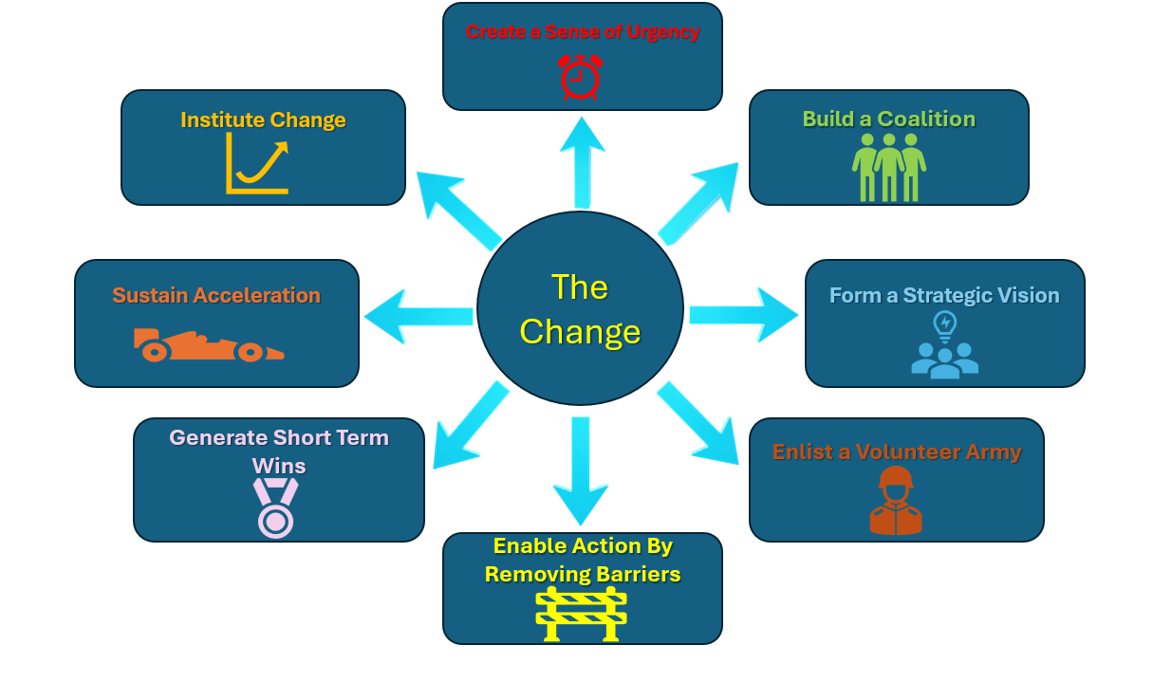
Figure 1 Kotter’s change model (kotterinc, 2025)

Applying Kotter’s model, at the first step management have failed, as there was no sense of urgency conveyed to the workforce. This wouldn’t have been hard as there was a sense of urgency due to the client urgently wanting to make up the lost hours, so they didn’t fall outside of safety protocols, but this wasn’t conveyed to the work force. Kotter notes “the failure to create a sense of urgency to be the single biggest error made when trying to change organisations” (Kotter, 2008). The second step is to build a coalition to guide the change this couldn’t have possibly happened as there was very little notice given to the workforce as to the change. They were only informed a few days before hand and there was no attempt from the mechanical bolting department, project or integrity department to help guide the work force. The role of a program sponsor is vital to the success of implementing an organisational change (Helm, 2005).
Step three a strategic vision was again missed there was no vision was created or laid out to the work force they were just told that the change was happening and when. The management used a very an autocratic style of management which isn’t in keeping with Kotter’s model. As a result, step four wasn’t met either as without the vision put in place it is going to be next impossible to get people onboard to champion the change and sell it to the rest of the work force. Step five was half achieved as most of the work force were already trained in this discipline as it was in keeping with their line of work. Unfortunately, these weren’t the work force who created the resistance to the change it was the platers and pipefitter who were resistant as it was outside of their line of work and trade. This would have been the perfect opportunity to help smooth out the change by offering them training in bolting this would have helped any doubts or worries they would have had in why they were transferred outside of their trade.

“Short-term wins help to demonstrate the viability of change and to build momentum” (Pollack, 2015). Step five was missed as there was no information fed back to any of the work force about the progress on reducing the hours the department was behind. This would have been the perfect opportunity to show the change was needed and the correct move as well as reassuring the three staff that were transferred outside of their trade that they were a help to the department and not moved for other reasons. As trust in the reasons for their transfer was very low and they were doubting the motives. Step seven didn’t happen as its hard to build on wins where no wins are conveyed to the work force. Strangely step eight seemed to be a success as over time all the work force transferred assimilated into the department and settled into their rolls this being the case moral was very low in most of the staff that had been transferred.

Lewin’s Forcefield

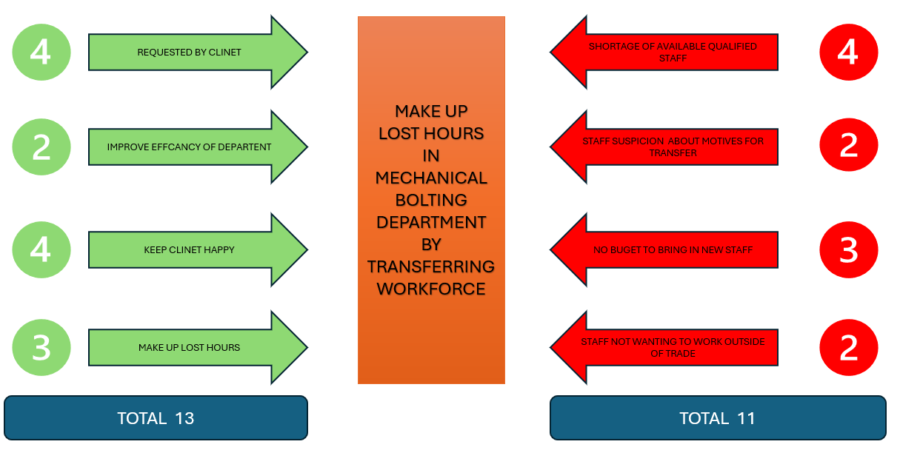
Figure 2 Lewins Forcefield (Reyes, 2024)

It can be seen in figure 2 that the main driving force behind implementing the change was pressure from the client and the need to keep the client happy. The force of change outweighs the force of resistance this means that the change was necessary. The main resisting forces to this were lack of qualified personally availed to fill the needed roles and the lack of budget to hire new personal. There for existing personal had to be used thou it wasn’t their field of expertise; they created another resistance as they were unwilling to transfer to this department.

How The Change Could Have Been More Effective

To look at how the change could have been managed more effectively the Lewin 3 step model will be applied as it is more applicable, and its broadness lends it to this situation. It alludes to the fact that change especially the mental change of employees is a journey as opposed to a straightforward step by step and can involve a few stages of misconception or mistrust before reaching the others side (Pawar, 2017).

The uses three steps the first of these is to unfreeze, this means to disrupt and break the pattern of the status quo. Only then can new behaviours and change start to be implemented and learnt. It also takes into count that the employees must feel safe and secure in the change before it takes place otherwise no change will occur. The second part is to change this considers that planned change is difficult to achieve and all force in action should be considered. The last step is to refreeze this looks to stabilize the group back into a new equilibrium to make sure new behaviours are set and safe from regression (Burnes, 2004).

To start to unfreeze the norm the first change that should have been made is the workforce being transferred should have been informed as soon as possible. Any questions that they had should have been heard and addressed this would have helped them feel secure in the approaching change. Instead, the lack of information creates uncertainty amongst individuals as effects and motives of the change can’t be predicted (van den Heuvel, 2015). They should have also been informed of the reasons for the transfers to the mechanical bolting department this would have also helped them understand the need for the transfer and tempered some of the resistance to the move (Kraft, 2016).

Once the transfer had taken place employees should have been offered training tailored to the new department, such as bolting, PSV and permit training. This would have been most advantageous to the three that were outside of their trade but would also have helped the mechanical bolters that were transferred. This would have helped them all understand the new role and become more efficient in it. It also would have made them feel valued in this role to show that they were being invested in (Ocen, et al., 2017). “According to social exchange theory, providing employees with continuous training opportunities can be viewed as a signal to employees, indicating that the organization cares about them and appreciates their contributions” (Mansour, 2022).

To refreeze the change in place management could have released to all the employees in the bolting department the figures on the amount the deficit of hours had been reduced. This would have acted as a reinforcement to the employees that the change was working and that they were making a difference. This would have helped the feel part of the department. “Realization and successful implementation of change in the organization enable a smoother experience of the positive consequences of change for both the employees and the organization” (Jalagat, 2016)

Mullins Motivation Model

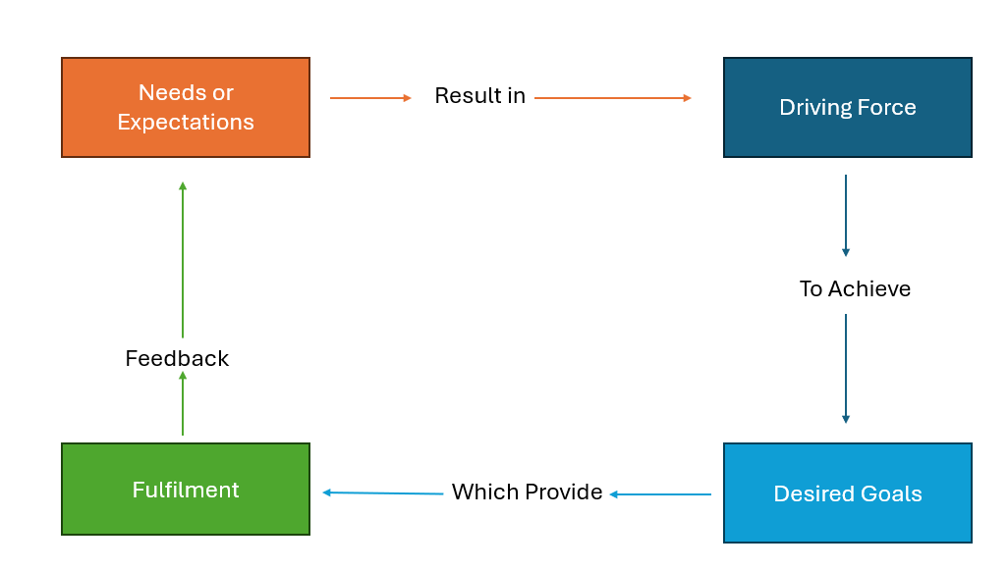
Figure 3 Simplified Mullins Motivation Model (Mullins, 2010)

Employees can be guided through change using the correct leadership style to suit the employee and supporting them through the process. for example, in the above scenario the management used and autocratic style across the board offered little to no explanation for the change and didn’t consult or support the employees this led to low motivation in the employees. Using the above model the management could have met with the workforce and explained the reasoning behind the change and found out the employees’ expectation and worries from this they could have been acted on. “Communication was the most significant factor affecting staff motivation. When described as ‘good’, it was open, honest, appropriate and timely” (Shannon, 2017) . Offering training in the department and presenting this as an opportunity to advance their skills depending on each employees driving goals. With regular meetings to check in on the employees to see how they are doing in the new department and seeing if anything else can be put in place would not only have raised motivation but productivity (Osabiya, 2015).

Conclusion

In conclusion the change of transferring staff to the mechanical bolting department by Altrad was poorly planned and executed. The very autocratic management style used didn’t lend well to the situation and led to no communication to the work force this led to low motivation and uncertainty. It doesn’t seem that any management model was used, and it was almost taken for granted by management that the employees would just get on with it. The employees would have greatly benefited from a meeting with the management explaining the reasons for the change due to the external pressures this would have help lower resistance to the change posed from the work force. This should have been done as soon as possible and any concerns that the employees had should have been addressed by management. Following this training should have bee offered to staff in the department this would have helped the transferred staff feel valued and secure in their new positions with added advantage of making sure they were efficient and able to carry out the role. Updates on the progress of the department would have been of great advantage and help show that the transfer was the correct move also that it was working to reduce the lost hours to put the department back on schedule. Results of following a change management model and carrying out these actions would have greatly raised moral and motivation in the work force made the transition far smoother. This backs that the change management models are still effective in the modern workplace but in some instances need slightly modifying as change isn’t always straight forward.

Bibliography

Bibliography
Altrad 2025 , 2025. uk.altradservices. [Online]
Available at: https://uk.altradservices.com/
altrad, 2025. altrad uk. [Online]
Available at: https://uk.altradservices.com/
[Accessed 23 march 2025].
Burnes, B., 2004. Kurt Lewin and the Planned Approach to Change:A Re-appraisal. journal of Management Studies, 41(6), p. 985.
Christy, L. J. M. G., 2016. Management & Organisational Behaviour. 11 ed. Harlow: Pearson Education Limited.
Dragomiroiu, E.-I. I. a. A. M. a. R., 2014. Role of Managers in Management of Change. Procedia Economics and Finance, Volume 16, pp. 293-298.
Have, D. M. R. &. S. t., 2022. Evidence-based change management. Organizational Dynamics, 51(3), p. 100899.
Helm, J. a. R. K., 2005. Effective project sponsorship an evaluation of the role of the executive sponsor in complex infrastructure projects by senior project managers. {Project Management Journal, 36(3), pp. 51--61.
Jalagat, R., 2016. The impact of change and change management in achieving corporate goals and objectives: Organizational perspective. International Journal of Science and Research, 5(11), pp. 1233 - 1239.
kotterinc, 2025. kotterinc. [Online]
Available at: https://www.kotterinc.com/methodology/8-steps/
[Accessed 15 4 2025].
Kotter, J. P., 2008. A Sense of Urgancy. 1 st ed. Boston: Harvad Buisness Press.
Kraft, A. S. J. &. P. C., 2016. Giving and Making Sense About Change: The Back and Forth Between Leaders and Employees. Journal of Business and Psychology, 33(1), pp. 71 - 87.
Lunenburg, F. C., 2010. Approaches to managing organizational change. International journal of scholarly academic intellectual diversity, 12(1), pp. 1 - 10.
Mansour, A. R. h. A.-G. J. A. N. N. M. A.-Q. S. S. H. &. A. A. H., 2022. Perceived benefits of training, individual readiness for change, and affective organizational commitment among employees of national jordanian banks.. Cogent Business & Management,, 9(1), pp. 1 - 27.
Mullins, L., 2010. work moteration and job satisfaction. In: Management and organisational behaviour. Harlow: Financial Times Prentice Hall, pp. 252 - 253.
Ocen, E. (. E., Francis, K. (. K. & Angundaru, G. (. G., 2017. The role of training in building employee commitment: the mediating effect of job satisfaction. EUROPEAN JOURNAL OF TRAINING AND DEVELOPMENT, 41(9), pp. 742 - 757.
Osabiya, B. J., 2015. The effect of employees motivation on organizational performance. Journal of public administration and policy research, 7(4), pp. 62 - 75.
Pawar, A. a. C. K., 2017. Study on adaptability of change management: review of Kurt Lewins and Kotter model of change. Research Revolution International Journal of Social Science and Management, 5(4), pp. 79 - 83.
Pollack, J. P. R., 2015. Using Kotter’s Eight Stage Process to Manage an Organisational Change Program: Presentation and Practice. Systemic Practice and Action Research, 28(1), pp. 51-66.
Prof Avinash Pawar, D. K. C., n.d. Study on Adaptability of change managment.
Reyes, J., 2024. safetyculture. [Online].
Reyes, J., 2024. safetyculture. [Online]
Available at: https://safetyculture.com/topics/force-field-analysis/
[Accessed 20 april 2025].
Sarayreh, B. H. a. K. H. a. B. E. A., 2013. Comparative study: The Kurt Lewin of change management. International Journal of Computer and Information Technology, 3(4), pp. 626 - 629.
Sergio Fernandez, H. G. R., 2013. Manging sucsesful organizational change in the public sector. In: J. R. D. Robert F. Durant, ed. Debating Public Administration Management Challenges, Choices, and Opportunities. 1st ed. New York: Routledge, pp. 7 - 27.
Shannon, E. A., 2017. Motivating the workforce: beyond the ‘two-factor’ model. Australian Health Review, 43(1), pp. 98 - 102.
van den Heuvel, S. S. R. &. v. A. M. A. L. M., 2015. Does a Well-Informed Employee Have a More Positive Attitude Toward Change? The Mediating Role of Psychological Contract Fulfillment, Trust, and Perceived Need for Change.. The Journal of Applied Behavioral Science,, 51(3), pp. 401 - 422.
Warrick, D., 2023. Revisiting resistance to change and how to manage it: What has been learned and what organizations need to do. Business Horizons, 66(4), pp. 0007-6813.
Yazdanifard, M. J. H. &. D. R., 2015. How Effective Leadership can Facilitate Change in Organizations through Improvement and Innovation. Global Journals Inc. (USA), 15(9), pp. 1 - 6.

