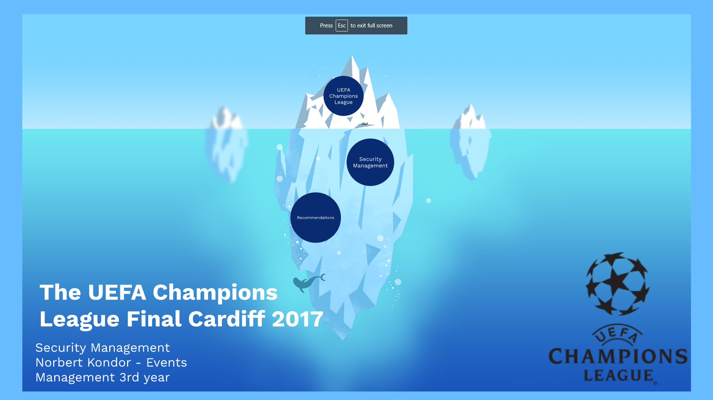
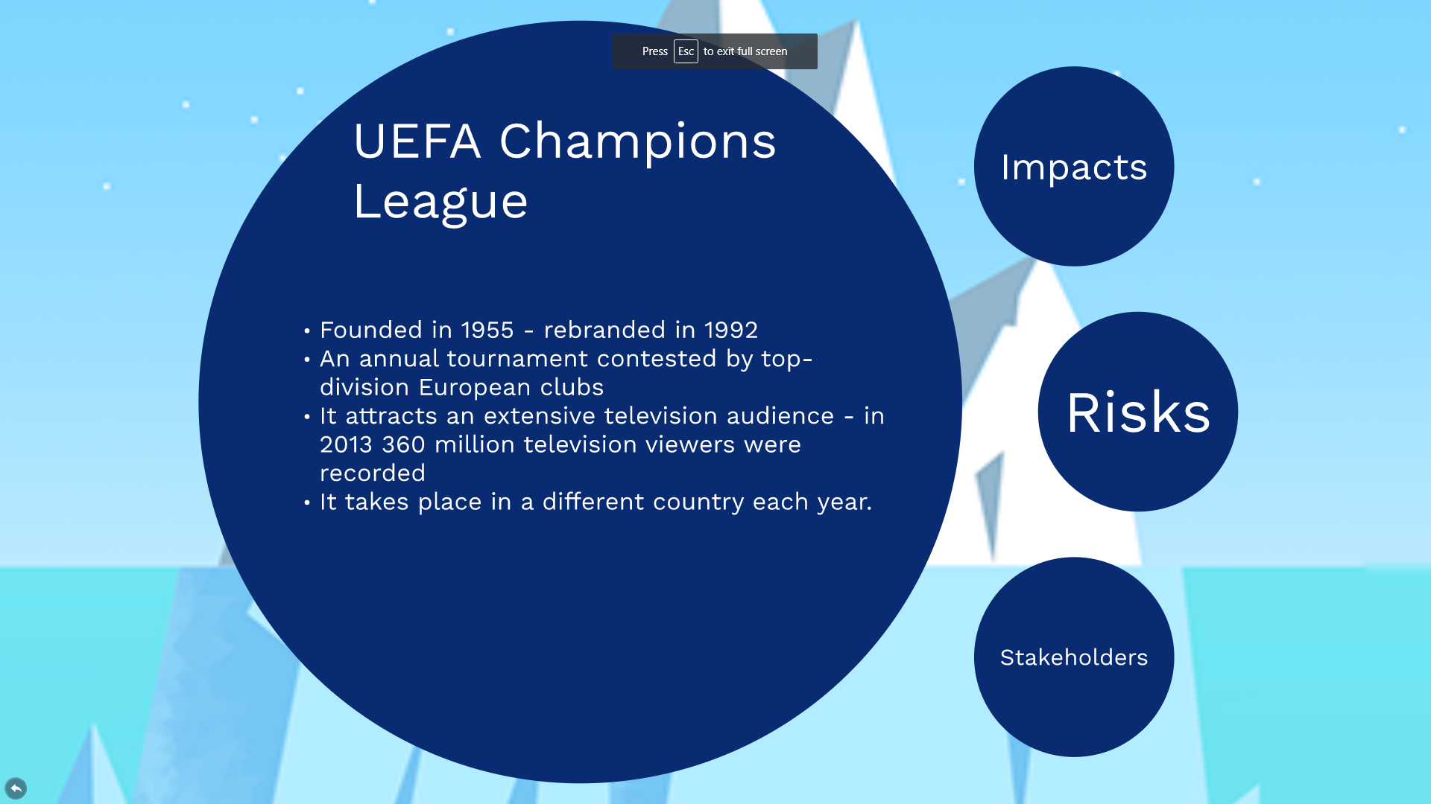

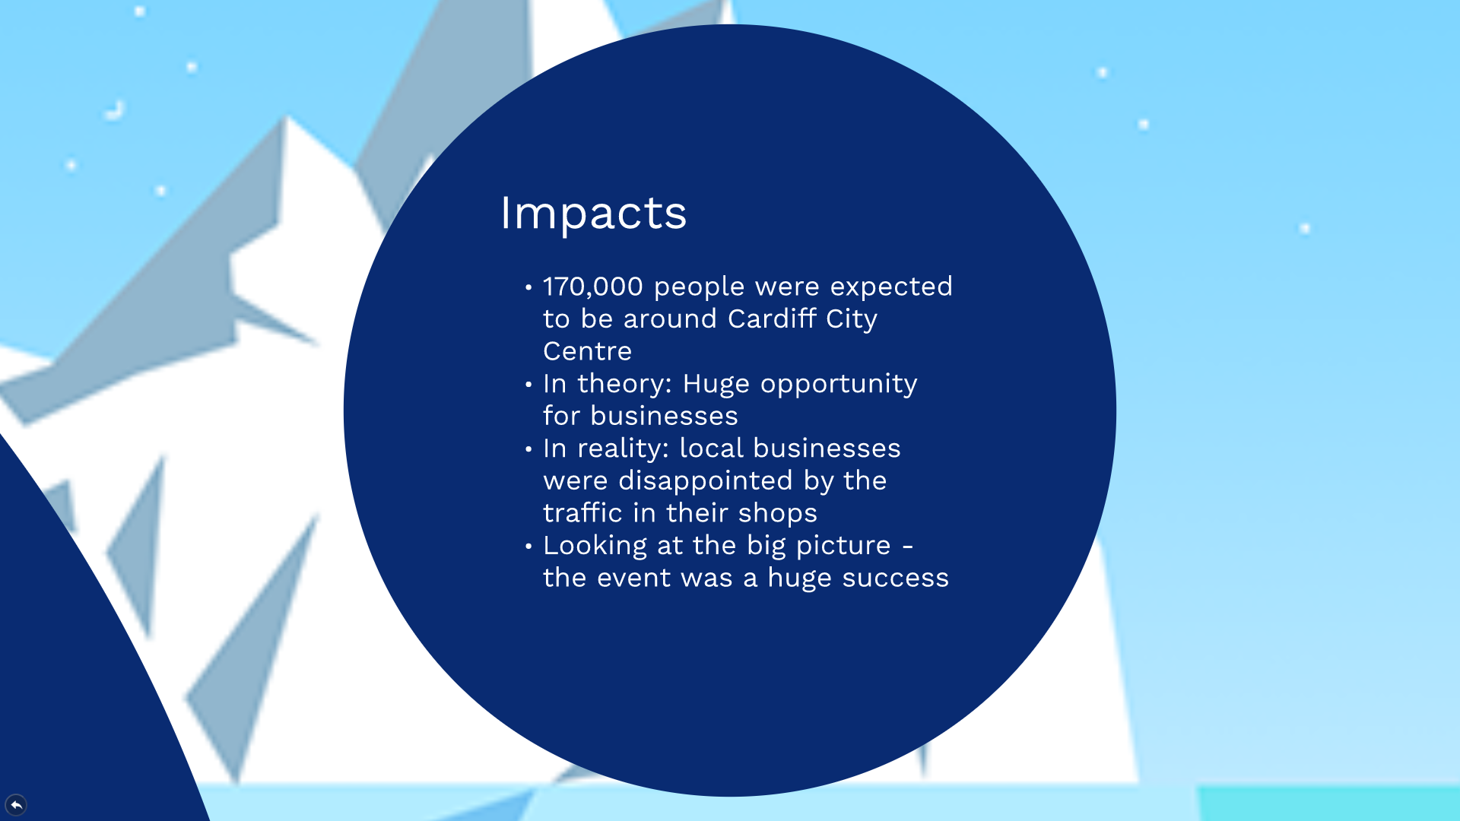
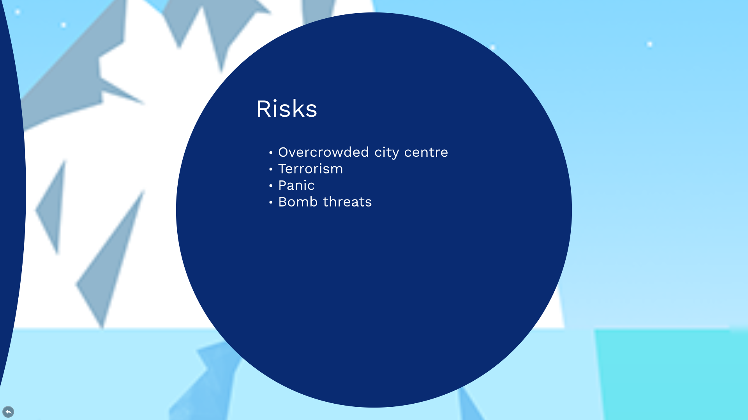

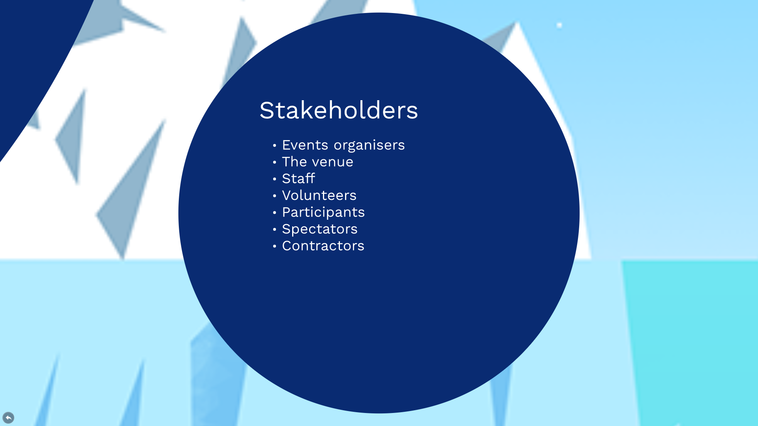
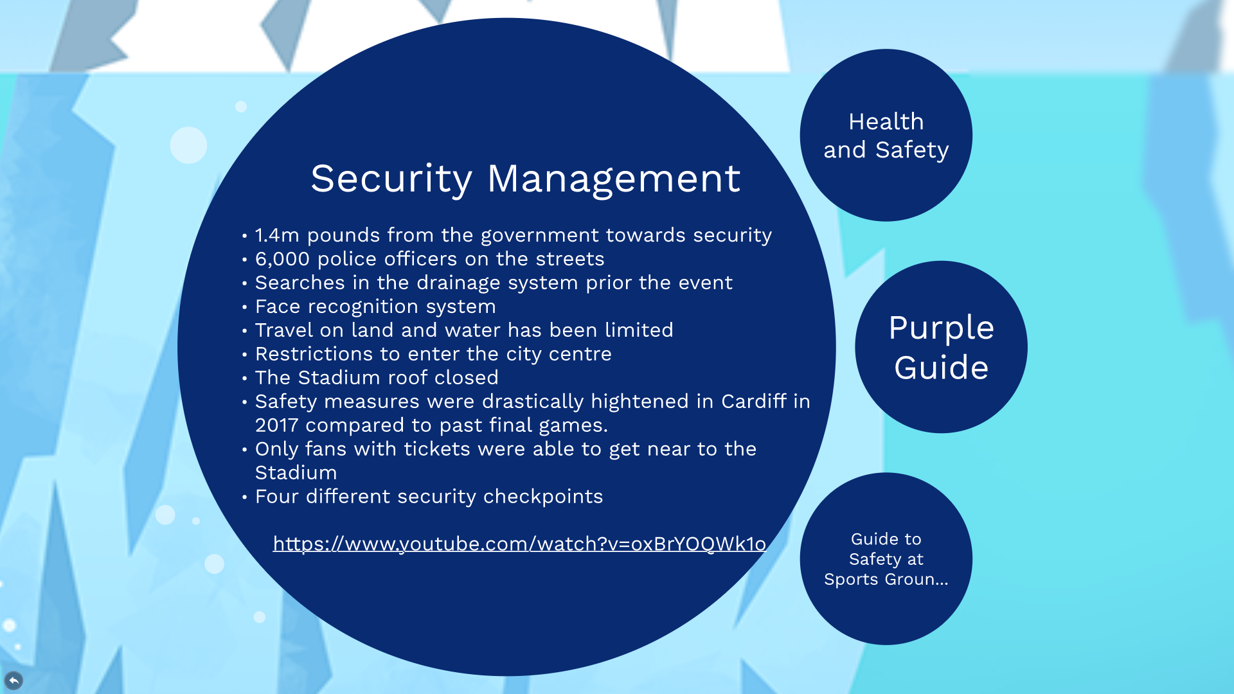

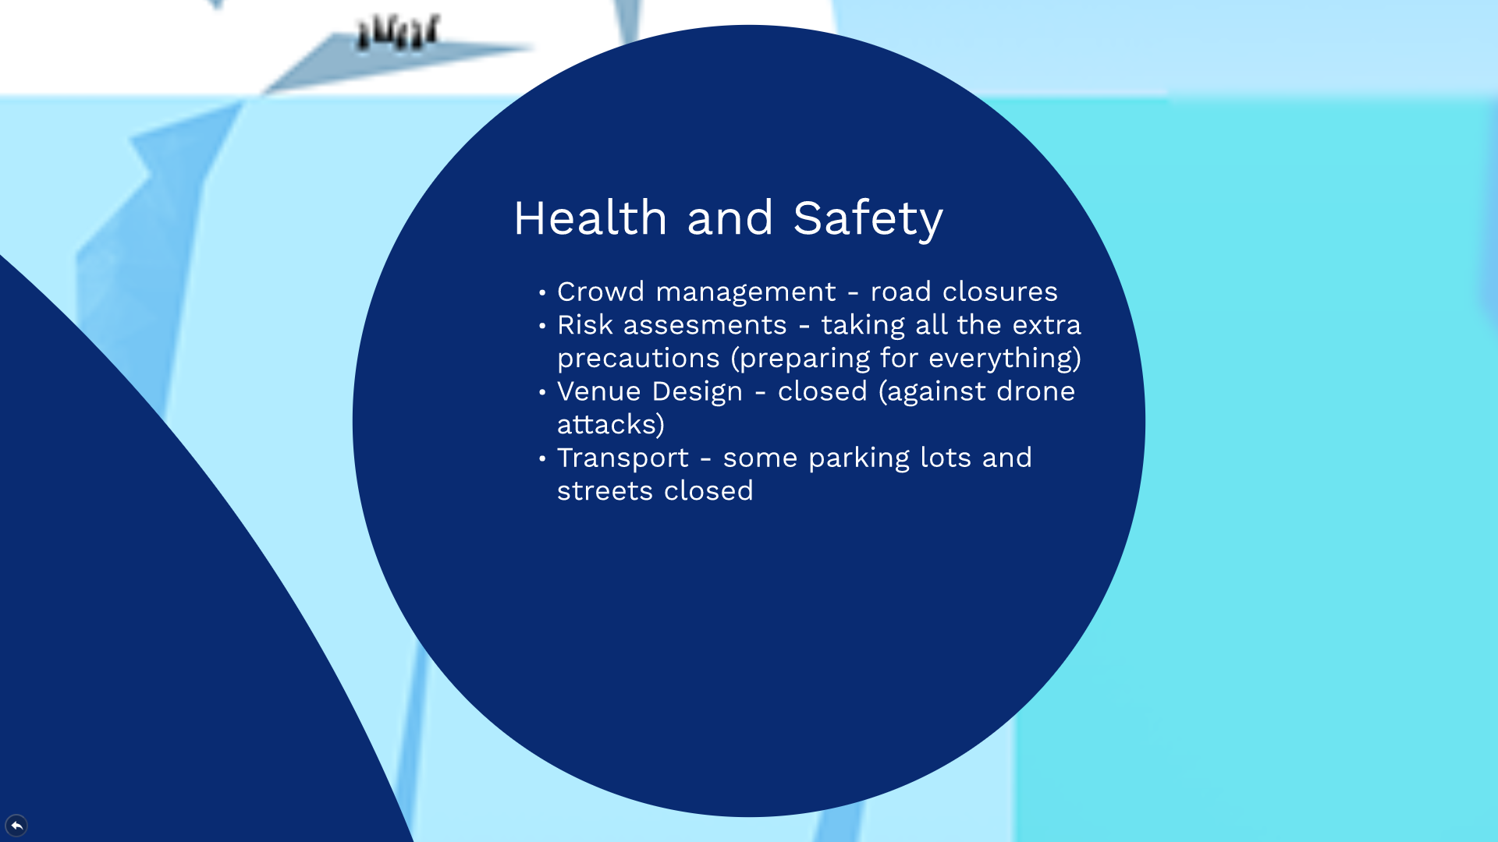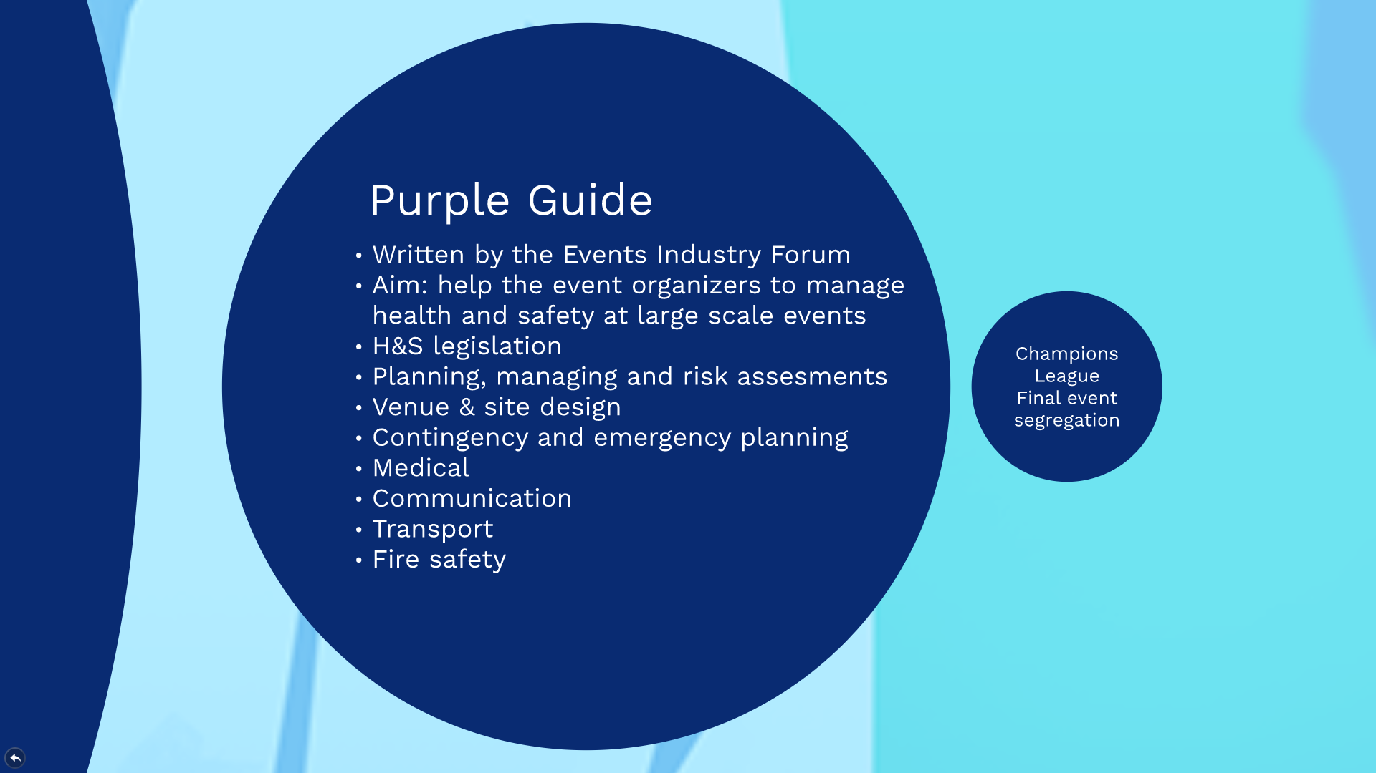

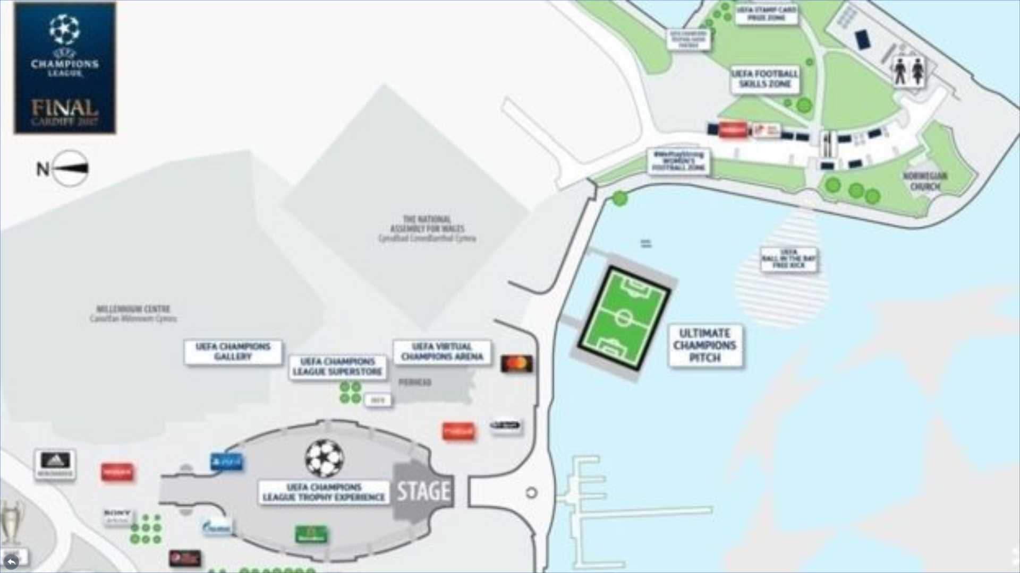
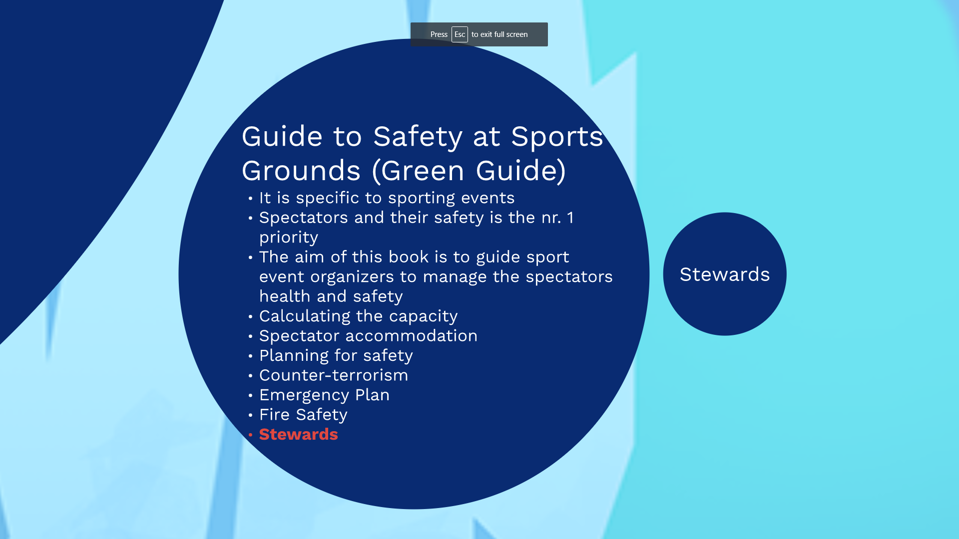

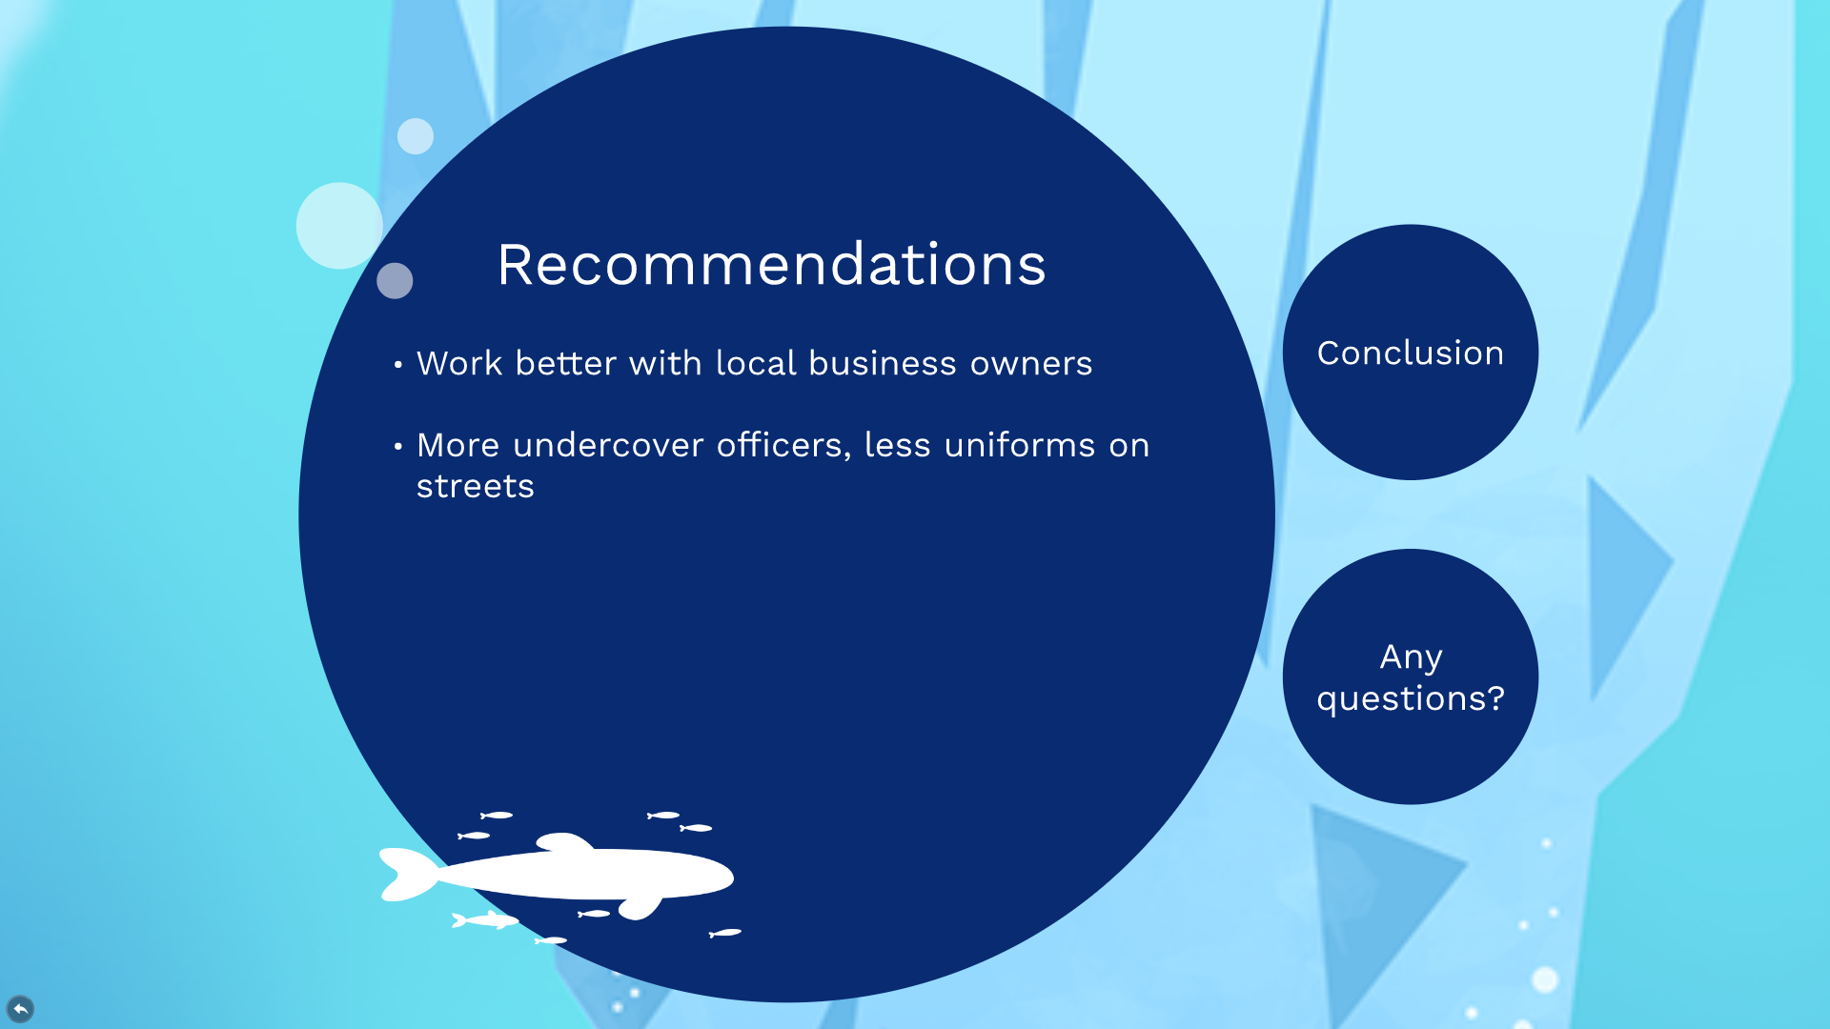

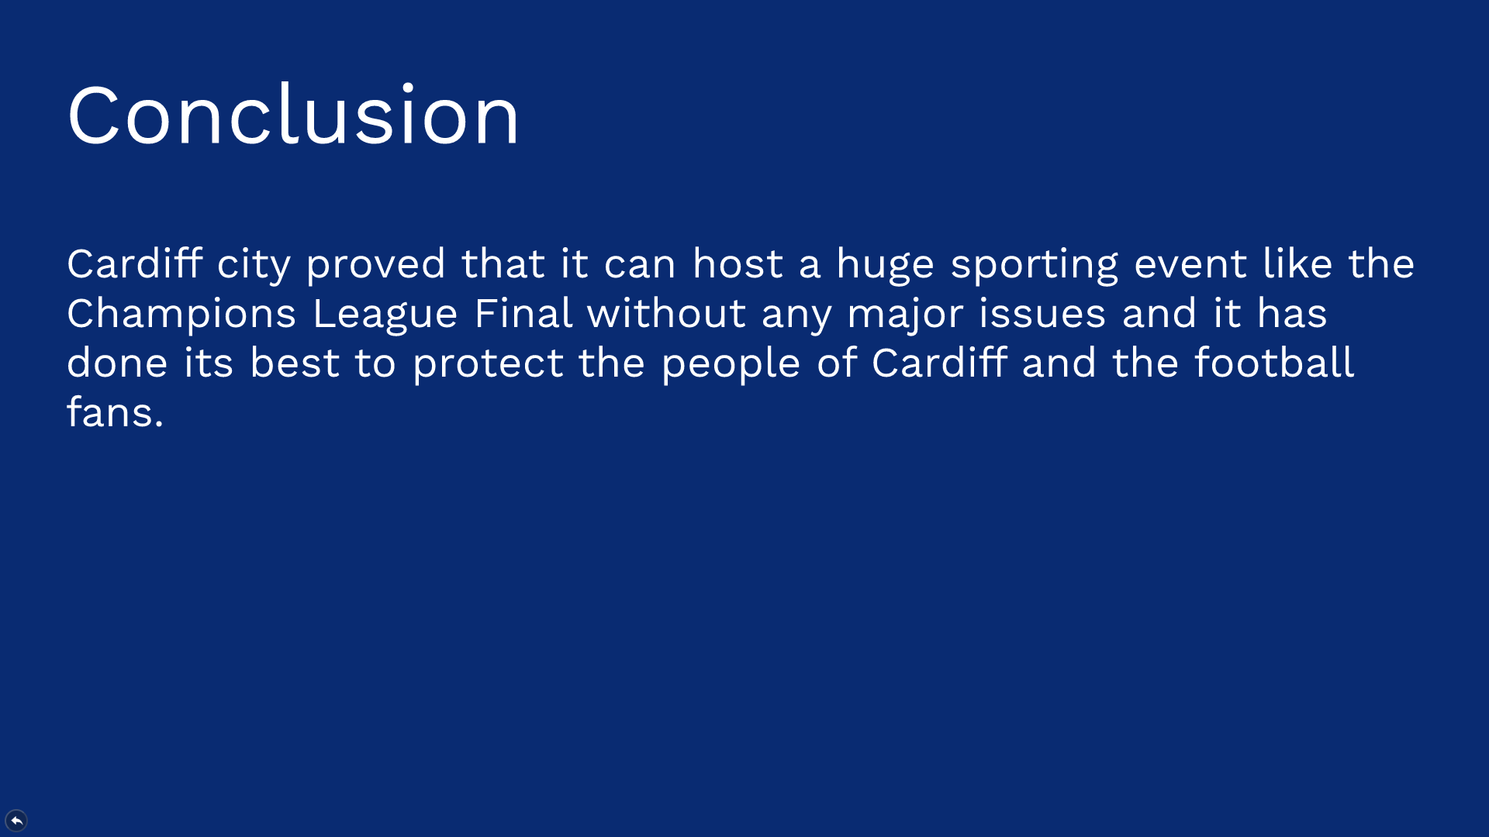


The UEFA Champions League was founded in 1955 although It has been rebranded in ’92. The champions league is an annual football tournament between the best European clubs – 32 in total in the group stages. It is the second biggest football event next to the Football World Cup so evidently hundreds of thousands of people are expected to participate on the day. The final takes place in a different city each year and the destinations are using the bidding process in order to ensure their city as the host for the Champion’s League final.
What does it mean for a city to host such a huge event? It has a huge impact on the tourism and economy and local businesses usually bloom during this period. On the other hand, in Cardiff, the local businesses were not happy at all since according to them, many of them recorded all time low sales figures and were generally very disappointed with the amount of traffic their businesses had. As per the business owners, some of the security arrangements were changed in the last minute which resulted in some unexpected road closures. Secondly, the locals were warned about the event and were told to avoid the city centre – many regular customers stayed away and the fans arrived late and left early. Looking at the big picture though, Cardiff managed to organize and deliver a mega event which ultimately proves the capabilities of the city and can be used in future bids for other major sporting events.
Hosting an event like the Champions League Finals comes with risks because as I mentioned earlier it attracts hundreds of thousands of people into the city and today the organizers are under a lot of pressure when it comes to security.
The skateholders are all the groups/organisations and individuals who are directly affected by the outcome of the event.
On the week of the champions league final 6,000 police officers have been deployed on the streets of Cardiff and the drainage system was searched prior to the event. Police forces also used real time cameras for facial recognition technology. Travel restrictions were also put in place, water travel along the River Taff and inside the Bay are was not allowed. During the event, military ships were present on these waters. Only fans with tickets were allowed to get near the stadium and those who wanted to get into the stadium had to go through four security checkpoints. Lastly, the stadium roof was also closed as there have been reports of concerns over the potential possibility of drones being used as part of a terrorist attack.
The purple guide has been written by the Events Industry Forum and its main aim is to help event organizers to manage health and safety precautions for a large scale event such as the Champions League Final. There are close to 20 key points in the purple guide; for example health & safety legislation – businesses involved in events have certain duties to ensure the health and safety of their employees and the public. Planning, managing and risk assessments (preparing an event safety plan, carry out a systematic assessment of the risks to employees, volunteers and the public). Venue and site design (designing the site layout to minimize risk, for example to segregate).
In Cardiff, the organizers have segregated the event facilities well which ultimately helped to ease the pressure on security and to make sure the fans are all around the city, not in one zone.
The guide to safety at sports grounds or green guide or green book is similar to the purple guide but this is specific to sporting events. The number one priority is the spectator health and safety and the aim of this book is to ensure that the event organizers are managing their health and safety well. Calculating the capacity, managing the spectator accommodation, planning for safety, taking precautions for counter-terrorism, having an emergency plan are just some of the key points the green book covers and one of the main elements to spectator safety are the stewards.
'Effective safety management requires the employment, hire or contracting of stewards in order to assist with the circulation of spectators, prevent overcrowding, reduce the likelihood and incidence of disorder, and provide the means to investigate, report and take early action in an emergency. In carrying out these duties, stewards should always be aware of, and ensure the care, comfort and well-being of all categories of spectators’. Stewards are one of the most important security assets during a sporting event and it is crucial that they know their area, they are aware of their duties, they have their necessary qualifications and most importantly, they are aware of their surroundings. It is key for the organizers to make sure they are being briefed and debriefed regularly so they are up to date with all the necessary information.
As recommendations I think it would be a great idea to work more and better with local business owners so that everybody can profit from huge opportunities like the Champions League Final. Organizers should find a way to make sure the local pubs and shops are full of people which would ultimately benefit Cardiff’s economy. Secondly, many people felt uneasy and a little bit nervous when they noticed the heightened security measures such as police checkpoints, officers roaming the streets, etc. As a solution it might be a better idea to have these officers undercover so that the public can focus on the event and the facilities.
Finally, Cardiff managed to prove that it can host a huge sporting event without any major issues and it has done its best to protect the people of Cardiff and the football fans.

BBC News. (2017). Champions League gloom for businesses. [online] Available at: http://www.bbc.co.uk/news/uk-wales-south-east-wales-40161554 [Accessed 6 Dec. 2017].
Chishti, Faisal (30 May 2013). "Champions League final at Wembley drew TV audience of 360 million". Sportskeeda. Absolute Sports Private Limited. Retrieved 31 December 2013.
Conwy.gov.uk. (2017). Cite a Website - Cite This For Me. [online] Available at: http://www.conwy.gov.uk/en/Business/Markets-and-Events/Organising-an-event-in-Conwy-County/Assets-SAG-group/Documents-SAG/The-Purple-guide-to-health-safety-and-welfare-at-music-and-other-events.pdf [Accessed 3 Dec. 2017].
Faw.cymru. (2017). FAW / Security. [online] Available at: http://www.faw.cymru/cardiff2017/local-knowhow/security/ [Accessed 2 Dec. 2017].
Mosalski, R. (2017). Everything we know about security at the Champions League final in Cardiff. [online] walesonline. Available at: http://www.walesonline.co.uk/news/local-news/everything-know-security-champions-league-13078397 [Accessed 2 Dec. 2017].
Walford, J. (2017). Policing for Champions League final will have to be re-evaluated. [online] walesonline. Available at: http://www.walesonline.co.uk/news/wales-news/policing-champions-league-final-re-13083348 [Accessed 3 Dec. 2017].

