2020
Steven James (1810370)
AWE plc/UWTSD
11/23/2020
Digital signals and processing

Contents
Abstract 2
Introduction 2
Background information 2
Simulation models 6
Results 7
Discussion 9
Conclusion 10
References 11
Appendix A - Results 13
ASK 13
PSK 14
QPSK 15
QAM 17
Appendix B – Alternate for QPSK 19

Abstract

This report considers the performance of four types of digital modulation using the SIMULINK software in MATLAB. The four modulation techniques are ASK, PSK, QPSK and QAM. Models are created in the software using an AWGN channel as the medium to transmit the signal through. The SNR in the AWGN channel is adjusted to investigate at whick level each of the techniques will begin to fail. A BER calculator is used, and total failure is considered to be a BER of 0.5.
QAM performs the best with regards to speed of data sent, however, if there is noise on the channel, it can fail relatively quickly with a BER of 0.5 at an SNR of ~2 dB. PSK is slower, however, performs much better in a noisy channel only reaching a BER of 0.427 at an SNR of -40 dB.

Introduction
A communication system is the sending of a signal or data from one point and receiving it at another. The invention of the telephone and telegraph in the mid 1800s allowed for long distance communication rather than sending a sound wave through the air, a signal was sent along a thin metal wire (classed as a ‘wired system’).
Radio was invented towards the end of the 1800s; there is debate whether Tesla or Marconi invented it. With radio a signal is sent from a transmitter to a receiver using waves in the air (classed as a wireless system [1]). Used throughout the 1900s, radio communication was key during WW2.
To transmit a signal either ‘wired’ or ‘wireless’ a baseband signal is used. This is the carrier wave. The signal is attached to the carrier wave so it can be transmitted. This process of attaching the signal to the carrier wave is known as ‘modulation’.
Standard radio communication has generally been analogue, where the amplitude or the frequency is modulated to send the signal. In more recent years there has been a shift from analogue systems to digital systems. Mobile phone, WiFi and communication via satellite are areas where the change to digital communication is very pronounced [2].
In digital modulation, the data is sent on the carrier wave by modulating certain parameters of the wave. More than one parameter can be modulated. In general, digital modulation uses high frequency carrier waves so that they can be sent over long distances [3].
For a communication system to perform well ideally noise will be avoided.
This report looks at four types of digital modulation, ASK, PSK, QPSK and QAM using SIMULINK from MATLAB. Noise is added to the system and a comparison between sent and received signals is conducted to find which system copes better with noise. This is done by adjusting the signal to noise ratio (SNR) and looking at how it affects the Bit Error Rate (BER).

Background information
Amplitude Shift Keying (ASK) is a simple modulation technique; it is also known as on-off keying. In ASK the amplitude of the carrier wave is modulated between two discrete levels, usually on and off, or low and high. These two levels represent binary data of 1 or 0. The frequency of the carrier is not changed and nor is the phase. The carrier wave is an analogue signal which is modulated to carry a digital code. It could be considered that an early example of ASK is Morse Code, where the dots and dashes are represented as 1s, and the time when no signal being sent represents the 0s. The alternate name of On-Off shift keying better represents this.
ASK can be represented by [4]:

$$s\left(t\right) =Acos\left(2πf_{c}t\right) for binary 1$$
$$s\left(t\right)=0 for binary 0$$

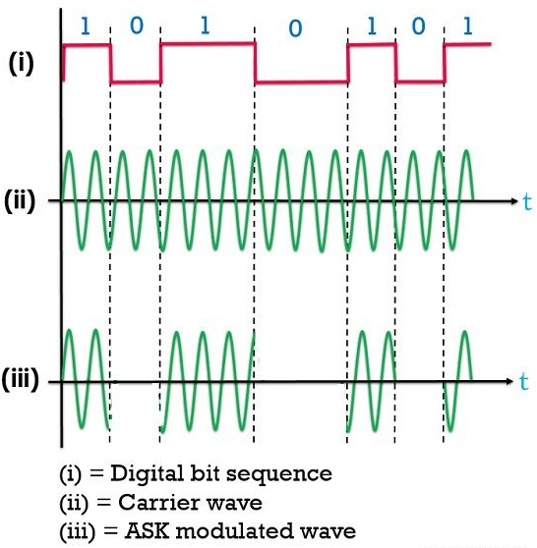
Figure 1 - example of ASK modulation [5]
An advantage of ASK is that it is easy to generate and detect, therefore the transmitter and the receiver can be of simple design.
Disadvantages of ASK include that it is unsuitable for transmission of data with a high bit rate, it is not efficient with use of bandwidth and is susceptible to external factors [5].
Uses of ASK include low frequency RF applications, systems to monitor tyre pressure and base stations for wireless systems, traditional modems and fibre optics [5] [6].
Phase Shift Keying (PSK) is a modulation technique where the data is carried on the carrier wave by alternating the phase of the carrier wave. The simplest form of PSK in Binary Phase Shift Keying (BPSK). In the BPSK technique, discrete values of 1 and 0 are expressed by a change in the phase of the carrier signal. The signal remains the same until the phase is shifted, at which point the data bit will change. The change in phase will be a 180º shift [7].

BPSK can be represented by [4]:
$$y=\cos\left(2πf_{c}t\right) for binary 0$$
$$y =\cos\left(2πf_{c}t+π\right) for binary 1$$

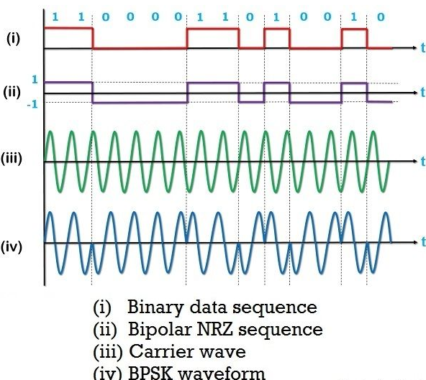
Figure 2 - example of PSK modulation [8]
Advantages of PSK is that transmission of the signal is more efficient. It also has some immunity to noise.
Disadvantages are the signal can be quite complex to detect and there can be a variation in the signal amplitude created by phase discontinuity. It is possible that the receiver may not know the phase of the signal so it is unable to determine whether the data is at state 1 or 0. The synchronisation clocks for transmit and receive would need to be accurate to overcome this possible problem [9] [10].
PSK is used in Bluetooth connections, local wireless area networks and RFID.

Quadrature Phase Shift Keying (QPSK) is a technique of modulation where two carrier waves are shifted in order to encode four 2-bit symbols, each separated by Pi/2 rads (90⁰).
Phase angle | Data symbol
45⁰ | 00
135⁰ | 01
225⁰ | 11
315⁰ | 10

The QPSK signal is created using the binary symbols. The signal is passed into a demultiplexer. The parts of the signal are separated out. The outputs are coded and phase shifted by pi/2 and brought back together to create the QPSK signal. A constellation diagram Figure 3 below shows how the phases are shifted into each quadrature to give a different bit symbol.

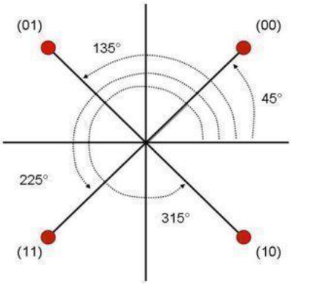
Figure 3 - Constellation diagram of QPSK [11]
QPSK is a popular technique used for sending digital communication through RF frequency carriers. It is used in satellite communication and videoconferencing. It is used so often as it is reasonably simple, being very efficient in both power and bandwidth. The information carried by a QPSK signal is double that of PSK [12].

Quadrature Amplitude Modulation (QAM) is a technique that uses an analogue and a digital concept. It uses the phase and amplitude component of the wave combining two carrier waves so they can be transmitted into a single channel. The two carrier waves have their phases shifted by pi/2 rads (90⁰), after which they are modulated and then combined. The combined signal now has an in-phase component (I) and an out of phase (quadrature) component (Q). In comparison to the earlier techniques discussed, QAM has both an amplitude and a phase modulation. This allows multiple data symbols to be sent. Figure 4 shows a constellation diagram of a 16bit QAM. Each point represents a specific value. A signal sent using this form of modulation can send data at higher data rates.
0101
0001
1001
1101
0100
0000
1000
1100
0110
0010
1010
1110
0111
0011
1011
1111
Figure 4 - constellation diagram of QAM [4]
QAM is commonly used at bit rates of 8, 16, 32, 64, 128 and 256 bits [13], however in order to meet the requirements of 5G communication systems a Universal Filtered Multi Carrier (UMFC) technique has been developed using 1024QAM system [14]. By using higher order bit rates, more bits can be sent with every symbol; this does have drawbacks though. As the number of bits increases, the points get closer together increasing the chance of data errors and susceptibility to noise [15].

Simulation models
To conduct the experiment SIMULINK in MATLAB was used. Specific models were built in the simulation programme. The requirement was to follow the basic set up as shown in Figure 5 using a Bernoulli Random Binary generator as the source. Along with this, an Additive White Gaussian Noise (AWGN) channel is used on the transmission channel.

Figure 5 - Basic set up of simulation model
An error rate calculator was used to compare the received data to the data sent. The requirement was for the noise to be put onto the channel and find out at what point the system would ‘totally’ fail. The Author decided that ‘total’ system failure would be a bit error rate of 0.5, this is the point where only half of the signal is successfully received and therefore would only be 50% ‘correct’.
The ASK simulation was set up as in Figure 6.
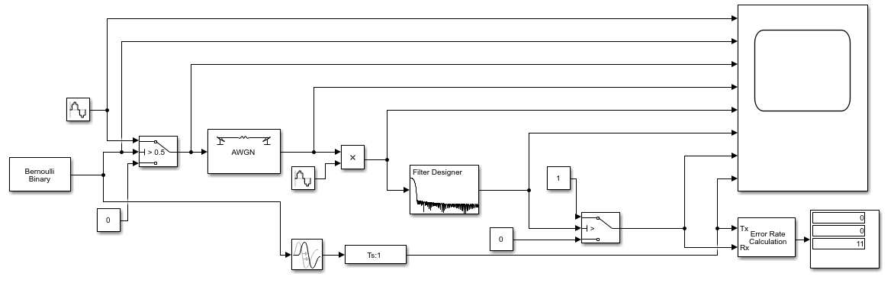
Figure 6 - ASK set up
The PSK simulation was set up as in Figure 7.

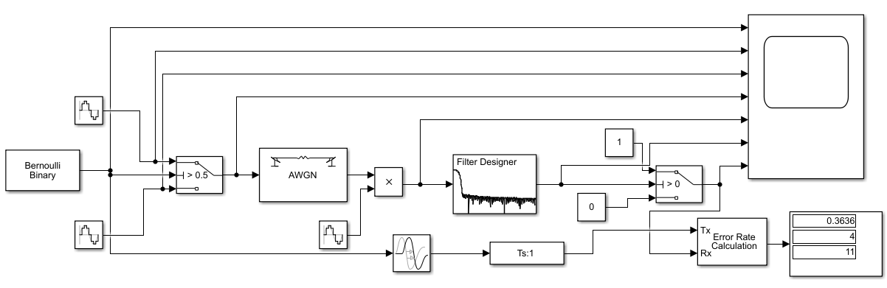
Figure 7 - PSK set up
The QPSK simulation was set up as in Figure 8.
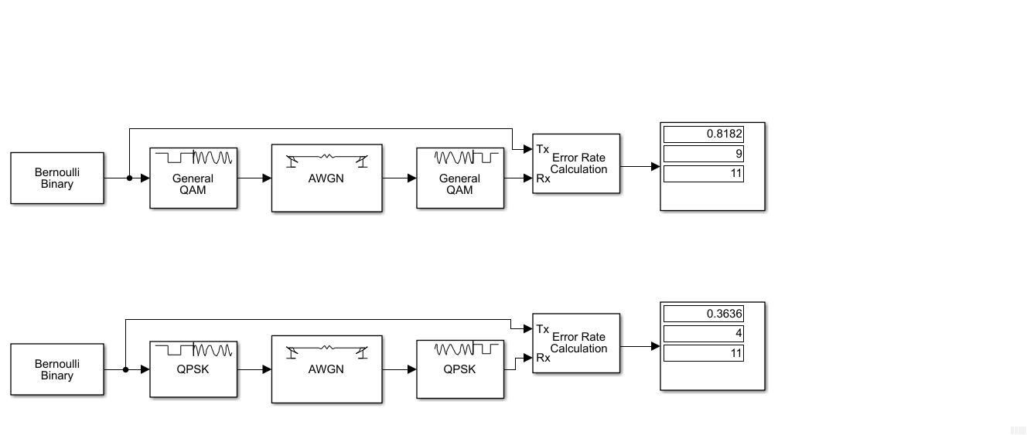
Figure 8 - QPSK set up
The QAM simulation was set up as in Figure 9.
Figure 9 - QAM set up
The noise was added or taken from the system by adjusting the SNR in the AGWN channel as shown in Figure 10.

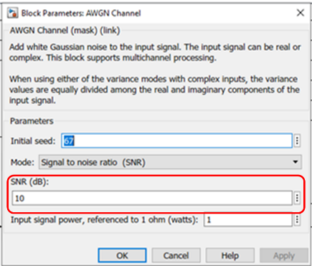
Figure 10 - How to adjust the SNR on the AGWN channel
For each simulation the author chose a value of noise to start the simulation from. As the Bernoulli Binary generator is a random signal, the simulation was run 10 times at each level of noise. This allowed for an average bit error rate to be taken for each SNR evaluated. The steps between SNRs were either 5 dB or 10 dB, depending on the predicted level of change. In some instances, a change of 1 dB was selected to predict a more accurate change in SNR reaction.

Results
Bit error rate is calculated as follows:
$$BER=\frac{number of errors recieved}{number of bits sent}$$
Individual results can be found in appendix A. The average results were as follows:
ASK
SNR | -50 | -30 | -20 | -19 | -18 | -17 | -15 | -10 | -5 | -1 | 0 | 1 | 10
BER | 0.5545 | 0.5455 | 0.4818 | 0.4455 | 0.4182 | 0.3364 | 0.2909 | 0.2727 | 0.2273 | 0.1455 | 0.0636 | 0 | 0

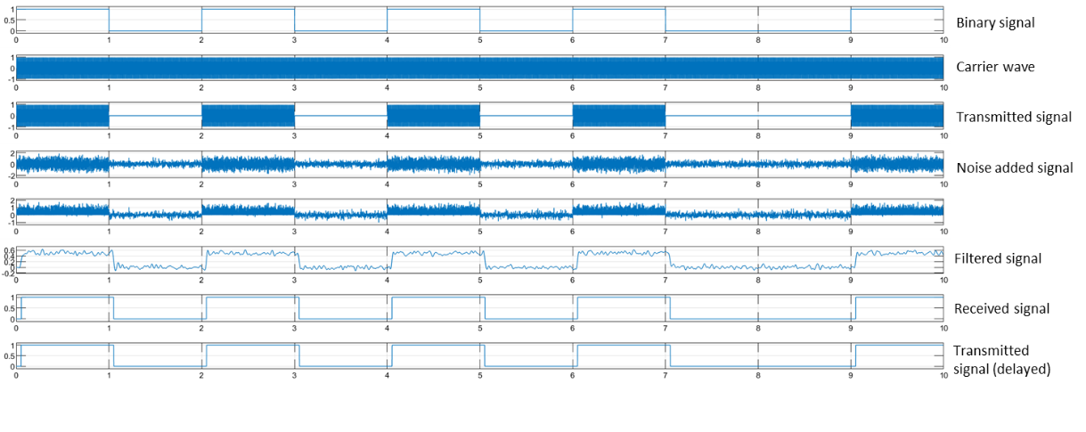
Figure 11 - example of scope output for ASK, SNR 1dB
PSK
SNR | -50 | -40 | -30 | -25 | -20 | -17 | -16 | -15 | -10 | -6 | -5 | 0
BER | 0.4182 | 0.4273 | 0.4000 | 0.3727 | 0.3182 | 0.3000 | 0.2636 | 0.2364 | 0.1909 | 0.036 | 0 | 0

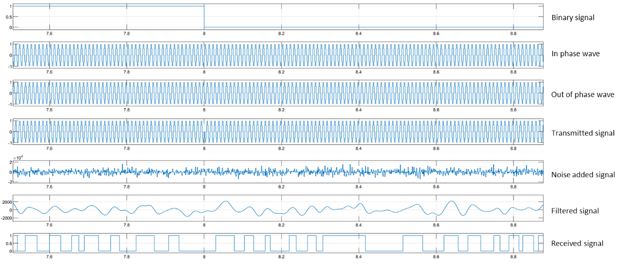
Figure 12 - example of scope output for PSK, SNR -40 dB
QPSK
SNR | -50 | -40 | -30 | -20 | -15 | -10 | -7 | -5 | -2 | 0 | 2 | 5 | 10
BER | 0.6909 | 0.7000 | 0.6727 | 0.6636 | 0.5909 | 0.5273 | 0.5091 | 0.3636 | 0.1455 | 0.1273 | 0.0273 | 0.0182 | 0

QAM
SNR | -50 | -40 | -30 | -20 | -15 | -10 | -5 | 0 | 5 | 10 | 15
BER | 0.9455 | 0.9455 | 0.9455 | 0.8909 | 0.8909 | 0.7909 | 0.6727 | 0.4182 | 0.1273 | 0.0182 | 0

The results were put into a graph, found in Figure 11.

Figure 13 - Graph of SNR and BER for all modulation types

Discussion
Figure 11 shows how each of the modulation techniques differ with respect to how they react to the SNR. The author chose to have a BER of 0.5 to represent total complete system breakdown. PSK, even with a SNR of -50 dB did not get to a BER of 0.5. ASK did get to a BER of 0.5, this wasn’t until an SNR of ~-20 dB. This shows that the relatively simple systems of ASK and PSK are still quite viable even when there is a lot of noise on the system. Moreover, they require the noise strength to be higher than the signal before they will start to incorporate errors on the system.
QPSK and QAM react differently to noise on the system, QPSK has a BER of 0.5 at ~-5 dB, whilst QAM has a BER 0.5 at ~-2 dB. What is more significant is that both QPSK and QAM see errors on the system when the signal is higher than the noise, QAM especially shows errors detected with an SNR of +10.
The simulation does show that as expected QAM and QPSK can be susceptible to noise on the system. This is due to their complexity; having symbol points close together can be ‘misunderstood’ by the system if noise prevents accurate detection of where the data is. The simpler systems of ASK and PSK are less susceptible to noise.
The author wishes to acknowledge that use of SIMULINK has not produced perfect results. This is due to lack of understanding on how to use the software. It was expected that constellation diagrams would be produced for QAM. However, the author was unable to obtain them. An example of an expected constellation diagram is found in Figure 14.

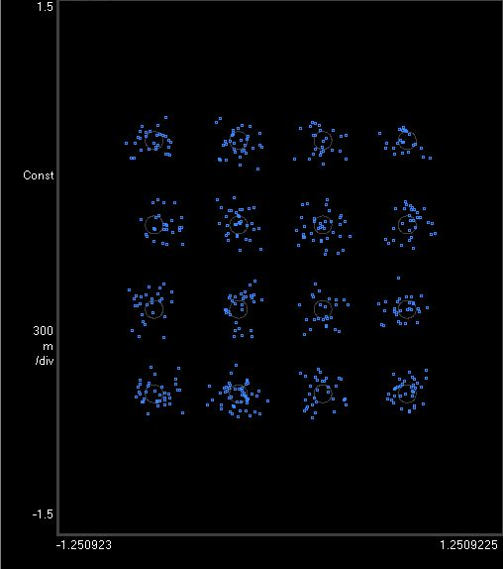
Figure 14 - example of 16QAM constellation diagram [16]

Appendix B contains variations of a QPSK system that the author was unable to simulate successfully due to not understanding the functions in the SIMULINK program.

Conclusion
SIMULINK is an easy way to model systems in order to predict how they will work. From Figure 11, it can be seen that QAM is the worst performer if there is noise on the system. This does not represent the effectiveness of the modulation, which, provided noise is minimised, can have exceptional data rates. For slow data rates ASK and PSK will be useful techniques, although they are slow, they can transmit and receive data even in noisy channels.
In order for an experiment of this kind to be successful, it is essential that the student is aware of how to fully utilise the software. Lack of understanding has led to the assignment not being completed to its full potential.

References

[1] | scienceaid.net, “Radio waves: A history, and communication, amplitude modulation (AM) and frequency modulation (FM),” Scienceaid, 2019. [Online]. Available: https://scienceaid.net/physics/waves/radio.html. [Accessed 23 11 2020].
[2] | S. Abdel-Razeq, A. Al-Azzeh and R. Ayyoub, “Study of QPSK Modulator and Demodulator in wireless communication systems using MATLAB,” Al-Hudson University College, Irbid, 2013.
[3] | W. L. Schweber, Data communicationss, New York: McGraw-Hill, 1988.
[4] | S. Mosey, Digital Modulation - Presentation, Swansea: UWTSD, 2020.
[5] | electronics coach, “Amplitude Shift Keying - ASK,” 2020. [Online]. Available: www.electronicscoach.com/amplitude-shift-keying.html. [Accessed 18 11 2020].
[6] | ElProCus, “Amplitude shift Keying (ASK) Working and applications,” Elporcus, 2020. [Online]. Available: www.elprocus.com/amplitude-shift-keying-ask-working-and -applications/. [Accessed 1 12 2020].
[7] | S. Bharati, M. Rahman and P. Podder, “Implementation of ASK, FSK and PSK with BER vs. SNR comparison over AWGN channel,” Ranada Prasad Shaha University, Narayanganj, U/K.
[8] | electronics coach, “Phase Shift Keying - PSK,” electronicscoach.com, 2020. [Online]. Available: www.electronicscoach.com/phase-shift-keying.html. [Accessed 1 12 2020].
[9] | D. R. Smith, Digital trnsmiaaion systems, New York: Springer, 2004.
[10] | S. S. Haykin and M. Moher, An introduction to analogue and digital communications, Wiley, 2007.
[11] | M. Poovra and M. Shashank, “Implementation of QPSK Modulation on MATLAB Simulation,” International Journal of Engineering and Innovative Technology (IJEIT), vol. 5, no. 8, 2016.
[12] | S. Mario and G. Dolecek, “Design and simulation of QPSK recinfigurable digital reciever,” in 53rd IEEE International Midwest Sympsium on Curcuits and Systems, Seattle, WA, 2010.
[13] | T. Youssef and E. Adbelfattah, “Performance Evaluation of Different QAM Techniques Using Matlab/Simulink,” University of Bridgeport, Bridgeport.
[14] | R. Kamurthi, S. Chopra and A. Gupta, “High order QAM Schemes in 5g UFMC system,” in 2020 International Conference on Emerging Smart Computing and Informatics (ESCI), Pune, India, 2020.
[15] | electronics notes, “What is QAM: quadrature amplitude modulation,” Electronics notes, 2020. [Online]. Available: www.electronics-notes.com/azrticles/radio/modulation/quadrature-amplitude-modulation-what-is-qam-basics.php. [Accessed 6 12 2020].
[16] | “Digital modulation basics, part 2: QAM and EVM,” 5g technology world, 2020. [Online]. Available: https://www.5gtechnologyworld.com/digital-modulation-basics-part-2-qam-and-evm/. [Accessed 17 12 2020].
[17] | I. Wells, Digital communications - Presentation, Swansea: UWTSD, 2020.
[18] | M. Belattar, “Chapter III: Phase Shift Keying modulation and,” February 2018. [Online]. Available: https://www.researchgate.net/publication/322926899_chapter_III_BPSK_and_QPSK_modulation_and_demodulation_with_Simulink. [Accessed 5 12 2020].

Appendix A - Results

ASK

PSK

QPSK

QAM

Appendix B – Alternate for QPSK

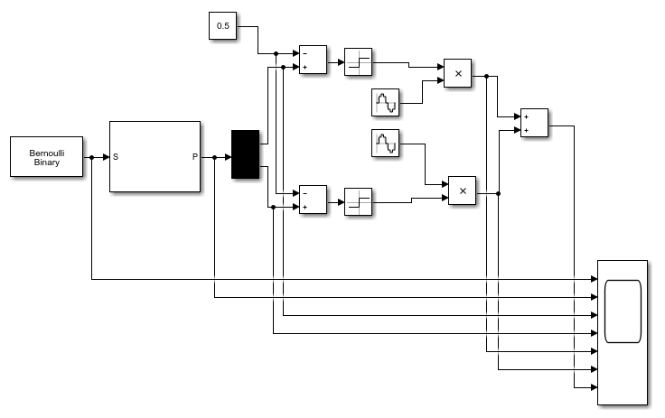
Figure 15 - [2]

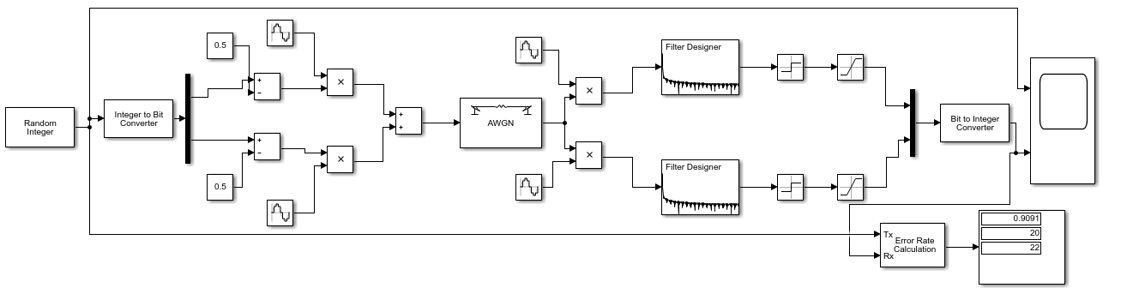
Figure 16 - [17]
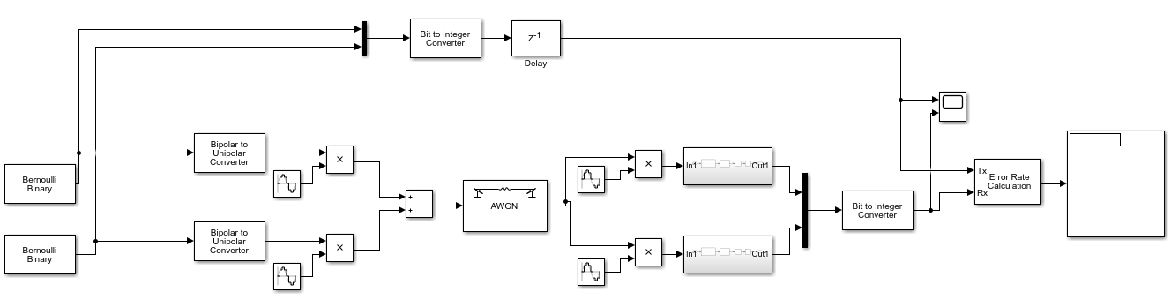
Figure 17 - [18]

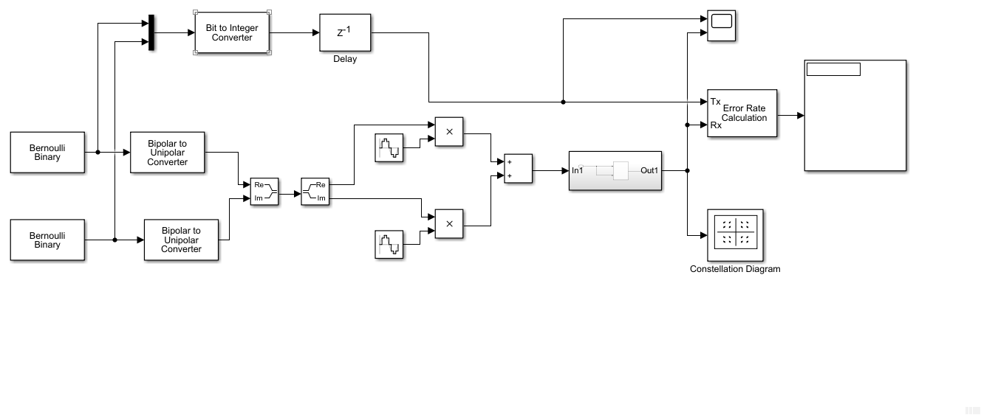
Figure 18 - [18]

