

Student name: Joseph Blackmore (1702858)

Programme: BEng Energy & Environmental Engineering

Module: Advanced Computational Methods

Module Code: M6X01197

Transient Thermal Diffusion Model using the Finite Difference Method

Contents

- Introduction to the problem under consideration
- The constitutive equation of the problem.
- Description of the numerical method chosen to discretise the constitutive equation.
3.1 Limitation of the Explicit Finite Difference Method
- The initial and boundary conditions implemented.
- Finite Difference model (Script)
- Analysis of the code results.
- Conclusion.
- Bibliography

Introduction

In this report Matlab is used as a computational tool to construct a simulation of temperature transfer through a 2 dimensional metal plate. The constitutive equation for the problem will be discussed along with the explicit finite difference method of discretisation of the equation. By using the aforementioned numerical method to write a code using Matlab, the effects of altering key aspects of the code such as the time step will be analysed. By using The prescribed initial and boundary conditions are as follows;
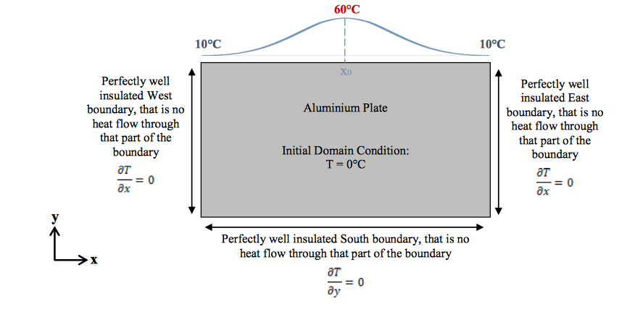

(Figure 1)

The 2 dimensional plate in question is aluminium, hence the properties that need to be considered by the code are as follows;
• Conductivity: k = 143 W/m.C
• Density: ρ = 2.8 × 103 kg/m3
• Specific Heat: c = 795 J/kg.C
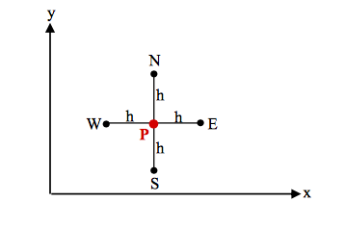
The temperature calculations across the plate are solved using the explicit method. By using a grid arrangement across the plate surface, the temperature at the next node in the simulation will be solved at time intervals according to the users inputs in grid spacing (h) and time step (t).

(Figure 2)

The dimensions of the plate, grid spacing and time step are manually inputted by the user. When inputting these simulation variables the compromise between setting up a more accurate temperature map and the time taken for the code to be completed needs to be considered. A smaller ‘h’ value (grid spacing) and smaller time step will increase the number of calculations that the computer must solve, hence increasing the time needed for the simulation to complete. This problem is exacerbated when the simulation is solving the heat transfer across a large plate.

Constitutive Equation of The Problem

Time dependent conduction in solids is described by the following thermal diffusion equation;

$$\frac{∂^{2}T}{∂x^{2} }+ \frac{∂^{2}T}{∂y^{2}}= \frac{1}{α} X \frac{∂T}{∂t}$$

In 2 dimensions where;
- t = time
- T = temperature
- $α$ = thermal diffusivity

Thermal diffusivity = $\frac{heat conducted}{heat stored }$ = $\frac{k}{ρ.cp}$

Where k= thermal conductivity, $ρ$= material density, cp= specific heat capacity.

This equation will need to be solved by Matlab in order for the propagation of thermal energy through the plate to be simulated. In order for Matlab to be able to solve this differential equation at different points in the grid it needs to be converted into a simple linear equation.

Discretisation of constitutive equation

  - Taylor Series
For this code the Taylor series is used in order to allow the constitutive equation to be solved using the explicit finite difference method.
The Taylor series allows the approximation of an arbitrary function ‘f’ by a polynomial.
To achieve this the assumption is made that the function can not only be evaluated at an arbitrary point ‘x0’, but also at its higher derivatives.

In certain cases a function $f\left(x\right)$ can be rewritten in terms of an infinite sum of other functions such as:

$$f\left(x\right)=f\left(x_{0}\right)+f^{'}\left(x_{0}\right).\frac{{\left(x-x_{0}\right)}^{1}}{1!}+f^{''}\left(x_{0}\right).\frac{{\left(x-x_{0}\right)}^{2}}{2!}+f^{'''}\left(x_{0}\right).\frac{{\left(x-x_{0}\right)}^{3}}{3!}+f^{\left(4\right)}\left(x_{0}\right).\frac{{\left(x-x_{0}\right)}^{4}}{4!}+⋯$$

For the problem dealt with in this report, the function that needs to be discretised is ‘x0+h’ as the function being solved is the next node in the grid space ‘h’ from the central point ‘x0’ in the north, east, west and south positions. This leads to the following;

$$f\left(x0+h\right)=f\left(x_{0}\right)+f^{'}\left(x_{0}\right).\frac{{\left(h\right)}^{1}}{1!}+f^{''}\left(x_{0}\right).\frac{{\left(h\right)}^{2}}{2!}+f^{'''}\left(x_{0}\right).\frac{{\left(h\right)}^{3}}{3!}+f^{\left(4\right)}\left(x_{0}\right).\frac{{\left(h\right)}^{4}}{4!}+…$$

The Taylor series relates the value of a function at a point x₀ to the value of the function at a nearby point (x₀ + h), that is

$$f\left(x_{0}+h\right)=f\left(x_{0}\right)+h.f^{'}\left(x_{0}\right)+\frac{h^{2}}{2!}f^{''}\left(x_{0}\right)+\frac{h^{3}}{3!}f^{\left(3\right)}\left(x_{0}\right)+⋯$$

rearranging the above gets;
As ‘h’ is small, this error term can be ignored. The accuracy of the approximation is dependent on the value of ‘h’ as the smaller the ‘h’ value the smaller the value of the error term.

$$\frac{f\left(x_{0}+h\right)-f\left(x_{0}\right)}{h}=f^{'}\left(x_{0}\right)+\frac{h}{2!}f^{''}\left(x_{0}\right)+\frac{h^{2}}{3!}f^{\left(3\right)}\left(x_{0}\right)+⋯$$

this is used to make the forward difference approximation to $f^{'}\left(x_{0}\right)$ thus

$$f^{'}\left(x_{0}\right)≈\frac{f\left(x_{0}+h\right)-f\left(x_{0}\right)}{h}$$

$$f\left(x_{0}-h\right)=f\left(x_{0}\right)-h.f^{'}\left(x_{0}\right)-\frac{h^{2}}{2!}f^{''}\left(x_{0}\right)-\frac{h^{3}}{3!}f^{\left(3\right)}\left(x_{0}\right)-⋯$$

Rearranging yields

$$\frac{f\left(x_{0}-h\right)-f\left(x_{0}\right)}{h}={-f}^{'}\left(x_{0}\right)-\frac{h}{2!}f^{''}\left(x_{0}\right)-\frac{h^{2}}{3!}f^{\left(3\right)}\left(x_{0}\right)-⋯$$

This can be used to construct the following backward difference approximation;

$$f^{'}\left(x_{0}\right)≈\frac{f\left(x_{0}\right)-f\left(x_{0}-h\right)}{h}$$

Both of these equations are approximations whereby the accuracy improves as the value of ‘h’ gets smaller. By combining both approximations to gain a central difference approximation the accuracy of results can be improved;

$$f\left(x_{0}+h\right)-f\left(x_{0}-h\right) = \left[f\left(x_{0}\right)+h.f^{'}\left(x_{0}\right)+\frac{h^{2}}{2!}f^{''}\left(x_{0}\right)+\frac{h^{3}}{3!}f^{\left(3\right)}\left(x_{0}\right)+⋯\right]$$
$$-\left[f\left(x_{0}\right)-h.f^{'}\left(x_{0}\right)+\frac{h^{2}}{2!}f^{''}\left(x_{0}\right)-\frac{h^{3}}{3!}f^{\left(3\right)}\left(x_{0}\right)+⋯\right]$$

$$=2.\left[h.f^{'}\left(x_{0}\right)+\frac{h^{3}}{3!}f^{\left(3\right)}\left(x_{0}\right)+⋯\right]$$
Therefore;

$$\frac{f\left(x_{0}+h\right)-f\left(x_{0}-h\right)}{2.h}$$

$$=f^{'}\left(x_{0}\right)+\frac{h^{2}}{3!}f^{\left(3\right)}\left(x_{0}\right)+⋯$$

and we can therefore construct the central difference approximation

$$f^{'}\left(x_{0}\right)≈\frac{f\left(x_{0}+h\right)-f\left(x_{0}-h\right)}{2.h}$$

A similar procedure can be followed to derive approximations to higher order derivatives. If we add equation (1) and equation (5) we get

$$f\left(x_{0}+h\right)+f\left(x_{0}-h\right)= \left[f\left(x_{0}\right)+h.f^{'}\left(x_{0}\right)+\frac{h^{2}}{2!}f^{''}\left(x_{0}\right)+\frac{h^{3}}{3!}f^{\left(3\right)}\left(x_{0}\right)+⋯\right]$$

$$+\left[f\left(x_{0}\right)-h.f^{'}\left(x_{0}\right)+\frac{h^{2}}{2!}f^{''}\left(x_{0}\right)-\frac{h^{3}}{3!}f^{\left(3\right)}\left(x_{0}\right)+⋯ \right]$$

$$=2.\left[f\left(x_{0}\right)+\frac{h^{2}}{2!}f^{''}\left(x_{0}\right)+\frac{h^{4}}{4!}f^{(4)}\left(x_{0}\right)+⋯\right]$$

Therefore

$$\frac{f\left(x_{0}+h\right)-2.f\left(x_{0}\right)+f\left(x_{0}-h\right)}{h^{2}}=f^{''}\left(x_{0}\right)+\frac{h^{2}}{12}f^{(4)}\left(x_{0}\right)+⋯$$

This allows the construction of the central difference approximation to the 2nd derivative

$$f^{''}\left(x_{0}\right)≈\frac{f\left(x_{0}+h\right)-2.f\left(x_{0}\right)+f\left(x_{0}-h\right)}{h^{2}}$$

As ‘h’ represents the grid spacing, or the distance between the nodes to put it another way,
The three functions in this approximation represent the central point and two other points spaced away from the central point. The above equation is used to derive the constitutive equation
$$\frac{∂^{2}T}{∂x^{2} }+ \frac{∂^{2}T}{∂y^{2}}= \frac{1}{α} X \frac{∂T}{∂t}$$

In the x-direction
‘$f^{''}\left(x_{0}\right)$’ is replaced by $\frac{∂^{2}T}{∂x^{2} }$
$x_{0}$denotes temperature of the central node, $x_{0}+h$denotes temperature east of the central node, $x_{0}-h$ denotes temperature west of the central node.

Therefore we get; $$\frac{∂^{2}Tp}{∂x^{2} }≈\frac{Te-2Tp+Tw}{h^{2}}$$

In the y-direction
‘$f^{''}\left(x_{0}\right)$’ is replaced by $\frac{∂^{2}T}{∂y^{2} }$
$x_{0}$denotes the temperature of the central node, $x_{0}+h$denotes temperature north of the central node, $x_{0}-h$ denotes temperature south of the central node.

Therefore we get;
$$\frac{∂^{2}Tp}{∂y^{2} }≈\frac{Tn-2Tp+Ts}{h^{2}}$$
also

$\frac{∂Tp}{∂t}$ $≈ \frac{T^{'}p-Tp}{∆t}$

When put together into the constitutive equation, the following equation describes the propagation of temperature through the plate;

$$\frac{Te-2Tp+Tw}{h^{2}}+ \frac{Tn-2Tp+Ts}{h^{2}} = \frac{1}{α} X \frac{T^{'}p-Tp}{∆t}$$

The Boundary conditions of the plate are known, however the equation needs to be able to calculate what happens through the plate in the future according to the time step input. This leads to the following equation;

$$\frac{T_{e}^{t}-2T_{p}^{t}+T_{w}^{t}}{h^{2}}+ \frac{T_{n}^{t}-2T_{p}^{t}+T_{s}^{t} }{h^{2}} = \frac{1}{α} X \frac{{Tp}^{t+∆t}p-Tp}{∆t}$$

Rearranged gives;

$${Tp}^{t+∆t}=\frac{α∆t}{h^{2} } (T_{e}^{t}+T_{w}^{t}+T_{n}^{t}+T_{s}^{t}+(\frac{h^{2}}{α∆t}-4) T_{p}^{t}$$

Where
$\frac{α∆t}{h^{2} }$ = the dimensionless value known as the Fouriers number or ‘Fo’.

Finally this gives the following equation;

$${Tp}^{t+∆t}=Fo (T_{e}^{t}+T_{w}^{t}+T_{n}^{t}+T_{s}^{t}+( \frac{1}{Fo}-4 ) T_{p}^{t}$$

This equation was derived using forward difference approximation in order gain the final explicit final difference approximation. By using the explicit finite difference method the unknown in question is explicitly solved using the known values at the previous time step. If the backwards difference approximation was used for this equation there would only be one known value instead of 5. (Lewis, et al., 1996)

Limitation of the Explicit Finite Difference Model

A disadvantage of the explicit finite difference model used above is that once $α$ and h are fixed, there is a maximum permissible time-step size $∆t$ which should not exceed the value imposed by the following stability criteria;

$$0<F_{0}≤\frac{1}{4}$$
Therefore,
$$0<F_{0}≤\frac{α∆t}{h^{2} }$$

This means that the time step chosen by the user of the code needs to meet the following criteria;

$$0<∆t≤\frac{h^2}{4α}$$

As Fouriers number is equivalent to $\frac{α∆t}{h^{2} }$ this limits the size of the permissible time step that can be inputted by the user of the code. Inputting a time step value that leads to the stability criteria being broken will not produce steady results. The main disadvantage of this aspect is found when trying to use this equation to solve the temperature propagation across a particularly large plate. Because the stability criteria cannot be broken, this forces the user of the code to input a relatively small time step, this leads to huge amounts of calculations growing exponentially as the size of the plate being simulated increases. This will lead to the simulation taking a lot of time to run without the user of the code having the ability to alter the setup in order to gain results more quickly.

Initial and Boundary conditions

For this simulation the west, east and south boundaries are taken as perfectly insulated. The Northern boundary condition is set to be a gaussian distribution of temperature of amplitude 50 degrees centigrade, with the peak temperature located directly at the centre of the northern boundary. In thermodynamics Dirichlet boundary conditions are described as surfaces (in 3D) or sides (in 2D) that are held at fixed temperatures. The boundary conditions of the plate being simulated in this report can be described as Dirichlet boundary conditions as they are kept constant throughout the simulation. (Cheng & Cheng, 2005).
There is no heat transfer (flux) through any of the boundary conditions other than the north boundary of the plate. The initial condition of the domain is set at 0 degrees centigrade, the code will plot the change in temperature through the domain with respect to time until thermal equilibrium is reached. In order for the Gaussian distribution to be plotted in the script the standard deviation must be calculated. The standard deviation is simply the square root of the variance or the average of the squared differences from the mean to put it in other terms.

Finite Difference Model (script)

clc
clear
close all
x= input(' what is x dimension of plate in metres?: ');
y= input(' what is y dimension of plate in metres?: ');
h= input(' enter grid spacing in metres, must be divisible by x and y values: ');

tstep=input ( 'enter time step in seconds; ');
The first part of the code initiates the user to input the dimensions of the plate, the chosen grid spacing and time step. The code instructs the user to choose a value for the grid spacing that is divisible by the x and y values so that a matrix can be produced.

p=2800;
c=795;
k=143;
alpha=k/(p*c); %thermal diffusivity
disp(alpha)
At this section of the script the properties of aluminium and their relationship to the Fouriers value are established along with the highest temperature and lowest temperatures of the Gaussian distribution. The while loop below these statements issues a conditional statement regarding the stability criteria. If the criteria is not met the code will issue a command to the user to adjust their grid spacing and time step values. Following on from this the script issues a conditional statement that, if the domain size and grid spacing values are not divisible, the user must input a different grid spacing value.
(Kwon & Bang, 2000)
fo= (alpha*tstep)/(h^2) ; %fourier number
tstep=fo*(h^2)/alpha ;
%f=alpha*deltat/h^2

t1=10 ; %first temp/last temp
t2=60 ; %highest temp

while fo>(1/4)||fo<0
'*stability not met. change values*';
h= input('change grid spacing (m) = ');
tstep= input('change time step (s) = ');
end

a=x/h+1; %columns
b=y/h+1; %rows

check_x=a == round(a); %make sure number is whole
check_y=b == round(b); %make sure the number is whole

if check_x==0 || check_y==0
'grid spacing is incorrect. implement different variables';
clear zeros
h= input('change grid spacing (M) = ');
a=x/h+1;
b=y/h+1;
end

In the next part of the script the standard deviation is calculated, followed by the equation for the temperature variation across the top boundary layer of the plate.

T=zeros(b,a);

x0=((a+1)/2); %finds midpoint
sd=sqrt((-(a-x0)^2)/(2*(log(t1/t2)))); %standard deviation

error=1 ;
while error<=a %makes all values
T(1,error)= (t2*exp(-((error-x0)^2)/(2*(sd^2)))); %equation for matrix

error=error+1;

end

tol=0.00001;
Here the explicit finite difference method is used to approximate the temperature transfer through the domain. In the initial while loop the node positions (south, east, north west and central) are denoted by the corresponding column and row position stated in the brackets. For the first column, there are no nodes to the west of the central node and the temperature propagation only needs to be calculated south of the gaussian boundary and for the last column of the matrix there are no nodes to the east. At the bottom row there are no nodes to be calculated to the south as this is the bottom boundary of the plate. In the left hand side corner of the bottom row there are no nodes to the west and for the right hand side corner there are no nodes to the east.
error=1;
n=0;
drawcount=0;

while error>tol
n=n+1;
Told=T;
% internal
for i=2:b-1
for j=2:a-1
T(i,j)=fo * (Told(i,j-1) +Told(i-1,j) +Told(i+1,j) +Told(i,j+1)-(4-1/fo)*Told(i,j));
end
end

for i=2:b-1 %first column
T(i,1)=fo * (Told(i,1+1) +Told(i-1,1) +Told(i+1,1) +Told(i,1+1)-(4-1/fo)*Told(i,1));
end
for i=2:b-1 %last column

T(i,a)=fo * (Told(i,a-1) +Told(i-1,a) +Told(i+1,a) +Told(i,a-1)-(4-1/fo)*Told(i,a));

End

for j=2:a-1 %bottom row

T(end,j)=fo * (Told(end,j-1) +Told(end-1,j) +Told(end-1,j) +Told(end,j+1)-(4-1/fo)*Told(end,j));
end

T(b,1)=fo * (Told(b,1+1) +Told(b-1,1) +Told(b-1,1) +Told(b,1+1)-(4-1/fo)*Told(b,1));

T(b,a)=fo * (Told(b,a-1) +Told(b-1,a) +Told(b-1,a) +Told(b,a-1)-(4-1/fo)*Told(b,1));

Within the nested ‘for loop’ the script instructs Matlab to plot the propagation of temperature through the matrix for every 30 iterations. ‘drawnow limitrate’ limits the live graphical updates to the solution to 20 frames per second in order to reduce the amount of time that the animation will take.
error=max(max(abs(Told-T)));
drawcount=drawcount+1;
if drawcount==30
contourf(T)
view(180,90)
drawnow limitrate

drawcount=0;

end
end

Analysis of code Results

Depending on the time step and grid spacing values inputted by the user of the code, the accuracy of the heat distribution plotted in the graph and the time taken for the code to run through to thermal equilibrium will vary. By using the run and time function in Matlab, the time taken for the code to be completed and the exact areas where the time was spent by the computer to run the code can be displayed.

For each of the simulations the plate was taken to be 1m by 1m in size. The effects of altering the grid spacing and time step values on the results gained by the code are discussed below;

Grid spacing= 0.5m Time taken to complete= 13 seconds
Time step = 10 seconds

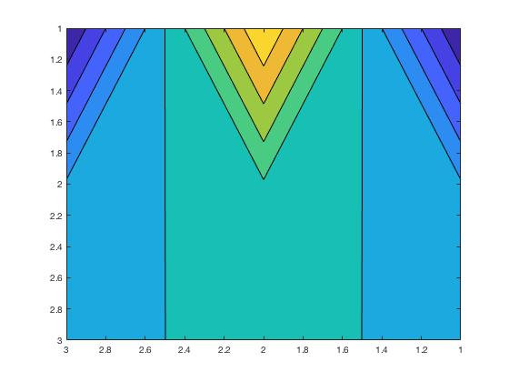
As can be observed in the image below, by inputting a grid spacing that is too large, the code cannot accurately represent the heat transfer across the plate. In order to achieve an accurate visual representation of the heat transfer across the plate at thermal equilibrium, a smaller grid spacing is required in order to allow the code to calculate the temperature at more points within the plate.

The effects of reducing the grid spacing on the code results and time taken are as follows;

Grid spacing= 0.1m
Time step= 10 seconds
Time taken= 14 seconds
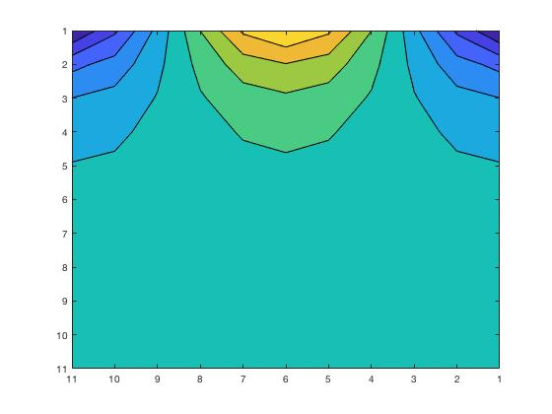

Grid spacing= 0.1m
Time step= 1 second
Time Taken= 41 seconds

By reducing the time step by a factor of 10, the code took roughly 4 times as long to complete as the heat propagation is displayed at more time intervals as the graph updates live in the programme. As the grid spacing was not altered however, the graph displayed at the end of the simulation is the same as the previous run.
It is not possible to reduce the grid spacing significantly in order to gain a more accurate graphical representation whilst maintaining the same value for time step as this would break the stability criteria relating to the value of Fouriers number. In order to gain results for a smaller grid spacing the time step must also be reduced leading to exponentially longer calculation times. For example, a grid spacing of 0.01m cannot be used with a time step of 10 seconds as this breaks the stability criteria.

Grid spacing= 0.01m
Time step= 0.1 seconds
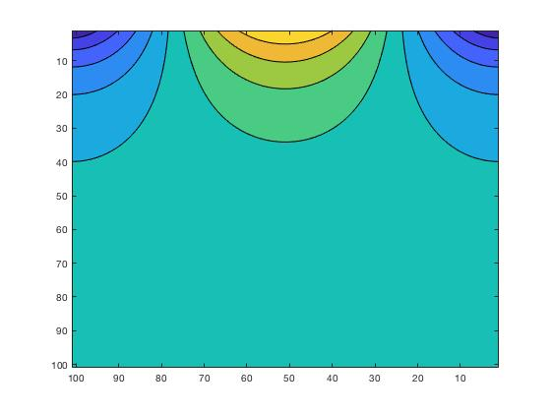
Time taken= 1043 seconds

By decreasing the grid spacing by a factor of 10, the contours on the graph were far more defined leading to a more accurate visual representation of the temperature throughout the plate. By choosing a grid spacing of 0.01 however, the value of the time step could not be chosen to be a larger value in order to reduce the time taken for the solution to reach equilibrium. This led to the time taken for the solution to reach equilibrium being much longer at 1043 seconds.

Conclusion
In order for this model to accurately simulate the propagation of temperature across a large metal plate, a lot of time will be needed in order for the code to run to completion. This limits the practicality of using the explicit finite difference method in order to calculate the temperature propagation in certain circumstances. This specific code is only applicable for calculating the propagation of temperature for the given material (aluminium) and the gaussian distribution of temperature given. By using this code the user is able to gain a graphical representation of how the heat applied to the plate will propagate through it.

Bibliography
Cheng, A. & Cheng, D. T., 2005. Heritage and early history of the boundary element method, Engineering Analysis with Boundary Elements. Engineering Analysis With Boundary Elements , Volume 29, pp. 268-302 .
Kwon, Y. W. & Bang, H., 2000. Introduction to Matlab . In: The Finite Element Method Using Matlab. s.l.:CRC Press, pp. 1-24.
Lewis, R., Morgan, K., Thomas, H. & Seetharamu, K., 1996. The finite element method in heat transfer analysis. s.l.:John Wiley & Sons.
MathWorks, n.d. MATLAB Answers. [Online]
Available at: https://uk.mathworks.com/matlabcentral/answers/index/?s_tid=gn_mlc_an
[Accessed 2020].

