
Sports Industry Research
Project Report M6X02100
Assignment 2

Student Name
Ben Cheley
P1600382

Project Title

Trends and barriers in sports participation for middle aged adults

Sport industry research project
Sport and outdoor education
Sports management course

Acknowledgements
Throughout this course including the writing of this dissertation, I have received a large amount of support from my lecturers within the university and all other university support provided. I would like to thank my dissertation supervisor Matthew James and the programme director Andrew Thomas who knowledge in the subject was invaluable and support helped me craft this research project to the best of my ability.

I would also like to thank my family for providing additional support throughout my course and the duration of this research project as their insight has helped guide me through this dissertation and other projects. My friends also played a vital role in assisting me during my time at the university their prior knowledge and experiences with their own courses helped guide me throughout the 3 years of my study.

Another important acknowledgment goes to my tutors Mark Napieralla, James Prosser, Marie Pitson and John Schropfer, Who have also provided a huge amount of support during all 3 years of my course. The resources and guidance they have provided has developed my writing skills and educated me in sports and also other key skills that I can use in the future.

Abstract
Sport has always been known to have its many benefits, these benefits range from both physical to mental health benefits and can vary dependant on the individual (F, Coalter, 2005). This project will decipher the issues middle aged adults have that prevent them from participating in sport. Sport Wales (2019) and other national bodies report every year their sports participation surveys which show that as age increases, the amount of adults regularly participating in sport decreases.
The UK Government implemented a 24 hour curfew in March 2020 due to the global outbreak of COVID-19 (Coronavirus). UWTSD took steps to support students remotely with continued online supervision. However, many National Governing Bodies (NGB's), Sports Teams and Schools closed during this period which meant that data collection became more challenging.
This paper aims not only to discover the barriers of sports participation but also wishes to provide key recommendations on how to break down these barriers. Numerous studies have found different barriers ranging from time constraints to more personal barriers such as age and current fitness level. The evaluation between the primary and secondary research found that there are many different barriers for each individual adult and recommendations need to be applied differently under their own circumstances. These recommendations range from age specific classes to increase confidence in each participant and draw more people of that age group. Another recommendation based around time constraints were to exercise at the same time as their children if they were a parent another great way to make time is to exercise just before or after work and working out from home.

Contents Page (use relevant number of pages)
List of figures and illustration......................................................................................4
Introduction....................................................................................................................6
- Rationale.....................................................................................................................6
- Background................................................................................................................6
- Aims and objectives..................................................................................................7
- Study analysis............................................................................................................8
Literature review........................................................................................................10
- Introduction..............................................................................................................10
- Sports participation rates within the United Kingdom........................................10
- Adult sports participation trends...........................................................................12
- Impacts of sports participation..............................................................................13
- Ageing and its impact in sports participation......................................................15
- Coaching principles in adults................................................................................16
- Trends associated with sports participation.......................................................17
- Theoretical models for sports participation........................................................17
- Understanding participation in sport and physical activity among children and adults.......................................................................................................................18
- Literature conclusion.............................................................................................19
Methodology.................................................................................................................21
Findings........................................................................................................................26
- Barriers found within sports participation..........................................................26
- Regularity of exercise............................................................................................26
- Motivating factors for sports participation........................................................28
- Benefits of sports participation...........................................................................29
- Sports popularity for middle aged adults...........................................................30
Conclusion...................................................................................................................31
- Introduction...........................................................................................................31
- Literature comparison..........................................................................................31
- Solutions for middle aged adults........................................................................34
- Recommendations’ for 3rd party organisations.................................................34
- Reflection..............................................................................................................35

Reference list...............................................................................................................37
Bibliography................................................................................................................42
Appendices..................................................................................................................43
Ethics form..................................................................................................................55

List of Figures or illustrations
Figure 1- Frequency of participation graph.................................................................5,33
Figure 2- Table of adult sports participation....................................................................9
Figure 3- Adult sport motivating factors.........................................................................10
Primary research survey
Figure 4- Area chart showing age range of the study....................................................25
Figure 5- Gender ratio pie chart
Figure 6- Regularity of exercise pie chart......................................................................25
Figure 7- Table of regularity of exercise for each participant.........................................26
Figure 8- Table of how often participants would ideally like to participate in physical activity............................................................................................................................26
Figure 9- Motivating factors of sports participation graph..............................................27
Figure 10- Barriers preventing exercise agreement pie chart........................................26
Figure 11- Doughnut chart showing which barriers are most prominent in sports participation..........................................................................................................25,28,31
Figure 12- Sporting opportunities bar graph..................................................................29
Figure 13- Pie chart representing agreement for lack of opportunities for adults sports participation....................................................................................................................33
Figure 14- Pie chart showing the results of mature sports club preferences.
Figure 15- Ideal cost of sport pie chart..........................................................................32
Figure 16- Adult sporting preference with children results.............................................28
Figure 17- Opportunities for sport doughnut chart.........................................................26
Figure 18- Government resources pie chart results......................................................27
Figure 19- Benefits of sports participation bar graph.....................................................29
Figure 20- Sports participation survey questions

Main body – Introduction (use relevant number of pages)
Key findings from national sporting bodies such as Sports Wales and Sport England’s annual sports participation survey show trends that sport participation end to be lower among older people and higher among younger people. In light of this, this research project will be focussing on the trends and barriers in sports participation for middle aged adults.

Rationale
The idea of this project came from a growing trend of older adults beginning to participate in the local lifesaving club. With equal opportunities within the club being recently established with ore pool time for adults and a family membership being implemented, it was curious to see such a recent change in participation within the age group.

The Collins dictionary defines middle aged as people between the ages of 40-60 years old. By studying this age group and ages close to either side of the target age it may help answer the question of identifying key barriers holding back middle aged adults from sport.

Background
Sport’s Wales publish yearly reports giving the sports participation rates across the nation split by the age and gender. Figure 1 Shows a frequency of participation table by age and gender from the 2019 Sport Wales ‘State of the Nation Report’. This table clearly show the older adults get, the less regularly they participate in sport. The amount of people participating in sport 3 times a week decreased from 40% for 35-44 year olds to 28% for 55-64 year olds. If these participation rates stay low like this, future generations may be affected and people will start become physically inactive at younger ages as these middle aged adults won’t be setting the best example. Reasoning behind this lack in sports participation changes as adults age however in this sports Wales survey all age groups answering the survey said that work is one of the key reasons why they don’t have time for sport.

Sports trends can be great turnstones in within sports participation to help boost fitness levels within the general public. The Guardian (2012) reported that Sport England found an extra 750,000 more people taking part in sport after the London 2012 Olympic Games. Huge sporting events like these can lead to increases in sports participation across all age groups. Whilst this is a great way to boost participation levels these rates drop after a length of time the sports participation levels drop back down again. If more emphasis was put into the retention of sport after major events maybe these participation rates would keep at a steady growth.

Aim and objectives
The aim and objectives of this study need to be clear and concise to help keep the focus of the study narrowed.
The aim of this study is a ‘Critical evaluation of the barriers affecting middle aged adults from regularly participating in sport’.
The objectives of the study are;
- Decipher the key barriers holding back middle aged adults from regularly participating in sport.
- Establish what the motivating factors are for active middle aged adults and how these can translate over to all middle age adults to increase overall sports participation.
- Develop recommendations for both the adults and sporting companies to help increase the sports participation in this age group.
Study analysis
Many different studies have been taken place over the years which analyse sports participation and how it affects each individual respectively. Articles like the Participation in Organized Sports and Self-Organized Physical Activity: Associations with Developmental Factors (Wiium, N, 2019) and the Participation, engagement and intensity of sports participants study (Buraimo, B, 2010) show benefits associated with sport and how the engagement of sport can lead to healthier lives. These articles are great evidence to educate people on the importance of sport however studies like these don’t analyse the issues behind the lack of sports participation. This study will not only evaluate the barriers behind participation in sport but will also discover the key motivating factors behind sports participation for those who regularly participate.

There are a plethora of already existing studies based around youth sports participation as schools implement healthy living and sports strategies such as Sport England’s ‘Activity Action Plan’ (Sport England, 2020) which aims to give children more opportunities to access their hour of daily sport and physical activity. These studies are great ways to implement change in the sports sector for this young age group as school is compulsory for the younger generation. This could be a reason for the lack of implementations put into place for older adults without a trending or compulsory activity that vast majorities of adults do, it is harder to reach and affect the same number of people than school programmes will.

Jenkin, C has been a part in various studies based with sports participation from ‘Sport for Adults Aged 50+ Years: Participation Benefits and Barriers’ (2018) to ‘Sport and ageing: a systematic review of the determinants and trends of participation in sport for older adults’ (2017). These studies both had similar objectives in identifying the primary benefits of sport for adults and the key barriers holding them back at the time. With only a year apart from these studies there were slightly different results. The earlier study identified the differing needs of each individual adult however poor current health was the most popular response given in this study as a barrier to sport. The 2018 study found alongside physical health again, time constraints were a major barrier to sports participation. The variation of these results identifies the need for this study to identify root causes and barriers. If well thought out recommendations can be implemented these ever changing responses can be met with more flexible answers to the issue linked with middle age sports participation.

Main body - Literature Review (use relevant number of pages)
Introduction
With growing evidence (Figure 2.) from our national sporting bodies showing a lower level of sports participation dependant on age, a clear study and review needs to be developed to look at the barriers affecting middle aged adults from participating in sport. According to Sport Wales (2018), Wales has an ageing population, more emphasis should be directed towards ageing adults and their health and well-being so as a nation, we can improve our wealth and prosperity in accordance with ‘The Wales we want 2050’.
The aims and objectives for this research project establish strong bonds together that will allow for a natural flow of discovery to take place through this study. Each paper reviewed can provide solid evidence either in participation statistics or second hand data collection, the papers that provide the statistics will be backed up with the questionnaires and surveys already conducted which provides the strong factors behind motivation behind physical activity or it will discover the barriers preventing it.
To clarify the study and target ‘Middle aged people’ various sources such as Britannica (2019) define middle aged as the period of an adults life that precedes the onset of old age. Middle aged is generally defined by a person being between 40 to 60 years old.

Sports participation rates within the United Kingdom
Lukas Audickas developed the audit ‘Sports participation in England’ in 2017 to look at participation rates based on intensity, type and socio-economic characteristics.
Age was among these different categories and the statistics showed that as age increased the percentage of people ‘active’ (150 minutes of exercise per week) slowly decreases from 65% between 35-44 to 58% between 55 and 64 years old.
This study interestingly showed the amount of people fairly active (30-149 minutes of exercise) stays relatively constant at 15% in the target age group.
Sports Wales published their ‘Adults (35-64) participation in sport in Wales’ in 2018 to get more accurate figures sports participation around the country and the factors that affect adults from regular sports participation.
Figure 3. contains a table showing the percentage of adults participating in sport from once a week to regular activity (three times a week or more). The results show that in all categories as age increases the percentage of people whom participate in sport, whether it is frequently or infrequently decreases and the percentage of adults who are inactive increases.
When researching the factors as to why adults are not staying active surveys were published asking what would allow people to participate in sport. Figure 3. shows a table of the factors that would allow adults to participate further in sport and the key findings showed that all age categories answered along the lines of fewer family commitments, fewer work commitments and their level of fitness.
The study showed that “disability, illness and injuries is more prevalent, as a reason, for those ages 55-64” whereas “cost and a lack of facilities or clubs appears to be more of an issue for those ages 35-44” (Sport Wales, 2018).
In early 2016, Sport Ireland developed their first ever ‘National Physical Activity Plan’ the underlying purpose of this plan was to discover the national sports participation rates and to increase the overall participation in sport.
A key target in this plan was to discover why adults had lower sports participation and to increase it from 43% to 50% around the country.
The study showed that the majority of adults were not participating in sport due to childcare duties or an increase in work hours.
Results found a strong correlation between adults that have children in sports clubs having a higher likelihood of sports participation. Club membership was another big aspect in increasing participation as linked membership between a child and the parents led to further sports participation (Sport Ireland, 2016).

In conclusion, sports participation around the United Kingdom decreases with age, the reviews published by Sport Wales, Sport England and Sport Ireland show lower levels of participation in adults as they age further with the key barriers being a lack of time to exercise and the cost to keep fit.

Adults sports participation trends
Stamatakis and Chaudhury (2008) investigated temporal trends for adult sports participation between 1997 and 2006 to evaluate sports promotion for adults and to identify population subgroups in need of tailored interventions to boost sports participation.
Interesting results found from this investigation showed a slight increase in overall middle age sports participation however, studies showed younger adult males were following a trend in decreased physical activity potentially leading to an overall drop in physical activity toward the future as these younger males age further.

Impacts of sports participation
Leisure activities and sports participation are both key factors in healthy adults’ lives (Sport Wales 2018). Research was conducted to find whether or not sports participation improved overall quality of life in adults who regularly participate in any form of sport rather than adults who do not.
From the survey conducted, results showed the adult persons that perform sports activities in a consistent and systematic way, have a better quality of life index compared to those who do not perform these types of activities (Georgian BĂDICU, 2017).
Results from this survey highlight key benefits for ageing adults to participate in sports the study provided solid evidence that the benefits to sport are not only physical benefits but also mental benefits to health and overall life quality.

L. Ramey (2016) discovered numerous determinants to boost adult sport participation however, psychological engagement has been identified as a critical factor in the potential benefits of emerging adults in leisure sports. Psychological studies were formed to see how psychological engagement relates to leisure sports.
The study a showed that positive psychological engagement significantly produced a desire to learn and exercise skills and abilities and favourable attitude to sports participation (Heather L. Ramey, 2016).

Master athletes can have positive and negative family influences in regards to sports participation. One of the biggest supporters of master athlete’s participation was simply their family allowing them to partake in the sport (R. Dionigi, 2012).
Another large contributor to participation was spouses training or partaking in the sport with them. It was found that when partners started training in sport together their consistency increased and their willingness to train increased (R. Dionigi, 2012).

During 2018 a study was created reviewing barriers in sport for adults aged 50 and over. Jenkin (2018) discovered that despite the health benefits of sport, the proportion of people participating in sport decreases with age.
This qualitative study focussed on investigating primary benefits of regular sports participation and they key barriers holding ageing adults back.
Primary evidence discovered showed that regular sports participation led to intergenerational opportunities, physical and mental health benefits, and social benefits.
The study also found key barriers holding ageing adults back to be; time constraint, physical health itself and appropriate playing opportunities.
This study along with others show the importance of adult sport participation however, lack of opportunities to engage in sports holds back ageing adults from receiving these major benefits (Jenkin, 2018).

Ageing and its impact in sport participation
In 2015, BioMed Central (BMC) public health set out to review the determinants and trends in sport for older adults. Two parallel studies were co-ordinated in nine different databases searching for specific studies that provided precise results for community dwelling older adults. When linking in the two questions the studies were narrowed down to eighteen and eight different studies. The most common results found in this paper identified health and using sport to negotiate the ageing process (Jenkin, 2017).
Additionally to this these studies also showed that poor health became a barrier for older adults which prevented them from partaking in sports.
In conclusion this, the article showed the differing needs of each individual adult and the need for specific strategies are required “to develop age appropriate sporting opportunities for older adults, so that sport can be presented as a viable physical activity option for this age group” (Jenkin 2017).

Expectations regarding age (ERA) are defined by “the beliefs that the persons have related to how well they will maintain their physical and cognitive health as they age” (Amber S. Watts, 2017).
Studies in 2017 were taken place to identify if there was a relationship between ageing expectations and physical activity among older adults. M. Andrews (2017) collected results from questionnaires and surveys to discover the effect ageing expectations have on people’s health and sports participation.
What was found showed that with low numbers of adults keeping active, poor ageing expectations can contribute to the lack of activity. Results in this study showed a significant link between lower ageing expectations and lack of physical activity. Poor ageing expectation can be seen as a barrier towards physical activity and if factors are identified to improve ageing expectations it could increase physical activity levels in our ageing society.
Coaching principles in adults
Teaching students academically in school and coaching athletes in specified sports take completely different approaches. The same could be said in regards to training master athletes or ageing adults. Older athletes can learn in different ways and have preferred methods towards coaching for example adults’ preferences for coaching approaches align with key learning principles of the andragogy in practice model (APM) (Knowles, Holton, & Swanson, 2012).
Studies were taken to identify how each of the six andragogical principle’s affect master athletes and ageing adults in comparison to younger athletes. It was found that “while affording both groups some degree of self-direction, she was more allowing of the masters group to choose their learning paths” (MacLellan/Callary/Young, 2019)
If this is the case more specialised training should be applied to coaches teaching older athletes to improve on their learning needs to keep them involved in sport.

Trends associated with sports participation
Over the past decade video games have materialized into a key social aspect of life. Studies were taken to look at the positive outcomes to playing video games and if sports video games are linked towards a boost in sports participation in that particular sport.
Gaming is often characterised in the news as a predictor of physical inactivity and obesity however active video games from consoles such as the Wii have been found positively influencing physical activity from young children all the way up to ageing adults (Adachi, 2016).
However, some problems were also created if people participated in playing non-active video games such as Massive Multiplayer Online (MMO) games they had negative correlation to physical activity.
This study shows how video games can promote physical activity however there is a thin line between playing for health benefits and playing for leisure and it can easily cause adverse effects at the same time (Paul Adachi, 2016).

Theoretical models for sports participation
S. Grima (2017), set out to review all the theoretical models based around sports participation in the present day in order to determine the relevance of these models and see if the same trends still emerge. Among Green’s (2005) sports development model, “The SLOTH framework” was reviewed which investigates a link between economic factors which could affect sports participation. The model suggests that the greater your wealth, the greater you care about your health and physical activity.
Similarly an interesting study, from S. Grima (2017), ‘Access to different sports’ generated interesting feedback as older people tended to participate more in walking, running and cycling whilst it was evident there were much more opportunities arising for more rigorous sports like football and rugby. However adults were less likely to participate in these rigorous sports in fear of injury and there were less opportunities to join running or cycling clubs due to these not being ‘team sports’. This lack of opportunity could be a big determining factor of these lower levels of sports participation.

A multilevel investigation of individual and systemic influences on adult sport participation using stages from Green’s (2005) sport development theoretical model aimed to discover the numerous factors affecting adult sports participation levels.
Using online focus groups asking open ended questions, it was discovered that the benefits of adult sports participation had improved over time. However, this study found overall delivery and accessibility for all should be focused on to improve the social aspect of adult sports participation.
Understanding participation in sport and physical activity among children and adults
Steven Allender’s (2006) review of participation in sport among all ages systematically examines previously published papers based upon participation rates in sport, to determine their experience in sports and the factors that hold them back from physical activity. This paper took an approach to split this review into age categories from ‘Young children’ to ‘Older adults’ to systematically generate more accurate results for barriers holding these ages back.
This review discovered older adults tend to enjoy the social aspect of sport participation and the benefits of being able to be physically active with their families. This study also discovers that these ageing adults were unsure about how much physical activity they should partake in due to their age. It was also shown that cost and time were some of the biggest barriers for them.

Literature conclusion
Due to the strong coherent links between the aims and objectives, evidence to support the research behind this project was easy to find. From this review there are numerous points to establish barriers to sports participation among middle aged adults and their current lack of participation in sport.
The numerous papers such as Allender’s (2006) and Green’s (2005) model provide supporting evidence that different theories and studies provide differing results in reasoning behind sports participation. It is clearly shown that participation rates fluctuate over the years with Sports Wales (2018) and Sports England (2017) both giving varied rates of participation over the years. As these studies quantify evidence adversely at different times it could be plausible to say that the factors motivating people to participate in sport have changed over the years.
When dealing with the barriers behind sports participation a considerable amount of similar evidence was provided over the multiple studies looked at in this project. Data collected from Sports Wales (2018) and M. Andrews (2017) show that major barriers preventing sports participation is linked to time constraints such as family and work commitments.
Another major barrier discovered was ageing expectation, which links well with people already feeling too unfit to workout. M. Andrews (2017) study showed that people who already were not taking care of themselves were less physically active and on the other side of the spectrum people who were already unfit didn’t feel like they were fit enough to partake in physical activity.
From this study going forward it seems pretty clear that rather than breaking down barriers, extra motivating factors need to be put in place to encourage physical activity among all ages. People need to be aware that being unfit, should motivate them to become healthier and not hold them back from an enjoyable healthy lifestyle according to G. Badicu (2017), increased physical activity is linked to a better and longer life which can encourage people around them to follow their path. By people viewing exercise in a more positive or important light it will encourage more people to exercise.

Main body – Methodology (use relevant number of pages)
Obtaining viable accurate data can be achieved in many ways. Different research methods are used for each appropriate study. Kothari (2004) defines the objectives of research “to discover answers to questions through the application of scientific procedures”. With this in mind there are 2 main approaches to take with research and data collection, these approaches are more commonly known as qualitative and quantitative data collection. Various studies can use a mixed methods approach if their information can be translated effectively from both methods.

Quantitative data as suggested is measured by a quantity and aims to quantify data and generalise results based on a proportion of people (Macdonald & Headlam, 2011). This method is a more structured approach using fixed numbers and data to get solid and clear evidence. Qualitative data on the other hand focuses on the quality of the data received to understand reasons and motivations in the study. Qualitative data tends to have fewer participants and numbers but greater detail in the answers to provide deeper understanding (Macdonald & Headlam, 2011).

To develop a thorough understanding in this project a quantitative research approach will be best suited, as high numbered responses will provide the information desired to understand middle aged sports participation and the correct recommendations to improve the rate of participation.

To increase the effectiveness of this research the understanding of research approaches, ontology and epistemology is needed as these topics need fluidity and understanding between them to create a valid project. The links between these topics are crucial, Hennik, Hutter and Bailey (2011) explain how data analysis and data interpretation is best informed by, the ontological and epistemological assumptions and arguments you are making as each person tends to have one specific view. This project using quantitative research will be taking an experimental approach, creating surveys and getting specific responses in quantitative amounts takes an etic approach to research. An etic approach is an epistemological method which takes an outside perspective to find the truth like using survey and questionnaires to receive information.
All of this research is then derived from a realist perspective of ontology. Richards (2003) believed ontology is our perception of reality and how we define it, whether there is one truth to an experiment or if multiple realities can exist. Realist perspectives believe all research of a topic will lead to one truth and using answers provided from this research it can show how sports participation changes with age and what needs to be done to improve their situation.

From these ontological and epistemological views come a varied range of positions. These positions are different from the perspectives as they vary based on how the researcher views the world and how they conduct research. These positions include; Positivism, Objectivism, Interpretivism and constructivism (Al-Saadi, 2014). Ontological positions which are Positivism and Objectivism have varied views; Paley (2012) explains how positivism links all knowledge through experience, how we perceive things and focuses on the objectivity in searching for the truth and how the researcher is affected by doing so. Objectivism on the other hand thinks and believes knowledge is subjective and scientific justification is not a concrete representation of the natural world.

Interpretivism and constructivism, both epistemological traditions are in total rejection to the positivist and objectivist views. Interpretivism and constructivism approaches believe knowledge is found through the understanding and exploration of the social world they are studying (Ormston R, 2014). Unlike the Ontological traditions which believe in distancing themselves from their studies, these studies try to take meaning from the interactions of their participants and construct their own interpretations from this.

The aim and objectives of this research project clearly highlight what needs to be discovered from primary research. By developing a questionnaire with both open and closed ended questions which can provide important statistical data that can help determine average daily participation in sport and other key data. The open ended questions will then provide essential detailed information to understand the major influencers behind adult sports participation and how it can translate to other adults who have fewer opportunities to exercise. By using both types of questioning it will provide understanding of this project and furthermore build a case that can provide accurate recommendations for the future.

Using online websites to create and develop the questionnaires allows for greater access to the participants and an easier way to share the questionnaire out. Online questionnaires can increase the number of participants through the sharing of social media and the ease of access to get the questionnaire as physically handing out numbers of questionnaires keep your number of responses limited. Putting the questionnaire online also limit the contact to the participants to keep the influence on the research minimalistic following an etic principle for this research.

Comparing the data collected from this research with previous data from other studies can show the progression and how the participation rates have changed over the years and whether the impact in recent years has been positive and negative. This data will also help to understand what influences the target audience to regularly participate in sport.

To effectively analyse the data received from the research, visual representation of all the collated answers can help show a clear pattern or indicate any irregularities within the answers. Finding this information is the key to breaking down the barriers within sports for this age group and developing a more equal and healthy society. Using graphs and charts are an easy way to visualise data and turn large numbers of data into an easily readable and translatable form. Visualisation aims to enhance the understanding of information through visual aid. Visualisation is widely used in many forms of research and is not only an effective tool for researchers but also any reader wishing to understand the study and topic themselves (Saket, Endert & Demiralp, 2015).

Main body – Findings (use relevant number of pages)
When analysing both the primary and secondary data uncovered in this study, it is important to recognize how sport impacts each individual differently. Figures 4.through 19 are all charts created from the middle age sports participation questionnaire.

Barriers found within sports participation
Carmines and Zeller (1979) explain reliability to being the extent of which a measuring procedure yields the same result on repeated trials. Secondary research conducted earlier within the literature review highlighted key barriers towards sport participation like familial duties, lack of time and current level of fitness (Sport Wales, 2018). Figure 11. is a chart showing barriers holding back middle age adults in sports participation conducted from the primary research. The chart found similar results to the Sports Wales (2018) survey with the highest responses being; lack of time, familial duties and long working hours. Whilst current level of fitness wasn’t within the top 3 responses it was 4th highest with 11%. The likeness between the Sports Wales (2018) survey and the primary research conducted helps to solidify the study and the research even while taking into account that this research was conducted on a smaller scale.

Regularity of exercise
Another result with similar results to larger scale studies is Figure 6. Figure 6. shows a regularity chart of exercise for middle aged adults, only 31% of adults answered that they exercise 3-4 times a week. Sport Wales’ Sport participation survey found extremely similar results with adults between 45 to 54 having the exact same result of 31%. Figure 4. shows the most popular age group of the primary research being between 45-55 years old as well. The similarities between all of these results help to identify the lack of changes that have occurred to help adults keep fit and healthy over the last few years.

Literary evidence collected in the literature review found varied results in sports participation rates. Sport England (2017) found rates as low as 58% in adults between 55 and 64 exercising 150 minutes per week whilst the questionnaire had a response of 45% between 1 and 3 hours of exercise per week (Figure 7). When comparing this result with their ideal number of hours of exercise per week (Figure 8), the primary research shows a larger spread of results; however the mean result had increased from 1-3 hours per week to 4-6 hours a week with a good number of participants wanting to do larger volumes of exercise than that. The lowest result being 1-3 hours with 8% shows that these participants clearly want to be doing further exercise however they cannot overcome the barriers holding them back, it’s clear that people understand the benefits and purpose behind keeping healthy however it is not being prioritised enough for a large percentage of people. The fact that people know they should be more active is a good start to improving the overall situation as if people are willing to participate more regularly in sport the primary focus on improving the situation will be more directed towards just increasing opportunities for people rather than educating them on why they should be doing more.

The need to review this research topic is further backed up by Figure 10. Figure 10. shows that 71% of participants felt like they were being held back from sports participation. With such an overwhelming response it is clear to see that people want to be participating further in sport to keep active. Figure 17. shows 86% of the participants would participate more in sport if they had the opportunity, this result mixed alongside the 67% of people in Figure 18. who believe that the government should be providing more resources to middle age sports participants, this provides clear evidence that the public want to be more active and believe the government holds a responsibility to provide more opportunity for them to keep physically and mentally healthy.

Motivating factors for sports participation
To discover motivating factors for adults who did regular sports participation, participants were asked for their main reasons for sport participation. Understanding the fundamental reasons for the target audience to keep fit could be seen as a major step in breaking down barriers for less active adults. Figure 9. shows various motivating factors for different adults and the numbered responses from them; the results showed an overwhelming response for keeping fit and healthy which is only to be expected, taking that result out of the picture however shows a better spread of answers that could potentially help resolve sports participation issues. Enjoyment, social benefits and weight reasons were the next most popular answers which provides better insight towards recommendations because if adults whom do not regularly exercise can understand the necessity behind keeping fit and find a way to enjoy it then more people will make exercise a higher priority in their daily lives.

With long working hours and lack of time being the primary barriers holding back middle aged adults from participating in sport, motivations for exercise need to be stronger. Time constraints affect all people as there is only 24 hours a day, with this fact in mind the NHS (2020) recommend at least 150 minutes of moderate activity a week. This split between the week averages less than 30 minutes a day which is easily achievable even with a busy lifestyle. People need to actively want to exercise to take the time out of their day to stay healthy and if they can enjoy sport to the fullest there’s a greater chance of them continuing regular exercise.

With Dionigi’s (2012) study showing evidence of family influences having both positive and negative impacts on sports participation, familial bonds are an unreliable method to motivate adults to participate in sport. Familial duties were also one of the top barriers preventing sports participation shown in Figure 11, this evidence leads adults to believe that family may have a negative overall significance in adults sports participation, however there are various ways in which families can help with keeping fit and healthy. Figure 16. is a chart showing whether people who have children would find it easier to participate in the same sports club or the opportunity to partake in sporting activities at the same time as them. The results for those parents with children showed huge favourability towards adults wanting to participate at the same time as their child or it was easier to access sports if they were members in the same sports club as them. Maclellan’s (2019) andragogical study found significant links towards disengagement of adults in sports due to the coaching methods they received. If adults do wish to be in the same club as their children for better accessibility to sport, these clubs need to have coaches who are trained to coach not only the children but coach seniors and respective masters in their sport.

Benefits of sports participation
Sport has numerous benefits, each individual can be impacted differently by sport. The secondary data collected in the literature review found that the mental and social benefits to sports participation are equally as important as the obvious physical benefits. To understand what benefits people believe are gained from sports, Figure 19. shows the range of responses from participants and aside from the clear physical and mental health benefits, the participants responded largely to social benefits clearly indicating they believe sport can break down the barriers of communication and help people socialise.

Sports popularity for middle aged adults
To fully understand and discover the best route to take in improving the sports participation standards within middle aged adults, it is important to uncover which sports people value highest as if substantial efforts could be put into increasing the ease of access to these sports then this could be an easy and fundamental way to increase the overall participation within this specific age range. When asked in the questionnaire about which sports people would be most interested in taking up there was a wide range of even responses. Figure 12. shows the varied responses and from examining this graph there are a lot of key points that can be taken made. Firstly; with such a wide range of responses it shows the individuality of each participant and the wide range of activities that they want to be more available for them. The top responses from this question were fitness based classes and the gym, reasons for this could range from; people looking for guidance to keep fit with fitness based classes like spin class and yoga or people think that the gym is an easily accessible area for their age range as the gym accepts all ages and backgrounds. Football had so much popularity it was made separate to team sports in the graph however these results show a huge recognition towards people wanting to partake in social sports. With sports being known to improve overall quality of life as discussed in the literature review, this combined with the social aspect makes sports essential for people of all ages to enjoy.
Main body – Conclusion (use relevant number of pages)

Introduction
Middle age sports participation is an often over looked within the sporting community. With governments focussing the majority of their resources on schools and healthy living regimes; the NHS (2020), sports clubs and their national governing bodies tend to also focus on the same age range. The primary and secondary research in this study uncovered valuable information that can help break down the barriers of sports participation within the target age range. With the various studies already conducted, solutions to the issues are not the obstacle to overcome providing simple effective solutions in order to produce clear recommendations and their implementation could be a far greater challenge. As previously mentioned sport impacts people in different ways hence the varied results found within the questionnaire and therefore different types of people may need different solutions.

Literature comparison
With the title of this research being “Trends and barriers in sports participation for middle aged adults” there are a variety of focuses within the study. By researching the trends within sports participation for those whom already keep fit, it can help answer the problems encased in this study. The varied objectives of the study were written to take an approach from all angles providing a better understanding to the barriers of sports participation, establishing current links to sports participation within this age range and find solid recommendations to take forward for not only the public but also for the government and to enable sporting bodies to consider improving their current guidelines thus positively affecting all parties involved.
The literature accumulated within this paper uncovered various key figures in sports participation numbers within the United Kingdom. Comparing the literature with the primary research is an essential comparison needed to discover the validity and solidarity of the research topic. Some of these key findings include ‘Sports Wales’ (2018) sports participation rates which uncovered that the rate of sports participation declines within the more mature population. With the added knowledge that we are an ageing population, the importance to improve the sports situation for ageing adults is crucial. The sports participation rates answered in the questionnaire found very similar results compared with the Sports England (2017) survey. Results found that whilst vast amounts of adults participate in light irregular exercise, regular participation in sport was much more uncommon. Only 31% of the participants would regularly exercise 3-4 times a week, these figures are extremely low as guidelines recommend at least 150 minutes of exercise each week.
Comparing barriers in sports participation between the literature and the primary research also yielded fairly similar results. The literature mostly concluded that the biggest barriers in sports participation were time constraints, either family ties or too much work was reported as big issues for this age range. These results correlated strongly with the primary research as the top barriers discovered in Figure 11. were; lack of time, long working hours and familial duties. On the other hand, further studies such as Andrews (2017) found substantial links with age and lack of fitness as a barrier to sport. Age and fitness barriers are very different to time affected barrier, ageing is a process that affects everyone and fitness barriers are all down to self confidence and belief. Whilst some ageing adults may have medical issues doctors and trained healthcare specialist should be identifying the best ways for those specific individuals to keep healthy.
Whilst age and current fitness were not among the most popular results in Figure 11. The primary research shows it is still affecting people when looking at it on a larger scale. These barriers stem from a lack of confidence or self belief. Sport is not restricted by age or ability, sport is available to all individuals in many different forms, all adults deserve the right to keep fit and healthy, if adults can feel these sporting benefits themselves a greater amount of them will prioritise sport higher on their daily to do list.

Whilst the primary research results showed that adults believe further government support is needed to help break down barriers in sports participation, there are also personal barriers each individual has to overcome. Personal barriers to sport for example; time related issues affect each individual differently. Whilst there’s no way to increase the amount of time in a day, a key recommendation would be for adults with a lack of time to partake in their physical activity in the morning. A great way to do this is exercising from the home, exercising at home is a lot less time consuming as travel time to get to the area of the physical activity is negligible. Exercising before work or during the lunch break is a great way to cram in exercise for any individual with a busy schedule. Online classes such as yoga classes are easily accessible and can be done from the comfort of an individual’s own home. Exercising at home is a great way to reduce the additional time involved with exercising as there’s no distance to travel. Whilst premium online fitness classes tend to come at a cost, Figure 15. on the primary research questionnaire highlights that adults are happy to pay the cost of exercise with the vast majority of participants willing to spend over £10 a week on sports and exercise to keep themselves fit and healthy.

Solutions for middle aged adults
Exercise can be hard to fit in once adults have their own families, child care is a job for all parents all day, every day and can restrict the amount of spare time that they could be using for exercise. A key recommendation to keep parents active even with this lack of time is to exercise at the same time as their child. Going for a swim or a run after dropping off their children in their sports activity/ club is a simple yet effective way to make time for exercise. Even joining the same sports club as them is an effective way to keep fit as it will increase the number of opportunities they will have to exercise.
A surprising result uncovered in the primary research showed that participants felt there is not a lack of opportunities for adult sports participation. When comparing this result to figure 13 in the primary research whilst people think there are plenty of opportunities to keep healthy, the questionnaire also discovered they believe the government should be providing more resources towards living a healthy life. Government resources in this case can range from dietary advice and education, to government run and funded sporting events and facilities held specifically for the target age group. Government healthy lifestyle advice can be spread publically to all ages, whilst funds are put into education in school to increase awareness; the results show a need for guidance even as people’s age increases out of education as figure 1. shows the drop in sports participation as age decreases.

Recommendations’ for 3rd party organisations
A possible solution includes the council and governments increasing sports participation in older adults through council run leisure centres. Leisure centres are multi-sport facilities that have a wide variety of different fitness opportunities for all if the local councils can provide either adults specific times for them to attend fitness classes or discounts for age groups with the lowest participation rates. This would have a multitude of positive affects alongside the obvious health and mental benefits this type of exercise can be social in fitness classes which was a key factor found in sports participation for middle age people. Another positive is that this could improve profits gained from leisure centres which in turn can be directly funded into better equipment and facilities in the future.

Reflection
This paper has identified the plethora of benefits sports participation has on individuals, increasing sports participation for middle age adults will not only impact this age group but can also create impacts for other ages. Other age groups could be impacted by this because parents, family and close friends can often get motivated into sports by participating with people they know. Parents who also begin regularly participating in sport will discover the benefits and make sure their children will get the same benefits as them.
This research paper set out with the various objectives to decipher key barriers for sports participation, establish the motivating factors for sports participation and to develop recommendations for both people and sporting bodies to help increase sports participation for middle aged adults. This study found key barriers to be family related, time constraints and too much work. The literature and the primary research found motivating factors to mainly consist of the health benefits associated with sport. Linking the two together can prove challenging as it is only possible to fully embrace the health benefits of sport by participating in it regularly, with this in mind other implementations will be needed to get people hooked on sports. This shows people need to understand the importance of exercise, if local councils and sporting bodies can provide discounts and deals for age groups with the lowest participation rates, more adults will possibly be encouraged to return to sport or have the incentive to explore new sporting activities. If sports clubs can offer family deals to members this could lead to an increase membership and sports participation across all ages. A local example of this is Langland Bay Lifeguard Club based in Swansea, the club implemented family memberships at a reduced price, and this in turn increased the number of adults becoming members within the club and participation rates in the seniors and masters training sessions increased dramatically. These adults enjoyed themselves to the point where they now consistently compete within the master’s age category within the lifesaving competitions across the country (SLSA 2020).
Keeping fit and healthy is an extremely important aspect that should be involved in everyone’s life, no matter the age or level of fitness everyone should have access and the opportunity to keep fit and healthy. The figures and evidence from this research within this study have provided good evidence to the barriers and issues behind the decline in sports participation with age. The recommendations made if implemented successfully are key to overcoming the issues and barriers identified. With greater participation in sports across all age groups achieved the benefit to individuals’ will be seen as we become healthier as a nation.

Reference List (use relevant number of pages)
Adachi, P.J.C & Willoughby, T, (2015). Does Playing Sports Video Games Predict Increased Involvement in Real-Life Sports Over Several Years Among Older Adolescents and Emerging Adults? Springer Science+Business Media, New York

Allender, S (2006). Understanding participation in sport and physical activity among children and adults: A review of qualitative studies. Advance Access Publication, Volume 21, Number 6

Al-Saadi, H (2014), Demistifying Ontology and Epistomology in research methods, Research Gate [Online] Available at: https://www.researchgate.net/publication/260244813_Demystifying_Ontology_and_Epistemology_in_Research_Methods (Accessed 10/02/2020)

Andrew. M, (2017), Positive Aging Expectations Are Associated With Physical Activity Among Urban-Dwelling Older Adults, The Gerontologist, Volume 57, Issue 2

Audicas, L, (2017). Sport participation in England. House of commons, London, Number CBP 8181

Badicu, G & Balint, L, (2017). The impact of leisure sports activities on the index of quality of life in adults. Transilvania University of Brasov, Faculty of Physical Education and Mountain Sports, Romania

Buraimo, B, Jones, H & Millward, P (2010), Participation, engagement and intensity of sports participants, Department for Culture, Media and Sport, [Online] Available at: https://assets.publishing.service.gov.uk/government/uploads/system/uploads/attachment_data/file/137993/TP_Sportparticipationreport__1_.pdf (Accessed 25/02/2020)

Carmines, E & Zeller, R, (1979), Reliability and validity assessment, London, Sage publications, [Online] Available at: https://academic.csuohio.edu/kneuendorf/c63111/C&ZSage.pdf (Accessed 08/04/2020)

Coalter, F, (2005), The Social Benefits of Sport; An Overview to Inform the Community Planning Process, Sport Scotland, [Online] Available at: http://www.sportni.net/sportni/wp-content/uploads/2013/03/the_social_benefits_of_sport_an_overview_to_inform_the_community_planning_process.pdf (Accessed 20/04/2020)

Collins Dictionary, (2020), Definition of middle-aged, [Online] Available at: https://www.collinsdictionary.com/dictionary/english/middle-aged (Accessed 22/02/2020)

Dionigi, R.A. Fraser-Thomas, J & Logan, J, (2012). The nature of family influences on sport participation in Masters athletes, Annals of leisure Research. Vol 15, No. 4, Routledge, School of Human Movement Studies, Charles Sturt University, Bathurst, NSW, Australia

E Stamatakis and M Chaudhury, (2008), Temporal trends in adults’ sports participation patterns in England between 1997 and 2006: the Health Survey for England, Department of Epidemiology and Public Health, University College London, London, UK

Eakins, J, (2018). An analysis of the determinants of sports participation and time spent in different sporting contexts. Vol 23, No.3, Routledge, Ireland

Grima, S (2017). Theoretical model for sports participation: Literature review. International Journal of Economics and Business Administration, Volume 5, Issue 3

Hennink, M, Hutter, I, & Bailey, A (2011), Qualitative Research Methods, Los Angeles: Sage.

Jenkin, R (2017). Sport and ageing: a systematic review of the determinants and trends of participation in sport for older adults. BMC Public Health, Australia

Jenkin, R, Rochelle M. Eime, Westerbeek, H, and G.Z. van Uffelen, J, (2018). Sport for Adults Aged 50+ Years: Participation Benefits and Barriers. Journal of Aging and Physical Activity, Human Kinetics

Kothari, C (2004), Research methodology; methods and techniques, University of Rajasthan, India, New Age International.

Macdonald, S & Headlam, N (2011), Research Methods Handbook, Manchester, Centre for Local Economic Strategies [Online] Available at: https://www.cles.org.uk/wp-content/uploads/2011/01/Research-Methods-Handbook.pdf (Accessed 08/02/2020)

MacLellan/Callary/Young (2019). Adult learning principles in master sport: A coach’s perspective. Canadian Association for the Study of Adult Education, Canada

NHS, (2020), Exercise, [Online] Available at: https://www.nhs.uk/live-well/exercise/ (Accessed 10/04/2020)

Ormston, R, Spencer, L, Barnard, M, & Snape, D (2014), The foundations of qualitative research. In J. Ritchie, J. Lewis, C. Nicholls & R. Ormston (Eds.), Qualitative Research Practice: A Guide for Social Science Students and Researchers (pp. 1-25), Los Angeles: Sage.

Ramey, H.L , Lawford, H.L & Rose-Krasnor, L, (2016). motivations for activity participation as predictors of emerging adults’ psychological engagement in leisure activities. Volume 38. Issue 4. Routledge, Canada

Richards, K (2003), Qualitative Inquiry in TESOL, Basingstoke: Palgrave Macmillan.
Saket, B, Endert, A & Demiralp, C (2015), Task-Based Effectiveness of Basic Visualizations, Journal of latex class files, Volume 14, No.8.

So Youn Lim, Warner, S, Dixon, M, Berg, B, Kim, C & Newhouse-Bailey, M, (2011). Sport Participation Across National Contexts: A Multilevel Investigation of Individual and Systemic Influences on Adult Sport Participation. European Sport Management Quarterly, Vol. 11, No. 3, 197-224, Routledge, USA.

Sport England, (2020), Children and young people, [Online] Available at: https://www.sportengland.org/campaigns-and-our-work/children-and-young-people (Accessed 25/02/2020)

Sport Wales, (2019), National survey for Wales 2018-2019, [Online] Available at: https://www.sport.wales/files/f16771b9041ecbd847704e346c9e15bc.pdf (Accessed 21/02/2020)

The Guardian, (2012), Britain's Olympic success leads to record boost in sport participation, [Online] Available at: https://www.theguardian.com/sport/2012/dec/06/olympic-record-boost-sport-participation (Accessed 27/02/2020)

Watts, A (2017). Expectations regarding aging, physical, and physical function in older adults. Voulme 3, Gerontol Geriatr Med,

Bibliography (use relevant number of pages)
Britannica, (2019), Middle age, [Online] Available at; https://www.britannica.com/science/middle-age#:~:targetText=Middle%20age,ages%20of%2040%20and%2060. (Accessed 01/12/2019)

SLSA, (2020), Calendar, [Online] Available at: https://www.slsawales.org.uk/calendar.asp (Accessed 12/04/2020)

Sport Wales, (2018), Adults’ (35-64) participation in sport in Wales, [Online] Available at: https://visionforsport.wales/downloads/adults-participation-in-sport-35-64.pdf?v=2 (Accessed 10/11/2019)

Welsh government, (2015), The Wales we want by 2050, Welsh Government, [Online] Available at: https://www.cynnalcymru.com/wp-content/uploads/2015/01/TWWW-Report-FINAL.pdf (Accessed 21/11/2019)

Wiium, N & Säfvenbom, R, (2019), Participation in Organized Sports and Self-Organized Physical Activity: Associations with Developmental Factors, International Journal of Environmental Research and Public Health, MDPI

Appendices (use relevant number of pages)
Figure 1:
Sport Wales’ state of the active nation 2019 report sport participation frequency graph segmented by age and gender.

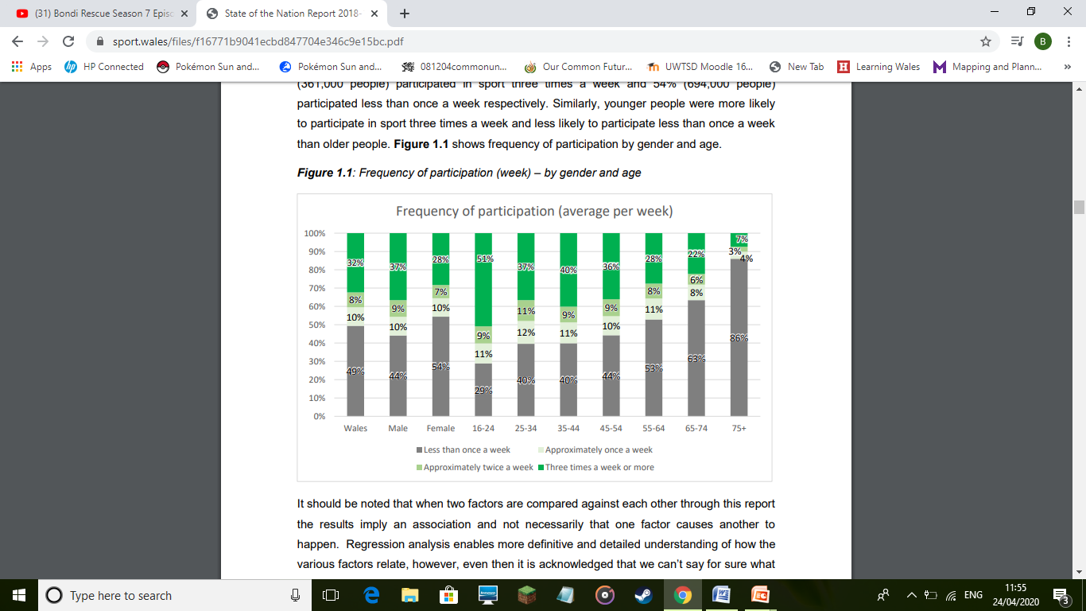

Figure 2:
Sport Wales (2018) table of adult sports participation
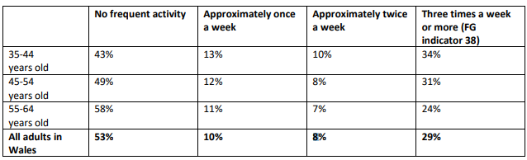
Figure 3:
Table showing what factors would help adults participate in sport frequently

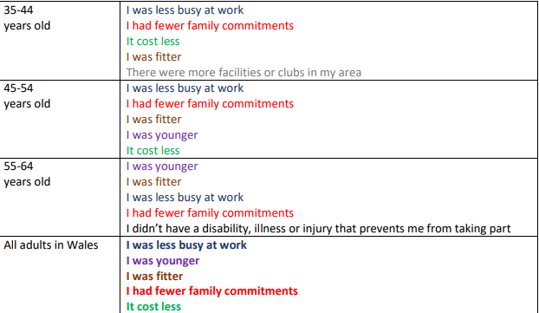
Graphs collated from the primary research questionnaire
Figure 4:
Area chart showing age range of the study

Figure 5:

Figure 6:

Figure 7:
Table showing the regularity of exercise for each participant.
If you do regularly exercise how many hours do you keep physically active per week? | Percentage results
I don’t regularly exercise | 4.1%
1-3 hours a week | 44.9%
4-6 hours a week | 32.6%
7-9 hours a week | 14.3%
10+ hours a week | 4.1%

Figure 8:
Table showing how often participants would ideally like to participate in physical activity.
Ideally how many hours per week would you like to partake in physical activity? | Percentage results
1-3 hours a week | 8%
4-6 hours a week | 48%
7-9 hours a week | 20%
10+ hours a week | 24%

Figure 9:

Figure 10:
Pie chart showing the whether the participants feel there are barriers holding them back from participating in sport.

Figure 11:
Chart showing the top barriers that are holding the participants back from sports participation

Figure 12:
Bar chart showing what sports participants they would most likely be interested in taking up.

Figure 13:
Pie chart showing whether the participants think there is a lack of opportunities for them to participate in sport.

Figure 14:
Graph showing the results of mature sports club preferences.

Figure 15:
Pie chart representing the ideal amount of money each participant would like to spend on sport each week.

Figure 16:
Doughnut chart showing whether parents would have an easier time participating in sport at the same time/club as their children.

Figure 17:
Chart showing whether the participants would like to participate more in sport if they had the opportunity.

Figure 18:
Pie chart showing if people think the government provides enough resources to promote healthy living for all adults.

Figure 19:
Bar chart showing the other added benefits the participants think can be gained from participating in sport.

Figure 12:
Primary research survey questions.

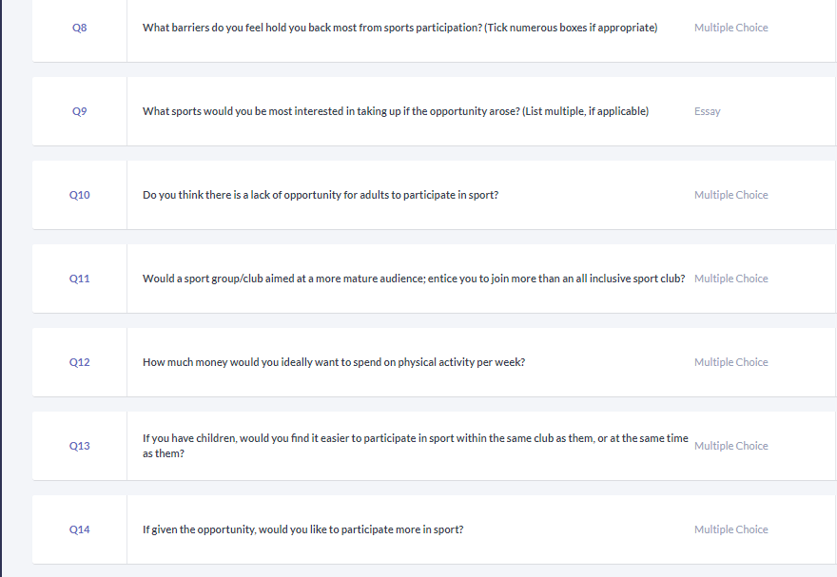
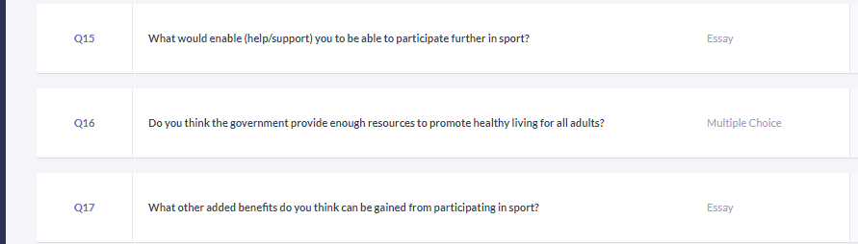

Insert Ethics Form P1 into the table below

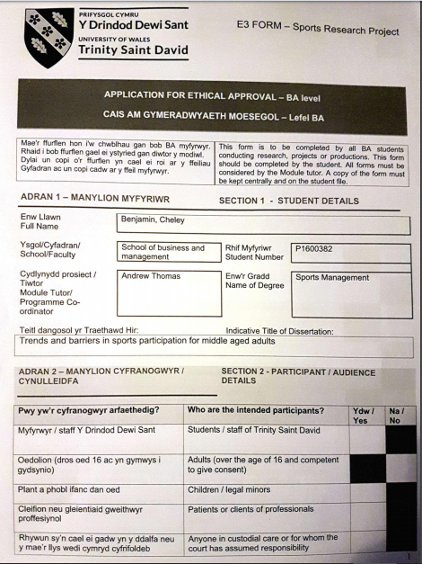

Insert Ethics Form P2 into the table below

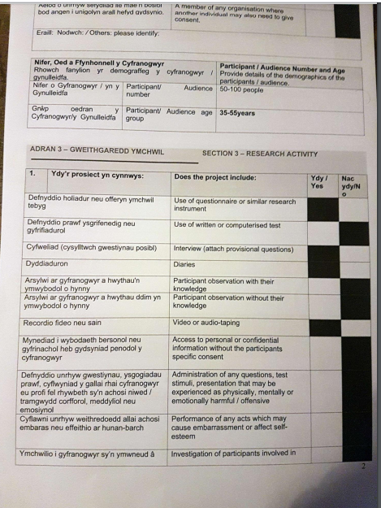

Insert Ethics Form P3 into the table below

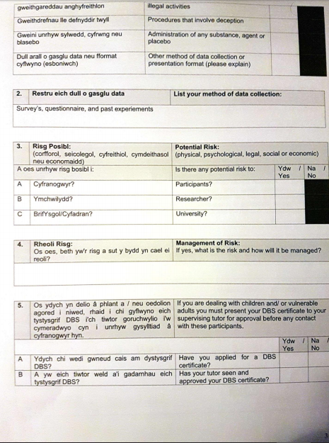

Insert Ethics Form P4 into the table below

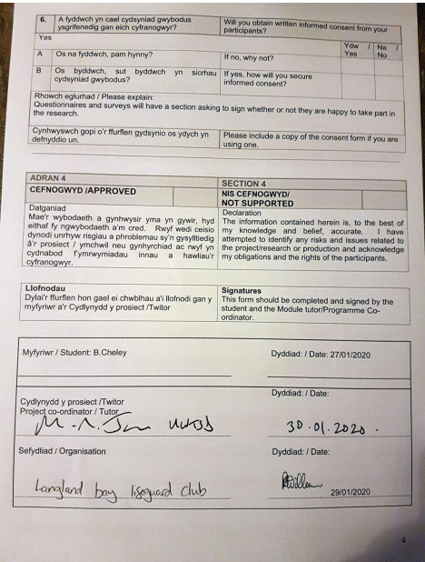

Insert Ethics Form P5 into the table below

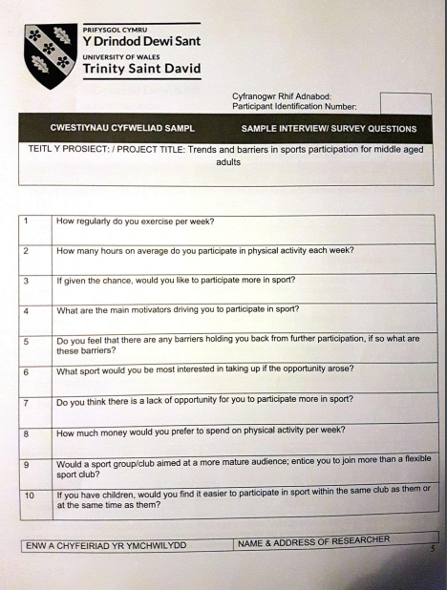

Insert Ethics Form P6 into the table below

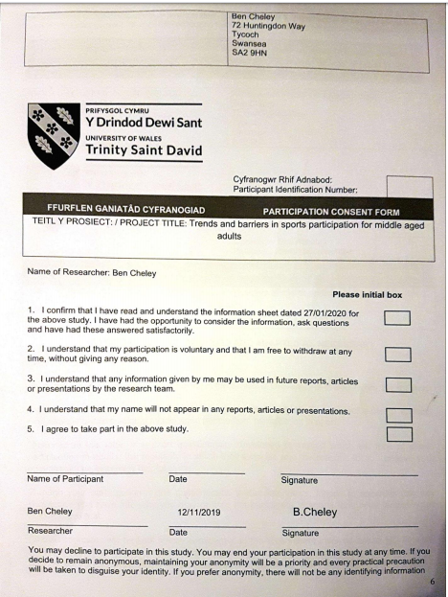

Insert Ethics Form P7 into the table below

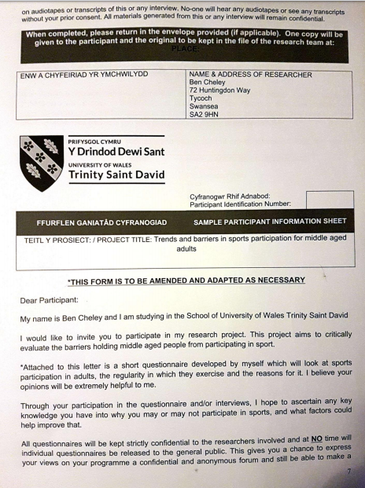

Insert Ethics Form P8 into the table below

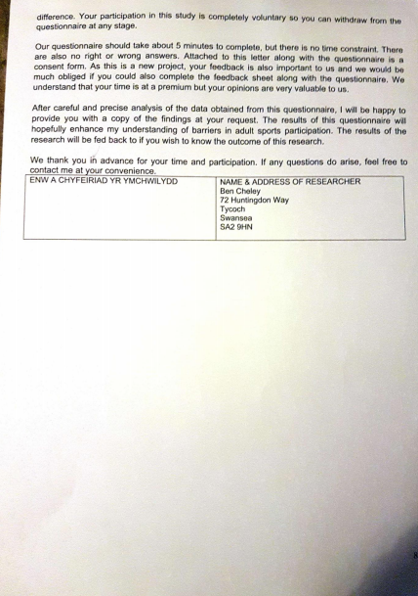

Submission Evidence

Faculty Office (1 x Paper Copy, Bind Professionally)
+
Online Turnitin Submission (prior to Deadline)



BA Sports Management Portfolio

Research Project
Report

UWTSDSport

