UNIVERSITY OF WALES TRINITY SAINT DAVID
Student name: Livia Zmuncila
Student ID: 1905565
Cultural Awareness M5X01923
Module tutor: Dr Olu Adegbite

CONTENT
Introduction………………………………………………………………………………………………2
RUSSIA……………………………………………………………………………………………………3
Religions in Russia……………………………………………………………………………..3
Russian culture………………………………………………………………………………3
Negotiating styles …………………………………………………………………………………………5
Russian traditional Food………………………………………………………………………………….5
CHINA……………………………………………………………………………………………………..6
Chinese values……………………………………………………………………………………………..7
National Chinese food……………………………………………………………………………………..8
Negotiations styles…………………………………………………………………………………………8
Handbook for Hotel Staff……………………………………………………………………………………...9
Conclusion…………………………………………………………………………………………………11
Bibliography……………………………………………………………………………………………….12

Introduction
The purpose of this work is to comprehend and acquire an understanding of different international customs and culture in order to increase the guest service experience. As well as critically understand international customer behavior to enhance visitor service delivery, through accumulating knowledge of global customs and culture. This work uses some methods of investigations such as: analytical thinking, evaluation and synthesis. Whether cultural intelligence is essential for Hotel Personnel.
From this issue that has been highlighted, the aim of the research study is:
- If customers vary across cultures in their behavior, habits and thoughts so they can vary in the hotel sector in their expectations concerning appropriate guest service delivery
The aim has emerged a set of research objectives:
- To establish the importance of cultural understanding in a global market place
- To investigate critically two international countries identifying key cultural differences, customs and behavior
- To produce a Handbook for hotel staff to assist in managing the guest experience for the international visitor.
- Cultural diversity can have a significant influence on the hospitality business. The study reveals that cultural diversity is highly important in hospitality business due to global customer-related industry.

2.
The assignment present investigation of two international countries: Russia and Chinese. The first is Russia.

RUSSIA
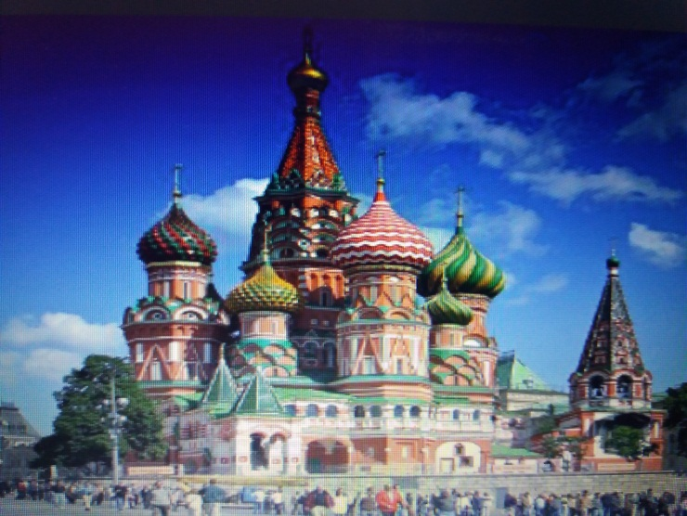 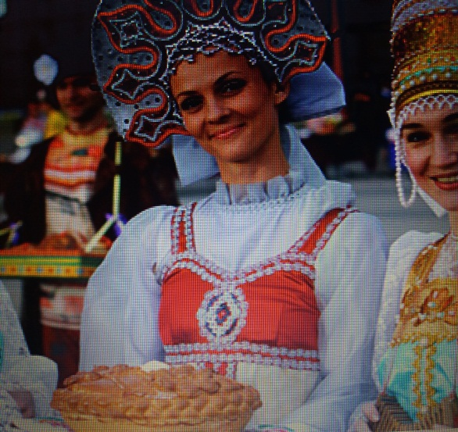 Greatest Churches of Moscow – BigTimeMoscow https://samovary.ru/article/63/
bigtimemoscow.com

Religions in Russia
Russia is multi-ethnic nation. People of different religions like: Orthodox Christianity, Roman Catholicism, Protestant Christianity, Judaism, Buddhism, Islam and Muslim live in the country. The official language of Russian Federation is Russian and it has three major dialects, which are intelligible. Majority of population speak English, German or one of the minority languages (Ukrainian, Moldovian, etc) as a second language. Russia is a federation and semi-presidential republic. In the head of state is the President and the Prime Minister is the head of the government. Moscow is the capital of the country.
Russian culture 3.
The culture of Russian people has a rich history, beautiful traditions, strong arts, especially philosophy, literature, ballet, classical music, painting, architecture, cinema and animation.
Moscow’s Saint Basil’s cathedral with its colorful cupolas is the most popular visual symbol of the country. Bread in Russia symbolized key aspect of national self-image. And round shaped bread with a salt cellar on top is the ancient custom of welcoming a guest as the mark of hospitality. Russian nesting dolls are also well-known symbol of the country are Russian nesting dolls.

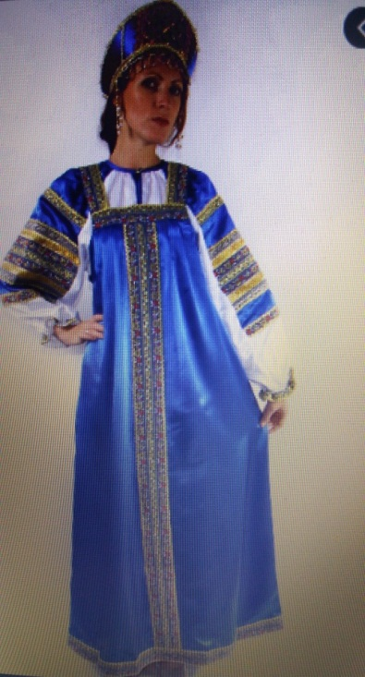

Women silk sarafan dress ''Vasilisa'' | RusClothing.com rusclothing.com · În stoc
Russian Costumes - Encyclopedia of Costumes
wikicostumes.com

4.
Russian people very often use in conversations o lot of metaphors, that make the language more difficult to learn and understand for foreigners. People like to speak about their open-minded soul, that means that they are very kind and want for them simple human happiness. Russian people believe that the destiny of every person is to build a house, to give birth to a son and to plant a tree. Russian has very interesting cultural form of have fun such as songs, a lot of fairytales that always have good morals, also jokes; poems and different games.
Russian people places a high value on the homeland, extended family ties, close friendship, mutual respect.
In our days in Russia, as were notices by diagnosis of the Russian society, were observed that people are concentrated on new forms of economic life and interested in technological innovations even more than Europeans. In the last decade only few people from Russia agree with the liberal model of behavior, they more concentrated on personal development, personal property and their economic life, their protection by law and personal possibilities (Trompenaars, 1996).
Negotiating styles
At the top of Russian style, reflects their cultural characteristics. are often seen as being interested with the methods of the negotiation process. They attend to please the other party to the extent possible. They can behavior impatient when there is a conflict. During negotiations they try to eliminate sources of conflict. Russian have tendency towards improvisation and flexibility, and always are looking for peaceful solving methods. They could focus on seemingly irrelevant details for long periods of time. They like the process of finding the way out of a problem. Russian people are very emotional and never hide it, use a lot of jokes, they are friendly, they are guided by reason or intuition. As members of self-directed culture, theory suggests, that Russian often are likely place value on their own interests or goals and can push for individual accomplishment.

Russian traditional food

5.
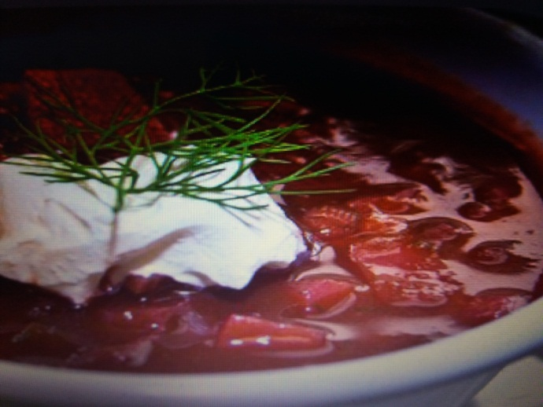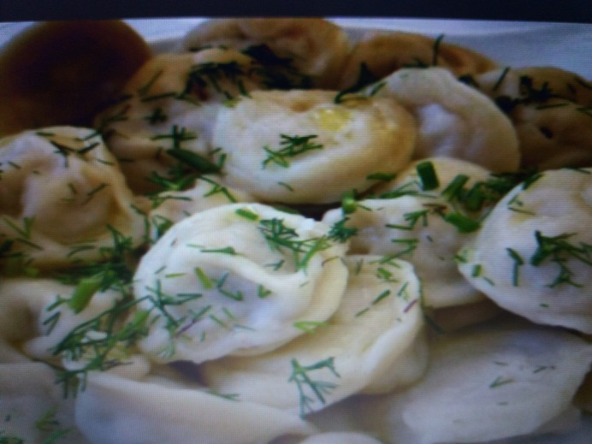
Russian traditional food is amazing delicious and has the huge variety of flavors food. There are some national favourite traditional dishes: borsch, pelmeni, okroshka, shchi, solyanka, ukha, pirozchy, blini, shashlyk, beef Stroganoff. National beverages are: kvas, vodka.

.Chinese 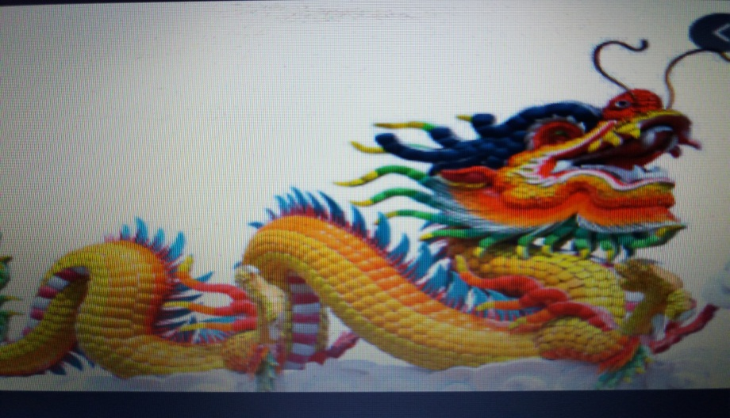 6.
Colourful chinese dragon isolate…fineartamerica.com
Religious
People practice Buddhism, Christianity and Islam in China, but the government of the country officially espouses state atheism. Christianity is seen as a foreign religion for the majority. Well known, that Taoism and Buddhism are practiced in China as well. There is a philosophy that this religion centered on the universe and everything should obey (Xu 2007). Because of this deep knowledge of Taoism people who follow this opinion want to live in harmony with the nature and themselves. (Ho 1995).And it is the reason why they want to solve all problems peacefully.
Chinese values
There are cultural values, according to Confucianism and standards of moral that can be seen as the basic of culture and morality in China from ancient times. Chinese people have a lot of positive qualities, like kindness, they behave in the way not to lose their face and try to be honest. (Wang, 2007). Important rules such as avoiding conflict situations and negative emotions allow them to achieve main goals. Family responsibility, according Confucian ideas, is explained as vital to understand their children, and the role of guiding their children in their way toward knowledge (Xu, 2007). Children are responsible to bring honor to their parents, to be responsible to them and be respectful to the elder generation, and to make their family member to be proud of them (Fang and Fang 2003).
The forces of modernization and the policy of delivering only one child changed the role of daughters in Chinese families and children were exposing to new rules that are completely different to the previous (Fang and Fang 2003).
Hofstede and Hofstede (2011) have defined five Chinese values in his own way: (1) power distance that shows that people accept that people are not equal in the same country.
(2) Individualism/collectivism: shows that a person considers as a part of a group. (3)Uncertainty avoidance: shows the level of anxiety in unrespectable situations. (4) Masculinity/femininity: shows if a person values attitudes between each other. (5) Short/long orientation: speakes about people who are looking for immediate profit.

Most Chinese used to hesitant to display emotions, to elude or reject compliments Chinese used are tried to be as modest as possible, that’s why they are right and honest with others and it express their cultural feature (Dai, 2017). It explains the fact that compliments sometimes can make them angry, if they were said just to please the person (Dukes, 1997).
7.
National Chinese food

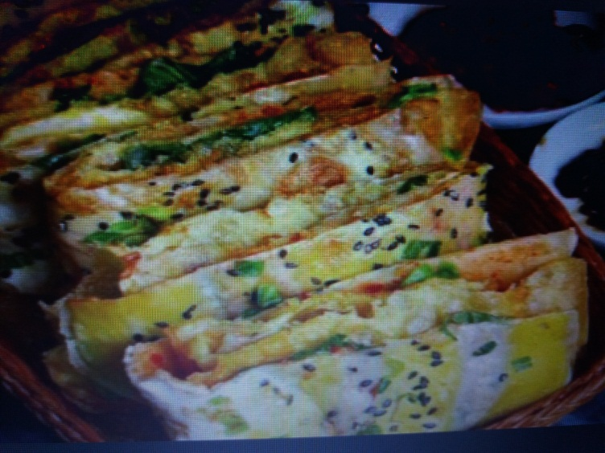
Authentic Chinese Egg Rolls (from a Chinese person) Recipe…allrecipes.com

Chinese traditional dishes are famous for color, aroma, taste, meaning and appearance. The most popular dishes among Chinese and foreigners are: a hotpot, a Sichuan pock, Braised Pork Balls in Gravy, Shrimp with Vermicelli and Garlic, dumplings, Chow Mein, Peking roasted duck, Steamed vermicelli rolls, Fried Shrimp with Cashew Nuts, Sweet and Sour Pork, Kung Pao Chicken, Ma Po Tofu, Wontons.
Negotiations styles
Negotiation styles reflect the cultural features of the nation. In contrast to members of self-directed culture, Chinese mostly focus on issues of trust and time horizons and integrative, or win-win outcomes are almost always possible, after underlying interest and creating potential benefits to both sides. It is because as collectivists they focus less on their own goals and interests than on those of the group (Tinsley and Brett, 1998). 8.

Handbook for Hotel Staff
Nationalities | DO’s | Religions | Languages | DON’Ts
Russian | When meeting is customary to shake hands with men and business women  Call women by their first name, like Elena, are you waiting for a taxi?  Leave the room if you need to blow your nose  Move to another room if you need to clean your nose  Compliment the person or say something pleasant  When you think about bringing flowers, always bring them in odd numbers because even numbers are common for funerals. | Orthodox Christianity, Roman Catholicism, Protestant Christianity, Judaism, Buddhism, Islam and Muslim | Russian | Don’t shake hands to a women who are not business women, as they don’t like it, just great them individually. Ex: Good morning Mrs Elena  Don’t shake hands with your gloves on  Women don’t like when you great them or call them by their family name Ex: Good morning, Elena  Don’t blow your nose in the presence of people, leave the room  Don’t pick or clean your nose in front of people.  Don’t clap people on the shoulder or the back who are not your friends  Don’t come close than a meter to the person you are talking to, as you violate personal space or even a threat  Don’t point your finger at people  or at something which you want to show the direction, or object, use your hand, gaze or a small object, like a pen or a ruler
Chinese | It is affordable to bow to people when you meet them, when you starting to thank you or bidding farewell. Fit forward a sland your head consequently  Do address the family name first  Do address a question or speak with a leader of a group of Chinese it is acceptable and he/she will explain everything to the rest | Buddhism, Christianity and Islam | Chinese,  Mongolian, Tibetan, Uyghur, Zhuang | Don’t come close than two meters to the person you are talking to, as you violate personal space or even a threat  Chinese used to hesitant to display emotions,

CONCLUSION
Similarities and diversities were noted as evidence how culture may influence behaviour during negotiations. Successful or unsuccessful candidates can be found in all countries and in all cultures and it is should be clear that, however, that not all Russian or Japan are the same. All humans are different and don’t always follow the rules of their culture all the time. People change their behaviour – sometimes unsuccessful –all depends on conditions. (Tinsley, 1998).
As there are challenges facing global hotel industry in performing its roles across cultures, the analysis found that cultural differences is highly important in hospitality business due to global customer-related industry. Therefore, there is a strong need for more education and training on cultural diversity in the future To understand the balanced scorecard approach with effective performance management.

This handbook aims to assist the staff of the Hotel to manage the guests experience for the international visitor in respect to the cultural differences. Cultural awareness of employees is important primary due to following reasons:
- First, understanding of cultural variations shows its effect on the industry for maximization of consumer benefits, as it is a global customer-related industry.
- Second, understanding of cultural differences as the key to successful business relationship between employees and customers
- Third, customs of various cultures in hospitality industry have different role service expectations from employees, starting from staff members to a manager of the business.

- Fourth, employees should be able to change their roles behaviour accordingly to what culture the guest belongs to. Cultural awareness equips employees with necessary model behaviour tools. 11.



