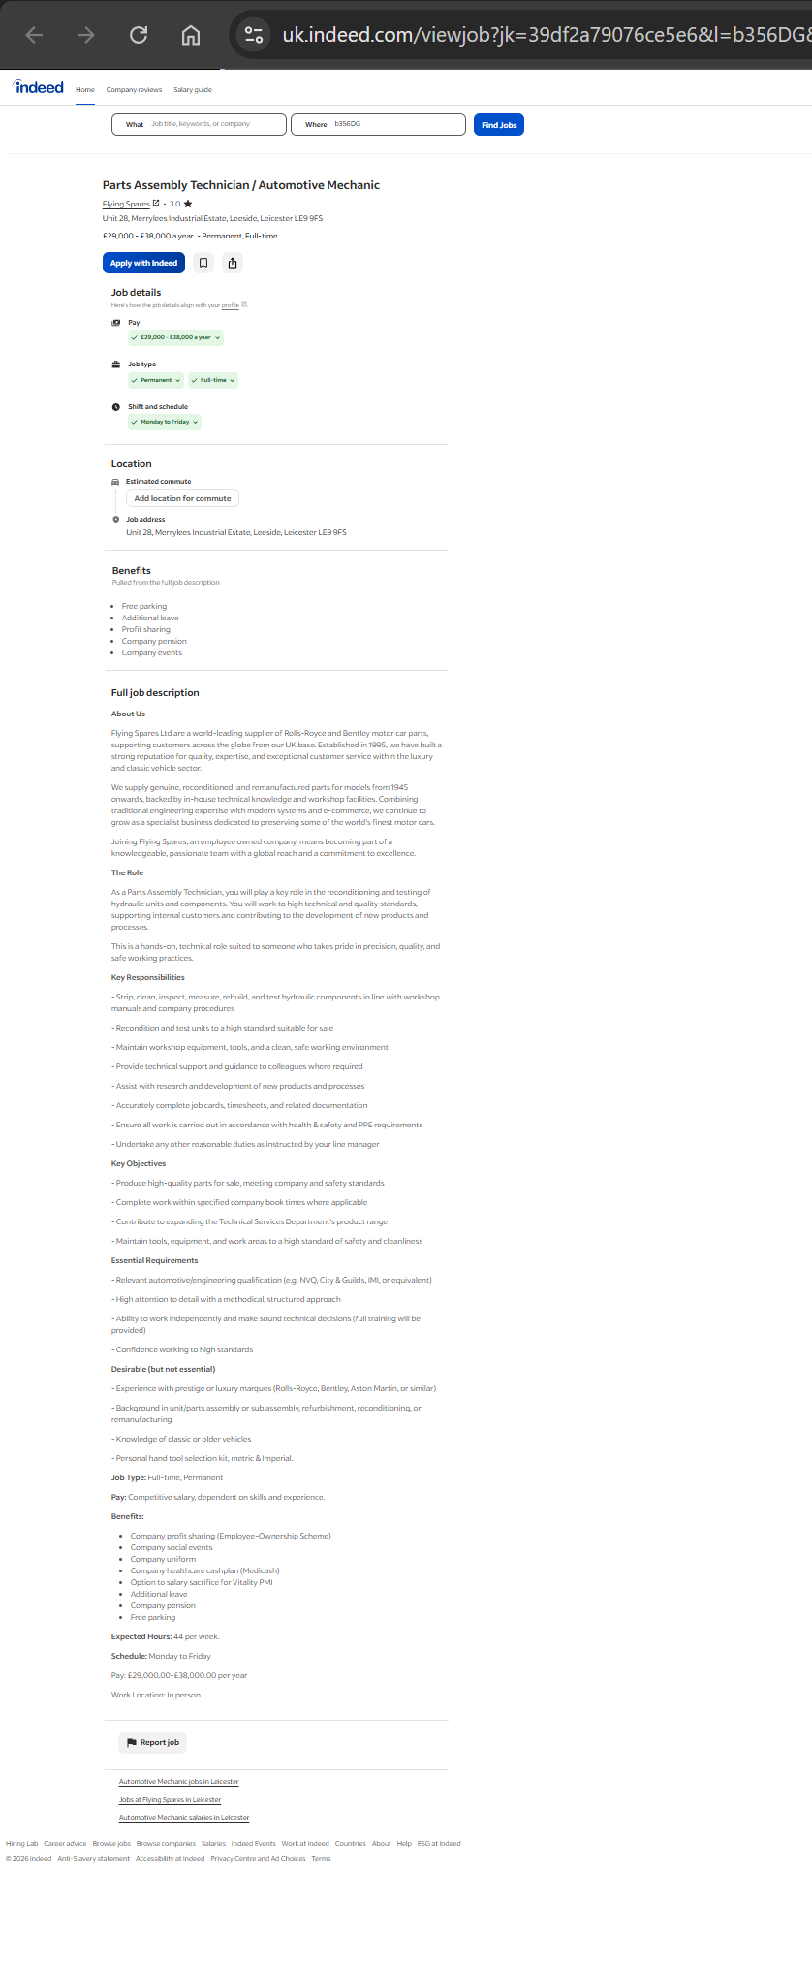
PATRYCJA MIKLAS
Automotive Parts Assembly Technician
Birmingham, B35 | 07851625743 | patrycjamiklas277@gmail.com

Professional Profile
Motivated and detail-oriented automotive and mechanical technician with hands-on experience in prototype battery assembly within the Powertrain Division at Jaguar Land Rover and bicycle servicing and assembly at Wiggle CRC. Experienced in following detailed assembly procedures, carrying out quality checks, diagnosing faults and working to high safety standards. A reliable team player with strong work ethic and a passion foe precision assembly and continuous improvement.

Professional Experience
Prototype Build Technician-Powertrain Division at Jaguar Land Rover (JLR), Coventry
Role Overview: Engaged in the early development stages of JLR’s future powertrain technology, focusing on prototype HV (High Voltage) battery pack builds.
Key Responsibilities:
- Built Battery Electrical Modules (BEM) following detailed assembly procedures and engineering specifications.
- Assembly electrical harnesses and installed busbars to quality standards.
- Installed contactors and pyrotechnic actuators (pyro fuses).
- Completed High Voltage (HV) cable assembly.
- Performed BEM coolant leak testing.
- Conducted isolation checks using Hioki 1000V Isolation Tester.
- Performed Continuity and Isolation checks using a digital multimeter to verify correct assembly and electrical integrity.
- Carried out Battery Electrical Module and High Voltage Junction Box enclosure leak testing using HMI leak testing equipment.
- Instrumented prototype BEM’s by installing surface thermocouples, strain gauges and voltage sense wires to specified locations.
- Routed and secured sensor wiring harnesses, ensuring correct bend radii and strain relief during vibration testing.
- Stripped wires, crimped terminals and soldered sensors leads to Data Acquisition boards and Battery Management System connectors.
- Performed resistance and insulation checks to endure sensors were not shorting against the module casting.
- Used calibrated torque wrenches, precision wire strippers and micro-crimping tools during assembly work.
- Marked up engineering drawings with as-build modifications and logged any sensor devastation or anomalies.
- Comprehensive Excel logbooks to track performance metrics.
- Worked safely on high-voltage system while following health and safety procedures.
- Maintained excellent attention to detail in a fast-paced prototype manufacturing environment.

Bike Technician, Wiggle CRC, Bilston
- Performed bicycle servicing and routine maintenance.
- Carried out safety inspections, gear turning, wheel turning and suspension servicing.
- Assembled new road, mountain and electrical bikes to manufacturer safety guidelines.
- Diagnosed technical issues, consulted with customers and provided repair estimates.
- Maintained high workshop standards while working efficiently to meet deadlines.

Qualification and achievements:
- Level 3 NVQ in Motor Vehicle Maintenance and Repair – Kronstadt Professional German School
- IMI Level 3 Award in Hybrid and Electric Vehicle Operation
- High Voltage Authorized Person (AP) – Issued by Avonside Safety Management

Additional Information:
- Languages: Native Polish, C2 English Proficient
- IT proficiency: Microsoft 356 (Words, Excel and Power Point)
- Full UK Driving licence
- Eligible to work in the UK

Dear Hiring Manager,

I am witing to express my interest in the Parts Assembly Technician/ Automotive Mechanic position at Flying Spares.
Having gained hands-on experience within the Powertrain Division at Jaguar Land Rover and as a Bike Technician at Wiggle CRC, I have developed strong mechanical and electrical assembly skills, excellent attention to detail and commitment to producing high-quality work. I believe my background makes me a strong candidate for this role and I would welcome the opportunity to contribute to your team.
During my time at Jaguar Land Rover, I worked on the assembly and instrumentation of Prototype Battery Electrical Modules (BEM’s), following detailed assembly procedures and engineering specifications. My responsibilities included assembling electrical harnesses, installing busbars, contactors and pychotechnic actuators, completing high voltage cable assembly and caring out coolant leak testing and enclosure leak testing. I also performed HV isolation checks using a Hioki 1000V Isolation Tester and AC cable continuity and isolation checks using a digital multimeter to verify correct assembly and electrical integrity.
In addition to assembly work, I instrumented prototype battery modules by installing thermocouples, strain gauges and voltage sense wires, routing and securing wiring harnesses, preparing and terminating cables and carrying out resistance and insulation checks. I regularly used precision hand tools and including torque wrenches, wire strippers a crimping tool while following engineering drawings and documenting any as-built modifications or anomalies.
My previous role as a Bike Technician at Wiggle CRC further strengthened my mechanical abilities and problem-solving skills. I carried out bicycle servicing, safety inspections, gear tuning, wheel truing and suspension servicing, while also assembling new road, mountain and electric bikes to manufacturer standards. Diagnosing faults, maintaining high workshops standards and delivering quality workmanship were key parts of my daily responsibilities.
I enjoy practical, hand-on work and take pride in completing every task to high standard. I am comfortable working independently, following technical procedures and supporting colleagues to achieve team objectives. My experience in prototype manufacturing has taught me the importance of precision, quality and safety, values that strongly align with Flying Spares reputation for excellence and craftsmanship.
I am excited by the opportunity to join a company that specialises in preserving and supporting some of the world’s finest motor cars. I am confident that my assembly experience, technical skills and strong work ethic would allow me to make positive contribution to your Technical Services team.
Thank you for taking the time to consider my application. I look forward to the opportunity to dissguss how my experience and enthusiasm can benefit Flying Spares.

Best Regards,
Patrycja Miklas

