REPORT
ON
EFFECTIVENESS OF USING MODERN TECHNOLOGIES IN THE WORKINKING PLACE

STUDENT NAME

STUDENT NUMBER | 1812785
MODULE TITLE | Digital Skills and Research Methods
MODULE CODE | BMSK4003
LECTURER | Balendran Kandasamy

Contents
SUMMERY 3
INTRODUCTION 4
Connection between business and modern technologies 4
Web conferencing communication 5
Livestorm and Lifesize 6
(Getapp, 2019) 8
Benefits of using Lifesize are: 8
Concerns about using Lifesize as follows: 8
Positive sides using Livestorm: 8
Negatives using Livestorm 9
Benefits of using tweeter for business purposes 9
My internet presentences 10
twitter 10
Facebook 11
Linkedin 11
Conclusion 12

SUMMERY

That report analysing the significant role of using modern technologies in the working place. The process of using technologies make the development in small or big companies, much more efficient and productive. The effectiveness and benefits of usage web conferencing in business. Comparing two webinar software’s – benefits and concerns in their usage. There is considering and exploring social media profiles – twitter - enormous opportunity for discovering new prospects, clients and partners.

INTRODUCTION

Connection between business and modern technologies
Technology has changed the way the businesses around the world operating. Phones, web cameras, internet are only few of the many tools which are been used from the business in 21st century. In result of that there is variety of benefits for small, middle and large companies globally.
The main advantage of the using modern technologies in working place is the huge financial savings. Regardless that in the past the ways of communication were very limited within the letters and landline telephones, traveling in a long-distance loosing time and finances to reach the company goals. However, the mobile phones are a great technical revolution for everyone, but they are part of the wide variety of tablets, small and very powerful laptops. All devices are been built in wireless capabilities. These technologies give wide range pf opportunities for business person to communicate easily without too many expenses and effort.
The improvement of technologies in working place bring to the labour market a new type of jobs and employability opportunities like – installation, operating and maintenance of technology tools. Business communication technology increased efficiency of the work and reaching the targets much quicker than before. Instead of waiting of documents to arrive with days, businesses now exchange files, letters, images within a second pressing a button.
Previously there has been planned conferences and meeting with weeks and months since each participant in the conference is available to take a place. Now that is totally changed by means of web conferencing (J, 2019).
Web conferencing is technologies which allows two or more people from different from different locations to communicate. The history of that tool is since 1990 and is a part of technological progress. During the years there was improvement in power and hardware (Technopedia, 2019).
Web conferencing give the opportunity for attending meetings using computer and internet. Various types companies to meet the employees who are not physically in different locations.
Companies can speak with client around the world. Web conferencing provides a few main benefits for business:
- Saving time and costs – if the firm want to bring together all the team spread on different location around the country and the world even or to meet the clients, before that was related with loosing time arrangement in advance and traveling. Web conferencing gives chance to meet everyone in a second. Even the organisation pays for conference service it is still much cheaper than the travel expenses.
- Increase efficiency – if the business wants to organise massive meeting neds to manage attendance, to book the conference room, to plan the schedule and in some cases to order a catering. Web conferencing save all that effort.
- Flexibility – organisation needs to send an invitation email to everyone who will take a part of the meeting. With web conferencing every attendant has ability to log in in a minute.
- Increase Commitment – web conferencing allows uploading files, images and graphics and in one with audio component. That helps for rising of the engagement level of the attendants in the meeting.
- Removes Geographic barriers – open possibility of communication with employees and customers worldwide.

Web conferencing communication
Off course there is a few concerns about web conferencing communication such as:
- Low levels of security - hacking the system is a real problem in our days. No matter the tightest security measures, hackers can find a way to access to company files
- Privacy factor is minimum – information thru web conferencing is a public targeted the public.
- Most of the conferencing software have additional costs – to avoid intervention in their meeting and confident information, come companies invest in their own servers.

In addition, we can compare two of the most popular web conferencing software’s:

Livestorm and Lifesize
Features | LIVESTORM | LIVESISE
API - functions and procedures allowing creating applications | Yes | No
Activity dashboard - includes the names of users, time they viewed the documents, sheets, and slides files. | Yes | No
Ad hoc reporting - shows information in a table or a chart that, which are in result of question that has not already been codified in a production report. | Yes | No
Automated sales - includes business sales and forecast analysis, order processing and tracking, inventory monitoring, control, customer management, employee evaluation. | Yes | No
Automatic schedule - gives option of deciding how much control business want over task scheduling in a project. | No | Yes
Automatic device recognition - recognizing targets or other objects based on sensors. | Yes | No
Availability indicator - indicates presentence of the members in conference | No | Yes
CRM Integration - automatic integration between the company website and marketing software and contains valuable customer information. | Yes | No
Call sharing | No | Yes
Chat | No | Yes
Conferencing | No | Yes
Content library –  that is online database of digital content including text, images, audio, video, or other digital information | No | Yes
Customer segmentation -grouping customers with common characteristics, so the companies can market to each group effectively and appropriately. | Yes | No
Data export/import | Yes | No
Data visualization - information is presented like chart, diagram, picture | Yes | No
Email alerts | No | Yes
Email invitations and reminders | Yes | No
Email notifications | Yes | No
Engagement analytics - measures how much time a group of visitors spend in webinar. | Yes | No
Live/video conferencing | No | Yes
Meeting management - number of people gathered together, to discuss a topic and presenting information related with it, taking a decision and developing a plan of action. | Yes | No
Multiple data sources - allows switching back and ahead between data sources. | Yes | No
Real time analytics - business can get insights or can draw conclusions immediately thru the data enters their system. That function allows the company to react without delay. | Yes | No
Real time data - reach to the end company as quickly as it is gathered. | Yes | No
Visual analytics - fields of information based on scientific visualization with purpose to support interactive visual interfaces. | Yes | No
Web integration - process of connecting all activities and components unifying the project in one whole. | Yes | No

(Getapp, 2019)

Benefits of using Lifesize are:
- Easy to use interface
- Very good for video calling or basic needs
- Making video call with touch on the screen
- Lifesize Cloud is stable and reliable
- Usage for contacting outside the company and training purposes

Concerns about using Lifesize as follows:
- When the user is presenting content the quality and performance is poor
- Lack of screen configurated features
- Extra cost for maintenance
- Extra cost for access to technical support
- Very expensive software
- Software need to be update regularly
- Better for operating with cable instead of using wireless
- More option for to customize
- Small storage units

Positive sides using Livestorm:
- Easy to setup and using
- Functional landing pages
- Emails and remainders access
- Video stream is smoot and clear
- Affordable price
- Great and very helpful customer service
- Webinar is very quick
- Prising is very flexible

Negatives using Livestorm
- The quality of the recorded replays is poor
- There is no indication what time the attendee joined and webinar
There were more insignificant and basic concerns in client’s feedback but in response of that the technical support of Livestorm working to improve those.
The feedback for Livestorm and Lifesize is very similar as the purpose of their software is communication. The overall comment for Lifestorm is five stars and for Livesise around four. The software’s are easy to use, there is some issues about the improvement of the system for Livesize and the customer service too. Compering this two-web conferencing software’s, the conclusion is that Lifesize is for users with basic needs and personal trend. In the Other side Livestorm is very good for business webinars, functional and it is pointed to business users.
Regarding the user’s reaction Lvestorm is better software - flexible, quick, easy for using. With very good and helpful customer service and as been coalified very good value for money.

Benefits of using tweeter for business purposes
Few years ago, using twitter to promote business was related with the prejudice. Because of the colossal number of celebrity’s profiles, it seems is not right for business users. In present days not using tweeter is missed prospect to make a contact with younger population, therefore that is enormous number of new consumers.
Using tweeter business owners have the opportunity to advertise their brand. That is a chance to tell their company story. To show their clients more about the brand. To let people, know about their existence and give more information about the nature of the company.
Another great opportunity is to share professional opinion, customers feedback and personal thoughts about marketing or management. Regarding marketing and management tweeter is a tool which can be used for announcing a product or new business idea. To ask the clients what their expectations are about particular service or invention.
Recently every company small or large have a social media profile. That is the way to resolve client’s issues or difficulties by using product or service. Tweeter is quick accesses on the costumer to the company, regardless any trouble. In other side easy way for business to keep their clients satisfied and informed. The significant prospect for achieving a new contact with partners, suppliers operating in the same industry. To keep the investors of the company updated about the progress and development of the business (Williams, 2017).

My internet presentences

twitter
https://twitter.com/AngelovaRayna
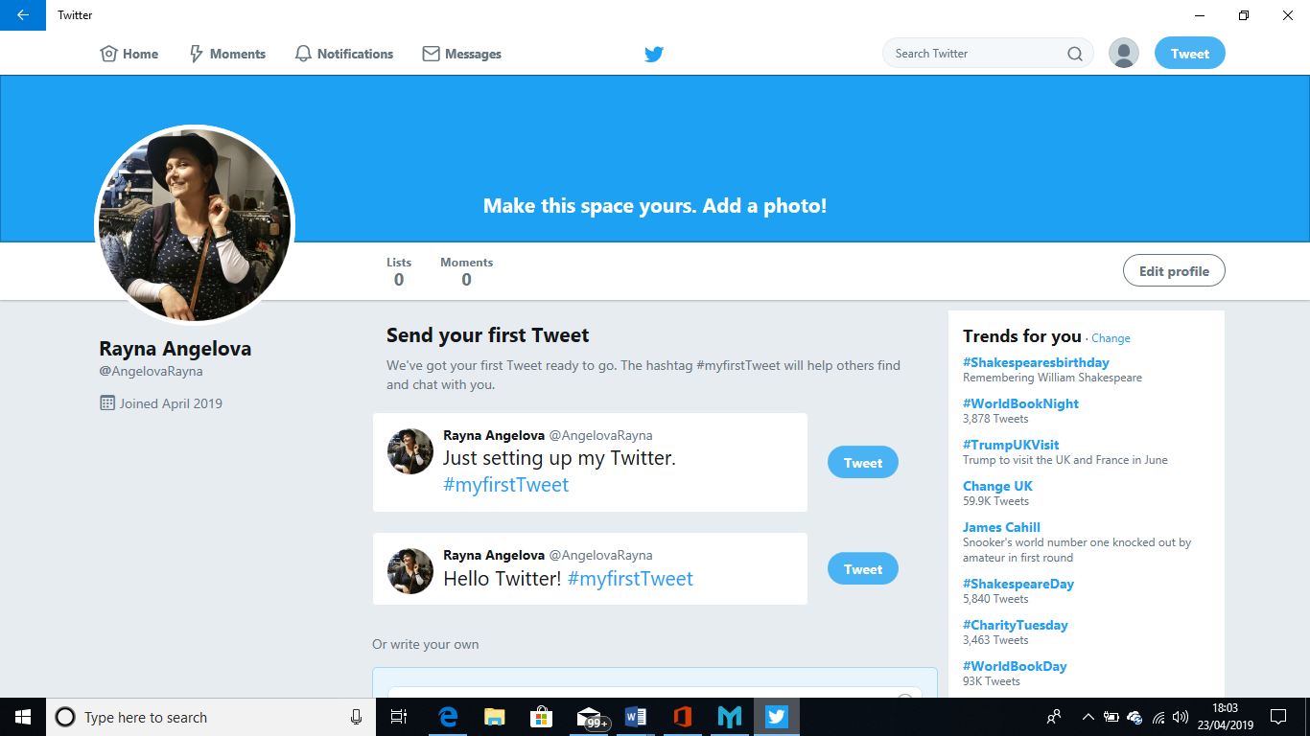

Facebook
https://www.facebook.com/profile.php?id=100007434405630&ref=bookmarks
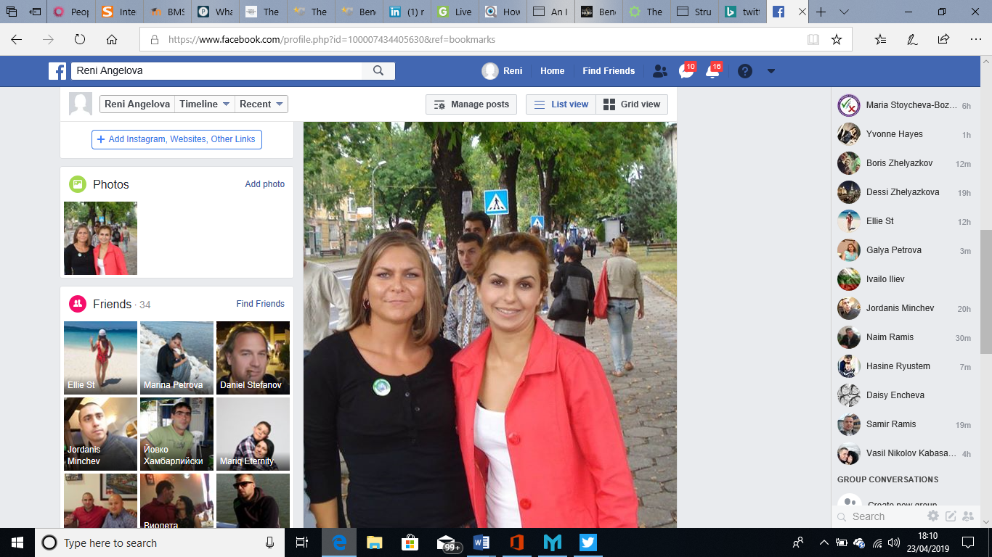

Linkedin
https://www.linkedin.com/in/rayna-angelova-284221185/

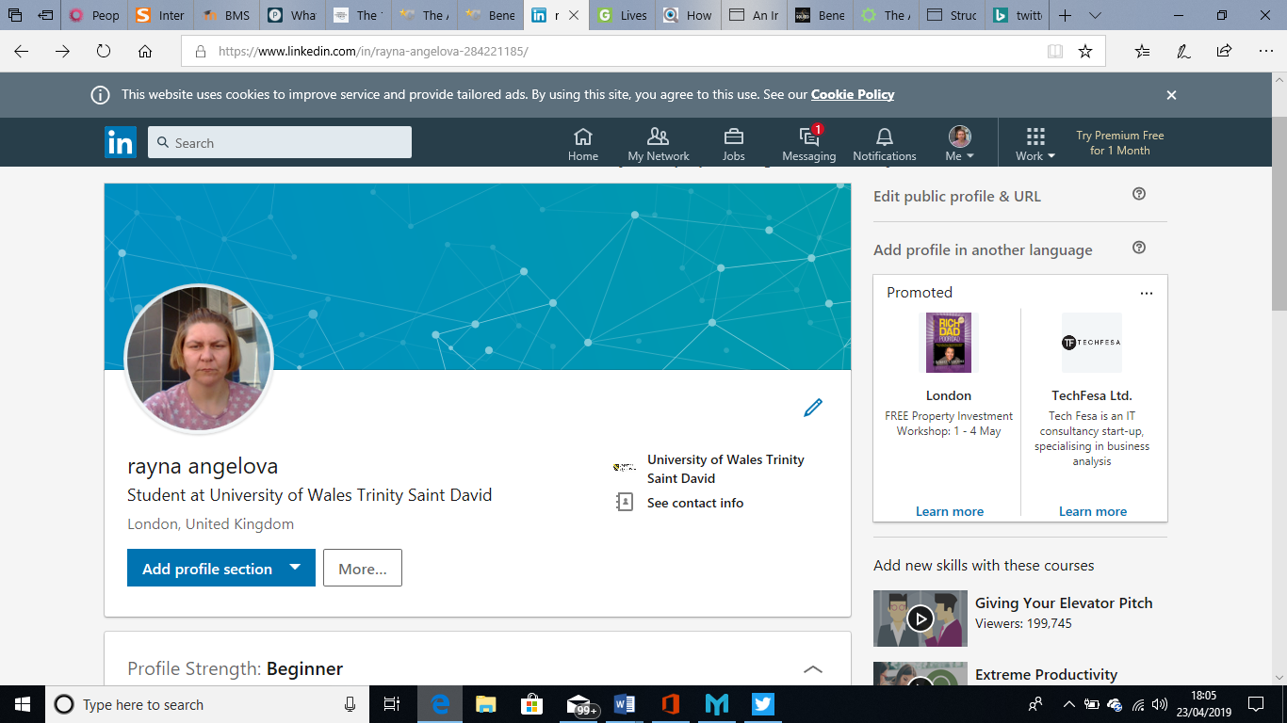

Conclusion
From the above discussion on modern technologies in working place, follows that:
Firstly, high levels of productivity and effective collaboration between employers, employees, clients as well. Technologies make the working process in the company much easier and simpler, because workers are free to prioritise their work, concentrating on a more important task.
Secondly the communication between different departments of the farm is constant, wherever their location is. Technologies allowing video and virtual exchanging of data, statistics and facts related with the efficiency.
Truthy technologies give a new prospect regarding keeping and storage of documents, statistics and reports.
Last but not less important the costs for business expenses are reduced, travel costs, warehousing costs too (Williams, 2017).

References

Getapp, 2019. Livestorm vs Lifesize Comparison Chart. [Online]
Available at: https://www.getapp.com/it-communications-software/a/rumble/compare/lifesize1/
[Accessed 18 April 2019].
J, H. K., 2019. The Advantages of Technology in Business Communication. [Online]
Available at: https://smallbusiness.chron.com/advantages-technology-business-communication-2824.html
[Accessed 17 April 2019].
Kazmeyer, M., 2019. The Advantages of Technology in the Business World. [Online]
Available at: https://itstillworks.com/technology-affects-business-operations-1659.html
[Accessed 13 April 2019].
Technopedia, 2019. Web Conferencing. [Online]
Available at: https://www.techopedia.com/definition/16054/web-conferencing
[Accessed 18 April 2019].
Williams, A., 2017. Benefits of Using Twitter for Your Business. [Online]
Available at: https://www.marketingsolved.com/benefits-of-using-twitter-for-your-business/#
[Accessed 14 April 2019].

